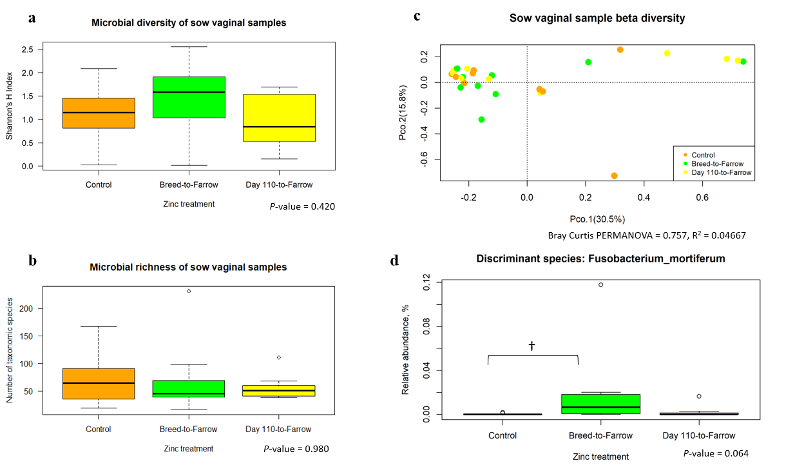
Figure S2. Microbial diversity of sow vaginal samples. (a-c) Microbial diversity measures for sow vaginal samples. (d) Discriminant species of sow vaginal samples.

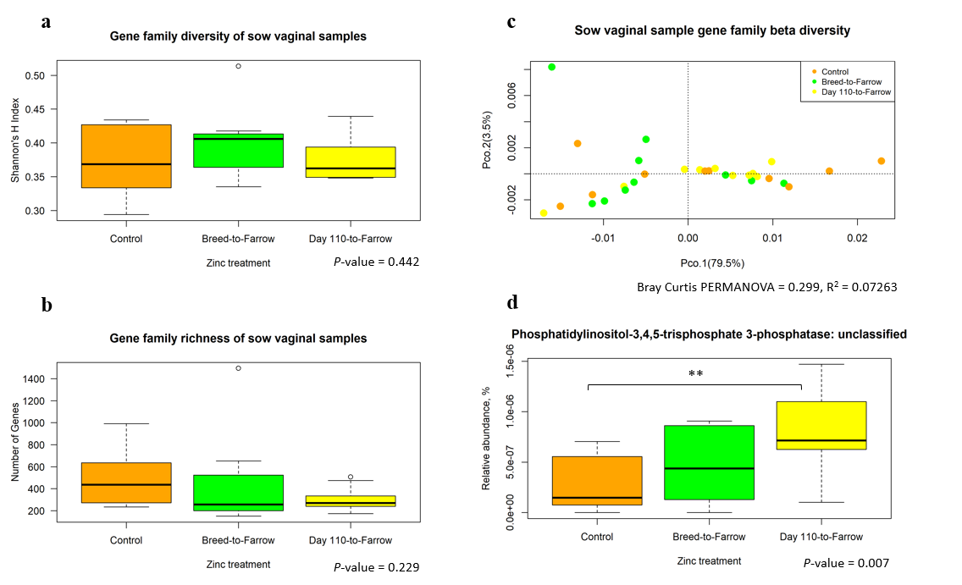

Figure S3. Diversity of sow vaginal gene families. (a-c) Diversity measures of sow vaginal gene families. (d) Discriminant gene family of sow vaginal samples.

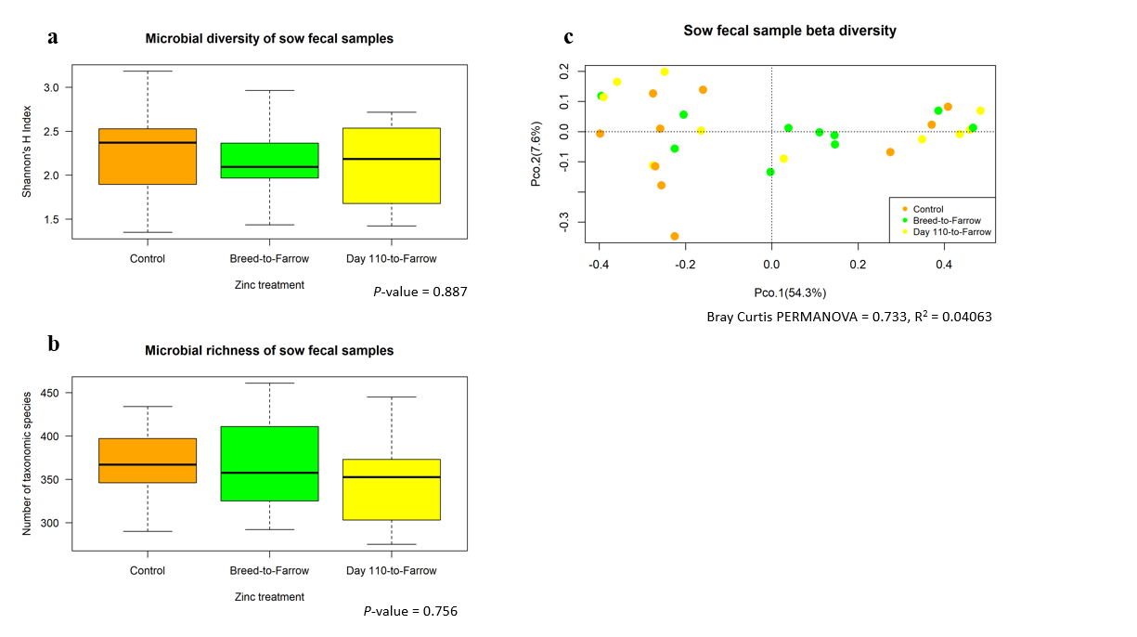
Figure S4. Microbial diversity of sow fecal samples.

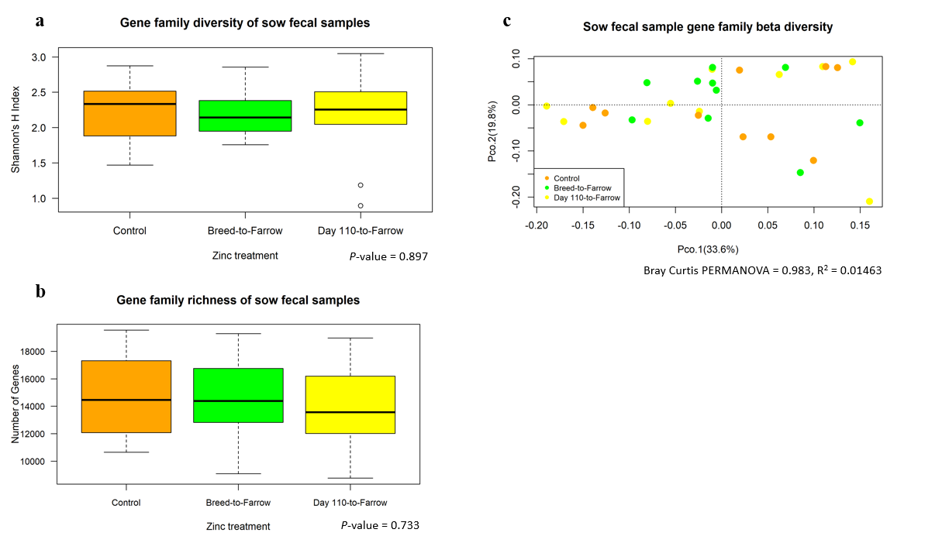
Figure S5. Diversity measures of sow fecal gene families. (a-b) alpha diversity of fecal gene families. (c) community composition of gene families in fecal samples of sows.

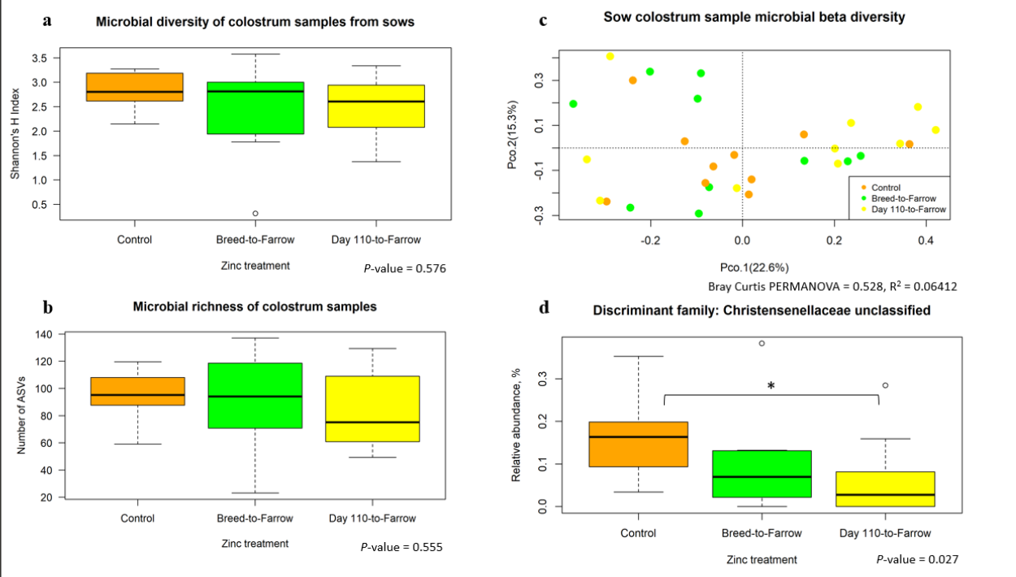
Figure S6. Microbial diversity measures of colostrum samples. (a-c) Microbial diversity and community composition of sow colostrum. (d) Discriminant family identified in colostrum samples.

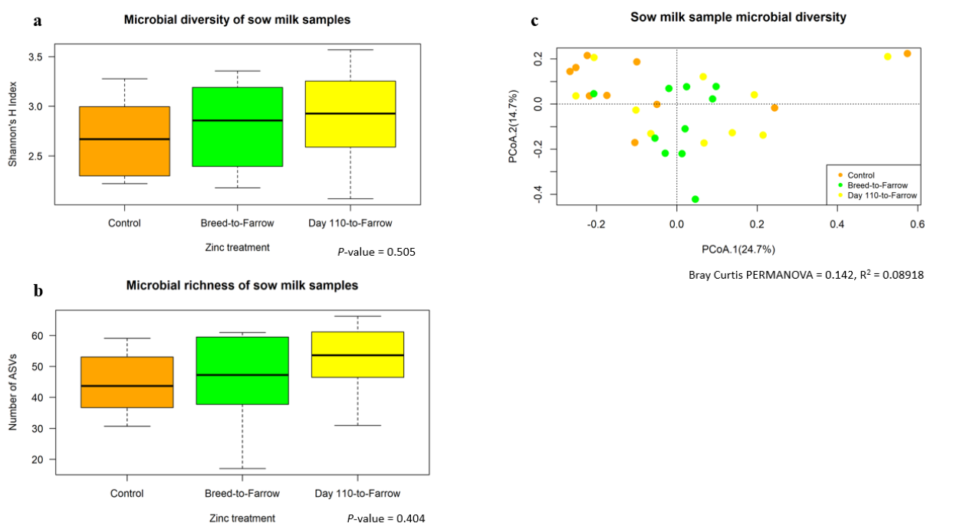

Figure S7. Microbial diversity measures of milk samples. (a-b) Microbial diversity of sow milk samples. (c) Community composition of milk samples.

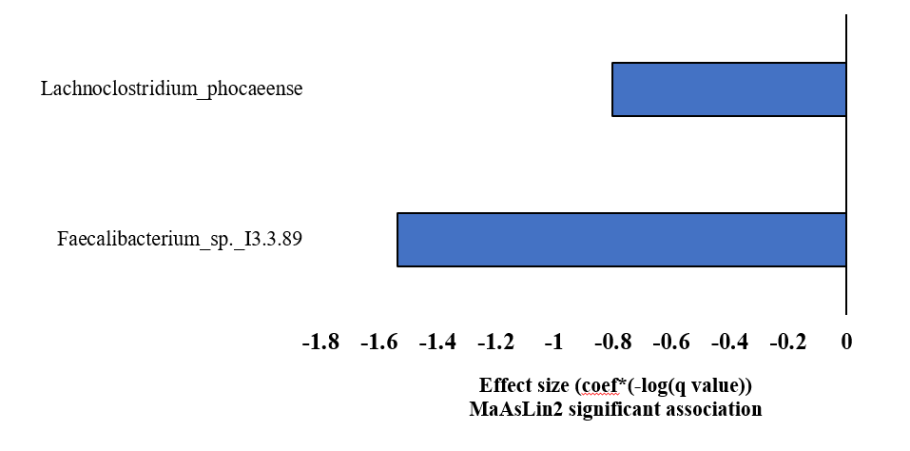
Figure S8. Discriminant species identified for low birth weight pigs (LBW) compared to average birth weight piglets (ABW).

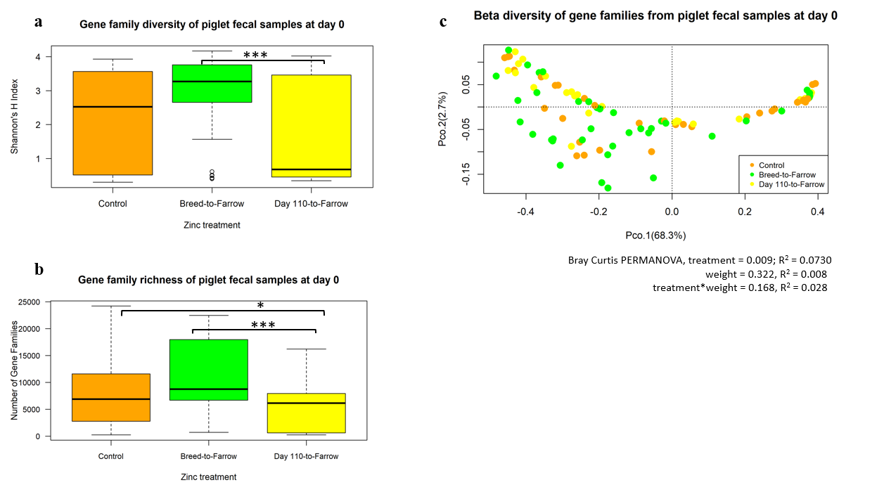
Figure S9. Diversity measures of pig fecal sample gene families at day 0 of age. (a-b) Gene family diversity of pig fecal samples at day 0 of age. (c) Community composition of gene families of pig day 0 fecal samples.

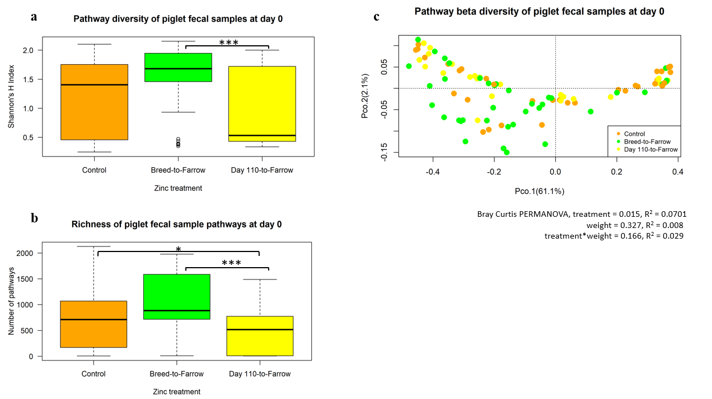
Figure S10. Diversity measures of pathways in piglet fecal samples at day 0 of age. (a-b) Pathway diversity of piglet fecal samples at day 0 of age. (c) Pathway beta diversity of piglet samples at day 0 of age.

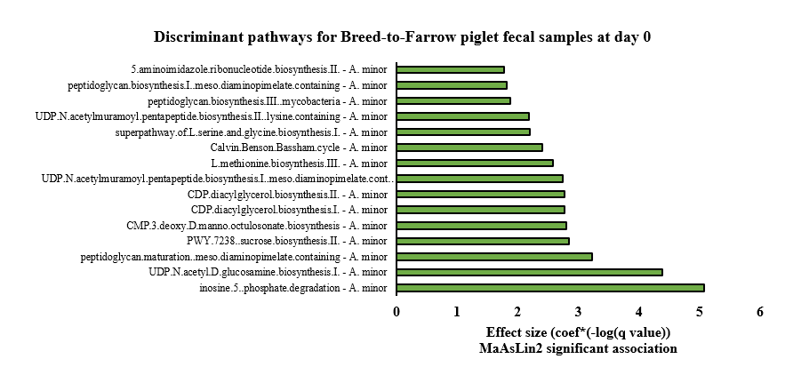
Figure S11. Discriminant pathways identified for Breed-to-Farrow piglets at day 0 of age compared to Control pigs. 105 pathways were identified for Breed-to-Farrow piglets however the top 15 pathways with the lowest q-value were selected.

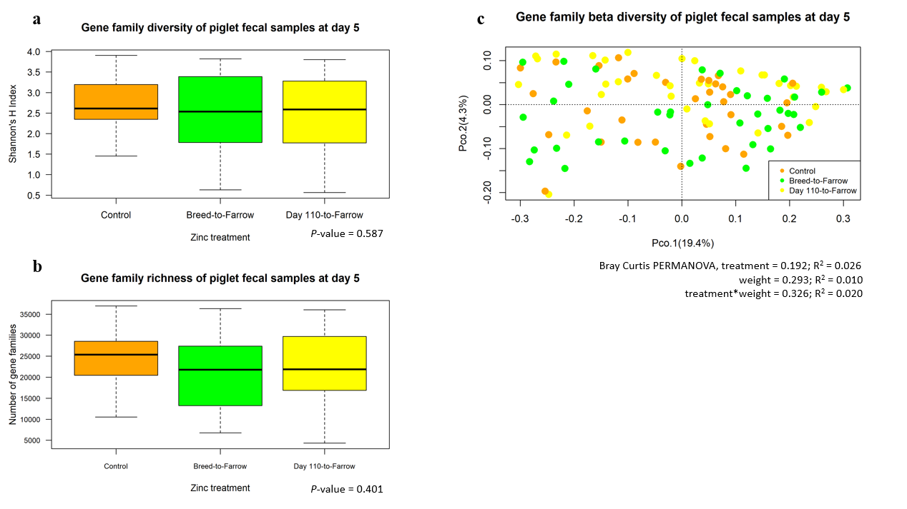
Figure S12. Diversity measures of piglet gene families at day 5 of age. (a-b) Alpha diversity measures for piglet gene families at day 5 of age. (c) Community composition of gene families at day 5 of age for pigs.

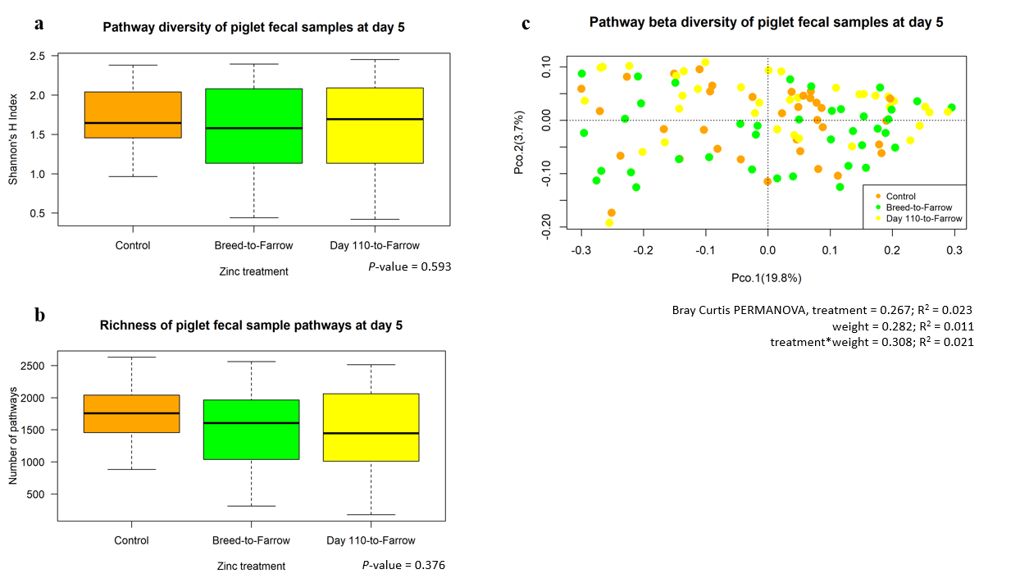
Figure S13. Diversity measures of pathways in piglet fecal samples at day 5 of age. (a-b) Alpha diversity measures for piglet pathways at day 5 of age. (c) Community composition of pathways at day 5 of age for pigs.

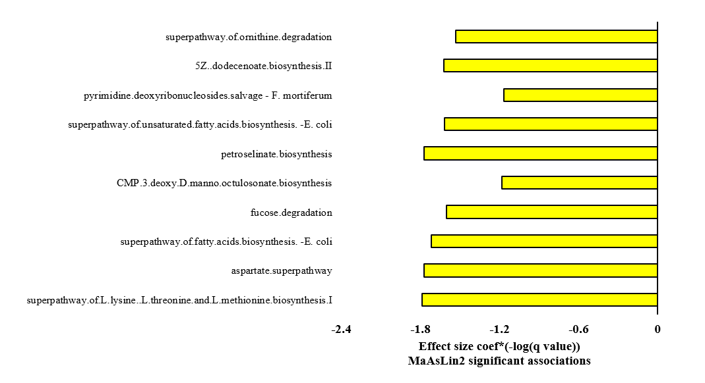
Figure S14. Discriminant pathways identified for Day 110-to-Farrow piglets at day 5 compared to Control pigs.

Table S1. Discriminant pathways in sow vaginal samples¹
Pathway |  | Treatment |  | Indicator value³ |  | Treatment t-value |  | Treatment p-value |  | Treatment q-value |  | Treatment Effect size⁴
aerobic respiration I cytochrome C – unclassified² |  | Day 110-to-Farrow |  | 0.4949 |  | 2.694 |  | 0.0122 |  | 0.012 |  | 5.155
aerobic respiration I cytochrome C² |  | Day 110-to-Farrow |  | 0.4890 |  | 2.744 |  | 0.0108 |  | 0.012 |  | 5.251
¹Includes 30 vaginal samples from sows (10 per treatment).
²Discriminant pathways in sow vaginal samples were only significant for Day 110-to-Farrow piglets compared to Control sows.
³An indicator analysis was conducted and discriminant pathways were confirmed for significance using a generalized liner mixed model. Sow vaginal pathways were considered with an indicator value ≥ 0.48.
⁴Effect size calculated as: treatment t-value*(-log(treatment q-value)). Effect size was calculated for treatments with a q-value < 0.10.

Table S2. Discriminant pathway in sow fecal samples¹
Pathway |  | Indicator value² |  | Breed-to-Farrow  t-value |  | Breed-to-Farrow  q-value |  | Day 110-to-Farrow t-value |  | Day 110-to-Farrow q-value |  | Breed-to-Farrow effect size³ |  | Day 110-to-Farrow effect size³
Glycogen degradation I – unclassified |  | 0.531 |  | -1.715 |  | 0.0979 |  | -2.807 |  | 0.0183 |  | -1.731 |  | -4.874
¹Data includes 30 samples (10 per treatment). Initially, an indicator analysis was conducted, and discriminant pathways were confirmed using a generalized linear mixed model. Pathways with an indicator value ≥ 0.50 were considered.
²An indicator analysis was conducted and discriminant pathways were confirmed for significance using a generalized liner mixed model. Sow fecal pathways were considered with an indicator value ≥ 0.50.
²Effect size calculated as: treatment t-value(-log(treatment q-value)). Effect size calculated for pathways with a q-value < 0.10.

Table S3. Discriminant pathway in piglet fecal samples at day 0¹
Pathway |  | Day 110-to-Farrow coefficient |  | SD² |  | P-value |  | Q-value² |  | Day 110-to-Farrow effect size
D-arabinose degradation I – unclassified |  | -0.970 |  | 0.301 |  | 0.002 |  | 0.090 |  | -1.015
¹One pathway was identified using the MaAsLin2 R package as significant for the Day 110-to-Farrow piglet fecal samples at day 0.
²SD = Standard deviation. Q-value = P-value corrected for false discovery rate.

Table S4. Discriminant pathway in Breed-to-Farrow piglet fecal samples at day 5
Pathway |  | Indicator value |  | Breed-to-Farrow  t-value |  | Breed-to-Farrow  q-value |  | Day 110-to-Farrow t-value |  | Day 110-to-Farrow q-value |  | Breed-to-Farrow effect size² |  | Day 110-to-Farrow effect size²
4-hydroxyphenylacetate degradation |  | 0.493 |  | 2.005 |  | 0.048 |  | -0.790 |  | 0.431 |  | -0.288 |  | ---
¹Data includes 110 fecal samples. Initially, an indicator analysis was conducted, and discriminant pathways were confirmed using the MaAsLin2 R package. Pathways with an indicator value ≥ 0.49 were considered.
²Effect size calculated as: treatment t-value(-log(q-value)). Effect size calculated for pathways with a q-value < 0.10.

