IJESRT
International Journal of Engineering Sciences & Research Technology
PRACTICABILITY INVESTIGATION & DESIGNING OF FILE AND WEB BASED INFORMATION EXTRACTION ALGORITHM
Karan Pahlani*
*Computer Science & Engineering, Acropolis Technical Campus, Indore (M.P.)-452001, India

DOI: 10.5281/zenodo.1002697

ABSTRACT
Information extraction (IE) aims at extracting specific information from huge amount of documents. Now a day’s internet became a great source of information and contains immeasurable amount of data which makes it tedious for normal users to retrieve relevant data, therefore it is a demand of present time to have a efficient information extraction system that convert web pages and their data into user friendly structures for this purpose many extraction system has been developed with variable performance this paper will going to throw light on such one IE system.
This research paper introduces a method that uses rule based technique to induce an extraction. This research paper enables the user to gather more relevant piece of information and helps to improve the search keyword to extract efficient desirable knowledge for end user

KEYWORDS: Information Extraction Algorithm, Information Extraction, Web based, File Based

- INTRODUCTION
A goal of IE System is to allow computation to be done from the semi-structured data. It is used to drawn structured information from the unstructured data. A more specific goal is to allow logical reasoning to draw inferences based on the logical content of the input data. Unstructured data is refers to information that either does not have a pre-defined data model or is not organized in a pre-defined format. Structured data is semantically well-defined data from a chosen target domain, interpreted with respect to category and context. It can take out information which is needed or necessary will be extracted from the free text files and unstructured data. This project introduces a method that uses rule based technique to induce an extraction. This experimental research shows that this gives the best results obtained so far for IE from semi- structured and unstructured documents based on regular expressions. This project enables the user to gather more relevant piece of information and helps to improve the search keyword to extract efficient desirable knowledge for end user.

- RELATED WORK
Since then several architectures have been developed to facilitate the process of the information systems development by providing the common platform for systems’ components design, integration and reuse. Among them are the Unstructured Information Management Architecture (UIMA), the General Architecture for Text Engineering (GATE), the Architecture and Tools for Linguistic Analysis Systems (ATLAS), the Automated Linguistic Processing Environment (ALPE).AutoSlog, LIEPsystem, PALKAsystem, CRYSTALare some ofthe learning system that generates extraction rules.

Information extraction automation has become more popular due to some restrictions of the previous approach, like time and effort consumption. Among the automated systems are WHISK, RAPIER, WIEN, SRV (supervised); IEPAD, OLERA (semi-supervised); DeLa, RoadDunner, DEPTA (unsupervised). Five of the most common supervised learning techniques are the Hidden Markov Models (HMM), Maximum Entropy Markov Models (MEMM), Conditional Random Fields (CRF), Sup-port Vector Machines and Decision Trees. There are many such systems are developed before on the basis of various predefined IE methods here we defined some of that models which are developed earlier, which mainly includes a GATE system and other which are defined below.

GATE
General Architecture for Text Engineering or GATE is a Java suite of tools originally developed at the University of Sheffield beginning in 1995 and now used worldwide by a wide community of scientists, companies, teachers and students for many natural language processing tasks, including information extraction in many languages.^{[1]}

GATE has been compared to NLTK, R and RapidMiner.^{[2]} As well as being widely used in its own right, it forms the basis of the KIM semantic platform.GATE community and research has been involved in several European research projects including TAO, SEKT, NeOn, Media-Campaign, Musing, Service-Finder, LIRICS and KnowledgeWeb, as well as many other projects.

OpenNLP
The Apache OpenNLP library is a machine learning based toolkit for the processing of natural language text. These tasks are usually required to build more advanced text processing services.

It supports the most common NLP tasks, such as tokenization, sentence segmentation, parts-of-speech-tagging,named-entity-extraction, chunking, parsing, and co reference.

Natural Language Toolkit
The Natural Language Toolkit, or more commonly NLTK, is a suite of libraries and programs for symbolic and statistical natural language processing (NLP) for the Python programming language. NLTK includes graphical demonstrations and sample data. It is accompanied by a book that explains the underlying concepts behind the language processing tasks supported by the toolkit,^{[5]} plus a cookbook.^{[6]}

NLTK is intended to support research and teaching in NLP or closely related areas, including empirical linguistics, cognitive science, artificial intelligence, information retrieval, and machine learning.^{[7]} NLTK has been used successfully as a teaching tool, as an individual study tool, and as a platform for prototyping and building research systems.

- DESIGN OF INFORMATION EXTRACTION SYSTEM
The development method which we are used is “Iterative Model Approach” since this approach have various amount of advantages over other models of development which will easily fitted and compatible to the system which we are developed.

Why we use iterative model in designing the system:
- Requirements of the complete system are clearly defined and understood. We know the basic glimpse of the system which is going to be developed and what and how we are going be developed.
- As we know that our project is going to became big, but easily divided into modules and modular approach is easily used with concept of the iterative model.
- An iterative life cycle model does not attempt to start with a full specification of requirements. The major requirements of system are pre defined and however, some details can evolve with time. This process is then repeated, producing a new modules of the software for each cycle of the model.
- With use of iterative model in the project development builds and improves the product step by step. Hence we can track the defects at early stages. This avoids the downward flow of the defects.
- With use of iterative model we can only create a high-level design and needed interface of the product before we actually begin to build the product and define the design solution for the entire product. Later on we can design and built a skeleton version of that, and then evolved the design based on what had been built.
- In iterative model we can get the reliable user feedback that we done by ourselves at each stage what we want. When presenting blueprints of the product to ourselves for the feedback of system, we are effectively able to ask and imagine how the product will work and what the need of the next steps is.
- As we know that in iterative model less time is spent on documenting and more time is given for designing.
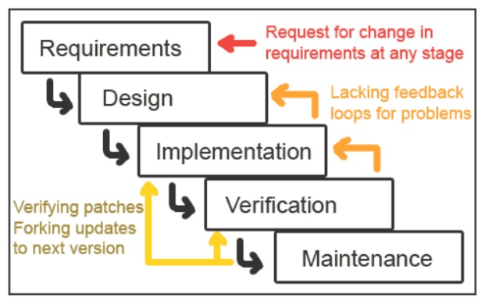
Figure 1: Iterative Waterfall Model
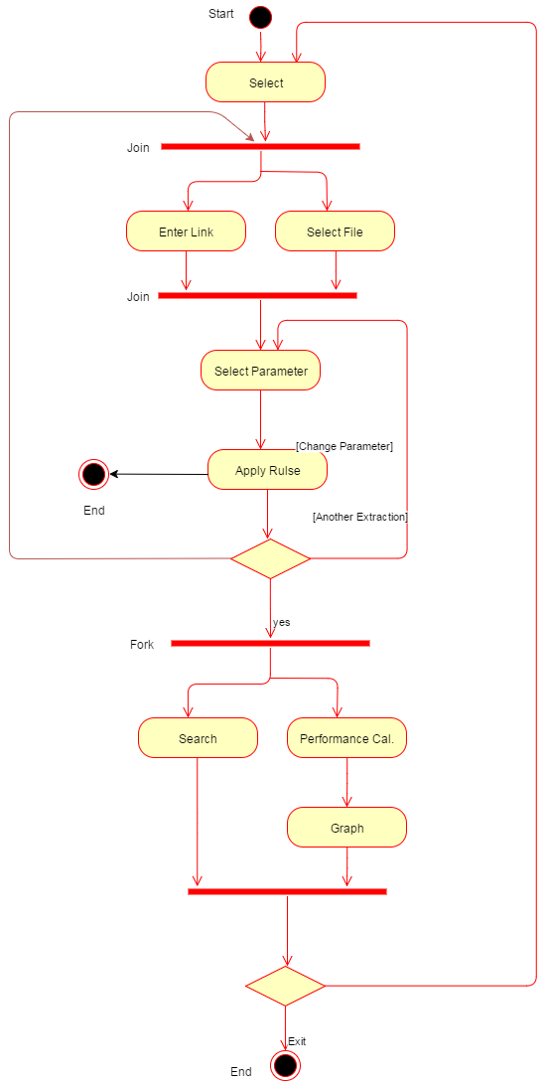
Activity Diagram
Figure 2: Activity Diagram for Information Extraction System

- CONCLUSION
In this research work we have discussed the problem of rapid increase of online data and various methods for extracting the content text from diverse Websites and pages with the use of specific tags. Rule based information extraction algorithm used for web information extraction is incredible system and recommended for the extraction of relevant web contents with high performance and efficient manner. On the one hand, implementation shows to be an effective mechanism to access highly relevant information, while on the other hand we can calculate various performance finding parameters inbuilt in system itself. The method of information extraction can also be applied to even non-HTML documents like laboratory records and curriculum vitae, resumes to facilitate the maintenance of large unstructured and semi structured documents. In the future time, IE from cross-website pages will become more important as we move toward semantic Web.

REFERENCES
- E. Riloff, “INFORMATION EXTRACTION AS A BASIC FOR HIGH-PRECISION TEXT CLASSIFICATION” ACM Transaction on Information Systems, vol. 12, no. 3, pp. 296–333, 1994.
- S. Sarawagi,” INFORMATION EXTRACTION”, Foundations and Trends R in Databases,Vol. 1, No. 3,2006
- A. Patel, “TEXT INFORMATION EXTRACTION USING RULE BASED METHOD” IJESRT August, 2015
- K. Chang, “DISCOVERING COMPLEX MATCHINGS ACROSS WEB QUERY INTERFACES: A CORRELATION MINING APPROACH” Proceedings of the tenth International Conference on Knowledge Discovery and Data Mining (KDD), 2004.
- M. Abdelmagid1, A. Ahmed2 and M. Himmat3,” Information Extraction Methods And Extraction Techniques in the Chemical Documents Contents: Survey”, ARPN Journal of Engineering and Applied Sciences, vol. 10, no. 3, February 2015
- Pinto, D. McCallum, A., Wei, X., & Croft, W. B. , “Table Extraction Using Conditional Random Fields.” ,In Proceedings of the 26th Annual International ACM SIGIR Conference on Research and Development in Information Retrieval (SIGIR’03).,pp. 235-242, 2003.
- Z. Zhang., ”Weakly-Supervised Relation Classification for Information Extraction”, In Proceedings of the Thirteenth ACM International Conference onInformation and Knowledge Management (CIKM’2004), pp581-588, 2004.
- T. Kristjansson, A.Culotta,, A. Viola , & McCallum ,”Interactive information extraction with constrained conditional random fields.” In Proceedings of AAAI’04, pp.412-418., 2004.
- Freitag, D. & McCallum, A. ,”Information Extraction with HMM Structures Learned by Stochastic Optimization.”, In Proceedings of the Sixteenth National Conference on Artificial Intelligence (AAAI’2000), 2000.
- D. M. Bikel, R. Schwartz, and R. M. Weischedel ,“An algorithm that learns what’s in a name. Machine Learning”,1999.
- Muslea, I., Minton, S., &Knoblock, C. STALKER,” Learning extraction rules for semistructured,.web-based information sources.”, In AAAI Workshop on AI and Information Integration. pp.74-81, 1998.
- Muawia Abdelmagid1, Ali Ahmed2 and Mubarak Himmat3,” INFORMATION EXTRACTION METHODS AND EXTRACTION TECHNIQUES IN THE CHEMICAL DOCUMENT'S CONTENTS: SURVEY”, ARPN Journal of Engineering and Applied Sciences, VOL. 10, NO. 3, 2015.

CITE AN ARTICLE
It will get done by IJESRT Team

