Table 1. Composition of the tomato snack bar
Ingredients | Amounts (g)
Tomato juice | 100
PPI | 10
Salt | 2
Olive powder | 2
Mint | 1
Thyme | 1
Red pepper powder | 1
LMP | 1/2/3
TP | 8/12/16

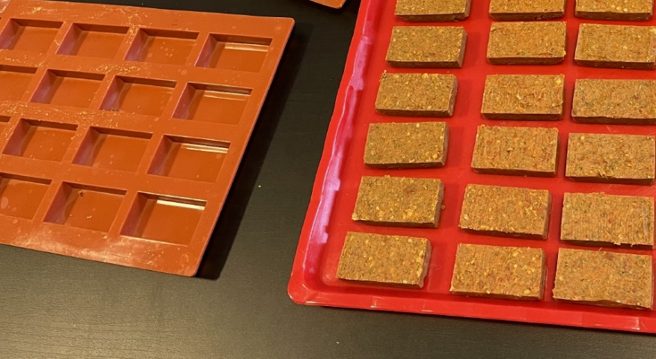
Figure 1. Photo of the molded tomato snack bars before drying

 | Before drying | After drying
TP concentration (%)
0 | 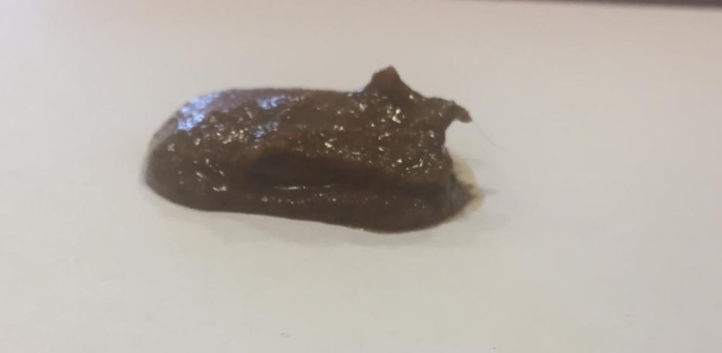 | 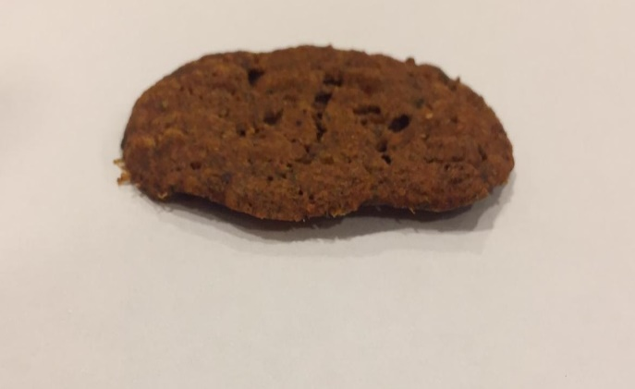
8 | 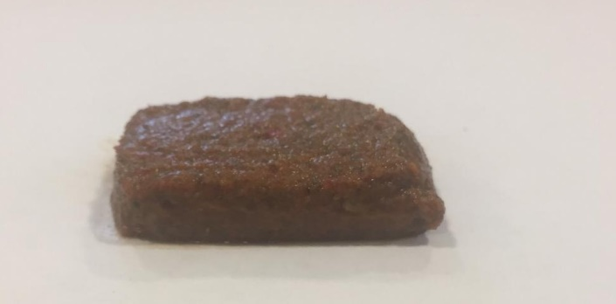 | 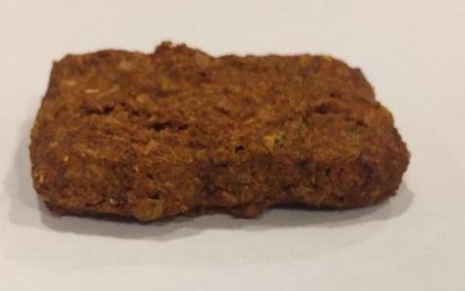
12 | 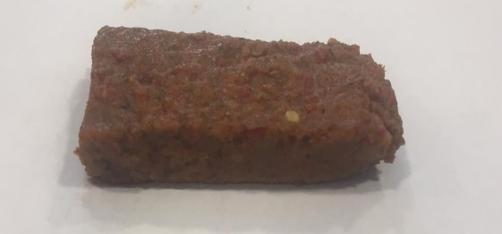 | 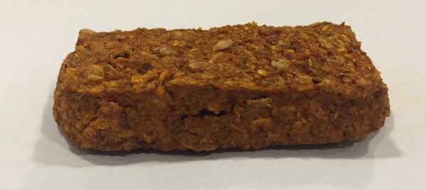
16 | 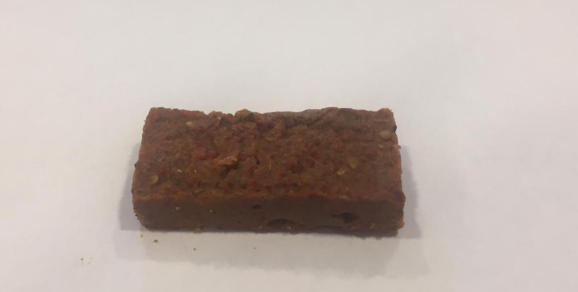 | 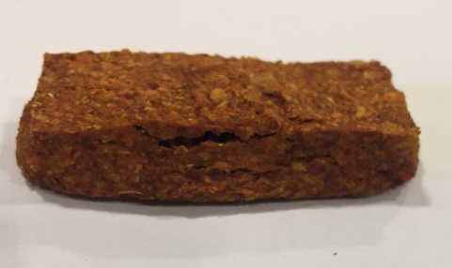
Figure 2. Photos of the tomato snack bars without LMP at different TP concentrations before and after microwave-vacuum drying

Table 2. Effect of LMP and TP concentration on color values of dried tomato snack bars
LMP (%) | TP (%) | L* | a* | b*
0 | 0 | 38.5±2.6^{abc} | 13.7±0.8^{d} | 23.4±1.9^{f}
0 | 8 | 42.3±3.4ª | 20.2±2.2^{ab} | 31.3±2.8^{abc}
0 | 12 | 42.5±1.9ª | 20.7±1.2^{ab} | 32.8±2.1^{ab}
0 | 16 | 42.5±3.6ª | 21.7±2.9ª | 32.9±2.2ª
1 | 0 | 33.8±5.3^{c} | 14.4±0.8^{cd} | 20.5±2.9^{g}
1 | 8 | 40.7±2.0^{abA} | 19.0±1.8^{abA} | 28.3±1.5^{cdA}
1 | 12 | 37.8±0.9^{abc} | 21.3±2.5ª | 28.2±1.8^{cde}
1 | 16 | 42.7±2.3ª | 22.2±1.2ª | 33.1±1.3ª
2 | 0 | 35.5±1.0^{bc} | 17.8±1.5^{bc} | 23.4±0.9^{f}
2 | 8 | 38.9±1.7^{abc} | 21.6±1.6^{ab} | 29.2±1.4^{abcd}
2 | 12 | 39.9±0.9^{ab} | 21.0±1.7^{ab} | 28.8±2.7^{cde}
2 | 16 | 37.4±1.8^{abc} | 20.2±2.3^{ab} | 28.4±2.0de
3 | 0 | 37.3±2.2^{abc} | 18.4±2.2^{ab} | 25.5±2.5^{ef}
3 | 8 | 39.0±3.2^{ab} | 20.6±2.9^{ab} | 29.9±3.6^{bcd}
3 | 12 | 39.0±3.9^{ab} | 22.1±1.3ª | 29.4±3.2^{abcd}
3 | 16 | 40.7±1.2^{ab} | 19.6±1.9^{ab} | 29.3±0.8^{cd}
1† | 8 | 26.5±0.15^{B} | 13.1±0.8^{A} | 15.3±0.5^{B}
†Represents the conventionally dried sample. Different small letters indicate significant differences (p<0.05) within the microwave-vacuum-dried samples, whereas different capital letters indicate significant differences (p<0.05) between conventionally dried and microwave-vacuum-dried samples at the same LMP and TP concentration. Errors are represented as standard deviations.

Table 3. MC and a_{w} of tomato snack bars
LMP (%) | TP (%) | MC (%) | a_{w}
0 | 0 | 18.0±1.4^{abc} | 0.59±0.06^{cd}
0 | 8 | 15.5±0.7^{cde} | 0.64±0.08^{abc}
0 | 12 | 14.3±0.4 de | 0.64±0.04^{abc}
0 | 16 | 18.9±0.1^{ab} | 0.73±0.03ª
1 | 0 | 15.9±1.3^{bcde} | 0.69±0.02^{ab}
1 | 8 | 15.1±1.6^{cdeB} | 0.65±0.03^{abcA}
1 | 12 | 18.2±0.4^{abc} | 0.58±0.01^{cde}
1 | 16 | 17.4±0.3^{abcd} | 0.59±0.01^{cd}
2 | 0 | 19.8±1.3ª | 0.60±0.00^{cd}
2 | 8 | 17.7±0.5^{abc} | 0.59±0.00^{cd}
2 | 12 | 16.3±0.3^{bcde} | 0.54±0.00de
2 | 16 | 15.3±0.3^{cde} | 0.50±0.00e
3 | 0 | 15.3±0.0^{cde} | 0.49±0.02e
3 | 8 | 15.0±0.1^{cde} | 0.49±0.01e
3 | 12 | 13.6±0.8e | 0.49±0.01e
3 | 16 | 15.4±1.2^{cde} | 0.61±0.05^{bcd}
1† | 8 | 30.4±0.7^{A} | 0.64±0.08^{A}
†Represents the conventionally dried sample. Different small letters indicate significant differences (p<0.05) within the microwave-vacuum-dried samples, whereas different capital letters indicate significant differences (p<0.05) between conventionally dried and microwave-vacuum-dried samples at the same LMP and TP concentration. Errors are represented as standard deviations.

Figure 3. Moisture sorption isotherm of tomato snack bar at 25℃. Solid line represents the GAB model.

Table 4. T₂ values and their corresponding areas of tomato snack bars
LMP (%) | TP (%) | T₂₁ (ms) | Area (%) | T₂₂ (ms) | Area (%) | T₂₃ (ms) | Area (%)
0 | 0 | 1.18±0.08^{b} | 65.9ª | 20.06±1.03^{b} | 15^{d} | 89.13±1.10^{bc} | 19.1^{efg}
0 | 8 | 0.63±0.01^{b} | 56.3^{abc} | 20.37±0.31^{b} | 16.9^{cd} | 96.99±3.20^{abc} | 26.9^{cdefg}
0 | 12 | 1.00±0.19^{b} | 67.5ª | 19.31±2.72^{b} | 15.3^{d} | 94.61±11.17^{abc} | 17.3^{fg}
0 | 16 | 1.17±0.07^{b} | 68.7ª | 20.48±1.79^{b} | 16.4^{d} | 91.68±8.41^{bc} | 14.9^{g}
1 | 0 | 0.75±0.07^{b} | 59.4^{abc} | 19.3±0.83^{b} | 17.3^{bcd} | 90.26±6.43^{bc} | 23.4^{cdefg}
1 | 8 | 0.82±0.08^{bB} | 39^{deB} | 20.78±0.04^{bA} | 26.9^{bA} | 97.18±2.64^{abcA} | 34.1^{abcA}
1 | 12 | 0.75±0.1^{b} | 56^{abc} | 17.3±0.4^{b} | 23^{bcd} | 78.37±4.07^{c} | 21^{defg}
1 | 16 | 0.89±0 ^{b} | 61.4^{ab} | 22.35±0.93^{b} | 19.5^{bcd} | 99.19±4.83^{abc} | 19.1^{efg}
2 | 0 | 1.05±0.07^{b} | 64.8ª | 19.26±0.75^{b} | 17.5^{bcd} | 86.30±0.34^{bc} | 17.8^{fg}
2 | 8 | 0.7±0.07 ^{b} | 45^{bcd} | 21.97±1.83^{b} | 23.7^{bcd} | 101.61±9.46^{ab} | 31.4^{bcde}
2 | 12 | 0.75±0.16^{b} | 55.2^{abcd} | 20.85±0.21^{b} | 20^{bcd} | 99.30±0.69^{abc} | 24.8^{cdefg}
2 | 16 | 0.63±0.05^{b} | 44.6^{cd} | 18.43±3.41^{b} | 22.2^{bcd} | 92.93±5.72^{bc} | 33.3^{bcd}
3 | 0 | 0.87±0.2 ^{b} | 27.1^{ef} | 18.86±2.23^{b} | 26.2^{bc} | 89.16±5.15^{bc} | 46.7ª
3 | 8 | 0.71±0.04^{b} | 43.5^{cde} | 19.38±0.78^{b} | 24.2^{bcd} | 91.25±4.39^{bc} | 32.4^{bcd}
3 | 12 | 3±0.71ª | 18.7^{f} | 29.93±1.29ª | 39ª | 116.55±7.85ª | 42.3^{ab}
3 | 16 | 0.45±0.09^{b} | 52.4^{abcd} | 16.61±0.35^{b} | 18.3^{bcd} | 92.06±0.21^{bc} | 29.4^{cdefg}
1† | 8 | 2.06±0.17^{A} | 71.4^{A} | 9.8±1.13^{B} | 16.2^{B} | 81.02±7.60^{A} | 12.5^{B}
†Represents the conventionally dried sample. Different small letters indicate significant differences (p<0.05) within the microwave-vacuum-dried samples, whereas different capital letters indicate significant differences (p<0.05) between conventionally dried and microwave-vacuum-dried samples at the same LMP and TP concentration. Errors are represented as standard deviations.

Table 5. Lycopene concentration (mg/g dry material) of tomato snack bars at different LMP and TP concentrations
 |  | TP (%)
LMP (%) | 0 | 8 | 12 |  | 16
0 | 59.1±3.2^{c} | 71.4±4.1^{b} | 72.5±1.8^{b} |  | 78.6±3.7ª
1 | 32.2±1.1^{f} | 40.4±1.1^{eB} | 43.2±6.6^{d} |  | 39.4±2.0e
2 | 19.5±0.8 ^{h} | 33.0±4.8^{f} | 28.2±1.9^{f} |  | 28.5±1.0^{f}
3 | 9.6±1.2^{i} | 15.4±1.6^{hi} | 17.1±0.6 ^{h} |  | 21.7±0.1^{g}
1† |  | 83.4±3.0^{A}
†Represents the conventionally dried sample. Different small letters indicate significant differences (p<0.05) within the microwave-vacuum-dried samples, whereas different capital letters indicate significant differences (p<0.05) between conventionally dried and microwave-vacuum-dried samples at the same LMP and TP concentration. Errors are represented as standard deviations.

Figure 4. FTIR spectra of LMP (blue), PPI (orange), TP (grey), microwave-vacuum-dried (yellow) and conventionally dried (green) tomato snack bar

Table 6. Textural properties of tomato snack bars
LMP (%) | TP (%) | Hardness (N) | Gumminess (N) | Chewiness (g.cm) | Cohesiveness
0 | 8 | 21.3±3.3e | 9.4 ± 0.1^{ef} | 142 ± 16.9^{fg} | 0.46±0^{b}
0 | 12 | 10.6±0.8^{f} | 7.0±1.1^{f} | 93±2.8^{h} | 0.44±0^{b}
0 | 16 | 15.1±0.8^{ef} | 7.3±0.1^{ef} | 129.5±2.1^{g} | 0.47±0^{b}
1 | 8 | 15.7±0.4^{efB} | 9.3±0.2^{efB} | 168.5±6.4^{fA} | 0.59±0^{aA}
1 | 12 | 33.7±0.1^{d} | 9.6±1.1e | 369±2.8e | 0.60±0.01ª
1 | 16 | 14.2±0.7^{ef} | 9.8±0.6e | 127.5±2.1^{g} | 0.60±0.01ª
2 | 8 | 47.3±0.3^{c} | 26.4±0.5^{c} | 489±8.5^{c} | 0.56±0ª
2 | 12 | 74.2±1.0^{b} | 38.8±0.9ª | 675±4.2ª | 0.57±0.01ª
2 | 16 | 40.6±3.9^{cd} | 20.3±0.8^{d} | 441.5±13.4^{d} | 0.55±0.01ª
3 | 8 | 41.6±1.2^{cd} | 40.6±0.2ª | 414±0^{d} | 0.57±0.01ª
3 | 12 | 74.4±4.6^{b} | 30.1±0^{b} | 606.5±2.1^{b} | 0.56±0.05ª
3 | 16 | 86.6±2.9ª | 26.9±0.4^{c} | 703±11.3ª | 0.60±0.01ª
1† | 8 | 28.5±1.9^{A} | 13.3±0.9^{A} | 195±20^{A} | 0.47±0^{B}
†Represents the conventionally dried sample. Different small letters indicate significant differences (p<0.05) within the microwave-vacuum-dried samples, whereas different capital letters indicate significant differences (p<0.05) between conventionally dried and microwave-vacuum-dried samples at the same LMP and TP concentration. Errors are represented as standard deviations.

