PROTOCOL DEVIATION FRAMEWORK For Academic Clinical Trials Units: Guidance authored by Trials Methodology Research Partnership (TMRP) Data Quality & Monitoring (DQM)

How to use this framework

This protocol deviation framework is aimed at supporting academic clinical trials units, especially in the UK, either as a training tool or a reference text. It outlines protocol deviation processes in clinical trials and is intended to be used alongside specific clinical trials unit standard operating procedures.

Contents
1. Introduction 3
2. Developing guidance for protocol deviations 4
3. Protocol Deviation Framework 6
3.1 Protocol development 7
3.2 Data Collection 10
3.3 Identification 10
3.3.1 Site identification of PDs 10
3.3.2 Trial management team, CTU, TSC/IDMC identification of PDs 10
3.3.3 Identification of PDs through statistical programming 11
3.3.4 Identification of PDs during any interaction with the trial or site 11
3.3.5 Identification of PDs via on-site, remote or central monitoring 11
3.4 Protocol deviation collection 11
3.5 Protocol deviation documentation 11
4. Classification and categorisation 12
4.1 Classification: Is it a PD after all? 12
4.2 Categorisation: Is the PD important or non-important? 12
5. Protocol deviation notification and recording 12
6. Assessing PD and taking action - Figure 3 13
7. Trial Analysis and reporting 14
8. Summary 14
9. Glossary and definitions 14
Acronyms 14
Definitions 15
10. References 15
Appendix 1: Tools 16
A: Protocol Data Collection Spreadsheet 17
B: Example spreadsheet template to manage PD at CTU 18
C: Template protocol deviation SOP 19

1. Introduction
Whilst there is huge variation in language, policies and practices, the most common and widely accepted definition of a protocol deviation (PD) is described in ICH E3 Q&As (R1) [1]. A PD is defined as “any change, divergence, or departure from study design or procedures as described in the approved study protocol. Important PDs are a subset of PDs that may significantly impact the completeness, accuracy, and or reliability of the study data or that may significantly affect a subject's rights, safety, and/or well-being.”. We will use this terminology throughout. Table 1 provides the link between the terminology we are using and other commonly used PD classification systems.

Table 1: Comparison of commonly used PD terminology
Description | Example 1 | Example 2 | Example 3 | As used in ICH and this framework
Umbrella term covering all the options below | Deviation | Non-compliance | Protocol deviation | Protocol deviation
Lowest significance | Non-important deviation | Deviation | Minor/Major | Not important
Medium significance | Important deviation | Violation | Critical | Important
Highly significant | Breach | Serious breach | Serious breach | Important

The definition of a PD does not indicate what action should be taken, and this is left open to the interpretation of those running clinical trials. Due to this lack of central PD management guidance, current practice is varied, making it difficult to collaboratively improve trial conduct in this area. It is important to optimise the PD process to fulfil the regulatory requirements whilst streamlining resource needs for sites and Clinical Trial Units (CTUs). The Trials Methodology Research Partnership Data Quality and Monitoring (TMRP DQM) group has created this framework to support CTUs in the management of PDs. This framework may provide useful background information in addition to the CTU PD SOP (Standard Operating Procedure).

It is crucial for a CTU to clearly define who is responsible for each action. The responsible person for each action varies between CTUs and therefore this information is not contained in this framework but may be found in local SOPs.

There should be some oversight of the PDs and the resolution of corrective and preventative actions (CAPA). Again, this is CTU specific at present and therefore is not outlined in this framework and should be specified in the CTU SOPs.

Tools and templates provided within this document (see Appendix 1) are summarised in Table 2 and can be amended and localised as required.
Table 2: Summary of tools provided in appendix 1
Tool | Description
A: Protocol Data Collection Spreadsheet | Used to distil the protocol into specific data requirements
B: Example minimal list of data to be stored on protocol deviations | A list of data that should be stored on each protocol deviation
C: example protocol deviation SOP | Used as CTU wide protocol deviation standard operating procedure with trial specific information in a separate document.

2. Developing guidance for protocol deviations
The need for this framework stemmed from a project developed by the TMRP DQM group to improve the way PDs are collected and processed. In the initial phase of this project in December 2020, all literature and guidance on PD management were collated and reviewed. The published guidance on the management of PDs tended to be high level guidelines such as ICH guidelines or non-binding guidance by regulators such as the EMA and FDA. Discussions with the Medicines and Healthcare products Regulatory Agency (MHRA) emphasised the need to write the study protocol to mitigate as many potential PDs as possible, to systematically collect PDs from all parties and to report important PDs in the trial report. Together, this work showed that we need a framework for PDs to improve process standardisation and efficiency, to promote best practice and to give a launchpad for further research in PDs. The content of this framework emerged from a semi-structured discussion with representatives from CTUs across the UK (Table 3). It was developed utilising the published evidence as well as good practice and standard operating procedures from CTUs shared by those involved in the development of the framework (Table 3).

Table 3: List of those who contributed to the development of this framework
Name | Role | Clinical Trials Unit
Sarah Baos | Research Fellow | Bristol Trials Centre
Hannah Berntsson | Trial Manager / QA Manager | Sheffield Clinical Trials Research Unit, ScHARR
Cherish Boxall | Research Fellow | Southampton CTU
Nick Kisengese | Director | ClinWin Research Services CRO
Sharon Love | Researcher | MRC Clinical Trials Unit at UCL
Garry Meakin | Senior Trial Manager | Nottingham CTU
Francesca Schiavone | Clinical Project Manager | MRC Clinical Trials Unit at UCL
Victoria Yorke-Edwards | Researcher | MRC Clinical Trials Unit at UCL

The working group identified the following sources as relevant references for the management of PDs (Table 4).

Table 4: Reference sources for PD management
Organisation  and URL (accessed 27Oct2022) | Short  name | Description
Clinical Trials Transformation Initiative  https://www.ctti-clinicaltrials.org/ | CTTI | Mission: To develop and drive adoption of practices that will increase the quality and efficiency of clinical trials.  CTTI comprises more than 80 organizations from across the clinical trial enterprise.  USA based private body, International
European Medicines Agency  https://www.ema.europa.eu/en | EMA | The European Medicines Agency (EMA) is a decentralised agency of the European Union (EU) responsible for the scientific evaluation, supervision and safety monitoring of medicines in the EU.  Public body, European Union
US Food and Drug Administration  https://www.fda.gov/ | FDA | The Food and Drug Administration is responsible for protecting the public health by ensuring the safety, efficacy, and security of human and veterinary drugs, biological products, and medical devices; and by ensuring the safety of our nation's food supply, cosmetics, and products that emit radiation.  Public body, USA and further afield
Health Research Authority  https://www.hra.nhs.uk/ | HRA | [HRA] vision is for high-quality health and social care research that improves people’s health and wellbeing, and [HRA] core purpose is to protect and promote the interests of patients and the public in health and social care research.  Public body, UK
International Council for Harmonisation of Technical Requirements for Pharmaceuticals for Human Use  https://www.ich.org/ | ICH | Brings together the regulatory authorities and pharmaceutical industry to discuss scientific and technical aspects of drug registration.  Private body, International
Medicines and Healthcare products Regulatory Agency  https://www.gov.uk/  government/organisations/  medicines–and–healthcare  -products-regulatory-agency | MHRA | Regulates medicines, medical devices and blood components for transfusion in the UK.  Public body, UK
National Institute for Health Research  https://www.nihr.ac.uk/ | NIHR | The UK's largest funder of health and care research and provide the people, facilities and technology that enables research to thrive. Working in partnership with the NHS, universities, local government, other research funders, patients and the public, [NIHR] deliver and enable world-class research that transforms people's lives, promotes economic growth and advances science.  Public body, UK
TransCelerate Biopharma Inc  https://www.transceleratebiopharmainc.com/ | TransCelerate | Aim to collaborate across the global biopharmaceutical research and development community to identify, prioritize, design and facilitate implementation of solutions designed to drive the efficient, effective and high-quality delivery of new medicines.  USA based, international
UK Trial Manager Network  https://www.tmn.ac.uk/ | UKTMN | Aim to facilitate the development of a well-trained, highly motivated, effective workforce of trial managers within the UK health care system who will make an important contribution to the efficient delivery of high-quality clinical trials.  Private body, UK

Each reference document was reviewed by three members of the working group; each reviewer detailed guidance text against each requirement specific to the management of PDs. Each piece of relevant guidance was then discussed via teleconference by the group to identify direct implications linked to the implementation (available on request).

3. Protocol Deviation Framework

The proposed PD management process is shown diagrammatically in Figure 1, Figure 2 and Figure 3 and explained in more detail in the following text.

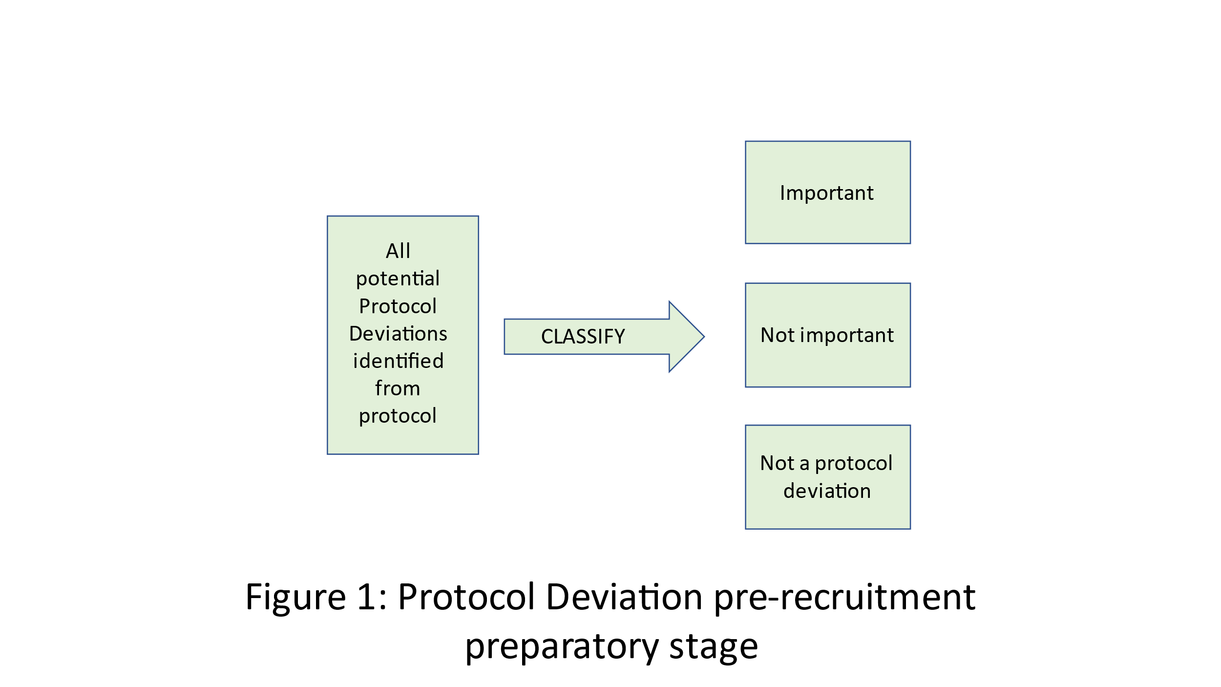

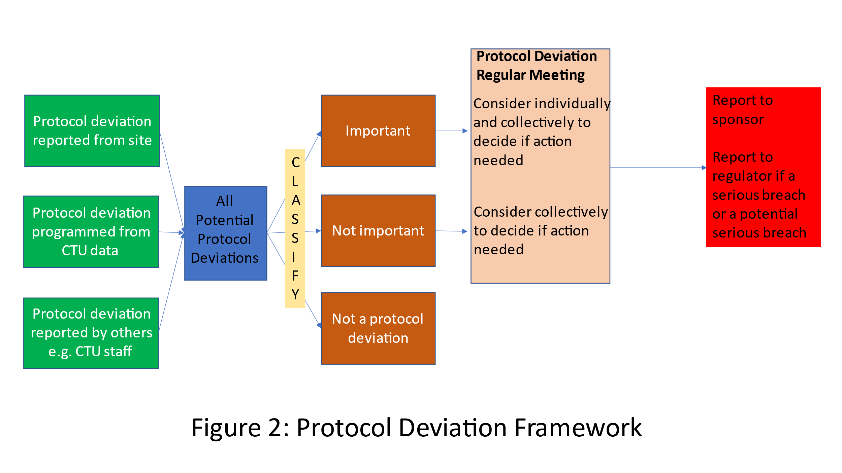
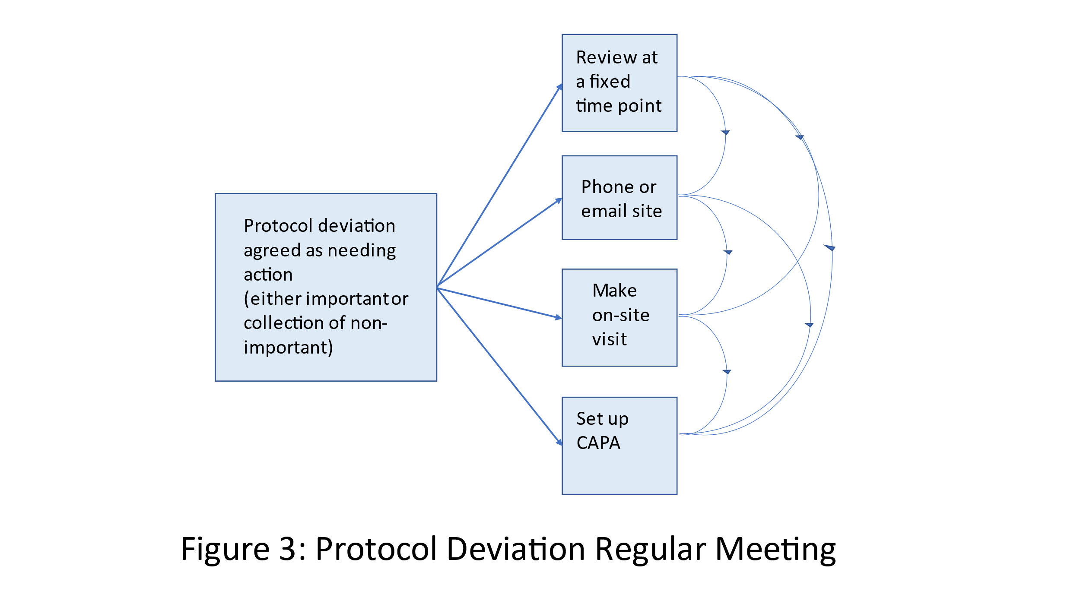

3.1 Protocol development
The principles of good protocol writing are embodied by the SPIRIT guidelines [2]. A good trial protocol not only ensures the reproducibility of the trial’s data but also transparency in trial procedures. The protocol should clearly state what is mandated and what is optional and, where relevant, provide windows of tolerance to ensure sites are not pushed out of compliance unnecessarily.

The protocol is improved and the need for subsequent protocol amendments is reduced if the PD process starts as part of the early stages of protocol development. One example of a PD process at the protocol development stage is to consider data collection using a protocol data collection assessment spreadsheet as described in the next section and given in Appendix 1. Another example is to involve a multidisciplinary team to ensure that the processes outlined in the protocol are feasible/deliverable in practice. Doing this consideration of data and processes at the time of protocol development ensures all implications relating to the participant schedule and trial assessments are considered. Another example of a PD process is for all potential PDs to be pre-emptively identified and listed for example in a relevant PD-specific spreadsheet, trial specific SOP or monitoring plan (Figure 1). PD’s with a clinical element should have a clinical review. Every PD should be reviewed by relevant members of the CTU to agree on its classification as a PD and categorisation as important or not. For example, a PD might be a dose of a drug being given late and this would be an important PD if the dose of a drug is given late enough to potentially have an impact on the safety of the patient. Further examples of important and non-important PDs are given in Table 5.

Table 5: Examples of protocol deviations with classifications into important or non-important (adapted from Appendix 1 of TransCelerate Protocol Deviation Process Guide https://www.transceleratebiopharmainc.com/wp-content/uploads/2021/03/Protocol-Deviations_Process-Guide_March-2021.pdf accessed 27Oct2022)
Category | Protocol deviation classification examples
 | Important | Non-important | Not a protocol deviation
Informed consent | Clinical study procedures conducted prior to signing initial informed consent. | If required by local regulation or IRB/EC, participant did not initial all pages. | Administrative items such as: participant did not use requested date format, participant did not sign on requested line, etc.
Inclusion/exclusion | Participants who entered the clinical study even though they did not satisfy the entry criteria.
Study Intervention | Participant dispensed and took study medication which underwent a temperature excursion and was deemed unacceptable for use. | Participant dispensed study medication which underwent a temperature excursion and was not taken or was taken but deemed acceptable prior to use. | Investigational product underwent a temperature excursion but was never dispensed to a participant.
Trial Procedures | Missed safety or efficacy assessments related to primary or key secondary endpoints. | Missed procedures that have no impact on reliability of study results (e.g., exploratory analysis). | Not calibrating a piece of equipment on a day it was not used to obtain participant data.
Safety reporting | Serious Adverse Events (SAEs) not reported within the expected turnaround-time per regulatory reporting requirements. | Non-serious AEs not reported within predefined protocol timelines. | Site appropriately reported an SAE. Later, the Sponsor data management team asked for the SAE to be split and recorded as multiple events. The time stamp of the new data entry made it appear that the site was delayed, but they actually were not.

3.2 Data Collection
Data collection must be clearly defined in any clinical trial protocol and reflect the needs of the trial, the collection of endpoint data and the overall risk of the trial. It is essential that a review of the trial protocol is carried out before it is finalised considering data collection requirements and that data management specialists are involved in its development.

From the protocol, one of the possible processes to ensure data collection is clearly defined in the trial is to map all data points in the protocol. For example, see Appendix 1 for a template Protocol Data Collection Spreadsheet. This tool aims to ensure that the nature of each data point is clearly defined in the protocol and agreed ahead of database and case report form (CRF) development. This tool can also clarify how data should be collected, its format and timepoint. Together this process aims to finalise all data collection requirements for the trial and in turn allow the trial team to reflect on trial-specific PDs and how they can be detected.

As a trial opens to recruitment, it is paramount that trial teams continue to re-assess the data collection tools, particularly after substantial protocol amendments to ensure compliance is maintained throughout the trial. If using a Protocol Data Collection Spreadsheet, it should be updated.

Clinical trials may fail to capture important data requirements if a systematic approach to data collection isn’t carried out at the protocol development stage, leading to inadequate data collection and potential serious breaches and inspection findings.

3.3 Identification
PDs can be identified via programmatic or manual processes, as outlined below. It may not be possible to identify all PDs (e.g. if using risk-based approaches), but monitoring plans should ensure the important PDs are captured as per ICH E3 guidance: “All important deviations related to study inclusion or exclusion criteria, conduct of the trial, patient management or patient assessment should be described.”[3]

3.3.1 Site identification of PDs
PDs may be identified by local sites and reported to the Sponsor/CTU. Some of the common ways for sites to identify PDs are outlined below:
- Site staff with knowledge of the protocol, (e.g. including the study research team, pharmacy and laboratory staff) may identify a PD as a result of becoming aware that a particular process is not compliant with the protocol.
- Site staff completing data collection forms identify a PD (e.g. data entered onto paper or electronic data collection tool highlights a non-compliance)
- Site staff completing data entry onto the study database become aware of a PD though queries being flagged on the study database

3.3.2 Trial management team, CTU, TSC/IDMC identification of PDs
PDs may be identified by the trial management team, the CTU, or independent committees such as the Trial Steering Committee (TSC) or the Independent Data Monitoring Committee (IDMC). These may be queried with sites for clarification or reported as necessary. Some of the common ways for PDs to be identified by these groups have been outlined below:
- Staff (e.g. trial management, data management) with knowledge of the protocol may identify a PD during review of the study data (e.g. in-built data queries, unusual looking data items)
- Staff (e.g. trial management, CTU, TSC, IDMC) with knowledge of the protocol may identify a PD through review of regular reports/tables produced from the study data (e.g. trial management team reports, TSC/IDMC reports)

3.3.3 Identification of PDs through statistical programming
PDs may be identified through statistical programming. These PDs are often reviewed by the trial management team ahead of querying with sites for clarification or reporting as necessary. Some of the common ways for PDs to be identified by statistical programming include:
- Programming of regular reports produced by study statisticians, where the report highlights a PD
- Programming of ad-hoc reports produced by study statisticians, where the report highlights a PD

3.3.4 Identification of PDs during any interaction with the trial or site
PDs may be identified through ad-hoc interactions with the trial data or with the trial site. Some of the common ways for PDs to be identified in an ad-hoc manner include:
- Site reporting PD via email, phone call, other direct contact with trial management team or CTU
- Site reporting ad-hoc study information via email, phone call, other direct contact with trial management team or CTU, and the trial management team or CTU identify a PD through the information received

3.3.5 Identification of PDs via on-site, remote or central monitoring
PDs may be identified through on-site, remote or central monitoring of the trial site. Some of the common ways for PDs to be identified through monitoring include:
- Trial management team, CTU, monitor, auditor reviewing source data, medical notes, data collection materials on site identify a PD
- Trial management team, CTU, monitor, auditor reviewing electronic data items and/or study reports identify a PD during remote monitoring
- Trial management team, CTU, monitor, auditor identify a PD through central monitoring processes
To aid the identification of a PD via on-site or remote monitoring, monitoring reports should explicitly state which findings are PDs.

3.4 Protocol deviation collection
Possible PDs need to be collected and amassed in one place (e.g. excel spreadsheet or table in the trial database). Each of these possible PDs need to be classified as to whether they constitute a PD and, if they do, whether they are an important PD or not (Figure 2). The pre specification of potential PDs (Figure 1) helps this process but as not all PDs can be pre-specified and interpretations may vary, it is essential that one group carry out a final classification as to whether a happening will be treated as a PD.

3.5 Protocol deviation documentation
Local bodies may require periodic reports on important and/ or non-important PDs. Those responsible for PDs must be informed. It is important to clearly document the review of the PDs and agreed actions or outcomes. See Appendix 1 Example Excel spreadsheet template to manage PDs.

4. Classification and categorisation

4.1 Classification: Is it a PD after all?
Events must be assessed to determine their classification as a PD. The ICH E3 Q&A R1 [1] defines a PD as “...any change, divergence or departure from the study design or procedures defined in the protocol.” As such, events related to a data point or process described in the protocol, or to documents/guidelines referenced in the protocol (e.g. good clinical practice (GCP)) can be classified as PDs and categorised as outlined below.

4.2 Categorisation: Is the PD important or non-important?
PDs can be categorised as important or non-important, depending on:
  - The impact the event may have on the completeness, accuracy and/or reliability of key study data or processes (the scientific integrity of the trial)
  - The impact the event may have on participants rights, safety or well being

For example, important PDs may include a deviation in IMP dose, randomisation of an ineligible participant, or failing to collect primary outcome data, as these may impact on participant safety and/or the scientific integrity of the trial (also see Table 4).

As noted in 3.1 and Figure 1, potential PDs should be pre-categorised (where possible) as important or non-important at the start of the trial and documented. Instances which have not been pre-categorised should be reviewed by a clinician, relevant members of the CTU and potentially the sponsor to determine the categorisation. The frequency at which PDs are reviewed for categorisation (by clinician, CTU, sponsor as just discussed) should be agreed at the beginning of the study, this may be on a case-by-case basis or at regular intervals in batches. Important PDs which are suspected serious breaches should be categorised as soon as possible, to ensure onward reporting timelines to the competent authority are met.

Repetitions of the same PD, which in isolation would not be considered an important PD could collectively become important. For example, failing to collect secondary outcome data may be considered non-important in isolation, however, multiple instances where secondary outcome data is not collected may be considered important where it impacts on the completeness of study data and planned analyses. Listing all PDs within a central PD log and assigning trial areas to each event, such as consent issue, deviation in IMP dose, missed visit window, may be useful in identifying repeated events. Similarly, multiple important PDs (or non-important PDs) could collectively become a serious breach.

5. Protocol deviation notification and recording
Any identified PDs, including those found through on-site monitoring, central monitoring, statistical analysis or by site staff, should be recorded, for example, in trial-specific PD logs. Separate logs may be kept at each site, as well as at the CTU or Sponsor, although those responsible for PDs (e.g. CTU, Sponsor) must ensure that all logs are regularly reviewed, and a central trial log (sometimes called a master log) of all PDs is maintained (see below).
The notification process:
  - On identification of a potential PD at site, site staff should record the deviation in the site-specific protocol deviations log. Sites should regularly inform those that oversee PDs (e.g. CTU, Sponsor) of any deviations that have been identified, but they should expedite the reporting of any PDs that might be important (i.e. those pre-categorised as important or those not yet categorised). This supports expedited reporting to regulatory authorities should it be deemed necessary.
  - It is good practice for the person overseeing PDs to assign a unique identifier to each potential PD to allow for reconciliation and quality assessment of PDs received.
  - On identification of a PD centrally, the central team should classify and record it in the central trial PD log. This must be done in a timely manner to enable expedited reporting to regulatory authorities should a PD be classified as potentially a serious breach. Any site-related PDs should be communicated to the site study team in a timely manner to allow the site staff to take corrective or preventative actions as necessary.
All PD logs (e.g. site-specific logs) should be periodically reviewed at the CTU to ensure nothing has been missed, and that all PDs are recorded on the central trial PD log, if relevant.
The central log of PDs must be stored in the trial TMF.

6. Assessing PD and taking action - Figure 3
The important PDs need to regularly be considered individually and collectively to see if action is needed to reduce the effect of the current deviation or/and to prevent this deviation occurring again. This can be done in meetings or via email but the assessments need to be made by more than one person and at regular intervals (rather than left to the end of the trial). PD meetings can be held at regular time intervals (e.g. every 3 months) or by the number of PDs identified (e.g. every 20 PDs). One factor to consider is that consistency may be better if the classification happens in batches. However, PDs are an opportunity to change processes (e.g. site induction training) and documentation (e.g. protocol) to avoid similar PDs in the future. If the PDs are not reviewed often enough, it may be too late to take appropriate action. Therefore, more frequent management should reduce repeat PDs and improve the delivery of the trial. The review of the PD in this protocol deviation regular meeting needs to be documented and filed in the TMF and therefore the meeting must have minutes.

The non-important PDs also need to be considered collectively to see if together they constitute an important deviation. If they do, they need assessing as an important deviation. If not, there may still be some action required to prevent re-occurrence. As noted in section 4.3, multiple important PDs (or non-important PDs) could collectively become a serious breach.

Action for important or non-important deviations may include contacting the site to talk through the deviation by email/phone or changing a process or documentation. For example, if an eligibility check is done outside of the time window, phoning a site to talk through the recruitment part of the protocol might be a good action. However, if an eligibility check has been done outside of the time window at several sites, it may be that the protocol should be checked to see if the time windows are plausible. The decision to take an action and the action must be logged. For some deviations, the action may be specified in a corrective and preventative action (CAPA) process.

Important deviations and any actions leading from important or non-important PDs may need to be reported to the Independent Data Monitoring Committee (IDMC). Their role is to assess the impact that PDs have on trial integrity and the data that the trial gathers.

For some PD, it may be necessary to review the risk assessment and trial monitoring plan as the PD found may alter the risk profile and subsequent monitoring strategies.

It is important to stop and reflect across all sites to improve protocol and trial procedures. For example, review the most common occurring PDs and decide if a protocol amendment is necessary to avoid future PDs and assess site staff training needs around the understanding of protocol and study procedures to mitigate future potential PDs.

It is also useful for a CTU running multiple trials to look at the PDs that have occurred across all trials in order to improve trial processes across the CTU.

7. Trial Analysis and reporting
The statistician will use the PD information in the analysis and reporting of the trial and therefore it must be stored in a way suitable for analysis. During the analysis, the statistician needs to allow for the PDs where applicable. For example, if a participant has a PD showing they did not take the intervention, then when assessing the effect of the intervention, the analysis may need to take account of the amount of intervention received. During the interpretation of the trial results, the statistician needs to consider any relevant PDs. For example, if treatment was delayed for several patients, this may be enough to impact the interpretation of the results. PDs altering the interpretation of the result are usually discussed with the IDMC. PDs need to be reported in detail in the clinical trial report, including how many of each type of PD occurred. A summary of the PDs relevant to the analysis or interpretation of the trial need to be included in the primary publication of the trial results.

8. Summary
Managing protocol deviations represents a significant part of conducting clinical trials. However, there is a lack of guidance on how to identify, classify and manage protocol deviations in academically run clinical trials. This framework aims to summarise current practice in academic CTUs in the UK and crystallise principles of good practice when managing protocol deviations.

The consensus reached while developing this framework is that, when talking about PDs, researchers should consider all aspects of trial conduct starting with a sound development of the protocol and a systematic approach to PD identification and classification at the early set-up stages. Furthermore, managing protocol deviations isn’t simply about regulatory compliance but it is directly linked to improving trial conduct and as a result, the robustness of trial’s data and the results generated.

CTUs should ensure a process-driven approach to PD management as well as oversight of CAPA management, both at trial level and Unit level, and to enable central monitoring of PDs. The multidisciplinary nature of clinical trials should be reflected in PD management processes, involving all members of a trial’s team, to ensure clinical, statistical and management input and oversight.

9. Glossary and definitions

Acronyms
AE | adverse event
CAPA | corrective and preventative action
CI | Chief Investigator
CTU | Clinical Trials Unit
GCP | Good Clinical Practice
ICH | International Council for Harmonisation of technical requirements for pharmaceuticals for human use
IDMC | Independent Data Monitoring Committee
MHRA | Medicines and Healthcare products Regulatory Agency
PD | Protocol Deviation
SAE | Serious Adverse Events
SOP | Standard Operating Procedure
TMRP DQM | Trials Methodology Research Partnership Data Quality and Monitoring
TSC | Trial Steering Committee

Definitions
A protocol deviation (PD) is defined as “any change, divergence, or departure from study design or procedures as described in the approved study protocol “

Central monitoring is looking to centrally identify any issues with trial conduct such as inadequate processes or procedures not being followed through a lack of clarity in the protocol or active fraud.

On-site monitoring is performed at the investigator sites at which the clinical trial is being conducted, via a physical visit by individuals from the sponsor (and/or its representatives, for example monitors and other CTU staff).

Remote monitoring is direct evaluation of a site performed by individuals from the sponsor at a location remote from the trial site. It replicates some activities of on-site monitoring but carried out away from the site.

Serious breach: Any deviation of the approved protocol version or the clinical trial regulation that is
likely to affect the safety, rights of trial participants and/or data reliability and robustness to a
significant degree in a clinical trial. Serious breaches need reporting to the competent authority within specified timelines.

10. References

- https://www.ema.europa.eu/en/documents/scientific-guideline/international-conference-harmonisation-technical-requirements-registration-pharmaceuticals-human-use_en-5.pdf (Accessed 3 March 2023)
- SPIRIT Group. Spirit statement endorsement, https:// www.spirit-statement.org/spirit-statement/
(Accessed 3 March 2023)
- https://www.ema.europa.eu/en/documents/scientific-guideline/ich-e-3-structure-content-clinical-study-reports-step-5_en.pdf
(Accessed 30Mar2023)

Appendix 1: Tools

These tools are examples.
- Protocol Data Collection Spreadsheet is an example of how to note every data item that is required.
- Example minimal list of data to be stored on protocol deviations
- Template protocol deviation SOP

A: Protocol Data Collection Spreadsheet
Each item of data that is required should be in this spreadsheet.

Req No. | Protocol section number | Data needing collection | Timepoint of assessment/collection | CRF Number/Name | CRF field label for data entry | CRF Field name
1
2
3

B: Example spreadsheet template to manage PD at CTU
Example minimal list of data to be stored on protocol deviations

Deviation Number
Site Name
Patient No.
Description of protocol deviation
Classification as important or not important
Date Deviation occurred
Date Site Aware
Date CTU Aware
Involved In Serious Breach?
Summary/Actions
CAPA*/File Note ID
Date Of Closure
*Corrective and preventative action

C: Template protocol deviation SOP
See one published example SOP in this publication:

A Toolkit for the Management of Protocol Deviations
S Mohan, M Mehra, M Petrizzo T Katz
Therapeutic Innovation and regulatory science 2016, 50:791-800
DOI: 10.1177/2168479016647987

