Standard Operation Procedure (SOP):

Cell viability-Propidium iodide differential staining assay
SOP for Tetrahymena thermophila

Date
12. 12. 2023

Version:
Number 1.0

Title: | Cell viability-Propidium iodide differential staining assay
Number: | 1
Date: | 12. 12. 2023
Version: | Version 1.0
Responsible for the implementation of this SOP: | Valentina Perc
 | Date / Signature
Author: | Valentina Perc, University of Ljubljana, Biotechnical faculty,  Sara Novak, University of Ljubljana, Biotechnical faculty,  Veno Kononenko, University of Ljubljana, Biotechnical faculty,  Sara Michelini, University of Ljubljana, Biotechnical faculty  Damjana Drobne, University of Ljubljana, Biotechnical faculty
 | Name, Organisation
Reviewed: | Sara Michelini, University of Ljubljana, Biotechnical faculty
 | Name, Organisation

Scope
This standard operating procedure (SOP) describes the protocol for measuring the viability of unicellular organism Tetrahymena thermophila treated with plastic and metal micro- and nanoparticles using flow cytometer and propidium iodide (PI) and Hoechst staining.

Basic
The combination of Hoechst and propidium iodide staining allows the simultaneous assessment of cell viability and nuclear morphology. Propidium iodide (PI) is a red fluorescent dye that binds to DNA by intercalating between the bases. It is fluorescent when it intercalates, otherwise the fluorescence is reduced many times over. PI is impermeable to living cells, but can penetrate cells with compromised cell membranes (dead or damaged cells). Hoechst 33342 (bisbenzimide) is a cell-permeable blue fluorescent dye that binds to adenine-thymine-rich regions of DNA. Based on the binding principle of the dyes, we can distinguish between living cells with an intact membrane and dead cells with a permeable membrane.

Materials and Instruments
a. Materials
Sterile tips
Serological pipette (Thermo) + controller
15 and 50 ml plastic tubes (Golias)
T25 flasks (Eppendorf)
Sterile 96-well flat bottom plates for cell culture (TPP)
Sterile culture medium (nutrient-rich growth medium for cell maintaining and nutrient poor exposure medium for experiments)
Ethanol 70% (Honeywell)
Multichannel reservoir
Triton X – 100 (Roche) (2%)
Tetrahymena thermophila in culture from the PROTOXKIT F (MicroBioTests)
Plastic dispersants and nanoparticle solutions
Propidium iodide (PI) (Sigma Aldrich)
Hoechst stain 33342
Phosphate-buffered saline (PBS) (Sigma Aldrich)
FACS tubes (Falcon)
b. Instruments
Inverted optical microscope (Zeiss)
Hemocytometer with Neubauer grid
Pipette (10, 100, 200 µl)
Multichannel pipette (200, 1000 µl)
Bio-safety cabinet
Incubator (32ºC)
Centrifuge
Spectrofluorimeter (BioTek, Cytation 3)
Vortex
Water bath 37°C
Sonicator bath
Flow cytometer (BD Facs Melody)

c. Solutions
- Plastic dispersants and nanoparticle solutions prepared according to
Vogel et al., (2021) [2]
- Propidium iodide and Hoechst stain in PBS (5 µg/mL)

Cell culturing procedure

a. Growth and exposure medium
Prepare a nutrient-rich growth medium (RM) containing 5 g d-glucose, 5 g proteose peptone, 1 g yeast extract, 1.2 g Trisma-base, chlorides (2.28 µM CaCl₂-2H₂O, 0.29 µM CuCl₂-2H₂O, 0.05 µM FeCl₃-6H₂O, 0.03 µM MnCl₂-6H₂O, 0.004 µM ZnCl₂) and sulphates (4.1 µM MgSO₄-7H₂O, 0.64 µM Fe(NH4)₂(SO4)₂-6H₂O), up to 1000 ml double-distilled H₂O, pH corrected to 7.35 with HCl.
The recipe of the nutrient-poor medium (PM) is the same, except that does not contain proteose peptone and yeast extract, according to the recipes of Schulz (1977) [1]. To ensure sterility, the medium is autoclaved, and to remove impurities, it is recommended that the exposure medium (PM) is also filtered.

b. Inoculation

Start the culture with an inoculum from a well-established Tetrahymena thermophila culture or a commercially available source (PROTOXKIT F - MicroBioTests). The inoculum is added to the RM medium in a sterile T25 flask and allowed to grow for 1 week. After at least 2 subcultures, the culture can be used for the experiment.

c. Incubation
Incubate the culture at 32 °C. Keep the temperature constant during the entire incubation period.

d. Subculturing
Every 3 days a subculture is created by transferring 1 ml of the stock culture to 50 ml of fresh RM medium. This prevents overcrowding and ensures optimal growth conditions.

e. Culture monitoring/contamination detection
Detecting bacterial contamination in a Tetrahymena thermophila culture is crucial for maintaining the integrity of experiments and ensuring the accuracy of research results. Two methods can be used for this purpose:
- Microscopy:
Regular microscopic examination of the culture is essential. Contaminants, such as bacteria or other microorganisms, may be visible under a microscope.

Detection of contamination using Triton-X 100 positive control

The positive control can also be used to detect bacterial contamination. Triton-X 100 at a concentration of 0.1 % leads to membrane permeabilization and cell death in T. thermophila but has no such effect on the bacteria viability. In the case of contamination, the viability result in the positive control is equal or even higher than in the control cells.

Experimental procedure
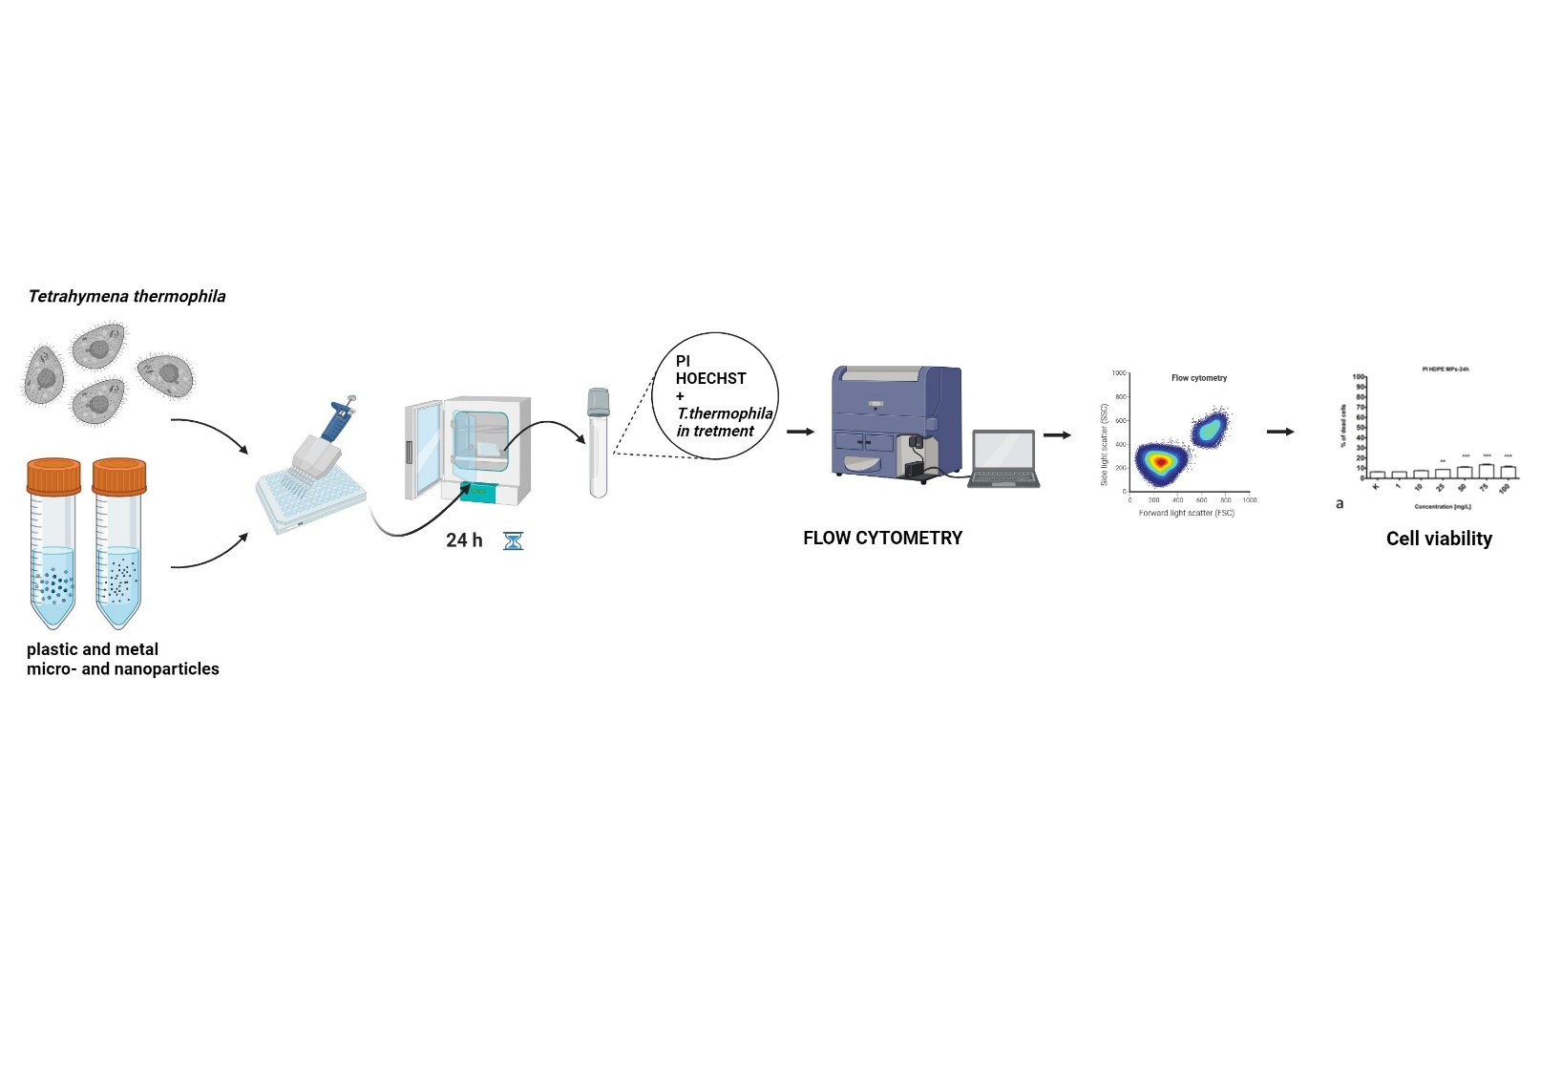

Figure 1: Experimental procedure scheme.

a. Hemocytometer counting

After 3 days of cell growth in RM medium, the cells are centrifuged at 200 rpm for 5 minutes. and resuspended in PM medium. The cells are counted with a hemocytometer by diluting a small volume of the culture 1:1 with 70% ethanol and the average cell number is multiplied by the dilution factor and the hemocytometer correction factor to obtain the total cell number per unit volume. Afterwards, a cell suspension (in PM medium) with a concentration of 15 x 10⁵ cells/mL cell is prepared and seeded in 96-well microtiter plates.

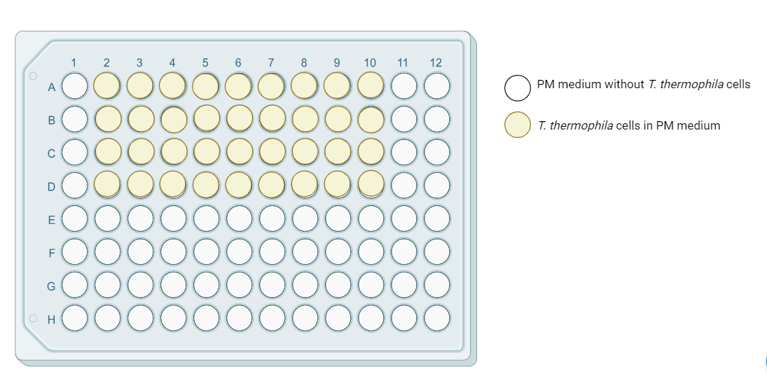
Figure 2: Seeding plate.

b. Treatment
- Ensure that the cells in the suspension are well mixed before pipetting. 100 μl of cells of cell suspension were seeded in 96-well plates treated with 50 μl of test material diluted in PM medium to a final concentration (e.g. 1, 10, 20, 50, 75, 100 mg/L). Afterwards the plate is incubated for 24 hours at 32°C.
- As a positive control 5 µL/well of 2% Triton X-100 to a final concentration of 0.1 % is added.

c. Experimental controls
- Positive control: cells treated with Triton X-100 to determine minimum/zero cell viability. The positive control is also used to detect culture contamination.

- Control: cells in medium without treatment, representing 100 % cell viability.

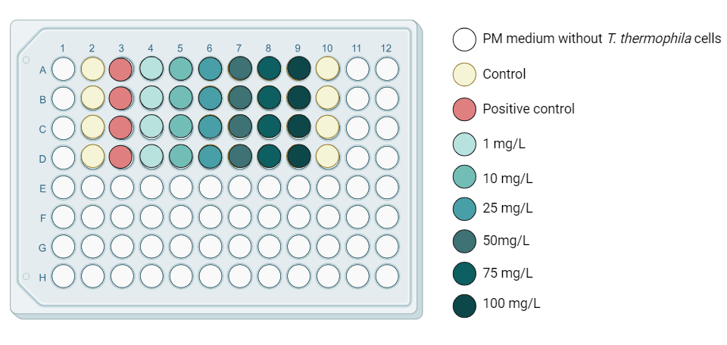
Figure 3: Particle treatment plan.

d. Repetitions

For each type of particle two independent sets of experiments with 2 replicates were performed.

e. PI and Hoechst staining
After 24 or exposure aliquot appropriate volumes of Tetrahymena thermophila cell suspension into FACS tubes. Add Propidium Iodide (PI) and Hoechst to each tube at a final concentration of 5 µg/mL. Mix gently and incubate the samples in the dark at room temperature for 20 minutes.

f. Flow cytometry reading
After 20 minutes of staining resuspend the Tetrahymena thermophila cells in an appropriate volume of PBS. Set up the flow cytometer with appropriate settings for Hoechst and PI detection. Propidium iodide (excited by 488 or 561 nm, with a bandpass filter 610/10) and Hoechst (excited with the UV laser at 350 nm, measured with 450/20 BP and 675 EFLP optical filter). Viable cells are Hoechst-positive, and PI-negative while dead ones are Hoechst-positive and PI-positive.

Data analysis
Use flow cytometry software to obtain results and FlowJo_V10 software to analyse. To quantify cell viability in percentages Microsoft Excel 2010 was used. Calculate the average values of the individual treatments and normalize the data according to the control (control = 100%) so that the final results are expressed as “cell viability (% of control) ± standard deviation”. To generate reliable results, perform at least 2 independent experiments”.

Criteria and quality check measures
- Maintain good aseptic techniques to avoid contamination and ensure the purity of the T. thermophila culture.
- Regular monitoring of the cell culture and detection of potential contaminants in a T. thermophila culture are critical to maintaining the integrity of the experiments and ensuring the accuracy of the research results.
- Particle suspensions/treatments must be freshly prepared prior use.
- The positive control (Triton X-100) should always show minimal/zero cell viability in all experiments.

Note
Partial procedures used to develop this document are described in standard ISO/TS 4988:2022: Toxicity assessment and bioassimilation of manufactured nano-objects in suspension using the unicellular organism Tetrahymena sp. [3]

Refrences:
[1] Schultz, T., TETRATOX: Tetrahymena pyriformis population growth impairment endpoint a surrogate for fish lethality. Toxicology Methods, 1997. 7(4): p. 289-309. https://doi.org/10.1080/105172397243079
[2] Vogel et al., 2021; InnoMat.Life https://nanopartikel.info/wpcontent/uploads/2021/06/InnoMatLife_Dispersion-SOP-polymers_V1.pdf
[3] ISO Nanotechnologies (2022) Toxicity assessment and bioassimilation of manufactured nano-objects in suspension using the unicellular organism Tetrahymena sp.

