Standard Operation Procedure (SOP):

CyQUANT Cell Proliferation Assay
SOP for Tetrahymena thermophila

Date
8. 12. 2023

Version:
Number 2.0

Title: | CyQUANT Cell Proliferation Assay
Number: | 2
Date: | 8. 12. 2023
Version: | Version 2.0
Responsible for the implementation of this SOP: | Valentina Perc
Authors: | Valentina Perc, University of Ljubljana, Biotechnical faculty,  Sara Novak, University of Ljubljana, Biotechnical faculty,  Veno Kononenko, University of Ljubljana, Biotechnical faculty,  Sara Michelini, University of Ljubljana, Biotechnical faculty  Damjana Drobne, University of Ljubljana, Biotechnical faculty
 | Name, Organisation
Reviewed: | Sara Michelini, University of Ljubljana, Biotechnical faculty
 | Name, Organisation

Scope
This standard operating procedure (SOP) describes the protocol for measuring the viability of unicellular organism Tetrahymena thermophila treated with plastic and metal micro- and nanoparticles using the CyQUANT Direct Proliferation assay kit.

Basics
CyQUANT Direct Cell Proliferation Assay Kit is based on a cell-permeable DNA-binding dye in combination with a masking dye reagent. The masking dye blocks staining of dead cells or cells with compromised cell membranes resulting in only healthy cells being stained. The combination of these two components results in an assay based on both DNA content, cell proliferation and membrane integrity. Fluorescence intensity is linearly dependent on cell number.

Materials and Instruments
a. Materials
Sterile tips
Serological pipette (Thermo) + controller
15 and 50 mL plastic tubes (Golias)
T25 flasks (Eppendorf)
Sterile 96-well flat bottom plates for cell culture (TPP)
Sterile culture medium (nutrient rich growth medium for cell maintaining and nutrient poor exposure medium for experiments)
Ethanol 70% (Honeywell)
Multichannel reservoir
Triton-X 100(Roche) (2%)
Tetrahymena thermophila in culture from the PROTOXKIT F (MicroBioTests)
Plastic dispersants and nanoparticle solutions
CyQUANT™ Direct Cell Proliferation Assay Kit [1]

b. Instruments
Inverted optical microscope (Zeiss)
Hemocytometer with Neubauer grid
Pipette (10, 100, 200 µl)
Multichannel pipette (200, 1000 µl)
Bio-safety cabinet
Incubator (32oC)
Centrifuge
Spectrofluorimeter (BioTek, Cytation 3)
Vortex
Water bath 37°C
Sonicator bath

c. Solutions
- Plastic dispersants and nanoparticle solutions prepared according to Vogel et al., (2021) [3]
- Prepare solutions according to CyQUANT™ Direct Cell Proliferation Assay Kit[1]:
- 2X Detection Reagent:
CyQuant® Direct nucleic acid stain
CyQuant® Direct background suppressor I

Cell culturing procedure

a. Growth and exposure medium
Prepare a nutrient-rich growth medium (RM) containing 5 g d-glucose, 5 g proteose peptone, 1 g yeast extract, 1.2 g Trisma-base, chlorides (2.28 µM CaCl₂-2H₂O, 0.29 µM CuCl₂-2H₂O, 0.05 µM FeCl₃-6H₂O, 0.03 µM MnCl₂-6H₂O, 0.004 µM ZnCl₂) and sulphates (4.1 µM MgSO₄-7H₂O, 0.64 µM Fe(NH4)₂(SO4)₂-6H₂O), up to 1000 ml double-distilled H₂O, pH corrected to 7.35 with HCl.
The recipe of the nutrient-poor medium (PM) is the same, except that does not contain proteose peptone and yeast extract, according to the recipes of Schultz (1977) [1]. To ensure sterility, the medium is autoclaved, and to remove impurities, it is recommended that the exposure medium (PM) is also filtered.

b. Inoculation
Start the culture with a small inoculum from a well-established Tetrahymena thermophila culture or a commercially available source (PROTOXKIT F - MicroBioTests). Add the inoculum to the RM medium in a sterile T25 flask and allow it to grow for 1 week. After at least 2 subcultures, the culture can be used for the experiment.
c. Incubation
Incubate the culture at 32 °C. Keep the temperature constant during the entire incubation period.

d. Subculturing
Every 3 days, a subculture is created by transferring 1 ml of the stock culture to 50 ml of fresh RM medium. This prevents overcrowding and ensures optimal growth conditions.

e. Culture monitoring/contamination detection
Detecting bacterial contamination in a Tetrahymena thermophila culture is crucial for maintaining the integrity of experiments and ensuring the accuracy of research results. Two methods can be used for this purpose:
- Microscopy:
Regular microscopic examination of the culture is essential. Contaminants, such as bacteria or other microorganisms, may be visible under a microscope.

Detection of contamination using Triton-X 100 positive control

The positive control can also be used to detect bacterial contamination. Triton-X 100 in a concentration of 0.1 % leads to membrane permeabilization and cell death in T. thermophila but has no such effect on the bacteria viability. In the case of contamination, the viability result in the positive control is equal or even higher than in the control cells.

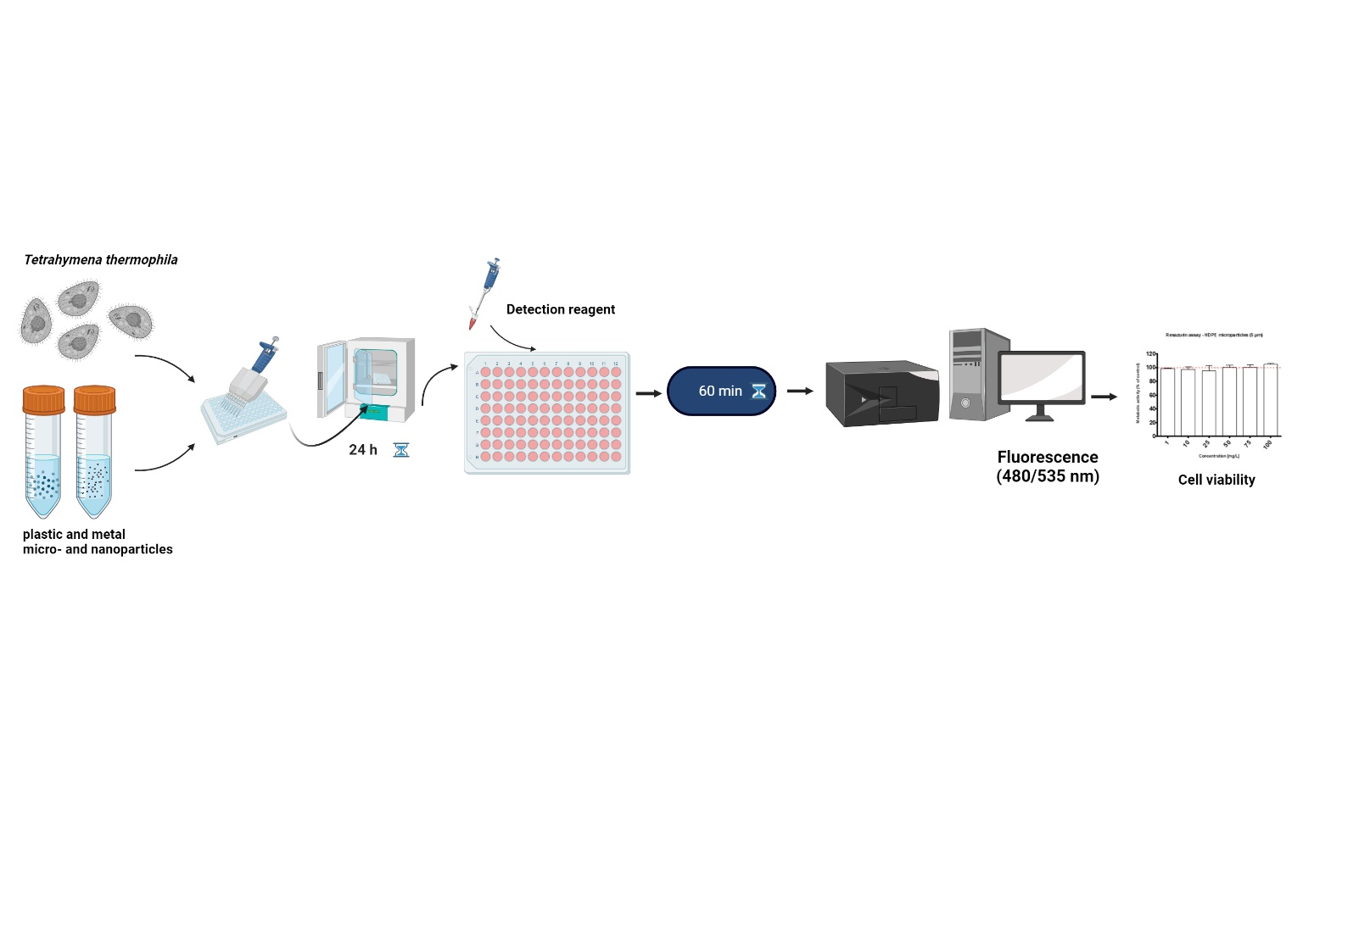
Experimental procedure
Figure 1: Experimental procedure scheme.

a. Hemocytometer counting

After 3 days of cell growth in RM medium, the cells are centrifuged at 200 rpm for 5 minutes. and resuspended in PM medium. The cells are counted with a hemocytometer by diluting a small volume of the culture 1:1 with 70% ethanol and the average cell number is multiplied by the dilution factor and the hemocytometer correction factor to obtain the total cell number per unit volume. Afterwards, a cell suspension (in PM medium) with a concentration of 15 x 10⁵ cells/mL cell is prepared and seeded in 96-well microtiter plates.

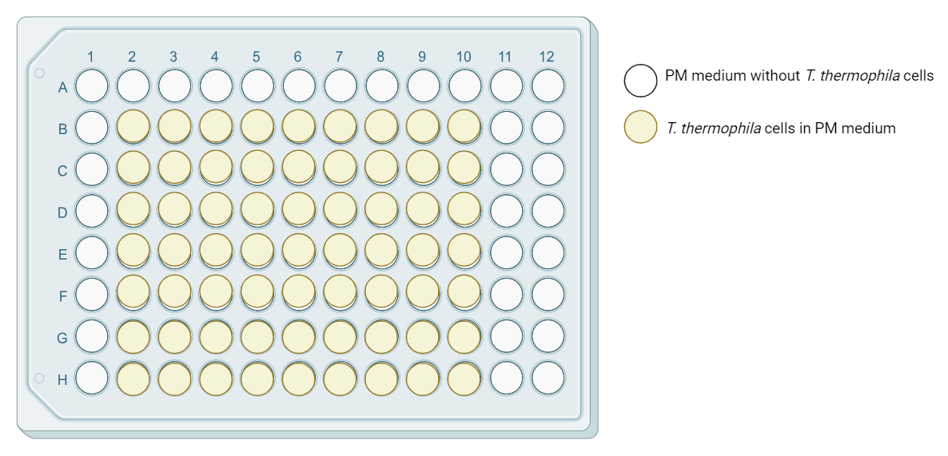
Figure 2: Seeding plate.

b. Treatment
- Ensure that the cells in the suspension are well mixed before pipetting. 100 μl of cells of cell suspension were seeded in 96-well plates treated with 50 μl of test material diluted in PM medium to a final concentration (e.g. 1, 10, 20, 50, 75, 100 mg/L). Afterwards the plate is incubated for 24 hours at 32°C degrees.
- As a positive control 5 µL/well of 2% Triton X-100 to a final concentration of 0.1 %) is added.

c. Experimental controls

- Positive control: cells treated with Triton X-100 to determine minimum resazurin conversion. The positive control is also used to detect culture contamination.

- Control: cells in medium without treatment, representing 100 % cell viability.

- Medium control: well with the treatment and the dye, but without the cells which defined the background provided by the medium/treatment
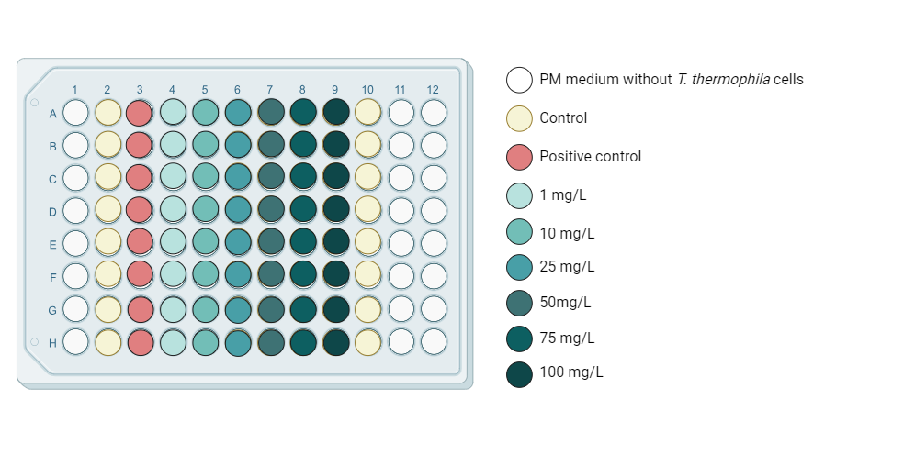
Figure 2: Particle treatment plan.

d. Experiment repetitions
For each type of particle three independent experiments with 6-7 replicates are performed.

e. Cell Proliferation Assay
1. Follow the manufacturer's instructions to prepare the CyQUANT™ Proliferation Assay [1] working solution:
The following recipe is for preparing 12 mL of 2X detection reagent, which is sufficient for one microtiter plate with 100 μL/well in a 96-well plate,
- Combine the following in 15 mL tube:
11,7 mL of culture medium
48 µL CyQuant® Direct nucleic acid stain
240 µL CyQuant® Direct background suppressor I

2. Add an equal volume of 2X detection reagent to cells in culture. For example, add 100 μL of 2X detection reagent to 100 µL of cells in cell culture media or buffer.
3. Incubate cells with the detection reagent for 60 minutes at 37°C.

f. Plate reading
Read fluorescence of samples using standard wavelengths (i.e., 480/535 nm, if using a monochrometer-based instrument).

Data analysis
The data from the spectrofluorometric measurements are collected in an Excel file. Calculate the average values of the individual treatments (with cells and with dye) and subtract the medium control. If the medium control values are high (above about 30% of the control value), this indicates that the treatments are interfering with the measurements. Then normalize the data according to the control (control = 100%) so that the final results are expressed as cell viability (% of control) ± standard deviation. To generate reliable results, perform at least 3 independent experiments.

Criteria and quality check measures
- Maintain good aseptic techniques to avoid contamination and ensure the purity of the T. thermophila culture.
- Regular monitoring of the cell culture and detection of potential contaminants in a T. thermophila culture are critical to maintaining the integrity of the experiments and ensuring the accuracy of the research results.
- Particle suspensions/treatments must be freshly prepared prior use.
- The positive control (Triton X-100) should always show minimal/zero cell viability in all experiments.
- A bottom-read plate reader is required to detect the fluorescence signal in the presence of the background suppression reagent. Use caution when moving microtiter plates to allow suspension cells to remain settled or in contact with the bottom of the plate.

Note
Partial procedures used to develop this document are described in standard ISO/TS 4988:2022: Toxicity assessment and bioassimilation of manufactured nano-objects in suspension using the unicellular organism Tetrahymena sp. [4]

References:
[1] Thermo Fisher (2021) CyQUANT™ Direct Cell Proliferation Assay Invitrogen (Catalog No. C35011)
ATP Cell Viability Luciferase Assay (Catalog No. SCT149) Darmstadt, Germany
[2] Schultz, T., TETRATOX: Tetrahymena pyriformis population growth impairment endpoint a surrogate for fish lethality. Toxicology Methods, 1997. 7(4): p. 289-309. https://doi.org/10.1080/105172397243079
[3] Vogel et al., 2021; InnoMat.Life https://nanopartikel.info/wpcontent/uploads/2021/06/InnoMatLife_Dispersion-SOP polymers_V1.pdf
[4] ISO Nanotechnologies (2022) Toxicity assessment and bioassimilation of manufactured nano-objects in suspension using the unicellular organism Tetrahymena sp.

