Standard Operation Procedure (SOP):

BrdU Cell Proliferation Assay
Protocol for Tetrahymena thermophila

Date
11. 12. 2023

Version:
Number 2.0

Title: | BrdU Cell Proliferation Assay
Number: | 2
Date: | 11. 12. 2023
Version: | Version 2.0
Responsible for the implementation of this SOP: | Valentina Perc
Author: | Valentina Perc, University of Ljubljana, Biotechnical faculty,  Sara Novak, University of Ljubljana, Biotechnical faculty,  Veno Kononenko, University of Ljubljana, Biotechnical faculty,  Sara Michelini, University of Ljubljana, Biotechnical faculty  Damjana Drobne, University of Ljubljana, Biotechnical faculty
 | Name, Organisation
Reviewed: | Sara Michelini, University of Ljubljana, Biotechnical faculty
 | Name, Organisation

Scope
This standard operating procedure (SOP) describes the protocol for measuring the viability of unicellular organism Tetrahymena thermophila treated with plastic and metal micro- and nanoparticles using the BrdU Cell Proliferation assay.

- Basics
In the BrdU cell proliferation assay, BrdU (bromodeoxyuridine (5-bromo-2'-deoxyuridine)) is incorporated into the newly synthesized DNA of replicating cells (during the S phase of the cell cycle), substituting for thymidine during DNA replication strands of actively proliferating cells. After partial denaturation of the double-stranded DNA, BrdU is detected immunochemically so that the population of cells actively synthesizing DNA can be determined. In addition to assessing cell proliferation, information such as cell number, morphology and analysis of cellular antigens can be obtained from a single culture.

Materials and Instruments

a. Materials
Sterile tips
Serological pipette (Thermo) + controller
15 and 50 ml plastic tubes (Golias)
T25 flasks (Eppendorf)
Sterile 96-well flat bottom plates for cell culture (TPP)
Sterile culture medium (nutrient rich growth medium for cell maintaining and nutrient poor exposure medium for experiments)
Ethanol 70% (Honeywell)
Multichannel reservoir
Triton X (Roche) (2 %)
Calbiochem® BrdU Cell Proliferation Assay kit [1]
Tetrahymena thermophila in culture from the PROTOXKIT F (MicroBioTests)
Plastic dispersants and nanoparticle solutions
b. Instruments
Inverted optical microscope (Zeiss)
Hemocytometer with Neubauer grid
Pipette (10, 100, 200 µl)
Multichannel pipette (200, 1000 µl)
Bio-safety cabinet
Incubator (32ºC)
Centrifuge
Spectrofluorimeter (BioTek, Cytation 3)
Vortex
Water bath 37°C
Sonicator bath

c. Solutions
1) Plastic dispersants and nanoparticle solutions prepared according to Vogel et al., (2021) [3]
2) BrdU kit solutions prepared according to BrdU Cell Proliferation kit [1]:
- BrdU LABEL: A 2.000-fold solution of BrdU and
Fixative/Denaturing Solution
- 100X Anti-BrdU Antibody: Stock solution of the antibody.
- Antibody Diluent: Solution for dilution of the anti-BrdU antibody.
- Peroxidase Goat Anti-Mouse IgG: Lyophilized. Refer to page 1 for reconstitution.
- Conjugate Diluent: For dilution of reconstituted Peroxidase Goat anti-mouse IgG peroxidase conjugate.
- Substrate: Tetra-methylbenzidine solution.
- 20X Plate Wash Concentrate: 20X concentrated solution of PBS and surfactant. Contains 2% chloroacetamide.
- Stop Solution: 2.5N sulfuric acid.

Cell culturing procedure

a. Growth and exposure medium
Prepare a nutrient-rich growth medium (RM) containing 5 g d-glucose, 5 g proteose peptone, 1 g yeast extract, 1.2 g Trisma-base, chlorides (2.28 µM CaCl₂-2H₂O, 0.29 µM CuCl₂-2H₂O, 0.05 µM FeCl₃-6H₂O, 0.03 µM MnCl₂-6H₂O, 0.004 µM ZnCl₂) and sulphates (4.1 µM MgSO₄-7H₂O, 0.64 µM Fe(NH4)₂(SO4)₂-6H₂O), up to 1000 ml double-distilled H₂O, pH corrected to 7.35 with HCl.
The recipe of the nutrient-poor medium (PM) is the same, except that does not contain proteose peptone and yeast extract, according to the recipes of Schultz (1977) [1]. To ensure sterility, the medium is autoclaved, and to remove impurities, it is recommended that the exposure medium (PM) is also filtered.

b. Inoculation
Start the culture with an inoculum from a well-established Tetrahymena thermophila culture or a commercially available source (PROTOXKIT F - MicroBioTests). The inoculum is added to the RM medium in a sterile T25 flask and allowed to grow for 1 week. After at least 2 subcultures, the culture can be used for the experiment.

c. Incubation
Incubate the culture at 32 °C. Keep the temperature constant during the entire incubation period.

d. Subculturing
Every 3 days, a subculture is created by transferring 1 ml of the stock culture to 50 ml of fresh RM medium. This prevents overcrowding and ensures optimal growth conditions.

e. Culture monitoring/contamination detection
Detecting bacterial contamination in a Tetrahymena thermophila culture is crucial for maintaining the integrity of experiments and ensuring the accuracy of research results. Two methods can be used for this purpose:
- Microscopy:
Regular microscopic examination of the culture is essential. Contaminants, such as bacteria or other microorganisms, may be visible under a microscope.

Detection of contamination using Triton-X 100 positive control

The positive control can also be used to detect bacterial contamination. Triton-X 100 in a concentration of 0.1 % leads to membrane permeabilization and cell death in T. thermophila but has no such effect on the bacteria viability. In the case of contamination, the viability result in the positive control is equal or even higher than in the control cells.

Experimental procedure
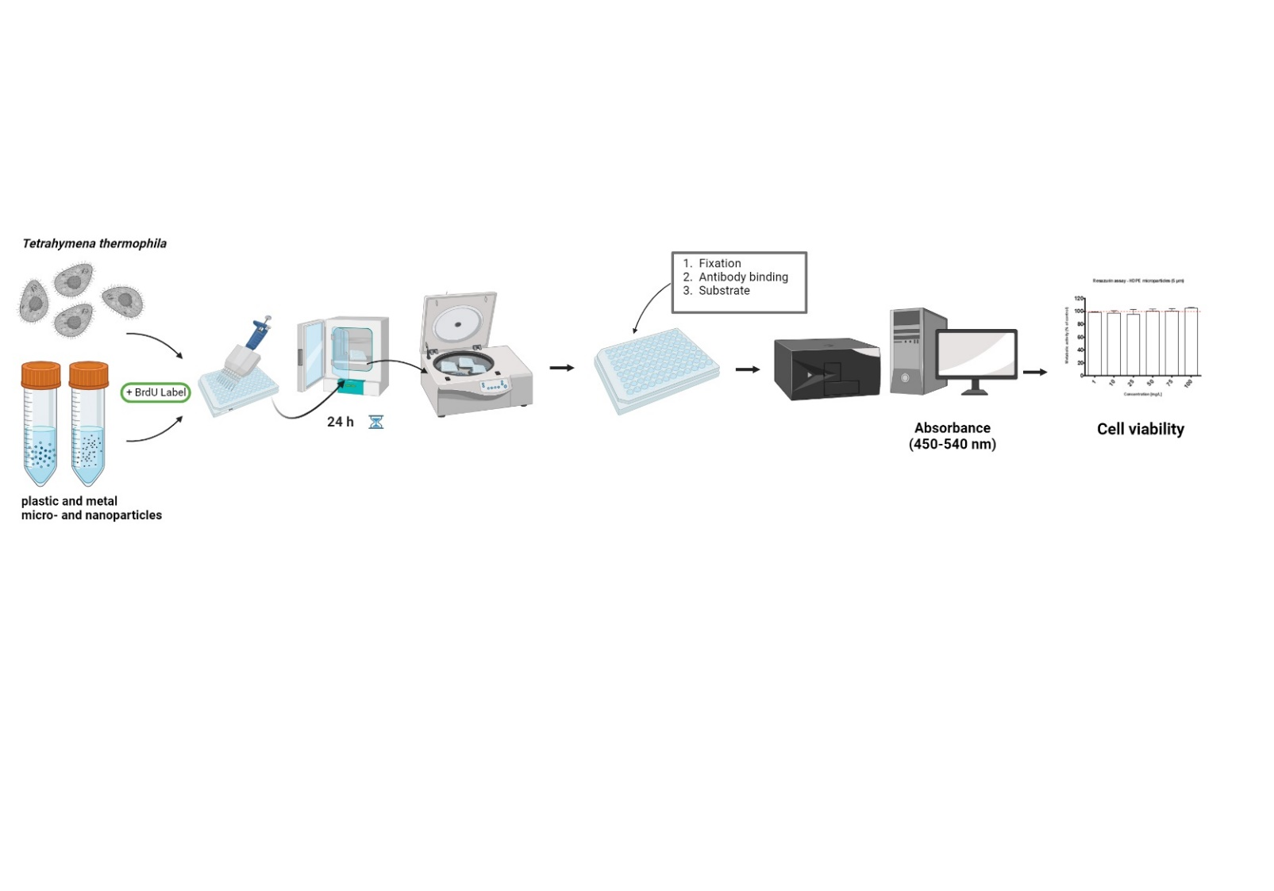
Figure 1: Experimental procedure scheme.

a. Hemocytometer counting

After 3 days of cell growth in RM medium, the cells are centrifuged at 200 rpm for 5 minutes. and resuspended in PM medium. The cells are counted with a hemocytometer by diluting a small volume of the culture 1:1 with 70% ethanol and the average cell number is multiplied by the dilution factor and the hemocytometer correction factor to obtain the total cell number per unit volume. Afterwards, a cell suspension (in PM medium) with a concentration of 15 x 10⁵ cells/mL cell is prepared and seeded in 96-well microtiter plates.

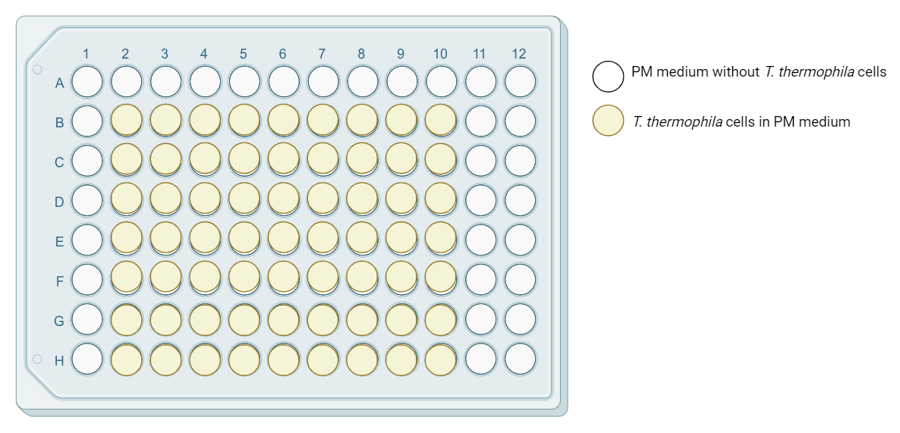
Figure 1: Seeding plate plan

b. Treatment
- Ensure that the cells in the suspension are well mixed before pipetting. 100 μl of cells of cell suspension were seeded in 96-well plates treated with 50 μl of test material diluted in PM medium to a final concentration (e.g. 1, 10, 20, 50, 75, 100 mg/L). Afterwards the plate is incubated for 24 hours at 32°C.
- Together with the treatment, 20 µl of the BrdU LABEL working solution (1:2000) is added to each well to be labeled.
- As a positive control 5 µL/well of 2% Triton X-100 to a final concentration of 0.1 % is added.

c. Experimental controls
- Positive control: cells treated with Triton X-100 to determine minimum resazurin conversion. The positive control is also used to detect culture contamination.

- Control: cells in medium without treatment, representing 100 % cell viability.

- Medium control: well with the treatment and the dye, but without the cells which defined the background provided by the medium/treatment

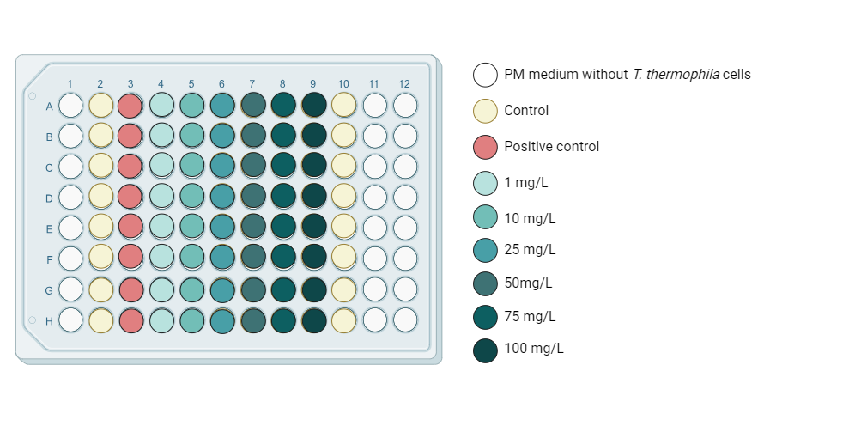
Figure 2: Particle treatment plan

d. Experiment repetitions
For each type of particle three independent experiments with 6-7 replicates are performed.

e. BrdU assay procedure
- After 24 hours of treatment and BrdU LABEL incubation, centrifuge the microtiter plates for 10 minutes at 3500 rpm (high, because T. thermophila are moving cells)
- Remove contents of wells by inverting over sink and blot gently on paper towels.
- Add 200 µl of the Fixative/Denaturing Solution to each well.
- Incubate for 30 min at room temperature.
- Remove contents of wells by inverting over sink and tapping on paper towels. Plates may be stored after this step at 4°C for 1 week.
- Dilute the 100X Anti-BrdU Antibody 1:100 in the Antibody Dilution Buffer (i.e. 120 µl to 12 ml of Antibody Diluent). Pipette 100 µl of this solution to each well and incubate for 1 h at room temperature.
- Prepare a working solution (1X) of Wash Buffer by adding 25 ml of the 20X concentrated solution (provided), to 475 ml of deionized water. Mix well.
- Wash wells 3 times with automatic plate washer or by hand with 1X Wash Buffer making sure each well is filled completely. Blot the plate gently on paper towels.
- Prepare the conjugate by diluting the reconstituted (in 1X PBS) Peroxidase Goat Anti-Mouse IgG HRP Conjugate in the Conjugate Diluent and syringe filter through 0. 2 µm filter.
- Pipette 100 µl of this solution into each well and incubate for 30 min at room temperature.
- Wash wells 3 times with automatic plate washer or by hand with 1X Wash Buffer making sure each well is filled completely.
- Flood entire plate with dH₂O. Remove contents of wells by inverting over sink and tapping on paper towels.
- Add 100 µl of Substrate Solution to each well and incubate in the dark at room temperature for 15 min.
- Add 100 µl of Stop Solution to each well in the same order as the previously added Substrate Solution.
f. Plate reading
Measure absorbance in each well using a spectrophotometric plate reader at dual wavelengths of 450-540 nm (or 450-595). Microtiter plates must be read within 30 min after adding the Stop Solution.

Data analysis
The data from the spectrofluorometric measurements are collected in an Excel file. Calculate the average values of the individual treatments (with cells and with dye) and subtract the medium control. If the medium control values are high (above about 30% of the control value), this indicates that the treatments are interfering with the measurements. Then normalize the data according to the control (control = 100%) so that the final results are expressed as cell viability (% of control) ± standard deviation. To generate reliable results, perform at least 3 independent experiments.

Criteria and quality check measures
- Maintain good aseptic techniques to avoid contamination and ensure the purity of the T. thermophila culture.
- Regular monitoring of the cell culture and detection of potential contaminants in a T. thermophila culture are critical to maintaining the integrity of the experiments and ensuring the accuracy of the research results.
- Particle suspensions/treatments must be freshly prepared prior use.
- The positive control (Triton X-100) should always show minimal/zero cell viability in all experiments.

Note
Partial procedures used to develop this document are described in standard ISO/TS 4988:2022: Toxicity assessment and bioassimilation of manufactured nano-objects in suspension using the unicellular organism Tetrahymena sp. [4]

Refrences:
[1] Millipore (2022) Calbiochem® BrdU Cell Proliferation Assay (Catalog No. D55436), Darmstadt Germany
[2] Schultz, T., TETRATOX: Tetrahymena pyriformis population growth impairment endpoint a surrogate for fish lethality. Toxicology Methods, 1997. 7(4): p. 289-309. https://doi.org/10.1080/105172397243079
[3] Vogel et al., 2021; InnoMat.Life https://nanopartikel.info/wpcontent/uploads/2021/06/InnoMatLife_Dispersion-SOP-polymers_V1.pdf
[4] ISO Nanotechnologies (2022) Toxicity assessment and bioassimilation of manufactured nano-objects in suspension using the unicellular organism Tetrahymena sp.

