Standard Operation Procedure (SOP):

Cell viability - ATP assay
SOP for Tetrahymena thermophila

Date
7. 12. 2022

Version:
Number 3.0

Title: | Cell viability - ATP assay
Number: | 3
Date: | 7. 12. 2022
Version: | Version 3.0
Responsible for the implementation of this SOP: | Valentina Perc
Authors: | Valentina Perc, University of Ljubljana, Biotechnical faculty,  Sara Novak, University of Ljubljana, Biotechnical faculty,  Veno Kononenko, University of Ljubljana, Biotechnical faculty,  Sara Michelini, University of Ljubljana, Biotechnical faculty  Damjana Drobne, University of Ljubljana, Biotechnical faculty
 | Name, Organisation
Reviewed: | Sara Michelini, University of Ljubljana, Biotechnical faculty
 | Name, Organisation

Scope
This standard operating procedure (SOP) describes the protocol for measuring the viability of unicellular organism Tetrahymena thermophila treated with plastic and metal micro- and nanoparticles using the ATP assay.

- Basics
The principle of an ATP assay is that the enzyme luciferase catalyses the reaction between ATP and luciferin, resulting in the emission of light. This emitted light is quantified and used to determine the ATP concentration in a sample. The test is very sensitive, and the amount of light produced is directly proportional to the amount of ATP present, so that the number of viable cells, cell proliferation and cell cytotoxicity can be determined.

Materials and Instruments
a. Materials
Sterile tips
Serological pipette (Thermo) + controller
15 and 50 ml plastic tubes (Golias)
T25 flasks (Eppendorf)
Multichannel reservoir
Sterile 96-well flat bottom plates for cell culture (TPP)
Sterile culture medium (nutrient rich growth medium for cell maintaining and nutrient poor exposure medium for experiments)
Ethanol 70% (Honeywell)
Triton X (Roche) (2%))
Tetrahymena thermophila in culture from the PROTOXKIT F (MicroBioTests)
ATP Cell Viability Luciferase Assay (Millipore) [1]
b. Instruments
Inverted optical microscope (Zeiss)
Hemocytometer with Neubauer grid
Pipette (10, 100, 200 µl)
Multichannel pipette (200, 1000 µl)
Bio-safety cabinet
Incubator (32ºC)
Centrifuge
Spectrofluorimeter (BioTek, Cytation 3) (+dispenser)
Vortex
Water bath 37°C
Sonicator bath
c. Solutions
- Plastic dispersants and nanoparticle solutions prepared according to Vogel et al., (2021) [3]
- Prepare solutions according to ATP Cell Viability Luciferase Assay kit [1]:
1) D-Luciferin
2) Firefly Luciferase
3) ATP Assay Buffer

Cell culturing procedure

a. Growth and exposure medium
Prepare a nutrient-rich growth medium (RM) containing 5 g d-glucose, 5 g proteose peptone, 1 g yeast extract, 1.2 g Trisma-base, chlorides (2.28 µM CaCl₂-2H₂O, 0.29 µM CuCl₂-2H₂O, 0.05 µM FeCl₃-6H₂O, 0.03 µM MnCl₂-6H₂O, 0.004 µM ZnCl₂) and sulphates (4.1 µM MgSO₄-7H₂O, 0.64 µM Fe(NH4)₂(SO4)₂-6H₂O), up to 1000 ml double-distilled H₂O, pH corrected to 7.35 with HCl.
The recipe of the nutrient-poor medium (PM) is the same, except that does not contain proteose peptone and yeast extract, according to the recipes of Schultz (1977) [1]. To ensure sterility, the medium is autoclaved, and to remove impurities, it is recommended that the exposure medium (PM) is also filtered.

b. Inoculation
Start the culture with an inoculum from a well-established Tetrahymena thermophila culture or a commercially available source (PROTOXKIT F - MicroBioTests). The inoculum is added to the RM medium in a sterile T25 flask and allowed to grow for 1 week. After at least 2 subcultures, the culture can be used for the experiment.

c. Incubation
Incubate the culture at 32 °C. Keep the temperature constant during the entire incubation period.

d. Subculturing
Every 3 days a subculture is created by transferring 1 ml of the stock culture to 50 ml of fresh RM medium. This prevents overcrowding and ensures optimal growth conditions.

e. Culture monitoring/contamination detection
Detecting bacterial contamination in a Tetrahymena thermophila culture is crucial for maintaining the integrity of experiments and ensuring the accuracy of research results. Two methods can be used for this purpose:
- Microscopy:
Regular microscopic examination of the culture is essential. Contaminants, such as bacteria or other microorganisms, may be visible under a microscope.

Detection of contamination using Triton-X 100 positive control
The positive control can also be used to detect bacterial contamination. Triton-X 100 at a concentration of 0.1 % leads to membrane permeabilization and cell death in T. thermophila but has no such effect on the bacteria viability. In the case of contamination, the viability result in the positive control is equal or even higher than in the control cells.

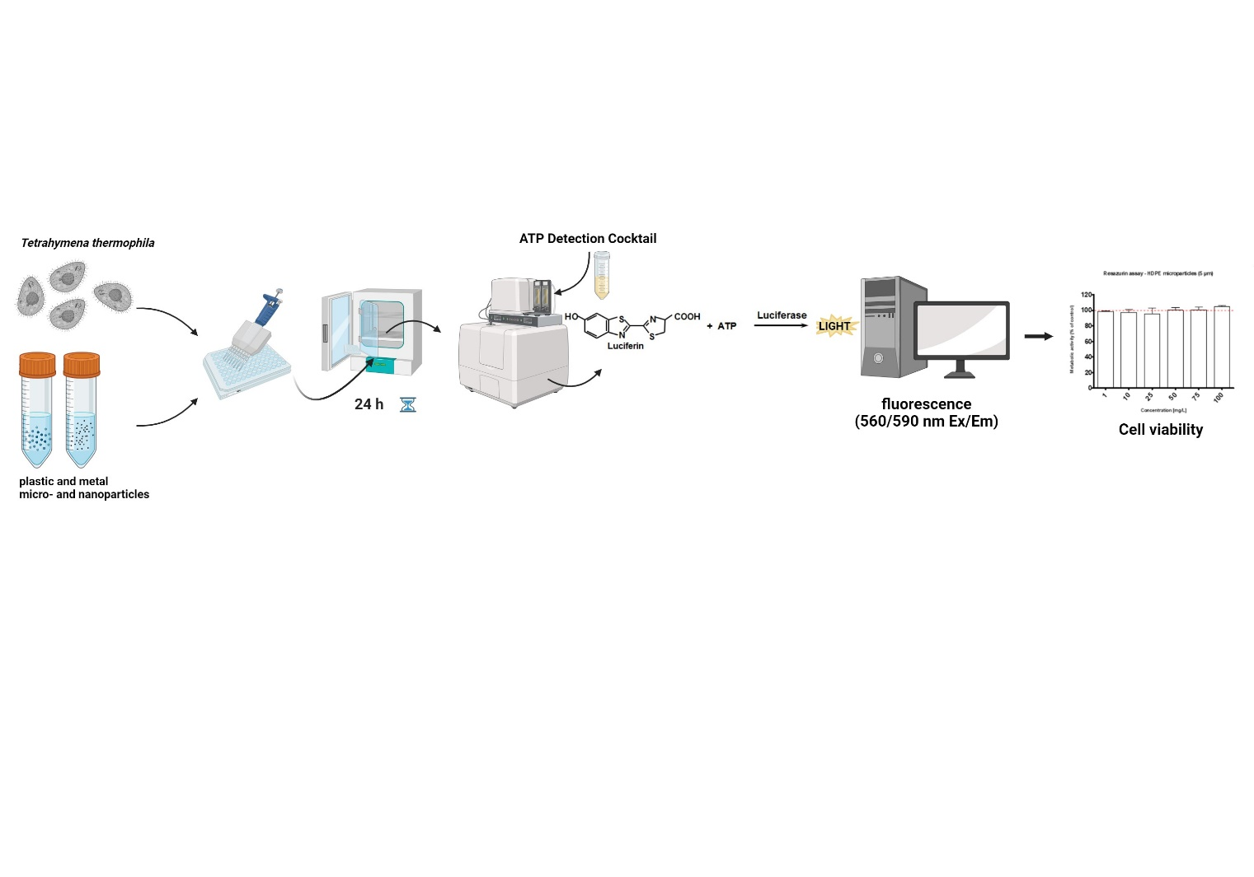
Experimental procedure
Figure 1: Experimental procedure scheme

a. Hemocytometer counting

After 3 days of cell growth in RM medium, the cells are centrifuged at 200 rpm for 5 minutes. and resuspended in PM medium. The cells are counted with a hemocytometer by diluting a small volume of the culture 1:1 with 70% ethanol and the average cell number is multiplied by the dilution factor and the hemocytometer correction factor to obtain the total cell number per unit volume. Afterwards, a cell suspension (in PM medium) with a concentration of 15 x 10⁵ cells/mL cell is prepared and seeded in 96-well microtiter plates.

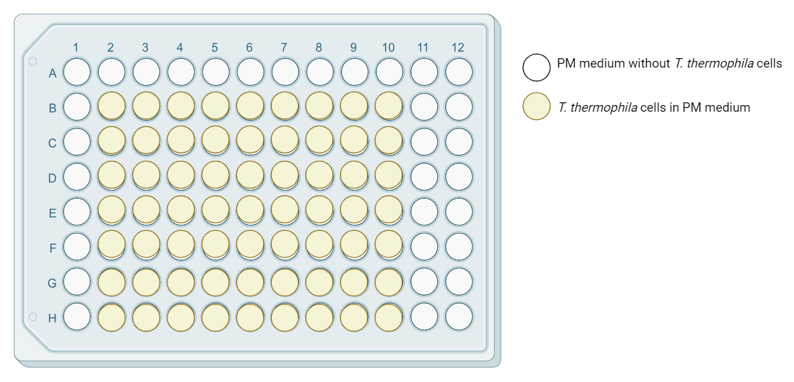
Figure 2: Seeding plate.

b. Treatment
- Ensure that the cells in the suspension are well mixed before pipetting. 100 μl of cells of cell suspension were seeded in 96-well plates treated with 50 μl of test material diluted in PM medium to a final concentration (e.g. 1, 10, 20, 50, 75, 100 mg/L). Afterwards the plate is incubated for 24 hours at 32°C degrees.
- As a positive control 5 µL/well of 2% Triton X-100 to a final concentration of 0.1 %) is added.

c. Experimental controls
- Positive control: cells treated with Triton X-100 to determine minimum resazurin conversion. The positive control is also used to detect culture contamination.

- Control: cells in medium without treatment, representing 100 % cell viability.

- Medium control: well with the treatment and the dye, but without the cells which defined the background provided by the medium/treatment

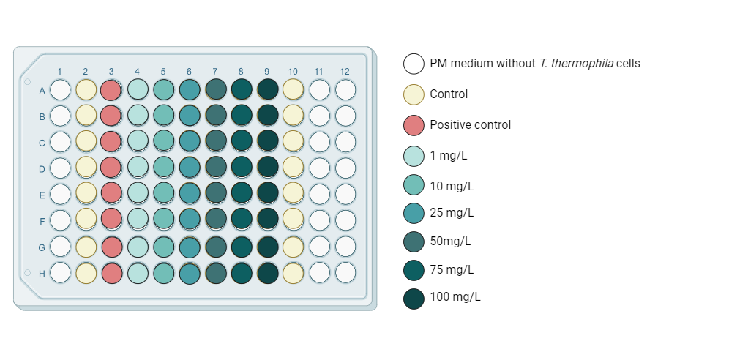
Figure 3: Particle treatment plan

d. Experiment repetitions
For each type of particle three independent experiments with 6-7 replicates are performed.

e. Luminescence assay
- ATP Detection Cocktail was prepared of 25 mL ATP Assay Buffer, 10 mg D-luciferin and 250 µL Firefly Luciferase. ATP Detection Cocktail should be prepared fresh before each use for maximum activity.
- Microplate reader was set up with a delay time of 10 seconds, an integration time of 10 seconds. For automated injections set a delay time of 5-10 second to allow sample to reach equilibrium.
- 100 µL of ATP Detection Cocktail was added by automated injection in each well. The luciferase activity was measured for 10 seconds.

f. Plate reading

The intensity of the luminescence signal, the light produced (green/yellow, 550-70 nM), is measured with s spectrofluorimeter.

Data analysis
The data from the luminescence measurements are collected in an Excel file. Calculate the average values of each treatment (with cells and with dye) and subtract the blank value from this number (the blank value is a signal from the well with the treatment and the dye, but without the cells). If the blank values are high (above about 30% of the control value), this indicates that the treatments are interfering with the measurements. Then normalize the data according to the control (control = 100 %) so that the final results are expressed as “cell viability (% of control) ± standard deviation”. To obtain final results, repeat the experiment with the same treatments at least three times.

Criteria and quality check measures
- Maintain good aseptic techniques to avoid contamination and ensure the purity of the T. thermophila culture.
- Regular monitoring of the cell culture and detection of potential contaminants in a T. thermophila culture are critical to maintaining the integrity of the experiments and ensuring the accuracy of the research results.
- Particle suspensions/treatments must be freshly prepared prior use.
- The positive control (Triton X-100) should always show minimal/zero cell viability in all experiments.
- Automated injection system provides the option to add reagents directly in measurement position and to start light signal integration after a constant, selectable delay. This opens the possibility to process even a large number of samples in a convenient and highly reproducible way.

Note
Partial procedures used to develop this document are described in standard ISO/TS 4988:2022: Toxicity assessment and bioassimilation of manufactured nano-objects in suspension using the unicellular organism Tetrahymena sp. [4]

Refrences:
[1] Millipore (2021). ATP Cell Viability Luciferase Assay (Catalog No. SCT149) Darmstadt, Germany
[2] Schultz, T., TETRATOX: Tetrahymena pyriformis population growth impairment endpoint a surrogate for fish lethality. Toxicology Methods, 1997. 7(4): p. 289-309. https://doi.org/10.1080/105172397243079
[3] Vogel et al., 2021; InnoMat.Life https://nanopartikel.info/wpcontent/uploads/2021/06/InnoMatLife_Dispersion-SOP-polymers_V1.pdf
[4] ISO Nanotechnologies (2022) Toxicity assessment and bioassimilation of manufactured nano-objects in suspension using the unicellular organism Tetrahymena sp.

