IJESRT
International Journal of Engineering Sciences & Research Technology
ENERGY EFFICIENT CLUSTERING HIERARCHY PROTOCOL IN WSN BASED ON RIDGE METHOD CLUSTER HEAD SELECTION
Krishan Bala ^{*1}, Paramjeet Singh ² & Shaveta Rani³
* Department of Computer Science, Giani Zail Singh Campus College of Engineering and Technology, MRS Punjab Technical University, Bathinda, India

DOI:

ABSTRACT
The WSN is also familiar with the name of wireless sensor and actuator network (WSAN). The WSNs technologies are broadly adopted by distinguished fields like as military, industry and consumer applications and so on. The WSN is made up of hundreds or more than of hundred nodes and every sensor node is linked to minimum one sensor node. The existence of WSN depends upon the existence of each node. The nodes perform the task of sending input to the base station from the nature. In this paper we have the proposed RMCHS (Ridge Method Cluster Head Selection) protocol. In the proposed work, Cluster head selection is on the basis of probability, maximum energy and distance factors.

KEYWORDS: Wireless Sensor Network, Wireless sensor and actuator network, Ridge Method Cluster Head Selection
- INTRODUCTION
All WSN is a group of nodes connected over one or more sensors. The cost of sensor node depends upon the complexity of each sensor node. WSN is used in various types of areas such as military, traffic observation, industry and consumer applications and so on [1], [2], [3]. There are some of the advantages of WSN are: it avoids a lot of wiring, spreading in large area, high fault tolerance and cost of installation is low [4].

To efficient potency and enhances the lifespan of network is one of the problems in WSN. Today, most of the energy saving approaches are planned to minimize power utilization as well as to enhance the network existence. Hierarchical technique is one of them which propose a view of cluster making and to assign the particular function to the sensor node inside the cluster which is known as CH. Clustering is considered as the collection of homogeneous objects between them and are heterogeneous to the objects belonging to other clusters. The sensor nodes deliver the input over the CH as well as CH delivers the input over base station (BS). The purpose of graded path is to minimize the power usage belonging to sensor nodes via associating them over multi hop transmission inside a specific collection of nodes. LEACH is the initial introduced hierarchical routing protocol.

Data aggregation
The most important objective of data aggregation is to gather and aggregate data within systematic manner so that to expand the network lifespan. The aim of data aggregation is to discard the unnecessary data transmission.

Cluster based hierarchical routing protocol: LEACH
LEACH (Low Energy Adaptive Clustering Hierarchy) is the basic protocol which was introduced via the Wandi Rabiner H. et.al [5] over reduces the power utilization within WSN. In LEACH cluster members deliver the input to the CH as well as the CH is liable to forwarding the collected input over the BS. LEACH Protocol is defined to perform the data fusion to “pinch” the total facts are delivered by the cluster head over BS. Moreover, LEACH is purposed over reduce the power usage as well as expand the system’s lifespan.

- LITERATURE REVIEW
Andera D. et.al [6] suggested a recent algorithm that is known as LEACH-B. This protocol is found on the cluster creation of decentralized algorithm. In which a node have information regarding its own location and have information regarding the location of base station only and have nothing knowledge about the locality of another nodes. The proficiency of LEACH-B [7] is better than LEACH-A, straight and expands the network existence.

Wendi Rabiner H. et.al [7] introduced a LEACH-C that is also known as centralized routing protocol. LEACH-C uses central control algorithm for the formation of clusters and be able to create superior clusters via distributing CH nodes in the system. LEACH-C produces superior results via spreading the CH nodes in the network. LEACH-C sends the bulk of data per unit area but LEACH sends minimum amount of data. LEACH-C results energy proficiency.

When the network start up the idea of cluster formation is stated. In this the location of CH interchanges between the nodes of the cluster similar to LEACH. LEACH-F (Fixed number of cluster LEACH) optimizes centralized cluster creation algorithm which is similar to LEACH-C for the procedure of cluster creation. The demerit of LEACH-F is: in the network if anyone node breakdown the confirmed clusters of LEACH-F never permit to be combined to unused nodes and never attained nodes behavior in the network [8].

I-LEACH adopts the dispersed clustering manner with respect to LEACH. The network field is distributed into equivalent subgroups as well as the election of CH in each subgroup is found by using T(n) approach. I-LEACH (Improved LEACH) [9] presents superior results in the form of energy rather than LEACH.

To obtain the high level steady clustering as well as better CH selection the K-LEACH [10] protocol operates on the K-medoids algorithm. In the CH election process K-LEACH examines minimum distance of a sensor node that is to be elected like a CH from the medium of a cluster like an indicator. K-LEACH [10] is distinguished into several tracks; each and every track includes cluster creation stage and steady state stage.

Authors proposed another advanced protocol is known as LEACH-P (Performance LEACH), in LEACH this protocol observes possibility of EAMR selection and forms superior selection of electing CHs and increasing the possibility of recreation of cluster. LEACH-P [11] has enhanced network lifespan than LEACH.

In V-LEACH (Vice-LEACH) [12] protocol the clusters include CH, vice CH and cluster nodes. In this protocol clusters contain a CH and also having a vice CH. Vice CH works as a real CH if the real CH decline. Vice CH gathers the input from the sensor nodes and delivers it over BS. By using V-LEACH network lifetime enhances [13], performance presents V-LEACH uses minimum amount of energy as compared to LEACH.

- PURPOSED WORK AND METHODOLOGY
- The In the purposed work intelligent node is used. The work load on the BS is minimized by using this intelligent node (I-Node).
- I-Node have maximum energy. The price of insertion of I-Node is obtained by enhancing the performance and network lifetime.
- In the purposed work the CH selection is on the basis of maximum energy, probability, and distance. In this Threshold based technique is used for CH selection. This is the effective CH selection.
- Sleep awake technique is also introduced in the purposed work.
- Using I-Node and sleep awake technique in the purposed work better data aggregation, enhances network lifetime and energy utilization is achieved.

Table 1- values for network parameters used
Simulator Used | MATLAB-2013
Parameters | Standard radio model
Environment Size | User defined
Deployed Sensor nodes | User defined
Base Station | 1
Referred Protocol | LEACH
CHs | Probability Based Selection
CSMA/CD | TDMA Based

- RESULTS AND DISCUSSION
Case 1: Using 150 nodes
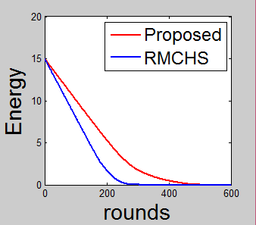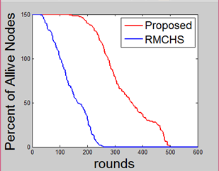
Fig.1. Energy of individual nodes Fig.2 Percentage of alive nodes in a sensor network
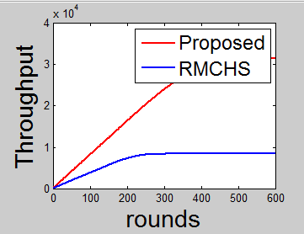

Fig.3 Throughput of the sensor network

Case 2: using 300 nodes
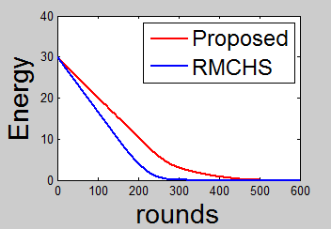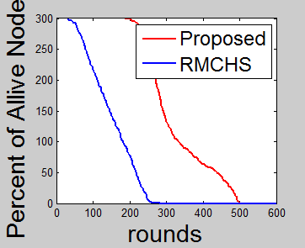
Fig. 4 Energy of individual node Fig.5 Percentage of alive nodes in a sensor network
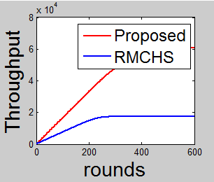

Fig. 6 Throughput of a sensor network

In the fig.1 and fig.4 results show that the same units of energy are used in more rounds in proposed work, energy is efficient and lifetime of network enhances. In the fig.2 and fig.5 results show that the percentage of alive nodes is used in network is same in more no. of rounds in the proposed work. In the fig.3 and fig.6 results show that the throughput of network is increased in the proposed work.

- CONCLUSION
The purpose of energy consumption holds it’s the highest importance due to the finite energy means. When the routing method is designed the first purpose is to retain sensors in running for possible long time and maximizing the lifespan of network. In the purposed RMCHS protocol CH selection is on the basis of energy, probability, distance whereas in the earlier RMCHS protocol CH selection is randomly on the basis of distance. The results of purposed RMCHS Protocol in terms of LEACH protocol present the minimum energy consumption and maximum lifespan of network.

REFERENCES
- Lan F. Akyildiz, Weilian Su, Sankarasubramaniam: A survey on sensor networks. In IEEE Communications Magazine, 40(8): 102.114, 2002.
- Alan Mainwaring, P. Joseph, Szewczyk.J, D. Culler, J: Wireless Sensor Networks for Habitat monitoring. In: WSNA’02, September 2002.
- M. Tubishat, Madria. S: Sensor Networks: An overview. IEEE Potentials, pp. 20-23, May, 2003.
- Valeria Loscri, S. Marano, G. Morabito: A Two Levels Hierarchy for Low Energy Adaptive Clustering Hierarchy. In: proceedings of VTC2005, pp. 1809-1813 Dallas USA, September, 2005.
- Wandi Rabiner Heinzelman, C. Anantha: “Energy efficient protocol for wireless sensor networks”. In: IEEE computer proceedings of the 33rd HICSS, Vol. 8, pp. 8020, January, 2000.
- Andrea D., Andrea Zanella, R verdone: “An energy efficient protocol for WSN”. In: proc. AINS, 2003, pp. 1-6, 2003.
- Wendi Rabiner Heinzelman, Chandrakasan Anantha, H Balakrishnan: An application specific protocol architecture for Wireless micro sensor networks: IEEE transaction on wireless communications, Vol. 1, No. 4, pp. 660-670, 2002.
- M. Para, R. Senthamil: A Survey on LEACH – Energy Routing Protocol. International Journal of Emerging Technology and Advanced Engineering, Vol. 3, Issue 12, pp. 657-660, December, 2013.
- Dr. Deepak D., H. Shivam Mehta: Analysis and Implementation of Improved – LEACH Protocol for Wireless Sensor Network. In IJCSC, IJ, Vol. 4, No. 2, pp. 8-12, September, 2013.
- Parul. B, Sheetal Mhajan: K-LEACH: An improved LEACH Protocol for lifetime improvement in WSN, In: International Journal of Engineering Trends and Technology, Vol. 4, Issue 5, pp. 1521-1526, May, 2013.
- Dongxiao Z., Cai. D: Research and Simulation of energy efficient protocol for wireless sensor network. In: proc. 2nd International Conference on Computer Engineering and Technology, Quanzhou, China, 2010.
- M. Bani Y., Al-Zou’bi.A, Khamayseh.Y and Mardini. W: Improvement on LEACH Protocol of Wireless Sensor Network (V-LEACH). International Journal of Digital Content Technology and its Applications, Vol. 3, No. 2, pp. 132-136, 2009.
- R.M. Bani, Abdalarheem A: A survey on LEACH Based Energy Aware Protocols for Wireless Sensor Networks. Published in: Journal of Communications, Vol. 8, No. 3, pp. 192-206, March, 2013.

