The FAIR Metroline - Steps for your FAIRification Workflow
March 21, 2024; 10.5281/zenodo.10850958
Contact person: Mijke Jetten, mijke.jetten@health-ri.nl

Relevance
Which steps are involved in making data FAIR? What do these steps mean and, importantly, how do you practically do these steps? The Health-RI FAIR Metroline below provides guidance to help you reach your FAIR goals. It gives an overview of steps used by a variety of publications and initiatives to reach their FAIR goals.

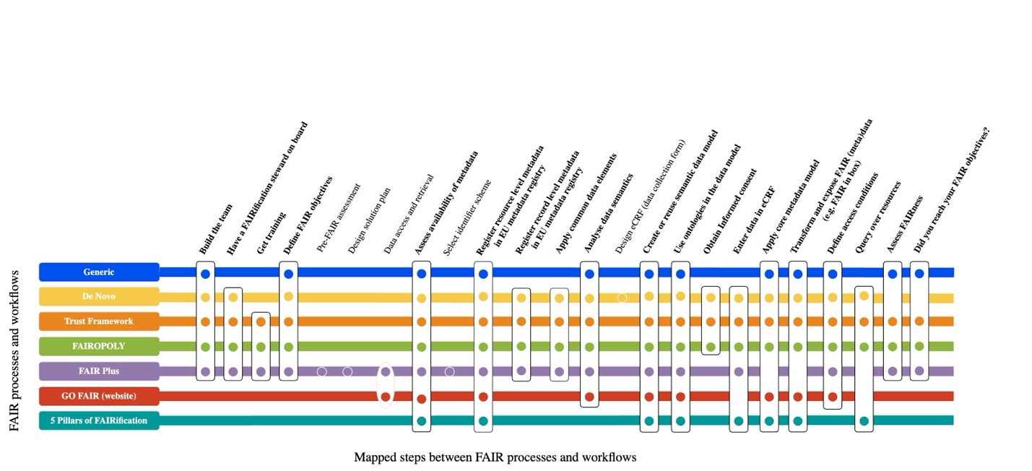

Background
The FAIR Metroline is a Health-RI initiative, together the European Joint Programme on Rare Diseases (EJP RD), which both rely on the FAIR principles to enable sustainable data reuse in the healthcare domain. The mission of Health-RI is better health for citizens and patients by reusing health data with an integrated health data infrastructure for research, policy and innovation. Recently, Health-RI has obtained a substantial grant from the National Growth Fund to establish a health data infrastructure in the Netherlands. At Health-RI, we strongly believe in the power of collaboration. We bring together all relevant parties, including healthcare professionals, policymakers, patient organizations, researchers, and industry, including a close-knit network of regional nodes (Nodes) in collaboration with a central point (Hub).

Aim
By properly describing what all of these steps entail and adding practical how-tos, the FAIR Metroline can be used to help a.o. researchers and data stewards make data more FAIR. The steps also provide guidance for a broad audience to onboard of (meta)data to the Health-RI Dutch National Health Data Catalogue. Since work on the health data infrastructure will ongoing for the years to come, the joint transformation of the FAIR Metroline to a set of practical workflows is an agile process.

Past work
Creating Findable, Accessible, Interoperable and Reusable (FAIR) data differs from project to project based on goals and domain requirements. For the Health-RI mission, it is essential to synchronise the various procedures and processes involved in FAIRification.
- A set of FAIRification workflows was mapped to understand the divergence among them and identify critical common FAIRification and domain-specific steps
- These workflows (see below) were selected based on workflows described by FAIR demonstrators, by workflows containing FAIRification steps and not only Research Data Management steps, and ny workflows published in scientific communication or endorsed by a University Medical Center
- A group of EJP RD and Health-RI experts was formed to analyse the workflows (content, nameing, subtasks, frequency). Any steps that were mapped in more than four workflows were considered critical (indicated in bold in the above FAIR Metroline image)
- Preliminary results show three critical steps:
  - Identification of FAIRification objectives and expertise. This can impact the success of the FAIRification of projects
  - (Meta)data assessment, definition and semantic modelling. These are intrinsically related to the core of the FAIR principles: semantic interoperability and machine actionability of (meta)data
  - Defining data licensing (or consent), access and use conditions. These are equally crucial for healthcare data reuse as they protect sensitive information

Current work
The FAIR Metroline contains many steps. Depending on a project and its FAIR objectives only a select number of steps may be relevant. Thus, each project will have its own workflow. To support projects to be able to implement the FAIR Metroline steps, joint Hub-and-Nodes collaborative work is ongoing to add for each step detailed how-to descriptions and real-life examples of process steps, based on the below template with references to existing resources and best practices. This includes collaboration with the health domain funders and their efforts to stimulate to incorporate FAIR into projects from the start.

Current work includes identifying and analysing domain-specific steps and detailing each critical step into recommended resources, checklists and needed expertise. Any training needs regarding the FAIR expertise capacity can then be identified from such descriptions. We expect that embedding critical FAIR steps in the national research infrastructure can improve FAIR data availability.

Currently (status March 2024) work on the FAIR Metroline can be found here, but since we work agile the location could change in the (near) future. Another place to look for information is the main Health-RI wiki. For both, navigate the left bar page content information. If you are curious but aren’t able to locate the FAIR Metroline, contact the Health-RI servicedesk.

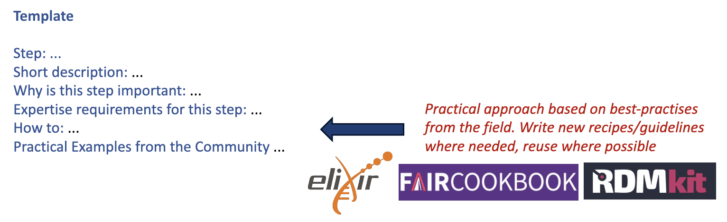

Models
- Generic
- De Novo
- Trust Framework (unpublished)
- FAIRopoly
- FAIR Plus
- GO FAIR
- 5 Pillars of FAIRification (unpublished)

Acknowledgements
Part of the information in this document is based on the following poster publication: Critical Steps towards Large-Scale Implementation of the FAIR Data Principles. We thanks all people who have contributed so far, including the Health-RI FAIR coordinators in the Nodes and their Node positioned data stewards. Did you contribute and you want your name added? Contact Health-RI (see details in top).

