Original Paper
Endoscopic Modified Lothrop procedure for recurrent frontal sinus disease
Garba Mainasara Mohammed¹*
Citation: First and Last Name Initials of the Authors.
Academic Editor: Dr. Sale Danjuma
Received: date: 2024
Revised: date: 2024
Accepted: date: 2024
Published: date:2024

Copyright: © 2024 by the authors. Submitted for possible open access publication under the terms and conditions of the Creative Commons Attribution (CC BY) license (https://creativecommons.org/licenses/by/4.0/).
¹ Department of surgery, College of Medicine, Kaduna state university
* Correspondence: mgmainas@yahoo.com; Tel.: +2348170000424 (Garba Mainasara Mohammed)
Abstract: Background
Endoscopic modified Lothrop has been a procedure of choice especially in recurrent frontal sinus disease but must centers in Sub Saharan Africa still practice open approach to manage frontal sinus disease.
Objective
To show the long-term outcome of endoscopic modified Lothrop procedure.
Methods
Review of patients that underwent endoscopic modified Lothrop in two institutions by single surgeon from January 2013 to December 2023. Patients’ demographic data, symptoms, indications and outcome were analyzed.
Results
Thirty-two patients underwent Endoscopic Modified Lothrop with an average age of 41.2 years, ninety two percent have favorable outcome, three patients were lost to follow up
Conclusions
Endoscopic Modified Lothrop procedure gives better outcome with less morbidity better cosmesis and less hospital stay, no recurrence as compared to an open external approach.
Keywords: Recurrent, frontal sinus, Endoscopic, Modified Lothrop

1. Introduction
Managing disease of frontal sinuses has been a challenge to surgeons for a long period of time especially those practicing in low resource settings. The inaccessibility of the frontal sinuses through the nose and close proximity of the anterior cranial fossa and in part to the complicated anatomy and variations found in the frontal recess makes it difficult to manage lesions in that area.^{1,2} Previously, the standard for management of frontal sinus disease was often an external approach such as the Lynch-Howarth frontoethmoidectomy or the osteoplastic flap (OPF) this approach has been cited as having high rate of recurrence (30%) and post-operative complications.^{3,4}
Lothrop’s in 1914 description of his technique consisted of an intranasal ethmoidectomy followed by an external Lynch type approach with resection of the medial frontal sinus floor, superior nasal septum, and intersinus septum creating a large frontonasal communication.⁵ Lothrop reported that intranasal approach to his procedure was too dangerous because of lack of visualization.
With recent advent of sinus endoscopes and functional endoscopic sinus surgery, disease can be removed from frontal recess of the ethmoid in most cases, thereby relieving the blockage of drainage of the frontal sinus.⁴
Material and method
Study design
This is a prospective study of all consented patients undergoing Endoscopic modified Lothrop from January 2013 to December 2023 by single surgeon in Kaduna North western Nigeria.
Study population
The operating surgeon serves three major hospitals within the city and also gets referral from other states but majority of the cases were done in a private facility equipped with navigation system.
Data collection: Data was collected using a proforma. Patient demographics, presenting complaints, previous paranasal surgeries, comorbidities, intraoperative findings and clinical outcome were studied.
Majority of the patients had previous sinus surgery but presented with recurrence of the disease, maximal medical therapy was instituted for chronic rhinosinusitis consisting of intranasal steroids, nasal irrigation and culture related antibiotics and all patients had CT scan paranasal sinuses prior to surgical intervention.
Intraoperative image guidance with Stryker Nav II was used in revision cases with standard endoscopic sinus surgery instruments and high-definition camera system
One of the patients was a 58-year-old lady with a large frontal mucocele who presented with 3 years history of frontal headache, and a slow growing painless mass on the right side of her forehead who had nasal surgery 8 years ago, no nasal blockage, nasal discharge or visual disturbance and no comorbidities. Examination revealed a right sided non tender frontal swelling measuring 10 by 8cm not freely mobile CT scan shows a non-enhancing mass in the right frontal sinus area with destruction of the anterior table of the frontal sinus and little destruction of the posterior table. Patient consented for endoscopic modified Lothrop based on the history of recurrent frontal sinus disease and she was worked up for the procedure and informed and understood consent was taken.

Surgical technique for mucocele
Surgery was performed with patient in supine position under general anesthesia, nose was decongested and the lateral nasal wall and anterior roof of the nose were infiltrated with 2% Lignocaine with 1:80 000 adrenaline
The surgical procedure was performed using zero- and seventy-degree endoscope. After ensuring adequate nasal preparation, major land marks such as agger nasi and frontal ethmoid cells, the floor of the mucocele were identified and opened by frontal sinus punches. The content of the mucocele was removed by suction fig2, the floor of the mucocele was further resected. The anterior-upper portion of the middle turbinate was removed up to the frontal sinus floor. The superior nasal septum anterior to the nasofrontal isthmus was also resected. These procedures permit broad visualization of the operative area. The perpendicular plate of the ethmoid was removed anteriorly to the frontal sinus floor, taking care to preserve the mucosa in the lateral wall of the frontal recess or frontonasal duct . The frontal sinus floor was removed by a drill anteriorly and medially to the frontonasal isthmus. The removal of the frontal sinus floor was continued until the opening of the frontal sinus floor reached to the contralateral middle turbinate.

Results
Thirty-two patients were included in this study with mean age of 41.2 years (range 18-61) with male to female ratio of (1.29:1). Twenty eight (28) patients had prior sinus surgery 25 endoscopic and 3 external approach and the mean follow up time was 20.1 months. Surgical indications include chronic frontal sinusitis 51%, Chronic rhinosinusitis with nasal polyps 36%, chronic rhinosinusitis without nasal polyps 8%, osteoma 5%. Preoperative major symptoms were resolved after endoscopic modified Lothrop procedure and no patient requires revision surgery after EMLP.

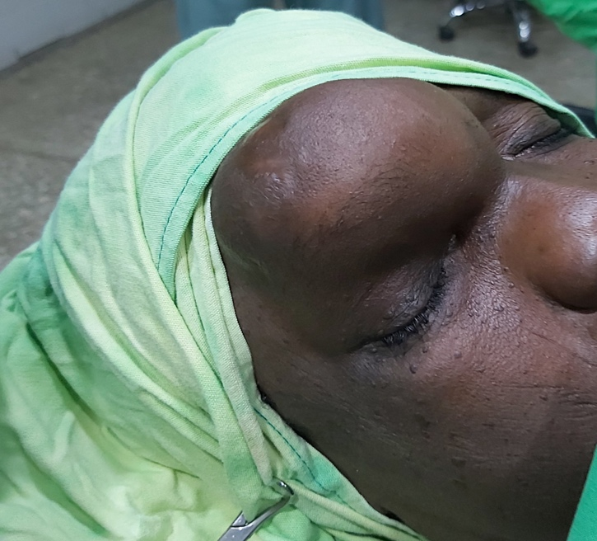
Fig 1. showing large frontal mucocele

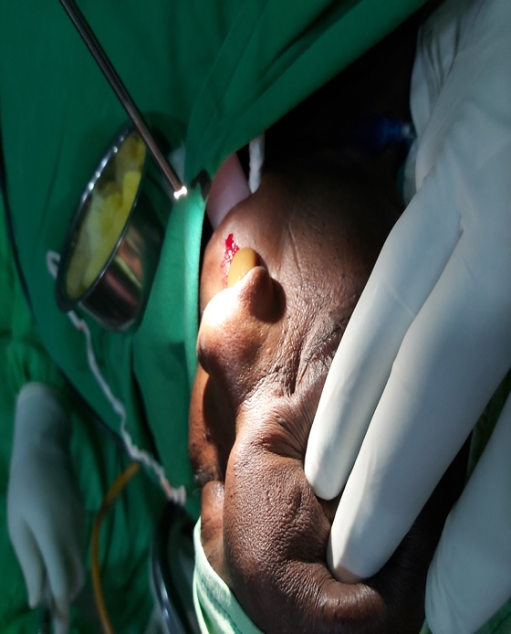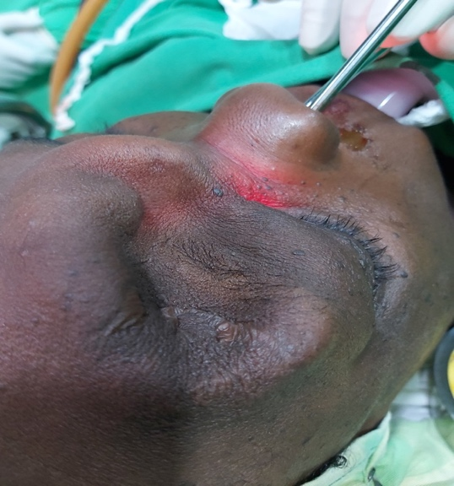
Fig 2 showing the content of the mucocele Fig 3 Showing collapse of the mucocele
After establishing drainage

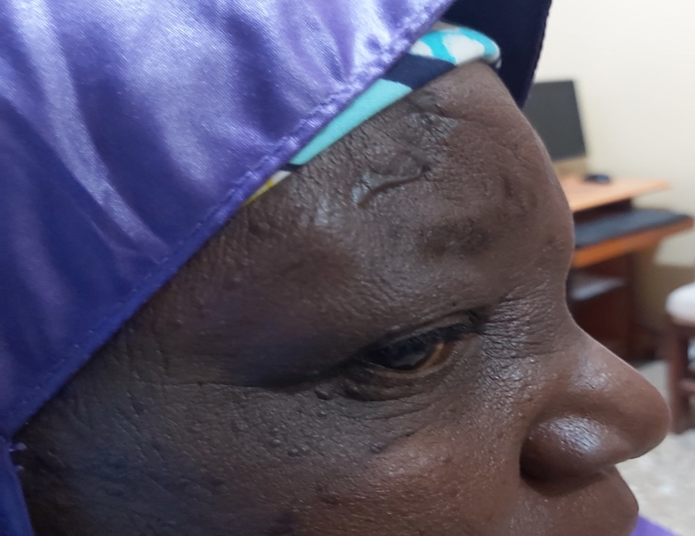

Fig 4: Three weeks post-operative

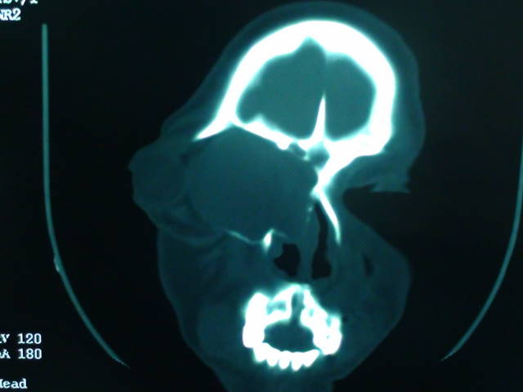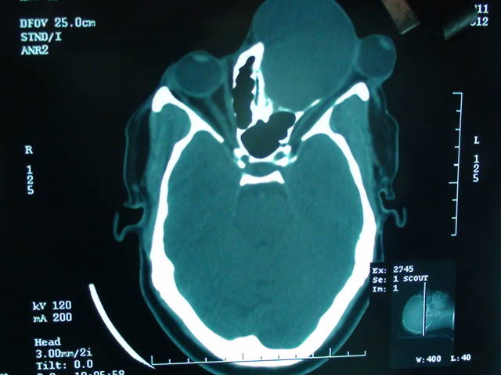
Fig 5: coronal scans showing huge mucocele. Fig 6: Axial scan showing a huge mucocele
displacing the left eye ball lateral compressing on the optic nerve

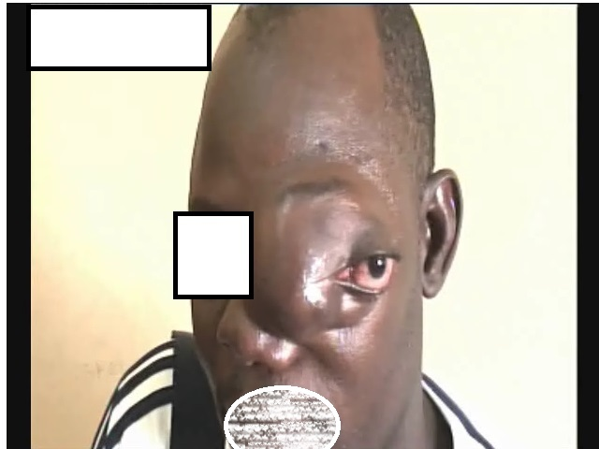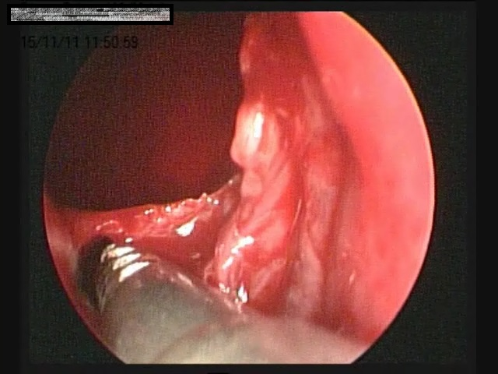
Fig 7: Preoperative picture of the patient Fig8: Intraoperative endoscopic view

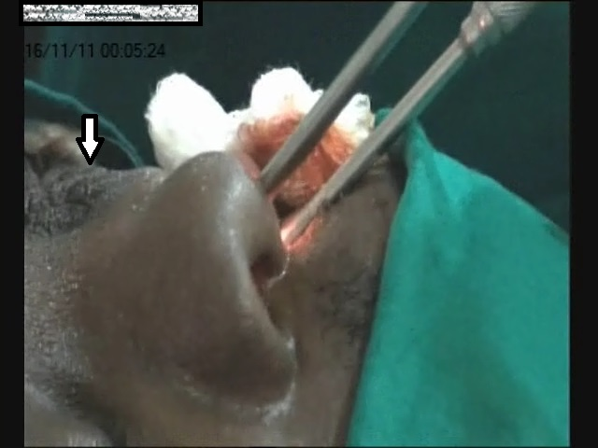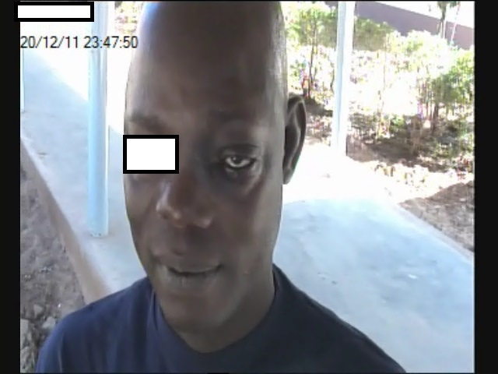
Fig 9: Arrow showing collapsed mucocele Fig10: 10days post operative

Discussions
The first-line management for chronic frontal sinusitis is endoscopic clearance of the frontal recess with established techniques. Removal of diseased frontoethmoidal cells in most patients restores aeration and mucociliary drainage of the frontal sinus⁶ . for recurrent frontal sinus diseases endoscopic modified Lothrop will provide wider drainage of the frontal sinus.
Restoring the drainage of the frontal sinuses through an endoscopic modified Lothrop can avoid some of the significant morbidity associated with the osteoplastic flap and obliteration. One of the difficult clinical problems that can occur after osteoplastic flap with obliteration is continued frontal pain. Between 6% and 10% of osteoplastic flaps with obliteration fail as a consequence of mucocele formation or sepsis of the implanted fat, and whether there is ongoing sepsis in the fat is often a difficult clinical decision because conventional radiology (CT and magnetic resonance imaging) may have difficulty separating infected from fibrosing fat.7 It provides many advantages over the osteoplastic frontal sinus obliteration for patients with severe persistent frontal sinusitis, also offers the patient less invasive procedure with a shorter hospital stay, less pain and improve cosmesis with no facial scar. External approach requires stenting for seven to nine days while endoscopic modified Lothrop requires no stenting of the frontal sinus.⁸ Endoscopic modified Lothrop is a technically demanding operation that should not be attempted by surgeons who have not been trained because of vital structures around the frontal sinus drainage pathway. In some studies, the presence of eosinophilic mucin, allergic fungal sinusitis and recalcitrant S. aureus on the rate of frontonasal restenosis in chronic rhinosinusitis patient.⁹ Adequate post op care with thorough nasal irrigation, antihistamine and culture-based antibiotic will reduce the chances of scarring, polyp recurrence, osteogenesis associated with blockage of frontal sinus and surgical failure. Due to the adequate post-operative care and regular follow-up to ensure compliance no patient require revision surgery.

Conclusions
Endoscopic modified Lothrop procedure ensures long lasting frontonasal patency with major symptoms relief; however, this can only be achieved with proper training and instrumentations.
Conflict of Interest
None to declare

References
- Casiano RR, Livingston JA. Endoscopic Lothrop procedure: the University of Miami experience. Am J Rhinol 1998;12: 335–339.

- Becker DG, Moore D, Lindsey WH, Gross WE, Gross CW. Modified transnasal endoscopic Lothrop procedure: further considerations. Laryngoscope 1995;105:1161–1166.

- Becker DG, Moore D, Lindsey WH, Gross WE, Gross CW. Modified trans- nasal endoscopic Lothrop procedure: further considerations. Laryngo- scope 1995;105:1161–1166

- Rice DD: Chronic frontal sinus disease Otolaryngol Clin North Am 26.619-622, 1993

- Lothrop HA: Frontal sinus suppuration Ann Surg 59:937-957, 1914

- Gross WE, Gross CW, Becker D, Moore D, Phillips D. Modi- fied transnasal endoscopic Lothrop procedure as an alter- native to frontal sinus obliteration. Otolaryngol Head Neck Surg 1995;113:427–434.

- Wormald: Salvage Frontal Sinus Surgery Laryngoscope, 113:276–283, 2003

- Iseh, K. R. (2010). Endoscopic and external surgical approach to paranasal sinus mucocele. Journal of Surgical Technique and Case Report. https://doi.org/10.4103/2006-8808.63728

- Tran KN, Beule AG, Singal D, et al. frontal ostium restenosis after endoscopic modified Lothrop procedure. Laryngoscope 2007;117:1457. [pubmed]

