6S RNA plays a role in recovery from nitrogen depletion in Synechocystis sp. PCC 6803

Beate Heilmann, Kaisa Hakkila, Jens Georg, Taina Tyystjärvi, Wolfgang R. Hess, Ilka M. Axmann, Dennis Dienst

Table S1
Sequences of primers used for construction and PCR-based verification of ΔssaA- and HIS-mutant strains, as well as for PCR-based generation of riboprobe templates. The T7 promoter sequence is each underlined. Oligonucleotides used for DNA 5´end-labeling.
Name | Sequence (5´- 3´)
Primer
ΔssaA_700up_fw (P1) | caccgcctaccctgaatatctg
ΔssaA_700down_rv (P2)  slr1288_fw (P3)  3´slr1288_rv (P4)  Km_fw (P5)  Km_rv (P6)  sll1166_fw (P7)  3´sll1166_rv (P8) | Caaggaattagaccgcatcgg  GGAGCCCCTAAGCCGTACC  CCTGCCATTATAACCCCATCCTTCG  GGTTATAATGGCAGGGGGGGGGGGGGGAAAGC  ACCTGAGAAGCAGAGCCGTCCCGTCAAGTCAGCGTAAT  CTCTGCTTCTCAGGTTTATCCCTCC  GGTAGATACCCTGGTCATTCTGGTTTTG
rpoC1His5 | GAGGTCATCAAAACCGAGGA
rpoC1His6 | CAAAGGGAGCAGGATCAAAA
6803ssaA-FwS  T7-6S_6803_rev  5S_6803_fw  T7-5S_6803_rev  SyR11_fw | GAAGTAACTACCGCGTTGGTGACTG  TAATACGACTCACTATAGGGAGAAGCACCACCACGCCG  TCTTGGTGTCTTTAGCGTCATGGAAC  TAATACGACTCACTATAGGGACTTGGCATCGGACTATTGTGC  AACGAAATAACACGGGGTCAC
SyR11_T7_rev | TAATACGACTCACTATAGGGacaattttaaagggatcaag
Oligonucleotides
5S rRNA-Oligo | GCATCGGACTATTGTGCCGTG
6S RNA-Oligo | caccacgccgttttacct

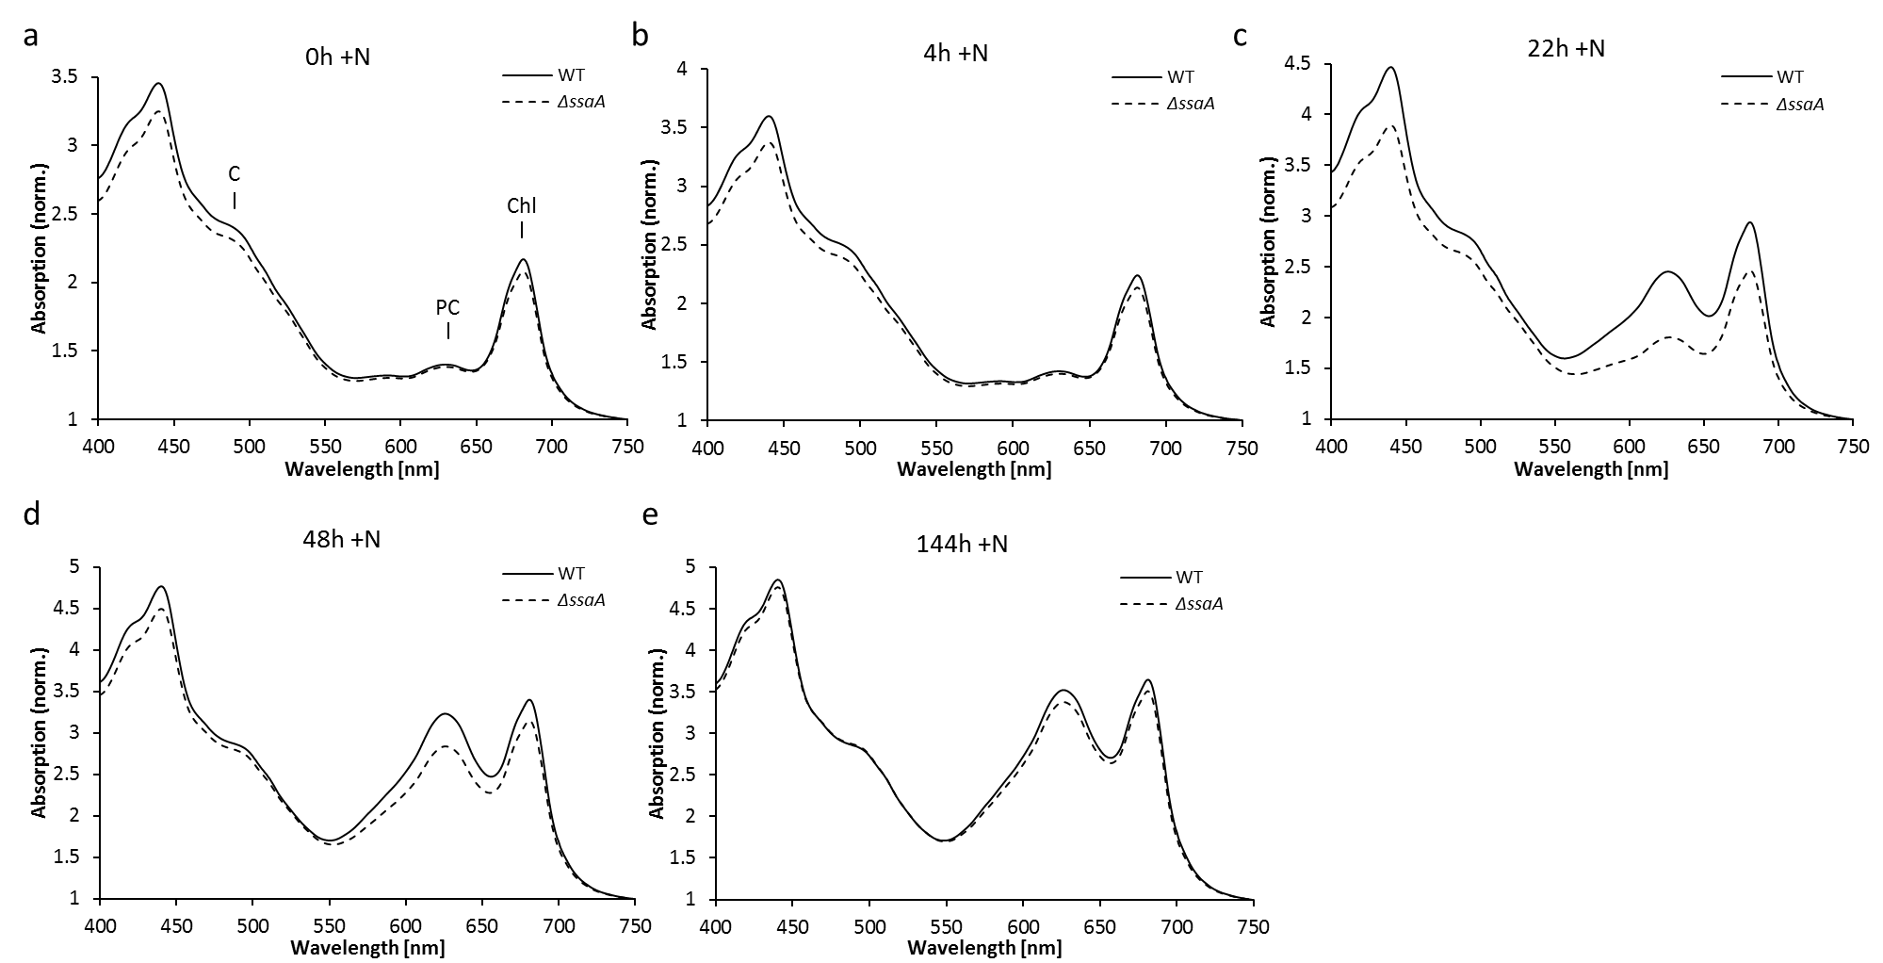

Figure S1
Pairwise comparison of whole cell absorbance spectra of Synechocystis 6803 WT and ΔssaA strain shown in Fig. 2c. Cultures were grown under continuous white light at an irradiance of 80 µmol photons m⁻² s⁻¹, at 30 °C, in nitrogen-depleted medium for 189 hours before recovery was initiated by adding nitrogen. Whole cell absorbance spectra were measured at nitrogen deficiency for 189h (t= 0h +N; (a)) and at recovery time points t= 4h, (b); t= 22h, (c); t= 48h, (d) and 144h (+N), (e). The spectra were normalized at 750 nm. C: carotenoids; PC: phycocyanine; Chl: chlorophyll a

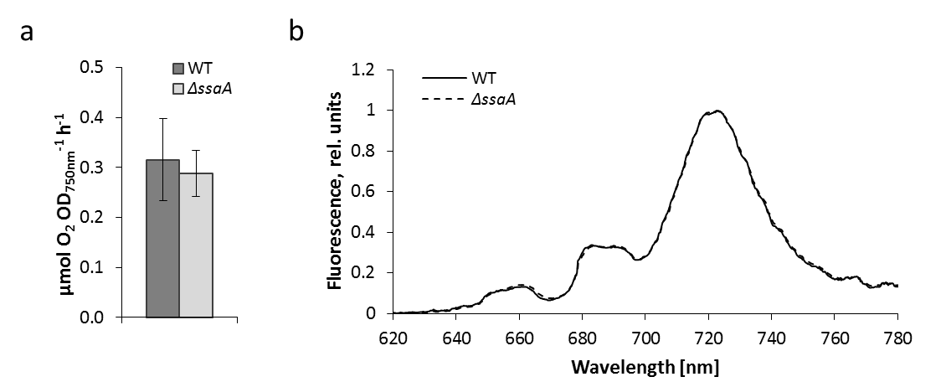
Figure S2
Photosynthetic parameters of wild type (WT) and ∆ssaA mutant during nitrogen starvation. (a) Oxygen evolution rates of photosynthesis examined in vivo at time point t= 72h -N under light-saturated conditions (3000 µmol photons m⁻² s⁻¹). Three technical replicates were measured of two independent biological replicates of each strain. The error bars represent the standard deviation (SD). (b) Orange light-excited fluorescence emission spectra of WT and ∆ssaA mutant measured at 77 K under nitrogen deficiency at time point t= 96h -N. Three independent biological replicates were measured and the spectra were normalized by dividing by the peak value of PSI at 721 nm and setting this value to 1.

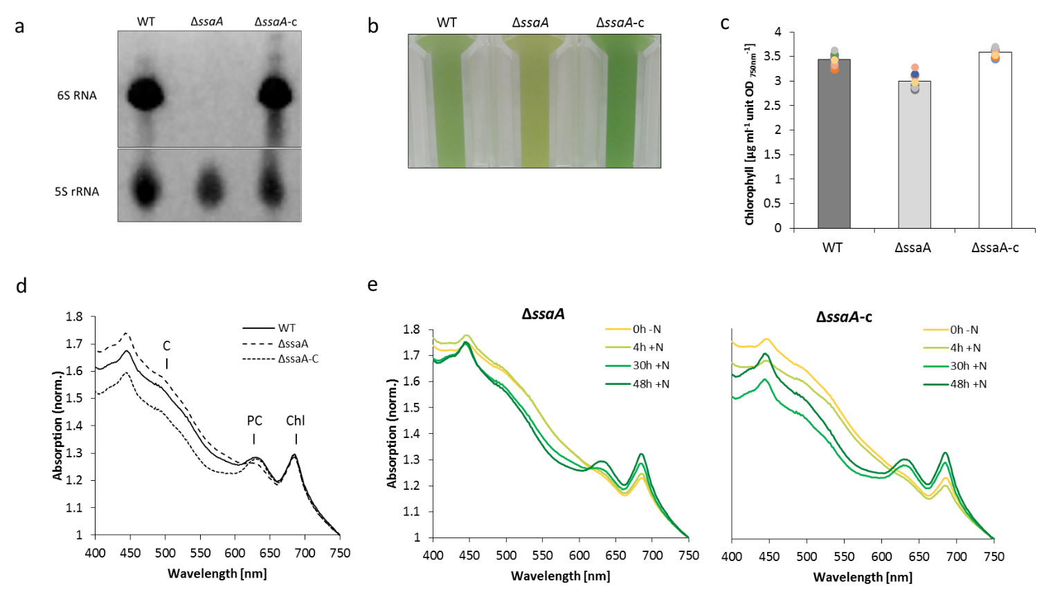
Figure S3
Verification of the genetic complementation of ssaA gene disruption. (a) Complementation of ssaA deletion in strain ΔssaA-c was confirmed by Northern Blot analysis. Each 5 µg of total RNA isolated from Synechocystis 6803 WT, ΔssaA and ΔssaA-C were separated by urea-PAGE and transferred to a positively charged nylon membrane. Hybridization of 6S RNA and 5S rRNA (loading control) was performed using DIG-labeled riboprobes. (b – e) Comparative physiological characterization of WT, ΔssaA and ΔssaA-C during recovery from nitrogen starvation. Cultures were grown at 30 °C in shaking flasks at an irradiance of 40 µmol photons m⁻² s⁻¹. (b) Photograph of cultures of WT, ΔssaA and ΔssaA-C strain at time point 30h +N during recovery. (c) Chlorophyll a content of the cultures at recovery time point 30h +N. The bars in the illustrated diagram represent the mean from three replicate cultures that were each measured in triplicate (n= 9). Additionally, the single values are illustrated separately as colored dots in the diagram. (d) Comparison of whole cell absorption spectra of WT, ΔssaA and ΔssaA-C strain at recovery time point 30h +N. C: carotenoids; PC: phycocyanine; Chl: chlorophyll a. (e) Absorbance spectra of ΔssaA and ΔssaA-C mutant strains are illustrated for the time point t= 0h +N, which corresponds to 188h under nitrogen deficiency (-N) and for the time points t= 4, t= 30 and t= 48 hours after nitrogen addition (+N). The spectra were normalized to the optical density at 750 nm.

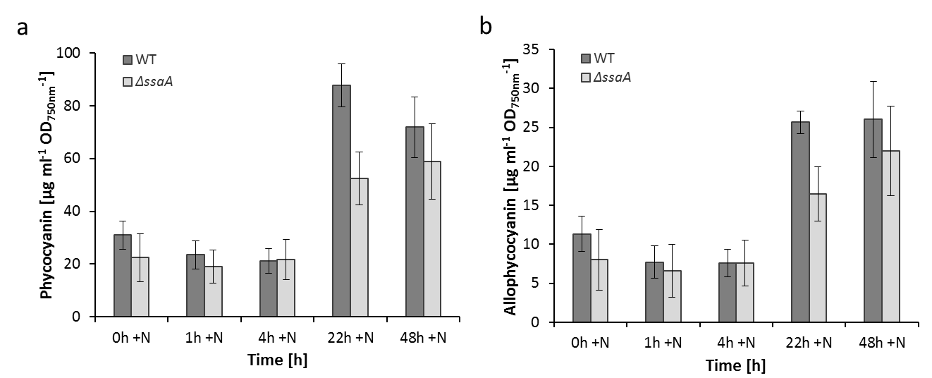
Figure S4
Pigment analysis of WT and ΔssaA. Phycocyanin (a) and allophycocyanin (b) were measured from the soluble protein fraction 158h under nitrogen deficiency (t= 0h +N) and at recovery time points t= 1h +N, t= 4h +N, t= 22h +N and t= 48h +N. The data illustrate the mean from three independent biological replicates and the error bars represent the SD.

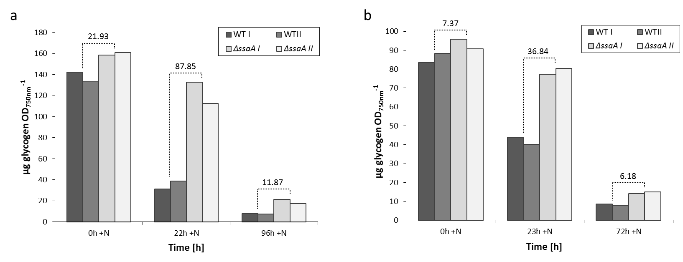
Figure S5
Glycogen consumption during recovery from nitrogen starvation. Glycogen content was determined for two independent experimental setups ((a) and (b)) in which Synechocystis 6803 WT and ΔssaA were cultivated in nitrogen-depleted medium for at least 6 days before recovery process was induced by transferring cells to NaNO₃-supplemented medium. (a) Corresponding data of the microarray analysis (Figs. 5 and 6), originating from the same experimental cycle. Glycogen content was measured after 7 days under nitrogen deficiency (0h +N) and during recovery at time points 22h and 96h +N. (b) Cells were cultivated under nitrogen deprivation for 6 days (0h +N) before recovery was triggered by nitrogen addition. Glycogen content was analyzed at recovery time points 23h +N and 72h +N. Two biological replicates of each strain were analyzed, named as I and II, respectively. The average difference for each time point is indicated by the values above the bars.

Figure S6
Volcanoplot showing the gene expression differences in WT and ΔssaA after prolonged nitrogen depletion and before nitrogen re-addition (t₁= 0h +N). Significantly differentially expressed RNA features (|log2 FC| ≥ 1, adj. p-Value ≤ 0.05) are drawn as black points. For detailed data see supplementary files 2 and 3.

Figure S7
Expression patterns of transcripts with significantly altered levels in the ΔssaA mutant strain at early recovery from nitrogen depletion. Total RNA from the sampling time point t₂= 1h +N was subjected to microarray analysis. The scatter plot shows the nitrogen recovery response in ΔssaA (x-axis) versus the response in WT (y-axis) for t₂= 1h +N in comparison to the 0h time point (see Fig. S6 for comparison). Significantly differentially expressed RNA features (|log2 FC| ≥ 1, adj. p-Value ≤ 0.05) are drawn as black points. Points beyond the transverse black lines indicate a different response to the recovery (|(WT xh – WT 0h) – (ΔssaA xh – ΔssaA 0h)| ≥ 1). Selected functional groups regarding to the Cyanobase GO classification are color coded. The nitrogen/ammonium transport group was defined manually and contains nrtA, nrtB, nrtC, nrtD, glnH, sll0536, amt3, amt2, amt1 and amiC. Differentially expressed asRNAs and sRNAs are indicted by a grey or orange border. See also Figs. S8 and S9. For detailed data see supplementary files 2 and 3.

Figure S8
Expression patterns of transcripts with significantly altered levels in the ΔssaA mutant strain at recovery from nitrogen depletion. Total RNA from the sampling time point t₃= 4h +N was subjected to microarray analysis. The scatter plot shows the nitrogen recovery response in ΔssaA (x-axis) versus the response in WT (y-axis) for t₃= 4h +N in comparison to the 0h time point (see Fig. S6 for comparison). Significantly differentially expressed RNA features (|log2 FC| ≥ 1, adj. p-Value ≤ 0.05) are drawn as black points. Points beyond the transverse black lines indicate a different response to the recovery (|(WT xh – WT 0h) – (ΔssaA xh – ΔssaA 0h)| ≥ 1). Selected functional groups regarding to the Cyanobase GO classification are color coded. The nitrogen/ammonium transport group was defined manually and contains nrtA, nrtB, nrtC, nrtD, glnH, sll0536, amt3, amt2, amt1 and amiC. Differentially expressed asRNAs and sRNAs are indicted by a grey or orange border. See also Figs. S7 and S9. For detailed data see supplementary files 2 and 3.

Figure S9
Expression patterns of transcripts with significantly altered levels in the ΔssaA mutant strain at recovery from nitrogen depletion. Total RNA from the sampling time point t₄= 22h +N was subjected to microarray analysis. The scatter plot shows the nitrogen recovery response in ΔssaA (x-axis) versus the response in WT (y-axis) for t₄= 22h +N in comparison to the 0h time point (see Fig. S6 for comparison). Significantly differentially expressed RNA features (|log2 FC| ≥ 1, adj. p-Value ≤ 0.05) are drawn as black points. Points beyond the transverse black lines indicate a different response to the recovery (|(WT xh – WT 0h) – (ΔssaA xh – ΔssaA 0h)| ≥ 1). Selected functional groups regarding to the Cyanobase GO classification are color coded. The nitrogen/ammonium transport group was defined manually and contains nrtA, nrtB, nrtC, nrtD, glnH, sll0536, amt3, amt2, amt1 and amiC. Differentially expressed asRNAs and sRNAs are indicted by a grey or orange border. See also Figs. S7 and S8. For detailed data see supplementary files 2 and 3.

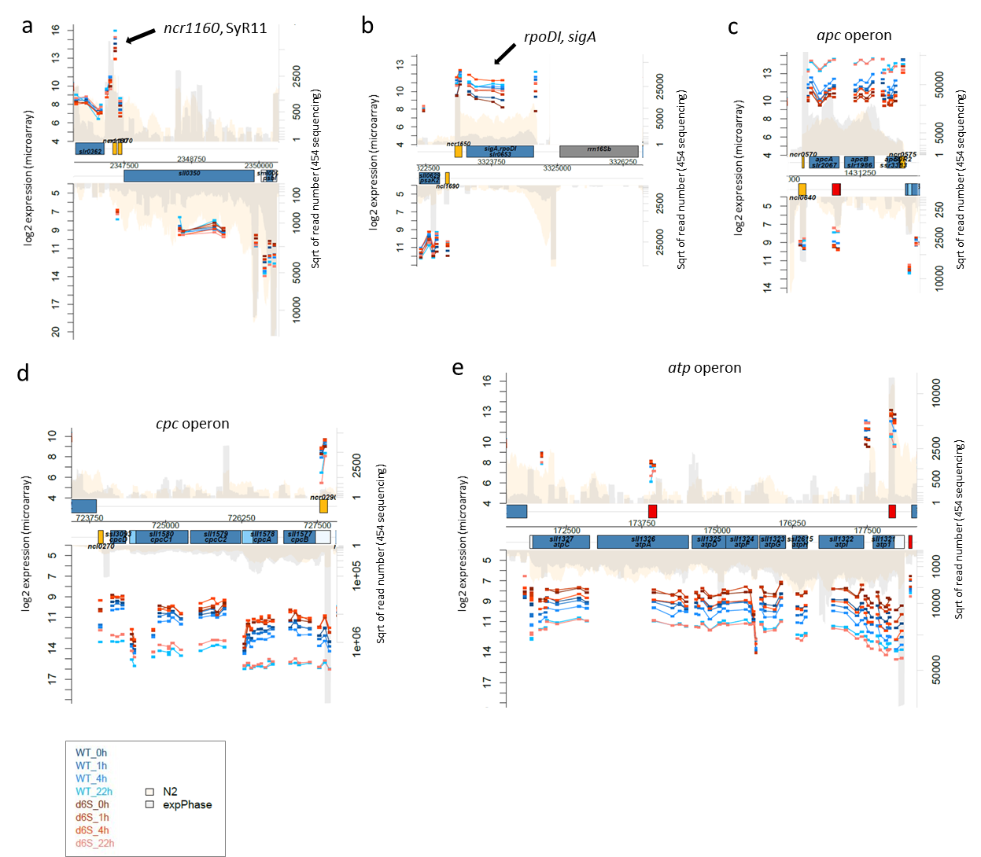

Figure S10
Microarray data analysis showing exemplary details of gene expression in Synechocystis 6803 WT and ∆ssaA strain (depicted as d6S) at time points t₁=0h +N (7d –N); t₂=1h +N, t₃=4h +N and t₄=22h +N. The following genome sections are pictured: (a) SyR11 gene (ncr1160; indicated by a black arrow), (b) sigA gene (rpoDI; indicated by a black arrow), (c) Allophycocyanin genes (apcA and apcB) and phycobilisome small linker polypeptide (apcC), (d) Phycobilisome small rod linker polypeptide genes (cpcD, cpcC1, cpcC2) and genes encoding for phycocyanin α subunit (cpcA) and β subunit (cpcB) and (e) ATP synthase gene operon (genes atpC, atpA, atpD, atpF, atpG, atpH, atpI, atp1).

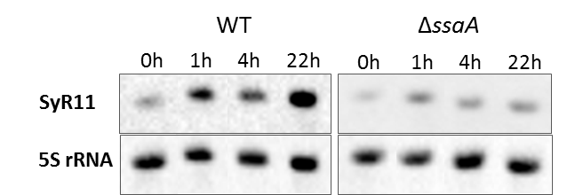

Figure S11
Validation of Microarray data analysis. Expression of SyR11 in Synechocystis 6803. Verification experiment for the accumulation of SyR11 transcript levels at time points t₁= 0h, t₂= 1h, t₃= 4h and t₄= 22h +N. 2µg RNA were subjected to Northern blot hybridization using a digoxigenin-labeled RNA oligonucleotide specific for SyR11. 5S rRNA was probed as a loading control.

