ANTIOXIDANT, ANTIMICROBIAL AND ANTITUMORAL EFFECTS OF STACHYS ANNUA (L.) L. SUBSP. ANNUA VAR. ANNUA IN COMPARATIVE CANCER PROFILES
Merve Alpay*, Gorkem Dulger & Ersin Karabacak
*Department of Biochemistry, Faculty of Medicine, Duzce University, 81620
Department of Medical Biology, Faculty of Medicine, Duzce University, 81620
Department of Biology, Faculty of Science and Art, Canakkale Onsekiz Mart University, 17100

 | Abstract
Keywords:  Stachys annua subsp. annua var. annua, antioxidant activity, antitumoral effect, antimicrobial activity, folk medicine. | The genus Stachys (Lamiaceae) have been used for the treatment of folk medicine. This study was carried out with an objective to investigate the in vitro antimicrobial, antioxidant and antitumor effects of leaves of Stachys annua subsp. annua var. annua. The antimicrobial activity of ethanol extract (75µL) of leaves of S. annua subsp. annua var. annua was evaluated for potential antimicrobial activity against some bacterial and fungal isolates obtained from hospital. Antimicrobial susceptibility testing was determined with using the disc diffusion method according to the protocol applied by CLSI. The results showed that the ethanol extract revealed similarly effect against bacteria as compared to standart antibiotics. But, the extract showed slightly effect against Candida species. Also, we used HeLa and PC3 cells to test anticancerogen effect on urinary system. The cells were cultured for ATCC protocol. After application of extract dilution, we analyzed MTT assay for viability detection at 570 nm. Based on cytotoxicity value, optimal concentration were evaluated at 50uM. The potency of cell growth inhibition for each extract was expressed as IC50 value. According to datas, we showed that antioxidant activity of this plant have significantly increased. Stachys annua (L.) L. subsp. annua var. annua may evaluated in advanced pharmacological studies for distinct features
Introduction
The genus Stachys (Lamiaceae) is represented by 93 species and 57 of the 118 taxa are endemic in Turkey. Plants of this genus have been used for the treatment of cold, cough, diarrhea, urinary system disorders, hypertension, throat pain and as an antipyretic or stomachic in folk medicine (1). Stachys annua (L.) is widely distributed in the middle and western regions in Turkey. Among the local people, Stachys annua subsp. annua var. annua is known as “haciosmanotu” or “dag cayi” and the leaves of this plant are used in the treatment of colds and diabetes among people (2)

Flavonoids have been known for centuries as plant pigments. Flavonoids are polyphenolic compounds and are phytochemicals that are popular due to antioxidant and free radical scavenger effects. Phytochemicals have effects such as detoxifying enzyme activation, immunostimulatory, gene expression related to cell proliferation and apoptosis, hormone metabolism, antibacterial and antiviral (3) Researchers have determinated that the Stachys annua subsp. annua var. annua has various amounts phytochemical contents such as protocatechuic, p-hydroxybenzoic, chlorogenic, ferulic, benzoic, rosmarinic acids, (+)-catechin, (−)-epicatechin, rutin, and apigenin (2).

Recently, multiple antibiotic resistance has emerged as a major public health that threatens human life. There is increasing need for new effective antimicrobial agents. Plant materials are considered as one of the most promising sources by many researchers (4). Also, Cancer deaths will continue to increase and 12 million deaths will cause cancer in 2030 all over the world. Natural compounds have been used extensively in the treatment of many diseases including cancer and are of interest to researchers both in their natural forms and as templates for synthetic modification (5) (Balkan B. The Effects of Vitamin E on Antioxidant Enzyme Activity in HepG2 Cells) Sample sources and molecular mechanisms are highly important in the development of novel, clinically useful anticancer agents for treatment. Numerous cancer research studies have been conducted using traditional medicinal plants in an effort to discover new therapeutic agents that lack the toxic side effects, drug costs and safety associated with current chemotherapeutic agents (6).

The present study was designated to evaluate the antimicrobial, antioxidant and antitumoral activity of the Stachys annua subsp. annua var. annua ethanol extract.

Material and methods

Plant Material
Aerial parts of the plant were collected from Duzce/Turkey during the flowering stage in July, 2017, and taxonomically identified by Assoc.Prof. Ersin KARABACAK, senior taxonomist from the Department of Biology, Canakkale Onsekiz Mart University. Voucher specimens of the plant were deposited at Duzce University.

Preperation of extract
The leaves of the plant were dried and powdered. Each dry powdered plant material (20 g) was extracted with 180 mL of 99% ethanol (Merck) for 12 h by using Soxhlet equipment. The extract was filtered using Whatman fitler no.1 and the filtrate solvent was evaporated under vacuum using a rotary evaporator at 55°C (yield: 14.12% for ethanol). The resulting dried extract was stored in labeled sterile screw-capped bottles at -20°C. The extract (in the form of sticky black substances) amounting to arround 2 g was dissolved in 0.1 mL. of DMSO (5 mg/mL) (dimethyl sulfoxide) before testing.

Test Microorganisims
All test microorganisims (Staphylococcus caprae, S. epidermidis, S. pettenkoferi, S. captis, Acinetocabter baumannii, Klebsiella pneumoniae, Escherichia coli, Serratia marcescens, Candida tropicalis, C. guilliermondii, C. albicans, C. glabrata), used in this study, obtained from obtained from the Microbiology Laboratory in Duzce University Hospital.

Disc Diffusion Method
The paper disc diffusion method was employed (7). Sterile 6 mm disc filter paper disc (Schleicher and Schul, 2668, Dassel, Germany) were impregnated with 75 μL of the plant extracts. The bacterial cultures were inoculated on Nutrient Broth (Oxoid) and incubated for 24 h at 37±0.1°C, while the yeast cultures were inoculated on Malt Extract Broth(Oxoid) and incubated for 48 h at 28±0.1°C. Adequate amounts of Mueller Hinton Agar (Oxoid) were dispensed into sterile plates and allowed to solidify under aseptic conditions. The counts of bacterial cultures and yeast cultures were adjusted to yield. 1.0 x 10⁷ – 1.0 x 10⁸ mL-1 and 1.0 x 10⁵ – 10⁶ mL-1, respectively, using the standard McFarland counting method. The test microorganisms (0.1 mL) were inoculated with a sterile swab on the surface of appropriate solid medium in plates. The agar plates inoculated with the test microorganisms were incubated for 1 h before placing the extract impregnated paper disc on the plates. The bacterial plates were incubated at 37 ± 0.1°C for 24 h while yeast plates were incubated at 28 ± 0.1°C for 48 h. After incubation, all plates were observed for zones of growth inhibition and the parameters of these zones were measured in millimeters. All tests were performed under sterile conditions in duplicate and repeated three times. Levofloxacin, Trimethoprim/sulphma ethoxazole, Imipenem, Nystatin, Miconazole, Posacanazole were used as positive control.

Cell culture
Two well-categorized human urinary tract cell lines, HeLa and PC3 were obtained for study purposes how is a well to moderately-differentiated. Whole cells were subcultured according to standard cell culture protocol under 5% CO2 and 37°C in a humidified air. Fresh medium was exchanged in 48 h period. After procedures complete, confluent flasks were used for experiment.

Cytotoxic activity
Cells were cultured in 96 well-plates for overnight after seem 70-80% confluent in T75 flask. Equal volume of 5x10⁴ cells/100 μl were seeded in each well.

1mg of plant crude extract dissolve in ethanol consider it as a stock solution. Then prepared different dilutions like 50 μg; 25 μg; 12,5 μg; 6,75 μg; 3,13 μg respectively and left one well for ethanol/DMEM, considered it as a control. Cell were cultured for 48 h to allow the drug to take effect at the end of the incubation add 10μl of freshly prepared MTT solution (5mg/ml in PBS) and incubated for 1-5 h to allow the MTT to be metabolized and followed by 100 μl SDS for 30 min. Treatment concentrations were measured to confirm IC50 by viability assay.

Measurement of antioxidant status
Antioxidants play an important role in preventing the formation of and scavenging of free radicals and other potentially toxic oxidizing species. Measurement of the combined non-enzymatic antioxidant capacity of Stachys annua subsp. annua var. annua effect on cancer cells to counteract reactive oxygen species (ROS). Total antioxidant capacity was applied with optimal the extract application and control group measured at 570 nm. Linear regression was calculated between the concentration of the special substances and the antioxidant activity to evaluate the contribution of the given compound to the biological effect.

Statistical analysis
Statistical significance of difference between control and Stachys annua subsp. annua var. annua experimental group was determined by Student’s t test and P < 0.05 was considered significant. Quantitative data are presented as mean and SE. Microscopic immunohistochemical analysis was done by Oxiron and photomicrographs were captured by Carl Zeiss AxioCam MRc5 camera.

Acknowledgement
This research of abstract was presented in TABKON 2017.

Results
In this study, firstly the antimicrobial activities of Stachys annua subsp. annua var. annua extract against the test microorganisims examined in this study were assessed by the presence of inhibition zones (Table 1). The effect of this plant ethanol extract on gram positive bacteria was found to be better than that of levofloxacin and trimethoprim/sulphamethoxazole but lower than imipenem (inhibition zones at 13 mm. to 18 mm.). In addition to, Levofloxacin and Imipenem showed a stronger effect while plant extract and trimethoprim/sulphamethoxazole antibiotic had a similar effect on Acinetobacter baumannii and Serretia marcescens, with ranged from 9 mm. and 11 mm., respectively. Notably, the extract have shown potential effect against Klebsiella pneumoniae as compared to trimethoprim/sulphamethoxazole with inhibition zone 12 mm., but showed a lower antibacterial effect than levofloxacin and imipenem. It has been observed that plant extract has no meaningful effect on Ecsherichia coli when compared to the antibiotics. The ethanolic extract of the plant was moderate antimicrobial effects against fungi, with inhibition zones at 9 mm. to 11 mm. As a results of the findings, the extract has more effective against the gram positive bacterial strains than gram negative bacterial strains and yeast strains.

The inhibition activity of Stachys annua subsp. annua var. annua on prostate cancer and cervical cancer cells were plated and treated with log concentration of drugs like 3,13 μg; 6,75 μg; 12.5 μg; 25 μg; 50 μg respectively. 0 mg of control (control) was taken as 100% for all time periods, and the viability values of the other samples were calculated from the mean absorbance values. Viability % rates in cell lysates were markedly decreased compared to increasing value of Stachys annua subsp. annua var. annua as shown in Figure 1. %58,15 antiproliferative activity shown in PC3 cell line in comparison to HeLa cells %62,02 was indicated. The extract was induced antiproliferative activity act out after 12,5 μg whereas the cytotoxic effect was not found for cells.

To investigate the antioxidant level of Stachys annua subsp. annua var. annua induced apoptosis in PC3 and HeLa cells, the oxidant status of flavonoid were queried. Effectual optimal Stachys annua subsp. annua var. annua group and control were evaluated by total antioxidant assay. Treatment lyzate in antioxidant status were significantly increased while antiproliferative impression display in Fig 2. Antioxidant capacity were especially stabilized between 3,13 μg to 6,75 μg. On the other hand, antioxidant level enhancement over 6,75 μg is remarkable continuing linearly up to 50 μg.

Analysis of the antioxidant capacity of this plant effect on distinct cancer profiles to counteract reactive oxygen species. It is thought that the initiation of cancer is caused by impairment of oxidative stress where deterioration of oxidants and antioxidants balance. This direct role is esteemed to understand the influence of plant.

Discussion
We know that different Stachys species are used in decoctions or infusions for the treatment of skin, stomach, ulcer, asthma, rheumatic disorders and vaginal tumors. In previously studies, some members of genus have been reported to be used as anti-inflammatory and antibacterial agents. Also, their antianxiety, antioxidant and antinephritic properties have also been reported. In our study, Stachys annua subsp. annua var. annua was selected based on its ethnomedical use (8).

Herbs and their active ingredients, in particular polyphenols, may play an important role in the treatment of these diseases due to the imperfection of physiological antioxidant mechanisms. Some antioxidant enzymes are produced by all mammalian species, while some human antioxidant mechanisms only contain substances that are synthesized in plants and therefore consumed with foods. Radnai et al. have been determinated that Stachys species contain components which seemingly ineffective at higher concentrations, and as a result, all antioxidant activity is a significant contributorv (9).

Antioxidants have been extensively studied for their ability to prevent or treat cancer in humans. Previous investigations have shown that in different experimental in vitro models, essential oils such as anticarcinogenic properties of Capparis spinosa, Melaleuca armillaris, Lycopus lucidus, Heracleum pastinacifolium, H. transcaucasicum, Stachys germanica, S. palustris and S. spinosa. There treatment were tested on human carcinoma cell, human breast cancer cells, liver carcinoma, breast cancer cell, human cervical adenocarcinoma, human colon adenocarcinoma, human B lymphoma, amelanotic melanoma and renal cell adenocarcinoma. Several experimental and epidemiological studies have shown that antioxidant compounds have large anticarcinogenic effects. Additionally, regular intake of natural antioxidants is associated with decreased risk of cancer (9).

In our study, Stachys annua subsp. annua var. annua was selected based on its ethnomedical use. Researchers have been reported that methanol extract obtained from aerial part of this plant showed good antibacterial activity against Staphylococcus aureus (10). Similarly, we determinated that the ethanol extract has more effective against the all Staphylococcus species in this study. In addition, for the first time in this study, antibacterial effect of S. annuna subps. annua var. annua on multidrug-resistant Acinetobacter baumanii that causing serious deaths in hospital infections was examined. The ethanol extract demonstrated an antimicrobial effect against multidrug-resistant A. baumanii. Dulger and Gonuz have been investigated antimicrobial activity of S. annua subsp. annua against Escherichia coli ATCC 11230, Stapylococcus aureus ATCC 6538P, Klebsiella pneumoniae UC 57, Pseudomonas aeruginosa ATCC 27853, Proteus vulgaris ATCC 8427, Bacillus cereus ATCC 7064, Mycobacterium smegmatis CCM 2067, Listeria monocytogenes ATCC 15313, Micrococcus luteus CCM 169, Candida albicans ATCC 10231, Rhodotorula rubra DSM 70403, and Kluyveromyces fragilis ATCC 8608. Researchers have been determinated that ethanol extract of this plant exhibited moderately effect all test microorganisms (11). In our study, the extract of S. annua subps. annua var. annua demonstrated similarly antimicrobial effect against bacteria and the yeast cultures used in this study.

The Stachys genus is one of the greatest genera of Lamiaceae and has limited information about its chemistry. The chemical composition of the organic volatile compounds from S. annua subps. annua var. annua of which 98.8 % was identified, contained a high proportion of monoterpene hydrocarbons (65.8%) followed by aldehydes (13.4%) and sesquiterpene hydrocarbons (11.5%). Recent evidence suggests that the volatile organic compounds of these Stachys species grown in Turkey contain relatively different components compared to the results of the same species grown in different regions of the world. Chemical differentiation within the same species can often occur as a consequence of various ecological or geographical origins as well as genetic differentiation, time of collection, climate or analysis (12,13).

With reference to antiproliferative effect results, we showed that the flavonoid content plant demonstrate inhibitory effect on proliferation in different cancer types. In recent years to think of herbal therapies as an alternative to chemotherapy which has been worked on.

However, this extract have been shown to increase antioxidant levels despite the fact that the cells lead to apoptosis and reduce the number of cells. Also, increased antioxidant levels are reducing cancer progression (14).
On the basis of our results, Stachys variety appear to be weak and safe natural antioxidant and anticancer agents and also, could be of significance alternative treatment in specialized human diseases. However, the concentration should be carefully using as an ingredient of functional foods as well as for pharmaceutical purposes (15).

References
- Renda G, Bektaş NY, Korkmaz B, Çelik G, Sevgi S, Yaylı N. Volatilite Constituents of Three Stachys L. Species from Turkey. Marmara Pharm J 2017; 21(2): 278-285.
- Kocak MS, Uren MC, Calapoglu M, Tepe AS, Mocan A, Rengasamy KRR, Sarikurkcu C. Phenolic profile, antioxidant and enzyme inhibitory activities of Stachys annua subsp. annua var. annua. S Afr J Bot 2017; 113:128-132.
- Nijveldt RJ, van Nood E, van Hoorn DEC, Boelens PG, van Norren K, van Leeuwen PAM. Flavonoids: a review of probable mechanisms of action and potential applications. Am J Clin Nutr 2001;74: 418 –25.
- Ginovyan MM and Trchounian AH. Screening of Some Plant Materials Used In Armenian Traditional Medicine for their Antimicrobial Activity. Chem Bıol 2017; 51(1): 44–53.
- Potter JD and Hunter D. Colorectal cancer: epidemiology. Encycl Cancer 1997; 1: 441–450.
- Crag GM and Newman DJ. Natural Products: A Continuing Source of Novel Drug Leads. Biochim Biophys Acta 2013; 1830(6): 3670–3695.
- Collins CH, Lyne PM, Grange JM. Microbiological Methods Butterworths & Co. Ltd. 1989. London.
- Goren AC. Use of Stachys Species (Mountain Tea) as Herbal Tea and Food. Rec Nat Prod 2014; 8(2):71-82.
- Háznagy-Radnai E, Czigle SZ, Zupkó I, Falkay GY, Máthé I. Comparison of antioxidant activity in enzyme-independent system of six Stachys species Fitoterapia 2006; 77: 521–524.
- Yildirim AB, Karakas FP, Turker AU. In vitro antibacterial and antitumor activities of some medicinal plant extracts, growing in Turkey. Asıan Pac J Trop Med 2013; 6(8):616-624.
- Dulger B, Gonuz A. Antimicrobial Activity of Some Endemic Verbascum, Salvia, and Stachys Species. Pharm Biol 2004; 42(4):301-304.
- Renda G, Korkmaz B, Çelik G, Sevgi S, Yaylı N. Three Stachys L. Species from Turkey. Marmara Pharm J 2017; 21(2): 278-285.
- Dinç M, Doğu S. Stachys gaziantepensis (Lamiaceae), a new species from South Anatolia, Turkey. Biological Sciences 2015; 1-5.
- Yurdakok DB, Alpay M, Kismali G, Filazi A, Kuzukiran O, Sireli UT. In vitro effects of phthalate mixtures on colorectal adenocarcinoma cell lines. J Environ Pathol Toxicol Oncol. 2015; 34:115–23.
- Vudnac VB, Pfeifhofer HW, Branther AH, Males Z, Plazibat M. Essential oils of seven Stachys taxa from Croatia. Biochem Syst Ecol 2006; 34: 875-81.

Datas

Table 1
75μl: Ethanol extract of Stachys annua (L.) L. subsp. annua var. annua; LEV: Levofloxacin 5 mcg, STX: Trimethoprim/sulphamethoxazole 25 mcg; IPM10: Imipenem 10 mcg; NY100: Nystatin 100 U; MCZ10: Miconazole 10 µg; PCZ5: Posacanazole 5 µg. NT: Not tried.

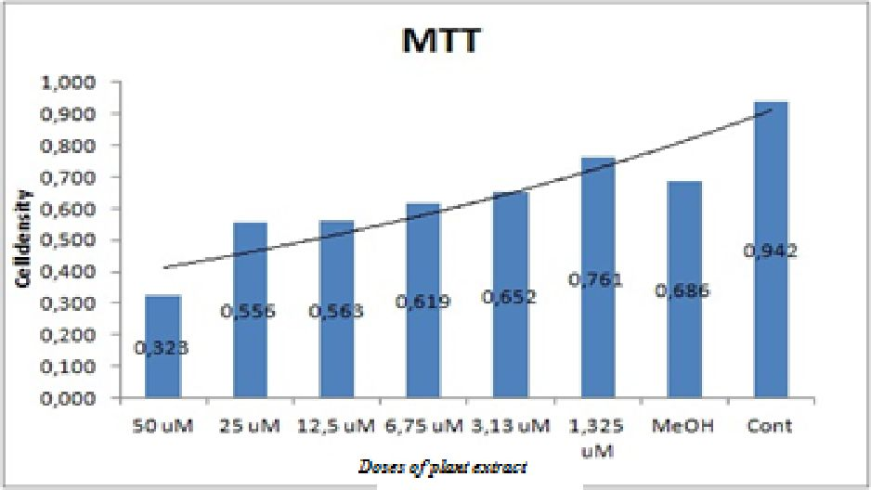
Figure 1. Cell proliferation assay with plant extract application

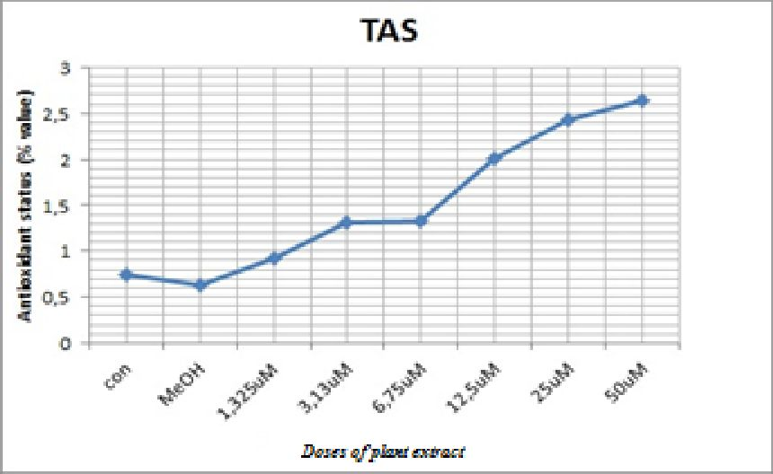
Figure 2. Total antioxidant activity

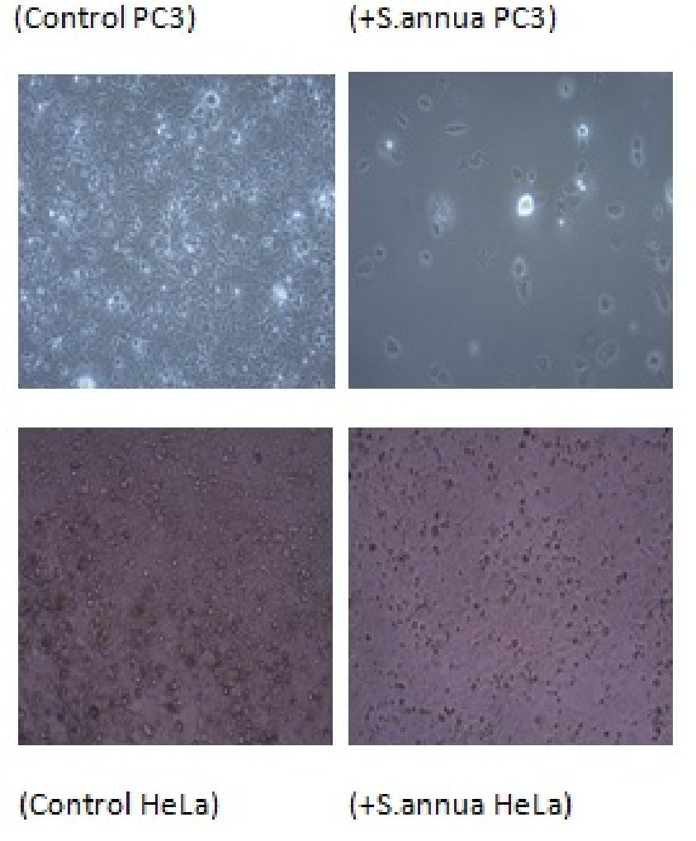
Figure 3. Morphological condition PC3 and HeLa cells

