Prediction Results – PDB-5CV
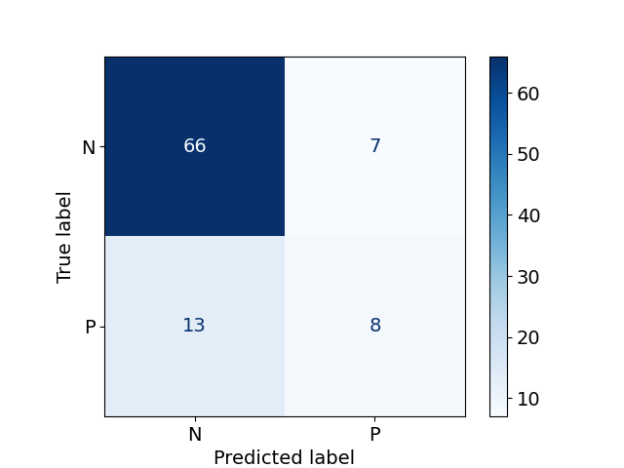
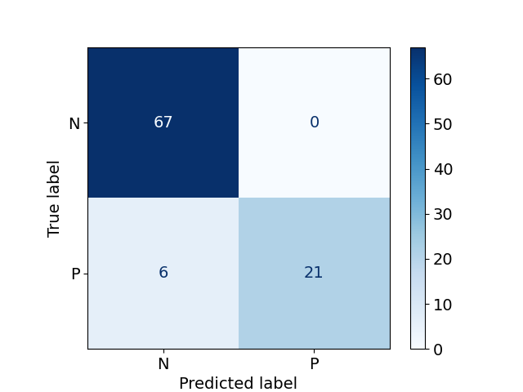
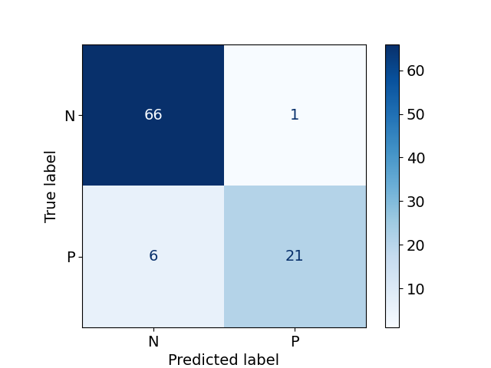
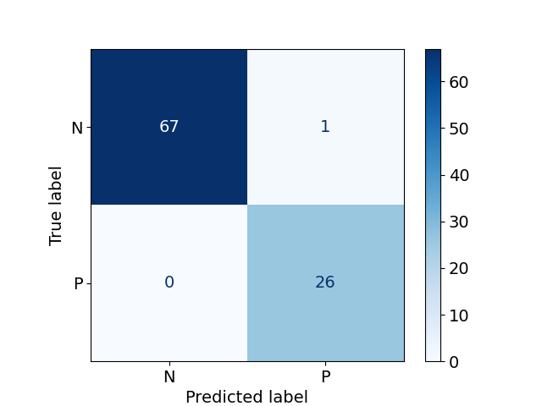
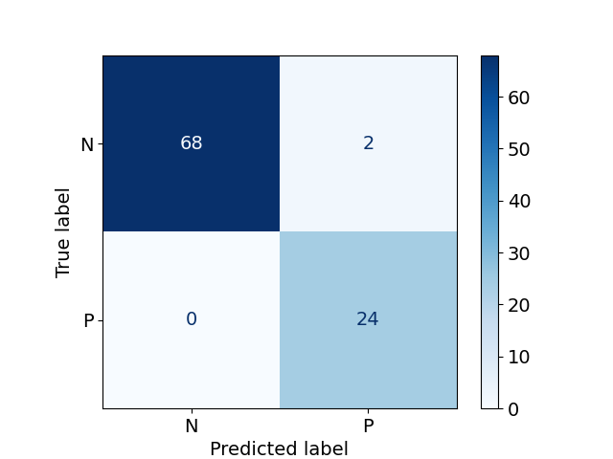

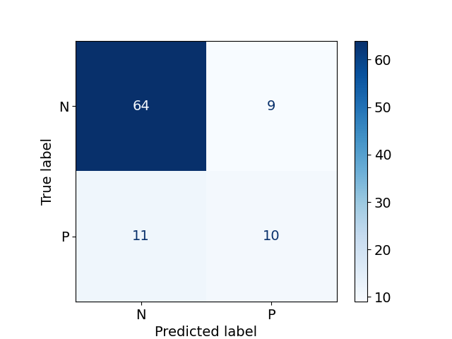
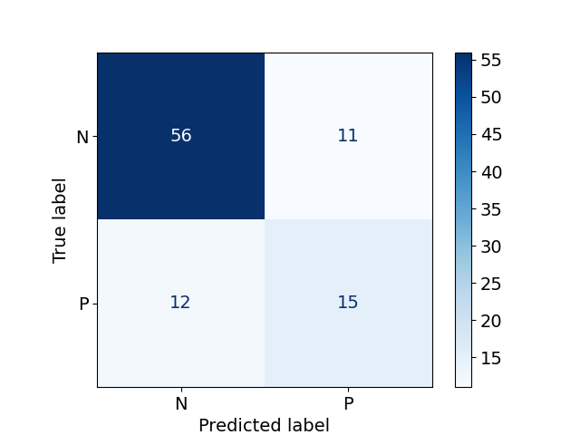
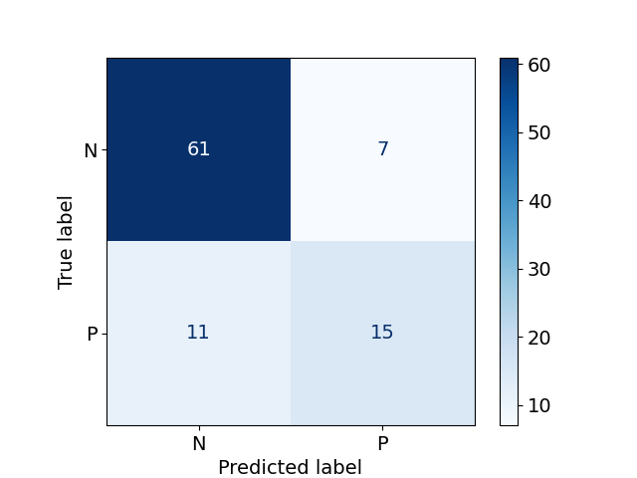
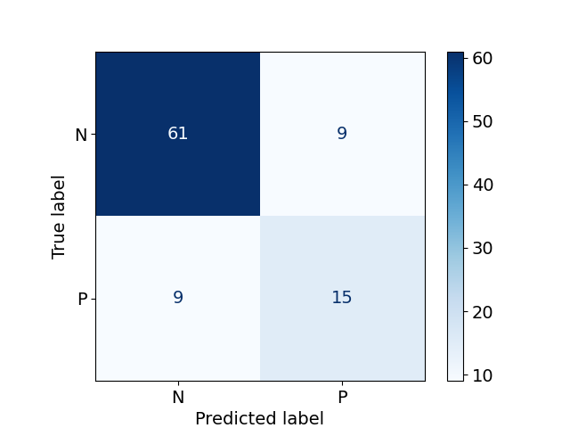
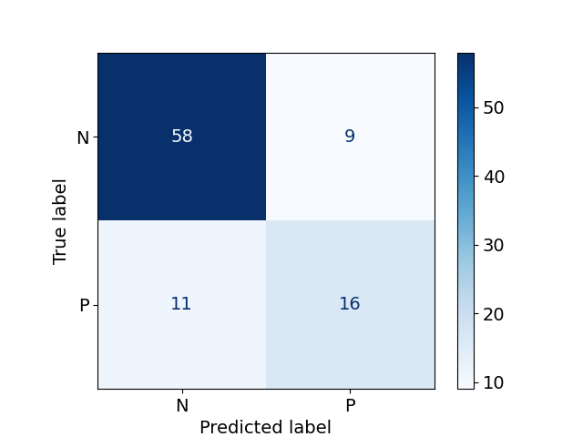
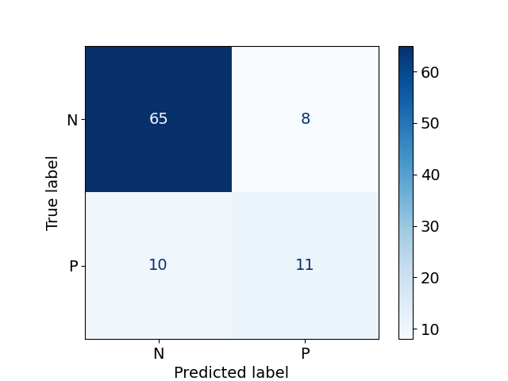
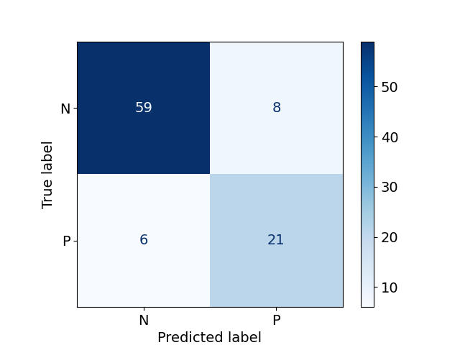
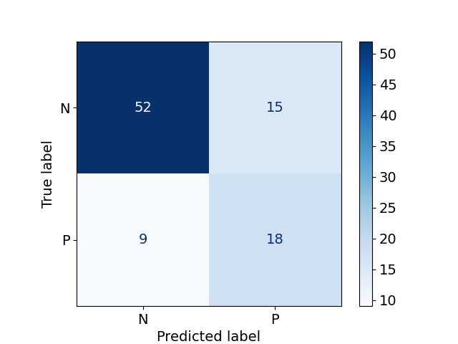
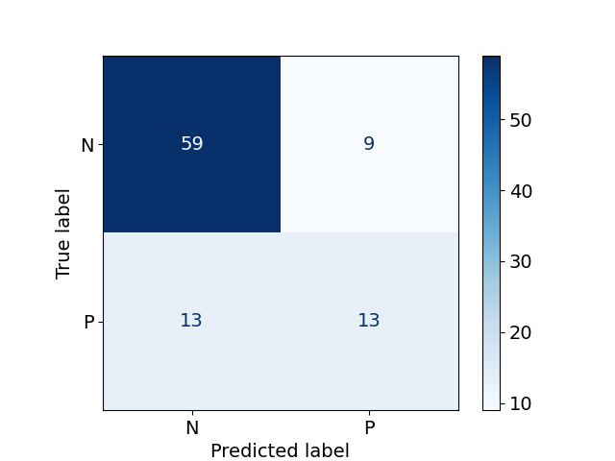
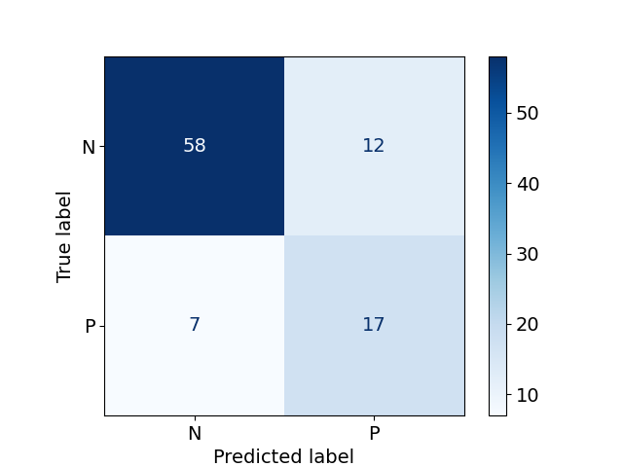
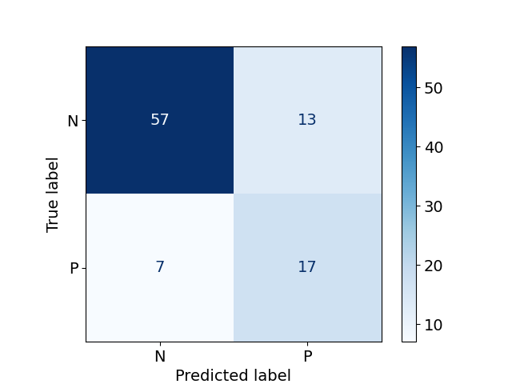
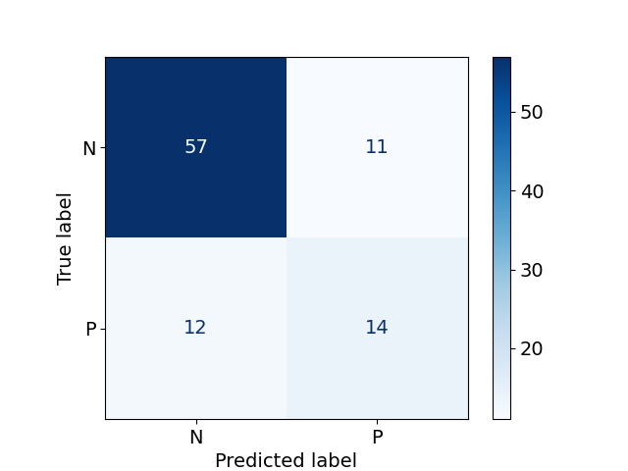
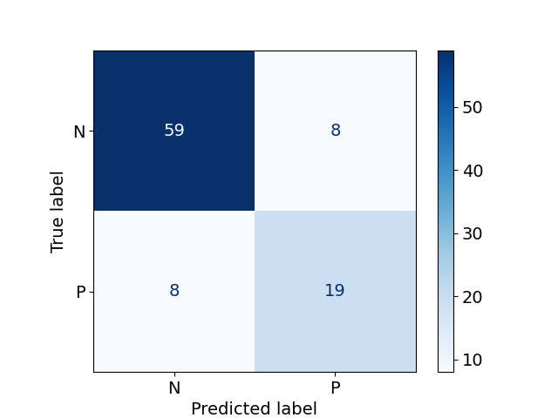
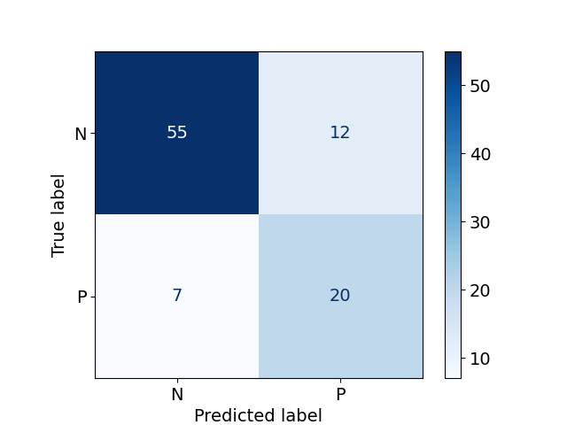
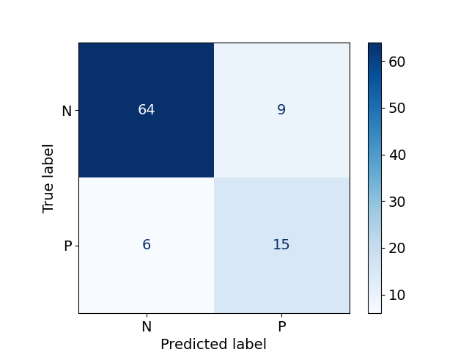
RFSMMA
NB
XGBoost
SMTRI

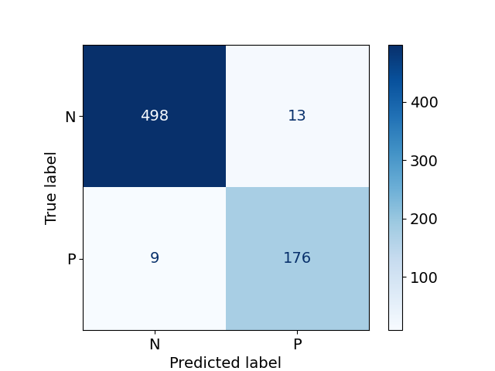
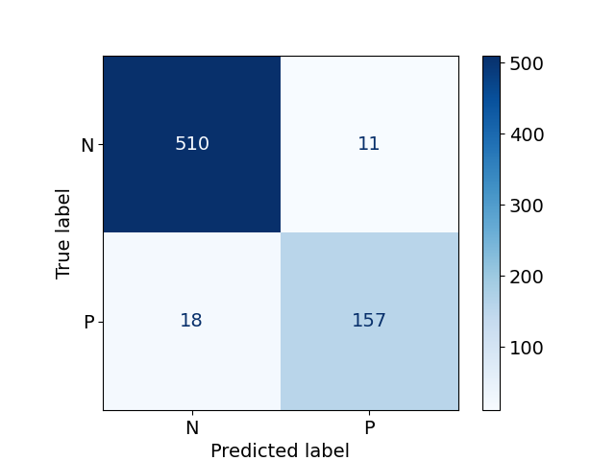
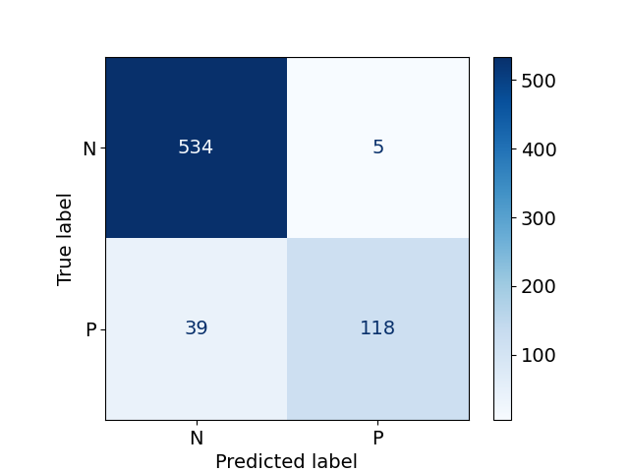
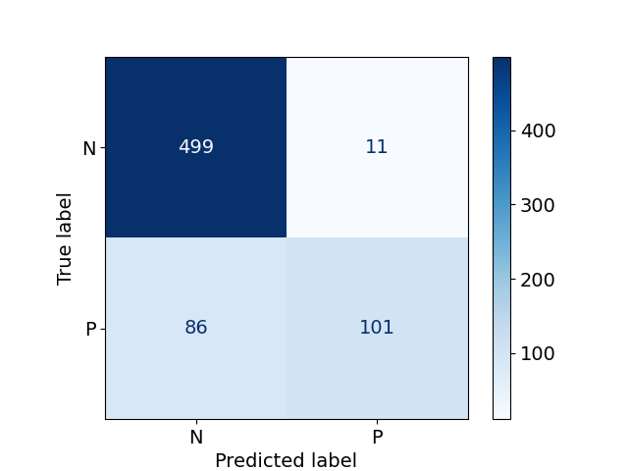
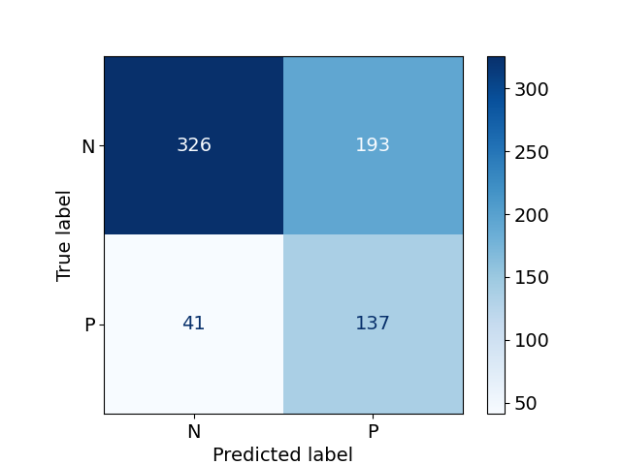
Prediction Results – PubChem-5CV

SMTRI

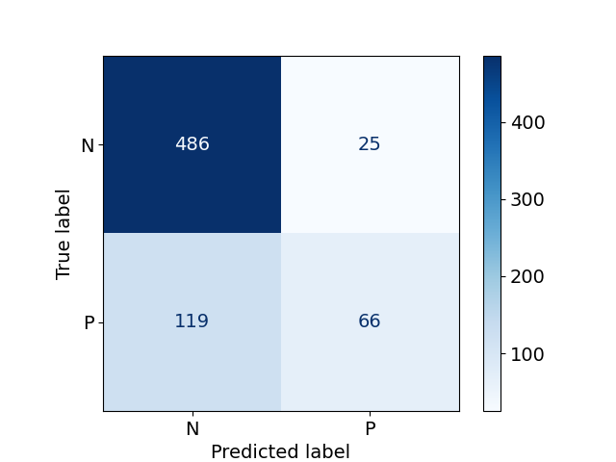
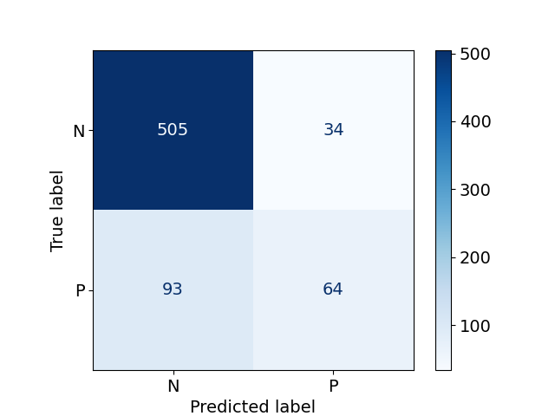
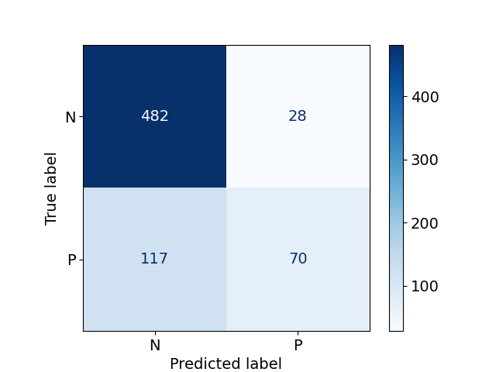
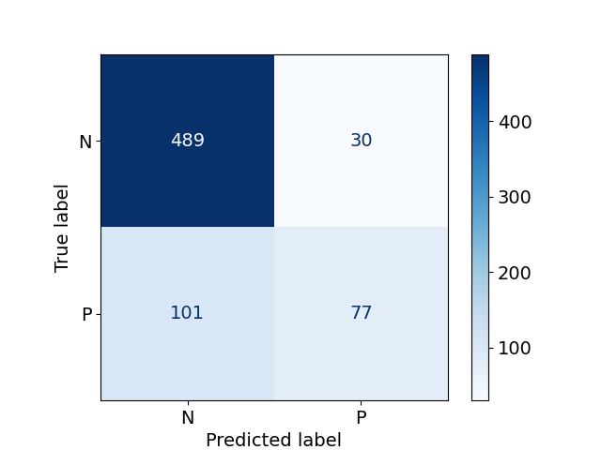
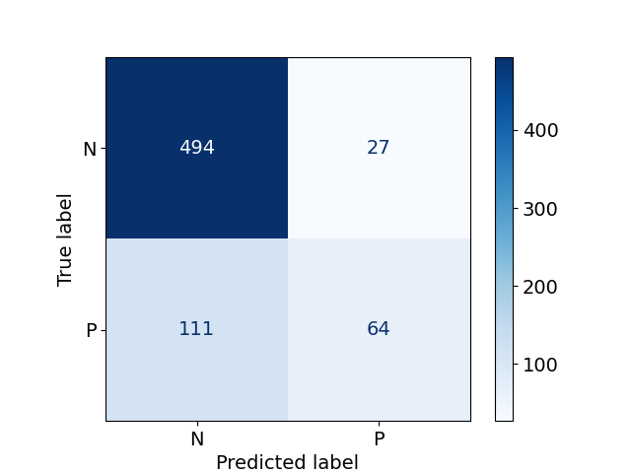
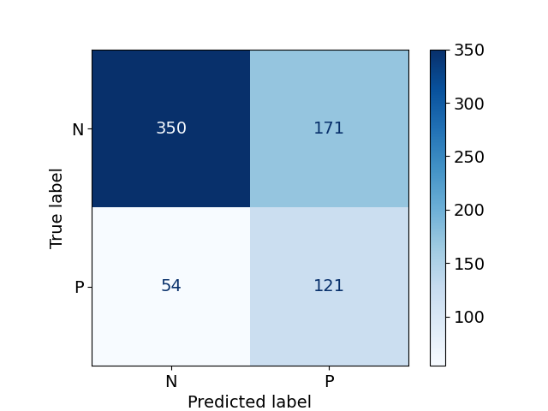
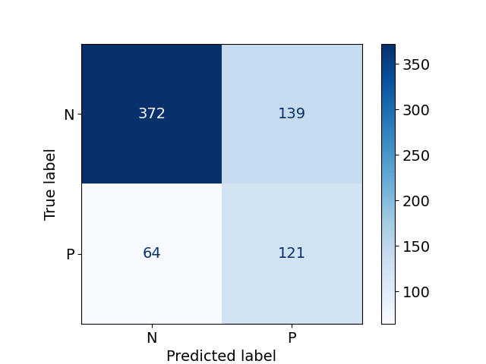
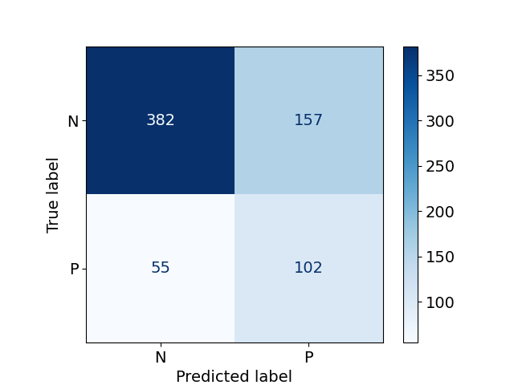
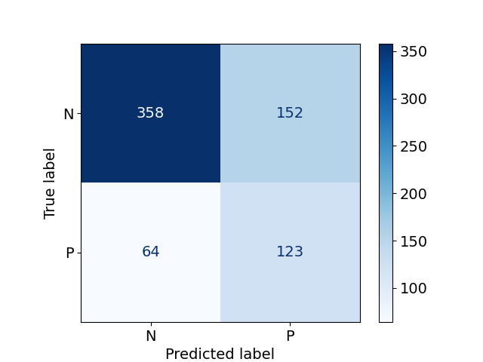
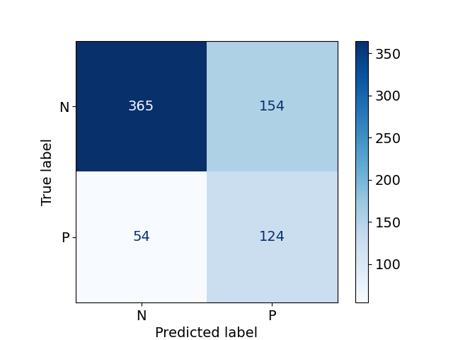
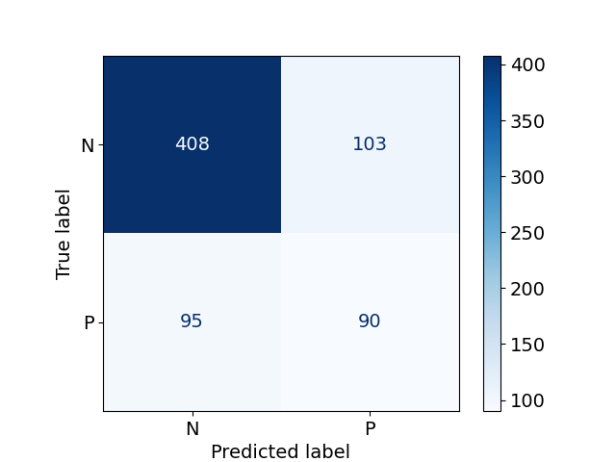
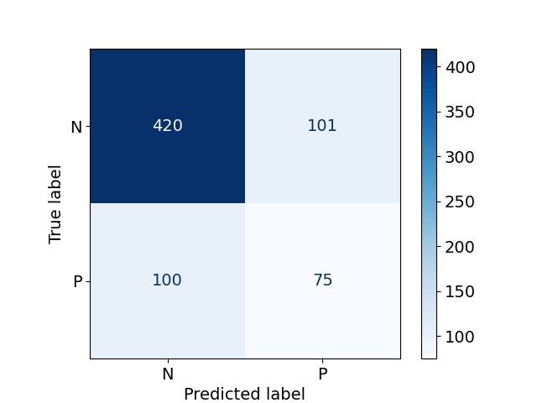
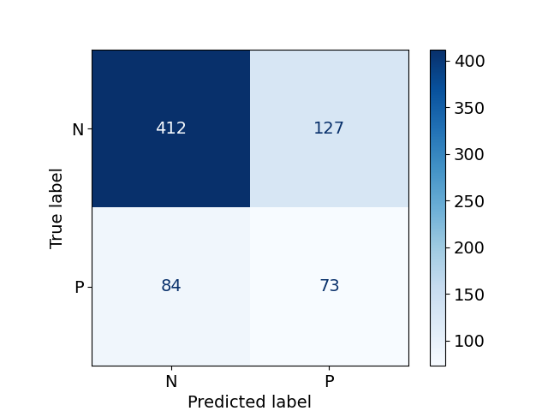
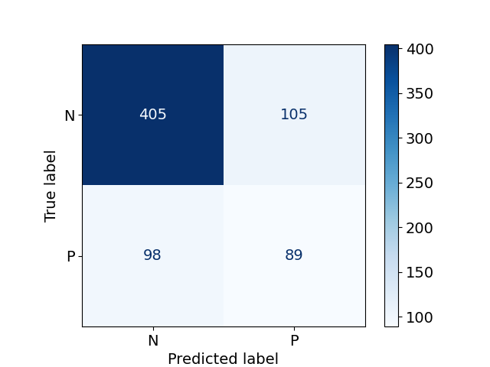
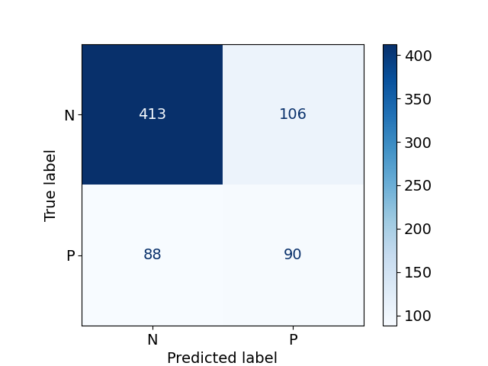
RFSMMA
NB
XGBoost

Prediction Results – RPocket-5CV
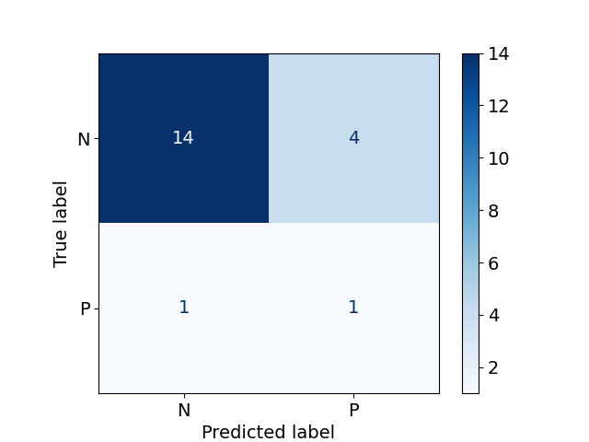
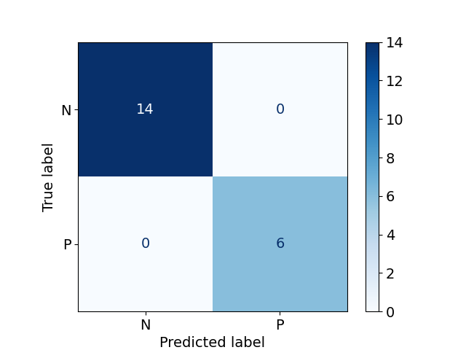
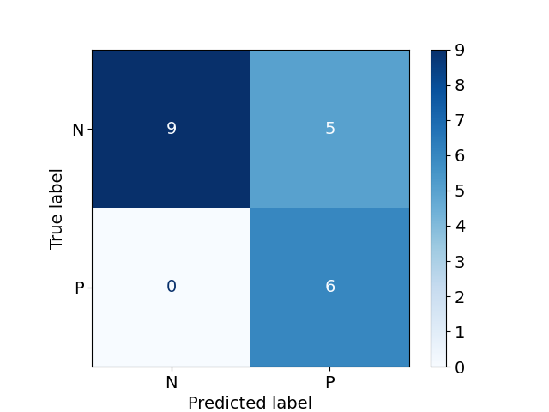
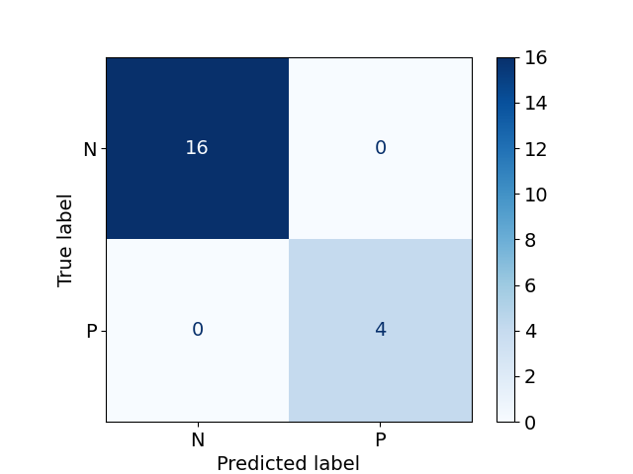
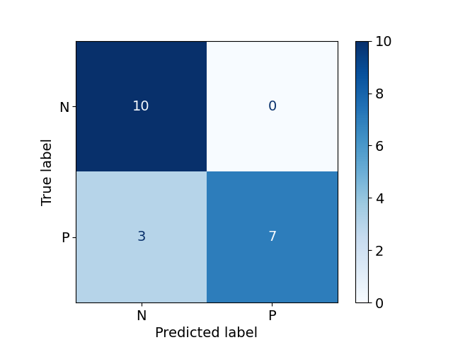

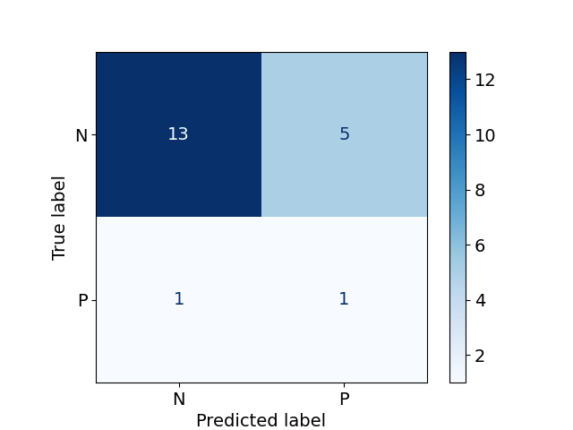
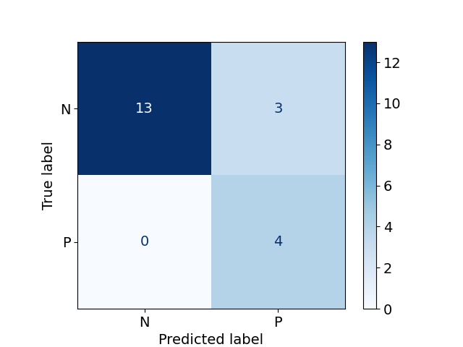
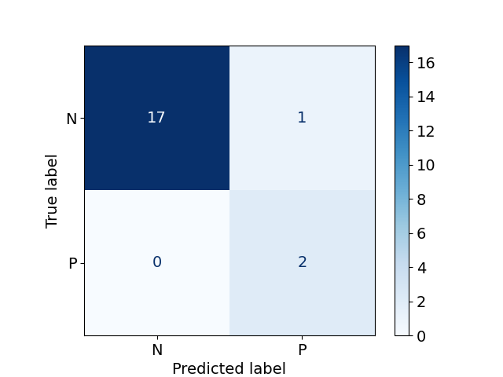
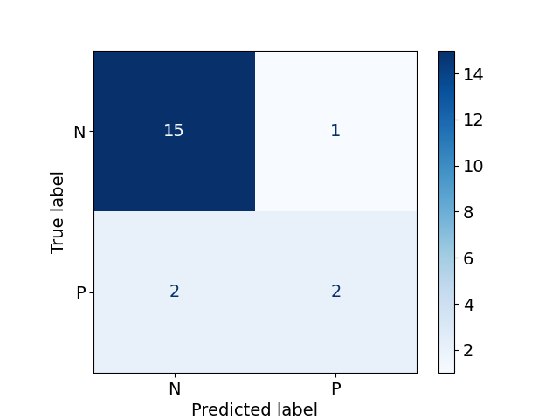

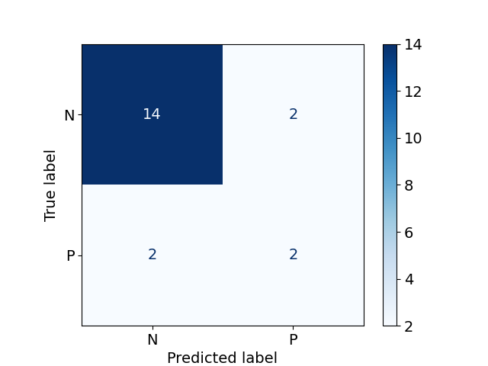
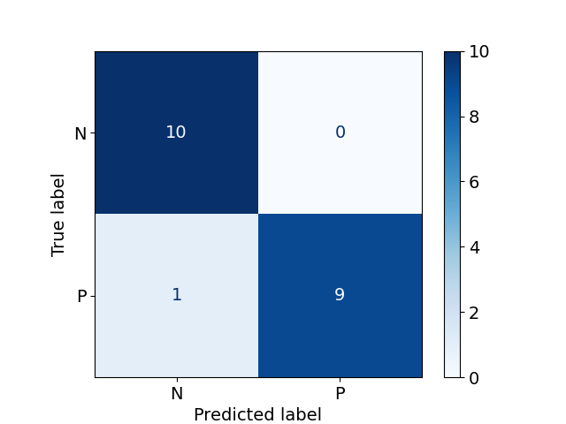
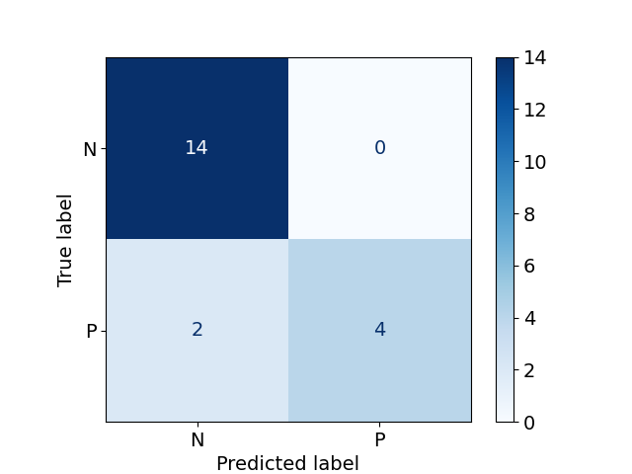
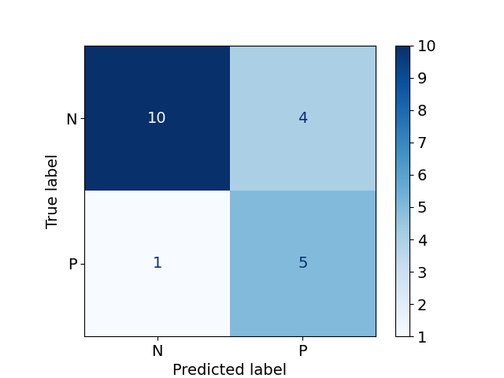
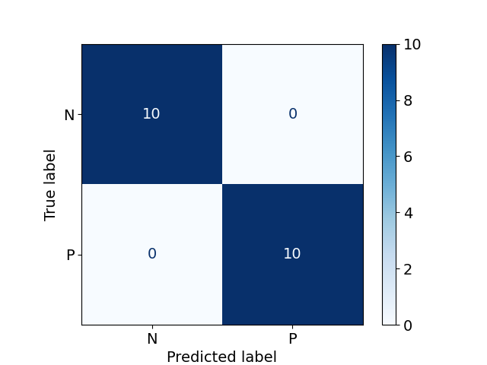
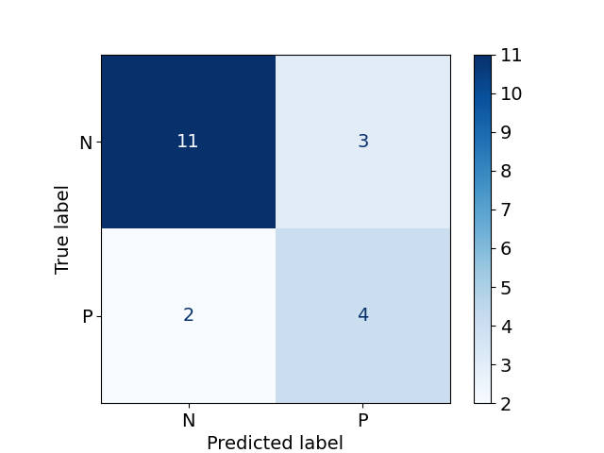
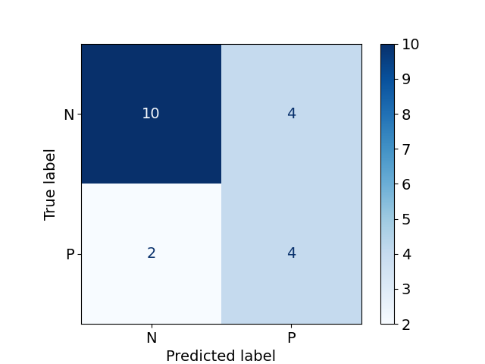
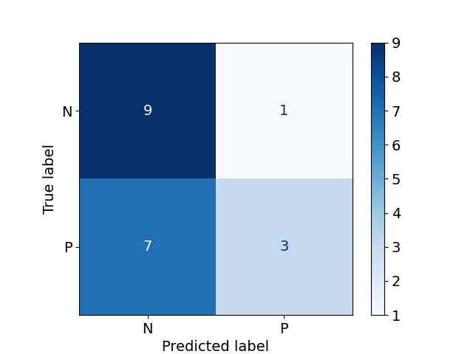
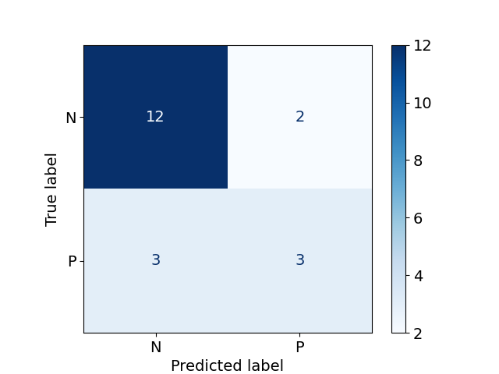
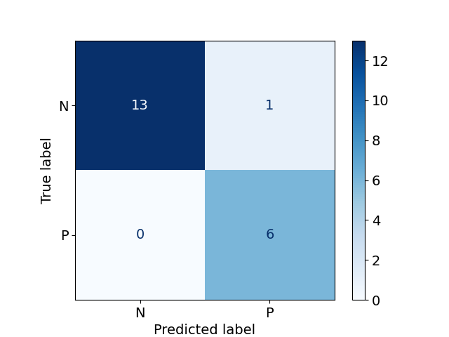
XGBoost
NB
RFSMMA
SMTRI
Table 1. The performance of SMTRI compared with other machine learning methods on PDB testing set (the highest score in each column is highlighted in bold).
PDB | AUC | Accuracy | Precision | Recall | F1 Score | MCC | Kappa
SMTRI | 0.947±0.087 | 0.923±0.072 | 0.875±0.173 | 0.787±0.226 | 0.823±0.196 | 0.781±0.236 | 0.775±0.238
XGBoost | 0.759±0.041 | 0.800±0.032 | 0.613±0.055 | 0.673±0.071 | 0.640±0.056 | 0.504±0.076 | 0.502±0.076
NB | 0.742±0.052 | 0.794±0.037 | 0.605±0.062 | 0.635±0.107 | 0.617±0.076 | 0.478±0.092 | 0.475±0.093
RFSMMA | 0.717±0.027 | 0.789±0.020 | 0.610±0.054 | 0.565±0.050 | 0.586±0.048 | 0.446±0.055 | 0.445±0.054

Table 2. The Performance of SMTRI compared with other machine learning methods on PubChem testing set (the highest score in each column is highlighted in bold).
PubChem | AUC | Accuracy | Precision | Recall | F1 Score | MCC | Kappa
SMTRI | 0.935±0.079 | 0.878±0.113 | 0.828±0.207 | 0.782±0.142 | 0.783±0.153 | 0.719±0.212 | 0.703±0.227
XGBoost | 0.632±0.014 | 0.712±0.008 | 0.436±0.038 | 0.472±0.026 | 0.453±0.028 | 0.258±0.030 | 0.258±0.030
NB | 0.686±0.008 | 0.694±0.011 | 0.433±0.026 | 0.670±0.020 | 0.526±0.020 | 0.332±0.018 | 0.315±0.020
RFSMMA | 0.666±0.012 | 0.803±0.010 | 0.703±0.026 | 0.388±0.029 | 0.498±0.022 | 0.416±0.019 | 0.389±0.023

Table 3. The performance of SMTRI compared with other machine learning methods on RPocket testing set (the highest score in each column is highlighted in bold).
RPocket | AUC | Accuracy | Precision | Recall | F1 Score | MCC | Kappa
SMTRI | 0.950±0.100 | 0.870±0.112 | 0.749±0.326 | 0.840±0.206 | 0.763±0.263 | 0.704±0.300 | 0.677±0.314
XGBoost | 0.820±0.109 | 0.840±0.080 | 0.665±0.304 | 0.780±0.177 | 0.685±0.221 | 0.609±0.246 | 0.583±0.249
NB | 0.821±0.135 | 0.850±0.114 | 0.681±0.171 | 0.767±0.200 | 0.711±0.167 | 0.615±0.243 | 0.607±0.243
RFSMMA | 0.708±0.133 | 0.760±0.116 | 0.575±0.238 | 0.560±0.233 | 0.529±0.221 | 0.408±0.257 | 0.391±0.267

