IJESRT
International Journal of Engineering Sciences & Research Technology
Σεισμιχ Αναλψσισ οφ Γ+3 Μυλτιστορεψ Βυιλδινγ Ωιτη ανδ Ωιτηουτ Λεαδ Ρυββερ Βεαρινγ Συππορτ Υσινγ Δεσιγν Σοφτωαρε
Mr Ankit Pal^{1*},Mr Arpit Chawda²
MTech scholar, Assistant professor Department of civil engineering,
RKDF SOE, Indore
DOI: 10.5281/zenodo.1146154

Abstract
The research is conducted with study of existing researches in the field of siesmc behaviour of buildings. Base isolation is one of the technology applied to reduce the effect of earthquake effect. The principle is to disconnect the base of the building from footing ground. The problem is taken as residential building design to withstand building against seismic action. Two types of base are used to analyze and compare building first is building with fixed base and second case is building with lead rubber bearing support.
Two software STAAD Pro and SAP 2000 are used to test fixed and lead rubber bearing base buildings. It is first time in India when residential buildings are tested with lead rubber bearing isolation are tested and analyzed for seismic zone V. It is found from results that deflection and stresses analyzed with lead rubber bearing are lesser than fixed base with remarkable margin and it is concluded that research recommends use of lead rubber bearing base isolation for seismic zone V in India.

KeywordS Seismic, Residential Building, Fixed Support, Lead Rubber Bearing Support, STAAD Pro, SAP 2000, Deflection, Stress, Strain.

introduction
Base isolation is a proven technology for the seismic design of structures. The system reduces the likelihood of structural and nonstructural damage to a building subjected to seismic forces. As a result of the use of base isolation, lives and property have been saved.
Base isolation technology is used primarily in critical facilities such as hospitals, museums, and emergency response centers, where the benefits of protecting the structure and its property from seismic damage far exceed the cost of implementing the system.
However, despite base isolation’s proven benefits, the technology is under-utilized.
Although tall, flexible, and non-critical facilities such as office buildings are not the most ideal candidates for base isolation, they may still achieve an optimal seismic design by using the technology. Therefore, in order to increase the quality and prevalence of base isolated structures, there is a need to study the technology’s seismic performance enhancements and cost effectiveness for projects on which the system is infrequently used.
IS 1893:2002 is the code to design structures under earthquake zones. There are two major methods of seismic analysis which are:

- Response Spectrum Analysis: This is based on ideal predefined data which are not real time data’s collected from real earthquake in the area.
- Time History Analysis: This is based on actual real time data collected under real earthquake. Building response and behavior is collected in real time and can be used to design future buildings under seismic loading.

PROBLEM FORMULATION
The seismic performance of RC structures before and after the application of flexibility and stiffness-based elements technique is to be studied in the current project. In this study we are introducing isolation system instead of conventional technique to get better performance of building during the earthquake.
This section provides model geometry information, including items such as joint coordinates, joint restraints, and element connectivity.
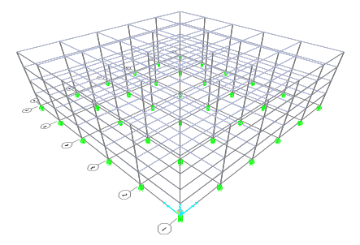
Figure 1: Finite element model

Specifications:

Plan: 30m x 30m
Number of Bays: 5 numbers of 6m each in X and Z Direction.
Storey Height: 3m
Column Size: 350mm x 450mm
Beam Size: 230mm x 500mm
Floor Thickness: 140mm

Seismic Data:

Seismic Zone: V (Five)
Soil Type: Medium
Beam Dead Load (UDL): 13.8 KN/m
Floor Dead Load (UDL): 5KN/m
Live Load: 1.5KN/m
Floor Dead Load (UDL): 5KN/m
Live Load: 1.5KN/m

Material Properties
Table 1: Basic Mechanical Properties
Material | Unit Weight  Kip/in³ | Unit Mass  Kip-s²/in⁴ | E1  Kip/in² | G12  Kip/in²
M30 | 2.3563E+01 | 2.4028E+00 | 2.5E+07 | 1.0E+07
Rebar | 7.6973E+01 | 7.8490E+00 | 2.0E+08

- METHODOLOGY
To meet the above mentioned objectives of the present study, following steps are adopted:-
- An extensive survey of the literature on the behavior and performance of base isolated R/C structures is to be performed for updating my knowledge regarding the base isolation and works which has been done.
- Analysis of G+3 storied RC building is to be performed using STAAD. Pro for Zone-V.
- Analysis of G+ 3 storied RC building for zone V on performed using SAP2000.
- Analysis of the proposed RC building before and after the application of base isolation technique.
- Comparison of the results before and after base isolation of RC structure.

- DATA COLLECTION AND ANALYSIS
Model is first created with STAAD Pro and then with SAP for fixed support and lead rubber bearing support. All floors and floor heights are defined at this stage and column base are defined as fixed.
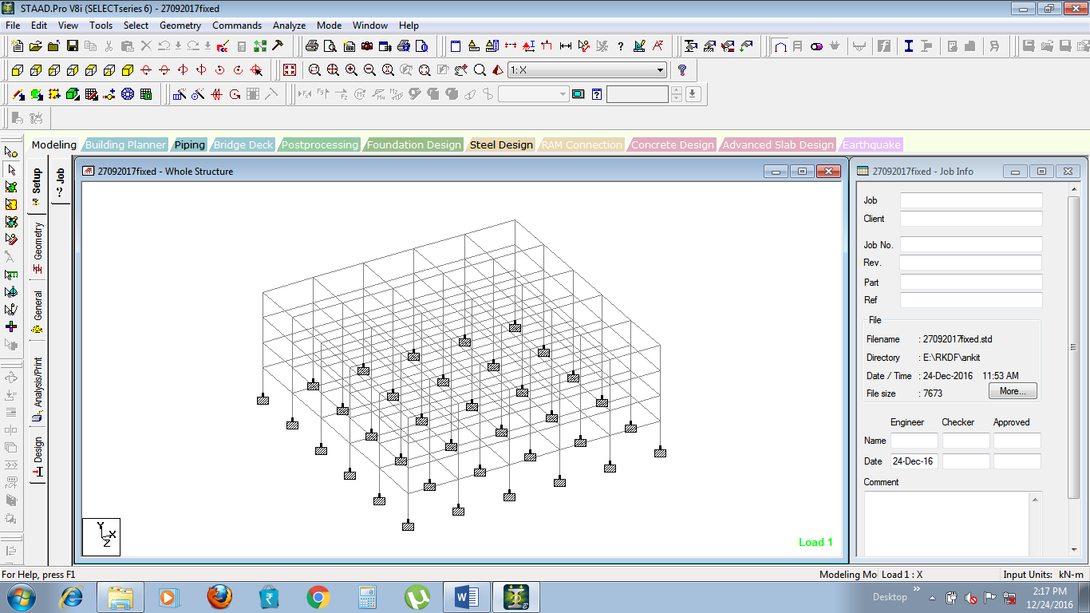
Figure 2: STAAD Pro Building Model for fixed support

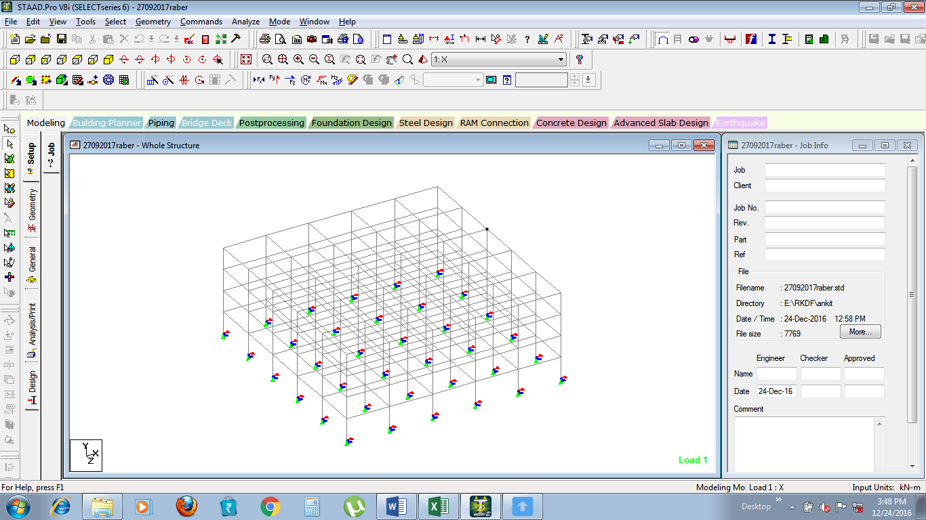
Figure 3: STAAD Pro Lead Ruber Bearing Support Model

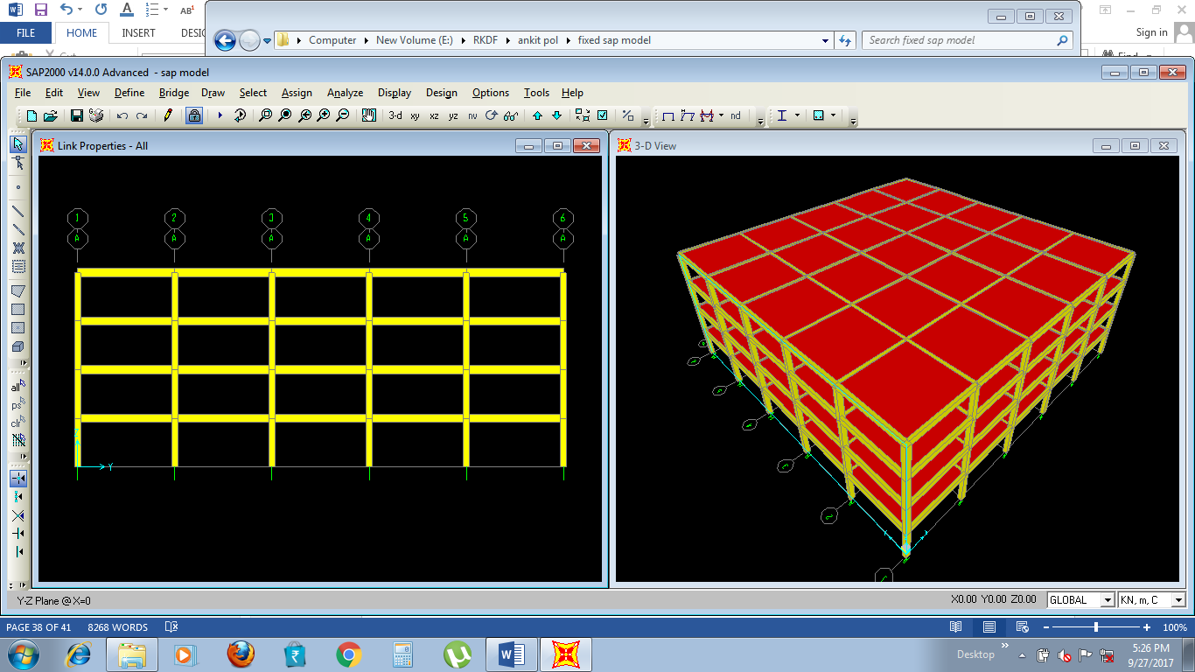
Figure 4: SAP Model for Fixed Support Building

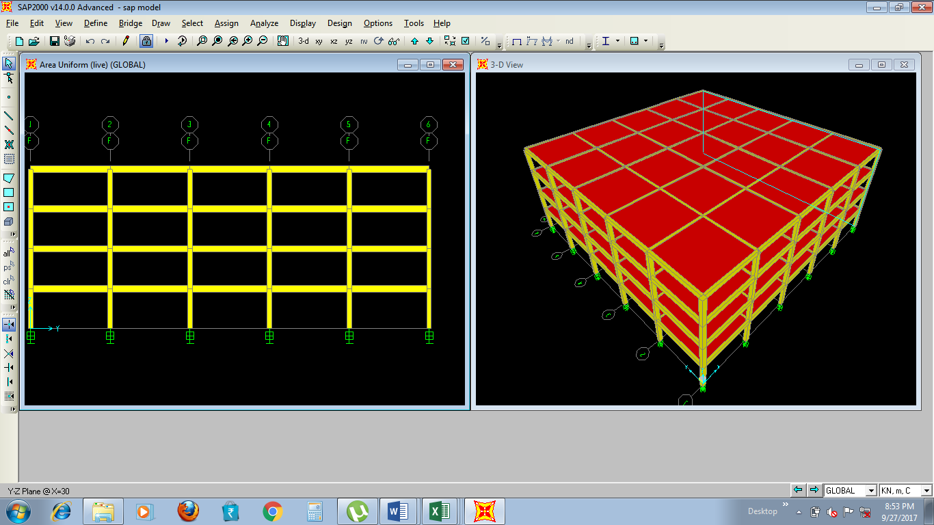
Figure 5: SAP Model for Lead Rubber Beaaring Support Building
Stress and deformation analysis is performed with Staad Pro and SAP both for both fixed and lead rubber bearing support.

Regular residential building is never been considered under research by researchers with lead rubber bearing support. Also STAAD Pro is not having option for defining lead rubber bearing support, still we manually defined lead rubber bearing support in STAAD Pro to compare with SAP.

- RESULTS AND DISCUSSION
Regular residential building is never been considered under research by researchers with lead rubber bearing support. Also STAAD Pro is not having option for defining lead rubber bearing support, still we manually defined lead rubber bearing support in STAAD Pro to compare with SAP.

STAAD Pro Results
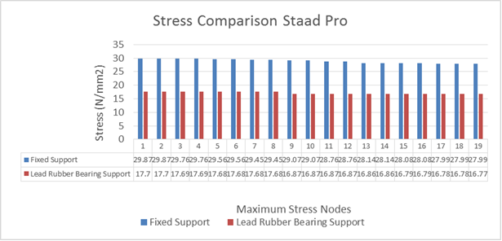
Figure 6: Stress Comparison Fixed vs Lead Rubber Bearing Support (Staad Pro)

The maximum permissible stress for M30 Concrete is generalized as 25 N/mm² and it is seen in STAAD Pro results obtained, that all the stress values obtained are greater than 25 N/mm² in fixed support base isolation and lower in case of lead rubber bearing base isolation.

Top maximum stresses obtained from STAAD Pro results are graphically tabulated and compared for fixed support base isolation and lead rubber bearing base isolation. It is concluded that STAAD Pro results suggest to use lead rubber bearing base isolation to achieve minimum stresses in same structure and to design more safe building under seismic loading conditions.

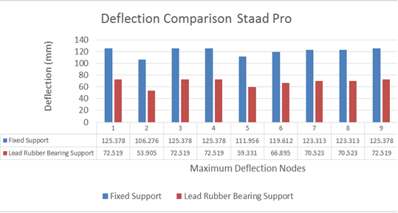
Figure 7: Deflection Comparison Fixed vs Lead Rubber Bearing Support (Staad Pro)

SAP Results
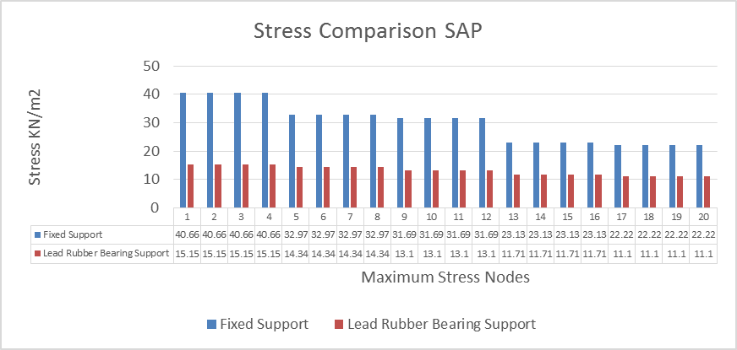
Figure 8: Stress Comparison Fixed vs Lead Rubber Bearing Support (SAP)

The maximum permissible stress for M30 Concrete is generalized as 25 N/mm² and it is seen in SAAP results obtained, that top twelve stress values obtained are greater than 25 N/mm2 in fixed support base isolation and all stress values are lower in case of lead rubber bearing base isolation.
Top maximum stresses obtained from SAP results are graphically tabulated and compared for fixed support base isolation and lead rubber bearing base isolation. It is concluded that SAP results suggest to use lead rubber bearing base isolation to achieve minimum stresses in same structure and to design more safe building under seismic loading conditions.

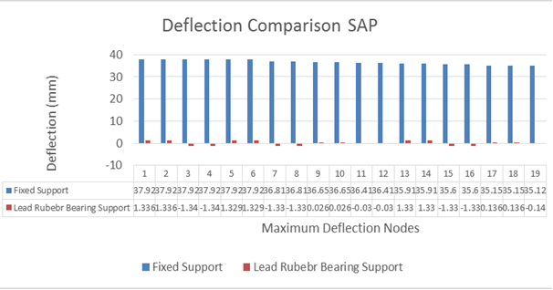
Figure 9: Deflection Comparison Fixed vs Lead Rubber Bearing Support (SAP)

Top maximum deflections obtained from SAP results are graphically tabulated and compared for fixed support base isolation and lead rubber bearing base isolation. It is overall concluded that SAP results suggest to use lead rubber bearing base isolation to achieve minimum deflection in same structure and to design more safe building under seismic loading conditions.
IT is overal concluded that SAP results can be concluded as the stress falls upto value of range 11 to 15 KN/m² from 22 to 42 KN/m² in case of lead rubber bearing support. Similarly deflection in case of lead rubber bearing suppoer is found as neglegible in compare to fixed support.

- CONCLUSION AND FUTURE SCOPE
Conclusion
Residential building is analyzed with fixed support and lead rubber bearing support. Two software’s were used to perform seismic analysis for both cases. The aim is to compare the results for both supports with both software’s. It was planned as an objective to test lead rubber bearing support advantages under seismic condition over the fixed support case. First model for both supports are modelled and analyzed with STAAD Pro and then same buildings are modeled and analyzed with SAP 2000.

The results with both software’s highlighted the remarkable advantage with lead rubber bearing support. There was an issue with STAAD Pro that lead rubber bearing definition option was not available with STAAD Pro, that’s why there was lack of research for lead rubber bearing support. In India there were few research which was conducted considering lead rubber bearing support and non-linear commercial building. In present work lead rubber bearing problem is manually designed and tested by changing and correcting supports for lead rubber bearing effects for residential building.

Future Scope
The Base Isolation technology is developing and its application is spreading in various fields of engineering structure. Factories, Hospital and residential houses will be protected from seismic effects. It is evident that this technology will be progressed and become more important in coming century.
In future base isolation system widely used in multi-storey RC frame building. Due to several significant features of base isolation it is used in many structures such as hospitals, schools. In future may be base isolation also used in soft soil and also consider the unsymmetrical structures and their heights. Base isolation may be used in high rise building in future. In current time it is used only for hard soil not for soft soil. In short the base isolation technique is mostly used in all types of structures as compare to other seismic technique.
In coming time the base isolation is become very useful technique due to it’s life and property saving approach. Like the other country we used vibration isolations the damage of life and property will definitely reduce.

VII. References
- PAN Wen and SUN Baifeng, Two Step Design Method For Base Isolation Structures, The 14th World Conference on Earthquake Engineering October 12-17, 2008, Beijing, China.
- Christophe Collette, Stef Janssens and Kurt Artoos, Review of Active Vibration Isolation Strategies, Recent Patents on Mechanical Engineering 2011, 4.
- Silviu Nastac and Adrian Leopa, Structural Optimization of Vibration Isolation Devices for High Performances, International Journal Of Systems Applications, Engineering & Development Issue 2, Volume 2, 2008.
- Saiful Islam, Mohammed Jameel and Mohd Zamin Jumaat, Seismic isolation in buildings to be a practical reality: Behavior of structure and installation technique, Journal of Engineering and Technology Research Vol. 3(4), pp. 99-117, April 2011.
- B. M. Saiful Islam*, Mohammed Jameel and Mohd Zamin JumaatJournal of Engineering and Technology Research Vol. 3(4), pp. 99-117, April 2011 Available online at http:// www.academicjournals.org/JETR ISSN 2006-9790 ©2011 Academic Journals
- University Stanford. Albanesi T., Nuti C., Vanzi I., (2000) ‘A Simplified Procedure to Assess the Seismic Response of Nonlinear Structures’, Earthquake Spectra, Vol. 16, No. 4, pp. 715-734.
- Almeida R. F., Barros R. C. (2003) ‘A New Multimode Load Pattern for Pushover Analysis: the Effect of Higher Modes of Vibration.’ In: Earthquake ResistantEngineering Structures IV, Ed.: G. Latini and C.A. Brebbia, WIT Press, U.K., p. 3 13.

- Bertero V.V., Uang C., (1997) ‘Issues and Future Directions in the Use of an Energy Approach for Seismic-Resistant Design of Structures’ , in Nonlinear Seismic Analysisand Design of Reinforced Concrete Buildings, P. Fajfar and H. Krawinkler, Eds.,Elsevier Applied Science, London and New York, 3-21.
- Chai Y.H., Fajfar P., Romstad K.M, (1998), ‘Formulation of duration-dependent inelastic seismic design spectrum’, Journal of Structural Engineering, ASCE, 124, 913-921.
- Chintanapakdee C., Chopra A.K. (2004) ‘Seismic Response of Vertically Irregular Frames: Response History and Modal Pushover Analyses’, Journal of Structural Engineering, ASCE, 130, 1177-1185.
- Dolsek M., Fajfar P. (2005). ‘Simplified nonlinear seismic analysis of infilled reinforced concrete frames.’ Earthquake Engineering and Structural Dynamics, 34, 49-66.
- Fajfar P. (2000). ‘A nonlinear analysis method for performance-based seismic design”, Earthquake Spectra, Vol.16, No. 3, 573-592.
- Gaspersic P., Fajfar P., Fischinger M. (1992), 'An approximate method for seismic damage analysis of buildings', Proc. I0th world conference in earthquake engineering,,Balkema, Rotterdam, Vol. 7, pp. 3921-3926.
- Kramer S. (1996) Geotechnical earthquake engineering. Prentice Hall, New Jersey. Krawinkler H. (1995) ‘New trends in seismic design methodology.’ Proceedings 10th ECEE, The Netherlands, Rotterdam, pp. 821-830.
- Matsumori T., Otani S., Shiohara H., Kabeyasawa T. (1999) ‘Earthquake member deformation demands in reinforced concrete frame structures’, Proceedings of the USJapanWorkshop on Performance-Based Earthquake Engineering Methodology for R/CBuilding Structures, PEER Center Report, UC Berkeley - 79-94, Maui, Hawaii.
- Medina R.A, Krawinkler H., (2005) ‘Evaluation of Drift Demands for the Seismic
- Performance Assessment of Frames’, Journal of Structural Engineering, ASCE, 131(7), 1003-1013.
- Park Y.J., Ang A.H. (1985). ‘Mechanistic Seismic Damage Model for Reinforced Concrete’, Journal of Structural Division, Proc. ASCE, Vol. 111, No. ST4, pp. 740-757.
- Park, Y.J., Ang, H.S., Wen, Y.K. (1985) ‘Seismic damage analysis of reinforced concrete buildings,’ Journal of Structural Engineering, 111(4), 740-757.
- Saiidi M., Sozen M.A. (1981). ‘Simple Nonlinear Seismic Analysis of R/C Structures’, Journal of the Structural Division, Vol. 107, ST5, ASCE, 937-952.
- SEAOC, (1995), ‘Performance based seismic engineering of Buildings’ Vision 2000 Committee, Structural Engineers Association of California, Sacramento, Cali

