The impact of sleep hygiene education and lavender essential oil inhalation on the sleep quality and overall well-being of athletes who undergo late-evening training: a randomized controlled trial

Experimental protocol
  - Population:
The minimum required sample size was calculated using the software G*power (version 3.1.9.6; Kiel University, Kiel, Germany) using the F test family (repeated measures, within-between interaction). We set the values of α and power (1-β) at 0.05 and 0.95, respectively. The effect size was estimated to be 0.8 (medium effect) for all studies. The minimum sample size required was 32 participants. To avoid drop out during experimental sessions, 40 participants will be involved for all studies. Inclusion criteria were age ≥18 years and practice resistance training for ≥ 1 h four times a week. Exclusion criteria were being morning (M-type) or evening (E-type) chronotype, tobacco use, history of lower extremity injury or surgery in the 6 months prior to recruitment, and prior exposure to sleep hygiene education which might have interfered with the validity of the study protocol.
  - Circadian typology
The assessment of circadian typology was conducted utilizing the Horne-Ostberg Morningness-Eveningness Questionnaire (MEQ) (Horne & Östberg, 1976). MEQ scores were utilized to classify them into three categories: morning-type (score ≥ 59), evening-type (score ≤ 41), or neither-type (score 42–58).
  - Aromatherapy
Lavender essential oil (LEO) will be used in all studies. Participants will be instructed to drip two drops of LEO on a cotton ball, then they will be asked to put it at a distance of 5 cm from their nose and inhale the aroma for 10 minutes through normal breathing at their own convenience.
  - Sleep hygiene session
All participants will be attended a sleep education session one day prior to the start of every study, the session will be led by a specialist in sleep research and athletic recovery and will last for 40-45 minutes. The session will focus on practical tips that are evidence-based and recommended by Nédélec et al. (2015). These tips include: 1) taking a post-training shower, 2) ensuring a quiet, cool, and dark bedroom environment, 3) removing the bedroom clock, 4) avoiding light-emitting technology devices at least 1 hour before sleep, 5) refraining from consuming caffeine, alcohol, or other stimulants before sleep, 6) drinking at least one glass of high-electrolyte fluids, such as milk, rather than only water between match cessation and bedtime, and 7) eating a light, high glycaemic index meal with few proteins. Participants will be given a leaflet summarizing the sleep hygiene recommendations to follow between training cessation and bedtime after the educational session. All participants will sleep in their accustomed bed at home.
  - Procedure
All studies will be four-armed, parallel group randomized controlled trials, where participants will be randomized and assigned into four groups according to their sleep hygiene questionnaire score to handle the heterogeneity between groups: control group (C-G), lavender essential oil group (LEO-G), sleep hygiene group (SH-G), and sleep hygiene and lavender essential oil group (SHLEO-G).
In this study, all groups will be asked to perform their habitual RTS at 20h00 and recorded the total lifted weight in every session for each exercise. Furthermore, the C-G and LEO-G will be instructed to maintain their usual lifestyle and sleep habits in their own home during the procedure. The SH-G and SHLEO-G will be asked to follow all sleep hygiene recommendation for the 7-day period. The LEO-G and SHLEO-G will be asked to inhale the LEO every night before sleep for the 7-day period. Sleep pattern will be recorded using GT3X actigraphy every night for the 7-day period. The Brunel Mood Scale (BRUMS) and Hooper questionnaires will be answered before and after the 7-day period.
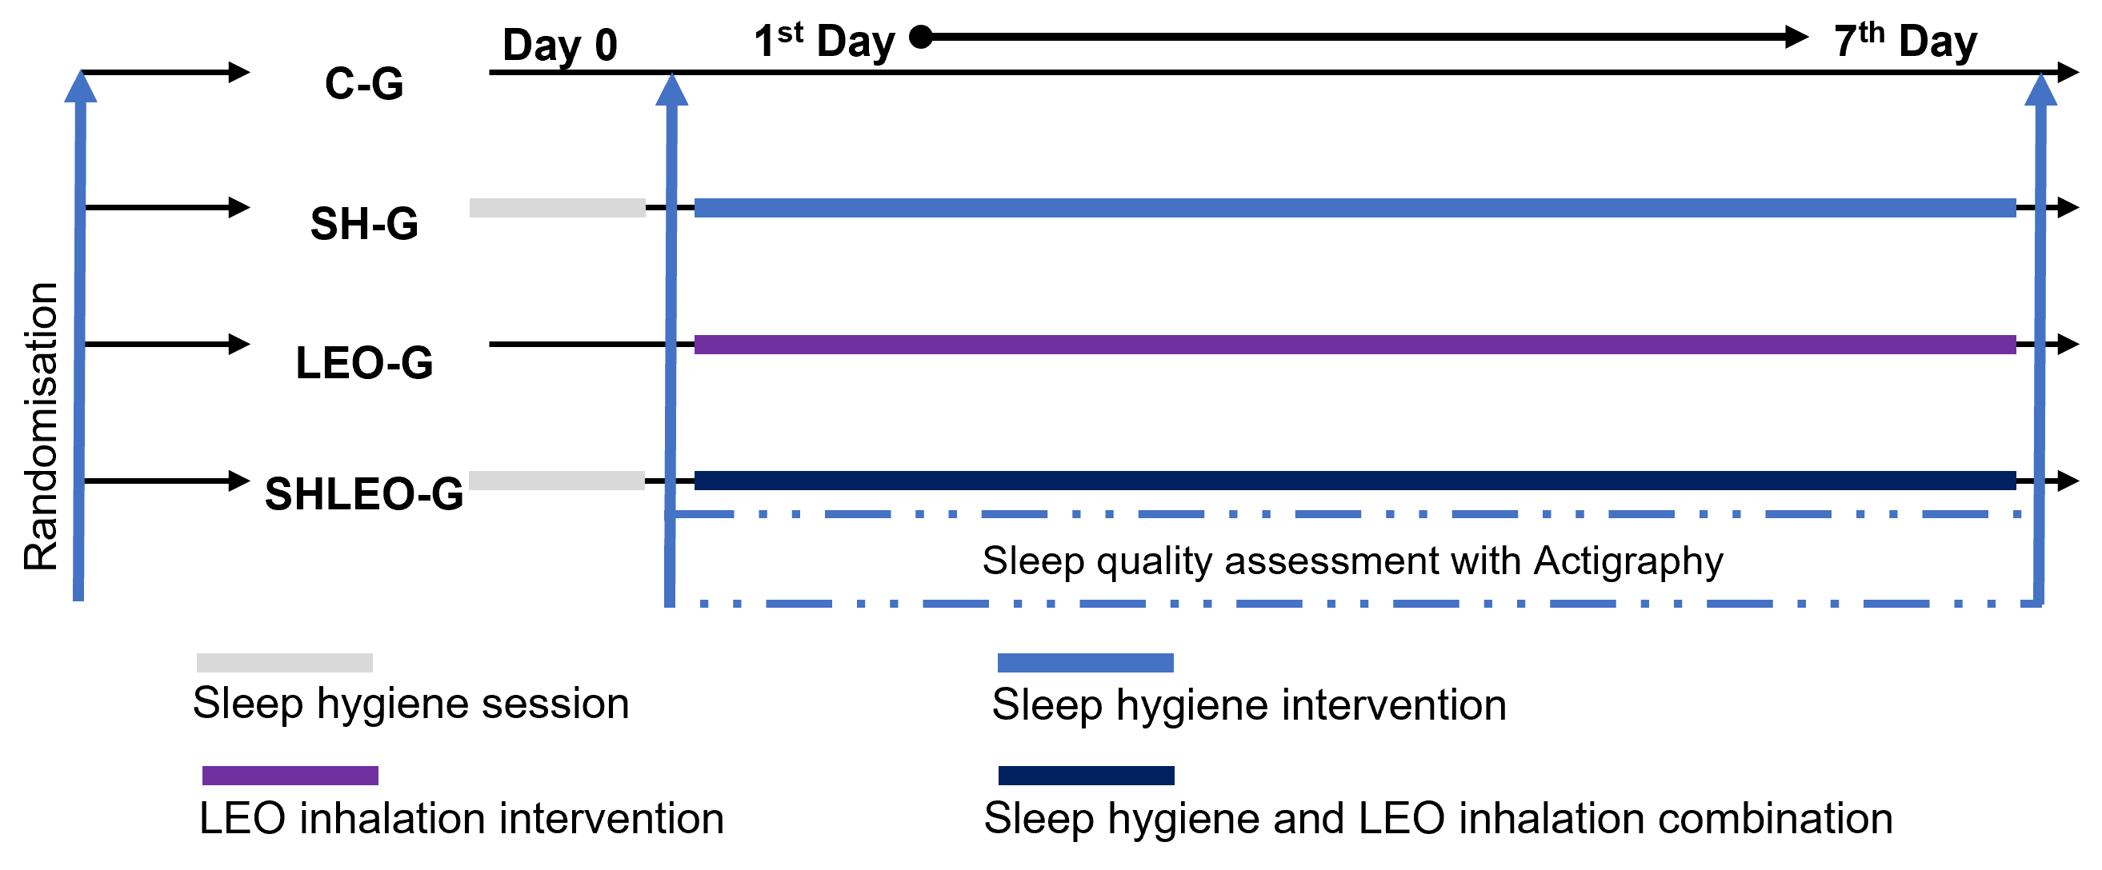
Figure 1. Experimental design. LEO: Lavender essential oil; C-G: Control group; SH-G: Sleep hygiene group; LEO-G: Lavender essential oil group; SHLEO-G: Sleep hygiene and Lavender essential oil combination group.
  - Measurements
    - Wristwatch actigraphy
In all studies, participants will be asked to wear the GT3X actigraphy (Actigraph, FL, USA) on the non-dominant wrist in order to evaluate the sleep pattern. The sleep and wake behaviour of the night will be evaluated by the Actilife 6 software to record the following parameters: bedtime, out bedtime, sleep latency, sleep efficiency, total time in bed, and total sleep time. The recorded data were scored using sleep analysis software which indicated sleep-awake patterns for each 60-s epoch.
    - Hooper questionnaire
The Hooper questionnaire detects signs of pre-fatigue and stress (Hooper et al., 1995). Participants provided information about their subjective assessment (i.e., feelings) of sleep, fatigue, stress, and muscle soreness. Each response was rated on a seven-point. Likert scale, with responses ranging from “very, very bad” to “very, very good” for sleep, and from “very, very low” to “very, very high” for fatigue, stress, and muscle soreness. The Hooper Index reflects the sum of the four ratings.
    - Brunel Mood Scale questionnaire
The Brunel Mood Scale (BRUMS) (Terry et al., 2003) was used to evaluate the participants' mood state. The BRUMS is composed of 32 items, divided into six subscales: Anger, Tension, Depression, Vigour, Fatigue, Confusion, Happy, and Calmness. Each item is rated on a 5-point Likert scale ranging from 0 (not at all) to 4 (extremely). The subscale scores are derived from four relevant items, with a possible range of 0 to 16. Participants were asked to complete the BRUMS before and after the 7-day period by responding to the prompt, "How do you feel right now?".

