10Xv2 RNASeq Sample Processing

Technical Authors & Contributors
Department | Name
Molecular Biology | [Redacted]

Date of SOP Creation (Version 0.1): 8/17/2018

Periodic Review
Biannual Annual Biennial None Last Review: 2/4/2019

Departmental Sign-Off: This SOP must be approved by the manager or director of the department responsible for executing or reviewing work. To approve, manager must enter their name and the date of approval.
Department | Review  Required | Approved By | Date
Structured Science Labs
In Vivo Sciences
Lab Animal Services
Neurosurgery and Behavior
Tissue Processing
Histology
Molecular Biology |  | [Redacted] | 2/4/2019
Electrophysiology Core
Imaging
Manufacturing & Process Engineering
3D Morphology and Reconstruction
EH&S Review (if applicable)
Regulatory Review (if applicable)
Other (if applicable)

- Scope and Applicability: Allows for rapid generation of 3’ transcriptomic-NGS-ready- single-cell-libraries from pools of cells.

- Materials:
  - Chromium Single Cell 3’ Library and Gel Bead Kit v2 (10X Genomics #120237)
    - RT Reagent Mix (220089)
    - RT Enzyme Mix (220079)
    - Additive A (220074)
    - RT Primer (x2) (310354)
    - Buffer Sample Cleanup 1 (x2) (220020)
    - Amplification MM (220125)
    - cDNA Primer Mix (220106)
    - cDNA Additive (220067)
    - Fragmentation Enzyme Blend (220107)
    - Fragmentation Buffer (220108)
    - Ligation Buffer (220109)
    - DNA Ligase (220110)
    - Adaptor Mix (220026)
    - SI-PCR Primer (220111)
    - Amplification MM (220125)
    - DynaBeads MyOne Silane Beads (2000048) (Stored at 4C)
  - Chromium Single Cell 3’ Gel Beads (10x Genomics #120235)
  - Chromium Single Cell A Chip Kit (10x Genomics #120236 & 1000009)
    - Single Cell A Chip (230027)
    - Gaskets (370017)
    - Partitioning Oil (220088)
    - Recovery Agent (220016)
  - Chromium Multiplex i7 Index Plate (10x Genomics #220103)
  - TempAssure PCR 8-tube strip (USA Scientific #1402-4700)
  - 0.2ml TempAssure PCR Tube with frosted caps (USA Scientific# 1402-8100)
  - 1.5mL DNA LoBind Tubes (Eppendorf #022431021)
  - 2.0mL DNA LoBind Tubes (Eppendorf #022431048)
  - SPRIselect Reagent Kit 60ml (Beckman Coulter #B23318)
  - Glycerol (EMP #4750)
  - Nuclease Free Water (Thermo #AM9937)
  - Low TE Buffer (Teknova #T0221)
  - Tween 20 (Millipore #655204-100mL)
  - 100% Ethanol (AAPER/Pharmco #E200G-P)
  - Twin.Tek 96-well PCR Plate Semi-Skirted (Eppendorf #0030129326)
  - Twin.Tek 96-well PCR Plate, Full-Skirted (Eppendorf# 0030129300)
  - BioRad Microseal ‘B’ (BioRad #MSB1001)
  - High Sensitivity NGS Kit (DNF-474-33)
  - Quant-it PicoGreen Reagent Kit (Thermo # P7589)
  - 50mL conical polypropylene Falcon tubes (Corning # 352098)
  - 15ml conical polypropylene Falcon tube (Corning# 430790)
  - 10ml serological pipette tip (Greiner# 607180)
  - 25ml serological pipette tip (Greiner# 357525)
  - 25mL divided reservoirs (VWR # 41428-958)
  - Qiagen Buffer EB (Qiagen# 19086)
- Equipment:
  - PCR Hood with UV for chip loading and processing
  - 10X Genomics Chromium Controller
  - BioRad C1000 Thermocycler with a deep-well block
  - Rainin P1000, P20, P200, P10 single channel pipettes
  - Rainin P200, P20, and P10 8-channel pipettes
  - Rainin Pasteur P1000 and P200 low retention filtered tips
  - Rainin 200 and 20 µl low retention filtered tips
  - Rainin 1000, 200 and 20 µl tips filtered tips
  - Eppendorf ThermoMixer C with 1.5 ml SmartBlock and heated lid (Eppendorf 2231000574)
  - Vortex Mixer
  - Ice Bucket
  - Integra aluminum PCR block
  - Aluminum 2ml microtube rack
  - MicroCentrifuge for both 1.5-2 ml tubes and 8-strips
  - Plate Sealer
  - Plastic spatula for sealing plates.
  - 10X Vortex Adapter (10x Genomics #330002)
  - 10X Chip Holder (10x Genomics #330019)
  - 10x Magnetic Separator (2x) (10x Genomics #120250)
  - Fragment Analyzer Instrument
  - Post-amplification PCR Hood
  - Post-amplification Vortex Mixer
  - Post-amplification Microcentrifuge for both 1.5-2 ml tubes and 8-strips
  - Camera for photo-documenting GEMs
  - Serological pipette
  - Lab timer with clock
- Safety:
  - Nitrile Gloves
  - Eye protection
  - Lab coat
  - Disposable Lab Sleeves
- Output:
  - Massively multiplexed single-cell NGS libraries.
- Reference Documents:
[Redacted]
Warning: Personal Protective Equipment (PPE) should be used at all times while operating this protocol. If you are unsure what PPE you should be using, see your immediate supervisor.

- Setup (At Least One Hour Before Starting):
  - Prepare 50x 1 ml aliquots of 50% glycerol by adding 25 ml glycerol to 25 ml of NFdH2O in a 50 ml falcon tube.
    - Vortex the tube for 10 seconds on setting 9.
    - Aliquot out 1 ml of the 50% glycerol into 2.0 ml DNA LoBind Tubes using a P1000 @ 1000 µl.
    - Store these tubes at -20C until needed.
  - Prepare 50x 1 ml aliquots of 10% Tween 20 by adding 5 ml of Tween 20 to 4 5ml of NFdH2O in a 50 ml falcon tube.
    - Invert 20x to mix and let stand at room temperature for 5 minutes.
    - Aliquot out 1ml of the 10% Tween 20 into ml DNA LoBind Tubes.
    - Store the aliquots at room temperature until needed.
    - Dispose of the aliquots after 1 year.
  - Fill the ice bucket with ice and place both the Integra aluminum PCR block and the aluminum 2.0 ml microtube rack onto the ice to cool.
  - If processing fewer than 8 reactions, set aside 3 aliquots of 50% glycerol on ice.
  - Remove Additive A (220074) from the kit and allow it to thaw at room temperature for 30 minutes.
  - Remove the Chromium Single Cell 3’ Gel Beads (120235) from the -80C and allow them to equilibrate at room temperature for at least 30 minutes.
  - Suspend the lyophilized RT primer (310354) in 40 µl of Low TE Buffer (Teknova #T0221) by briefly centrifuging the oligoes and then using a P200 @ 40 µl to add the low TE.
    - Vortex the primers on max for 15s, centrifuge briefly, and then leave at room temperature for 30 minutes.
  - Allow the RT Reagent Mix (220089) to thaw for 5 minutes at room temperature before placing it in the aluminum block in the ice bucket.
  - Once thawed, vortex the RT Reagent Mix (220089), Additive A (220074), and re-suspended RT Primer (310354) for 15s on max.
    - Verify there are no precipitates before returning to the RT Reagent Mix (220089) to ice, and the Additive A (220074) and RT Primer to room temperature.
      - Repeat every 5 minutes as necessary until no precipitates are present.
  - Remove the RT Enzyme Mix (220079) from the kit and place it in the aluminum block in the ice bucket.
  - Using care to only handle the edges and avoiding contact with the ports or bottom surface, place a Single Cell A Chip (230027) into the 10X chip holder (330019).
  - Prior to chip loading, if fewer than 8 reactions are planned, add the following volumes of 50% glycerol to each unused well, in the following order:
    - 90 µl in labeled row 1 unused wells using a P200 @ 90 µl.
    - 40 µl in labeled row 2 unused wells using a P200 @ 40 µl.
    - 270 µl in labeled row 3 unused wells using a P1000 @ 270 µl with a Pasteur tip.
- Methodology/Procedures:
  - Chip Loading and GEM Generation:
    - Prepare enough RT master mix for each reaction with 10% excess volume by consulting the following table, vortexing each reagent for 5s at max and adding reagents in the order listed to a 1.5 ml Eppendorf LowBind Tube (Eppendorf #022431021):
      - Add 440 µl of vortexed RT Reagent Mix (220089) to the 1.5 ml Eppendorf LoBind master mix tube using a P1000 @ 440 µl.
      - Add 33.4 µl of RT Primer (310354) to the master mix tube using a P200 @ 33.4 µl.
        - Each 40 µl primer tube supplies enough primer for 8 reactions. Avoid pooling the primers if possible.
      - Add 21.1 µl of Additive A (220074) to the master mix tube using a P200 @ 21.1 µl.
      - Add 88 µl of RT enzyme mix (220079) to the master mix tube using a P200 @ 88 µl.
    - Vortex the master mix tube for 10 seconds at max speed.
    - Briefly spin down the master mix tube to collect.
    - Aliquot 66.2 µl of RT master mix into each well of a TempAssure PCR 8-strip using a P200 @ 66.2 µl.
    - Briefly spin down this strip and place it in the Integra aluminum block in the ice bucket.
    - After the cells or nuclei are sorted, cleaned and counted, use the targeted cell recovery table to calculate the volume of cells and water needed for addition to the TempAssure 8-strip containing the RT master mix.
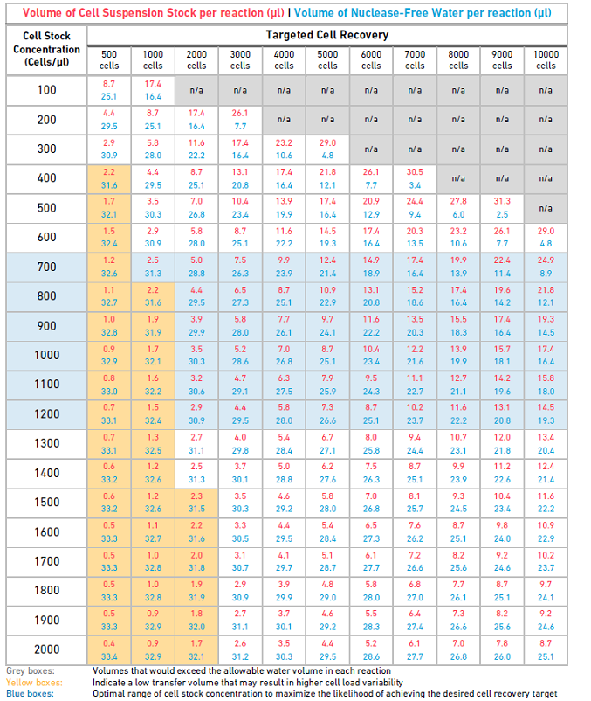
    - Add the water first, if needed, using a P20 and the volume listed in blue text above.
    - To add the cells, triturate the cell solution 10 times, with the tip opening in the middle of the cell solution, using a P200 with a low-retention Pasteur tip @ the volume listed in red in the targeted cell recovery table.
    - Note: For nuclei, use a regular filtered P200 low-retention tips.
      - Immediately add the homogenous cell solution to the TempAssure 8-strip containing RT master mix using the same P200 pipette and tip that were used to homogenize the sample.
    - Gently pipette mix (10x) the tubes containing the cells and RT master mix using an 8-channel P200 equipped with low-retention Pasteur tips @ 90 µl.
      - Note: For nuclei, use a regular filtered P200 low-retention tips.
      - Without discarding the tips, transfer 90 µl of the cells and master mix to the wells in labeled row 1.
        - Pipette slowly with the tips in the bottom of the central well depression and taking 2 seconds to depress the pipette plunger while raising the tips at the same rate the solution is filling the wells.
        - Take care to not introduce air bubbles.
    - Allow the chip to sit and gravity prime for at least 30 seconds before adding any additional reagents.
    - During the 30s-chip prime, snap the Singe Cell 3’ Gel Beads (120235) into the 10X vortex adapter (330002) and vortex on max speed for 30 seconds.
    - Remove the beads from the vortex adapter, and using your wrist sharply snap the bead strip downwards to collect the beads in the bottom of the well and remove air bubbles.
    - Pierce the foil on the bead strips using fresh P200 tips.
      - Discard the tips after piercing.
    - Using an 8-channel P200 @ 40 µl and low-retention tips, add 40 µl of Single Cell 3’ Gel Beads (120235) to the labeled row 2 of the chip.
      - Pipette slowly with the tips in the bottom of the central well depression and taking 2 seconds to depress the pipette plunger while raising the tips at the same rate the solution is filling the wells.
      - Take care to not introduce air bubbles.
    - Add 270 µl of partitioning oil (220088) to labeled row 3 using a P1000 @ 270 µl and a low-retention Pasteur tip.
      - Pipette the oil slowly just above the bottom of the well, avoiding bubbles.
    - Touching only the outer edges of the 10X Gasket (370017), attach it smooth side down to the chip holder lining up the notch on the upper left corner of the chip and gasket.
      - Do not tip the chip holder, keep the assembly horizontal to avoid any wetting of the 10X Gasket with partitioning oil.
      - Do not press downwards on the gasket. This will lead directly to “wetting errors” that produce failed libraries.
    - Place the assembly into the Chromium Controller.
    - Press the large “Eject” button in the middle of the screen to load the chip.
    - Press the large “Play” button on the screen to begin running the chromium controller.
      - Runs will take a little over 6 minutes to finish.
    - Return reagents to their proper storage locations.
      - Note the freeze/thaw cycles of the beads as this may affect performance.
    - Proceed directly to GEM Transfer and RT
  - GEM Transfer and RT:
    - Label a semi-skirted Twin.Tek PCR plate (Eppendorf #0030129326) with the capture name according to the paperwork.
      - Place this plate onto the Integra aluminum block in the ice bucket to chill.
    - Start the GEM-RT protocol on the C1000 thermocycler to get the block and lid to temperature.
    - Upon completion of GEM formation on the Chromium Controller, press the large “eject” button on the screen.
    - Remove the chip assembly from the Chromium Controller.
    - Carefully remove and discard the 10X Gasket from the assembly.
    - Open the 10X Chip holder (330019) and fold the lid backwards until it clicks to create a 45 degree well angle.
    - Slowly aspirate 100 µl of GEMs from the lowest point of the recovery wells (labeled with a left arrow) using a P200 @ 100 µl and low-retention Pasteur tips.
      - GEMs have high viscosity and need to be pipetted slowly.
      - GEMs should appear even; excess partitioning oil suggests a clog occurred during the run.
    - Photo document the GEMs, Naming the photo after the load ID and saving it in the 10xV2_GEM_Photos folder on PWA.
    - Dispense the GEMs into the labeled Twin.Tek PCR plate slowly over the course of several seconds.
      - Pipette against the sidewalls of the wells, keeping the tips above liquid level to minimalize GEM loss.
    - Seal the Twin.Tek PCR plate using BioRad microseal ‘B’ (BioRad #MSB1001) and a plastic spatula.
    - If the GEM solution has air gaps, spin down the plate for 10s at 1000xg.
    - Load the plate onto the thermocycler running the GEM-RT program.
Lid Temperature | Reaction Volume | Run Time
53C | 125ul | 55 min
Step | Temperature © | Time (Min)
1 | 53 | Hold
2 | 53 | 45:00:00
3 | 85 | 5:00
4 | 4 | Hold

    - Advance the thermocycler program to begin RT.
      - Run time is around 55 minutes.
    - Re-seal the plate with an aluminum seal
    - Upon completion, plate may be stored at 4C for up to 72 hours or at -20C for up to one week.
    - When ready, proceed directly to Post GEM-RT Cleanup and cDNA Amplification.
  - Post GEM-RT Cleanup and cDNA Amplification:
    - Conduct the following steps in a Post-AMP PCR clean hood.
    - Remove the DynaBeads MyOne Silane Beads (2000048) from the 4C and allow them to equilibrate to room temperature (30 minutes).
    - Fill the ice bucket with ice and place both the Integra aluminum PCR block and 1.5-2.0 ml aluminum microtube block on ice to cool.
    - From the 10X Chromium Single Cell 3’ Library and Gel Bead Kit v2 (10X Genomics #120237) stored at -20C, remove the following items and allow them to thaw.
      - cDNA Additive (220067)
      - cDNA Primer Mix (220106)
      - Additive A (220074)
    - Once thawed, vortex and briefly centrifuge.
    - Check Additive A (220074) for precipitates. Leave this reagent at room temperature after initial thaw.
    - Keep the cDNA Primer Mix (220106) and cDNA Additive (220067) at room temperature until needed.
    - From the 10X Chromium Single Cell 3’ Library and Gel Bead Kit v2 (10X Genomics #120237) stored at -20C, remove the Amplification Master Mix (220125) and place it in the aluminum microtube block on ice.
    - Remove the tubes of Buffer Sample Clean Up 1 (220020) from the kit and place them in the Eppendorf ThermoMixer C at 65C for 10 minutes at max speed (3,000 x RPM).
      - Check for precipitates and crystals. Vortex and return to the ThermoMixer for an additional 2 minutes if crystals are present.
      - Repeat as needed.
      - Allow tubes to cool to room temperature before using.
    - Prepare 15 ml of 80% Ethanol in a 15 ml conical Falcon tube (Corning# 430790) by combining 12 ml of 100% Ethanol with 3 ml of water using two 10mL serological pipettes, switching tips between reagents.
    - Retrieve the RT-GEM plate from either -20C or 4C storage.
    - Add 125 µl of Recovery Agent (220016) to each well using a single-channel P200 @ 125 µl.
      - Use care not to touch the surface of the fluid to avoid complexity loss.
      - Do not pipette mix or vortex this biphasic mixture.
    - After 60s, transfer the biphasic mixture to a TempAssure PCR 8-strip (USA Scientific #1402-4700) using 2x P200 @ 115 µl and low-retention Pasteur tips.
    - Carefully pipette out the organic pink phase from the bottom of the tubes using an 8-channel P200 @ 115 µl and low-retention tips.
      - Remove any significant volumes of organic pink phase using a single channel P20 with low-retention tips and volumes of close to 5 µl based off visual estimates.
      - Do not remove all the organic phase since much of the cDNA exists at the interphase between layers. Leave between 5-10 µl of pink fluid in the bottom of every well of the sample strip.
    - Vortex the DynaBeads MyOne Silane Beads (2000048) until fully re-suspended.
    - Prepare DynaBeads cleanup mix by adding the following reagents, in order, to a 1.5 ml Eppendorf LoBind tube (Eppendorf #022431021):
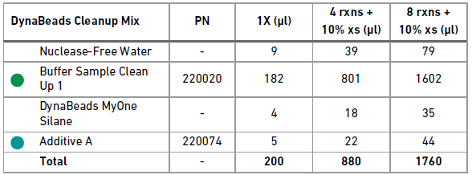
      - Add 79 µl of NfdH2O to the DynaBeads Cleanup Mix 1.5 ml Eppendorf LoBind tube by using a P200 @ 79 µl.
      - Vortex and spin down the room-temperature Buffer Sample Clean Up 1 (220020) tubes.
      - Add 1602 µl of Buffer Sample Clean Up 1 (220020) to the 1.5 ml Eppendorf tube using a P1000 @ 1000 µl and a P1000 @ 602 µl.
      - Add 35 µl of homogenized and fully re-suspended DynaBeads MyOne Silane beads (2000048) to the DynaBeads Cleanup Mix 1.5 ml Eppendorf tube using a P200 @ 35 µl.
      - Vortex and add 44 µl of Additive A (220074) to the DynaBeads Cleanup Mix 1.5 ml tube using a P200 @ 44 µl.
    - Vortex the DynaBeads Cleanup Mix 1.5 ml tube at max speed for 15 seconds.
      - Spin down briefly to collect.
    - Add 200 µl of DynaBeads Cleanup Mix to the sample strip using a P200 @ 200 µl using low retention tips.
      - Do not touch the sample with the pipette tips or pipette mix the solutions.
    - Close the caps and briefly vortex the strip for 5 seconds at max speed.
    - Allow the samples to sit at room temperature for at least 10 minutes.
    - During the 10-minute incubation, prepare Elution Solution 1 by adding the reagents in the order shown below to a 1.5 ml Eppendorf LoBind tube (Eppendorf #022431021):
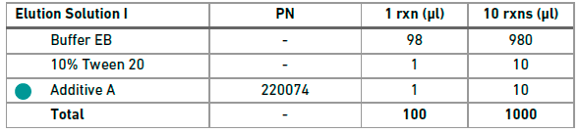
      - Add 980 µl of Buffer EB (Qiagen# 19086) using a P1000 @ 980 µl to the Elution Solution 1 tube.
      - Add 10 µl of 10% Tween 20, from the 1 ml aliquot prepared earlier, to the Elution Solution 1 tube by using a P20 @ 10 µl.
      - Vortex and add 10 µl of Additive A (220074) to the Elution Solution 1 tube using a P20 @ 10 µl.
    - Aliquot out 40 µl into each well of a new TempAssure PCR 8-strip using a P200 @ 40 µl.
      - Label that strip “ES1” and set it aside for now.
    - Label 0.2 ml TempAssure PCR tubes (USA Scientific# 1402-8100) for each sample and set aside for now.
    - Once the 10-minute incubation is complete, briefly spin down the tube strip and place it in the 10X Magnetic Separator (120250) in the “High” position.
    - Wait 2 minutes or until the supernatant is clear.
    - Free pour roughly 5 ml of 80% Ethanol into a 25 ml divided reservoir (VWR# 41428-958) and set this aside.
      - Discard tips and waste into an appropriate waste container.
    - Once the sample strip is clear, carefully remove the supernatant using a P200 @ 150 µl (twice) equipped with low retention tips.
      - Discard tips and waste into an appropriate waste container.
    - Add 150 µl of 80% Ethanol to each well of the sample strip using an 8-channel P200 @ 150 µl and low retention tips.
    - Immediately add another 150 µl of 80% Ethanol, using an 8-channel P200 @ 150 µl and new low retention tips, for a total of 300 µl.
    - Let this solution stand for 30 seconds.
    - Carefully remove and discard the Ethanol wash using an 8-channel P200 @ 150 µl with low retention tips.
      - Repeat with new tips to remove all the residual Ethanol.
    - Carefully add 200 µl of 80% Ethanol to the 8-strip using an 8-channel P200 @ 200 µl with low retention tips.
      - Let solution stand for 30 seconds.
    - Remove the Ethanol wash using an 8-channel P200 @ 200 µl with low retention tips.
    - Remove the strip from the 10X Magnetic Separator (120250) and briefly spin it down.
    - Place the strip back into the 10X Magnetic Separator (120250) on the “Low” position.
    - Start a timer for 1 minute.
    - During the 1 minute wait, remove any remaining Ethanol from the strips using an 8-channel P20 @ 10 µl with low retention tips.
    - At the end of the 1 minute drying, remove the strip form the 10X Magnetic Separator (120250) and immediately add 35.5 µl of Elution Solution 1 from the “ES1” strip using an 8-channel P200 @ 35.5 µl with low retention tips.
    - Close the strip caps and pulse vortex them at max speed for 15 seconds.
    - Briefly spin the strip to collect the sample and incubate it off magnet at room temperature for 5 minutes.
    - Return the strip to the 10X Magnetic Separator (120250) in the “Low” position.
      - Leave the strip in the separator until it clears (around 1 minute).
    - Transfer 35 µl of purified GEM-RT products to pre-labeled 0.2 ml TempAssure PCR tubes (USA Scientific# 1402-8100) using a P200 @ 35 µl with low retention tips.
    - Place PCR tubes in the Integra aluminum block in the ice bucket and proceed with preparation of cDNA amplification.
    - Create cDNA Amplification MM by adding the following reagents, in order, to a 1.5 ml Eppendorf low-bind tube (Eppendorf #022431021).
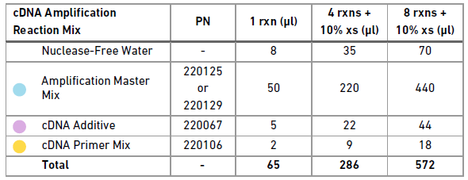
      - Vortex and add 70 µl of NFdH2O (Thermo #AM9937) to the cDNA Amplification Master Mix tube using a P200 @ 70 µl.
      - Vortex and add 440 µl of Amplification Master Mix (220125) to the cDNA Amplification Master Mix tube using a P1000 @ 440 µl.
      - Vortex and add 44 µl of cDNA Additive (220067) to the cDNA Amplification Master Mix tube using a P200 @ 44 µl.
      - Vortex and add 18 µl of cDNA Primer Mix (220106) to the cDNA Amplification Master Mix tube using a P20 @ 18 µl.
    - Vortex the cDNA Amplification Master Mix for 5s on max.
    - Spin down the master mix tube briefly to collect.
    - Add 65 µl of cDNA Amplification master mix to each sample using a P200 @ 65 µl.
      - Take care to not touch the pipette tip to the sample when pipetting. Do not pipette mix the sample.
    - Close the caps on the sample tubes and briefly vortex for 5 seconds on max speed.
    - Spin down the PCR tubes to collect the volume and return the tubes to the aluminum block in the ice bucket.

    - To determine PCR cycling conditions, consult the following table. Use intermediate values for numbers near the borders.
AMPLIFICATION | Cells | Nuclei
Targeted Cell Capture | cDNA Amp Cycles | cDNA Amp Cycles
<2000 | 14 | 16
2000-6000 | 12 | 14
6000-10000 | 10 | 12
>10000 | 8 | 10

    - Load the tubes containing cDNA and master mix onto a thermocycler and run “cDNA PCR NN” where NN is equal to the number of cycles for each sample.
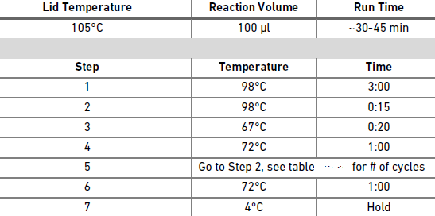
      - Upon completion of PCR, samples may either be stored at 4C for up to 72 hours or proceed directly with SPRIselect cleanup.
    - To begin cleanup, vortex the SPRIselect reagent on max speed until fully re-suspended.
    - Label a TempAssure PCR 8-strip (USA Scientific #1402-4700) “Beads” for SPRIselect reagent.
    - Free pour 5 ml of 80% Ethanol into the 25 ml divided reservoir.
    - Label three additional TempAssure PCR 8-strips (USA Scientific #1402-4700), one for post-cleanup samples, one for sample QC, and one for EB storage.
    - Fill the 8-strip labeled for EB storage with 50 µl of Qiagen Buffer EB using a P200 @ 50 µl.
    - Add 65 µl of fully homogenized SPRI to the “Beads” TempAssure PCR 8-strip using a P200 @ 65 µl.
    - Using an 8-channel P200 @ 60 µl, transfer 60 µl of the homogenized SPRI from the “Beads” 8-strip to the sample strip using low retention tips.
    - Pulse vortex the 8-strip with PCR products and SPRI beads 15 times at max speed.
    - Incubate the strip for 5-minutes at room temperature.
    - Once the 5-minute incubation is over, place the 8-strip into the 10X Magnetic Separator (120250) using the “High” position.
      - Leave the strips on the magnet with their lids closed until clear.
        - This step generally takes between 2-5 minutes. Check every 2 minutes until clear.
    - Carefully remove and discard the supernatant using an 8-channel P200 @ 180 µl taking care not disturb the bead pellet.
    - Carefully wash the beads by slowly adding 200 µl of 80% Ethanol from the reservoir using a P200 @ 200 µl.
      - Let the wash solution stand on the beads for 30 seconds.
    - Carefully remove and discard the wash solution using an 8-channel P200 @ 200 µl.
    - Repeat the wash step by adding a fresh aliquot of 80% Ethanol from the reagent reservoir using an 8-channel P200 @ 200 µl.
      - Let the wash solution stand for 30 seconds.
    - Remove and discard the Ethanol wash using an 8-channel P200 @ 200 µl.
    - Remove the 8-strip from the magnet, cap it, and very briefly (<10s) spin the tube down.
    - Immediately return the 8-strip to the magnet, this time in the “Low” position.
    - Start a lab timer for 2 minutes, uncap the tubes, and remove any residual Ethanol using an 8-channel P20 @ 10 µl.
      - It is very important not to over dry the samples, so small amounts of residual Ethanol are fine.
    - Upon completing the end of the 2-minute drying, remove the strip from the magnet and add 40.5 µl of Qiagen Buffer EB (Qiagen# 19086) from the EB 8-strip using an 8-channel P200 @ 40.5 µl.
      - Pipette mix the samples 15 times or until the beads are fully re-suspended.
    - Close the caps and briefly pulse vortex the strip 10x at max speed.
    - Let the strip incubate off magnet for 5 minutes at room temperature.
    - Briefly spin down the strip to collect the volume.
    - Upon completion of the 5-minute room temperature incubation, place the 8-strip back into the 10X Magnetic Separator in the “High” position.
      - Leave the sample on the magnet until it clears (around 2 minutes).
    - Transfer 40 µl of the cleaned post cDNA amplified products to the pre-labeled TempAssure 8-strip using a P200 @ 40 µl.
    - Add 8 µl of Qiagen Buffer EB (Qiagen# 19086) from the EB 8-strip to the QC labeled 8-strip using an 8-channel P10 @ 8 µl.
    - Transfer 2 µl of cleaned post cDNA amplified product to the QC strip using an 8-channel P10 @ 2 µl.
      - Close and vortex the QC strip for 5 seconds at max speed then spin down to collect.
      - Store the QC strip and 4C until ready for Post AMP 10X Quant and QC.
    - Store cleaned cDNA samples at 4C for up to 72 hours, or -20C for up to one week before library preparation.
  - Post AMP 10X Quant and QC
    - Follow MB0194: 384-well PicoGreen to quantify the sample, using 3 µl from the 5x diluted QC strip.
    - Multiply the resulting concentration and yield by 5 to achieve the actual sample concentration and yields.
    - Run 1 µl of the 5x diluted 10X QC sample on the FA using the FA SOP.
      - Check the trace of the amplified cDNA. High quality cDNA should closely resemble the following:
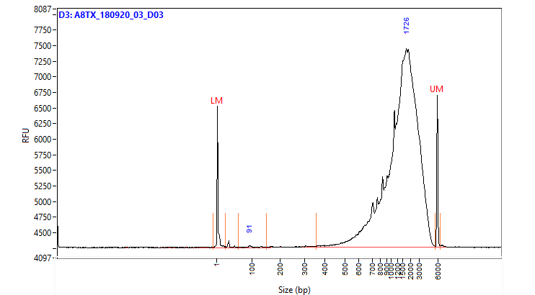

    - In addition, check the trace for:
      - Any extraneous peaks.
      - Significant products smaller than 400bp.
      - Significant differences in yield when compared to PicoGreen results.
    - Samples which do not pass QC should not proceed to library preparation. All other samples should proceed with 10X Library Construction.
  - 10X Library Construction
    - Conduct the following steps in a Post-AMP PCR hood.
    - Fill an ice bucket with ice and place both the Integra aluminum block and 1.5-2 ml microtube block on the ice to chill.
    - Remove the following items from the Chromium Single Cell 3’ Library and Gel Bead Kit v2 (10X Genomics #120237) and allow them to equilibrate to room temperature:
      - Ligation Buffer (220109)
      - Fragmentation Buffer (220108)
      - Adaptor Mix (220074)
      - Si-PCR Primer (220111)
    - Remove the following items from the Chromium Single Cell 3’ Library and Gel Bead Kit v2 (10X Genomics #120237) and place them directly in the microtube block on ice:
      - Fragmentation Enzyme Blend (220107)
      - DNA Ligase (220110)
      - Amplification Master Mix (220125)
    - Remove the Chromium Multiplex i7 Index plate (10x Genomics #220103) from the -20C and place it at room temperature to thaw.
    - Fill a 50 ml Falcon tube (Corning # 352098) with 16 ml of 100% Ethanol using a 25 ml serological pipette (Greiner# 357525).
    - Add 4 ml of NFdH2O (Thermo #AM9937) to the 16 ml of Ethanol using a 10 ml serological pipette (Greiner# 607180) to make 2 0ml of 80% Ethanol.
    - Prepare a thermalcycler by initiating the Frag, A-Tail protocol.
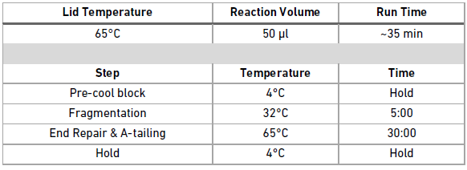
    - Remove the cleaned post cDNA amplified product from either the 4C or -20C and place it on the Integra block in the ice bucket.
    - Vortex the fragmentation buffer (220108) and verify there is no precipitate.
      - Vortex again if needed.
    - Prepare the fragmentation master mix on ice by adding the reagents in the order and volumes shown below to a 1.5 ml Eppendorf LoBind tube (Eppendorf #022431021).
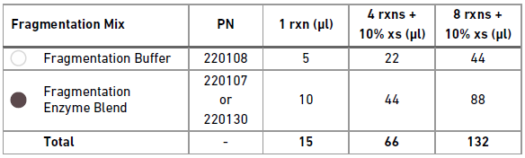
      - Vortex and add 44 µl of fragmentation buffer (220108) to the fragmentation mix tube using a P200 @ 44 µl.
      - Vortex and add 88 µl of fragmentation enzyme blend (220107) to the fragmentation mix tube using a P200 @ 88 µl.
    - Vortex the fragmentation master mix for 10 seconds at max speed. Spin down to collect.
    - At this point, assign i7 index primers to each sample and check them out on the tracking sheet linked in 6.4.
    - Together with a witness, label a new TempAssure PCR 8-tube strip with the sample names determined by the index well that will be used and place it on ice.
    - Add 15 µl of fragmentation master mix to each well in the new, labeled TempAssure PCR strip using a P20 @ 15 µl.
    - Under witness, transfer 35 µl of purified cDNA to each well containing the fragmentation master mix using an 8-channel P200 @ 35 µl.
    - Close the caps and pulse vortex 5 times at max speed.
    - Spin down the strip to collect the volume.
    - Transfer the tube strip to the pre-cooled thermocycler running the Frag, A-Tail protocol and press “Skip” to initiate the protocol.
    - Upon completion of the thermocycler protocol, proceed directly with double sided size selection using SPRIselect.
    - Vortex the SPRIselect reagent until fully re-suspended.
    - Fill a TempAssure 8-strip with 60 µl of Qiagen buffer EB (Qiagen# 19086) using a P200 @ 60 µl and label this strip “EB”.
    - Label a TempAssure 8-strip “Beads” and fill it with 45 µl of homogenized SPRIselect reagent.
    - Add 30 µl (0.6X) of SPRIselect reagent from the “Beads” strip to each sample using a P200 @ 30 µl.
    - Cap and pulse vortex the strip 5 times at max speed.
    - Allow the strip to incubate at room temperature for 5 minutes.
    - Spin down the strip to collect the volume and place it in the 10X magnetic separator in the “High” position.
    - Label a new TempAssure 8-strip.
    - Add 10 µl of SPRIselect reagent from the “Beads” 8-strip to each well of the newly labeled TempAssure strip using a P10 @ 10 µl.
    - Once the sample strip in the magnetic separator clears, transfer all 75ul, using an 8-channel P200 @ 75 µl of the supernatant to the new strip containing 10 µl of beads.
      - Do not discard the supernatant as it contains the desired fraction of the sample.
      - Discard the strip sitting on the magnetic separator.
    - Pulse vortex the TempAssure strip containing the sample and beads 5 times at max speed.
    - Allow the strip to incubate at room temperature for 5 minutes.
    - Spin down the strip to collect and place it in the 10X magnetic separator in the “High” position.
    - Fill the long half of a divided reservoir (VWR # 41428-958) with 5 ml of 80% Ethanol by free pouring.
    - Once the solution is clear, remove and discard 80 µl of supernatant using an 8-channel P200 @ 80 µl.
      - As the bead volume is small, it is critical to not disturb or remove any of the beads. Some residual volume is preferable to prevent this from occurring.
    - Add 125 µl of 80% Ethanol from the divided reservoir using an 8-channel P200 @ 125 µl.
    - Allow the Ethanol wash to stand for at least 30 seconds.
    - Carefully remove and discard the Ethanol wash with an 8-channel P200 @ 125 µl.
    - Repeat the wash by adding 125 µl of 80% Ethanol from the divided reservoir using an 8-channel P200 @ 125 µl.
    - Incubate the Ethanol wash for at least 30 seconds.
    - Carefully remove and discard the Ethanol wash with an 8-channel P200 @ 125 µl.
    - Cap the strip and briefly spin the tubes and return to the 10X magnetic separator in the “Low” position.
    - Remove the residual Ethanol with an 8-channel P20 @ 10 µl, being careful to not remove any of the beads.
    - Immediately remove the strip from the magnetic separator and add 50.5 µl of Qiagen buffer EB to the 8-strip using an 8-channel P200 @ 50.5 µl.
      - Pipette mix the beads until re-suspended.
      - Due to the low volume of beads it is critical to not over dry the beads, so re-suspend the beads immediately after the Ethanol is removed.
    - Incubate the strip and beads for 5 minutes at room temperature.
    - Spin down the strip briefly to collect the volume and place the strip back into the 10X magnetic separator in the “High” position.
    - Label a new TempAssure 8-strip.
    - Transfer 50 µl of the double-sided SPRIselect cleaned products into the newly labeled TempAssure 8-strip tube using a P200 @ 50 µl.
    - Dispose of the divided reservoir containing 80% Ethanol.
    - Start the 20C LIGATE protocol on the thermocycler.
Lid Temperature | Reaction Volume | Run Time
30°C | 100 µl | 15 min
Step | Temperature | Time
1 | 20°C | Hold
2 | 20°C | 15:00
3 | 4°C | Hold

    - Prepare adaptor ligation master mix in a 1.5 ml Eppendorf LoBind tube (Eppendorf #022431021) by vortexing and adding the following regents in order:
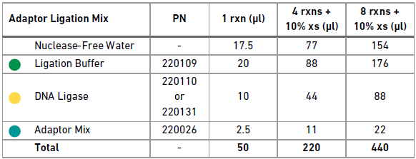
      - Add 154 µl of NFdH2O (Thermo #AM9937) using a P200 @ 154 µl.
      - Vortex and add 176 µl of ligation buffer (220109) using a P200 @ 176 µl.
      - Vortex and add 88 µl of DNA Ligase (220110) using a P200 @ 88 µl.
      - Vortex and add 22 µl of Adaptor Mix (220026) using a P200 @ 22 µl.
    - Vortex the adaptor ligation master mix at max speed for 5 seconds and spin down briefly to collect.
    - Add 50 µl of adaptor ligation master mix to each well of the 8-strip containing double-sided SPRIselect cleaned products.
    - Close the caps and vortex the strip for 5 seconds.
    - Spin down the strip briefly to collect the volume.
    - Transfer the strip to the thermocycler running the 20C LIGATE and advance the protocol to begin the 15 minute 20C ligation incubation.
    - Upon completion, return the samples to the Post-AMP hood to begin post-ligation cleanup.
    - Free-pour 5 ml of 80% Ethanol into a 25 ml divided reservoirs (VWR# 41428-958).
    - Label TempAssure 8-tube strip(s) (USA Scientific# 1402-4700) to accommodate the final cycling conditions and library IDs of each sample.
    - Label a TempAssure 8-tube strip (USA Scientific #1402-4700) “EB” and add 40 µl of Qiagen Buffer EB (Qiagen# 19086).
    - Vortex the SPRIselect reagent until fully re-suspended.
    - Add 80 µl of SPRIselect reagent to each sample in the 8-strip using a P200 @ 80 µl.
    - Cap the strip and pulse vortex it at max speed for 5 seconds.
    - Incubate the strip for 5 minutes at room temperature.
    - Place the strip in the 10x magnetic separator in the “High” position until the solution clears.
    - Carefully remove and discard the supernatant using an 8-channel P200 @ 180 µl.
    - Add 200 µl of 80% Ethanol from the reagent reservoir to the strip using an 8-channel P200 @ 200 µl.
    - Let the Ethanol wash stand for 30 seconds.
    - Carefully remove and discard the Ethanol wash using an 8-channel P200 @ 200 µl.
    - Repeat the Ethanol wash a second time by adding 200 µl of 80% Ethanol using an 8-channel P200 @ 200 µl.
    - After 30 seconds carefully remove and discard the Ethanol wash using an 8-channel P200 @ 200 µl.
    - Cap and briefly centrifuge the 8-strip to collect the residual Ethanol.
    - Start a timer for 2 minutes, place the 8-strip into the 10X magnetic separator on the “Low” position, and uncap the tubes.
    - Remove any residual Ethanol using an 8-channel P20 @10ul.
    - After the 2-minute drying time is up, remove the strip from the magnet and add 30.5 µl of Qiagen Buffer EB (Qiagen# 19086) from the “EB” strip using an 8-channel P200 @ 30.5 µl.
      - Vortex the beads and elution buffer at speed 9 until the beads are homogenous in solution.
    - Incubate the eluted beads in the strip for 5 minutes at room temperature.
    - Briefly centrifuge the strip to collect the volume and place it in the 10X magnetic separator in the “Low” position until the solution clears (around 2 minutes).
    - Transfer 30 µl of the post-ligation cleanup products to the labeled TempAssure 8-strip tubes.
    - Spin down the thawed Chromium Multiplex i7 Index Plate (10x Genomics #220103).
    - Briefly vortex the Sample Index PCR master mix reagents for 5 seconds at max speed.
    - Prepare the sample index PCR master mix by adding the reagents in the order and volumes listed below to a 1.5 ml Eppendorf LoBind tube:
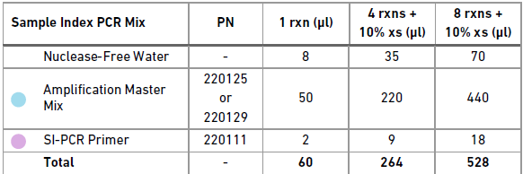
    - Add 70 µl of NFdH2O (Thermo #AM9937) using a P200 @ 70 µl.
    - Add 440 µl of Amplification Master Mix (220125) using a P1000 @ 440 µl.
    - Add 18 µl of SI-PCR Primer (220111) using a P20 @ 18 µl.
    - Pulse vortex the sample index PCR master mix 5x at max speed and spin down to collect.
    - Add 60 µl of sample index PCR mix to each tube containing the post ligation sample using a P200 @ 60 µl.
    - Under witness, add 10 µl of individual index from the Chromium Multiplex i7 Index Plate (10x Genomics #220103) to each well.
      - Record the index IDs associated with each sample for demultiplexing.
    - Cap and vortex the tubes for 10 seconds at max speed.
    - Consult the following table for the number of PCR cycles based off the amount of input determined by PicoGreen earlier:
    - After determining the PCR cycling conditions, run the following PCR protocol on the thermocycler: INDEX PCR NN where NN is equal to the number of PCR cycles.
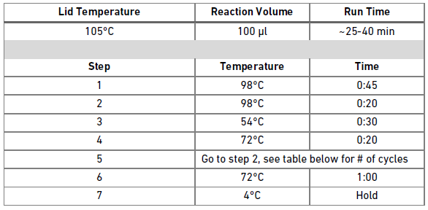
    - Store samples at 4C for up to 72 hours, or -20C for up to one week before proceeding with the final double-sided size selection.
    - Label four TempAssure 8-tube PCR strips, one for QC, one for buffer EB, and two for samples during cleanup.
    - Label a 96-well Eppendorf Twin.Tek Full-Skirted PCR plate (Eppendorf# 0030129300) with the library name for post-cleanup sample storage.
    - Add 50 µl of Qiagen Buffer EB (Qiagen# 19086) to the EB labeled strip.
    - Free pour 5 ml of 80% Ethanol into a new divided reservoir (VWR# 41428-958).
    - Vortex the SPRIselect reagent (Beckman Coulter #B23318) until completely re-suspended.
    - Label a TempAssure 8-tube PCR strip “Beads” and add 85 µl of homogenized SPRIselect reagent (Beckman Coulter #B23318) to each well.
    - Label a TempAssure 8-tube PCR strip with the sample IDs.
    - If necessary to condense the samples into single 8-strips, under witness, transfer the entire volume (100 µl) of sample from the 8-strip tubes to the corresponding wells of the sample ID labeled 8-strip.
    - Add 60 µl SPRI reagent from the “Beads” strip to the sample labeled 8-strip using an 8-channel P200 @ 60 µl.
    - Cap and vortex the tube strip and then let it stand at room temperature for 5 minutes.
    - Briefly spin down the strip to collect the volume and place it in the 10X magnetic separator in the “High” position.
    - In the other TempAssure 8-tube PCR strip labeled for cleanup, add 20 µl of SPRIselect reagent from the “Beads” strip to each well of the new 8-strip using a P20 @ 20 µl.
    - Once clear, transfer 150 µl of the supernatant from the strip on the magnetic separator to the strip containing 20 µl of SPRIselect using an 8-channel P200 @ 150 µl.
      - Take care to not transfer any of the beads at this point.
      - Discard the strip from the 10X magnetic separator with large products bound to the beads.
    - Cap and vortex the cleanup strip for 10 seconds at max speed.
    - Allow the strip to incubate off-magnet for 5 minutes at room temperature.
    - Once the incubation is over, place the strip into the 10X magnetic separator in the “High” position until the solution is clear.
    - Carefully remove and discard the supernatant using an 8-channel P200 @ 165 µl.
      - NOTE: Due to the low volume of beads it is important to not discard any beads with the supernatant, so the volumes will leave some small volume behind.
    - With the strip still in the magnetic separator, add 200 µl of 80% Ethanol to the beads to wash them using an 8-channel P200 @ 200 µl.
    - Allow the wash to stand for 30 seconds.
    - Remove and discard the Ethanol wash using an 8-channel P200 @ 200 µl.
    - Repeat the wash a second time by adding 200 µl of 80% Ethanol using an 8-channel P200 @ 200 µl.
    - Allow this wash to stand for 30 seconds.
    - Remove and discard the Ethanol wash using an 8-channel P200 @ 200 µl.
    - Cap the tubes and briefly centrifuge them to collect any residual volume.
    - Place the strip in the 10X magnetic separator in the “Low” position.
    - Remove and discard any residual Ethanol wash using an 8-channel P20 @ 10 µl.
    - Remove the strip from the magnet and immediately add 35.5 µl of Qiagen Buffer EB (Qiagen# 19086) from the “EB” labeled strip to the strip containing the beads using an 8-channel P200 @ 35.5 µl.
    - Vortex the beads on speed 9 until the solution is homogenous.
    - Allow the strip to stand off-magnet at room temperature for 5 minutes.
    - Return the strip to the 10X magnetic separator in the “Low” position until clear.
    - Transfer 35 µl from the tube strip into the labeled Twin.Tek 96-well PCR plate (Eppendorf# 0030129300) using an 8-channel P200 @ 35 µl.
      - The samples should be transferred to the well in the plate that corresponds with their selected index.
    - Add 9 µl of Qiagen Buffer EB (Qiagen# 19086) to the “QC” labeled strip using an 8-channel P10 @ 9 µl.
    - Add 1 µl of the cleaned 10X library product in the Twin.Tek 96-well PCR plate to the “QC” strip using an 8-channel P10 @ 1 µl.
    - Store samples at 4C for up to 72 hours, or -20C long term.
    - Proceed to Library Quant and QC using the 10-fold diluted 10x libraries in the QC strip.
  - Library Quant and QC
    - Follow MB0194: 384-well PicoGreen to quantify the sample, using 3 µl from the 10x diluted QC strip.
    - Multiply the resulting concentration and yield by 10 to achieve the actual sample concentration and yields.
    - Run 1 µl of the 10x diluted 10X QC sample on the FA using the FA SOP.
      - Check the trace of the amplified cDNA. High quality cDNA should closely resemble the following:
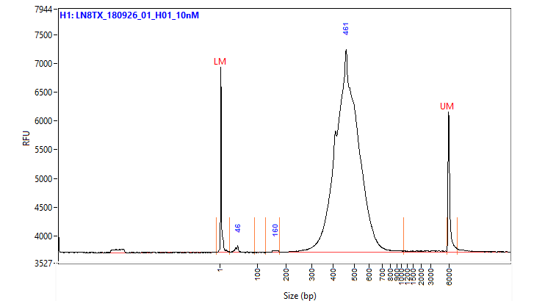
      - All products should be between 200-600bp since those are ideal sizes for sequencing.
      - Check for significant differences between the FA yield and PicoGreen yield.
- Take Down:
  - Return any unused reagents.
  - Clean the hood and ice bucket per the MolBio HowTo documents.
- Appendix:
  - Document Update Tracking Table
Name | Date | Doc Version | Changes Made
[Redacted] | 8/17/2018 | 0.1 | New draft SOP
[Redacted] | 2/14/2019 | 1.0 | New major version; all required approvals have been recorded

