10xV3 Genomics Sample Processing

- Scope and Applicability: Allows for rapid generation of 3’ transcriptomic-NGS-ready- single-cell-libraries from pools of cells.

- Materials:
  - Chromium Single Cell 3’ GEM Kit v3 16 rxns (-20ºC) (10X Genomics 1000077)
    - RT Reagent (2000086)
    - RT Enzyme C (2000085)
    - Template Switch Oligo (3000228)
    - Reducing Agent B (2000087)
    - Cleanup Buffer (2000088)
    - cDNA Primers (2000089)
    - Amp Mix (2000047)
  - Chromium Single Cell 3’ Library Kit v3 (-20ºC) (10X Genomics 1000078)
    - Fragmentation Enzyme Blend (2000090)
    - Fragmentation Buffer (2000091)
    - Ligation Buffer (2000092)
    - DNA Ligase (220110)
    - Adaptor Oligos (2000094)
    - SI Primer (2000095)
    - Amplification Mix (2000047)
  - DynaBeads MyOne Silane Beads (10X Genomics 2000048) (Stored at 4ºC)
  - Chromium Single Cell 3’ Gel Bead Kit v3 (10X Genomics 1000076) (-80ºC)
  - Chromium Chip B Single Cell Kit (10X Genomics 1000073) (RT)
    - Chip B Single Cell (2000060)
    - Gaskets (370017)
    - Partitioning Oil (220088)
    - Recovery Agent (220016)
  - Chromium Multiplex i7 Index Plate (10X Genomics 220103)
  - TempAssure PCR 8-tube strip (USA Scientific 1402-4700)
  - 0.2 ml TempAssure PCR Tube with frosted caps (USA Scientific 1402-8100)
  - 1.5 ml DNA LoBind Tubes (Eppendorf 022431021)
  - 2.0 ml DNA LoBind Tubes (Eppendorf 022431048)
  - SPRIselect Reagent Kit 60 ml (Beckman Coulter B23318)
  - Glycerol (EMP 4750)
  - Nuclease Free Water (Thermo AM9937 or equivalent)
  - Low TE Buffer (Teknova T0221)
  - Tween-20 (Millipore 655204-100ml)
  - 100% Ethanol (AAPER/Pharmco E200G-P)
  - Twin.Tek 96-well PCR Plate Semi-Skirted (Eppendorf 0030129326)
  - Twin.Tek 96-well PCR Plate, Full-Skirted (Eppendorf 0030129300)
  - BioRad Microseal ‘B’ (BioRad MSB1001)
  - High Sensitivity NGS Kit (DNF-474-33)
  - Quant-it PicoGreen Reagent Kit (Thermo P7589)
  - 50 ml conical polypropylene Falcon tubes (Corning 352098)
  - 15 ml conical polypropylene Falcon tube (Corning 430790)
  - 10 ml serological pipette tip (Greiner 607180)
  - 25 ml serological pipette tip (Greiner 357525)
  - 25 ml divided reservoirs (VWR 41428-958)
  - Qiagen Buffer EB (Qiagen 19086)
- Equipment:
  - PCR Hood with UV for chip loading and processing
  - 10X Genomics Chromium Controller
  - BioRad C1000 Thermocycler with a deep-well block
  - Rainin P1000, P20, P200, P10 single channel pipettes
  - Rainin P200, P20, and P10 8-channel pipettes
  - Rainin Pasteur P1000 and P200 low retention filtered tips
  - Rainin 200 and 20 µl low retention filtered tips
  - Rainin 1000, 200 and 20 µl tips filtered tips
  - Eppendorf ThermoMixer C with 1.5ml SmartBlock and heated lid (Eppendorf 2231000574)
  - Vortex Mixer
  - Ice Bucket
  - Integra aluminum PCR block
  - Aluminum 2 ml microtube rack
  - Microcentrifuge for both 1.5-2 ml tubes and 8-strips
  - Plate Sealer
  - Plastic spatula for sealing plates.
  - 10X Vortex Adapter (10X Genomics 330002)
  - 10X Chip Holder (10X Genomics 330019)
  - 10X Magnetic Separator (2x) (10X Genomics 120250)
  - Fragment Analyzer Instrument
  - Post-amplification PCR Hood
  - Post-amplification Vortex Mixer
  - Post-amplification Microcentrifuge for both 1.5-2 ml tubes and 8-strips
  - Camera for photo-documenting GEMs
  - Serological pipette
  - Lab timer with clock
- Safety:
  - Nitrile Gloves
  - Eye protection
  - Lab coat
  - Disposable Lab Sleeves
- Output:
  - Massively multiplexed single-cell NGS libraries.
- Reference Documents:
  - MB0073 Fragment Analyzer Operation for PCR Products
    - https://www.protocols.io/view/fragment-analyzer-operation-for-pcr-products-bg4yjyxw
  - MB0194 384-Well PicoGreen
    - https://www.protocols.io/view/384-well-picogreen-bezejf3e/abstract
  - Appropriate current link tracking index usage e.g.

Warning: Personal Protective Equipment (PPE) should be used at all times while operating this protocol. If you are unsure what PPE you should be using, see your immediate supervisor.

- Setup (At Least One Hour Before Starting):
  - Prepare 50x 1 ml aliquots of 50% glycerol by adding 25 ml glycerol to 25 ml of NFdH2O in a 50 ml falcon tube.
    - Vortex the tube for 10 sec on setting 9.
    - Aliquot out 1 ml of the 50% glycerol into 2.0 ml DNA LoBind Tubes using a P1000 @ 1000 µl.
    - Store these tubes at -20ºC until needed.
  - Prepare 50x 1 ml aliquots of 10% Tween 20 by adding 5 ml of Tween 20 to 45 ml of NFdH2O in a 50 ml falcon tube.
    - Invert 20x to mix and let stand at room temperature for 5 minutes.
    - Aliquot out 1 ml of the 10% Tween 20 into ml DNA LoBind Tubes.
    - Store the aliquots at room temperature until needed.
    - Dispose of the aliquots after 1 year.
  - Fill the ice bucket with ice and place both the Integra aluminum PCR block and the aluminum 2.0 ml microtube rack onto the ice to cool.
  - If processing fewer than 8 reactions, set aside 3 aliquots of 50% glycerol and equilibrate to room temperature.
  - Remove Reducing Agent B (200087) from the kit and allow it to thaw at room temperature for 30 minutes.
  - Remove the Chromium Single Cell 3’ v3 Gel Beads (200059) from the -80ºC and allow them to equilibrate at room temperature for at least 30 minutes.
  - Suspend the lyophilized Template Switch Oligo (3000228) in 80 µl of Low TE Buffer (Teknova T0221) by briefly centrifuging the oligoes and then using a P200 @ 80 µl to add the low TE.
  - Vortex the primers on max for 15s, centrifuge briefly, and then leave at room temperature for 30 minutes.
  - Allow the RT Reagent (2200086) to thaw and equilibrate to room temperature.
  - Once thawed, vortex the RT Reagent (2200086), Reducing Agent B (2000087), and re-suspended Template Switch Oligo (3000228) for 15 sec on max.
    - Verify there are no precipitates before returning to the RT Reagent (2200086), the Reducing Agent B (2000087) and Template Switch Oligo (3000228) to room temperature.
      - Repeat every 5 minutes as necessary until no precipitates are present.
  - Remove the RT Enzyme C (2000085) from the kit and place it in the aluminum block in the ice bucket.
  - Using care to only handle the edges and avoiding contact with the ports or bottom surface, place a Chromium Chip B Single Cell (2000060) into the 10X chip holder (330019).
  - Prior to chip loading, if fewer than 8 reactions are planned, add the following volumes of 50% glycerol to each unused well, in the following order:
    - 75 µl in labeled row 1 unused wells using a P200 @ 75 µl.
    - 40 µl in labeled row 2 unused wells using a P200 @ 40 µl.
    - 280 µl in labeled row 3 unused wells using a P1000 @ 280 µl.
- Methodology/Procedures:
  - Chip Loading and GEM Generation:
    - Conduct the following steps in the designated PCR clean UV hood to prevent contamination and potential wetting failures.
    - Prepare enough RT master mix for each reaction with 10% excess volume by consulting the following table, vortexing each reagent for 5 sec at max and adding reagents in the order listed to a 1.5 ml Eppendorf LoBind Tube (Eppendorf 022431021):
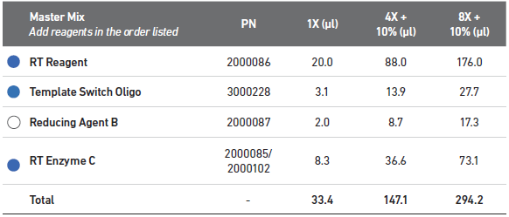
      - Add 176 µl of vortexed RT Reagent (2000086) to the 1.5 ml Eppendorf LoBind master mix tube using a P200 @ 176 µl.
      - Add 27.7 µl of Template Switch Oligo (3000228) to the master mix tube using a P200 @ 27.7 µl.
      - Add 17.3 µl of Reducing Agent B (2000087) to the master mix tube using a P20 @ 17.3 µl.
      - Add 73.1 µl of RT Enzyme C (2000085) to the master mix tube using a P200 @ 73.1 µl.
    - Vortex the master mix tube for 10 seconds at max speed.
    - Briefly spin down the master mix tube to collect.
    - Aliquot 33.4 µl of RT master mix into each well of a TempAssure PCR 8-strip using a P200 @ 33.4 µl.
    - Briefly spin down this strip and place it in the Integra aluminum block in the ice bucket.
    - After the cells or nuclei are sorted, cleaned and counted, use the targeted cell recovery table to calculate the volume of cells and water needed for addition to the TempAssure 8-strip containing the RT master mix.
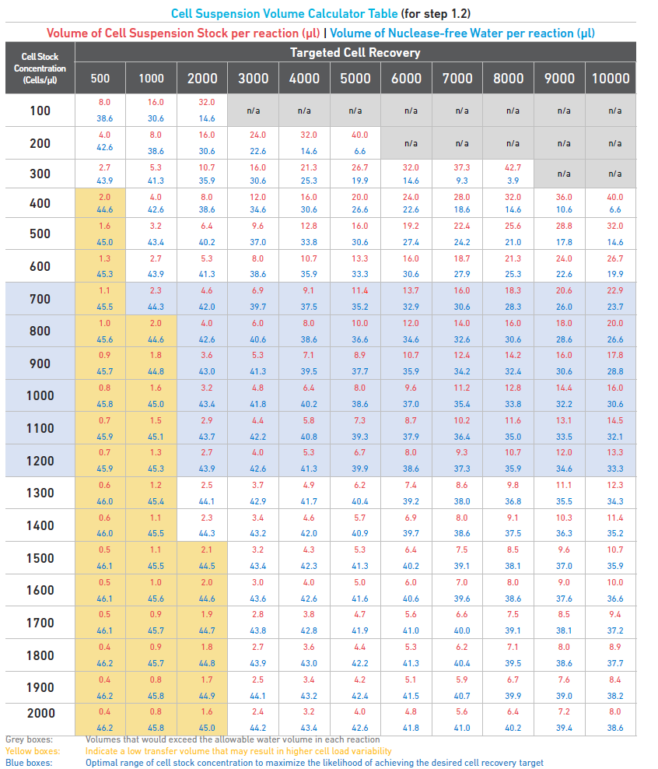
    - Add the water first, if needed, using a P20 and the volume listed in blue text above.
    - To add the cells, triturate the cell solution 10 times, with the tip opening in the middle of the cell solution, using a P200 with a low-retention Pasteur tip @ the volume listed in red in the targeted cell recovery table.
    - Note: For nuclei, use a regular filtered P200 low-retention tip.
      - Immediately add the homogenous cell solution to the TempAssure 8-strip containing RT master mix using the same P200 pipette and tips that were used to homogenize the sample.
    - Gently pipette mix (10x) the tubes containing the cells and RT master mix using an 8-channel P200 equipped with low-retention Pasteur tips @ 60 µl.
      - Note: For nuclei, use a regular filtered P200 low-retention tip.
      - Without discarding the tips, transfer 75 µl of the cells and master mix to the wells in labeled row 1 using the same 8-channel P200 @ 75 µl.
        - Pipette slowly with the tips in the bottom of the central well depression and taking 2 seconds to depress the pipette plunger while raising the tips at the same rate the solution is filling the wells.
        - Take care to not introduce air bubbles.
    - Allow the chip to sit and gravity prime for at least 30 seconds before adding any additional reagents.
    - During the 30s-chip prime, snap the Singe Cell 3’ Gel Beads (2000059) into the 10X vortex adapter (330002) and vortex on max speed for 30 seconds.
    - Remove the beads from the vortex adapter, and using your wrist sharply snap the bead strip downwards to collect the beads in the bottom of the well and remove air bubbles.
    - Pierce the foil on the bead strips using fresh P200 tips.
      - Discard the tips after piercing.
    - Using an 8-channel P200 @ 40 µl and low-retention tips, add 40 µl of Single Cell 3’ Gel Beads (120235) to the labeled row 2 of the chip.
      - Pipette slowly with the tips in the bottom of the central well depression and taking 2 seconds to depress the pipette plunger while raising the tips at the same rate the solution is filling the wells.
      - Take care to not introduce air bubbles.
    - Add 280 µl of partitioning oil (220088) to labeled row 3 using a P1000 @ 280 µl and a low-retention Pasteur tip.
      - Pipette the oil slowly just above the bottom of the well, avoiding bubbles.
    - Touching only the outer edges of the 10X Gasket (370017), attach it smooth side down to the chip holder lining up the notch on the upper left corner of the chip and gasket.
      - Do not tip the chip holder, keep the assembly horizontal to avoid any wetting of the 10X Gasket with partitioning oil.
      - Do not press downwards on the gasket. This will lead directly to “wetting errors” that produce failed libraries.
    - Place the assembly into the Chromium Controller.
    - Press the large “Eject” button in the middle of the screen to load the chip.
    - Press the large “Play” button on the screen to begin running the Chromium Controller.
      - Runs will take a little over 6 minutes to finish.
    - Return reagents to their proper storage locations.
      - Note the freeze/thaw cycles of the beads as this may affect performance.
    - Proceed directly to GEM Transfer and RT once the chip has finished running.
  - GEM Transfer and RT:
    - Label a semi-skirted Twin.Tek PCR plate (Eppendorf 0030129326) with the capture name according to the paperwork.
      - Place this plate onto the Integra aluminum block in the ice bucket to chill.
    - Start the GEM-RT protocol on the C1000 thermocycler to get the block and lid to temperature.
    - Upon completion of GEM formation on the Chromium Controller, press the large “eject” button on the screen.
    - Remove the chip assembly from the Chromium Controller.
    - Carefully remove and discard the 10X Gasket from the assembly.
    - Open the 10X Chip holder (330019) and fold the lid backwards until it clicks to create a 45 degree well angle.
    - Slowly aspirate 100 µl of GEMs from the lowest point of the recovery wells (labeled with a left arrow) using a P200 @ 100 µl and low-retention Pasteur tips.
      - GEMs have high viscosity and need to be pipetted slowly.
      - GEMs should appear even; excess partitioning oil suggests a clog occurred during the run.
    - Photo document the GEMs, Naming the photo after the load ID and saving it in the 10x_GEM_Photos folder on SharePoint.
    - Dispense the GEMs into the labeled Twin.Tek PCR plate slowly over the course of several seconds.
      - Pipette against the sidewalls of the wells, keeping the tips above liquid level to minimalize GEM loss.
    - Seal the Twin.Tek PCR plate using BioRad microseal ‘B’ (BioRad MSB1001) and a plastic spatula.
    - If the GEM solution has air gaps, spin down the plate for 10 sec at 1000xg.
    - Load the plate onto the thermocycler running the GEM-RT program.
Lid Temperature | Reaction Volume | Run Time
53C | 125ul | 55 min
Step | Temperature © | Time (Min)
1 | 53 | Hold
2 | 53 | 45:00:00
3 | 85 | 5:00
4 | 4 | Hold

    - Advance the thermocycler program to begin RT.
      - Run time is around 55 minutes.
    - Re-seal the plate with an aluminum seal
    - Upon completion, plate may be stored at 4ºC for up to 72 hours or at -20ºC for up to one week.
    - When ready, proceed directly to Post GEM-RT Cleanup and cDNA Amplification.
  - Post GEM-RT Cleanup and cDNA Amplification:
    - Conduct the following steps in a Post-AMP PCR clean hood.
    - Remove the DynaBeads MyOne Silane Beads (2000048) from the 4ºC and allow them to equilibrate to room temperature (30 minutes).
    - Fill the ice bucket with ice and place both the Integra aluminum PCR block and 1.5-2.0 ml aluminum microtube block on ice to cool.
    - From the 10X Chromium Single Cell 3’ Library and Gel Bead Kit v2 (10X Genomics 120237) stored at -20ºC, remove the following items and allow them to thaw.
      - cDNA Primers (2000089)
      - Reducing Agent B (2000087)
    - Once thawed, vortex and briefly centrifuge.
    - Check Reducing Agent B (2000087) for precipitates. Leave this reagent at room temperature after initial thaw.
    - Keep the cDNA Primers (2000089) at room temperature until needed.
    - Remove the Dynabeads MyOne Silane beads (2000048) from the 4ºC and allow them to equilibrate to room temperature.
    - From the 10X Chromium Single Cell 3’ Library and Gel Bead Kit v2 (10X Genomics 120237) stored at -20ºC, remove the AMP Mix (2200047) and place it in the aluminum microtube block on ice.
    - Remove the Cleanup Buffer (22000088)) from the kit and place them in the Eppendorf ThermoMixer C at 65ºC for 10 minutes at max speed (3,000 x RPM).
      - Check for precipitates and crystals. Vortex and return to the ThermoMixer for an additional 2 minutes if crystals are present.
      - Repeat as needed.
      - Allow tube to cool to room temperature before using.
    - Prepare 15 ml of 80% Ethanol in a 15 ml conical Falcon tube (Corning# 430790) by combining 12 ml of 100% Ethanol with 3 ml of water using two 10 ml serological pipettes, switching tips between reagents.
    - Retrieve the RT-GEM plate from either -20ºC or 4ºC storage.
    - Add 125 µl of Recovery Agent (220016) to each well using a single-channel P200 @ 125 µl.
      - Use care not to touch the surface of the fluid to avoid complexity loss.
      - Do not pipette mix or vortex this biphasic mixture.
    - After 60 sec, transfer the biphasic mixture to a TempAssure PCR 8-strip (USA Scientific 1402-4700) using 2x P200 @ 115 µl and low-retention Pasteur tips.
    - Carefully pipette out the organic pink phase from the bottom of the tubes using an 8-channel P200 @ 115 µl and low-retention tips.
      - Remove any significant volumes of organic pink phase using a single channel P20 with low-retention tips and volumes of close to 5 µl based off visual estimates.
      - Do not remove all the organic phase since much of the cDNA exists at the interphase between layers. Leave between 5-10 µl of pink fluid in the bottom of every well of the sample strip.
        - The strip should resemble the below image when finished.

    - Vortex the DynaBeads MyOne Silane Beads (2000048) until fully re-suspended.
    - Prepare DynaBeads cleanup mix by adding the following reagents, in order, to a 1.5mL Eppendorf LoBind tube (Eppendorf 022431021):
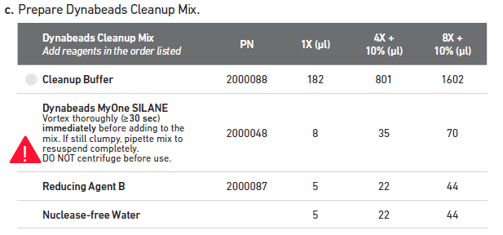
      - Add 44 µl of NfdH2O to the DynaBeads Cleanup Mix 1.5 ml Eppendorf LoBind tube by using a P200 @ 44 µl.
      - Vortex and spin down the room-temperature Cleanup Buffer (2000088).
      - Add 1602 µl of Cleanup Buffer (2000088) to the 1.5 ml Eppendorf tube using a P1000 @ 1000 µl and a P1000 @ 602 µl.
      - Add 70 µl of homogenized and fully re-suspended DynaBeads MyOne Silane beads (2000048) to the DynaBeads Cleanup Mix 1.5 ml Eppendorf tube using a P200 @ 70 µl.
        - Vortex thoroughly for >30s immediately before addition to the mix.
      - Vortex and add 44 µl of Reducing Agent B (2000087) to the DynaBeads Cleanup Mix 1.5 ml tube using a P200 @ 44 µl.
    - Vortex the DynaBeads Cleanup Mix 1.5mL tube at max speed for 15 seconds.
      - Spin down briefly to collect.
    - Add 200 µl of DynaBeads Cleanup Mix to the sample strip using a P200 @ 200 µl using low retention tips.
      - Do not touch the sample with the pipette tips or pipette mix the solutions.
    - Close the caps and briefly vortex the strip for 5 seconds at max speed.
    - Allow the samples to sit at room temperature for at least 10 minutes.
      - Vortex the strip again for 5 seconds at max speed after the first 5 minutes of the incubation.
    - During the 10-minute incubation, prepare Elution Solution 1 by adding the reagents in the order shown below to a 1.5 ml Eppendorf LoBind tube (Eppendorf 022431021):
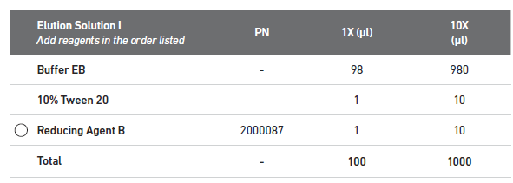
      - Add 980 µl of Buffer EB (Qiagen 19086) using a P1000 @ 980 µl to the Elution Solution 1 tube.
      - Add 10 µl of 10% Tween 20, from the 1 ml aliquot prepared earlier, to the Elution Solution 1 tube by using a P20 @ 10 µl.
      - Vortex and add 10 µl of Reducing Agent B (2000087) to the Elution Solution 1 tube using a P20 @ 10 µl.
    - Aliquot out 40 µl into each well of a new TempAssure PCR 8-strip using a P200 @ 40 µl.
      - Label that strip “ES1” and set it aside for now.
    - Label 0.2 ml TempAssure PCR tubes (USA Scientific 1402-8100) for each sample and set aside for now.
    - Once the 10-minute incubation is complete, briefly spin down the tube strip and place it in the 10X Magnetic Separator (120250) in the “High” position.
    - Wait 2 minutes or until the supernatant is clear.
    - Free pour roughly 5 ml of 80% Ethanol into a 25 ml divided reservoir (VWR 41428-958) and set this aside.
    - Once the sample strip is clear, carefully remove the supernatant using a P200 @ 150 µl (twice) equipped with low retention tips.
      - Discard tips and waste into an appropriate waste container.
    - Add 150 µl of 80% Ethanol to each well of the sample strip using an 8-channel P200 @ 150 µl and low retention tips.
    - Immediately add another 150 µl of 80%, using an 8-channel P200 @ 150 µl and new low retention tips, for a total of 300 µl.
    - Let this solution stand for 30 seconds.
    - Carefully remove and discard the ethanol wash using an 8-channel P200 @ 150 µl with low retention tips.
      - Repeat with new tips to remove all the residual ethanol.
    - Carefully add 200 µl of 80% ethanol to the 8-strip using an 8-channel P200 @ 200 µl with low retention tips.
      - Let solution stand for 30 seconds.
    - Remove the ethanol wash using an 8-channel P200 @ 200 µl with low retention tips.
    - Remove the strip from the 10X Magnetic Separator (120250) and briefly spin it down.
    - Place the strip back into the 10X Magnetic Separator (120250) on the “Low” position.
    - Start a timer for 1 minute.
    - During the 1 minute wait, remove any remaining ethanol from the strips using an 8-channel P20 @ 10 µl with low retention tips.
    - At the end of the 1 minute drying, remove the strip form the 10X Magnetic Separator (120250) and immediately add 35.5 µl of Elution Solution 1 from the “ES1” strip using an 8-channel P200 @ 35.5 µl with low retention tips.
    - Close the strip caps and pulse vortex them at max speed for 15 seconds.
    - Briefly spin the strip to collect the sample and incubate it off magnet at room temperature for 5 minutes.
    - Return the strip to the 10X Magnetic Separator (120250) in the “Low” position.
      - Leave the strip in the separator until it clears (around 1 minute).
    - Transfer 35 µl of purified GEM-RT products to pre-labeled 0.2 ml TempAssure PCR tubes (USA Scientific 1402-8100) using a P200 @ 35 µl with low retention tips.
    - Place PCR tubes in the Integra aluminum block in the ice bucket and proceed with preparation of cDNA amplification.
    - Create cDNA Amplification Reaction Mix by adding the following reagents, in order, to a 1.5 ml Eppendorf low-bind tube (Eppendorf 022431021).
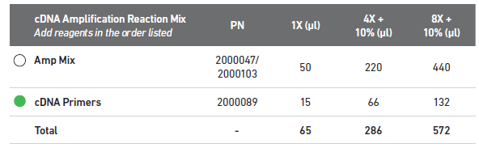
      - Vortex and add 440 µl of AMP Mix (2000047) to the cDNA Amplification Master Mix tube using a P1000 @ 440 µl.
      - Vortex and add 132ul of cDNA Primers (2000089) to the cDNA Amplification Master Mix tube using a P200 @ 132 µl.
    - Vortex the cDNA Amplification Reaction Mix for 5 sec on max.
    - Spin down the master mix tube briefly to collect.
    - Add 65 µl of cDNA Amplification master mix to each 35 µl sample using a P200 @ 65 µl.
      - Take care to not touch the pipette tip to the sample when pipetting. Do not pipette mix the sample.
    - Close the caps on the sample tubes and briefly vortex for 5 seconds on max speed.
    - Spin down the PCR tubes to collect the volume and return the tubes to the aluminum block in the ice bucket.

    - To determine PCR cycling conditions, consult the following table. Use intermediate values for numbers near the borders.
AMPLIFICATION | Cells | Nuclei
Targeted Cell Capture | cDNA Amp Cycles | cDNA Amp Cycles
<2000 | 14 | 16
2000-6000 | 12 | 14
6000-10000 | 10 | 12
>10000 | 8 | 10

    - Load the tubes containing cDNA and master mix onto a thermocycler and run “cDNA PCR NN” where NN is equal to the number of cycles for each sample.
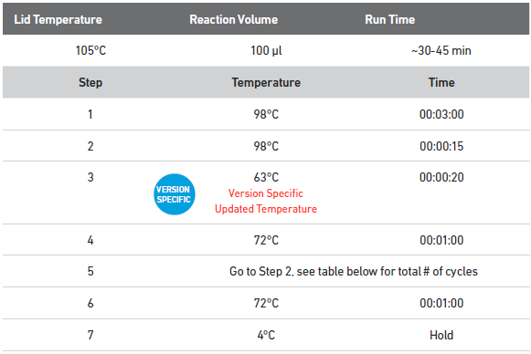
      - Upon completion of PCR, samples may either be stored at 4ºC for up to 72 hours or proceed directly with SPRIselect cleanup.
    - To begin cleanup, vortex the SPRIselect reagent on max speed until fully re-suspended.
    - Label a TempAssure PCR 8-strip (USA Scientific 1402-4700) “Beads” for SPRIselect reagent.
    - Free pour 5 ml of 80% ethanol into the 25 ml divided reservoir.
    - Label two additional TempAssure PCR 8-strips (USA Scientific 1402-4700), one for sample QC, and one for EB storage. Label one 96-well Eppendorf Twin.Tek Full-Skirted PCR plate (Eppendorf 0030129300) for the post-cleanup samples.
    - Fill the 8-strip labeled for EB storage with 50 µl of Qiagen Buffer EB using a P200 @ 50 µl.
    - Add 65 µl of fully homogenized SPRI to the “Beads” TempAssure PCR 8-strip using a P200 @ 65 µl.
    - Using an 8-channel P200 @ 60 µl, transfer 60 µl of the homogenized SPRI from the “Beads” 8-strip to the sample strip.
    - Pulse vortex the 8-strip with PCR products and SPRI beads 15 times at max speed.
    - Incubate the strip for 5-minutes at room temperature.
    - Once the 5-minute incubation is over, place the 8-strip into the 10X Magnetic Separator (120250) using the “High” position.
      - Leave the strips on the magnet with their lids closed until clear.
        - This step generally takes between 2-5 minutes. Check every 2 minutes until clear.
    - Carefully remove and discard the supernatant using an 8-channel P200 @ 180 µl taking care not disturb the bead pellet.
    - Carefully wash the beads by slowly adding 200 µl of 80% ethanol from the reservoir using a P200 @ 200 µl.
      - Let the wash solution stand on the beads for 30 seconds.
    - Carefully remove and discard the wash solution using an 8-channel P200 @ 200 µl.
    - Repeat the wash step by adding a fresh aliquot of 80% ethanol from the reagent reservoir using an 8-channel P200 @ 200 µl.
      - Let the wash solution stand for 30 seconds.
    - Remove and discard the ethanol wash using an 8-channel P200 @ 200 µl.
    - Remove the 8-strip from the magnet, cap it, and very briefly (<10 sec) spin the tube down.
    - Immediately return the 8-strip to the magnet, this time in the “Low” position.
    - Start a lab timer for 2 minutes, uncap the tubes, and remove any residual ethanol using an 8-channel P20 @ 10 µl.
      - It is very important not to over dry the samples, so small amounts of residual ethanol are fine.
    - Upon completing the end of the 2-minute drying, remove the strip from the magnet and add 40.5 µl of Qiagen Buffer EB (Qiagen 19086) from the EB 8-strip using an 8-channel P200 @ 40.5 µl.
      - Pipette mix the samples 15 times or until the beads are fully re-suspended.
    - Close the caps and briefly pulse vortex the strip 10X at max speed.
    - Let the strip incubate off magnet for 5 minutes at room temperature.
    - Briefly spin down the strip to collect the volume.
    - Upon completion of the 5-minute room temperature incubation, place the 8-strip back into the 10X Magnetic Separator in the “High” position.
      - Leave the sample on the magnet until it clears (around 2 minutes).
    - Transfer 40 µl of the cleaned post cDNA amplified products to the pre-labeled 96-well Eppendorf Twin.Tek Full-Skirted PCR plate using a P200 @ 40 µl.
    - Add 9 µl of Qiagen Buffer EB (Qiagen 19086) from the EB 8-strip to the QC labeled 8-strip using an 8-channel P10 @ 9 µl.
    - Transfer 1 µl of cleaned post cDNA amplified product to the QC strip using an 8-channel P10 @ 1 µl.
      - Close and vortex the QC strip for 5 seconds at max speed then spin down to collect.
      - Store the QC strip and 4ºC until ready for Post AMP 10X Quant and QC.
    - Store cleaned cDNA samples at 4ºC for up to 72 hours, or -20ºC for up to one week before library preparation.
  - Post AMP 10X Quant and QC
    - Follow MB0194: 384-well PicoGreen to quantify the sample, using 3 µl from the 10X diluted QC strip.
    - Multiply the resulting concentration and yield by 10 to achieve the actual sample concentration and yields.
    - Run 1 µl of the 10X diluted 10X QC sample on the FA using the FA SOP (MB0073: Fragment Analyzer Operation for PCR Products).
      - Check the trace of the amplified cDNA. High quality cDNA should closely resemble the following:
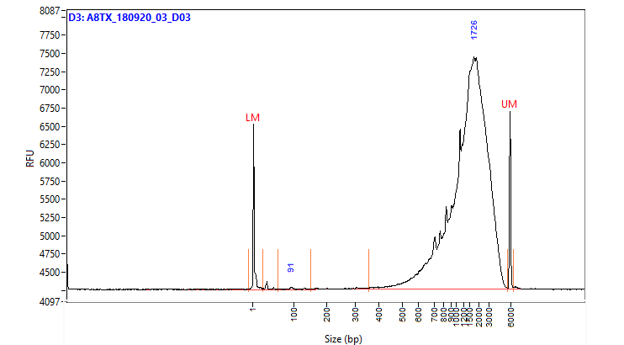

    - In addition, check the trace for:
      - Any extraneous peaks.
      - Significant products smaller than 400bp.
      - Significant differences in yield when compared to PicoGreen results.
    - Samples which do not pass QC should not proceed to library preparation. All other samples should proceed with 10X Library Construction.
  - 10X Library Construction
    - Conduct the following steps in a Post-AMP PCR hood.
    - Fill an ice bucket with ice and place both the Integra aluminum block and 1.5-2 ml microtube block on the ice to chill.
    - Remove the following items from the Chromium Single Cell 3’ Library and Gel Bead Kit v2 (10X Genomics 120237) and allow them to equilibrate to room temperature:
      - Ligation Buffer (2000092)
      - Fragmentation Buffer (2000091)
      - Adaptor Oligos (2000094)
      - SI Primer (2000095)
    - Remove the following items from the Chromium Single Cell 3’ Library and Gel Bead Kit v2 (10X Genomics 120237) and place them directly in the microtube block on ice:
      - Fragmentation Enzyme (2000090)
      - DNA Ligase (220110)
      - AMP Mix (2000047)
    - Remove the Chromium Multiplex i7 Index plate (10X Genomics 220103) from the -20ºC and place it at room temperature to thaw.
    - Fill a 50 ml Falcon tube (Corning 352098) with 16 ml of 100% ethanol using a 25 ml serological pipette (Greiner 357525).
    - Add 4 ml of NFdH2O (Thermo AM9937) to the 16 ml of ethanol using a 10 ml serological pipette (Greiner 607180) to make 20 ml of 80% ethanol.
    - Prepare a thermocycler by initiating the Frag, A-Tail protocol.
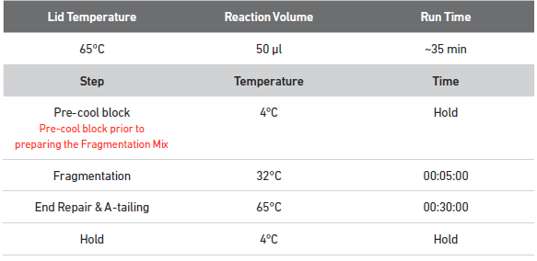
    - Remove the cleaned post cDNA amplified product from either the 4ºC or -20ºC and place it on the Integra block in the ice bucket.
    - Vortex the Fragmentation Buffer (2000091) and verify there is no precipitate.
      - Vortex again if needed.
    - Prepare the fragmentation master mix on ice by adding the reagents in the order and volumes shown below to a 1.5 ml Eppendorf LoBind tube (Eppendorf 022431021).
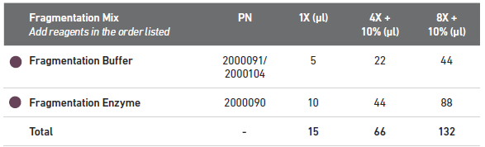
      - Vortex and add 44 µl of Fragmentation Buffer (2000091) to the fragmentation mix tube using a P200 @ 44 µl.
      - Vortex and add 88 µl of fragmentation Enzyme (2000090) to the fragmentation mix tube using a P200 @ 88 µl.
    - Vortex the fragmentation master mix for 10 seconds at max speed. Spin down to collect.
    - At this point, assign i7 index primers to each sample and check them out on the tracking sheet
    - Together with a witness, label a new TempAssure PCR 8-tube strip with the sample names determined by the index well that will be used and place it on ice.
    - Add 15 µl of fragmentation master mix to each well in the new, labeled TempAssure PCR strip using a P20 @ 15 µl.
    - Add 25 µl of Qiagen Buffer EB to each well using a P200 @ 25 µl, to bring the volume up to 40 µl.
    - Transfer 10 µl of purified cDNA to each well containing the fragmentation master mix using an 8-channel P10 @ 10 µl. Do this under witness to ensure sample integrity.
      - The remaining 30 µl of cDNA can be stored long term at -20ºC for generation of additional 3’ gene expression libraries.
    - Close the caps and pulse vortex 5 times at max speed.
    - Spin down the strip to collect the volume.
    - Transfer the tube strip to the pre-cooled thermocycler running the Frag, A-Tail protocol and press “Skip” to initiate the protocol.
    - Upon completion of the thermocycler protocol, proceed directly with double sided size selection using SPRIselect.
    - Vortex the SPRIselect reagent until fully re-suspended.
    - Fill a TempAssure 8-strip with 60 µl of Qiagen buffer EB (Qiagen 19086) using a P200 @ 60 µl and label this strip “EB”.
    - Label a TempAssure 8-strip “Beads” and fill it with 45 µl of homogenized SPRIselect reagent.
    - Add 30 µl (0.6X) of SPRIselect reagent from the “Beads” strip to each sample using a P200 @ 30 µl.
    - Cap and pulse vortex the strip 5 times at max speed.
    - Allow the strip to incubate at room temperature for 5 minutes.
    - Spin down the strip to collect the volume and place it in the 10X magnetic separator in the “High” position.
    - Label a new TempAssure 8-strip.
    - Add 10 µl of SPRIselect reagent from the “Beads” 8-strip to each well of the newly labeled TempAssure strip using a P10 @ 10 µl.
    - Once the sample strip in the magnetic separator clears, transfer all 75 µl, using an 8-channel P200 @ 75 µl of the supernatant to the new strip containing 10 µl of beads.
      - Do not discard the supernatant as it contains the desired fraction of the sample.
      - Discard the strip sitting on the magnetic separator.
    - Pulse vortex the TempAssure strip containing the sample and beads 5 times at max speed.
    - Allow the strip to incubate at room temperature for 5 minutes.
    - Spin down the strip to collect and place it in the 10X magnetic separator in the “High” position.
    - Fill the long half of a divided reservoir (VWR 41428-958) with 5 ml of 80% ethanol by free pouring.
    - Once the solution is clear, remove and discard 80 µl of supernatant using an 8-channel P200 @ 80 µl.
      - As the bead volume is small, it is critical to not disturb or remove any of the beads. Some residual volume is preferable to prevent this from occurring.
    - Add 125 µl of 80% ethanol from the divided reservoir using an 8-channel P200 @ 125 µl.
    - Allow the ethanol wash to stand for at least 30 seconds.
    - Carefully remove and discard the ethanol wash with an 8-channel P200 @ 125 µl.
    - Repeat the wash by adding 125 µl of 80% ethanol from the divided reservoir using an 8-channel P200 @ 125 µl.
    - Incubate the ethanol wash for at least 30 seconds.
    - Carefully remove and discard the ethanol wash with an 8-channel P200 @ 125 µl.
    - Cap the strip and briefly spin the tubes and return to the 10X magnetic separator in the “Low” position.
    - Remove the residual ethanol with an 8-channel P20 @ 10µl, being careful to not remove any of the beads.
    - Immediately remove the strip from the magnetic separator and add 50.5 µl of Qiagen buffer EB to the 8-strip using an 8-channel P200 @ 50.5 µl.
      - Pipette mix the beads until re-suspended.
      - Due to the low volume of beads it is critical to not over dry the beads, so re-suspend the beads immediately after the ethanol is removed.
    - Incubate the strip and beads for 5 minutes at room temperature.
    - Spin down the strip briefly to collect the volume and place the strip back into the 10X magnetic separator in the “High” position.
    - Label a new TempAssure 8-strip.
    - Transfer 50 µl of the double-sided SPRIselect cleaned products into the newly labeled TempAssure 8-strip tube using a P200 @ 50 µl.
    - Dispose of the divided reservoir containing 80% ethanol.
    - Start the 20C LIGATE protocol on the thermocycler.
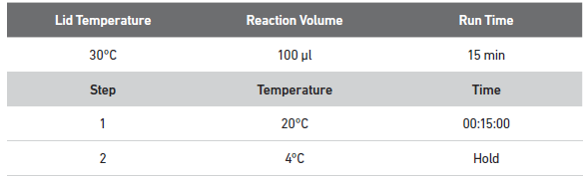
    - Prepare adaptor ligation mix in a 1.5 ml Eppendorf LoBind tube (Eppendorf 022431021) by vortexing and adding the following regents in order:
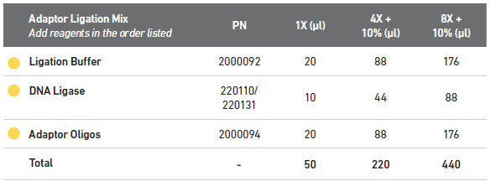
      - Vortex and add 176 µl of ligation buffer (2000092) using a P200 @ 176 µl.
      - Vortex and add 88 µl of DNA Ligase (220110) using a P200 @ 88 µl.
      - Vortex and add Adaptor Oligos (2000094) using a P200 @ 176 µl.
    - Vortex the adaptor ligation master mix at max speed for 5 seconds and spin down briefly to collect.
    - Add 50 µl of adaptor ligation master mix to each well of the 8-strip containing double-sided SPRIselect cleaned products.
    - Close the caps and vortex the strip for 5 seconds.
    - Spin down the strip briefly to collect the volume.
    - Transfer the strip to the thermocycler running the 20C LIGATE and advance the protocol to begin the 15 minute 20ºC ligation incubation.
    - Upon completion, return the samples to the Post-AMP hood to begin post-ligation cleanup.
    - Free-pour 5 ml of 80% ethanol into a 25 ml divided reservoirs (VWR 41428-958).
    - Label TempAssure 8-tube strip(s) (USA Scientific 1402-4700) to accommodate the final cycling conditions and library IDs of each sample.
    - Label a TempAssure 8-tube strip (USA Scientific 1402-4700) “EB” and add 40 µl of Qiagen Buffer EB (Qiagen 19086).
    - Vortex the SPRIselect reagent until fully re-suspended.
    - Add 80 µl of SPRIselect reagent to each sample in the 8-strip using a P200 @ 80 µl.
    - Cap the strip and pulse vortex it at max speed for 5 seconds.
    - Incubate the strip for 5 minutes at room temperature.
    - Place the strip in the 10X magnetic separator in the “High” position until the solution clears.
    - Carefully remove and discard the supernatant using an 8-channel P200 @ 180 µl.
    - Add 200 µl of 80% ethanol from the reagent reservoir to the strip using an 8-channel P200 @ 200 µl.
    - Let the ethanol wash stand for 30 seconds.
    - Carefully remove and discard the ethanol wash using an 8-channel P200 @ 200 µl.
    - Repeat the ethanol wash a second time by adding 200 µl of 80% ethanol using an 8-channel P200 @ 200 µl.
    - After 30 seconds carefully remove and discard the ethanol wash using an 8-channel P200 @ 200 µl.
    - Cap and briefly centrifuge the 8-strip to collect the residual ethanol.
    - Start a timer for 2 minutes, place the 8-strip into the 10X magnetic separator on the “Low” position, and uncap the tubes.
    - Remove any residual ethanol using an 8-channel P20 @10 µl.
    - After the 2-minute drying time is up, remove the strip from the magnet and add 30.5 µl of Qiagen Buffer EB (Qiagen# 19086) from the “EB” strip using an 8-channel P200 @ 30.5 µl.
      - Vortex the beads and elution buffer at speed 9 until the beads are homogenous in solution.
    - Incubate the eluted beads in the strip for 5 minutes at room temperature.
    - Briefly centrifuge the strip to collect the volume and place it in the 10X magnetic separator in the “Low” position until the solution clears (around 2 minutes).
    - Transfer 30 µl of the post-ligation cleanup products to the labeled TempAssure 8-strip tubes.
    - Spin down the thawed Chromium Multiplex i7 Index Plate (10X Genomics 220103).
    - Briefly vortex the Sample Index PCR master mix reagents for 5 seconds at max speed.
    - Prepare the sample index PCR master mix by adding the reagents in the order and volumes listed below to a 1.5 ml Eppendorf LoBind tube:
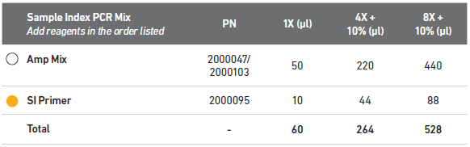
    - Add AMP Mix (2000047) using a P1000 @ 440 µl.
    - Add 88 µl of SI Primer (2000095) using a P200 @ 88 µl.
    - Pulse vortex the sample index PCR master mix 5x at max speed and spin down to collect.
    - Add 60 µl of sample index PCR mix to each tube containing 30 µl of post ligation sample using a P200 @ 60 µl.
    - Under witness, add 10 µl of individual index from the Chromium Multiplex i7 Index Plate (10X Genomics 220103) to each well.
      - Record the index IDs associated with each sample for demultiplexing.
    - Cap and vortex the tubes for 10 seconds at max speed.
    - Consult the following table for the number of PCR cycles based off the amount of input determined by PicoGreen earlier:
    - After determining the PCR cycling conditions, run the following PCR protocol on the thermocycler: INDEX PCR NN where NN is equal to the number of PCR cycles.
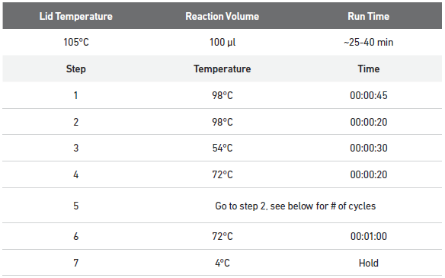
    - Store samples at 4ºC for up to 72 hours, or -20ºC for up to one week before proceeding with the final double-sided size selection.
    - Label four TempAssure 8-tube PCR strips, one for QC, one for buffer EB, and two for samples during cleanup.
    - Label a 96-well Eppendorf Twin.Tek Full-Skirted PCR plate (Eppendorf 0030129300) with the library name for post-cleanup sample storage.
    - Add 50 µl of Qiagen Buffer EB (Qiagen 19086) to the EB labeled strip.
    - Free pour 5 ml of 80% ethanol into a new divided reservoir (VWR 41428-958).
    - Vortex the SPRIselect reagent (Beckman Coulter B23318) until completely re-suspended.
    - Label a TempAssure 8-tube PCR strip “Beads” and add 85 µl of homogenized SPRIselect reagent (Beckman Coulter B23318) to each well.
    - Label a TempAssure 8-tube PCR strip with the sample IDs.
    - If necessary to condense the samples into single 8-strips, under witness, transfer the entire volume (100 µl) of sample from the 8-strip tubes to the corresponding wells of the sample ID labeled 8-strip.
    - Add 60 µl SPRI reagent from the “Beads” strip to the sample labeled 8-strip using an 8-channel P200 @ 60 µl.
    - Cap and vortex the tube strip and then let it stand at room temperature for 5 minutes.
    - Briefly spin down the strip to collect the volume and place it in the 10X magnetic separator in the “High” position.
    - In the other TempAssure 8-tube PCR strip labeled for cleanup, add 20 µl of SPRIselect reagent from the “Beads” strip to each well of the new 8-strip using a P20 @ 20 µl.
    - Once clear, transfer 150 µl of the supernatant from the strip on the magnetic separator to the strip containing 20 µl of SPRIselect using an 8-channel P200 @ 150 µl.
      - Take care to not transfer any of the beads at this point.
      - Discard the strip from the 10X magnetic separator with large products bound to the beads.
    - Cap and vortex the cleanup strip for 10 seconds at max speed.
    - Allow the strip to incubate off-magnet for 5 minutes at room temperature.
    - Once the incubation is over, place the strip into the 10X magnetic separator in the “High” position until the solution is clear.
    - Carefully remove and discard the supernatant using an 8-channel P200 @ 165 µl.
NOTE: Due to the low volume of beads it is important to not discard any beads with the supernatant, so the volumes will leave some small volume behind.
    - With the strip still in the magnetic separator, add 200 µl of 80% ethanol to the beads to wash them using an 8-channel P200 @ 200 µl.
    - Allow the wash to stand for 30 seconds.
    - Remove and discard the ethanol wash using an 8-channel P200 @ 200 µl.
    - Repeat the wash a second time by adding 200 µl of 80% ethanol using an 8-channel P200 @ 200 µl.
    - Allow this wash to stand for 30 seconds.
    - Remove and discard the ethanol wash using an 8-channel P200 @ 200 µl.
    - Cap the tubes and briefly centrifuge them to collect any residual volume.
    - Place the strip in the 10X magnetic separator in the “Low” position.
    - Remove and discard any residual ethanol wash using an 8-channel P20 @ 10 µl.
    - Remove the strip from the magnet and immediately add 35.5 µl of Qiagen Buffer EB (Qiagen 19086) from the “EB” labeled strip to the strip containing the beads using an 8-channel P200 @ 35.5 µl.
    - Vortex the beads on speed 9 until the solution is homogenous.
    - Allow the strip to stand off-magnet at room temperature for 5 minutes.
    - Return the strip to the 10X magnetic separator in the “Low” position until clear.
    - Transfer 35 µl from the tube strip into the labeled Twin.Tek 96-well PCR plate (Eppendorf 0030129300) using an 8-channel P200 @ 35 µl.
      - The samples should be transferred to the well in the plate that corresponds with their selected index.
    - Add 9 µl of Qiagen Buffer EB (Qiagen 19086) to the “QC” labeled strip using an 8-channel P10 @ 9 µl.
    - Add 1 µl of the cleaned 10X library product in the Twin.Tek 96-well PCR plate to the “QC” strip using an 8-channel P10 @ 1µl.
    - Store samples at 4ºC for up to 72 hours, or -20ºC long term.
    - Proceed to Library Quant and QC using the 10-fold diluted 10X libraries in the QC strip.
  - Library Quant and QC
    - Follow MB0194: 384-well PicoGreen to quantify the sample, using 3 µl from the 10X diluted QC strip.
    - Multiply the resulting concentration and yield by 10 to achieve the actual sample concentration and yields.
    - Run 1 µl of the 10X diluted 10X QC sample on the FA using the FA SOP
(MB0073 Fragment Analyzer Operation for PCR Products)
      - Check the trace of the amplified cDNA. High quality cDNA should closely resemble the following:
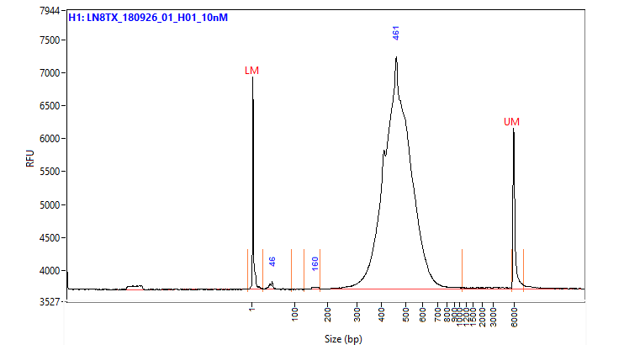
      - All products should be between 200-600bp since those are ideal sizes for sequencing.
      - Check for significant differences between the FA yield and PicoGreen yield.
- Take Down:
  - Return any unused reagents.
  - Clean the hood and ice bucket per the MolBio How To documents.

