3D Reconstruction of Neurons in Vaa3D/Mozak

- Scope and Applicability: Our goal is to generate accurate digital representations of neuron morphologies from a variety of brain regions and species. Each reconstruction captures the positions and thicknesses of the soma, dendrites and axon of a biocytin-filled cell within a slice of brain tissue. To generate the reconstruction we use an image stack containing ~200-700 serial 2D images that captures the full extent of the cell within the slice. We use the Vaa3D (Terafly) program with the Mozak user interface to visualize the 2D images in 3D. Once the stack is loaded in Mozak, the reconstruction is generated by placing nodes in 3D space. The placement of these nodes is dependent on the signal in the images. Our final output, an SWC text file (.swc format), contains many thousand rows. Each row contains a node ID, an x, y, z coordinate, radius value, neurite type, and parent node ID. After tracing is complete, we perform post processing to provide radius values, check for errors and consistency.
- Materials:
  - Image stack

- Equipment:
  - Vaa3d/Terafly (Mozak)
    - At the following link navigate to the “Get Started” section and click on “Vaa3d Download Link” download the entire Vaa3D folder and place it on your desktop.
    - https://portal.brain-map.org/explore/toolkit/morpho-reconstruction/vaa3d-mozak?edit&language=en
  - Launch Vaa3d by double clicking the file with .exe extension
  - If you get an error similar to “MSVCR120.dll Is Missing From Your Computer” you’ll need to download Visual C++ Redistributable Packages outlined below.
  - C++ visual studio
    - Use the following link to download Visual studio appropriate for your machine:
  - https://www.microsoft.com/en-us/download/details.aspx?id=40784
  - Download and run the file named “vcredist_64x.exe,” which is the 2013 package of Visual Studio C++ containing files that Vaa3D requires to run.
- Output: SWC file

- Setup:
  - Preparing Image Stacks
    - Vaa3d requires white on black images, therefore it might be necessary to invert your image stack before proceeding to the Teraconversion. Fiji (ImageJ) is a suitable free software to do this step.
  - TeraConverting Image Stacks: TeraConverter is a tool for converting terabytes of multidimensional image data (e.g. TIFF series) to Terafly format.
    - From the Vaa3D menu bar, select Advanced > Big-Image-Data > TeraFlyConverter in order to launch the TeraConverter
    - Selected TIFF (series, 2D) as your input type and browse the directory to point to your image stack location
    - Select Vaa3D raw (tiles, 3D) as your output type and browse the directory to point to location you want to save your converted files.
    - Select “Max” for the downsampling method
    - Hit Start

- Methodology/Procedures:
  - Opening Terafly Format in Mozak
    - Launch Vaa3d by double clicking the file with .exe extension
    - Select Advanced > Mozak
    - Navigate to the folder containing the tera-fly files
    - Select any RES sub-folder
    - The image stack will load

Example:
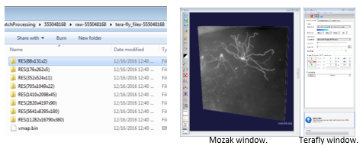

  - Reconstructing a cell

Mozak Tool Bar and Features:
Tool bar buttons can be clicked with the mouse or activated by click and hold of the hot key (polyline & auto-z select do not require a hold down of the key while performing the action) in parenthesis below.
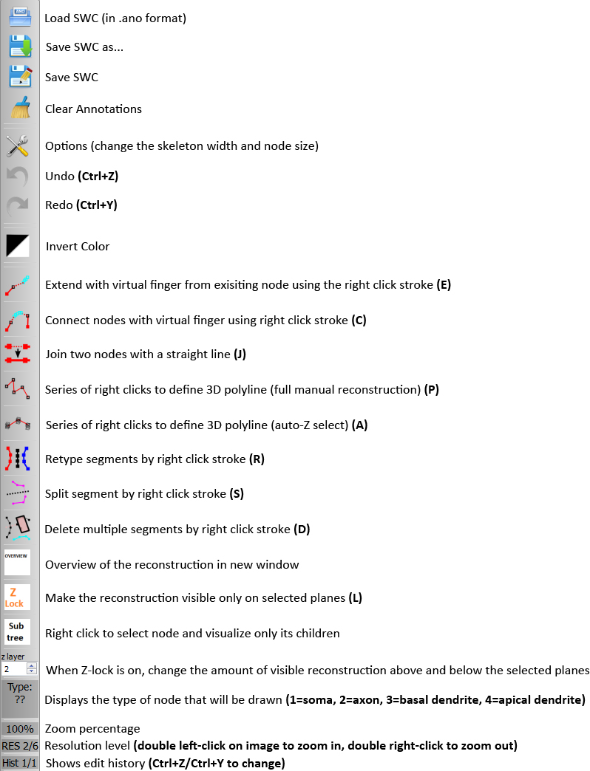
Additional Mozak Features without tool bar buttons
- Right click (or right click and drag) to use selected tool
- Left click image and drag to rotate, use mouse scroll wheel to change zoom in and out
- Space Bar or \: Reset view (very useful!)
- H: Make skeleton transparent
- O: Make skeleton invisible
- Scroll wheel : Zoom within your current resolution
- [ / ] : Rotate image along z-axis
- Ctrl + A: rotate tissue space around the x-axis
- G: Toggle a grid on and off
- G + mouse wheel scroll: change size of the grid squares
- Options: Change the skeleton/nodes size
- Ctrl + M: save a movie of the current tissue space
- N: Disconnected mode: light blue when connected to main skeleton, original branch color when not connected
- V: Change colormap of skeleton (5 modes)
- One color per type (Soma=Black, Axon=Red, Basal Dendrite=Blue, Apical Dendrite=Pink, FixIt=Green, etc.).
- Different shades for each type (helps differentiate segments).
- Loop detection, segments involved a loop will flash
- Grey except for FixIt type (for making tag team edits), this also highlights loops.
- Shift + {hotkey}: Lasso tool applies hotkey to all encircled nodes (i.e. Shift + D deletes all lassoed nodes)
Scroll Bar on the right
- Use the slider to quickly adjust image contrast, an essential tool for finding weakly-labeled segments.
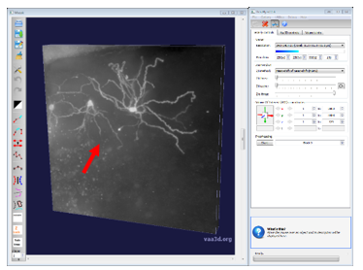

Reconstructing tools

Tools for tracing signal
- Virtual finger is a semi-automated tracing tool where you can roughly trace your branch in xy and the algorithm chooses the xyz node location based on image signal intensity. This is the most efficient tool that works best for dendrites and axon with continuous signal. To use, right click and drag over signal, you can also extend from a previously drawn node using the Hotkey E. Accuracy of virtual finger depends on the level of resolution when using the tool. It is most accurate at full resolution or one out from full resolution. When axon becomes dotty the below tools are more useful than virtual finger.
- Polyline is a fully manual tool in which you dictate precisely where a node is placed in x, y and z, using the mouse scroll wheel to move through the stack in z.
- Polyline with auto z-select also requires that you dictate where exactly a node is placed in x and y but automatically places the node in z based on signal in a restricted portion of the stack designated by you via the mouse scroll wheel.

Connecting/Editing Segments
- You can connect two nodes with virtual finger
- Or with a straight line
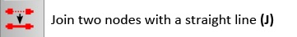

Split/Delete
- Often you may want to split a segment so you can only delete part of it

Z-Lock
- Z-Lock (L hotkey) is a mode that you can toggle to restrict the rendering of the reconstruction to the z-subvolume in view. It is recommended that Z-lock is always on. You will only see the benefit of Z-lock in Polyline or Polyline auto z-select modes.

Nodes
- There are two types of nodes – root and regular nodes. Root node’s default size is larger than a regular node. When you delete a segment, it will delete until finds a root node. Splitting a node will make a regular node become a root node.

Saving and loading reconstructions
- The first time you save use the Save As button so you can name your file appropriately.

- File types
  - When you save in Mozak three file types are generated; ano, apo and swc. Mozak only loads the .ano file so if you need to pick up where you left off you’ll need to point to the .ano file after hitting the “Load SWC” button

- If you ever have just a swc file, within Vaa3d go to Plug-In>linker_file and point to folder containing your swc file. It is important that the swc file is the only file in the folder.
- Save often but if the software crashes and you did not recently save look for a set of files called “autosave.xxx” from within your downloaded Vaa3D folder on your desktop.

The Process of Reconstruction
Your goal as a reconstructor is:
- Capture all “true” signal
- Differentiate between axonal and dendritic signal.
- Making reasonable connections between gaps in signal

Drawing the Soma and Initial Stems
- Zoom to the soma region using the highest or second highest resolution (as reported in the bottom left of the Mozak tool bar)
- Set your type as soma by clicking 1. Place a single node in the center of the soma using the polyline tool (hotkey P). After activating the polyline tool use your mouse wheel to scroll thought the stack in z, once you find your ideal z location place a node with the RIGHT mouse click. When using the polyline tool, you must place 2 or more nodes, so we place a second node of to outside edge of soma where there are no other branches. Having a 2nd node also helps keeps node the type as soma. To exit out of polyline mode uncheck the button or hit “P” again. The image below shows where the type changes can be seen in the interface.
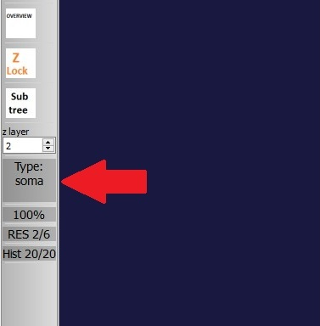
- Now that your soma node is created use virtual finger to trace the remainder of the stems. Hold hotkey E, hover over your soma node then right mouse click and drag over the signal you wish to trace.
- It is important to try identify the axon start early in reconstruct process, the axon can either exit soma or basal dendrite. The axon rarely comes out of apical dendrite but can happen.

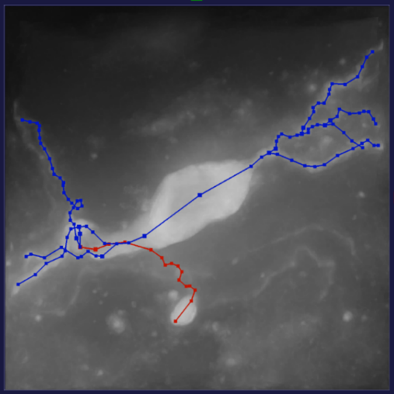
The soma above is a bipolar cell with only two dendrites exiting the soma and axon initiating from one of the dendrites.

Appropriately typing your reconstruction
In the above image, you’ll see the reconstruction representing the dendrites and axon as different colors, use the below segment types to appropriately assign compartment to your reconstruction.
- By clicking on a respective number you can change the node types at any time.
- These are the standard types/colors and the final reconstruction nodes should only be one of these four.
1: Soma – black
2: Axon – red
3: Basal Dendrite – blue
4: Apical Dendrite – pink
- These are types/color to help with tracing process. Feel free to have in-house/within reconstructor assignment of the colors.
5: fork point – bright blue
6: end point – yellow
7: Fix It! Axon – bright green
8: Fix It! Dendrite – light pink
9: Fix It! ??? – olive green
0: ??? – white

- To select a type, press the number keys 1-4, subsequent reconstructions will be this type.
- To change the compartment type of your reconstruction already generated use the retype button below (hotkey R) while right click and dragging your mouse over a node of a segment you want to change.
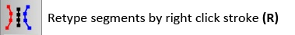

Dendrites
Dendrites can be identified by thicker signals than axon and tend to branch away from the soma in orderly fashion. If cell is spiny, the dendrites will have spines as well. Be sure not to trace the cilia which is a thinner, short signal coming out of soma. For some spiny cells, there is typically only 1 apical dendrite. Apical dendrites are identified by being thickest branch leaving the soma, longest branch, and most complex branch. Often apical dendrite will be heading towards direction of pia (for cortical cells). Once the initial stems are traced and the axon initial segment is identified follow each dendritic tip to its end. When using virtual finger, be sure to rotate the image slightly after each segment is placed to make sure the correct z-depth was captured. Sometimes the virtual finger tool can take an undesired path, if this happens, it can help to trace a shorter segment.

When using the polyline tool, try to place each node in the center-of-mass of the dendrite. To identify the center-of-mass, look for the highest signal intensity and most in-focus part of the dendrite. Below is a strip of 5 sequential z-planes. Polyline nodes would be placed only on images 3 and 4, as images 1, 2 and 5 only contain the edges of the signal.

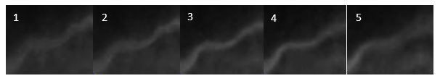

Once you get to the presumed end of a dendrite view in polyline mode to ensure your reconstruction has goes to the end of the signal.

Once all the dendrites are captured, move on to the axon.

Axon
Capturing axonal signal is the most challenging part of a reconstruction as it can be faint and discontinuous. Axon is thinner than dendrite and will often branch at obtuse angles, however the initial axon branch is thicker than more distal axon. Consider using the Mozak grid (G hotkey). Exhaustively trace all the axon in a single grid square, then move on to the next, making connections as you go. This method can be less overwhelming than tackling the whole image at once.

What not to trace

Dendritic spines – Short protrusions leaving the dendrites, aka dendritic spines, should not be reconstructed. It can be difficult to differentiate between a spine and a very short branch. Our general rule is that at least 3 nodes need to be placed to be considered a short dendritic segment. However, you will need to consider the rest of the neuron; if there are multiple borderline segments on many branches it is likely that they are all spines, if there are only one or two borderline calls on the entire reconstruction, they are more likely real branches. Below are examples of spiny and aspiny dendrites:
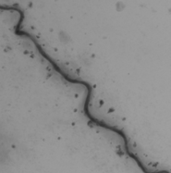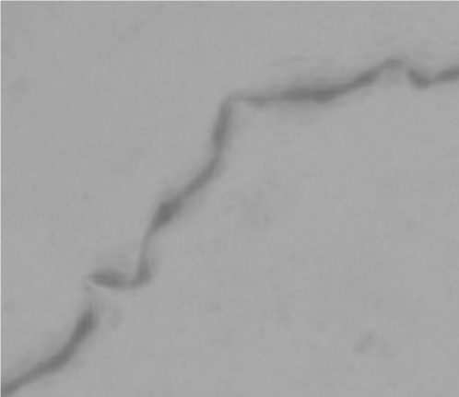

Axon Bouton- Similar in appearance to dendrite spines, although are sparser and longer in appearance, it is also feature we do not trace. Similar rule to spines, that needs to be at least 5 nodes to be consider a short axon branch. Below are examples pointed by the red arrow.
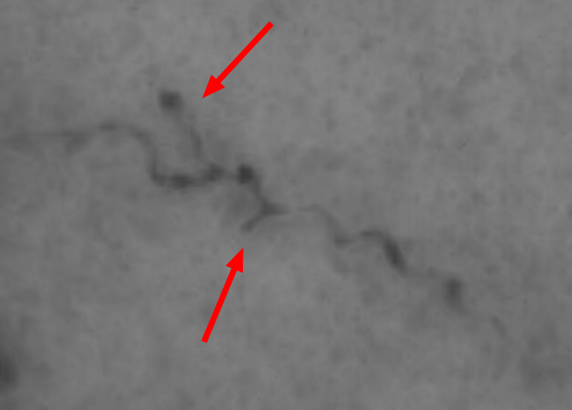

Neurites from other patch attempts – Often other cells are fully or partially filled with biocytin near your cell of interest. Ensure any branch you trace is likely to come from your own cell.
To be most certain, you should be able to connect the neurite back to your main skeleton of your cell of interest. However, in some cases you will trace disconnected bits, be sure they are near your target cell and similar in appearance and texture to the other branches of your target cell. See blue arrow at below for an example of partially filled cell.

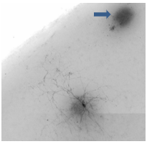

Blood vessels – In some cases blood vessels in brightfield imaging are visible. These generally have a very different appearance than dendrites and axon but can be mistaken for either. The image at right has many visible blood vessels, only a few of which are highlighted with red arrows:
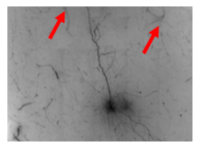

Non-specific surface labeling – This is a prevalent and difficult type of artifact to avoid while tracing. It appears in the first several planes of the image stack that contain in-focus tissue (green arrow). Our general rule is that you can trace any neurite that you follow into the zone, but should avoid tracing apparent segments that do not leave the zone, as they may be unrelated to your cell of interest. Here are example images of what the artifact looks like in yz (left image) and from xy (right image):
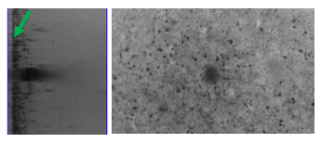

Tips and Tricks
- To add a single node to the end of an existing branch, use polyline to place a node in your desired location then another node in a random nearby location. Join the node you want to keep to your existing branch, split the reconstruction at last legit node and delete the subsequent trace.
- You can change the settings to allow for more of reconstruction to be visible to you, regardless of your field of view. Before loading in an annotation, navigate to the Terafly window and click “Options”> “Annotations”>"Virtual space size”>click “Unlimited” This allows for more timely indication of loops and continuous detection of disconnected segments.
- Click Options to change the skeleton width, node point size, and root point size from the default values of 2, 5, and 9, respectively. By decreasing each of these values, you will be able to better visualize the underlying signal while reconstructing.
- If hotkeys are not responding, just do quick right-click small trace somewhere, delete and Vaa3D should work normally.
- If you ever move the stack while still in polyline tool (aka stack is collapsed), the stack will remain collapsed even if exit polyline tool. Go to the right sided toolbar, go to Vaa3D control > Volume Cut to expand the z cut.
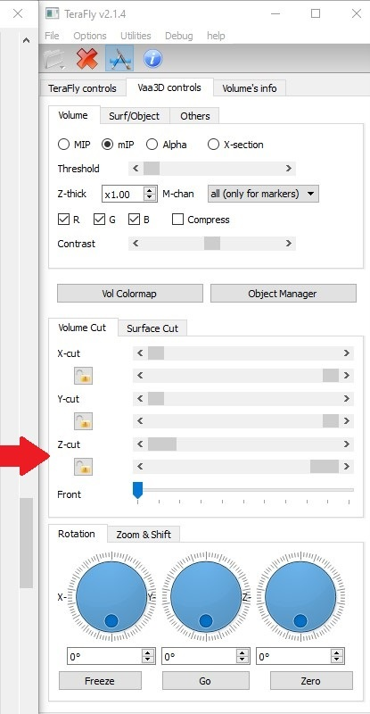
- Fully Connected Structure – Ideally a reconstruction would be fully connected. Use the disconnected mode (toggle hotkey N) to quickly see which branches still need to be connected to the main tree. All connected branches will be in light blue, while the disconnected branches will be in their original color. It can be very helpful to boost the contrast and restrict the z-planes to see faint connections.

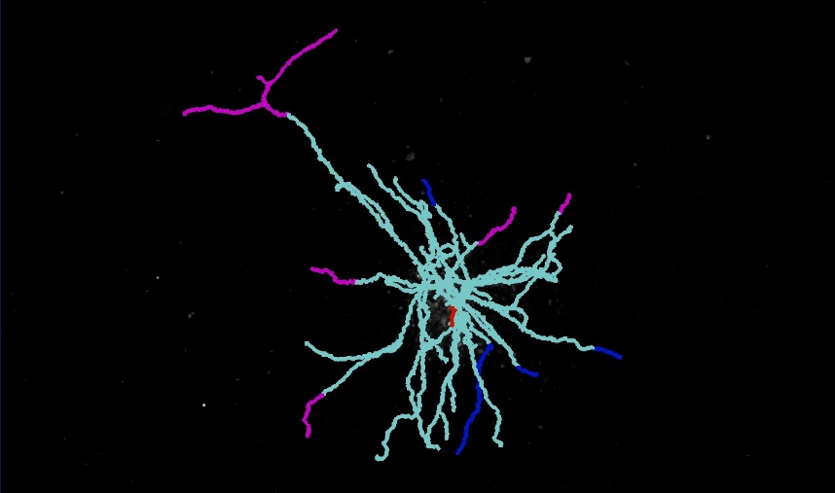

Loops- If you accidentally create a loop the affected segments will flash in the loop detection colormap (toggle hotkey V). Be sure to check for loops and correct them often. To fix a loop, keep splitting nodes till only one area is highlighted (example below on right). It's often easier to delete that entire highlighted area and just retrace it.
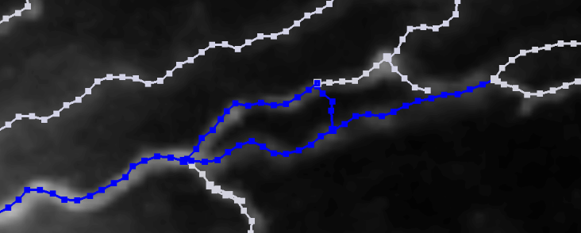
Note: Connection view and Loop detection are only performed on the skeleton in view (unless you have virtual space size set to unlimited).

Standardization of SWC file
We recommend following the below steps for giving your final reconstruction a standardized appearance.
- Representing soma radius as a sphere
  - Measure the radius of soma (can use ImageJ or any other preferred program)
    - We measure the long and short axis of the soma, add those values and then divide that by 4 to get the radius.
  - Open swc text file and enter the number on the radius column of the first row. This should be the row of the first soma node (type 1). Replace the default 1.000 with the found soma radius.
  - Disclosure – not a required step: to delete the second soma node placed in the beginning of the reconstruction, open the swc text file and delete the second row that has type 1. This step is optional as leaving the second soma node will not affect the standardization process.
- Sorting Plugin – used to generate a version of completed reconstruction that places root nodes before any regular nodes.
  - Open Vaa3D > Plug-In (dropdown menu) > IVSCC > IVSCC_sort_swc > sort_ swc
  - Use soma node id as root number when prompted.
  - Save sorted swc file.
- Bulk Plugin – used for smoothing and standardizing reconstruction.
  - Open Vaa3D > Plug-In (dropdown menu) > IVSCC > AllenNeuron_postprocessing > part 1
    - The plugin components are in the following order: sort > resample (length 10) > sort > pruning (length 2) > sort > internode pruning > sort > Z-smooth (length 10; optional) > sort
  - Select your sorted SWC file, click yes when asked to smooth the SWC file and ok to maintain the pruning distance at 5.
    - The smoothing option should only be used once per file. So if the reconstruction has been smoothed before, do not smooth it again. You can press no if need use this Bulk Plugin Again.

We also do other steps such as manually assigning and interpolating radii, as well as marking branch cut ends to give the reconstruction a standardized appearance.

