Flow cytometry analysis of diatoms and coccolithophores with diagnostic stains (via a BD Biosciences Accuri C6)
This general protocol can be used for assessing eukaryotic populations with various diagnostic stains (SYTOX for live/dead cells; DAF-FM for nitric oxide producing cells; DCFDA for reactive oxygen species; others). It is geared for samples that are ~5-10 µm in size, using a 70 µm orifice.

- To begin looking at the samples set a desired threshold and set up a preliminary plot with the Y-axis being FL3-H (chlorophyll) and the X-axis being SSC-H both in log scale. Start with an unstained control sample.
- Then divide the plot into quadrants based on a positive and a negative chlorophyll fluorescence (the vertical line is the cut off, i.e. above it is positive and bellow it is negative).
- Gate the top two quadrants with a square (i.e. this will be population R1)—these will represent the positive fluorescence--- with the ‘zoom view’ being all the way out (the important thing here is the horizontal line).

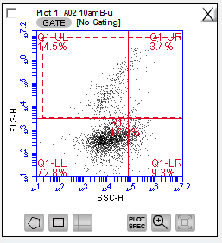

- Set up a new plot with the Y-axis being FL3-H (chlorophyll) and X-axis being FSC-H both in log scale.
- In the gate options of this plot, include only R1 from Plot 1.
- Then, divide the plot into quadrants with the vertical line crossing the X-axis at 5.6 × 10⁵ so that everything on the right of this line is stuff larger than 1 µm in size.
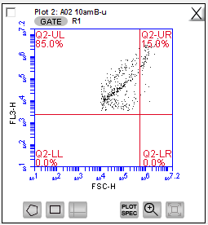
- Set up a new plot with the Y-axis being FL1-H (green fluorescence) and the X-axis being FSC-H both in log scale. In the gate option select the quadrant marker option and include the upper right quadrant from Plot 2 (i.e. Q2-UR in R1).
- Then divide the plot into quadrants with the unstained population being in the bottom right quadrant bellow the vertical line (this line is the cut off between negatively and positively stained cells).

