Purification of viruses via CsCl gradient and ultracentrifugation
Equipment (for one sample):
- 12 mL of sample (from PEG precipitation)
- Four 15 mL falcon tubes
- Beckman 14 x 89 ultra-clear, ultra-centrifugation tube
- 2 mL microcentrifuge tube
- 3 mL syringe (BD)
- 22G1 Precision Glide syringe needle (BD)
- Multipurpose extension clamp

Gradients (cm³) |  | CsCl (g)
1 |  | 0.03
1.2 |  | 0.8319
1.4 |  | 1.644
1.6 |  | 2.4495

Steps:

- Dispense above into four 15 mL falcon tubes.

- Add 3 mL of sample into each tube. Shake until the CsCl is dissolved.

- Starting with the densest, carefully layer the gradient blocks in the Beckman tube (3 mL
per layer). Use a pipette or pour like Irish coffee (it is well worth taking time during this step).

- Balance accurately (to within 0.02-0.03 g).

- Use SW40Ti rotor.

- Rotor settings: 25000 rpm for 3 h at 15°C, max acceleration/deceleration 9.

- Open the centrifuge chambers carefully and pull out the ultracentrifuge tube.

- Clamp the ultracentrifuge with a multipurpose extension tube clamp holder (Figure 1A).

- Assemble the needle and syringe and make sure that there is no air in the syringe.

- Gently puncture a hole into the ultracentrifuge tube exactly at the same place where
the band is seen. Extract band gently (Figure 2B). If there are multiple bands on
the gradient, start with the upper most band working your way down.

- Pre-weigh a 2 mL microcentrifuge tube prior to adding the extracted band volume.
Note the volume.

- Re-weigh the tube containing the band extract and calculate the difference in weight
Calculate the buoyant density of recovered material using the above weight & volume.
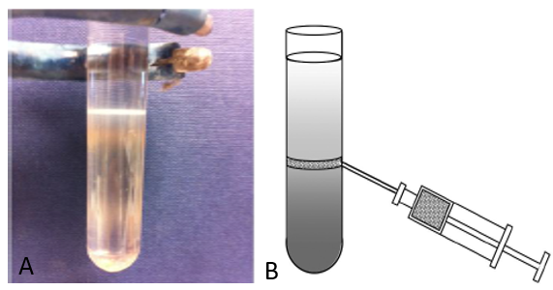
Fig. 1. An ultracentrifugation tube attcehd to a multipurpose extension clamp (A) and the extraction of the band from the tube in a donwards 45° angle (B).

Further reading:
Lawrence J.E., and Steward G.F. (2010) Purification of viruses by centrifugation. MAVE Chapter 17:166–181.

