Virus nucleic acids extractions from 0.02 µm anotop filters

This protocol has been modified from the original method developed and reported by Steward and Culley (2010) and Mueller et al. (2014). As a starting point we assume that viruses have been collected from the environment on 0.02 µm syringe filters (Anotop, Whatman).

Materials and equipment (Figure 1):
- Total nucleic acid extraction kit (MasterPure complete DNA/RNA purification kit, Epicenter; catalog # MC85200)
- Polyacryl carrier (Molecular Research Center; catalog # PC 152)
- BD 3 mL syringes (sterile, disposable, with Luer-Lok tips, VWR; catalog # BD309657)
- Luer-Lok female–female adapter fittings (Waters; catalog # WAT011422)
- Hybridization oven with rotisserie (with up a range of temperatures up to at least 65°C).
- Isopropanol (2-Propanol ≥99%, SIGMA; catalog # l9516-500 mL).

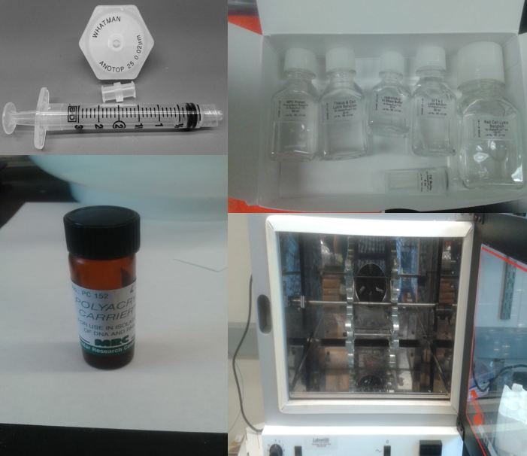

Fig.1. Materials and equipment required for the extraction of DNA, based on
Culley and Steward (2007).

Chemicals:
To make the extraction buffer add 2 µL from the supplied Proteinase K to 1 mL of the either X1 or X2 T+C lysis solution (resulting in 100 µg mL⁻¹ Proteinase K concentration).

Steps:
- Thaw the anotop filters at room temperature for 5 minutes and remove the parafilm coating from the inlet and outlet of the filters.
- Knock the filters on kimwipe paper a few times with the outlet facing down so that any remaining water from these filter is removed from the filter housing prior to adding the extraction buffer.

- Then, add 1 mL of the extraction buffer to a sterile 3 mL syringe that has been fitted with a female–female Luer-Lok adapter (this is the injection syringe).

- Ensure that there is minimal air in the injection syringe-adapter assembly and then connect it to the outlet of the anotop filter. Hold the filter+syringe assembly vertically with the injector syringe pushing upward from below. Hold the filter securely to the injection syringe and gently push the extraction buffer into the filter housing until liquid just begins to appear in the inlet of the filter (do not lose any of this liquid).

- Connect a second 3 mL syringe to the filter inlet (this is the aspiration syringe).

- Attach firmly the syringe assembly (filter with two syringes attached; Figure 2) into a rotisserie with elastic bands to the clips of the rotisserie and incubate the assembly for 15 minutes at 65°C in a hybridization oven (Figure 3) at a rotor speed of 5 (or at an equivalent low speed rotation option). The elastic band attachment of the syringe-filter assembly to the rotisserie is important in order to ensure that the entire filter surface is wetted during the 15 minute incubation time. This also overcomes the possible presence of air bubbles in the housing that may interfere with the wxtraction buffer coming in contact with the surface of the entire filter.

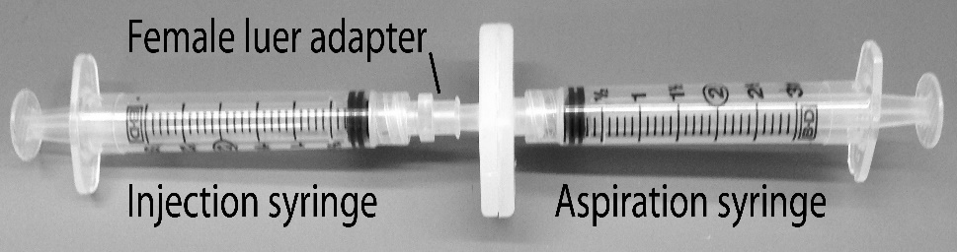
Fig. 2. Injection and aspiration syringe assembly containing the
1 mL extraction buffer.
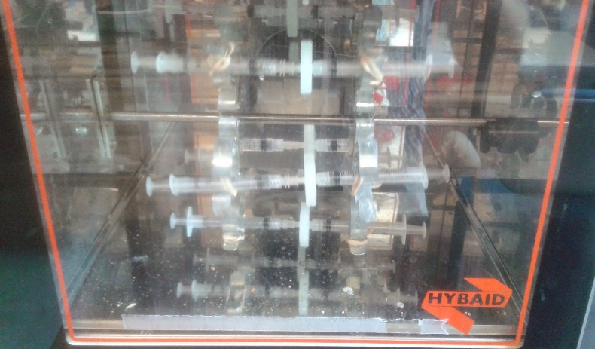
Fig. 3. A hybridization oven equipped with a
multispeed spinning rotisserie to which the syringe
assembly can be attached to and incubated in.
- Then remove the syringe-filter assembly from the oven and allow to cool briefly at room temperature. Remove the extract by holding the syringe assembly vertically with the aspiration syringe underneath (and the filter upside down) and gently pulling on the plunger to pull the extract into the aspiration syringe (make sure that you firmly hold the plunger of the aspiration syringe in order to prevent a back flush of the buffer back into the syringe housing).

- Then detach the aspiration syringe gently to prevent back-flush pressure and transfer the extract to a sterile 2 mL microcentrifuge tube. The extract should be around 1 mL however this may vary slightly due to the efficiecnies during the extraction of the buffer from the housing after the incubation step.

- Chill the extract in the 2 mL tubes on ice for 3 minutes.

- Add one-half volume (should be ~ 500 µL) of MPC protein precipitation reagent (supplied in the kit) and vortex for 10 seconds.

- Pellet the debris by centrifugation at 13,000 rpm for 15 minutes at 4°C.

- Transfer the supernatant (containing the nucleic acids) to a sterile 2 mL microcentrifuge tube. Be careful to avoid the pellet (containing the protein complex). All or some of the sample may be archived at this point by freezing at –80°C.

- Transfer 800 μL of the sample to a fresh sterile 2 mL microcentrifuge tube; add 1 μL polyacryl carrier, and vortex briefly (the carrier improve yields when working with nanogram and subnanogram concentrations of nucleic acids).

- Add an equal volume (should be ~800 uL) of 100% isopropanol and mix by inverting the tube several times (i.e. 10-40 times).

- Centrifuge the sample at 13000 rpm for 45 min. Longer centrifugation times may improve the yields for small amounts of nucleic acids.

- Carefully decant or aspirate the supernatant as the nucleic acids pellet can dislodge easily and be lost.

- Wash the pellet twice with 1 mL of 70% ethanol centrifuging for 1 min. Then either decant the pellet until dry in a hood or gently aspirate with a pippete to remove the ethanol.

- Air-dry the pellet, then dissolve in 35 μL of 0.02-filtered, sterile TE buffer (supplied in the kit as (10 mM Tris-HCl [pH 7.5], 1 mM EDTA) heated to 50°C.

- If needed, DNA or RNA can be selectively removed from the total nucleic acid precipitate by enzymatic digestion with DNase or RNase.

References:

Steward G.F. and Culley A.I. (2010) Extraction and purification of nucleic acids from viruses. MAVE Chapter 16: 154-165.
Mueller, J.A., Culley, A.I., and Steward, G.F. (2014) Variables influencing extraction of nucleic acids from microbial plankton (viruses, bacteria, and protists) collected on nanoporous aluminum oxide filters. Appl. Environ. Microbiol. 80: 3930–3942.

