A single cell RNA sequencing protocol for the pig colon
Tao Li, Pu-Qing Yuan, Yvette Taché
- Cell suspension preparation
- The full thickness tissue samples of proximal (pC), transverse (tC) and distal (dC) colon were obtained from the pigs undergoing resection surgery. The tissue samples were washed in ice-cold, carbogen (95% O₂ and 5% CO₂)-bubbled PBS. Importantly, the solutions used in all steps were equilibrated in the carbogen gas.
- The outer smooth muscle layers along with the myenteric plexus were peeled off from the underlying tissue using forceps.
- Incubation the smooth muscle layer in enteric neuron media, containing Neurobasal A media with B-27, 2 mM L-glutamine, 1% fetal bovine serum (FBS), 10 ng/ml Glial Derived Neurotrophic Factor and 1x Antibiotic/Antimycotic, in the presence of 45 µM Actinomycin D (ActD) for 15 min on ice. ActD application minimizes artificially induced transcriptional changes during single-cell dissociation and thus enables faithful characterization of baseline transcriptional profiles (Figure 1).
- The samples were then cut into small pieces < 1 mm and transferred to the enteric neuron media containing 1mg/ml collagenase B and dispase II and 45 µM ActD for 1 hour at 37°C.
- After the addition of 1 mg/ml deoxyribonuclease I and 10% FBS, the tissue pieces were dissociated using fire polished Pasteur pipettes.
- Following manual trituration, the cells were filtered through 70 µm Nitex mesh filter and pelleted at 375 g for 10 min, and resuspended in the ice-cold, carbogen-bubbled rinse medium containing F12 media with 10% FBS and 1x antibiotic/antimycotic.
- Estimation of viable cell number was done by Trypan Blue dye exclusion method.
- The viable cells were collected via fluorescence-activated cell sorting (FACS), whose viability was assessed using a Countess II FL Automated Cell Counter.
- Single-cell capture, library construction, and sequencing
- ~10,000 single cells per cell suspension were loaded on a Chromium Controller (10× Genomics) to generate single-cell gel beads in emulsion (GEMs).
- A Chromium Single Cell 3′ Reagent kit, v2 Chemistry (10× Genomics) was used to prepare single-cell RNA sequencing (scRNA-Seq) following the manufacturer's instructions. The quality of one single-cell cDNA library was shown in Figure 2.
- The libraries were sequenced on an Illumina NextSeq 500 Sequencer as 1 x 75 single-end reads.
- Cell Ranger v.1.3 (10× Genomics) was used to generate FASTQ files, which were then aligned to sus_scrofa genome and transcriptome using the Cell Ranger v.1.3 pipeline to generate ‘gene vs cell’ expression matrix.
- For filtering and unsupervised clustering, the gene expression matrix from Cell Ranger was used for downstream analysis (using Python 3.7.4 and R 3.6.2). The single-cell clusters in pC were shown in Figure 3.

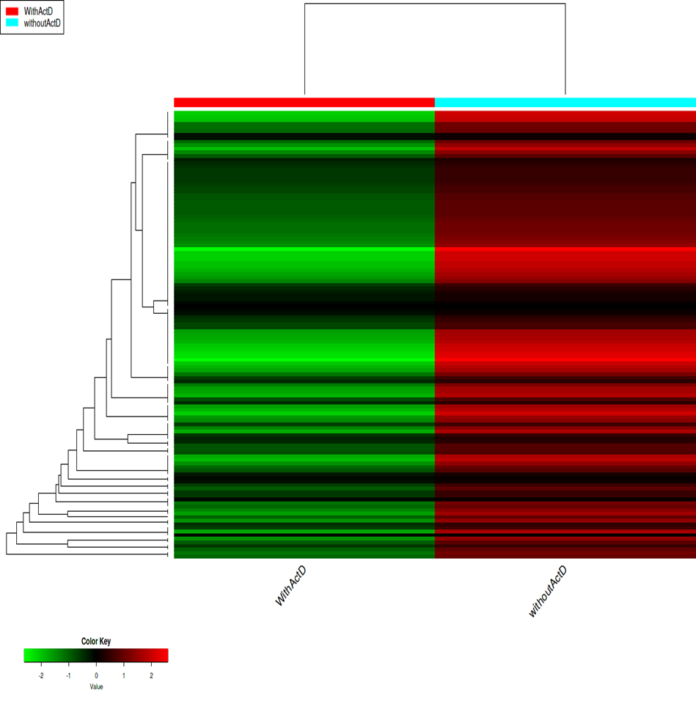
Figure 1 Heatmap depicts expression profiling of 131 immediate-early genes (IEGs) under ActD-treated condition (WithActD) with that under normal condition (withoutActD). IEGs are rapidly and transiently induced by various cellular stimuli including synaptic activity. Therefore, they are good markers showing if the transcriptional profiling changes during single-cell dissociation. After RNA extraction from dissociated cells and cDNA library construction, RNA sequencing was performed to generate the raw reads on Hiseq 3000 platform. The sequencing data showed that there were 131 IEGs in pig transcriptome. Of them, 127 IEGs showed remarkably reduced induction with ActD application. This means that ActD application minimizes artificially induced transcriptional changes during single-cell dissociation and thus enables faithful characterization of baseline transcriptional profiles.

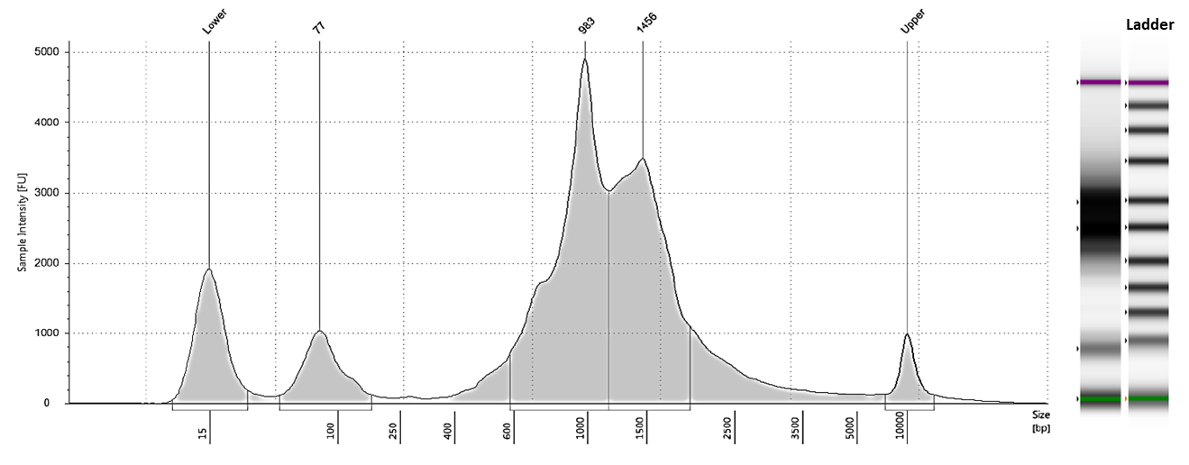
Figure 2 Analysis of cDNA fragments from dissociated cells in pig proximal colon (n = 1) using High Sensitivity D5000 ScreenTape®. The size distribution and smears were visualized as electropherograms and gel images. The fragment sizes ranged from 600 bp to 2,000 bp, which is ideal for NextSeq 500. The calibrated concentrations of the peaks at 983 bp and 1456 bp were 3200 and 2800 pg/µl, respectively.
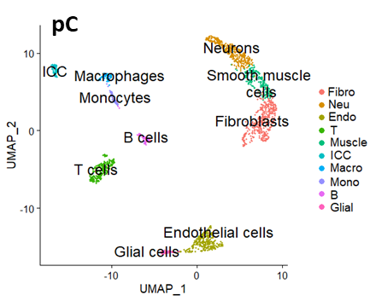
Figure 3 Visualization of the single-cell clusters from pig proximal (pC) colon using two-dimensional uniform manifold approximation and projection (UMAP) embedding. The single-cell data were obtained from 2,091 cells in pC, sequenced to a depth of about 1,400 median genes per cell. Principal component analysis (PCA) was first carried out to reduce dimensionality. Based on the PCA output, non-linear dimensional reduction techniques, such as UMAP, were used to visualize and explore the datasets. Each point in UMAP depicts a single cell, colored according to cluster designation. There were 10 distinct major cell clusters found in muscularis externa of pC. The clusters comprised fibroblasts (Fibro), neurons(Neu), endothelial cells (Endo), T cells (T), smooth muscle cells (Muscle), interstitial cells of Cajal (ICC), macrophages (Macro), monocytes (Mono), B cells (B) and glial cells (Glial).
Correspondence to: pqyuan@mednet.ucla.edu

