Assessment of Anti-cancerous Effect of Green, Roasted and Decaffeinated Coffee on Oral Squamous Cell Carcinoma Cell Line
(In Vitro Study)

PICO
Submitted to Faculty of Dentistry, Cairo University.
For partial fulfillment of the requirement of the doctoral Degree in Oral and Maxillofacial pathology

Presented by:
Asmaa Emad El-Din Mohammed Rashad
BDS, Cairo University (2009)
MSc, Cairo University (2016)

Supervisors
Professor Dr. Mohsen Kazem
Lecturer: Dr. Manar Abdul-waniss

PICO
Patient / Population: Human Oral squamous cell carcinoma cell line
Intervention1: Green coffee
Intervention2: Roasted coffee
Intervention3: Decaffeinated coffee
Control: no application
Outcome:
Primary outcome 1: assessment of proliferative activity OSCC cell line treated with coffee using ELISA.

Primary outcome 2: Assessment of apoptotic cell death of OSCC cell line treated with coffee using RT-PCR.

 | Outcome measure | Measuring device | Measuring unit
1- Primary1 | Proliferative activity | ELISA | Comparative (light absorbed) numerical value
1- Primary2 | Apoptotic cell death | RT-PCR | Comparative (fold changes) numerical value

Research question

Do different types of coffee affect proliferation and/or apoptosis of human oral squamous cell carcinoma cell line?

- Search Strategy:
  - Items of interest: Anti-proliferative, apoptotic activity, coffee, oral squamous cell carcinoma.
  - 3.2. Synonyms:
- Source: The result has been searched in two databases: PubMed, Google scholar.
- Date: 20/5/2018 till now
Synonyms | PICO item
- OSCC  - Head and neck squamous cell carcinoma  - HNSCC  - Oral epithelial cancers  - Oral epithelial neoplasms  - Oral epithelial malignancy  - Oral malignant epithelial tumors | Oral squamous cell carcinoma
- Green coffee  - Raw coffee  - Green coffee extract  - Decaffeinated coffee  - Coffea arabica  - Roasted coffee | Coffee
- Cellular proliferation  - Cellular multiplication | Proliferative activity
- Apoptosis, intrinsic pathway  - Apoptosis, extrinsic pathway  - Cancer Apoptosis  - Apoptosis induction | Apoptosis

4. Selection Criteria:

Exclusion criteria | Inclusion criteria
- Articles published in any other language.  - Studies done to assess other outcomes of coffee  - Clinical studies  - Observational studies  - Review articles  - Research articles  - SYSTEMATIC REVIEWS  - Sarcoma, lymphoma and non-epithelial cancer studies  - Other type of cancers. | - Articles published in English.  - In Vitro and in Vivo studies  - Must be related to epithelial oral cancer  - Any type of coffee or its chemical components  - Studies done to assess the preventive capacities of coffee against cancer  .

- DATABASES:

Electronic search was done through:
A- PubMed database.
B- Cochrane library.
A- Pubmed Advanced Search Builder
- Search name: Coffee and oral squamous cell carcinoma
- Data Run: from inception till June, 2018.
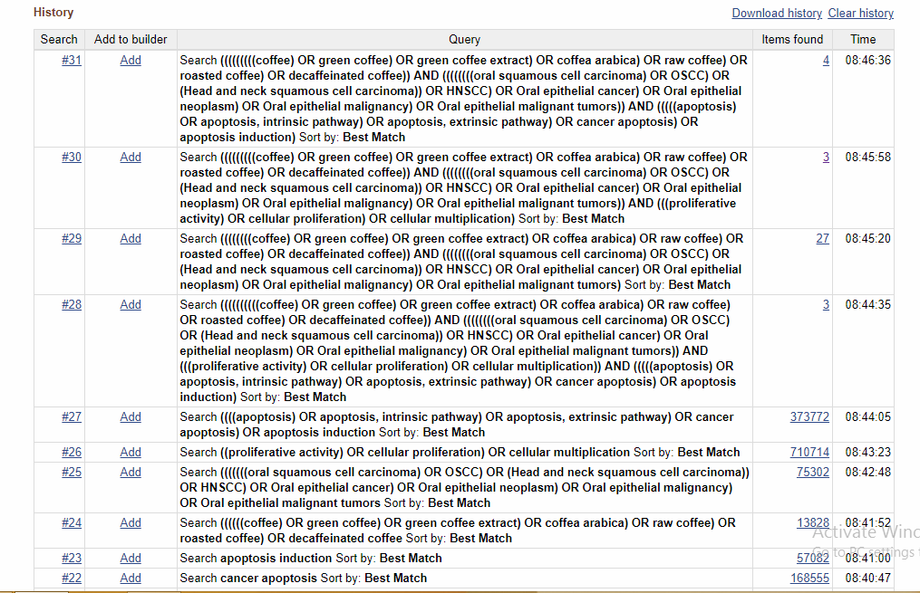
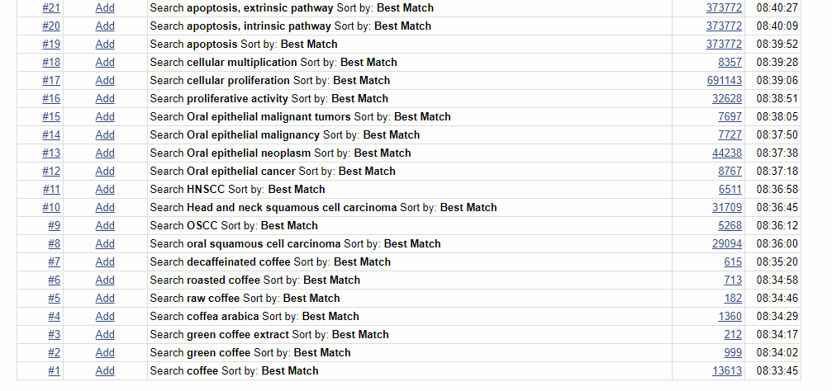
B- Cochrane Advanced Search Manager:
- Search name: Coffee and oral squamous cell carcinoma.
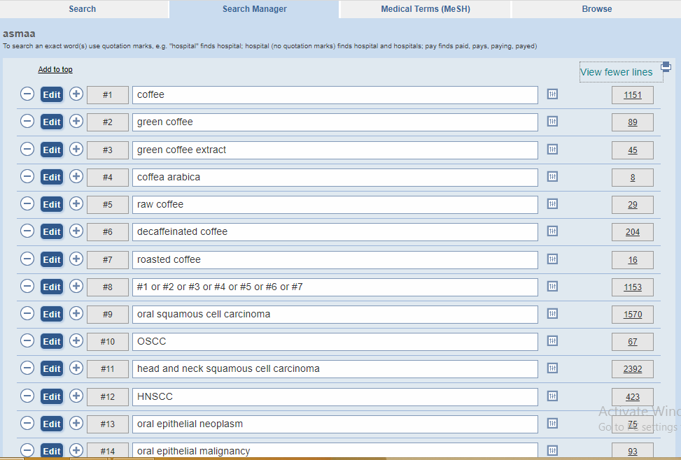
- Data Run: from inception till ^{st} of January, 2018.
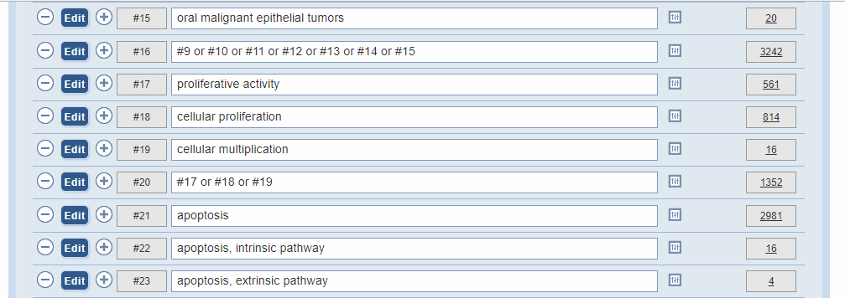


- PRISMA 2009 Flow Diagram:
Screening
Included
Eligibility
Identification
Records identified through Pubmed searching
(n =27)
Records identified through Cochrane library searching
(n =6)
Records after duplicates removed
(n =33)
Records screened
(n =33)

Records identified through hand searching
(n =10)

Records excluded
(n =13)

Full-text articles assessed for eligibility
(n =20)
Full-text articles excluded, with reasons
(n=18)

Studies included in qualitative synthesis
(n = 2)
)

- Summary of Findings Table (SOFT):

Demographics of included studies:

No. of study | Study 1st Author  (Year/ country) | Study  Type | Study title | Study group(s) | Researched variables | Used techniques
1 | Chae J et al, 2014 | In vivo | Anti‐Proliferative Properties of Kahweol in Oral Squamous Cancer Through the Regulation Specificity Protein 1 | Oral squamous cell lines (OSCCs), HN22 and HSC4. | anti-proliferation and apoptosis effect of indicated concentrations of kahweol for different time points (24 or 48 h) on oral squamous carcinoma cell line  SP1 protein measurement | (MTS) assay for cell viability measurement  (DAPI) staining and flowcytometry for detection of apoptosis  Immunocytochemistry to stain SP1 protein  Western blot analysis
2 | Kotowski U et al, 2015 | In vivo | Effect of the coffee ingredient cafestol on head and neck squamous cell carcinoma cell lines. | head and neck squamous cell carcinoma (HNSCC) cell lines | The effects of cafestol in head and neck squamous cell carcinoma (HNSCC) cells  The rate of apoptosis  Cell viability after using increasing conc. of cafestol (0-200 μM) and with combination with cisplatin | Flowcytometry using Annexin-V for detection of apoptosis  Cell viability assay using MMT assay Clonogenic assay

Results:

Studies | Apoptotic potential | Measurement units | Anti-proliferative potential | Measurement unit | P value | Statistical significance | Other results
1 | No.of apoptotic cell 1.9 ± 0.7, 17.5 ± 1.1, and 33.8 ± 3.1% in the presence  of 0, 20, 40 and 60 μM kahweol | % | Cell viability decreased ranging from 100% to %60 in the presence of of 0, 20, 40 and 60 μM kahweol | % | < 0.05 | Significant | .  Suppression of the transcription factor specificity protein 1 (Sp1)
2 | Percentage of apoptotic cells ranges from 22%- 40% in the presence of 50-100 μM of cafestol in 48h and after 72 hours | % | IC50= 71.9± 1.09 μM in the presence of increasing conc. of cafestol (0-200 μM) | μM | < 0.05 | Significant | Combination with irradiation shows a reduction of clonogenic survival  Combination of cisplatin with cafestol has antagonistic effect
- Table of Excluded Studies:-

No.  of Study | Author | Title of Study |  | Reason of Exclusion
1 | Miranda J et al, 2017 | Coffee is protective against oral and pharyngeal cancer: A systematic review and meta-analysis |  | Systematic review
2 | Ren JS et al, 2010, united states |  | Patients with oral, pharyngeal , laryngeal, gastric and oesophageal cancers  The relationship between hot tea, iced tea, coffee and carbonated soft drinks consumption and upper gastrointestinal tract cancers risk | Prospective cohort study
3 | Saroja M, 2001, Syria |  | Coffee enhances the development of 7,12-dimethylbenz[a]anthracene (DMBA)-induced hamster buccal pouch carcinomas. | Other measurement not the anticancer effect
4 | Biazevic MG, et al 2011, Sao Paulo, Brazil, |  | Cumulative coffee consumption and reduced risk of oral and oropharyngeal cancer | A Prospective Case-series study
5 | Radoï L et al, 2013  France |  | Tea and coffee consumption and risk of oral cavity cancer: results of a large population-based case-control study, the ICARE study | Case control study
6 | Oze I et al, 2014  Japan |  | Coffee and green tea consumption is associated with upper aerodigestive tract cancer in Japan. | Case control study
7 | Hildebrand J et al, 2012 |  | Coffee, tea, and fatal oral/pharyngeal cancer in a large prospective US cohort | Case series study
8 | Zhang Y et al, 2015 |  | Association between coffee consumption and the risk of oral cancer: a meta-analysis of observational studies.. | Observational study
9 | Tverdal, A et al, 2011 |  | Coffee intake and oral–oesophageal cancer: follow-up of 389 624 Norwegian men and women 40–45 years | Case series study
10 | Wang et al, 2016 |  | Coffee and cancer risk: A meta-analysis of prospective observational studies | Observational study
11 | Li et al, 2016 |  | Coffee consumption associated with reduced risk of oral cancer: a meta-analysis. | Case series study
12 | Naganuma T et al, 2008 |  | Coffee consumption and the risk of oral, pharyngeal, and esophageal cancers in Japan: the Miyagi Cohort Study. | Case series study
13 | Galeone C et al,2010 |  | Coffee and tea intake and risk of head and neck cancer: pooled analysis in the international head and neck cancer epidemiology consortium. | Case series study
14 | Yan et al, 2016 |  | [Tea, coffee intakes and risk of oral squamous cell carcinoma: a case-control study]. | Case study
15 | Miller E et al, 1988 |  | Inhibition of hamster buccal pouch carcinogenesis by green coffee beans. | The coffee was not pure  The research is older than 15 years
16 | Bundgaard T et al, 1995 |  | Case-control study of squamous cell cancer of the oral cavity in Denmark. | Case study
17 | Dasanayake A et al, 2005 |  | Moderate coffee intake may reduce the risk of oral, pharyngeal, and esophageal cancer. | Case study
18 | Miller E et al, 1991 |  | Kahweol and cafestol: inhibitors of hamster buccal pouch carcinogenesis. | Measure tumor size

References:

- Biazevic, M.G.H., Toporcov, T.N., Antunes, J.L.F., Rotundo, L.D.B., Brasileiro, R.S., Carvalho, M.B.D., Filho, J.F.D.G. and Kowalski, L.P., 2011. Cumulative coffee consumption and reduced risk of oral and oropharyngeal cancer. Nutrition and cancer, 63(3), pp.350-356.

- Bundgaard T, Wildt J, Frydenberg M, Elbrond O, Nielsen JE. Case-control study of squamous cell cancer of the oral cavity in Denmark. Cancer Causes & Control. 1995 Jan 1;6(1):57-67.

- Chae, J.I., Jeon, Y.J. and Shim, J.H., 2014. Anti‐Proliferative Properties of Kahweol in Oral Squamous Cancer Through the Regulation Specificity Protein 1. Phytotherapy research, 28(12), pp.1879-1886.

- Dasanayake, A.P., 2005. Moderate coffee intake may reduce the risk of oral, pharyngeal, and esophageal cancer. Journal of Evidence Based Dental Practice, 5(1), pp.31-32.

- Galeone, C., Tavani, A., Pelucchi, C., Turati, F., Winn, D.M., Levi, F., Yu, G.P., Morgenstern, H., Kelsey, K., Dal Maso, L. and Purdue, M.P., 2010. Coffee and tea intake and risk of head and neck cancer: pooled analysis in the international head and neck cancer epidemiology consortium. Cancer Epidemiology and Prevention Biomarkers, pp.1055-9965.

- Hildebrand, J.S., Patel, A.V., McCullough, M.L., Gaudet, M.M., Chen, A.Y., Hayes, R.B. and Gapstur, S.M., 2012. Coffee, tea, and fatal oral/pharyngeal cancer in a large prospective US cohort. American journal of epidemiology, 177(1), pp.50-58.

- Kotowski, U., Heiduschka, G., Seemann, R., Eckl-Dorna, J., Schmid, R., Kranebitter, V., Stanisz, I., Brunner, M., Lill, C. and Thurnher, D., 2015. Effect of the coffee ingredient cafestol on head and neck squamous cell carcinoma cell lines. Strahlentherapie und Onkologie, 191(6), pp.511-517.

- Li, Y.M., Peng, J. and Li, L.Z., 2016. Coffee consumption associated with reduced risk of oral cancer: a meta-analysis. Oral surgery, oral medicine, oral pathology and oral radiology, 121(4), pp.381-389.

- Miller, E.G., Formby, W.A., Rivera-Hidalgo, F. and Wright, J.M., 1988. Inhibition of hamster buccal pouch carcinogenesis by green coffee beans. Oral Surgery, Oral Medicine, Oral Pathology, 65(6), pp.745-749.

- Miller, E.G., McWhorter, K., Rivera‐Hidalgo, F., Wright, J.M., Hirsbrunner, P. and Sunahara, G.I., 1991. Kahweol and cafestol: inhibitors of hamster buccal pouch carcinogenesis.

- Miranda, J., Monteiro, L., Albuquerque, R., Pacheco, J.J., Khan, Z., Lopez-Lopez, J. and Warnakulasuryia, S., 2017. Coffee is protective against oral and pharyngeal cancer: A systematic review and meta-analysis. Medicina oral, patologia oral y cirugia bucal, 22(5), p.e554.

- Naganuma, T., Kuriyama, S., Kakizaki, M., Sone, T., Nakaya, N., Ohmori-Matsuda, K., Nishino, Y., Fukao, A. and Tsuji, I., 2008. Coffee consumption and the risk of oral, pharyngeal, and esophageal cancers in Japan: the Miyagi Cohort Study. American journal of epidemiology, 168(12), pp.1425-1432.

- Oze, I., Matsuo, K., Kawakita, D., Hosono, S., Ito, H., Watanabe, M., Hatooka, S., Hasegawa, Y., Shinoda, M., Tajima, K. and Tanaka, H., 2014. Coffee and green tea consumption is associated with upper aerodigestive tract cancer in Japan. International journal of cancer, 135(2), pp.391-400.

- Radoï, L., Paget-Bailly, S., Menvielle, G., Cyr, D., Schmaus, A., Carton, M., Guida, F., Cénée, S., Sanchez, M., Guizard, A.V. and Velten, M., 2013. Tea and coffee consumption and risk of oral cavity cancer: results of a large population-based case-control study, the ICARE study. Cancer epidemiology, 37(3), pp.284-289.

- Ren, J.S., Freedman, N.D., Kamangar, F., Dawsey, S.M., Hollenbeck, A.R., Schatzkin, A. and Abnet, C.C., 2010. Tea, coffee, carbonated soft drinks and upper gastrointestinal tract cancer risk in a large United States prospective cohort study. European Journal of Cancer, 46(10), pp.1873-1881.

- Saroja, M., Balasenthil, S., Ramachandran, C.R. and Nagini, S., 2001. Coffee enhances the development of 7, 12-dimethylbenz [a] anthracene (DMBA)-induced hamster buccal pouch carcinomas. Oral oncology, 37(2), pp.172-176.

- Tverdal, A., Hjellvik, V. and Selmer, R., 2011. Coffee intake and oral–oesophageal cancer: follow-up of 389 624 Norwegian men and women 40–45 years. British journal of cancer, 105(1), p.157.

- Wang, A., Wang, S., Zhu, C., Huang, H., Wu, L., Wan, X., Yang, X., Zhang, H., Miao, R., He, L. and Sang, X., 2016. Coffee and cancer risk: A meta-analysis of prospective observational studies. Scientific reports, 6, p.33711.

- Yan, L.J., Chen, F., Liu, D.M., Huang, J.F., Liu, F.P., Wu, J.F., Liu, F.Q., Ye, J.Z., Qiu, Y., Lin, L.S. and He, B.C., 2016. Tea, coffee intakes and risk of oral squamous cell carcinoma: A case-control study. Zhonghua liu xing bing xue za zhi= Zhonghua liuxingbingxue zazhi, 37(11), pp.1531-1535.

- Zhang, Y., Wang, X. and Cui, D., 2015. Association between coffee consumption and the risk of oral cancer: a meta-analysis of observational studies. International journal of clinical and experimental medicine, 8(7), p.11657.

