Brain Dissection of Post-natal Mice

- Scope and Applicability: Procedure for removal and embedding of the post-natal mouse brain.

- Materials:
  - 100% Ethanol (-80°C)
  - 70% Ethanol (RP0032)
  - Aluminum foil
  - Absorbent pad
  - Cryo-box
  - Kim wipes or Gauze pads (VWR 82004-740 or equivalent)
  - Dissection tools
    - Sharp curved mayo scissors (Roboz RS-6871SC or equivalent)
    - Angled dissecting scissors (Fine Scientific 14081-09 or equivalent)
    - Fine dissection scissors (Roboz RS-5852 or equivalent)
    - Fine tipped forceps (Fine Scientific 11210-10 or equivalent)
    - Spatula (VWR 82027-490 or equivalent)
  - Plastic bag with zip lock (carcass bag)
  - Dry ice
  - Wet ice
  - Etching pencil
  - Embedding chamber
  - Isoflurane
  - OCT (Embedding Medium) (VWR 25608-930 or equivalent)
  - Approved disinfectant
  - HEPES Sucrose Cutting Solution
  - Spatula (VWR 82027-490 or equivalent)
  - Small aluminum plates
  - Rectangular dry ice bucket (15” x 13”)
  - Round Ice bucket(s) (VWR 89233-340 or equivalent)
  - Petri dish
  - LabTracks task
  - Filter paper

- Equipment:
  - Leica Dissecting Microscope
  - -80°C Freezer
  - VetEquip Table-Top Laboratory Animal Anesthesia System (or equivalent)
  - Class II Biological Safety Cabinet (BSC)
  - Digital Thermometer
  - LED Gooseneck light (or equivalent)
  - Camera

- Safety:
  - See ACWI-AH012 Vivarium Entry Procedures and Movement Between Rooms

Warning: Personal Protective Equipment (PPE) should be used at all times while conducting this SOP. If you are unsure what PPE you should be using, see your immediate supervisor.

Isoflurane Warning: Acute over-exposure to waste anesthetic gases (WAG) may cause eye irritation, headache, nausea, drowsiness or dizziness. Repeated exposure may cause damage to cardiovascular system and central nervous system. Refer to MSDS for additional information. Consult the surgical workstation guide to ensure all parts of the dispensation rig are functioning properly. Employee exposure monitoring is periodically conducted by EHS and may be requested at any time from EHS.

Only IACUC approved and appropriately trained personnel may perform this procedure.

- Output:
  - Brains are harvested, embedded and stored for use on designated projects.

- Reference Documents:
  - AF0075 Mouse Cardiac Perfusion Fixation and Brain Collection
    - dx.doi.org/10.17504/protocols.io.8epv51bejl1b/v8
  - LASWI-0038 Isoflurane Use for Anesthesia
  - ACWI-AH012 Vivarium Entry Procedures and Movement Between Rooms.
  - VetEquip Table-Top Laboratory Animal Anesthesia System operation manual.
  - QC1011 Tissue Quality Evaluation for Brain Perfusion/Dissection Specimens
    - dx.doi.org/10.17504/protocols.io.kxygxeonwv8j/v3
  - Cold Storage Catalogue (Note: access restricted)
  - Perfusion and Dissection Notes
  - Photography of Animals and Human Tissue Policy
  - SharePoint List of Dissection Notes

- Setup:
  - Prechill 100% Ethanol with lid loosely open in the 80°C fridge located in 155 for approximately 15 minutes before use.
  - Ensure Isoflurane level is sufficient to complete procedure.
  - Fill the round ice bucket approximately 2/3 full of dry ice and set aside.
  - Large Setup – Place adequate quantity of aluminum plates in the large rectangular ice bucket. Fill the rectangular ice bucket with dry ice without blocking the aluminum plates. Pour 100% Ethanol in the ice bucket until the level of alcohol is to the top of the plate. Place thermometer into ethanol/dry ice slurry to track when freezing chamber hits at least -78°C. Cover and let cool.
  - Small Setup - Place aluminum plates in the bottom of ice bucket (use ice bucket with a large bottom). Fill the ice bucket with dry ice without blocking the aluminum plates. Pour 100% Ethanol in the ice bucket until the level of alcohol is to the top of the plate. Place thermometer to track when freezing chamber hits at least -78°C. Cover and let cool.
  - Fill another ice bucket with regular ice. Place approximately 3” x 3” squares of aluminum foil on the ice. Dispense approximately 3 mL of embedding media (OCT) onto each square.

- Methodology:
  - Print out the LabTracks task. Retrieve animals from designated room by verifying that the cage card has the same cage number and LabTracks ID as listed on the task.
  - After removing mouse from cage, double check the cage number, LabTracks ID, ear notches, sex, and tattoos are all consistent with the LabTracks task.
  - Follow steps in LASWI-0038 Isoflurane Use for Anesthesia to anesthetize animal to a surgical plane.
  - Remove mouse from induction chamber. Weigh animal and record weight on the task sheet. Ensure that the mouse has been anesthetized to a surgical plane by performing a toe pinch and/or corneal reflex check. If there is no response, proceed.
  - Decapitate the animal, leaving approximately 1-2 cm of the neck.
  - For mice P28 and older:
    - Follow steps 8.1-8.5.
    - Partially remove the skin from the head, until the eyes are exposed, leaving the skin intact to the nose as something to hold onto.
    - Remove any excess tissue or muscle from the cranium.
    - If eye collection is requested, carefully remove the eyes from the eye socket
    - Be sure to not puncture the eye and keep as much of the optic nerve intact as possible.
    - Remove the interparietal and occipital bones.
    - Carefully remove the bones around the paraflocculi. This can be achieved by first cracking them to release suction, and then pull them away from the brain.
    - Cut horizontally across the lacrymal area rostral to the eye sockets and olfactory bulbs. Next, make another horizontal cut slightly more rostral to the first cut and remove the bone from in between the cuts.
    - Remove the small bones and cartilage from underneath and around the olfactory bulbs.
    - Make a small cut down the midline from the caudal end of the skull.
    - Peel back the frontal and parietal bones. When removing these bones carefully remove dura underneath and from around the brain.
    - Gently peel the brain out of the skull and cut the trigeminal nerves. Make sure to break off all connections still attached to the brain using forceps or scissors.
    - Remove the brain completely from the skull
    - If brain is a fresh collection, place in OCT or specified solution for evaluation. If the brain is perfused it can be held in hand and evaluated.
    - Evaluate dissection (and perfusion, if applicable) quality using the Tissue Quality Evaluation for Brain Perfusion/Dissection Specimens Chart (reference 6.5).
      - For fresh collections use microscope to evaluate.
    - Enter any notes in the Tissue Collection Power App under “Data Entry” on the LAS SharePoint homepage (reference 6.7).
    - Skip to section 8.10, embedding.
  - For mice P27 and younger:
    - Follow steps 8.1-8.5.
    - Partially remove the skin from the head, leaving a flap of skin underneath for holding on to.
    - Carefully remove any excess tissue or muscle from the cranium.
    - Remove the eyes.
    - Cut across the lacrymal area rostral to the eye sockets and olfactory bulbs. Next cut slightly more rostral to the first cut and remove the bone from in between the cuts.
    - Perform a small cut along midline of skull from olfactory bulbs toward cerebellum.
    - At endpoint of cut, perform a small Y cut toward the left and right hemispheres of the brain by lifting the skull away from the brain.
    - Peel skull flaps away from brain exposing the majority of the right and left hemispheres of the cortex.
    - Remove interparietal bone by grasping the rostral side of bone and lifting up and away from the olfactory bulbs.
    - Remove the occipital bone, by making a slice through the center of the bone toward the brain stem and then peel away the bone flaps.
    - Take care when removing the bones around the para and around the brain stem.
    - Gently peel the brain out of the skull and cut the trigeminal nerves.
    - Remove the brain completely from the skull.
    - If brain is a fresh collection place in OCT or specified solution for evaluation. If the brain is perfused it can be held in hand and evaluated.
    - Evaluate dissection (and perfusion, if applicable) quality using the Tissue Quality Evaluation for Brain Perfusion/Dissection Specimens Chart (reference 6.5).
      - For fresh collections use microscope to evaluate.
    - Enter any notes in the Tissue Collection Power App under “Data Entry” on the LAS SharePoint homepage (reference 6.7).
    - Skip to section 8.10, embedding.
  - For P0 mice
    - Prepare a chilled petri dish of HEPES Sucrose Cutting solution on ice.
    - Follow steps 8.1-8.5.
    - Place the head in a petri dish filled with HEPES Sucrose Cutting solution , confirming there is enough solution to provide coverage or buoyancy of the head.
    - The petri dish can be removed from ice during dissection but needs to be kept chilled.
    - Carefully remove the skin from the head, limiting pressure on the soft skull.
    - Remove eyes.
    - From the caudal side of the vertebrae, carefully find a hold on the skull and limit intrusion to brain stem.
    - Use a second pair of forceps to gently tear and peel the soft skull away. If possible, expose as much of the cerebellum if the hold stays.
    - Alternatively, a pair of small dissection scissors can be used to cut an opening in the lateral area between the cerebellum and cortex.
    - Shift hold to eye sockets.
    - Carefully peel away skull until majority of dorsal brain is exposed.
    - Gently peel the brain out of the skull and sever the trigeminal nerves.
    - Remove the brain completely from the skull.
    - Use a spatula or equivalent to lift the brain out of solution.
    - Use filter paper to carefully remove excess solution.
    - Place brain in OCT and evaluate using a microscope.
    - Evaluate dissection (and perfusion, if applicable) quality using the Tissue Quality Evaluation for Brain Perfusion/Dissection Specimens Chart (reference 6.5).
      - For fresh collections use microscope to evaluate.
    - Enter any notes in the Tissue Collection Power App under “Data Entry” on the LAS SharePoint homepage (reference 6.7).
    - Skip to section 8.10, embedding.
  - For mice with a headpost
    - Follow steps 8.1-8.5.
    - Take note of the age and type of headpost to assess whether popping the headpost off is going to be efficient. If so, remove muscle tissue from the back of the headpost and around the frame.
    - Remove any exudate or glue that surrounds the frame of the headpost.
    - Expose the brain stem.
    - Grasp the nose of the mouse with one hand and use an opposing motion with your other hand to gently pry the headpost off.
    - Once the head post is removed clean away any tissue left over the skull.
Note: Some mice may have craniotomies and part of the brain may be exposed.
    - Complete section 8.6 as normal.
    - If the headpost does not pop off, then proceed with steps below.
Note: the steps below may vary in their completed order based on attachment of the head post and dissector preference.
    - Remove excess muscle tissue from around the headpost.
    - Remove eyes (or collect if requested).
    - Make a horizontal cut across the lachrymal area rostral to the eye sockets and olfactory bulbs.
    - Grasp the nose and firmly hold the cranium and headpost in the other hand.
    - Pull the tip of the nose (including bones) away from the cranium and along the jaw line taking the lower jaw completely off.
    - Hold the brain and headpost upside down, ventral side of the brain up while removing bones and exposing the brain.
    - Remove any leftover muscle tissue.
    - Remove the basioccipital bone from around the brain stem.
    - Expose the paraflocculi by removing the bones surrounding them.
    - Remove the palate bones along the center of the skull.
    - Expose the olfactory bulbs by removing the bones and cartilage that encase them.
    - Remove the maxillary and basisphenoid bones.
    - Gently peel out the brain away from the well of the headpost making sure to remove dura.
    - Evaluate dissection (and perfusion, if applicable) quality using the Tissue Quality Evaluation for Brain Perfusion/Dissection Specimens Chart (reference 6.5).
      - For fresh collections use microscope to evaluate.
    - Enter any notes in the Tissue Collection Power App under “Data Entry” on the LAS SharePoint homepage (reference 6.7).
  - Embedding
    - If the brain was perfused or does not require embedding, skip to section 9.0.
    - Place the brain in the chilled embedding medium on aluminum foil for approximately 2 minutes.
    - Place the freezing chamber full of embedding material in the dry ice/alcohol bath so it freezes about ¼” up from the bottom.
    - Take the brain from the aluminum foil and place it in the chamber about half-way down. The dorsal side of the cortex should be facing the bottom of the chamber and the olfactory bulbs should point toward the “N” printed on the top of the embedding chamber.
      - Using a spatula, gently manipulate the OCT around the brain to ensure the brain is centered in all three planes.
    - Once the brain is centered in all three planes, take the chamber to the dissecting scope. The midline of the brain should line up with the grid in the dissecting microscope.
      - Evaluate the embedding quality based off how centered and level the brain is in the chamber. Enter any notes in the Tissue Collection Power App under “Data Entry” on the LAS SharePoint homepage (reference 6.7).
    - Place the chamber on a paper towel or laminated sheet on the LabTracks dissection task and take a photo of the chamber from the top to demonstrate the embedding orientation of the brain in the chamber (Figure 1).
      - Paper towel or laminated sheet should cover all identifying information except the animal details.
      - Chamber number should be written next to each animal ID on the LabTracks task.

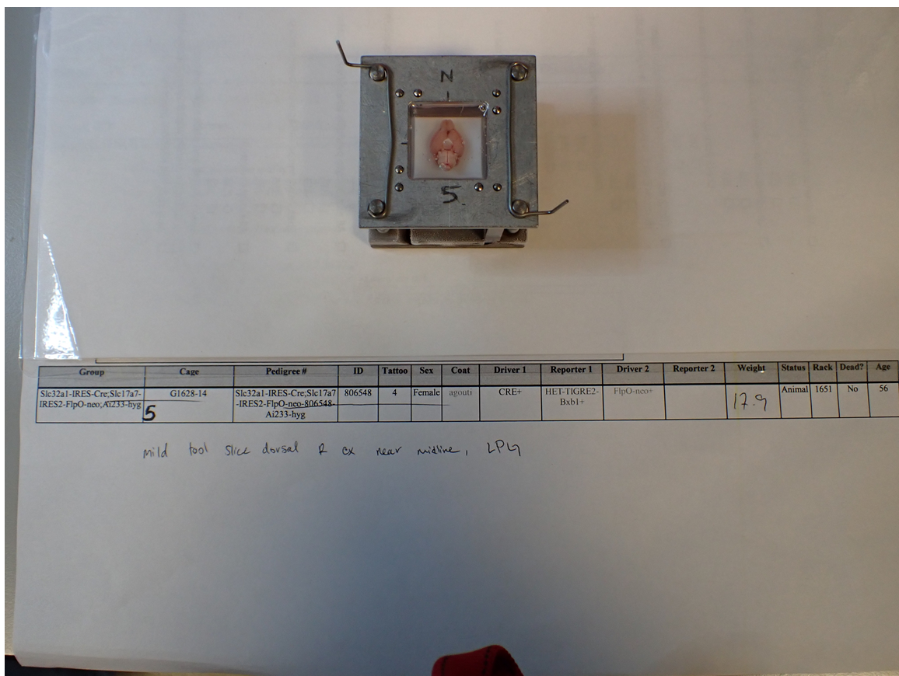
Figure 1. Photo of embedding orientation with cover over identifying task
information to comply with photo policy.

    - Place the chamber back into the dry ice/alcohol bath to freeze completely.
    - Using an etching pencil, write the orientation of the brain on the frozen embedding medium by writing an “N” on the edge where the olfactories are facing (rostral end of the brain). In the center of the block, write the specimen ID. Write a “V” on the bottom of the block if the brain was frozen with the ventral side up.
    - Disassemble the freezing chamber. Place chamber parts into a bucket of warm water.
    - Remove block and place it into the round ice bucket filled with dry ice from 7.3. Deliver blocks to location specified on the LabTracks task.
    - If the block(s) were delivered to the vivarium -80°C freezer, enter the specimen(s) into Cold Storage Catalogue (reference 6.7).

- Take Down:
  - Place dissection tools in the sink and spray with approved disinfectant. Use water and a brush to remove debris. Rinse tools in 70% Ethanol and place them on an absorbent pad to dry.
  - Remove the freezing chamber parts from the bucket of warm water, rinse with warm water and transfer to a bucket with 70% Ethanol. Let them soak for a couple minutes. Remove the parts from the Ethanol and place them on the absorbent pad to dry.

- Technical Information:
  - Animal Care guidelines and IACUC information

- Disposal:
  - Retain all expired Isoflurane for disposal by Stericycle or other authorized Reverse Distributor. Submit a ServiceNow ticket to arrange pickup.
    - Deface the labels on empty Isoflurane bottles and leave in the BSC for approximately 24 hours to allow remaining Isoflurane to evaporate. Dispose of in the glass waste container.
  - Deface the labels on empty Ethanol bottles and leave in the BSC for approximately 24 hours to allow remaining Ethanol to evaporate.
    - Remove the cap from the Ethanol bottle and dispose of it in the trash. Empty Ethanol bottles can be disposed of in the recycling bin.

