Coating Slides with Gelatin

- Scope and Applicability: The protocol describes how 1x3 glass microscope slides are coated with gelatin to improve adherence of fixed adult mouse brain sections or other tissue to slides.

- Materials:
  - Labeled slides (SOP EQ0009) or blank slides
  - Gelatin slide coating solution (SOP RP0194)
  - Benchtop paper
  - Filter Paper, Qualitative, 15 cm (VWR 28310-128 or equivalent)
  - Glass funnel

- Equipment:
  - Slide racks
  - Staining containers (e.g. Coplin jar, autostainer containers or larger glass staining well; size is dependent on number of slides to coat)
  - Slide storage boxes

- Safety:
  - Nitrile Gloves
  - Lab coat
  - Eye protection

- Output:
  - Uniformly gelatin-coated 1x3 glass slides, ready for use to mount sections (by cryosectioning or wet-mounting)

- Reference Documents:
  - EQ0009 Leica IPS Slide Printer Operation
    - To be Published
  - PF0009 1x3 Slide Sectioning
    - To be Published
  - RP0194 Preparation of Gelatin Slide Coating Solution
    - https://www.protocols.io/view/preparation-of-gelatin-slide-coating-solution-bfzvjp66

Warning: Personal Protective Equipment (PPE) should be used at all times while operating this protocol. If you are unsure what PPE you should be using, see your immediate supervisor.

- Setup:
  - Determine the type and number of slides required (SOP PF0009). Obtain suitable slide rack and staining containers.

- Methodology/Procedures:
  - Load clean, lint-free glass microscope slides onto an appropriate size slide rack for the number of slides to be coated. The label side of the slide should be placed upwards.
  - Place fluted filter paper into a glass funnel. Pour the freshly-made ~50°C Gelatin Solution (SOP RP0194) through the filter into a container that is suitable for the slide rack (see Section 3.2).
  - Immerse the slide rack making sure that all slides are completely covered by the gelatin solution. Gently agitate rack to make sure slide surface is covered and no bubbles adhere to slide surface. Slides should be submerged past the painted label.
  - Remove the slide rack after 30 seconds. Place on benchtop paper to drip dry.
  - Leave the slides in the slide rack to air dry overnight at room temperature in a dust and lint-free environment or cover with aluminum foil loosely.
  - The slides are ready for use when dried and can be boxed and kept cool and dry for up to 1 month. Label box with date and slide coating, and preparer’s initials.
  - The same solution can be used for multiple racks. Repeat Step 8.3, and add more gelatin solution to make sure slides are completely submerged.
  - Labels can only be printed on the slides (SOP EQ0009) before coating. Sending gel-coated slides through the printer increases the risk that the slides will be scratched.

- Take Down:
  - Residual gelatin solution should be diluted ≥2X with warm water and rinsed down the municipal drain.
  - Rinse the staining containers and racks thoroughly with hot water then clean appropriately with water and 70% EtOH.

- Technical Information:
  - This is based upon the IHC World Online protocol:
http://www.ihcworld.com/_protocols/histology/gelatin_slides.htm

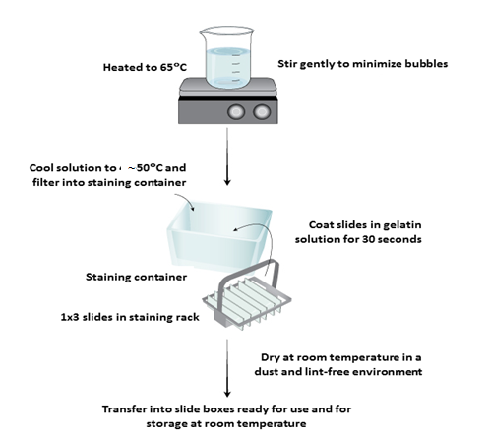

Process modified from: http://www.rndsystems.com/ihc_detail_objectname_gelatin_slides.aspx

