Core Protocol for Serial Imaging of Fluorescently-Labeled Mouse Brain on the TissueCyte 1000 System

- Scope: Instructions for setup and scanning of fluorescently-labeled tissue sections mounted in agarose and attached to a slide using the TissueCyte 1000 block face 2-photon system are described.

- Materials:
  - Agarose-embedded brain attached to a barcoded 1x3 slide (SOP PF0262, PF0272, PF0315)
  - 70% Isopropyl alcohol
  - MilliQ water
  - Vibratome blade (Accutek Blades Microkeratome Blade part 89-0034-0000)
  - Nylon mesh strainer
  - 1000 ml wide mouth beaker
  - Soft brush
  - Small paintbrush
  - T-Square Ruler
  - LED flashlight
  - 50 ml conical tube (VWR 21008-951 or equivalent)
  - 50 mM Phosphate buffer with 0.1% Sodium Azide (SOP RP0197)
  - Disposable transfer pipette

- Equipment:
  - TissueCyte 1000 system components, including xyz stages, PCs (2) running the TissueCyte Vivace & Orchestrator software packages (on rack), barcode scanner, PMT power supply (System 0 only), piezo controller, specimen bath.
  - Air table (Newport)
  - 3/32” hex key
  - Mai Tai (Laser) and associated components:
    - Mai Tai Laser Head (on Newport air table)
    - Power Supply (on floor)
    - Chiller (on floor)
  - PC connected to laser running MaiTai software (Spectra Physics Mai Tai 0454-8260).
  - Network attached storage arrays (one on each system)
  - IR viewer

- Safety:
  - Nitrile gloves
  - Laser-safe eye protection
  - Laser-safe lab coat

WARNING: The Mai Tai is a Class IV laser and, as such, emits laser radiation that can permanently damage eyes and skin, and is also considered a fire hazard. Take precautions to prevent exposure to direct and reflected beams. Obtain proper laser safety training prior to operating the system. Wear protective eyewear. Laser may be shut down in emergencies using the Emergency Stop switch on the wall.

- Output: For 100 µm vibratome cutting thickness of an adult C57BL/6 mouse, ~140 serial images collected throughout the entire mouse brain, stored to disk. About 140 100 µm thick mouse brain sections, collected in a conical tube for storage at 4°C.

- Reference Documents:
  - PF0260 Slide Preparation for Mounting Samples for TissueCyte 1000 Sectioning and Imaging
    - https://www.protocols.io/view/slide-preparation-for-mounting-samples-for-tissuec-bdvni65e/abstract
  - PF0315 TissueCyte Specimen Embedding - Acrylamide co-embedding
    - https://www.protocols.io/view/tissuecyte-specimen-embedding-acrylamide-coembeddi-ber4jd8w/abstract
  - RP0197 Phosphate Buffer with 0.1% Sodium Azide
    - https://www.protocols.io/view/50-mm-phosphate-buffer-with-0-02-sodium-azide-opti-bezjjf4n/abstract
  - EQ0063 Maintenance of TissueCyte System
    - https://www.protocols.io/view/maintenance-of-tissuecyte-system-ber3jd8n/abstract
  - EQ0067 TissueCyte Installation and Alignment Guide
    - https://www.protocols.io/view/tissuecyte-installation-and-alignment-guide-ber2jd8e/abstract
  - EQ0068 TissueCyte Troubleshooting Guide
    - https://www.protocols.io/view/tissuecyte-troubleshooting-guide-beryjd7w/abstract

- Setup: See Appendix for overall Process Workflow diagram.
  - Preparation for imaging
    - Make sure the laser is shuttered, and the PMTs are off prior to opening the TissueCyte doors to place a new sample! (see Figure 1) If the PMTs are exposed to ambient light from the room lights while the power box is on, they will be destroyed.
    - If the laser was switched off previously, it must be turned on, initialized and allowed 40 minutes to warm up. See Section 8.0 Initializing the Laser for procedural details.
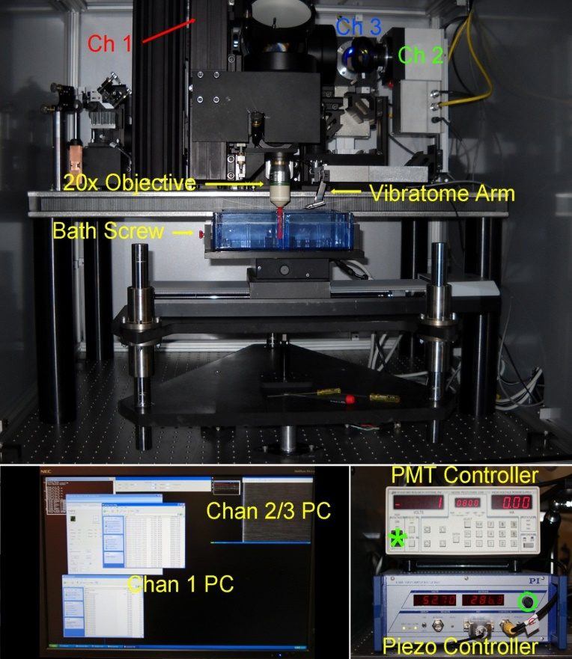
Figure 1: TissueCyte System. Note: Only System 0 has a manual PMT controller. All other systems have software-based GUI PMT controllers.

  - Remove the Vibratome arm from inside the TissueCyte using 3/32” hex key.
    - The used blade is removed by slightly loosening the 0.05” screws on the back as shown in Figure 2.
    - Dispose of the used blade in the Sharps disposal container. Place the new blade in the Vibratome. Replace the Vibratome arm, and make sure that it is evenly tightened, aligning it to be parallel with the block face. This is essential to ensure even cutting during system operation.

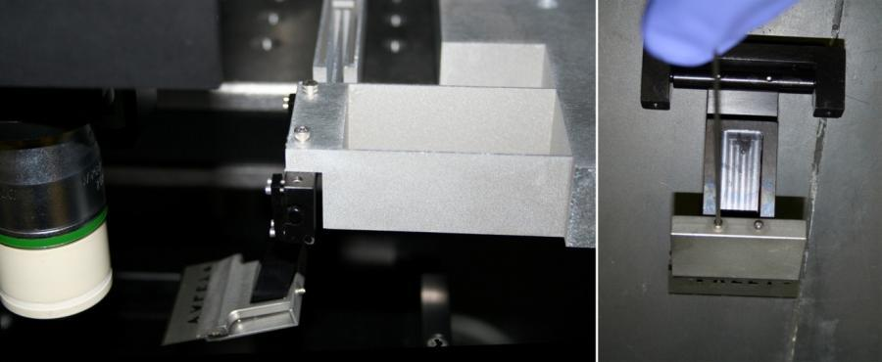
Figure 2: Vibratome arm with blade


  - Start up the Channel 1 PC and open the Orchestrator software from its desktop icon.
  - Open Vivace Client on PC2.
    - Note: with the TissueVision software, do not press buttons repeatedly as this causes the system to crash. Press a button and wait for the action to be completed prior to pressing the button again.
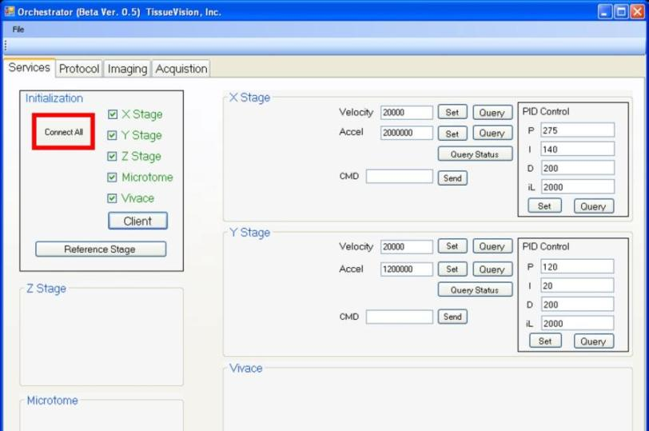
Figure 3: Orchestrator Services tab

  - In the Services tab, connect to each component, by hitting the “Connect All” button and allowing them to initialize (see Figure 3). The x, y, and z stages, as well as the Vibratome and imaging module (Vivace) will connect. Vivace will open on the Channel 1 PC.
    - Once all checkboxes turn green, click Client to launch.
    - Once the client has launched on the slave system, click Reference Stage.
  - Enter the Sample ID. Use a specimen that is mounted to a slide, according to PF0315 TissueCyte Specimen Embedding - Acrylamide co-embedding.
    - In Orchestrator, open the Protocol tab, and highlight the “Sample ID” bar. See Figure 4 for software interface example; Sample ID bar is highlighted in red.
    - With the handheld barcode scanner, scan the barcode on the slide with the agarose-embedded brain attached. The Sample ID field should populate with the barcode number. Visually confirm that the barcode on the slide is appearing as the number in this field.
    - Next, enter the 5 digit specimen number into the Description field.

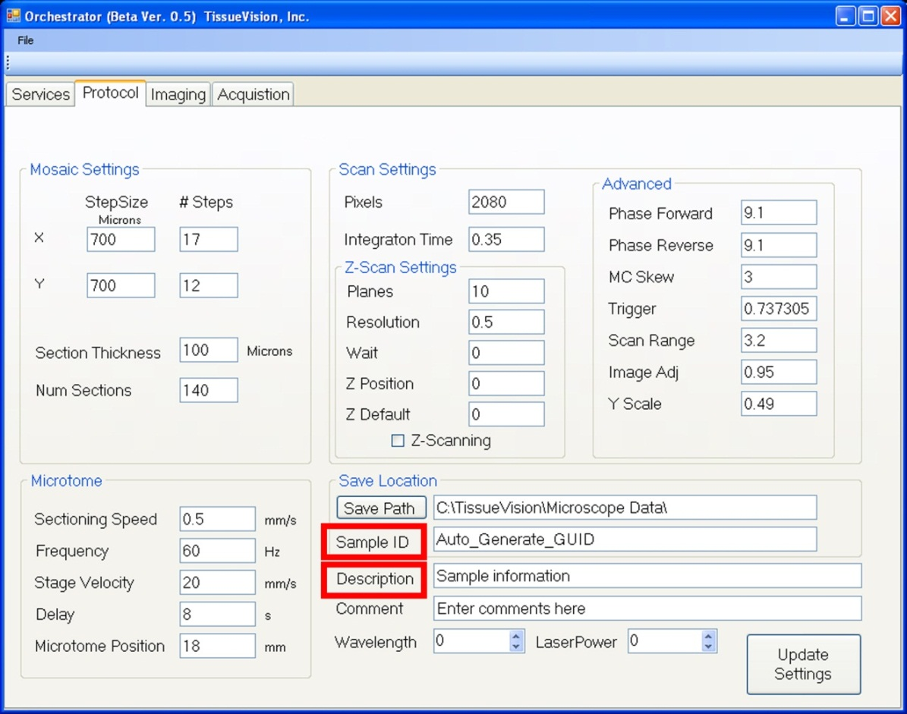
Figure 4: Orchestrator Protocol tab

  - Place the barcoded slide with specimen mounted on it onto the center of the raised metal platform inside the bath, such that the top of the brain will face the doors of the TissueCyte system. The barcoded end of the slide should be on the left. See Figure 5 for a diagram of buffer chamber (from top and side views) and slide placement. The magnets on the slide base will hold the slide to the metal platform.
  - Use the T-square ruler to carefully center the specimen, such that the midline is oriented exactly parallel to the sides of the bath, and exactly centered within the bath. Use a ruler and the screws on the sides of the bath to help in sample orientation. See Figure 5 for a diagram of buffer chamber and slide placement; refer to the crosshairs in the upper panel for correct slide and specimen alignment.

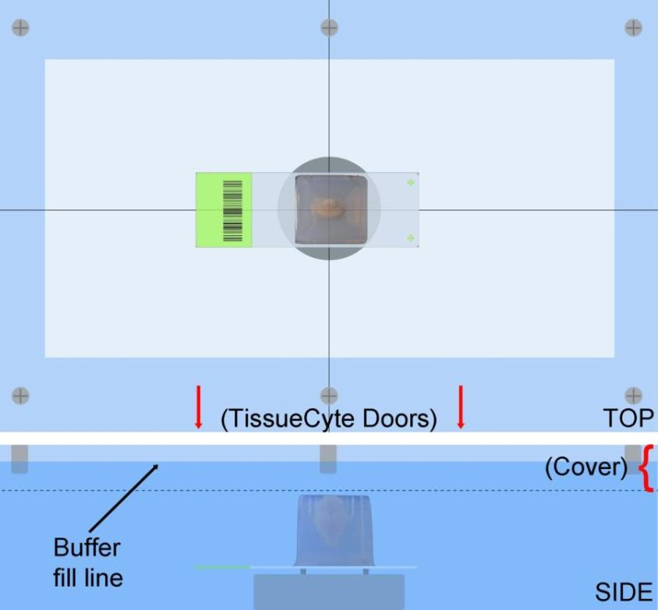
Figure 5: Centering the specimen in the bath

  - Once the sample and Vibratome blade are properly loaded, fill the bath with phosphate buffer with 0.1% Sodium Azide (SOP RP00197) until solution is midway up the bath cover, as seen in the side view. Add the solution slowly and avoid bubble formation, especially underneath the glass slide. Bubbles that get stuck underneath the objective will severely impact image quality; be sure to displace any bubbles before run. These can be displaced with a transfer pipette.
  - Carefully load the bath into the microscope, taking care not to spill any buffer. Avoid bumping the objective and the Vibratome. Push the bath backward to its limit, and then rotate the screw on the left side of the bath to secure it in place.
  - Using Stage Control in the Imaging tab on Orchestrator, adjust the z axis to approximately the height of the trimmed agarose block by moving the stage up in small increments (less than 1000 µm) until the top of the agarose block is approximately at the same plane as the Vibratome blade (see Figure 6).
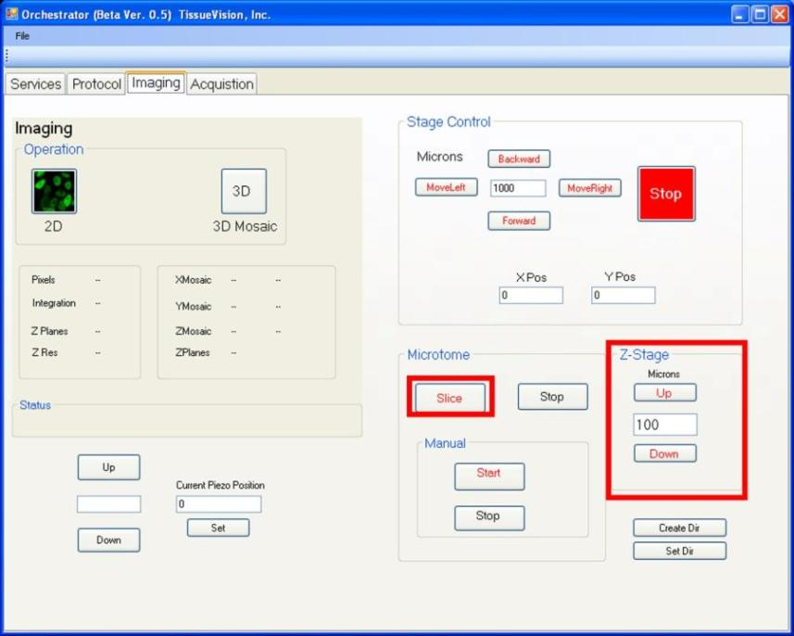
Figure 6: Orchestrator Imaging tab

  - Click “Slice” to cut a section; this will result in the cutting of a single 100 µm section. If the blade is still above the plane of the agarose block, continue to move the stage up in 100-200 µm increments, and slice again after each movement.
  - Once the blade cuts the first section of tissue, cut additional sections without moving the z stage by pressing “Slice” once, waiting for a section to be cut, then slicing again until 3 total sections have been cut. This will ensure a flat cutting plane is achieved.
  - Set the starting point for sectioning.
    - Cut through the brainstem until the edge of the cerebellum is visible.
    - The last trim section should contain both brainstem (BS) and a small piece of cerebellum (CB) as shown in Figure 7.

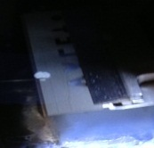 | CB  BS
Figure 7: Final trim section (floating)

- Initializing the laser: (See Figures 8-12)
  - The laser systems stay on continuously for most of the year. These steps are only necessary when the laser has occasionally been powered down.

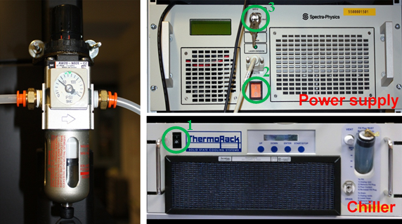
Figure 8: Mai Tai laser power switches
  - Verify that the air table pressure is approximately 40 psi. If the table oscillates, the pressure is likely suboptimal. Contact Engineering if this occurs.
  - Turn on the chiller (1). Verify that the chiller is set to 21°C.
    - If chiller temperature is not optimal, contact Engineering so that Chlor-T can be added.
  - Turn on the power supply (2, orange switch). The power supply LCD screen will display “Spectra-Physics” and “Warmup: 0.0%” (Figure 9).

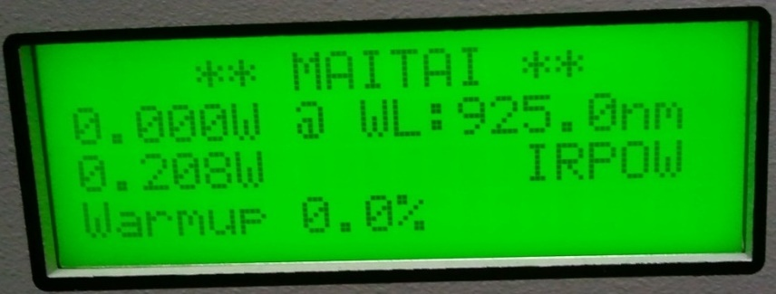
Figure 9: Power Supply display
    - Wait 2 minutes, and then turn the key ON (3, 90° clockwise). The Mai Tai DeepSee controller, on top of the power supply will display “Initializing” (Figure 10).

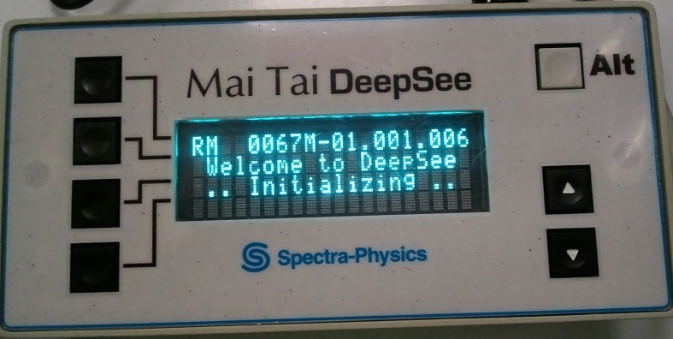
Figure 10: Mai Tai initialization

    - At 65.0% warmup the DeepSee finished “Initializing” and will display the “template” option. Press DOWN (4) to select the “_20XW1.00ZEI” template. Once the template is loaded it’ll display WaveLn: 925* (Figure 11).

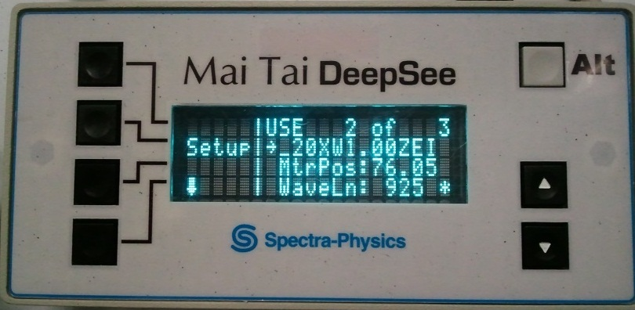
Figure 11: Mai Tai Template Loaded

    - The system takes approximately 40 minutes to achieve 100% warmup, which will be displayed on the LCD screen. At that point, the system is ready to use.
  - Double-click to open the Spectra Physics Mai Tai 0454-8260 software and click OK.
  - When the system status displays “Ready to turn on,” turn ON the laser by right-clicking and holding down the ON button for about 3 seconds until the EMISSION light turns on (note: no laser is emitted from the laser head until the shutter is opened). Note: When laser is in emission mode, the DANGER light activates outside the lab door. Laser power climbs gradually and the system will enter Pulsing operation. Once IR power rises and stops oscillating, the laser is ready to use. This takes approximately 20-30 minutes.
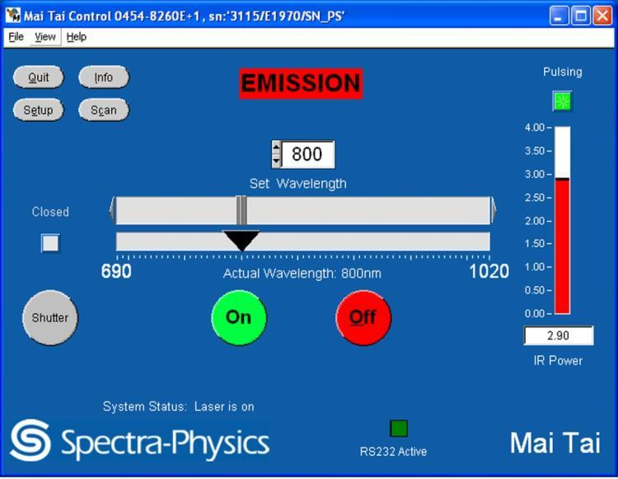
Figure 12: Mai Tai Control
  - Set the wavelength for initial specimen setup to 925 nm (invisible infrared) and allow the laser to adjust to this value. The slider will gradually adjust to this setting over approximately 30 seconds.
  - Open the shutter by clicking down on and holding the SHUTTER button for about 3 seconds until the shutter light turns red. Laser emission is now present. Note: the shutter can be closed by clicking the SHUTTER button again at any time without turning off the laser.

- Image acquisition
  - Laser power calibration setting. Prior to starting an imaging run, check the laser power at the objective and adjust either the LCVR voltage (systems 3 and 4) or the halfwave plate (all others) until the desired power is achieved.
  - Turn off overhead room lights.
  - Adjust the V2 setting in Vivace on the Channel 1 PC by 0.05 steps to the value that provides the required laser power (TC0 only).
  - Open the internal TissueCyte shutter, by changing the setting from “Automatic” to “Open” (TC0 only; Figure 13).
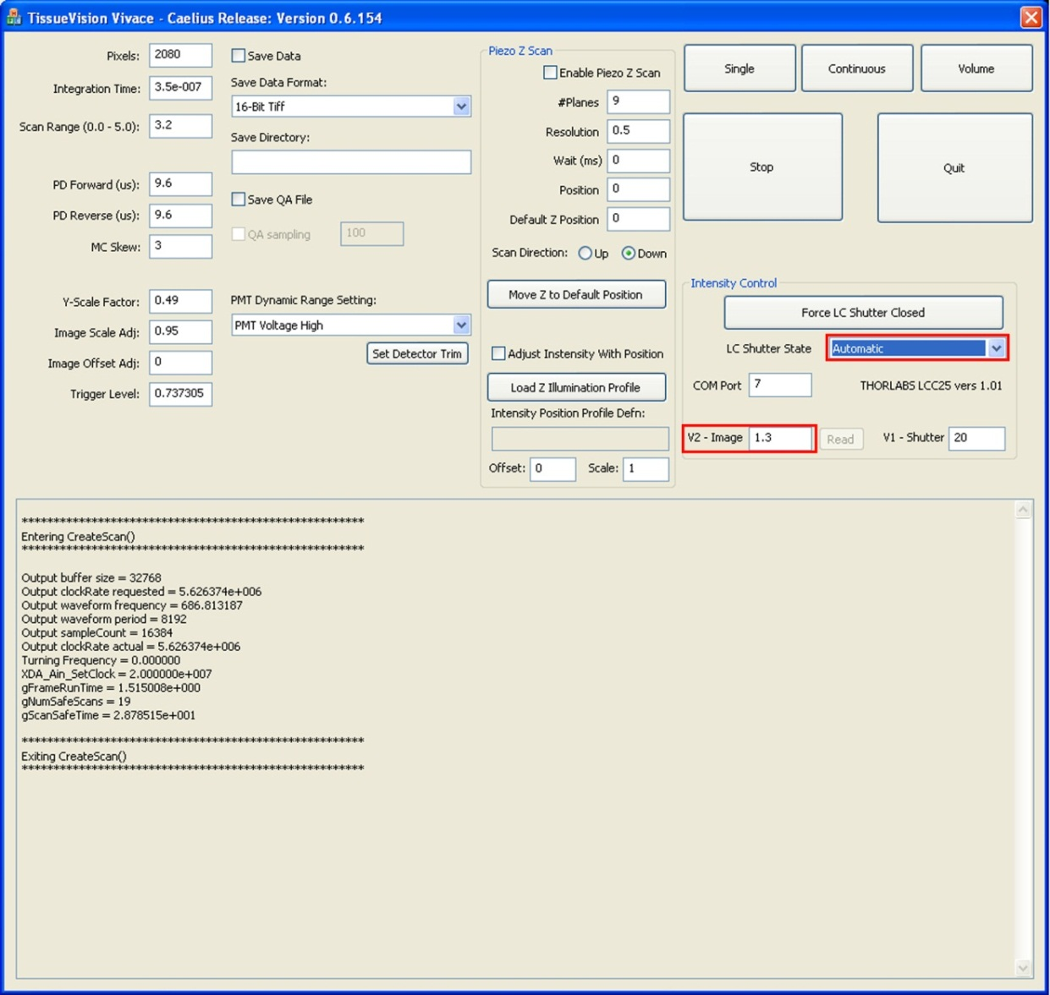
Figure 13: Vivace window
  - With both shutters open, laser light is visible using the IR viewer. The laser should be illuminating the bath. Move the stage forward in 1000 µm steps, until the brainstem of the sample is illuminated, which places the brainstem directly below the objective.
  - Close the internal TissueCyte shutter by changing the setting from “Open” to “Automatic” (see Figure 13).
  - Close the doors of the TissueCyte system, and secure the doors using the snaps at the base.
  - Turn on the PMTs by turning the voltage supply to ON (System TC0) or opening the PMT GUI, then input the voltage (e.g. 600V), and click On (Figure 14). Recommended PMT voltages are: 600,625 and 650V.
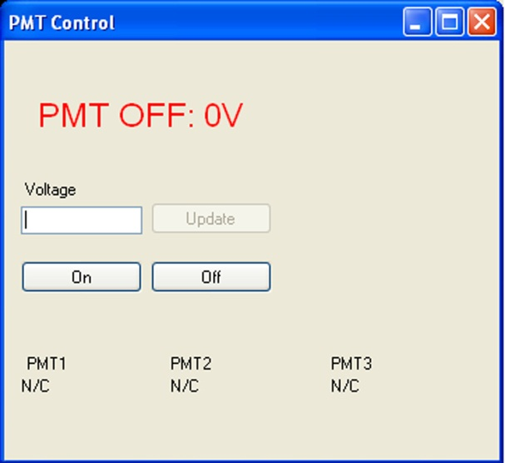
Figure 14: PMT GUI
  - Take a snapshot image by clicking “2D” on Orchestrator. Images from Channel 1 (red) will be displayed on the Channel 1 PC, and images from Channels 2 (green) and 3 (blue) will be displayed on the Channel 2/3 PC.
  - Change to following options on Channel 1’s image drop boxes:
    - Image Display: Auto Max/Min → Manual
    - Maximum: 1000
  - Use the piezo controller to find the top of the sample. The piezo moves the objective in the z axis up to 400 µm by carefully twisting the dial clockwise to move down or counterclockwise to move up.
  - Once the top of the sample is found, record the setting on the piezo corresponding to the top, then move 50 µm deeper into the sample.
    - Move to an area showing only brain stem’s tissue and ensure that the mean intensity of the image is 250 or higher. If the intensity is lower than 250 increase the PMT voltage up to 650V. If the intensity is too high (e.g. 600+) decrease the PMT voltage down to 600V.
    - The image has good brightness as long as the intensity is 250 or higher. However, there are cases where the intensity will be below 250. The lower limit for intensity is around 200. Below 200 the runplan should be aborted and the laser settings need to be readjusted.

  - Find the right and left edges of the sample by moving the stage in Orchestrator in intervals of 1000 µm. Once both edges have been found, move to the center (in L/R) of the sample.
  - Find the front and back edges of the sample by moving the stage in Orchestrator in intervals of 500 µm. Once both edges have been found, move to the center (in F/B) of the sample (see Figure 15).

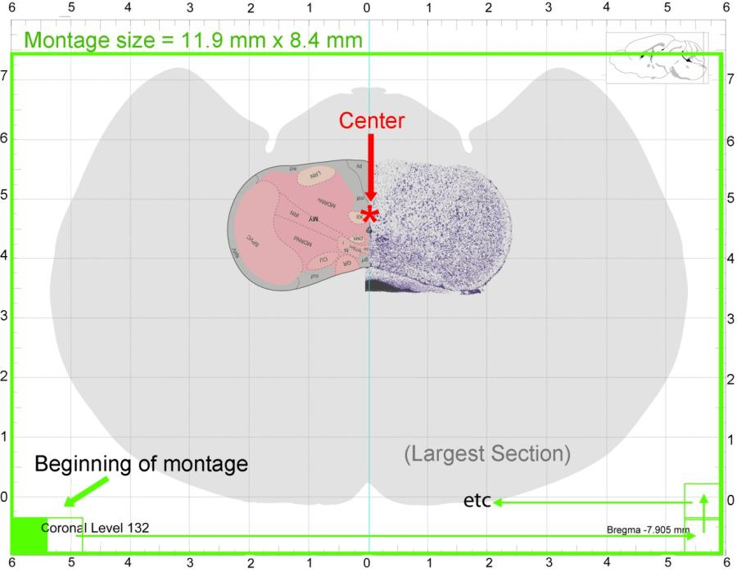
Figure 15: Scan area

    - A more reliable method to center the brain is by aligning the brain’s central canal at the middle-right edge of Channel 1’s image (Figure 16). Note: the actual image’s width extends about 25% passes the bottom of the screen.
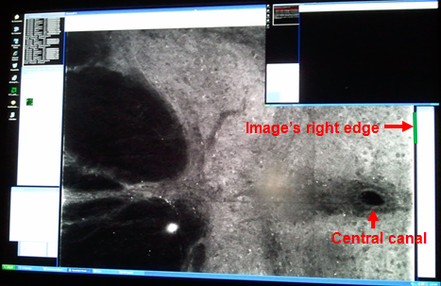
Figure 16: Aligning a brain using the Central Canal

    - Sometime a brain might arrive with short brain stem, thus the central canal might not be presented. In this case the brain can be centered by aligning the brain’s midline 100 µm passes the middle-left edge of Channel 1’s image (Figure 17).

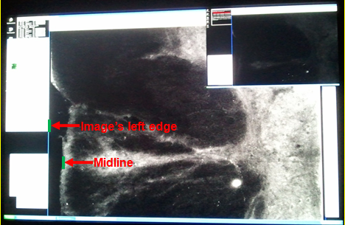
Figure 17: Aligning a brain without a visible central canal
  - Once the center of the specimen has been found, move the stage 5.5 mm (5500) back and 5.8 mm (5800) right.
  - Move the piezo to the appropriate value (either 75 or 100 µm below the top of the section, or as project requires).
  - Make sure that the drive is available on both PCs for image acquisition. Different systems will show the drive as D or E. It DOES NOT matter if the drives are recognized as D or E, but the drive designation must be IDENTICAL on both Master and Slave systems.
  - Enter image parameters in the Mosaic Settings panel of the Protocol tab on Orchestrator (see Figure 18).
    - X: 700 µm x 17 columns
    - Y: 700 µm x 12 rows
    - Num Sections: 140 sections (full thickness of brain)
  - Click Update settings in Orchestrator, and make sure that Vivace settings mirror those entered in Orchestrator. Orchestrator will save the Mosaic Settings in the case of a computer crash.
  - Click “3D mosaic”. The TissueCyte will now image and section the entire brain. This should take about 18 hours. Note: Be sure to leave overhead lights off during the entire acquisition cycle. Close the hard sliding door when exiting the room in order to avoid accidental light exposure or room disturbance.
Figure 18: Mosaic Protocol tab
- Takedown:
  - Once the entire mosaic is finished, “Completed 3D mosaic” will be displayed on the Channel 1 PC.
  - Turn off the power supply for the PMTs.
  - Shutter the laser (on the laser control PC).
  - Open the doors of the TissueCyte system.
  - Using the Z-Stage portion of the imaging tab in the Chan 1 PC Orchestrator, move the stage down (approximately 35 mm) until the top of the bath is beneath the plane of the blade on the Vibratome (see Figure 19).
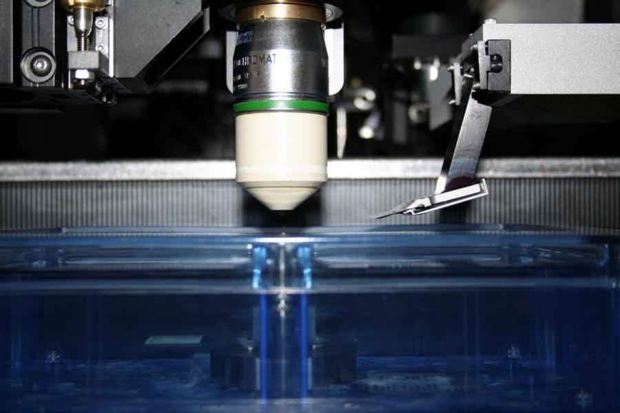
Figure 19: Bath positioned below Vibratome

  - Capturing & storing tissue sections
    - Loosen the bath screw, and carefully remove the bath from the stage.
    - Position the Nylon mesh strainer over the 1000 ml beaker, in the sink.
    - Carefully pour the buffer and floating sections from the bath, through the strainer, into the beaker (see Figure 20).
    - Check that all sections were removed from the bath. Perform multiple rinses (emptying through the strainer should remove all sections). Any sections left in the bath can be removed using a small paintbrush.
    - Using the paintbrush, carefully move the sections from the mesh sieve into the original conical tube that is labeled with the specimen and project information. Replace the cap securely, label tube with the TissueCyte operating week, and parafilm the circumference of the tube around both cap and tube.
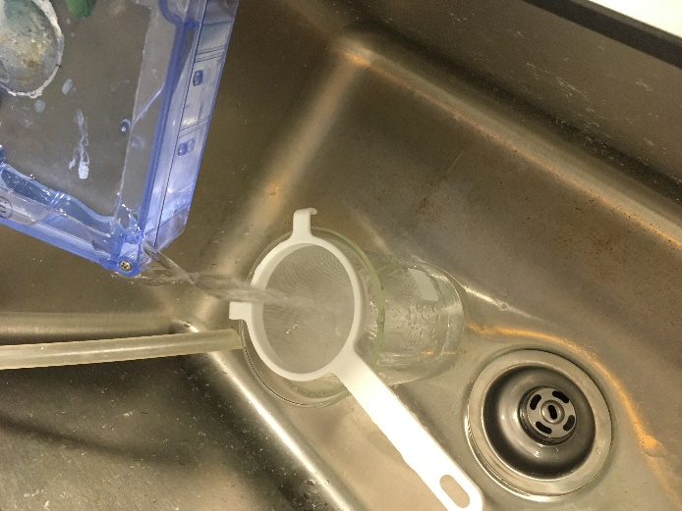
Figure 20: Moving sections from bath to strainer.

    - Store tube at 4°C, with minimal direct light exposure.
    - Clean the empty bath by running water from the tap into the bath, then rinsing with deionized water; air dry. Do not use soap.
    - Enter TissueCyte run information into your Laboratory Information Management System.

- Technical & Reference Documents:
  - Laser manual – Spectra Physics Mai Tai
  - ANSI Laser Safety Regulations

- Appendix:
  - Laser emergency shutoff

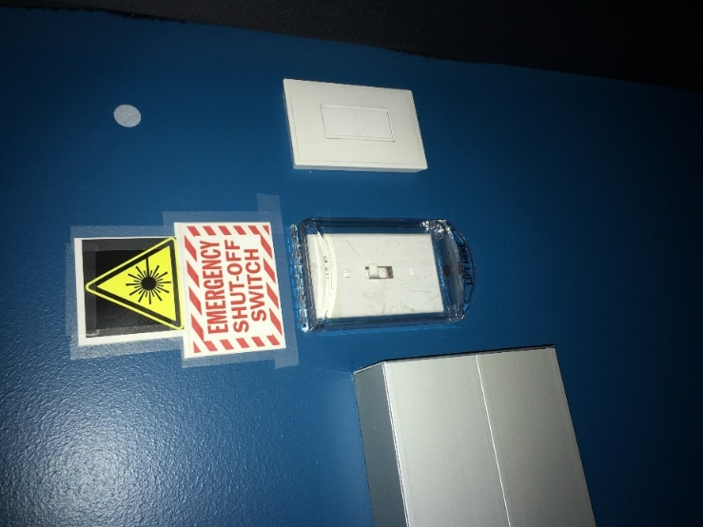

  - Laser safety goggles. The goggles that are appropriate for PPE in the TissueCyte rooms have an OD greater than 5 at 925 nm.
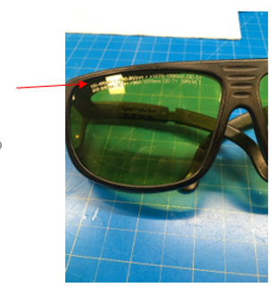

  - Troubleshooting:
    - Routine operational system maintenance is required; see SOP EQ0063 for more information and recommendations on frequency.
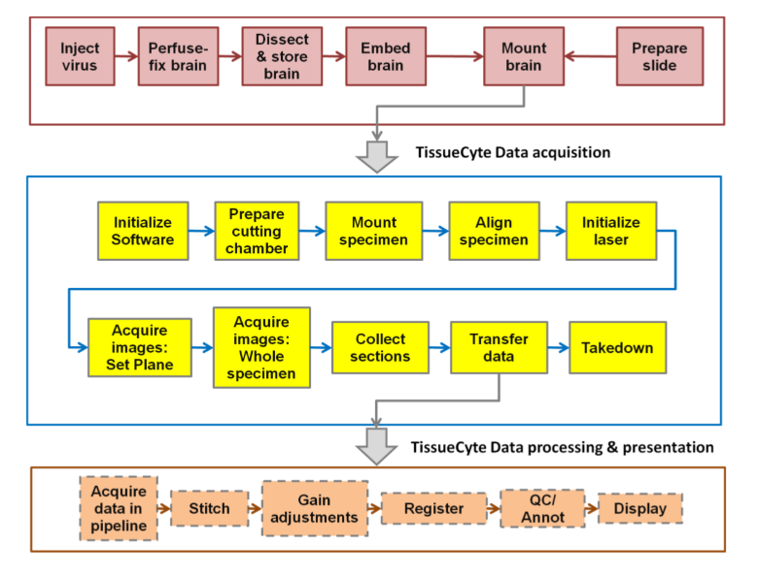
  - Process Overview: Steps covered in this SOP are shown in yellow.

