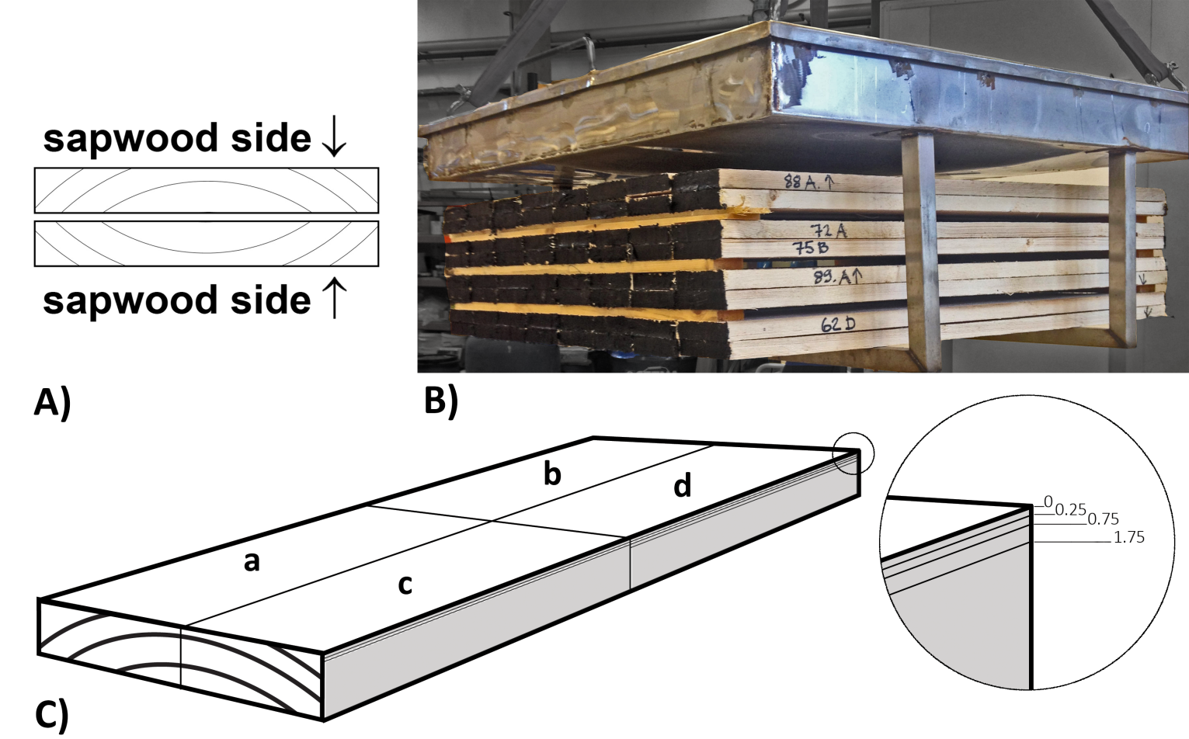
Fig 1. Drying and board preparation scheme. (A) double-stacking of boards with the sapwood side of each board facing outwards in each pair, (B) stacking of boards in the laboratory kiln, and (C) planing depth scheme for specimens: (a) unplaned, (b) 0-0.25 mm, (c) 0.25-0.75 mm, and (d) 0.75-1.75 mm planing depth.

Extraction of extractives and analysis
All the air-dried boards and 10 randomly selected kiln-dried boards were cut to a length of 250 mm and a width of 100 mm, and then split into four specimens (Fig 1C). These specimens were used for the determination of the distribution of lipophilic extractives . The sapwood sides of three of four specimens were planed three times to depths of 0.25, 0.75 and 1.75 mm from the original un-planed surface. 3.5 g of the shavings from each planing were milled in a Fritch planetary mill and 0.5 g was used for moisture content determination, 1.0 g was used for the extraction of lipophilic compounds, and the remainder was left untreated and stored at a temperature of -20°C.
The extraction was done using acetone (VWR Chemicals: 20165.323, 75 ml) in a mini-Soxhlet extractor according to the SCAN-CM 49:03 standard method [29]. The total lipophilic extractives content was given in mg g⁻¹ of dry mass after evaporation of the acetone and drying of the extracted solution.
Fatty acids and resin acids in the acetone extract were analysed using GC-MS after trimethylsilylation. The silylation with 100 µl of BSTFA and 50 µl of TMSCl was performed in an oven at 70°C for 20 minutes according to Sjöström [30] with 1-methylnaphthalene dissolved in pyridine as internal standard [31].
A SUPELCO SLB-5 MS capillary column (L × I.D. 30 m × 0.25 mm, d_{f} 0.25 μm) was used starting at a temperature of 50°C and finishing at 270°C with an entire analysis cycle of 25 minutes. The injector and detector temperatures were 270°C and 290°C, respectively.
The resin acid and fatty acids were identified by NIST Mass Spectral Library [32] and a quantitative estimation was made by comparing the peak areas with that for the internal standard.
The total phenolics content was determined by FC assay according to a procedure described by Julkunen-Tiitto [33]. The absorption was measured after 40 minutes at 735 nm against that of a mixture containing all the reagents except for the sample. Tannic acid (VWR Chemicals; 83510.260) was used as a standard and the results are expressed in mg (TAE) g⁻¹ dry mass of wood.

