FACS Single Cell Sorting

- Scope and Applicability: This protocol provides step by step instructions for performing single-cell sorting by using BD FACSAria II machine or BD FACSAria Fusion machine and BD FACSDiva software.

- Materials:
  - Single cell suspension of sample, filtered, and ready for sorting
  - Negative control cell samples
  - Positive control cell samples (if expression is not obvious)
  - Single label stained cell samples (if compensation is required)
  - BD FACS Accudrop beads (BD Bioscience 345249).
  - BD Cytometer Setup & Tracking beads (BD Bioscience 23-91-47-00 or 23-91-07-29).
  - Rainbow Fluorescent particles (Sphero 556291).
  - 1X PBS (SOP RP0001)
  - MilliQ water
  - Sheath fluid (BD Bioscience 342003)
  - 70% Ethanol (RP0032)
  - 5 ml Polystyrene round bottom tubes (BD Falcon 352058)
  - 5 ml Polystyrene round bottom tubes with filter (BD Falcon 352235)
  - Sterile tissue culture 96 well plates (Falcon 353072)
  - 0.2 ml non-skirted PCR plate (Thermo Scientific AB-0600)
  - Aluminum plate seals (VWR 60941-076)
  - Solvent resistant markers
  - Kimwipes
  - P2 Pipette tips
  - P10 Pipette tips
  - P1000 Pipette tips
  - Cotton-tipped swabs

- Equipment:
  - Sonicator (Branson 200 or equivalent)
  - Flow cytometer (FACSAria II or FACSAria Fusion)
  - Centrifuge with plate holder (Beckman Coulter X-14R or equivalent).
  - PCR hood
  - Plate centrifuge (LabNet MPS1000 or equivalent)
  - Biohazard waste disposal container
  - 4ºC Refrigerator
  - Chilled aluminum blocks for holding PCR plates
  - Plate frames for proper mounting of aluminum blocks (custom made in house)
  - P2 Pipette
  - P10 Pipette
  - P1000 Pipette

- Safety:
  - Nitrile gloves
  - Safety glasses
  - Labcoat

- Output:
  - Single cells or nuclei from a selected population of mouse or human tissues sorted into microtitre wells for transcriptomic or epigenetic analysis.
  - Data from experiment entered in your Laboratory Information Management System.

- Reference Documents:
  - BD FACS Aria II manual
    - “BD_FACSAria_II_User_Guide.pdf”
  - BD FACS Aria III manual
    - “BD_FACSAria_III_User_Guide.pdf”
  - FACSDiva Software manual (With software open Click Help > Literature > Reference Material)
    - “bd_facsdiva_software_v_8.0_manual.pdf”
  - CS&T Calibration Manual for FACS Diva 6.0 (p. 117 of BD FACS Aria II Manual)
    - “BD_FACSAria_II_User_Guide.pdf”
  - CS&T Calibration Manual for FACS Diva 7.0 and higher (p. 136 of BD FACS Aria III Manual)
    - “BD_FACSAria_III_User_Guide.pdf”

  - EQ0071 FACS Aria II Startup and Calibration.
    - https://www.protocols.io/view/bd-facs-aria-ii-start-up-and-calibration-besajeae/abstract
  - RP0001 Phosphate Buffered Saline (PBS)
    - https://www.protocols.io/view/phosphate-buffered-saline-pbs-bezgjf3w/abstract

- Startup:
  - Startup the machine following the procedure outlined in SOP EQ0071 FACS Aria II Startup and Calibration. This protocol applies to both the FACSAria II and the FACSAria Fusion machines.
  - Conduct daily instrument setup and calibration following the procedure outlined in SOP EQ0071 FACS Aria II Startup and Calibration.
  - Obtain the cell/nuclei suspension to be sorted.

- Methodology/Procedure
  - Create a new experiment from an existing template:
    - Select Experiment > New Experiment, click on the name tab, select the desired experiment and click OK. The experiment will appear in the browser window.
      - Rename the file to reflect the new Experiment, Specimen and Tube. Right-click Experiment name>Rename or click on experiment name to highlight it, click on Experiment in the Inspector window and add a new name in the name line, click Enter to save.
      - The naming convention will be determined based on the workflow. An example convention would contain the name of instrument (ARIA 478=F1, ARIA Fusion in 278= F2) group name, the datefluorescent label and operator’s initials.
    - Alternatively, import an earlier similar experiment from a network location.
      - Click file>Import>Experiments>My network places. Navigate to the correct experiment and click Import.
      - Open the imported experiment by double-clicking on the brown folder icon. Right click on experiment name, choose Duplicate without data and rename experiment.
    - Modify cytometer settings:
      - In the Browser window, double click the Experiment name and single click on Cytometer Setting.
      - The Inspector - Cytometer Settings window will open (Figure 1).
      - On the Parameters tab of the Inspector window, delete all fluorescence parameters that will not be used for the experiment.
      - Add any missing fluorescent parameters by using the Add button and the channel pull up menu.
      - In the same window, check the A (area) and H (height) boxes next to the desired channels.
      - Check the “W” box for the FSC (“Forward Scatter”) and SSC (“Side Scatter”) parameters to exclude doublets (highly recommended). Make sure FSC and SSC are not in log scale while fluorescent parameters are.
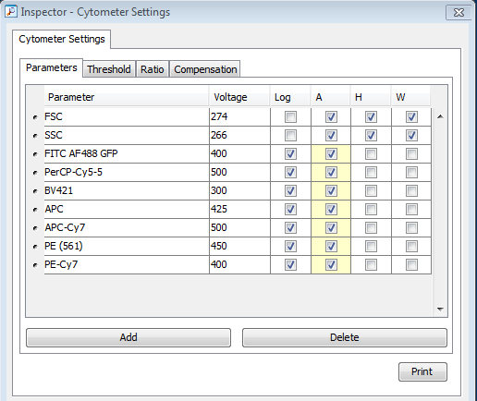
Figure 1: Inspector window

    - Add a Specimen by right-clicking the Specimen button in the Browser window (indicated with a syringe icon) and selecting Add New Specimen or clicking Experiment>New Specimen. For any experiment on a given day, each sample will be run as an individual tube within the Specimen. The name can be redundant to the experiment or descriptive of the sample.
    - Create a new sample by clicking on the Sample button (indicated with a tube icon). Click on tube pointer to the left of each sample name and it will change to green. Create a new name for a sample in the Inspector window and press Enter. It is recommended to name the samples descriptively rather than simply assigning numbers.
  - Set PMT voltages:
    - Adjust the FSC and SSC PMT voltages by analyzing your negative (unstained) control cells.
    - Adjust PMT voltage for all fluorescent parameters used such that most negative cells are visible on a normal log plot, with staining not exceeding the second and third decades (10² and 10³).
    - Load your fluorescent-stained cells (positive controls) and begin analyzing to make sure they are still in the dynamic range (<2x10⁵). If the positives are too bright, reduce PMT voltage in the Parameters tab in the Cytometer window to get the bright signal back in the dynamic range. TdTomato+ cells from AI14 mice are often off scale after setting voltages on the negative controls since they are so bright.
  - Adjust laser area scaling:
    - The area scaling must be to be adjusted for FSC analyzing cells. Make sure that the FSC-H vs. FSC-A plot is created in the experiment. The area scaling can be adjusted in the Cytometer window, under the Laser tab, by adjusting the number in the FSC Area Scaling box. Examples of an FSC area scaling that needs adjustment (left) and a FSC-H vs. FSC-A plot with properly adjusted FSC area scaling (right) are shown in Figure 2. Note: For instructions on how to adjust area scaling consult the BD FACSAria II User’s Guide p.310.

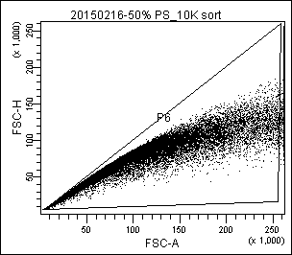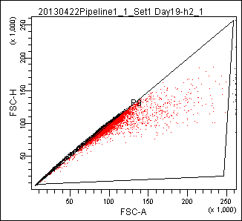
Figure 2: Example of a plot when the FSC area scaling needs adjustment (left)
and a FSC-H vs FSC-A plot with properly adjusted area scaling (right).

  - Compensation
Compensation is not necessary if RFP and DAPI are the only fluorescent parameters. If RFP and GFP or YFP are used, compensation improves analysis. Since our regular stains are so well separated and don’t require compensation on our instruments, we don’t provide detail on compensation here. Instructions can be found in the Aria manuals.
  - Gating for sorting RFP+ mouse cortical neurons.
Note: Determining the population of interest for each gating step described below is beyond the scope of this document. Gating strategies require experimental validation.

The Experimental Template (NAME) will have gates and a gating hierarchy. For sorting mouse cortical cells the following gating strategy should be used (Figure 3). Note that the Morphology gate here includes all events that pass FSC threshold to allow profiling of all possible RFP⁺ cells. SC-FSC and SC-SSC are to exclude doublets, and RFP+ cells are sorted from the rest of the cell based on the RFP+ DAPI- phenotype. These cells are frequently very rare.

Figure 3: Example of analysis of mouse neurons labeled by expression of tdTomato.
Cell types and the gating hierarchy are shown.
  - Analyze the sample to sort.
    - Wipe down the surfaces of the flow cytometer with 70% Ethanol before starting to sort a sample.
    - Load the sample onto the sample pedestal and click Load. The instrument will automatically begin acquiring data.
    - Click “Record” to record the fluorescence data into the data file.
    - Verify that the population of interest is gated correctly, then proceed to sorting.

  - Sorting cells:
    - Cell sorting considerations
      - Accuracy is dictated by the flow rate due to hydrodynamic focusing. Thus, for best results, the flow rate should always be under 5.
      - Most current single cell expression analyses use the 130 µm nozzle that functions at 10 psi. Some sort now for 10X use the 70 µm nozzle that functions at 70 psi.
      - Sample dilution can also impact sorting. Dilute samples to ~100,000 cells/ml for optimal sorting.
      - Single cells should be sorted on Single Cell Mode.
      - The outer left side stream must be used to sort cells into microtitre plates.
    - Ensure stream looks good and is stable. If the stream is not stable, consult Section 9.0 of SOP EQ0071.
    - Ensure deflector plates are clean.
      - Use a cotton-tipped swab wet with 70% Ethanol to wipe off any saline that has accumulated on the deflector plates.
    - Set drop delay with Accudrop beads
      - Open an Accudrop Drop Delay experiment. There is a pre-set experiment in the general templates folder Experiment>New Experiment>General tab in Experimental Templates window>Accudrop Drop Delay >OK.
      - Highlight Specimen and select Tube 1
      - Click the + button next to Tube_001 to view subfiles. Then click Sort Layout_001 to open the sort layout.
      - Setup Sort Layout _001 table. In the Device window choose 4 Tube, in Precision window choose Fine Tune, in Target Events: Continuous, in Save Reports:Save None, In Far Left window, right click and choose P1.
      - Load a 5 ml tube containing 1 drop of Accudrop beads diltuted in 1 ml PBS Note: diluted beads can be stored for 1 week at 4°C.
      - Adjust the voltage slider for the far left side stream in the stream window so that the sorted Accudrop beads fall in the middle of the left optical filter box. Make sure the far left sidestream is set between 12 and 16 (for the 130 micron nozzle-different nozzle require different setttings) and all other sidesteams are set to 0 using the Voltage slider control.
      - In the Laser tab in the Cytometer window, set the Window Extension to 0.
      - Set the Drop 1 to the current position and turn on “Sweet Spot” by pressing button at the top of the Breakoff window.
      - Adjust the sample flow rate to ~1000 events per second.
      - Turn on voltage in side stream window.
      - Turn on optical filter.
      - Press Sort in the Sort Layout window
      - Press cancel to acknowledge the warning to keep waste drawer out.
      - During Accudrop bead sorting, in the Drop Breakoff window ensure the GAP is approximately 12. If not, then adjust the GAP to 12 by changing the Amplitude. In the 130 micron window, the number displayed in the left box should be as high as possible (98-100%) and the number displayed in the right box should be as low as possible (0-1%). The two numbers should add up to very close to 100%. Adjust the Drop Delay by slowly clicking on the Drop Delay button in 0.3 increments to find the best spot. The GAP must be actively monitored as a GAP below 10 and above 14 will significantly impare sorting (these values are different for different size nozzle-consult the manual if not using the 130 µm nozzle.
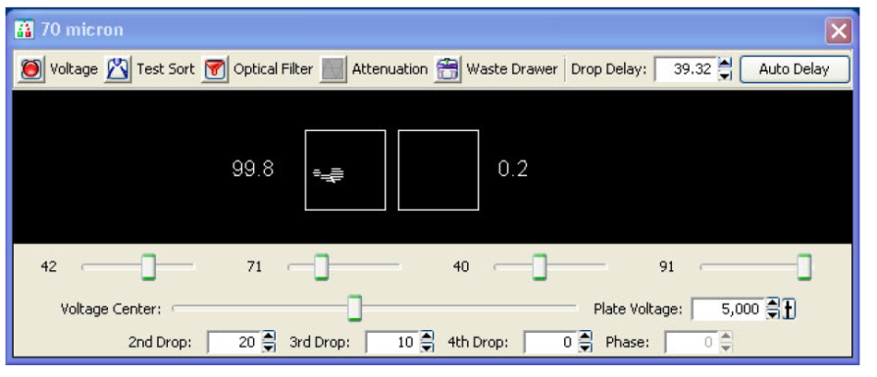
Figure 4: Side stream window showing a good drop delay. Note 99.8% of sorted fluorescent particles are present in the sidestream and only 0.2% have not been sorted.

      - When Drop Delay is set, change the Drop 1 target value in the 130 micron window to match the Drop 1 actual value in the Drop Breakoff window.
      - Stop sorting (click on sort button in the Sort Layout table).
      - Click Cancel at the Confirm dialog.
      - Unload the tube.
      - Reset the window extension to 4 for the 130 µm window (different window extension values for other nozzles-check manual).
    - Align plate holder arm and side stream to collect cells into a plate.
      - Slide the Automated Cell Deposition Unit (ACDU) adapter into the slot fitting below the sort aspirator drawer and push it all the way in (Figure 5).
      - Align outer side stream so that it passes through the hole of the ACDU adapter with the minimum deflection (usually 12 works well)
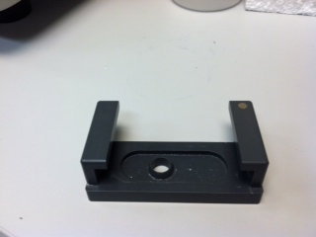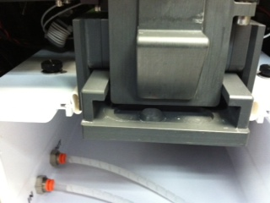
Figure 5: ACDU Adapter for sorting into 96 well plates (left) and its location on the sort chamber (right). For correct installation, the adapter must be pushed in all the way. Plate sorting cannot be carried out with the ACDU adapter in place.

    - Check the alignment of sorting to a 96 well target plate
      - Open Accudrop experiment and create a sort layout.
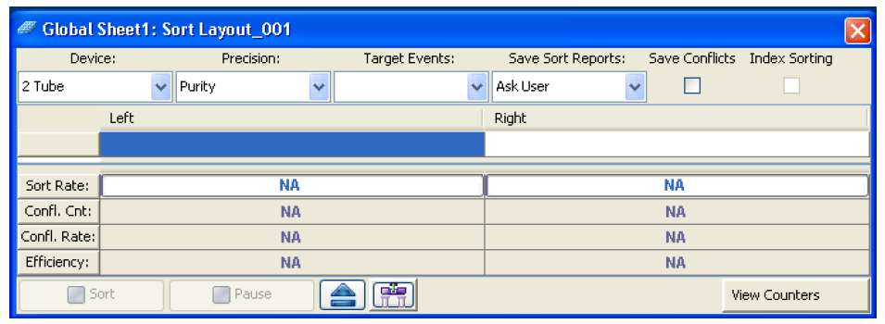
Figure 6: Sort Layout Window. All sort adjustments are made in this widow. Eject button is in the middle on the bottom.
      - In the Sort Layout window, click the Eject button to move the stage to the front of the sort collection chamber (Figure 6).

      - Prepare a testing target plate assembly by stacking a target plate (with
plastic seal), chilled aluminim block and plate frame (Figure 7)
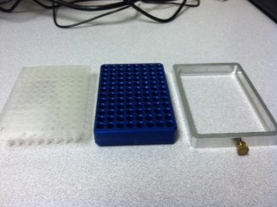
Figure 7: Sealed Target plate (left), chilled aluminum block (middle), and custom plate frame with screw knob lock (right). All three parts are necessary for proper plate sort and calibration.

      - Install the plate with well A1 toward the front of the stage (Figure 8). Note differences below for the 2 machines. Sorting starts on the front left corner of the device (A1 location).
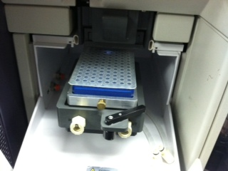
Figure 8: Plate loaded on the AriaII SORP (AriaFUSION is not shown)

      - Aria II only: use the custom aluminum block adaptor and keep the screw on. Place block and adapter on the stage so it rests against the four metal posts in the back and on the left. The tensioner will hold it tightly in place.

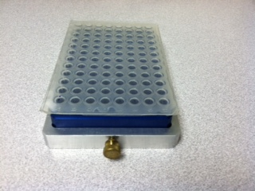

Figure 9: PCR plate loaded onto the aluminum block and in the frame.
Note: the screw knob lock cannot be used on the AriaFUSION.

      - Aria Fusion only: use the custom adapter and leave the locking screw off. When placing on the stage, push the device to the back and right.
    - Open Accupdrop experiment folder. (Section 8.7.6.1)
      - Click the + button next to tube_001 to view subfiles.
      - Click sort Set-up Sort Layout_001 table and set up the parameters.
          - Device window: 96w falcon
          - Precision window: Single Cell
          - Target events: 20
          - Save Reports window: save none
          - Plate layout: select wells from A1 to B12, right click and choose P1 gate.
      - The system is now set to sort 20 accudrop beads per well for the top two rows.
      - In the Sort Layout window click the Access Stage button to bring the ACDU stage to the front.
      - Place targetting PCR plate with a plastic seal on the stage and send it back by clicking the Eject button in the sort lay-out window.
      - Load Accudrop beads into the cytometer loading port and click Load button located in the Acquisition Dashboard window.
      - Confirm settings: drop delay, flow rate set to 1, voltage slider set to 12 (for 130 µm nozzle).
      - Click the Sort button in the sort lay-out window.
      - Click OK when you are prompted. This will open the aspirator drawer and turn on the deflection plates.
      - Confirm that a blinking dot is visible in the 130 micron window.
      - Continue sorting until the required number of cells has been acquired.
      - Turn off the voltage in the 130 micron window.
      - Take the 96 well plate from the stage and visually inspect to see where the drops were deposited. One drop should have been deposited in the center of each sorted well (A1 through B12).
      - If drops were deposited off center, adjust the home location for the plate (see below).
    - Adjust the Home location if Necessary
      - Make sure target plate is on ACDU arm
      - Select Sort > Home Device.
      - In the Device Setup window (Figure 10) select collection device (96 well Falcon) on the left side and click Go to Home. The stage moves to the preprogrammed home position.
      - Before performing test sort, check the stream, turn on Voltage (click on Voltage button) open waste drawer (click on waste drawer button).
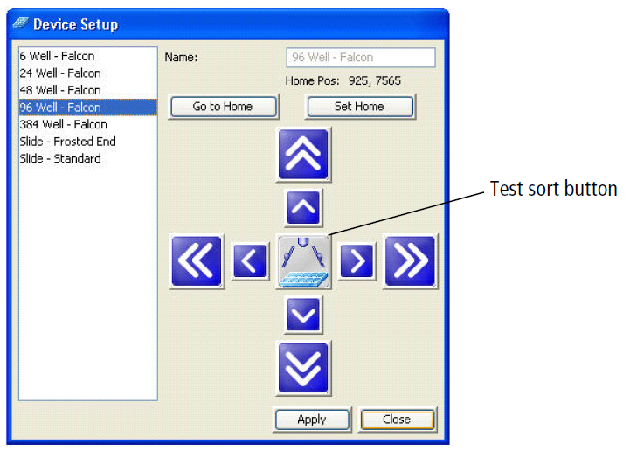
Figure 10: Device Setup window with Test Sort button indicated. Note: each device has its own home position. Custom devices can also be added.

      - Rapidly double click the Test Sort button to deposit a drop at the home location of 96 well plate (A1).
      - Inspect the collection device to see where the drop was deposited. The drop should be located right in the center of the well A1.
      - Adjust the home location if necessary. Click the appropriate directional arrow buttons to move the ACDU arm as needed. Large arrows move the tray by 5 steps. Small arrows move the tray by one step.
      - Repeat adjustments until the drop is centered appropriately.
      - When Home position is adjusted accurately, click Set Home > Apply > Close.
      - Confirm alignment (Section 8.7.6).
      - Backflush the system by pressing Cytometer > Cleaning Modes> Sample Line Backflush to pruge remaining beads in the sample line. Press Start and allow 30 seconds of backflushing before sorting.
    - Prepare for Cell Sort.
      - Open experiment for sorting mouse/human cells/nuclei from step 8.1.
      - Create a new sort layout by clicking the Sort >New Sort Layout button on the Browser toolbar.
      - Make appropriate entries in the Sort Layout window to determine how many cells to sort in which wells
    - Sort cells.
      - Ensure the stream is stable
      - Ensure the drop delay is set and hasn’t drifted more than 10 units from the defined value. If it has, recalibrate drop delay.
      - Check the gap during sorting; adjust amplitude to maintaing a gap between 10 and 14.
      - Load the sample and analyze to verify gating for sort.
      - Set up Sort Layout window to specify how many cells to collect per position.
      - Adjust the flow rate so not too many events per second. Keep under flow rate of 6. Slow is usually best.
      - Open the sort collection chamber door and install the collection plates. Make sure open wells aren’t exposed to the air any longer then necessary. Prepare plates for sorting in PCR hood.
      - Begin Acquisition of samples.
      - Click Record Data in the Acquisition window to save data.
      - Click Sort button located in the Sort Layout window.
      - Click OK when you are prompted to open the aspirator drawer and turn on the deflection plates. Always verify that waste drawer and deflection plate voltage during sortin.
      - Sample will begin sorting. While the sample is sorting, pay attention to the stream. In the stream break-off window, the Gap number should be close to 12 and Drop number shouldn’t differ from Drop 1 number by more than 10 pixels either way. Also pay attention of the analyzed events. Stop sorting if any major aberrations are observed.
      - Seal and name plate (as in 9.8), vortex, spin down, and give to tissue processing group for storage at -80ºC.
      - Save a PDF of the sort before moving gates to keep a permanent record of the gating strategy.
  - Name the sorted sample.
    - For every plate, or strip, name and label plate using current naming convention.

  - Experiment export and data management:
    - Export Experiment to the network and also store locally. Right click on experiment, choose Export > Experiment > Browse > My Network Places > folder name.
    - Save data in PDF format
      - PDFs from each sort, and from the experiment’s batch analysis should be exported.
    - Save the Plate layout
      - Excel spreadsheet of plate layout should be saved in the same folder.
    - Add data to your Laboratory Information Management System
      - All data associated with the experiment should be uploaded.

