Human Neurosurgical Tissue Processing

- Scope and Applicability: This protocol describes the procedure for receiving human surgical tissue, followed by trimming, mounting, embedding, and slicing under sterile conditions in order to produce tissue suitable for both slice culture as well as acute slice electrophysiology recording.

- Materials:
  - Fresh surgical tissue kept oxygenated in chilled, filtered ACSF.VII
  - Agarose, Type I-B, low EEO (Sigma A0576 or equivalent)
  - Tissue ink (Bradley Products, Inc. 1013-3)
  - 70% Ethanol (RP0032)
  - ACSF.VII (RP0227)
  - ACSF.VIII (RP0228)
  - Blue Absorbent Pads (Fischer Scientific 14-206-59 or equivalent)
  - MilliQ Water
  - 1x PBS (RP0001)
  - Large Heat Sink (Precisionary Instruments)
  - Large Specimen Syringe (Precisionary Instruments)
  - Sapphire Blade (Electron Microscopy 93060) or Zirconium Ceramic Blade (Specialty Blades EF-INZ10) for Compresstome
  - Ice Pan filled with Wet ice
  - Kimwipes
  - Krazy Glue All-Purpose w/ Brush (KG925 or equivalent)
  - Black Sharpie marker (or equivalent)
  - 100 mm Petri Dishes (Corning 351029 or equivalent)
  - Filter Paper (VWR 28320-121)
  - Carbogen (95% O₂/5% CO₂) setup with multiple aspirators
  - 12-well Brain Slice Keeper chambers (Scientific Systems Design Inc. BSK12)
  - Bracken Forceps (Roboz RS-5211)
  - Large Scalpel
  - Small Scalpel
  - Microdissecting Scissors (RS-5852)
  - Razor blade (VWR 94-0391)
  - VWR Flat/Spoon Spatulas, Stainless Steel (82027-532)
  - Specimen label attached to glass slide
  - Wide mouth transfer pipette (3 ml w/ end cut off)
  - Semi-wide mouth transfer pipette (3 ml w/end cut off where mouth narrows)
  - 1.7 ml Eppendorf tubes (Genesee Scientific 22-282 or equivalent)
  - Bleach
  - Bead Sterilizer (GER 5287-120V)
  - Surgical masks (Kimberly Clark 62692 or equivalent)
  - VWR Single Use Tri-Pour 100 ml beakers (VWR 25384-154 or equivalent)
  - P1000 pipette tips (Rainin 30389273 or equivalent)
  - Millipore sterile 0.22 µm syringe filters (Corning 431098 or equivalent)
  - 0.22 µm filter system with 1000 ml sterile container (Sigma-Aldrich CLS430517 or equivalent)
  - 6-Well cell culture plates (Corning 07-200-83 or equivalent)
  - Membrane Inserts (Corning 07-200-170)
  - Slice culture media (RP0252)
  - Small petri dishes (for slice transferring) (Corning 351008 or equivalent)
  - Autoclaved, stainless steel Compresstome bath (Precisionary)
  - Moria spoon 20 mm diameter (Fine Science Tools 10370-17)

- Equipment:
  - 4°C refrigerator
  - Microwave
  - Balance
  - Vacuum hood
  - Vacuum line or pump (for filtering ACSF.VII)
  - Small Water Bath (Cole-Parmer UX-39066-00)
  - Digital Camera (or equivalent)
  - Compresstome (Precisionary Instruments VF-200 or VF-300)
    - Two compresstome should be used for large specimens so that multiple blocks can be processed in parallel.
  - Autoclaved stainless steel buffer tray for each compresstome to be used
  - Computer/laptop with custom camera viewer software installed (for block subdividing)
  - Thermomixer (VWR 89232-910 or equivalent)
- Safety:
  - Disposable Gloves
  - Lab Coat
  - Eye Protection
  - Surgical masks
- Output:
  - 350 µm human brain slices suitable for both acute and slice culture applications.
- Reference Documents:
  - RP0001 Phosphate Buffered Saline (PBS)
    - https://www.protocols.io/view/phosphate-buffered-saline-pbs-bezgjf3w/abstract
  - RP0227 ACSF.VII
    - https://www.protocols.io/view/artificial-cerebrospinal-fluid-vii-acsf-vii-beznjf5e/abstract
  - RP0228 ACSF.VIII
    - https://www.protocols.io/view/artificial-cerebrospinal-fluid-viii-acsf-viii-beprjdm6/abstract
  - RP0252 Slice culture media
    - https://www.protocols.io/view/slice-culture-media-bfzzjp76
  - Compresstome VF-300 operation manual
    - “Compresstome-VF-300-0Z-User-Manual-Edited-8-14.pdf”

Warning: Personal Protective Equipment (PPE) should be used at all times while operating this protocol. If you are unsure what PPE you should be using, see your immediate supervisor.

Procedure should be performed inside a sterilized hood to prevent contamination of slice cultures.

- Setup:
  - Prepare hood for slicing
    - Wipe down interior of hood (all surfaces, compresstome, and water baths) and outside surface of the hood shield with 70% Ethanol and kimwipes.
    - Prepare fresh sterile/disposable bubblers (P1000 tips attached to 0.22 µm syringe filters) and disposable Tri-Pour beakers for each slicing station (1 beaker/bubbler for heated bath, 1 beaker/bubbler on ice for slice storage, and 1 bubbler for compresstome bath)
    - Prepare all tools that will be needed in the hood (dissection scissors, flat spoon, large moria spoon, forceps, small petri dishes, large petri dishes, wide bore pipettes, crazy glue, specimen plunger and syringe).
    - Sterilize metal tools in bead sterilizer (forceps, scissors, metal spoons etc.)
      - Allow ~20 minutes for bead sterilizer to reach desired temperature. Place heads of tools in the heated beads for ~30 seconds. Remove the tools from the bead sterilizer. Ensure tools have had sufficient time to cool before use.
    - Attach a sterile, metal bath to the compresstome, then attach and secure the blade holder with a new, ceramic blade.
Check the blade alignment. The blade should be as close as possible to the metal plunger (no more than 2mm away) while not coming into any contact at any point during the full range of travel as that can damage the compresstome.
    - Close the hood shield and run a UV cycle to help with sterilization. Note: Surfaces of all items brought into the hood must be sterilized with 70% Ethanol prior.
  - Prepare ice bucket
    - Fill with wet ice.
    - Insert heat sink.
    - Place petri dish upside down on the ice and cover with a piece of filter paper.
  - Filter all ACSF.VII through 0.22 µm filtration system into 1L sterile bottles.
  - Using clean P1000 pipette tips and Millipore 0.22 µm syringe filter attachments, bubble carbogen through ~1-2 Liters filtered ACSF.VII on ice for the Compresstome bath and disposable beakers
  - Bubble carbogen through ~100 ml ACSF.VII in a disposable beaker in a hot water bath set to 34 degrees Celsius.
Do not heat ACSF.VII in hot water bath until within one hour of tissue collection (recommended to wait until hearing from procurement team that they are in process of collecting tissue before heating, as surgeries are often delayed. Want to keep ACSF.VII as fresh as possible and limit time in waterbath).
  - If acute slices will be generated, bubble carbogen through ~500 ml ACSF.VIII in separate BSK12 chamber at room temperature. ACSF.VIII is not needed if all tissue is going to culture.
    - Depending on the size of the acquired surgical tissue specimen, several BSK12 chambers of ACSF.VIII may be required to hold all slices.
Note: All ACSF should be fresh (expires after 48 hours) and bubbled for approximately 15 minutes before use.
  - Prepare 2% Agarose
    - Place 500 ml flask on the balance and tare the scale.
    - Add 0.5 g low melt Agarose.
    - Pour in 25 g 1x PBS.
    - Add 3 drops of black tissue ink.
    - Swirl to mix.
    - Heat in microwave for 1.5 minutes, stopping to swirl every ~30 seconds.
    - Put beaker back on the balance and add MilliQ water to bring the total weight up to 25.5 g.
    - Aliquot Agarose into 1.7 ml Eppendorf tubes and put in tube holes in the Thermomixer set to 43°C and within the range of 600 RPM.
  - Turn on Compresstome and set the advance knob to 1 or to the setting where it takes ~20-30 seconds to complete a full slice cycle. Set the oscillation to ~3-4. Refer to Figure 1.
    - The optimal advance speed and oscillation settings for each Compresstome should be determined by an experienced user and may need to be adjusted while slicing for optimal performance.
  - Set cutting thickness:
    - If using a VF-300 Compresstome, set cutting thickness to 350 µm on the control module.
      - If using a VF-200 Compresstome, slice thickness needs to be adjusted manually by advancing the micrometer 350 µm after each slice is sectioned.
        - 1 unit = 10 µm on VF-200 micrometer. To advance 350 µm, the micrometer must be advanced 35 units before the next slice is taken.
  - Turn on computer with camera attached for recording how blocks are sub-divided and trimmed. Verify that there is a live image showing.
  - Set out tools for tissue trimming and examination:
    - Large scalpel
    - Small scalpel
    - Spatula
    - Scissors
    - Semi-wide mouth transfer pipette
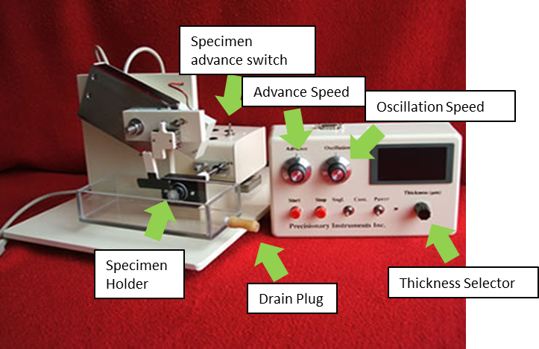
Figure 1: Diagram of Compresstome VF-300 including control module.
- Methodology/Procedures:
  - All personnel working with or near tissue are required to wear surgical masks unless it is known only acute slices will be generated.
  - Remove tissue from bubbling transfer ACSF.VII.
  - Place on filter paper next to specimen label, wetting occasionally with oxygenated ACSF.VII.
  - Photograph the specimen being sure to capture images for all sides with optimal focus. A specimen label with scale should be visible in the photodocumentation.
A ‘specimen’ is any surgical tissue acquired from the same patient and a ‘block’ is each piece that is mounted and sliced. Use the following convention for naming:
H16.......03.......008..........11............01
Year Site Patient Specimen/Block Slice

  - Inspect tissue and determine ideal subdivision and mounting strategy. Smaller specimens may require minor trimming prior to mounting. If a specimen is large, it will require cutting into multiple blocks.
    - Place a slide label with the block number next to each block while photographing the block’s different sides.
    - If a specimen needs to be sub-divided, video record these cuts so all blocks can be identified from the intact surgical tissue specimen image.
    - Surgically resected tissue will be extremely variable in size/shape/quality so ideal mounting surface will be different for every case and needs to be determined at the time of slicing (See figure 2 for proper and improper mounting examples). It is recommended that the time specimen is exposed to air and removed from oxygenated solution be kept to a minimum (less than three minutes).
      - Ensure that each specimen is no taller than ~1.5 cm.
      - Block of tissue should be mounted so that it is cut perpendicular to the pial surface to obtain desired cutting angle for downstream processing.
        - Pial surface should NOT be on the side that is mounted to base or facing up. If block has a curved gyrus, mount the block so the majority of the pial surface is on one of the sides that is perpendicular to the mounting surface.
      - Block of tissue should span white matter to pia and cover all six neocortical layers.
      - Mounting surface of the specimen should be as flat as possible in order to create a stable base.
      - Mounting surface should be wide enough in relation to top of block so that it isn’t top heavy and unstable, however if base is too wide (block too large) it will prevent agarose from surrounding all 4 sides of tissue in the syringe creating issues when slicing.

Be sure block is mounted in the center of plunger and not making contact with sides of metal plunger as this can damage slices.

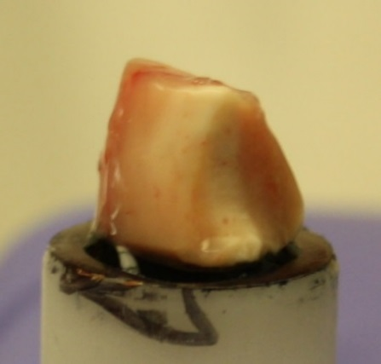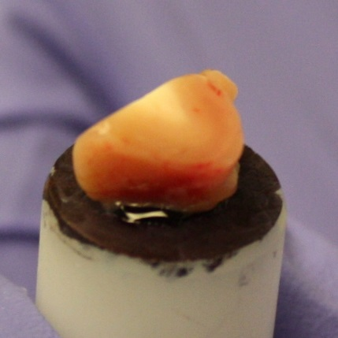
A
B
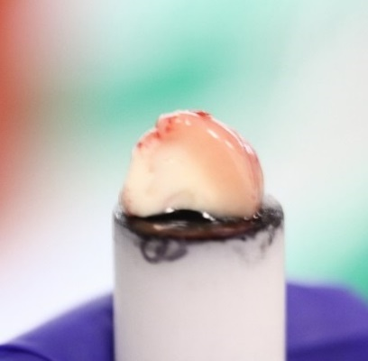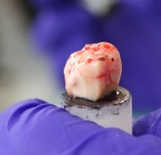
D
C

Figure 2: Examples of proper and improper mounting strategies. White matter to pia is identifiable in tissue blocks A, B, C and D. In block A, the ideal surface is mounted on the base of the plunger, creating the largest possible mounting surface. However, if the block chunks off during early slicing, the ideal slices may be lost. In block B, the ideal surface is mounted away from the plunger and is the ideal size (equal to or less than an 80% tissue to 20% agarose ratio), increasing the likelihood of obtaining good slices. This strategy should only be used when the “non-ideal” surface has a similar area to the ideal surface. The top of Block C is improperly angled due to the curve of the gyrus. It is also too big. Block D is too big and should have been trimmed on the sides to achieve the optimal tissue to agarose ratio.

  - Mount tissue block for slicing.
    - Place trimmings and prepared tissue blocks back into the storage bottle containing ACSF.VII for mounting inside of the hood.
      - In the hood, apply glue to large specimen syringe using the brush applicator.
      - Mount brain to specimen syringe.
      - Make sure mounting surface of the specimen isn’t too wet as that will create adhesion issues with the glue. Dab with dry piece of filter paper if needed. Ensure tissue has had sufficient time to adhere to syringe before adding agar.
      - Move the metal holder into place.
      - Fill with black agarose over the mounted specimen with semi-wide mouth pipette and solidify the Agarose by encasing the specimen end of the specimen syringe in the pre-chilled heat sink for 10-15 seconds. This step can be performed outside of the hood.

  - Tissue Slicing
    - Insert specimen syringe into the bath of the Compresstome up to the guard on the specimen syringe. Rotate the specimen syringe so that the pial surface is oriented perpendicular to the compresstome blade.
    - Fill the bath with chilled, sterile, filtered, carbogenated ACSF.VII and continue bubbling the bath.
    - For slicing on VF-300:
      - Unlock the motor from the standby position, move the motor forward and lock it down in the cutting position.
      - Flip selector switch on the motor to fast forward until the bar extends out and touches the end of the specimen syringe and then continue advancing until the tissue is exposed on the cutting edge. Flip selector switch back to neutral.
      - Set switch to the ‘single slice’ mode.
    - For slicing on VF-200:
      - Flip the micrometer into position and advance until it touches the back end of the specimen syringe. Continue advancing until the tissue is exposed on the cutting edge.
    - Begin cutting.
      - Press ‘start’ on Compresstome control module to slice.
      - Adjust the advance speed and oscillation as needed, to prevent tissue tearing or thick/thin slices. For example, slightly decrease the oscillation speed if the tissue seems to be moving more than usual or is tearing. Slightly increase the oscillation speed if the tissue is compressing against the blade rather than cutting cleanly.
      - Adjust tissue thickness setting on Compresstome if slices appear to consistently come out too thick or too thin to generate slices as close to desired 350 µm as possible. If slices are consistently thick or thin, consider servicing the machine for calibration.
        - Due to downstream issues with patch clamp recording, mounting, and imaging, it is better to have slices on the thin side of 350 µm then it is to have slices that are too thick. However, thinner slices may compromise the recovery of complete morphologies and/or synaptic connectivity.
      - If slice is not completely separated from block after cutting (due to pia attachment or other issue), carefully separate from the block with scissors. It is important not to pull/loosen the mounted tissue apart from the base of the specimen holder.
    - Once slice is detached from mounted block and in Compresstome bath, gently separate the slice from the agarose by gentle suction using the wide mouth transfer pipette. Transfer slices from the Compresstome bath to a disposable beaker filled with bubbling, chilled ACSF.VII sitting in a small ice bucket filled with ice.
      - It can be difficult to see slice quality in steel buffer trays. An intermediate “QC” step is recommended where slices are transferred from the compresstome bath to a small petri dish over a black background to provide sufficient contrast prior to transferring to the chilled ACSF.VII beaker.
  - Repeat steps 8.7.5.1 to 8.7.6.1 until no tissue remains in the block.
  - Transfer the slices from the chilled, bubbling ACSF.VII to a bubbling, ACSF.VIII filled disposable beaker, heated in a hot bath set to 34˚C.
  - Start a timer for 10 minutes once the last slice has been placed in the heated ACSF.VII. Record the start and end incubation time on a tracking sheet.
  - Transfer and separate slices for team distribution. Note: Due to the variability in the amount of tissue received and personnel available to process, distribution of slices should be discussed with stakeholders prior to and post slicing on all cases.
    - At the end of the 10 minute incubation, remove the disposable beaker from the hot water bath and transfer the slices to the appropriate locations based on previously discussed distribution plan.
    - Select which slices will go to what project/team
      - For slices going to acute ephys recording, transfer slices with a wide bore transfer pipette to a labeled BSK12 carousel containing bubbled, room temperature ACSF.VIII. The first slice should go in the one o’clock position of the BSK12 with subsequent slices being added clockwise.
        - Remember to remove all bubbles that may have formed underneath each well of the carousel prior to transferring.
      - For slices going to culture, transfer selected slices to a freshly prepared 6-well cell culture plate. Each well should contain a membrane insert and slice culture media.
        - After transferring a single slice to each of the wells, aspirate all leftover solution on and around the slice with a pipette.
          - Once excess solution has been removed from the wells, store the plates in designated incubators.
        - Slices to be used for applications other than physiology (fixed tissue cell filling, transcriptomics, histology, cell culture, etc.) should follow appropriate workflow.
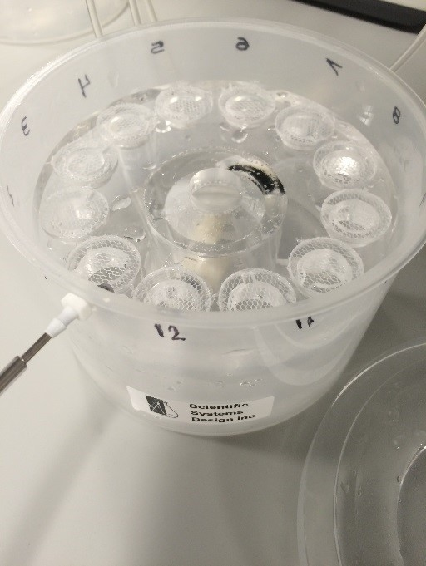
Figure 3: 12-Well Brain Slice Keeper Chambers

- Take Down:
  - Drain the Compresstome bath and all liquids used in processing into a large beaker or waste bottle containing bleach (final concentration should be 10% bleach). Let sit for at least 30 minutes before washing down the drain.
    - Unused ACSF can be disposed of down the sink.
  - Remove the metal Compresstome bath
    - Rinse with MilliQ water. Spray down with 70% Ethanol and dry with Kimwipe. Place into a labeled autoclave bag and place in the drop off box in the autoclave room.
  - Remove leftover tissue and glue from the specimen syringe, using a razor blade to scrape it off.
    - Dispose of remaining tissue/agarose/paper in biohazard waste bin.
  - Wipe area and hood down with 70% Ethanol and dispose of and replace blue absorbent pads.
  - Place all tools and ice bucket in the sink and wash with hot water.
  - After rinse, spray with 70% Ethanol.
  - Lay tools out on absorbent pad to dry.
  - Place used scalpel blades in biohazard sharp disposal container.
  - Check to make sure that Carbogen and Compresstome are turned off.
- Technical Information:
  - Compresstome VF-300 User Guide:
http://www.youtube.com/watch?v=qDP01YC9wvU&list=PL29437B1E9BB78090
- Appendix:
  - QC: Check Compresstome advance calibration quarterly, using a micrometer. Check general operation and alignment quarterly.

