Human Post-Mortem Brain Processing

- Scope and Applicability: This SOP describes the steps for processing post-mortem human brain, starting from whole brain or a single hemisphere.

- Materials:
  - Wet Ice
  - Dry ice, pellet form or crushed block
  - MilliQ H₂O
  - Cavex Life Cast Normal Alginate (Cavex Holland ALGINATE)
  - Fresh Human Brain (whole or single hemisphere)
  - Isopentane aka 2-Methylbutane (J.T. Baker Q223-08 purchased as VWR EM-MX0760-1)
  - Blue Works Dry Lube (Grainger 5JPN9)
  - India Ink: black, plus another color (white, yellow, green, blue)

- Equipment:
  - Brain Slicer Apparatus
  - Encasing Chambers and accessories
  - Clear plastic bags (large for cerebrum, small for cerebellum)
  - Balance/Scale
  - Plastic or metal Spatula
  - Styrofoam box/cooler
  - Plastic Beaker (500 ml)
  - Fluke meter
  - 20 µl Pipetteman
  - 20 µl pipette tips
  - Scalpel
  - Large metal forceps
  - New surgical knife (Mopec)
  - Large plastic bin(s) for freezing tissue
  - Teflon coated freezing plates (small and large)
  - Digital camera with 18 – 55 mm lens
  - Two or more ice buckets
  - Sagitally hemisected brain mold
  - Blender or power mixer
  - Vacuum Sealer
  - Vacuum Seal bags: 1 pint (Jarden Store FSFSBF0116-000)
  - Labels
  - Measuring tape
  - Metal scoopula or spoon
  - Wooden-handled Cotton Swabs (VWR 89133-810 or equivalent)
  - Saran wrap / cellophane
  - Bulldog clips
  - Fume hood or Biological Safety Cabinet (BSC)
  - -80°C freezer
  - 4°C refrigerator or cold room

- Safety:
  - Disposable lab coat
  - Gloves
  - Glove liners
  - Eye protection
  - BioSafety in Microbiological and Biomedical Laboratories Manual (BMBL) 5th edition classifies all human tissue as Biosafety Level 2.

- Output:
  - Frozen 1 cm slabs of human brain tissue from the cerebrum
  - Frozen 1.5 cm slabs of human brain tissue from the cerebellum
  - Frozen brainstem slabs

- Reference Documents:
  - N/A

- Setup
  - Keep the brain chilled (on ice or at 4°C) during setup.
  - Separate labels into groups appropriate for each brain region.
    - Left hemisphere slabs are labeled 1-20.
    - Right hemisphere slabs are labeled 40-59.
    - Cerebellum slabs are labeled 60-70.
    - Brainstem slabs are labeled 91-95.
  - Prepare the Alginate immediately prior to use; do not make ahead of time
    - Pour 2000 ml of MilliQ water into the high-speed blender.
    - Weigh out 270 g (approximately 1/2 pack) of Cavex Alginate and pour into the Waring Blender containing the MilliQ water.
    - Apply and snap secure the foam arrestor to the top of the Waring Blender.
    - Turn on the Waring Blender and blend the mixture on high speed for thirty (30) seconds or until thoroughly blended and no more dry powder is visible.
    - Turn off the Waring Blender.
    - Remove the foam arrestor.
    - Pour the Alginate mixture in the desired mold
  - Prepare the Embedding Chambers for the Cerebrum
    - If processing a whole brain, wrap each hemisphere of the brain mold in cellophane prior to embedding in liquid alginate. If processing a single hemisphere, determine which side you have and use brain mold from the same hemisphere.
    - Line each of the chambers with a clear plastic bag (large) and insert the plastic plates. Secure the plastic plates with bulldog clips.
    - Mark the chamber-liner bag with the anatomical orientation of the brain: Dorsal (D), Ventral (V), Anterior (A) and Posterior (P).
    - Pour the prepared alginate liquid into each of two cerebrum encasing chambers until the chamber is ~2/3 full.
    - Use the sagittal brain mold to create a cavity for each hemisphere to be processed. The Left and Right hemisphere alginate cavity should be made so that the medial surface of each brain hemisphere can be embedded UP (see Figure 1). The molds can be created simultaneously to reduce the overall amount of time to process both hemispheres.
    - Immerse ~1/2 of the brain mold into the liquid alginate, ensuring the longest (anterior to posterior) aspects of the mold are parallel to the long sides of the chamber. Hold the mold in place while the alginate sets up enough that the brain mold will not sink. Transfer the chamber to 4°C until the brain is ready for embedding.
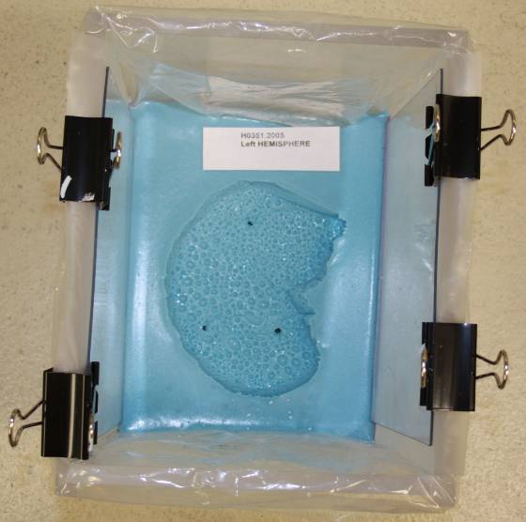
Figure 1. Brain Mold for hemisphere with medial side embedded down

  - Prepare the embedding chamber for the Cerebellum.
    - Prepare the alginate according to Section 7.2
    - Line the chamber with a clear plastic bag (small) and insert the plastic plates. Secure the plastic plates with bulldog clips.
    - The cerebellum is encased in alginate using a similar method to that described for creating the left and right hemisphere molds. Rather than using a mold to create the cavity, a solid base is used (Figure 2).
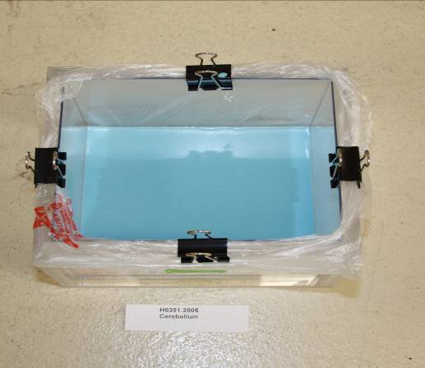
Figure 2. Smooth alginate base for the cerebellum.

    - Pour approximately 2” of alginate into the mold to create a base and place at 4°C.
    - Once the base has hardened, after being placed at 4°C, use a spoon or similar device to scoop out a cavity roughly the size of the cerebellum to be processed (whole or single hemisphere).
    - Notch a small amount of the alginate out of each corner of the base to create a lock and key affect with the top layer to be poured. Doing this will prevent the two layers from separating during the slabbing process.
  - Prepare the Dry Ice/Isopentane Bath
    - While the brain mold is solidifying, prepare the dry ice/isopentane slurry. Place isopentane and dry ice in the bottom of one ice bucket adding enough volume to submerge ~1/3 of the tissue.
    - Using a fluke meter, maintain the isopentane/dry ice slurry at a temperature between -60°C and -70°C. The temperature of the slurry is maintained or controlled by the amount of dry ice in the slurry. Add dry ice to maintain optimal freezing temperatures throughout the freezing process.
    - Monitor the volume of isopentane throughout the freezing process so that the liquid level always remains approximately 1/3 from the top of the tissue; it may be necessary to create a second freezing station to accommodate thicker slabs to avoid continued volume level adjustments as the right hemisphere has variable thicknesses.
    - When beginning the freezing process, never completely submerge tissue as this greatly increases the risk of cracking or fracturing. If additional volume is required while thicker slabs are being frozen, slowly and carefully add additional isopentane away from the specimens.
    - Important! – Use new (fresh) isopentane for freezing each hemisphere, and the cerebellum. Over time the isopentane becomes saturated with water from both the brain tissue and the dry ice, this dilution of the isopentane and its separation from the water results in ice crystal formation at the surface of the tissue; subsequently, the ice crystals penetrate the superficial layers of the tissue resulting in fine ice crystal artifact formation. Also, NEVER reuse isopentane for purpose of freezing fresh tissues.

- Methodology/Procedures: Photo documentation
  - Remove the brain from the shipment container and place on balance, record weight and photo document the weight and brain while on the balance (if available).
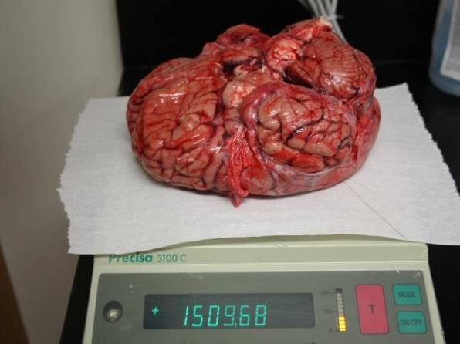
Figure 3. Weighing intact brain

  - Place the brain on the working surface and photo document the ventral, dorsal, lateral and posterior views using the digital camera; ensure the labels are visible in each image.
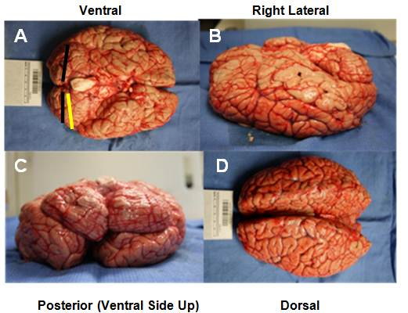
Figure 4. Image orientations of the brain

- Methodology/Procedures: Removal of the brainstem and cerebellum
  - Prior to removing the cerebellum and brainstem, mark the inferior surface of the cerebellum with black India ink (Figure 5) use a wooden handled swab (or equivalent) to apply; additionally, mark the anatomical left inferior surface of the cerebellum with a second line of ink; you can use a different color of India ink (green, blue, white, yellow) if you prefer. The mark should be placed from midline (vermis) to the pole of the left hemisphere. See example above in the ventral image. These marks are to ensure the slabbing occurs in the proper anatomical left to right plane, as well as provide further orientation of the individual cerebellar slabs once excised from the cerebrum. The black dot will be applied opposite of these marks.

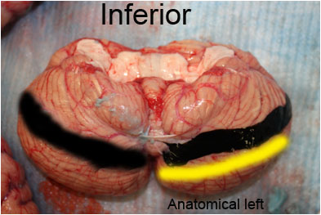
Figure 5. India ink orientation marks on the inferior surface of the left and right hemispheres of the cerebellum. Black mark represents inferior; yellow represents anatomical left. Note the yellow can be replaced with any other color that is distinguishable from black.

  - Once the ink has been applied, remove the cerebellum and brain stem from the brain by making a transverse cut through the primary axis of the brainstem below (caudal) the level of the Inferior and Superior Colliculi avoiding the Thalamus (cut at red dotted line).

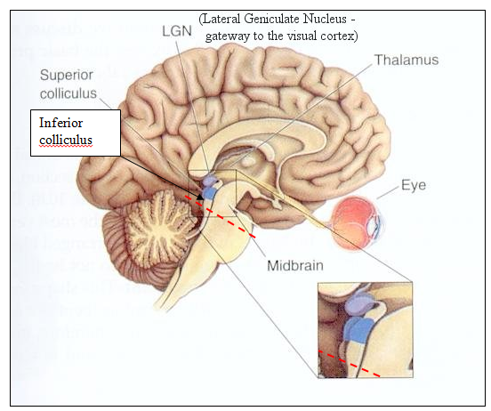
Figure 6. Anatomical resection diagram for severing the brain stem and cerebellum from the cerebrum
Source: http://kybele.psych.cornell.edu/~edelman/Psych-4320/midbrain.jpg

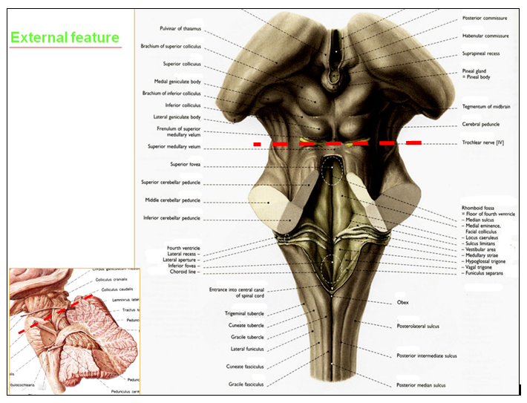
Figure 7. Alternative view of anatomical resection sites for severing the brain stem and cerebellum from the cerebrum.
Source: https://4.bp.blogspot.com/-BKB4PsjFjls/TaSOJX30MfI/AAAAAAAADhA/tt9TaCQFw4c/s320/External%2Bfeature%2Bof%2BBrain%2Bstem%2B1.png
  - Remove the brainstem from the cerebellum and photo document both.
  - Place both the cerebellum and brainstem on wet ice until ready to slab and/or embed.
- Methodology/Procedure: Hemisection of Cerebrum into Left and Right Hemispheres (If processing whole brain)
  - Place the cerebrum ventral side down on a cutting surface.
  - Pull the temporal lobes out and away from the midline of the brain.
  - Separate the two hemispheres so that the corpus callosum is visible.
  - Using a sharp knife (Mopec) or similar, bisect the brain into left and right hemispheres so that a clean cut is made through the corpus callosum, mammillary bodies and the optic chiasm.
  - Separate the hemispheres and photo document the medial and lateral surfaces of each hemisphere.
  - Document all necessary brain measurements as outlined in the tissue procurement summary (TPS) report.
  - Place the hemispheres back on wet ice.

- Methodology/Procedures: Embedding of the left and/or right cerebral hemisphere.
  - For each of the LEFT and/or RIGHT hemispheres, place the medial surface up in the premade alginate mold. Note: as all brains differ slightly in volume and shape it may be necessary to enlarge or reshape the cavity so that the hemisphere of the brain is not compressed in any direction.
  - Place a marker (cotton swab or similar – long enough to protrude through the top layer of alginate once poured) immediately adjacent to both the frontal and occipital poles (using a different color to indicate anterior to posterior) into the alginate. Those markers indicate the location of the embedded tissue.
  - Prior to pouring the top layer of alginate, indicate dorsal, ventral, anterior and posterior either on the mold itself or on the plastic liner bag.
  - Optional: Prior to pouring the top layer of alginate on the hemisphere, cut out a 2 cm³ piece of alginate from each corner of the base mold. This is done so that the top layer does not shift during the slabbing process.
  - Encase the left and/or right hemispheres by pouring alginate into the mold to fill in all the crevices, being careful to leave as much of the medial face exposed and visible as possible Use a spatula or other device to direct the alginate away from brain as it is being poured into the mold.
  - Place the embedded hemisphere(s) at 4°C to allow the alginate to harden. Repeat this process for the second hemisphere if appropriate.
  - Once hardened, mark the surface of the alginate with the anatomical orientation of the brain: Dorsal (D), Ventral (V), Anterior (A), and Posterior (P). Refer to the marks placed on the plastic bag.

- Methodology/Procedures: Slabbing and Freezing the Brainstem.
  - Prepare labels for the five brainstem slabs: BS.91 (midbrain), BS.92 (rostral pons), BS.93 (caudal pons), BS.94 (rostral medulla), and BS.95 (caudal medulla).
  - Prepare a bin or bucket of wet ice.
  - Place a layer of saran wrap or absorbent pad over the wet ice.
  - Use an India ink pen or permanent marker to place the following orientation marks directly on the ventral surface of the brainstem: At junction of midbrain/pons, through middle of pons, through middle of medulla
  - Remove the brainstem from the chilled absorbent pad and place on a cutting board, Teflon plate, or solid surface i.e. Brain slicer.
  - Align the Steel Blocking Blade with the orientation marks and carefully and firmly make a transverse cut through the brainstem. Avoid twisting the brainstem while making the cut.
  - Once the first cut has been made, mark the dorsal/rostral (opposite of the Pons) surface of BS.91 (Figure 8).

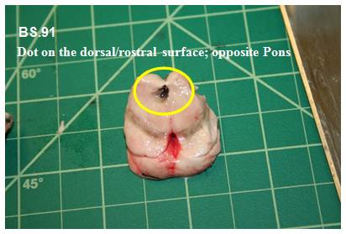
Figure 8. Orientation marks- BS.91 dorsal/rostral, opposite Pons (whole brainstem).

  - Once marked, place BS.91 back on the chilled absorbent pad.
  - Again, orientate the steel blocking blade with the second orientation mark and carefully, but firmly separate pons into rostral/caudal blocks. These will be slabs 92 and 93 respectively.
  - Place a black ink mark on the dorsal/rostral surface of BS.92 and BS.93 (Figure 9).
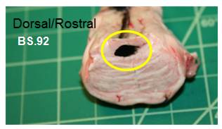
Figure 9. BS.92 black dot on the dorsal/rostral surface (whole brainstem)
  - Next, separate the medulla into rostral/caudal blocks and number BS.94 and BS.95 respectively. Place all five slabs back on the chilled absorbent pad.
  - Spray a generous coating of Blue Works on two small (4x4”) Teflon coated surface (green surface).
  - Carefully pick up and place BS.91 caudal surface down (Black dot UP) on the Blue Works (Figure 10).
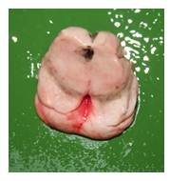
Figure 10. Freezing orientation for BS.91. Rostral surface up (Black dot UP), caudal or cut surface down on the freezing plate.

  - Place the plate containing BS.91 into a 1/3-½” depth of the dry ice slurry and allow to freeze solid. Monitor the temperature of the bath and adjust as needed (Figure 11).
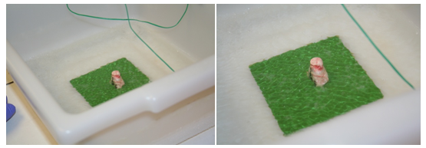
Figure 11. Isopentane/dry ice slurry

  - While BS.91 is freezing, carefully transfer BS.92-BS.95 onto Blue Works treated 4x4 freezing plates. Tissue should be frozen so that the flattest surface is facing down and contacting plate to best maintain anatomical shape. This orientation could differ depending on if full brainstem or single hemisphere (Figure 12).
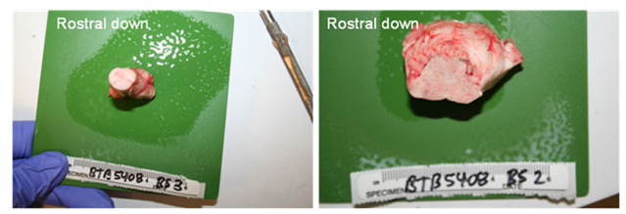
Figure 12. Freezing orientation of slabs BS.92 and BS.93 for full brainstem; rostral surface down.
  - Once BS.91 has completely frozen, repeat the same freezing steps for BS.92-95 ensuring the freezing temperature of the bath is constantly maintained. Post freezing, remove the plate and slabs from dry ice slurry, and place the slab and corresponding label into a vacuum seal bag. Make sure the label text is visible.
  - Once in the bag, vacuum seal and place the bag containing the slab on dry ice, or in a -80°C freezer. Repeat this process for all five slabs.

- Methodology/Procedures: Embedding, Slabbing and Freezing the Cerebellum (Slabs 60-70).
  - Place the cerebellum smooth (superior) side down so that the anterior aspect (where it was cut from the brainstem) is facing towards you in the mold (Figure 13). In other words, the side with the yellow/orange ink should face up.
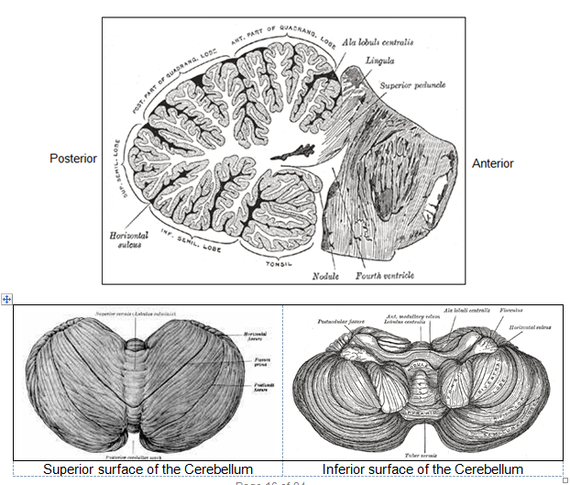
Figure 13. Anatomical orientation of the cerebellum.
Sources:
- http://images2.wikia.nocookie.net/psychology/images/thumb/9/97/Gray704.png/300px-Gray704.png
- https://upload.wikimedia.org/wikipedia/commons/thumb/e/e4/Gray703.png/120px-Gray703.png
- https://image.slidesharecdn.com/presentation-130828044422-phpapp02/95/cerebellum-9-638.jpg

  - Once seated, place a wooden handled swab (or similar) immediately adjacent to left and right lateral aspects of the tissue and directly into the alginate to mark the location of the anatomical left lateral aspect of the tissue; mark the left swab with yellow or orange ink to provide a visual verification of the orientation of the cerebellum once fully encased in alginate. The marker needs to be long enough to protrude through the top encasement layer.
  - Deflect the alginate from the tissue using a spatula or similar device and fully encase the cerebellum.
  - Once fully encased in alginate, place the cerebellum chamber at 4°C until it has solidified. Once solidified, mark the surface of the alginate with permanent ink to indicate left, right, anterior and posterior orientations.
  - Remove the block from the chamber and place it in the slicer, positioning the left lateral aspect marked earlier facing forward toward the slicing guide. The cerebellum is cut in a sagittal orientation (anatomical) left to right at 1.5 cm intervals.
  - After the first cut is made, thoroughly coat a Teflon plate and place it firmly against the lateral surface of embedded cerebellum slab during each cut. After the slab has been cut, slowly lower the plate to reveal the cut slab. Insert a plastic plate between the right surface of the cut slab and the left surface of the uncut surface creating a sandwich out of the cut slab. Lower cut slab to the surface. Mark the superior, right face or (cut side) of the slab with India ink.
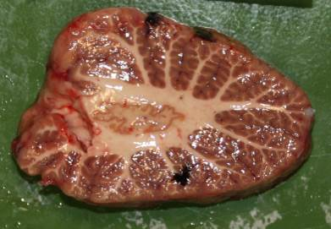
Figure 14. Superior ink mark on the right (cut side) of the cerebellum

  - Repeat until the entire cerebellum from left lateral hemisphere to right lateral hemisphere has been slabbed.
  - Remove all alginate from tissue and photo document each slab with appropriate cerebellum label prior to freezing.
  - Place a second liberally coated (Blue Works Dry Lube) freezing place on the posterior surface of the slab so that the slab is sandwiched between the two freezing plates. Note: the poles, first and last slabs, do not require a second plate on top and should be frozen cut side down.
  - Flip the slab over and freeze right side down. This method helps to minimize white matter collapsing while freezing.
  - Add dry ice to the isopentane/dry ice slurry to lower the temperature to -60 to -70°C.
  - Place slab and freezing plates into the Isopentane slurry. Allow slab to fully freeze (2 - 4 minutes). Tap the center of the slab with metal forceps to determine if it is fully frozen. Repeat this process for all slabs.
  - Once frozen, move the slab onto dry ice until it can be placed into a vacuum seal bag and sealed.
  - Using chilled metal forceps place each frozen slab into a vacuum seal bag so that the left side is facing the smooth side of the bag along with its label. Make sure the label is visible, and then use the vacuum sealer to seal the frozen slabs. Immediately place on dry ice following vacuum sealing. NOTE: Do not handle the frozen slabs once they have been removed from the Isopentane slurry, use the chilled metal forceps to avoid damaging freeze/thaw of tissue.
  - Immediately place slabs in cooler containing dry ice until they can be permanently stored in a -80ºC freezer.

- Methodology/Procedures: Slabbing and Freezing the Cerebrum
  - If processing left hemisphere, slabs should be numbered 1-20 going anterior to posterior. If processing right hemisphere, slabs should be numbered 40-59 anterior to posterior.
  - Once the top layer of alginate has completely set, remove the block of alginate containing a single hemisphere and carefully place onto the brain slabbing apparatus.
  - Make the first cut using the Mopec knife, just in front of the marker placed adjacent to the frontal lobe prior to adding the top layer of alginate. This is to remove any excess alginate.
  - After the initial cut, all the remaining slabs from both hemispheres will be sectioned at 1 cm intervals anterior to posterior (Figure 15). Note: Every 3-4 slabs, take a top down image showing medial surface and knife angle to aid in downstream registration.
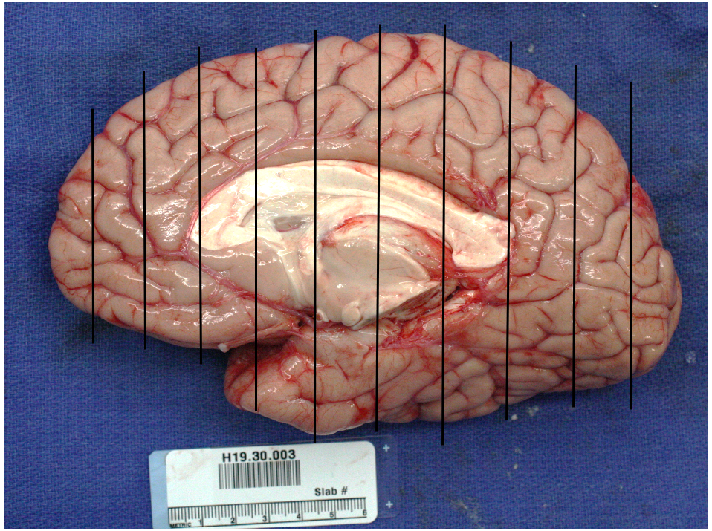
Figure 15. Cerebral hemisphere slabbing diagram

  - After each cut, thoroughly coat a Teflon plate with Blue Works Dry Lube and hold it snuggly against the anterior surface of embedded brain slab during each cut. After the slab has been cut, slowly lower the plate to reveal the cut slab. Insert a plastic plate between the posterior surface of the cut slab and the anterior surface of the uncut surface creating a sandwich out of the cut slab (Figure 16). Lower the cut slab to the surface.
Figure 16. Example of slabbing

  - Place each slab onto a Teflon plate coated liberally with Blue Works Dry Lube. Ensure tissue lays flat and is not curled up on any of its edges, as this will affect the freezing process. Remove any alginate and carefully reposition the slab so that it is symmetrical.
  - Replace any misaligned gyri back to their correct anatomical positions. Remove meninges from the posterior surface of the slabs using forceps.
  - Mark the white matter on posterior/medial/dorsal surface with ~0.5 µl of India ink (Figure 17).
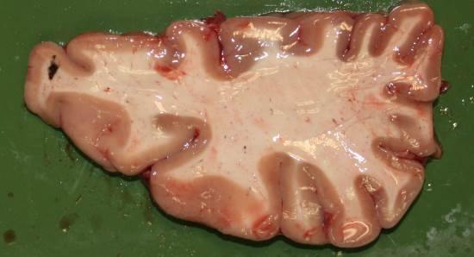
Figure 17. Example of a posterior-medial-dorsal India ink mark on a cerebrum slab, note the placement and size of the mark in the white matter.

  - Place the appropriate label with the slab and photo document using a digital camera, ensuring that both the label and tissue are visible and the label is readable in the image.
  - Place a second Teflon-coated freezing plate liberally sprayed with Blue Works Dry Lube on the posterior surface of the slab so that the slab is sandwiched between the two freezing plates.
  - While holding both plates and tissue in your hands carefully flip the slab 180° so that posterior surface of the slab is now on the bottom. Make sure the plates stay snug to the tissue during this rotation. Note: this process ensures that the white matter on the posterior surface of the slab comes in full contact with the freezing place; doing so reduces the constriction of the white matter as the surface tension between the plate and the tissue will keep the white matter in place.
  - Slowly place slab and freezing plates into the isopentane slurry. While this slab begins to freeze, prepare the next slab for freezing. For efficiency purposes it may be prudent to make two identical isopentane/dry ice baths to speed up the process. Be sure to monitor the temperature of both baths throughout the duration of the freezing process. Note: it is important to avoid freezing the slabs too rapidly or submerging them as this results in surface cracks or fractures.
  - Remove the top freezing plate from the tissue once the tissue is frozen.
  - Remove the slab and the freezing plate from the isopentane dry ice slurry and immediately place on dry ice. The slabs should remain on dry ice until they are ready to be transferred to the freezer bag for vacuum sealing.
  - Using chilled metal forceps carefully grasp and place each frozen slab into a vacuum seal bag so that the anterior (w/out black dot) side is facing the smooth side of the bag along with its label. Make sure the label is visible, and then use the vacuum sealer to seal the frozen slabs. Do not handle the frozen slabs once they have been removed from the Isopentane slurry, use the chilled metal forceps to avoid damaging freeze/thaw of tissue.
  - Immediately place slabs in a cooler containing dry ice until slabs can be permanently stored in a -80ºC freezer.
  - Repeat steps 14.2-14.17 for the opposite hemisphere if processing a whole brain.

- Take Down:
  - Soak all instruments in 10% bleach for a minimum of 30 minutes. Dry thoroughly after soaking to prevent rusting.
  - Dispose of used and excess alginate in the biohazard waste disposal container.
  - Dispose of Mopec Knife used for slicing in the biohazard sharps disposal container.

- Technical information
  - Handling isopentane (2-methylbutanol) – when returning used isopentane to its original container from the freezing bath DO NOT place the lid back on the container. Simply pour the isopentane back into the container and place the container into the hood and place the lid next to the container. Only after the liquid has equilibrated to room temperature should the lid be placed on the container.

- Appendix: End of processing checklist
  - Complete the Tissue Procurement Summary (TPS) report before leaving for the day.
  - Make sure all frozen slabs have been placed in the -80°C freezer.
  - Do a physical inventory against the slabbing manifest to ensure all frozen slabs have been accounted for in the -80°C freezer.
  - Place all consumables and hardware back in the storage locations.
  - Audit the physical inventory noting on the TPS report any items that need to be reordered.
  - Ensure that all blood, CSF or other tissue specimens have been properly stored.

