Human Tissue Slicing and Dissections for Nuclear Isolations

- Scope and Applicability: This protocol describes the slicing and microdissection procedure on frozen post-mortem human brain tissue to be used to isolate nuclei for subsequent transcriptional profiling.

- Materials:
  - Frozen Tissue block from ROI to be profiled
  - RNase Away RNase Decontamination Solution (VWR 17810-491)
  - Nuclease free water (Life Technologies AM9932)
  - 10X PBS, pH 7.4 (Ambion AM9625)
  - 1M DL-Dithiothreitol solution (DTT) (Sigma BioUltra, molecular biology grade, 1M solution in water, 43816 or equivalent)
  - 1.5 ml microcentrifuge tubes, PCR grade RNase-free (Eppendorf, DNA LoBind, 0030108051)
  - Agarose (Bioexpress E3121 or equivalent)
  - Peel-A-Way Rectangular Plastic Disposable Embedding Molds (VWR 15160-339)
  - Neurotrace 500/525 Nissl Stain (Thermo Fischer Scientific N21480)
  - RNasin Plus RNase inhibitor (Promega N2615)
  - 15 ml conical tubes (VWR 21008-670 or equivalent)
  - 50 ml conical tubes (VWR 21008-951 or equivalent)
  - 500 ml Sterile Plastic Bottles (Corning 09-761-10 or equivalent)
  - 250 ml RNase-free Glass Erlenmeyer flask (Sigma Z723088)
  - Large Sterile Petri Dish – 100 mm (Corning 430167)
  - Small Sterile Petri Dish – 35 mm (Corning 430165)
  - Sterile 24-Well Plate (Corning 3524 or equivalent)
  - Sylgard Coating Kit (Dow Corning #4019862)
  - P20 pipette tips
  - P200 pipette tips
  - P1000 pipette tips
  - 25 ml Serological pipettes
  - 50 ml Serological pipettes
  - Kimwipes
  - Dry ice
  - Dry ice container
  - Wet ice
  - Wet ice container
  - Superglue
  - 70% Ethanol
  - Mayo Scissors (Roboz RS-6875SC or equivalent) (optional)
  - Moria perforated spoon (Fine Science Tools 10370-18) (optional)
  - Scalpel (Feather 2976)
  - Disposable Plastic Handle Microknife (Fine Science Tools 10318-12 or equivalent)
  - Paintbrush (Ted Pella #1)
  - RNase free Dumont Fine-Tip Forceps (Roboz RS-5045)
  - RNase free Bracken Blunt-Tip Forceps (Roboz RS-5211)
  - Flat/Spoon Spatulas, Stainless Steel (VWR 82027-532)
  - Small Filter Paper
  - Sterile Plastic Transfer Pipette (3 ml), several cut to increase opening size to fit slice (BD Falcon 52947-970)
  - Razor blade (VWR 94-0391 or equivalent)
  - Zirconium Ceramic Blade (Specialty Blades EF-INZ10)
  - Bleach
  - Sharps Container
  - Biohazard waste bin

- Equipment:
  - 4°C refrigerator
  - -20°C freezer
  - Balance
  - Vibratome (Leica VT1200 or equivalent)
  - Computer/laptop computer with image capture software installed
  - Microwave
  - Vortex Mixer (VWR 10153-838 or equivalent)
  - Serological Pipette
  - Fluorescent dissecting microscope, camera and image acquisition software (Nikon SMZ1500 or equivalent)

- Safety:
  - Disposable lab coat
  - Gloves
  - Eye Protection
  - BioSafety in Microbiological and Biomedical Laboratories Manual (BMBL) 5th edition classifies all human tissue as Biosafety Level 2. People who come in contact with donor tissue or blood should follow the procedures described in the BMBL.

- Output:
  - Micro-dissected ROI’s from tissue slices ready for single-nuclei isolation and transcriptional profiling

- Reference Documents: (Include all that apply)
  - RP0001 Phosphate Buffered Saline (PBS)
    - https://www.protocols.io/view/phosphate-buffered-saline-pbs-be2hjgb6
  - EP0027 Human Post Mortem Brain Processing
    - https://www.protocols.io/view/human-post-mortem-brain-processing-bf4ajqse
  - PF0291 Isolation of Nuclei from Adult Human Brain Tissue
    - https://www.protocols.io/view/isolation-of-nuclei-from-adult-human-brain-tissue-ztqf6mw/abstract

Warning: Personal Protective Equipment (PPE) should be used at all times while performing this protocol. If you are unsure what PPE you should be using, see your immediate supervisor.

- Setup:
  - Prepare Stock solutions as needed
    - 1M DTT Stock (Sigma BioUltra, molecular biology grade, 1M solution in water)
      - The 1M DTT solution should be aliquoted and stored at -20°C immediately upon receipt from the manufacturer.
      - Prior to aliquoting 1M DTT solution, allow the solution to come to room temperature and check for the presence of precipitates. If precipitates are present, shake the solution until they dissolve.
      - Prepare 3 ml aliquots of 1M DTT solution in sterile 15 ml conical tubes, label appropriately and immediately freeze at -20ºC.
      - Discard aliquots after 6 months at -20ºC.
    - 4% Agarose Blocks
      - Measure 100 ml of nuclease-free water (Ambion) using a serological pipette and dispense into RNase-free glass Erlenmeyer flask.
      - Weigh out 4 g of Agarose and add to the 100 ml of water.
      - Heat in microwave for ~1 minute at 50% power.
      - Carefully swirl the flask and place back in the microwave.
      - Continue heating at 50% power until Agarose is fully dissolved. Stop the microwave every 15-20 seconds to swirl the Agarose. Take care not to allow the Agarose to bubble out of the flask.
      - Pour the heated Agarose into plastic embedding molds and allow the Agarose to set at either room temperature or in a 4ºC fridge. Place the set Agarose blocks into a clean box or plastic baggie and cover.
      - Store at 4ºC for up to 2 weeks.
  - Prepare Day of Use Solutions:
    - 10 mM DTT PBS Buffer
      - On day of nuclei prep, remove a 3 ml aliquot of 1M DTT from the -20ºC freezer and thaw. A dry heat block set to 45ºC can be used to speed thawing (optional). After thawing, vortex the 1M DTT well prior to adding to the solution.
      - Measure 30 ml of 10X PBS (Ambion, pH 7.4) with a serological pipette and dispense into a sterile 500 ml plastic bottle
      - Measure 267 ml of nuclease-free water using a serological pipette and dispense into the 500 ml plastic bottle.
      - Add 3 ml of 1M DTT to the bottle.
      - Close the cap of the bottle and mix by inverting ~10 times.
      - Place the solution on ice or in a 4ºC fridge to cool. The solution should be ice-cold prior to use. If necessary, solution can be placed in a -20ºC freezer for 20-30 minutes to speed cooling.
    - Nissl Staining Solution
      - Using a serological pipette, remove 20 ml of 10mM DTT PBS buffer and dispense into a sterile 50 ml Conical tube.
      - Add 200 µl of Neurotrace 500/525 Nissl Stain (Thermo Fisher Scientific) to the 10mM DTT PBS buffer.
      - Vortex to mix.
      - Add 100 µl of RNasin Plus RNase inhibitor (final concentration 0.5%, 0.2U/µl) to the Nissl staining solution.
      - Mix by inverting the tube 5-10X. Do not vortex once the RNase inhibitor has been added to the tube. Place the tube on ice until ready to use
      - Note: Neurotrace staining solution contains DMSO and will thaw very slowly at room temperature. To speed thawing, remove from the -20ºC and thaw in a dry block heater set to 45ºC for ~10 minutes. Return the tube of Neurotrace back to the -20ºC freezer after use.

- Methodology/Procedures:
  - Tissue Sectioning
    - Set-up:
      - Remove sealed bag containing block of tissue to be sliced from the -80⁰C freezer and place on dry ice until ready to use.
      - Spray down all work surfaces and tools with RNase Away.
      - Wipe down the Vibratome chuck and bath with 70% Ethanol and wait about five minutes for Ethanol to evaporate.
      - Place a sterile petri dish on ice and fill with cold 10mM DTT PBS buffer and cover petri dish with lid until ready to use.
      - Prepare a 24-well plate with the Nissl staining solution by adding ~1 ml to each well of a 24-well culture plate and place the plate on ice, keeping covered when not in use. Fill 10-12 wells as that is how many slices are produced from a typical tissue block.
      - Place the bath into position in the holder and carefully fill the vibratome bath holder with wet ice. Cover the bath with a 24-well plate lid to prevent wet ice from contaminating the bath.
      - Slide the holder into place and tighten side handle to lock in place.
      - Turn on the Vibratome and set settings. The thickness should be set to 500 µm and speed set to 0.12 mm/s.
    - Thawing and Mounting Tissue
      - Remove a clean Agarose block from the 4⁰C fridge and cut away plastic molding. Place Agarose block on sterile petri dish and trim down sides until ~2-4 times the size of the tissue block.
      - Dry surface of Agarose block with a kimwipe and apply glue to vibratome chuck. The superglue should match the size of the tissue block to be sectioned.
      - Place Agarose block on the glue and allow to dry at room temperature for 3-5 minutes.
      - When ready to thaw tissue, cut open the bag with a clean razor and drop tissue into a petri dish containing 10mM DTT PBS buffer on ice. Allow tissue to thaw in cold buffer for ~1-2 minutes, or until no visible ice remains on the surface of the block.
      - If you need to trim the block, use clean blunt-tip forceps or flat spatula (VWR) to gently transfer tissue block to the lid of a clean petri dish. Use disposable scalpels to trim off problem and/or excess areas (WM or pia), or to create a better mounting surface.
      - Apply glue to the vibratome chuck in front of the Agarose block and to the bottom half of the block on the side that will contact the tissue.
      - Dab tissue with a kimwipe or filter paper to remove excess liquid taking care not to let the kimwipe stick to the surface of the tissue. Tissue can also be placed in a moria perforated spoon (Fine Science Tools) and dabbed on a piece of filter paper.
      - Carefully mount the tissue block by positioning so that slices will be perpendicular to pial surface. The black dots seen on tissue blocks mark the pial surface and generally delineate the optimal cutting plane (see figure 1). Slicer should use their own discretion when deciding the best way to mount a block as blocks can vary widely. Note that it is typically better to position the tissue block so the blade slices through pia last to avoid snagging, so the pial surface is often mounted against the Agarose block (although not always the case). In situations where there is a small or uneven base for mounting in the correct slicing plane and trimming isn’t an option, small strips of trimmed agar blocks can be glued to the chuck and used as “wedges” to help support the block from underneath. If this is required, the underside of the agar wedges should be glued to the chuck, and the top should be glued to tissue it is supporting. (see figure 2 for example of mounted tissue with and without support wedges)
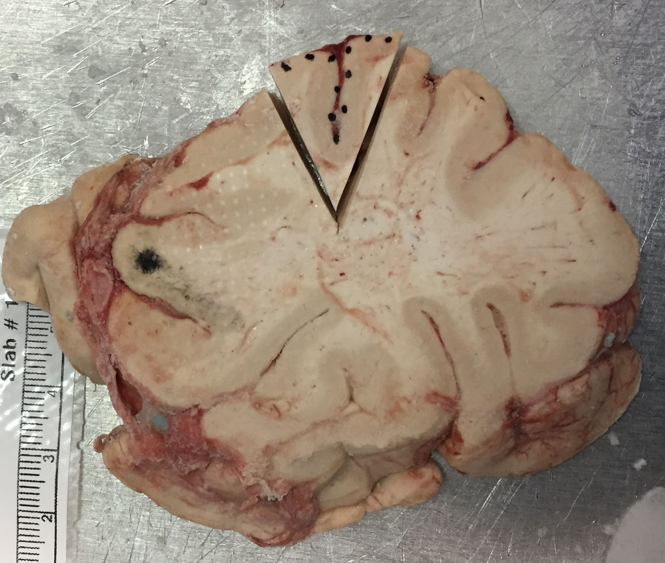
Figure 1: Black dots mark pial surface and should be used for orientation when mounting

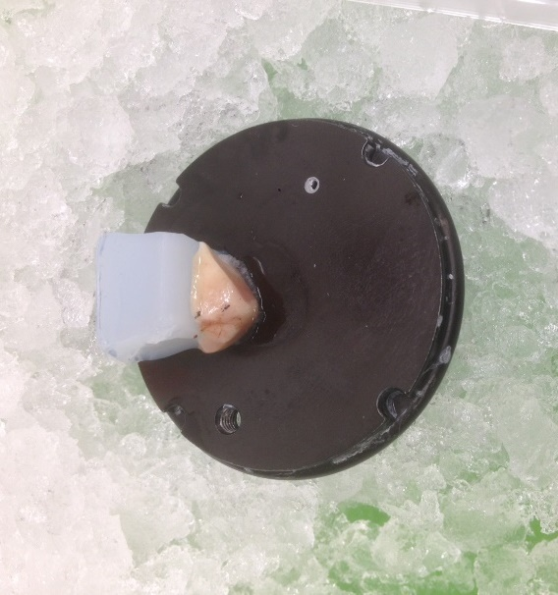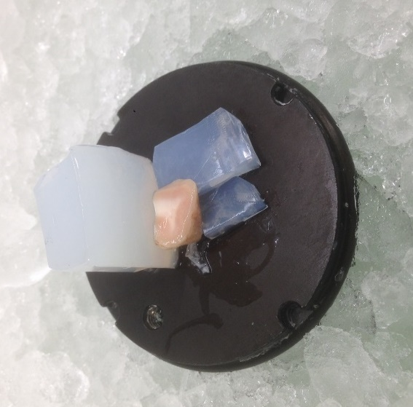
Figure 2. Tissue blocks mounted to chuck with and without support wedges

      - Place vibratome mounting disk on the surface of the ice and wait 2-3 minutes for glue to dry.
    - Vibratome Slicing
      - Fill vibratome bath with ice cold 10mM DTT PBS buffer (a cold slurry is optimal).
      - Place the vibratome chuck w/ mounted Agarose block and tissue in the bath so the block is on the blade side and the Agarose block is away from the blade.
      - Using forceps, place a clean ceramic blade in the knife holder and tighten with hex wrench.
      - Use hex wrench to lower blade until second white line on far left is barely visible. If needed, use the Vibratome check feature to check z-axis displacement and calibrate if appropriate.
      - Raise the vibratome stage by pressing the “Up” button until the blade is positioned ~1-5 mm above the surface of the tissue.
      - Set the start and end positions.
        - Advance the blade towards the tissue block using the forward arrow. When the blade is close to the tissue, set the first cutting window edge, by holding down the cutting edge button until the light turns green.
        - Advance the blade ~1-5 mm past the agar block and set the second cutting window edge, by holding down the button until it turns green.
      - Press the Run/Stop button to begin sectioning.
        - If the blade is well above the tissue surface, press Pause and then press Run/stop twice. This will advance the blade one full section (ie. 500 µm). Repeat as necessary until the blade reaches the tissue.
      - Using a wide mouth transfer pipette, pick up the cut section and transfer it to the 24-well plate containing Nissl staining solution on ice being careful to minimize the volume of 1M DTT transferred along with section.
      - Repeat the sectioning procedure until the entire block is cut, placing the sections sequentially in the 24-well cell culture plate containing Nissl staining solutions.
      - The sections should be in the staining solution for a minimum of 5 minutes and on ice at all times.
    - Vibratome clean up
      - After sectioning is complete, pour the 10mM DTT buffer into a secondary container and label as hazardous waste. Any remaining Nissl staining solution can be combined with 10mM DTT PBS buffer. EHS will discard of the hazardous waste.
      - Remove any remaining pieces of human tissue from the vibratome chuck and place the chuck in a container with 10% bleach for at least 20 minutes to disinfect.
      - Rinse the vibratome chuck, bath, and holder with copious amounts of distilled water.
      - After rinsing, spray the chuck, bath, and bath holder with 70% Ethanol and wipe down with a kimwipe.
      - Clean all tools with 70% Ethanol and dry with a Kimwipe.
      - Discard the ceramic razor blade into a sharps container and wipe down the knife holder with 70% Ethanol after rinsing blade holder and cutting head with MilliQ.
      - Turn off vibratome and proceed to dissecting microscope.

  - Microdissections
    - Prepare and label individual microcentrifuge tube for each layer of tissue (sample) to be dissected with approximately 500 µl of Nissl staining solution or 10mM DTT PBS buffer supplemented with 0.5% RNasin Plus or RNaseOUT and store tubes on ice.
    - Using a wide-mouth plastic pipette, transfer each slice to a sterile sylgard-coated small petri dish containing 10mM DTT PBS buffer or fluorescent Nissl solution.
    - Take a fluorescent image of each slice and return to the 24-well plate containing Nissl solution.
    - Select the best slices for layer dissections. Aim to select slices with minimal damage and even thickness. Ideal slices contain full cortical thickness and have clear pia to white matter as well as layer clarity (see figure 3 for reference). A minimum of two 500µm slices is preferred for nuclear preparations, but a single good slice can be used if needed.
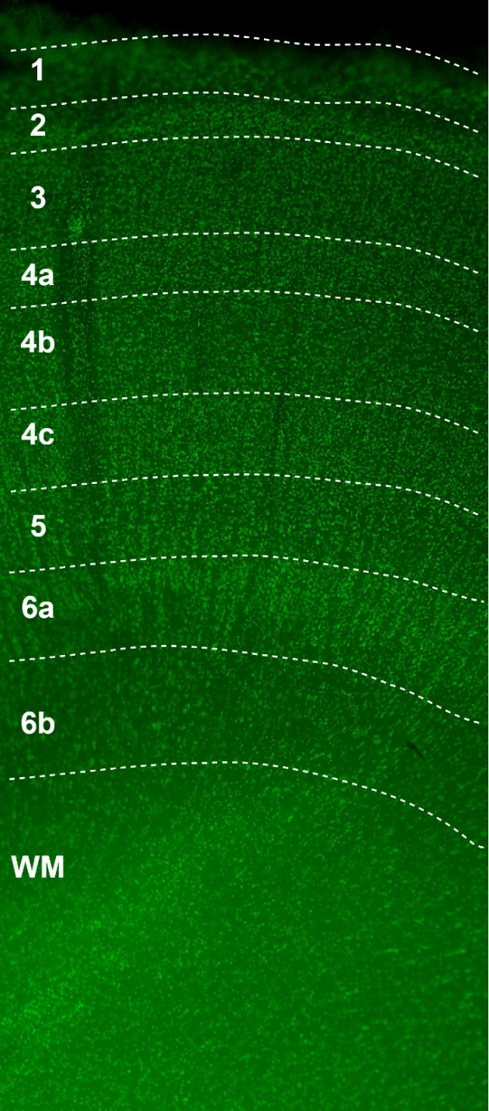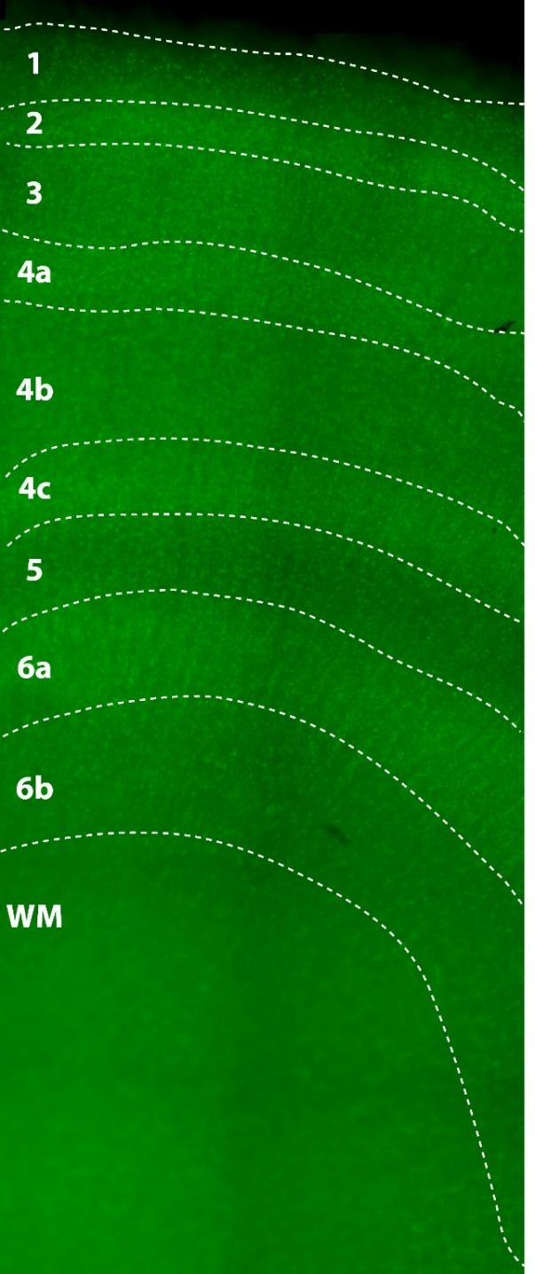
Figure 3. Fluorescent Nissl Staining seen in slice from VISp

    - Using a wide-mouth plastic pipette, transfer a slice to be microdissected to a sterile sylgard-coated small petri dish containing approximately 1 ml cold 10mM PBS DTT.
    - Using the microdissecting tools and referencing example images when available, Dissect out desired layers.
      - Mark the boundary between each layer by making a horizontal cut at each layer boundary with the microknife. Then, starting a layer 1, make vertical cuts to remove the microdissected piece of each layer. Work in sequence from layer 1 to layer 6.
    - Use a razor blade to remove the tip of a P1000 pipette tip. Use this tip and a P1000 pipette to transfer the dissected layers to their respective labeled microcentrifuge tubes on ice.
    - Repeat steps 8.2.5-8.2.7 for any additional slices to isolate from. Reuse of the widened P1000 pipette tip is allowed.
    - Photograph each section after dissection is complete and ROIs have been removed.
    - Once all samples have been collected, proceed to Nuclear Isolation Protocol (PF0291)

- Take Down:
  - 10mM DTT in PBS can be disposed of down the sink directly into the municipal sewer system. Any remaining Nissl staining solution can be combined with 10mM DTT PBS buffer.
  - 1M DTT stock should be treated as hazardous waste and collected in an appropriately labeled waste container for Environmental Health and Safety to dispose of.
  - Remove any remaining pieces of tissue from vibratome mounting disk and place in a 10% bleach solution in 50 ml conical tube for at least 20 minutes to disinfect. Discard in biohazard waste.
  - Place vibratome blade, razor and scalpel in sharps container.
  - Rinse vibratome mounting disk, bath and holder with distilled water, followed by 70% Ethanol.
  - Wipe down vibratome and blade holder with 70% Ethanol.
  - Wipe down lab bench, tools and other equipment with 70% Ethanol.

