

Study Protocol
Improving Diagnosis in Cognitive Disorders

Co-sponsors | The University of Edinburgh & Lothian Health Board  ACCORD  The Queen’s Medical Research Institute  47 Little France Crescent  Edinburgh  EH16 4TJ
Chief Investigator | Dr Laura McWhirter
Sponsor Reference | AC19002
REC Number | 19/SS/0038
Version Number and Date | IDCD protocol V2 26 March 2019
Protocol authors | Laura McWhirter, Alan Carson, Jon Stone, Craig Ritchie

Background
In recent years, increased prominence of dementia as a public health problem in media reports, alongside government and health service drives to diagnose dementia at earlier stages, has led to increasing numbers of people seeking medical help for memory problems. In a 2012 public survey, 66% of adults over 55 and indeed 61% of people aged 18-24 reported being worried about themselves or someone they know developing dementia; 70% of all those surveyed worried more about dementia than they did about heart disease, cancer, or stroke (Yougov.uk, 2012).
A significant proportion – between 12% and 70%, but generally around 30% – of symptomatic patients attending memory clinics do not have dementia (Almeida, Hill, Howard, & O’Brien, 1993; Berrios & Hodges, 2000; Pennington, Hayre, Newson, & Coulthard, 2015; Schmidtke, Pohlmann, & Metternich, 2008). Although a range of differential diagnoses may be considered for these patients who have cognitive symptoms without evidence of neurodegenerative disease (neurological illness, medical illness, impairment due to medication, and surgery), review of the literature suggests a significant proportion have cognitive symptoms with a functional (psychogenic) basis. Furthermore, studies from UK memory clinics seem to confirm our clinical experience that the proportion of patients presenting with non-organic memory complaints is increasing. In Liverpool the proportion increased from 50.8% between 2002-4 to 67.1% in 2008-2009 and 70.2% between 2009-10 (Hussey, Foy, & Meehan, 2009; Menon & Larner, 2011). In Sheffield, the proportion of patients attending who did not fulfil criteria for any organic memory problem increased from 35% of all attendees in 2004 and 2006 to 55% in 2012 (Blackburn et al., 2014; Le Couteur et al., 2013).
The scientific literature on cognitive symptoms not due to neurodegenerative disease is a tangled landscape of overlapping terminology. Early 20th century physicians used the term ‘pseudodementia’ to describe clinical syndromes with the appearance of dementia but rather caused by depression, conversion disorders (hysteria), dissociative states (also described amongst ‘Ganser states’), or disordered personality (Bleuler, 1934; Kiloh, 1961; Wells, 1979). The breadth of the ‘pseudodementia’ concept has been lost over time although ‘depressive pseudodementia’ persists as a term for cognitive impairment associated with severe depression. In recent years, dementia researchers investigating subjective cognitive decline (also called subjective cognitive impairment) have been so strongly invested in identifying markers of prodromal and pre-clinical dementia that little attention has been paid to alternative causes of symptoms. Individuals (particularly younger individuals) presenting with cognitive symptoms and normal cognitive examination are also often described, perhaps unhelpfully, as the ‘worried well’.
While in a minority subjective cognitive symptoms may be an early sign of dementia, it is likely that a significant proportion – including some in whom cognitive tests lead to descriptions of mild cognitive impairment or dementia – are best described as having a functional cognitive disorder. Functional cognitive disorder (FCD) is a type of functional neurological disorder, producing cognitive symptoms which are genuine but experienced inconsistently and not related to organic disease. FCD may mimic dementia in the same way that other functional neurological disorders mimic organic causes of paralysis, seizures, tremor, or speech disorders. FCD is likely to be heterogeneous: a recent review hypothesised a set of overlapping sub-categories: memory symptoms as part of anxiety or depression; excessive attentional focus on ‘normal’ memory problems; an isolated functional memory disorder in which symptoms are neither 'normal' nor entirely explained by anxiety; health anxiety about dementia; memory symptoms as part of another functional disorder; and dissociative amnesia (Stone et al., 2015).

Introduction
The important clinical problem that this study wishes to address is of how we might more confidently identify patients with functional cognitive disorders in a clinical setting.
This clinical problem is becoming more pressing for two reasons.
Firstly, large numbers of individuals with functional cognitive disorders are presenting to cognitive clinics, but as the disorder has not been clearly defined, they are not receiving evidence-based treatment. Defining this group will allow trials of treatment for FCD.
Secondly, clinical tools enabling accurate diagnosis of FCD will reduce misdiagnoses of Alzheimer’s dementia and so reduce the risks of inappropriate treatment or inclusion in clinical trials. Much current research aims to identify and study high risk populations in the very earliest – preclinical and prodromal – stages of Alzheimer’s dementia, with a view to changing disease course through accurate diagnosis and thereafter intervention. It is now considered that neurodegenerative disease can present with a series of ‘stages’: from preclinical disease through subjective cognitive decline through MCI before the full dementia syndrome is reached. Although clinically helpful, in the early phases these categories represent mixed, complex and overlapping clinical and biological phenotypes, and there is a risk that patients with FCD are being incorrectly identified as having preclinical Alzheimer’s disease and vice versa. With new treatments aimed at individuals with these very early symptoms it is going to become increasingly important to be able to identify confidently those with FCD who will not benefit but who may be harmed by inappropriate intervention.
Research into functional neurological disorders (FND) in recent years has ensured that functional neurological disorder is no longer a diagnosis of exclusion, but rather one made on the basis of positive clinical signs, such as the Hoover’s sign of functional leg weakness - weakness of voluntary hip extension which normalises during contralateral hip flexion (McWhirter, Stone, Sandercock, & Whiteley, 2011). Defining these signs has improved patient care and invigorated research into mechanisms of and treatments for FND (Espay et al., 2018). Research into functional cognitive symptoms has lagged behind that of FND in general, and although a number of distinctive features have been observed, no clear positive diagnostic test or profile has yet been identified.
Review of the literature suggests that most promising diagnostic signs for FCD may be those relating to differences in behavioural and linguistic interaction during the physician-patient interaction between individuals with FCD and those with neurodegenerative disease (Reuber et al., 2018; Williamson & Larner, 2018). For example, patients with functional cognitive impairment seem more likely to attend alone, are more concerned about their memory problem than others, report premorbidly exceptional memory, provide detailed histories, and are able to answer questions with multiple components. It has been suggested that patients with FCD may answer questions where there is a 50:50 chance of obtaining the correct answer (‘forced choice’) with a rate of correct answers significantly less than chance (a feature of force-choice effort/performance validity tests), suggesting that the correct answer is known at some level (Stone et al., 2015).
The intention of this study is to explore the discriminant ability of the features listed above, and others, and from this to develop a diagnostic scoring tool which can accurately identify FCD in memory clinic patients.

Hypothesis and Aims
The primary aim of this project is to develop a diagnostic scoring tool which can be used to diagnose functional (psychogenic) cognitive disorders (FCD) in an outpatient clinic setting among those presenting with cognitive symptoms where the differential diagnosis includes dementia / neurodegenerative disease (ND). A secondary aim is characterise those individuals presenting for assessment of cognitive symptoms which are ultimately assessed to have a functional (psychogenic) cause.
The primary hypothesis is:
- Functional cognitive disorders can be positively identified by a characteristic profile of communication and behaviour features observable during standard clinical assessment.

Secondary hypotheses are:

- A significant proportion of patients presenting with cognitive symptoms and assessed for possible neurodegenerative disease have functional (psychogenic) cognitive disorders.
- Individuals with FCD report greater levels of cognitive symptoms, distress, disability, quality of life impairment and psychiatric comorbidity than patients with neurodegenerative disease.

Method

Study design
The proposed study is a cross-sectional study of adult patients presenting to outpatient clinics with cognitive symptoms, with the exception of those presenting late with established dementia in whom there is no diagnostic doubt. The study population will include patients referred to the City of Edinburgh Memory Assessment and Treatment Service, the Neurology Department of the Western General Hospital, and the Neuropsychiatry Department of the Western General Hospital.
The study pathway and summary of the data gathered at each stage is illustrated in Figure 1 and Appendix 1. Following standard clinical assessment participants will attend for an additional research assessment by a researcher (LM) blinded to information collected in the clinical assessment (clinical history, cognitive testing, and investigations) but not blinded to referral details or demographic information.
The research assessment will constitute a standardised interview, brief cognitive tests, brief neurological examination, and questionnaires. Each participant will be scored against a standardised schedule of behaviours and communication features during this standardised assessment. The predictive value of individual items (some binary, some continuous) will be examined against a reference standard diagnosis (panel diagnosis A) established by panel consensus following usual clinical assessment, and a scoring tool developed from the items with best predictive accuracy.
Electronic medical records will be examined after 1-2 years in order to identify cases of either a) resolution of cognitive symptoms or b) change of diagnosis to dementia, and predictive value of both individual factors and the resulting scoring tool will be re-assessed.

Inclusion criteria
Participants will be included if they have presented to the memory clinic, neurology, or neuropsychiatry clinic with predominantly cognitive symptoms, are >18 years old, and are able to give informed consent.
Participants will be excluded if:
- They are severely cognitively impaired and receive a diagnosis of probable Alzheimer’s type dementia (according to current consensus diagnostic criteria(McKhann et al., 2011)) or a probable diagnosis of another dementia syndrome.
- They do not speak English (as the study includes English-language validated questionnaires)
- They have a learning disability
- They are under the age of 18
- They have a severe psychiatric disorder (including active suicide risk, severe personality disorder, or psychosis)
- There is evidence or strong clinical suspicion that they have factitious disorder

Procedure
The research study pathway is illustrated in Appendix 1.

Recruitment and consent
Participants will be recruited from three sources: neurology outpatient clinics at the Western General Hospital, Neuropsychiatry clinics at the Western General Hospital, and from the City of Edinburgh Memory Assessment and Treatment Service (MATS).

- Recruitment from neurology
Patients referred to neurology outpatient clinics at the Western General with predominantly cognitive symptoms will be recruited following clinical assessment. The consultant neurologist (direct care team) who has assessed the patient will consider whether the patient is suitable to take part in the study. If the patient meets inclusion criteria the consultant neurologist will provide the potential participant with the Participant Information Sheet (PIS), and explain the study to the potential participant at the end of the appointment. The potential participant will be offered the opportunity to be contacted by a researcher to find out more about the study, but it will be made clear that there is not requirement to do so and if they would prefer not to be contacted this will not affect their clinical care. If the potential participant would like more time to think about whether they wish to find out more about the study from a researcher, they will be invited to take the PIS away and make contact with the researcher directly, using provided contact details, at a later date.
Dr McWhirter will contact those who have consented to be contacted by telephone after at least 24 hours to explain the study in detail and give the potential participant the opportunity to ask questions.

- Recruitment from neuropsychiatry
Potential participants attending neuropsychiatry clinics at the Western General Hospital with predominantly cognitive symptoms will be recruited following clinical assessment.

The consultant neurologist (direct care team) who has assessed the patient will consider whether the patient is suitable to take part in the study. If the patient meets inclusion criteria the consultant neurologist will provide the potential participant with the Participant Information Sheet (PIS), and explain the study to the potential participant at the end of the appointment. The potential participant will be offered the opportunity to be contacted by a researcher to find out more about the study, but it will be made clear that there is not requirement to do so and if they would prefer not to be contacted this will not affect their clinical care. If the potential participant would like more time to think about whether they wish to find out more about the study from a researcher, they will be invited to take the PIS away and make contact with the researcher directly, using provided contact details, at a later date. Dr McWhirter will contact those who have consented to be contacted by telephone on a single occasion after at least 24 hours to explain the study in detail and give the potential participant the opportunity to ask questions.

- Recruitment from the older-adults psychiatry memory clinic (MATS)
Participants will be recruited from the memory clinic (MATS) in two ways:
a) Potential participants meeting inclusion criteria will be told about the study by the clinician who has performed their clinical assessment: a consultant psychiatrist or consultant neurologist from the direct care team. The consultant neurologist (direct care team) who has assessed the patient will consider whether the patient is suitable to take part in the study. If the patient meets inclusion criteria the consultant neurologist will provide the potential participant with the Participant Information Sheet (PIS), and explain the study to the potential participant at the end of the appointment. The potential participant will be offered the opportunity to be contacted by a researcher to find out more about the study, but it will be made clear that there is not requirement to do so and if they would prefer not to be contacted this will not affect their clinical care. If the potential participant would like more time to think about whether they wish to find out more about the study from a researcher, they will be invited to take the PIS away and make contact with the researcher directly, using provided contact details, at a later date. Dr McWhirter will contact those who have verbally consented to be contacted by telephone on a single occasion after at least 24 hours to discuss the study and give the potential participant the opportunity to ask questions.
b) At the time of initial assessment at MATS, all patients are asked whether they would be willing to be contacted by a researcher for a range of studies being run in the Centre for Dementia Prevention. This interest is documented in an e-Register (the Scottish Brain Health Register). From this register, eligible participants will be contacted by Dr McWhirter by telephone / post / email as per the preference they have indicated at the time of joining the e-Register. Interested potential participants will be send a participant information sheet with covering letter and then contacted by Dr McWhirter, once, after a period of at least 5 days with the opportunity to ask questions. It is hoped that this will allow additional participants to be identified from MATS who have signed up to the e-Register but where the consultant who has assessed the patient has forgotten or not had the opportunity to provide information about the study at the time of the clinical assessment.

Usual clinical assessment
Those who agree to participate will already have undergone usual clinical assessment, including a clinical history, mental state examination, baseline cognitive profiling with the Addenbrooke’s Cognitive Examination (iii), the Lawton-Brody Activities of Daily Living scale and a caregiver burden assessment scale. These measures are part of the standard assessment at MATS, and for the purpose of standardising clinical assessment for this study, will be included in the clinical assessment carried out on neurology and neuropsychiatry patients. These are standard clinical tools widely used in patients presenting with memory problems. Some, but not all, subjects will have had brain imaging studies. For those potential participants in whom MRI brain is requested, combinostics cNeuro quantitative analysis of images will be requested, providing quantitative scores of regional and global atrophy (this is routinely available clinically).

Research Assessment

Location
Those who agree to participate will be invited to attend either the Centre for Dementia Prevention (a Clinical Research Facility), or the Outpatient Department at the Department for Clinical Neurosciences, or to be visited by a researcher (LM) at home, at a date and time convenient to them for the research assessment, within 8 weeks of their standard clinical assessment. The research assessment will take no more than 2 hours. Participants will be reimbursed for reasonable travel expenses.

Informed consent
Informed consent will be taken from all participants prior to the research assessment. In the first instance, verbal consent will be taken over the telephone a) after potential participants have received and read the participant information sheet b) after potential participants have had the study explained to them by Dr McWhirter, have had the opportunity to ask questions, and have been satisfied with the answers to all questions, and c) after potential participants have verbally agreed to participate and for a research appointment date and time to be arranged. Written informed consent will again be taken in person on the day that the participant attends for the research assessment. No information will be collected without written consent, and participants will be reminded that they are free to withdraw consent at any time.

Content of research assessment
underlined = associated with functional cognitive disorder
A Interactional/conversational features (structured interview)
- Attendance for assessment (Attends with someone; attends alone)
- Length of first turn (head turns; few words; answer lasting more than a few seconds)
- ‘Tell me about a time your memory failed you.’ (head turns or asks AA; non-specific vague example; detailed example; can estimate timescale)
- ‘Another example’ (head turns or no more examples, ‘don’t know’, >1 detailed example)
- Compound question (answers 0/2 parts; answers 1/2 parts; answers both parts)
- Repetition (repeats somethings said earlier without marking; repeats with marking)
- Report of premorbid memory (normal or poor; ‘brilliant memory’)
- Direct reported speech (no reported speech; reported speech)
B Cognitive
- Digit span and reverse digit span
- MOCA (10-15 minutes)
  - Immediate vs delayed recall ratio (delayed < immediate; immediate < delayed)
  - Responses timed using a stopwatch – end of instruction to end of response (consistently slow; inconsistent response times)
C Examination / motor /praxis
- Gait and coordination (primarily to observe ability to follow instructions)
- Luria 3-step test
- Interlocking fingers test
D Effort / Performance Validity
- Green’s Medical Symptom Validity Test (£620 for 100 uses, funded from CCBS discretionary fund)
- Coin-in-hand test (requires participant to remember which hand a coin is in over 10 trials).
- 3 brief ‘Ganser’ questions
E Cognitive representations and metacognition
- Subjective Memory Complaint 5-point Likert scale: ‘In general, how would you rate your memory?’
- The Multifactorial Memory Questionnaire (Troyer & Rich, 2002).
- Beliefs about cause of problems and prognosis.
- Spouse, partner, sibling or parent with dementia. Y/N (and describe relationship)
- Ever daily contact with or caring for a person with dementia. Y/N
F Psychiatric and health status
- Mini International Neuropsychiatric Interview (English version 7.0.2 for DSM 5)
- Physical symptoms (PHQ-15, including extra questions as used in the Scottish Neurological Symptoms Study)
- Sleep quality (Pittsburgh Sleep Quesionnaire)
- Hospital Anxiety and Depression Scale
In addition the research will record a binary outcome (FCD / not FCD) consisting the researcher’s opinion at the end of the assessment.
The licence fee for the Green’s Medical Symptom Validity Test will be funded from CCBS (University of Edinburgh) discretionary funds. All other measures are freely available without licence.

Panel assessment to establish reference diagnosis
A consensus diagnosis, for the purposes of the research project (which may or may not align with any diagnosis or description established following standard clinical evaluation), will be reached for each participant after discussion by a panel consisting a Consultant Neurologist, Consultant Neuropsychiatrist and Consultant Psychiatrist of Ageing. In order to reach the main reference diagnosis Panel Diagnosis A, the panel will be provided with the clinical history, including past medical history, clinical notes and clinical letter from the standard memory clinic assessment, electronic medical records, and results of neuroimaging and other investigations.
After panel diagnosis A has been finalised and documented, additional information will be provided to the panel in stages, and the panel asked to review their diagnosis at each stage. These additional panel diagnoses (B, and C1-5) will compared with Panel diagnosis A in analyses of longitudinal outcome. In addition, information about the likelihood of each additional piece of information influencing the panel diagnosis will be used following analysis to aid decisions about which elements to ultimately include in the diagnostic scoring tool.
The panel consensus procedure is describe in detail in appendices 2 and 3.

Follow-up Assessment / Data collection
A proportion of participants will be followed-up in the memory clinic as part of usual clinical care, and some will also undergo further cognitive or biomarker assessments as part of their participation in other Centre for Dementia Prevention research projects. 1-2 years after the initial standard clinical assessment, available medical notes will be examined by a researcher blinded to research panel diagnosis and not involved in the first phase of data collection, to establish any change to the clinical diagnosis during the follow-up period, including progression of cognitive impairment / conversion to dementia / death. Where data is unclear or unavailable via the electronic medical record, the researcher will telephone the participant’s GP practice to enquire about any change in diagnosis as regards cognitive state.

DATA MANAGEMENT

Personal Data
The following personal data will be collected as part of the research:
Name, CHI number, date of birth, address, telephone number, email address, and medical history as reported to researcher during the study and as recorded in health records. Personal data will be stored by the research team on password-protected NHS Lothian Servers and password-protected University of Edinburgh servers accessible to Dr Laura McWhirter. Pseudonymised (by study number) paper files will be stored in locked filing cabinets at the Kennedy Tower, University of Edinburgh, the key stored within the Kennedy Tower and accessible to Dr Laura McWhirter. Participant contact details (name, date of birth, address, telephone number, and email address, but excluding CHI number) will be stored in a separate locked filing cabinet also within the Kennedy Tower at the University of Edinburgh, accessible to Dr Laura McWhirter.
Personal data will be stored for five years after participation.

Transfer of Data
Data collected or generated by the study (including personal data) will not be transferred to any external individuals or organisations outside of the Sponsoring organisation(s). Data will not be transferred outwith the University of Edinburgh or NHS Lothian.

Data Controller
The University of Edinburgh and NHS Lothian are joint data controllers.

Data Breaches
Any data breaches will be reported to the University of Edinburgh and NHS Lothian Data Protection Officers who will onward report to the relevant authority according to the appropriate timelines if required.

Statistical Methods
Factor analysis will be performed in order to identify the elements of the research assessment which best predict reference diagnosis (Panel diagnosis A), taking account of demographic characteristics and other influences on pre-test probability of having neurodegenerative disease vs functional cognitive disorder.
Secondary analysis will be performed to assess whether information from the research assessment influences the panel opinion: whether Panel diagnosis B differs from Panel diagnosis A, and which elements of the research assessment are most likely to result in a change in the panel opinion.
The elements of assessment with greatest utility will be combined to form a diagnostic scoring tool.
R will be used for statistical analyses.

Sample size calculation
In the absence of an available diagnostic test for FCD, sample size calculation is based on estimated test accuracy and estimated (on the basis of literature review and clinical experience) prevalence of FCD in the study population. As table 1 shows, assuming a prevalence of 30% functional cognitive disorder in the study population (suggested by review of the memory clinic literature), and 90% sensitivity and 90% specificity, a minimum sample size of 115 will be required.
Table 1 - Sample size calculation
 | 95% sensitive, 95% specific | 95% sensitive,  90% specific | 90% sensitive,  95% specific | 90% sensitive,  90% specific | 80% sensitive  95% specific | 80% sensitive,  90% specific | 70% sensitive  95% specific | 70% sensitive,  90% specific
Prevalence 15% | 487 | 122 | 922 | 230 | 1639 | 410 | 2151 | 538
Prevalence 20% | 365 | 91 | 691.5 | 173 | 1229 | 307 | 1613 | 403
Prevalence 30% | 243 | 61 | 461 | 115 | 820 | 205 | 1076 | 269
Z = 1.96 (95% CI)

GOOD CLINICAL PRACTICE

ETHICAL CONDUCT
The study will be conducted in accordance with the principles of the International Conference on Harmonisation Tripartite Guideline for Good Clinical Practice (ICH GCP).
Before the study can commence, all required approvals will be obtained and any conditions of approvals will be met.

INVESTIGATOR RESPONSIBILITIES
The Investigator is responsible for the overall conduct of the study at the site and compliance with the protocol and any protocol amendments. In accordance with the principles of ICH GCP, the following areas listed in this section are also the responsibility of the Investigator. Responsibilities may be delegated to an appropriate member of study site staff.

Informed Consent
The Investigator is responsible for ensuring informed consent is obtained before any protocol specific procedures are carried out. The decision of a participant to participate in clinical research is voluntary and should be based on a clear understanding of what is involved.
Participants must receive adequate oral and written information – appropriate Participant Information and Informed Consent Forms will be provided. The oral explanation to the participant will be performed by the Investigator or qualified delegated person, and must cover all the elements specified in the Participant Information Sheet and Consent Form.
The participant must be given every opportunity to clarify any points they do not understand and, if necessary, ask for more information. The participant must be given sufficient time to consider the information provided. It should be emphasised that the participant may withdraw their consent to participate at any time without loss of benefits to which they otherwise would be entitled.
The participant will be informed and agree to their medical records being inspected by regulatory authorities and representatives of the sponsor(s).
The Investigator or delegated member of the trial team and the participant will sign and date the Informed Consent Form(s) to confirm that consent has been obtained. The participant will receive a copy of this document and a copy filed in the Investigator Site File (ISF) and participant’s medical notes (if applicable).

Study Site Staff
The Investigator must be familiar with the protocol and the study requirements. It is the Investigator’s responsibility to ensure that all staff assisting with the study are adequately informed about the protocol and their trial related duties.

Data Recording
The Principal Investigator is responsible for the quality of the data recorded in the CRF at each Investigator Site.

Investigator Documentation
- The Principal Investigator will ensure that the required documentation is available in local Investigator Site files ISFs.

GCP Training
For non-CTIMP (i.e. non-drug) studies all researchers are encouraged to undertake GCP training in order to understand the principles of GCP. However, this is not a mandatory requirement unless deemed so by the sponsor. GCP training status for all investigators should be indicated in their respective CVs.

Confidentiality
All laboratory specimens, evaluation forms, reports, and other records must be identified in a manner designed to maintain participant confidentiality. All records must be kept in a secure storage area with limited access. Clinical information will not be released without the written permission of the participant. The Investigator and study site staff involved with this study may not disclose or use for any purpose other than performance of the study, any data, record, or other unpublished information, which is confidential or identifiable, and has been disclosed to those individuals for the purpose of the study.. Prior written agreement from the sponsor or its designee must be obtained for the disclosure of any said confidential information to other parties.

Data Protection
All Investigators and study site staff involved with this study must comply with the requirements of the appropriate data protection legislation (including the General Data Protection Regulation and Data Protection Act) with regard to the collection, storage, processing and disclosure of personal information.
Computers used to collate the data will have limited access measures via user names and passwords.
Published results will not contain any personal data and be of a form where individuals are not identified and re-identification is not likely to take place

STUDY CONDUCT RESPONSIBILITIES

PROTOCOL AMENDMENTS
Any changes in research activity, except those necessary to remove an apparent, immediate hazard to the participant in the case of an urgent safety measure, must be reviewed and approved by the Chief Investigator.
Amendments will be submitted to a sponsor representative for review and authorisation before being submitted in writing to the appropriate REC, and local R&D for approval prior to participants being enrolled into an amended protocol.

MANAGEMENT OF PROTOCOL NON COMPLIANCE
Prospective protocol deviations, i.e. protocol waivers, will not be approved by the sponsors and therefore will not be implemented, except where necessary to eliminate an immediate hazard to study participants. If this necessitates a subsequent protocol amendment, this should be submitted to the REC, and local R&D for review and approval if appropriate.
Protocol deviations will be recorded in a protocol deviation log and logs will be submitted to the sponsors every 3 months. Each protocol violation will be reported to the sponsor within 3 days of becoming aware of the violation. All protocol deviation logs and violation forms should be emailed to QA@accord.scot
Deviations and violations are non-compliance events discovered after the event has occurred. Deviation logs will be maintained for each site in multi-centre studies. An alternative frequency of deviation log submission to the sponsors may be agreed in writing with the sponsors.

SERIOUS BREACH REQUIREMENTS
A serious breach is a breach which is likely to effect to a significant degree:
(a) the safety or physical or mental integrity of the participants of the trial; or
(b) the scientific value of the trial.
If a potential serious breach is identified by the Chief investigator, Principal Investigator or delegates, the co-sponsors (seriousbreach@accord.scot) must be notified within 24 hours. It is the responsibility of the co-sponsors to assess the impact of the breach on the scientific value of the trial, to determine whether the incident constitutes a serious breach and report to research ethics committees as necessary.

STUDY RECORD RETENTION
All study documentation will be kept for a minimum of 3 years from the protocol defined end of study point. When the minimum retention period has elapsed, study documentation will not be destroyed without permission from the sponsor.

END OF STUDY
The end of study is defined as the last participant’s last visit.
The Investigators or the co-sponsor(s) have the right at any time to terminate the study for clinical or administrative reasons.
The end of the study will be reported to the REC, and R+D Office(s) and co-sponsors within 90 days, or 15 days if the study is terminated prematurely. The Investigators will inform participants of the premature study closure and ensure that the appropriate follow up is arranged for all participants involved. End of study notification will be reported to the co-sponsors via email to resgov@accord.scot
A summary report of the study will be provided to the REC within 1 year of the end of the study.

CONTINUATION OF TREATMENT FOLLOWING THE END OF STUDY
No treatment will be provided as part of this study.

INSURANCE AND INDEMNITY
The co-sponsors are responsible for ensuring proper provision has been made for insurance or indemnity to cover their liability and the liability of the Chief Investigator and staff.
The following arrangements are in place to fulfil the co-sponsors' responsibilities:
- The Protocol has been designed by the Chief Investigator and researchers employed by the University and collaborators. The University has insurance in place (which includes no-fault compensation) for negligent harm caused by poor protocol design by the Chief Investigator and researchers employed by the University.
- Sites participating in the study will be liable for clinical negligence and other negligent harm to individuals taking part in the study and covered by the duty of care owed to them by the sites concerned. The co-sponsors require individual sites participating in the study to arrange for their own insurance or indemnity in respect of these liabilities.
- Sites which are part of the United Kingdom's National Health Service will have the benefit of NHS Indemnity.
- Sites out with the United Kingdom will be responsible for arranging their own indemnity or insurance for their participation in the study, as well as for compliance with local law applicable to their participation in the study.

REPORTING, PUBLICATIONS AND NOTIFICATION OF RESULTS

AUTHORSHIP POLICY

Ownership of the data arising from this study resides with the study team.

Timescale
December 2018 – February 2019 Application for ethical approval
March 2019 – May 2020 Recruitment and data collection
June 2020 – December 2021 Follow-up, analysis, writing up

Ethics and data sharing
Ethical approval will be sought from the South East Scotland Research Ethics Committee.
This protocol will be pre-registered at protocols.io. Anonymised data may be shared via the Edinburgh Datashare respository.

Public/patient involvement
This protocol has been forwarded to FND support groups for review and comments.

Appendix 1 – study pathway (blue = usual care, red = research study)

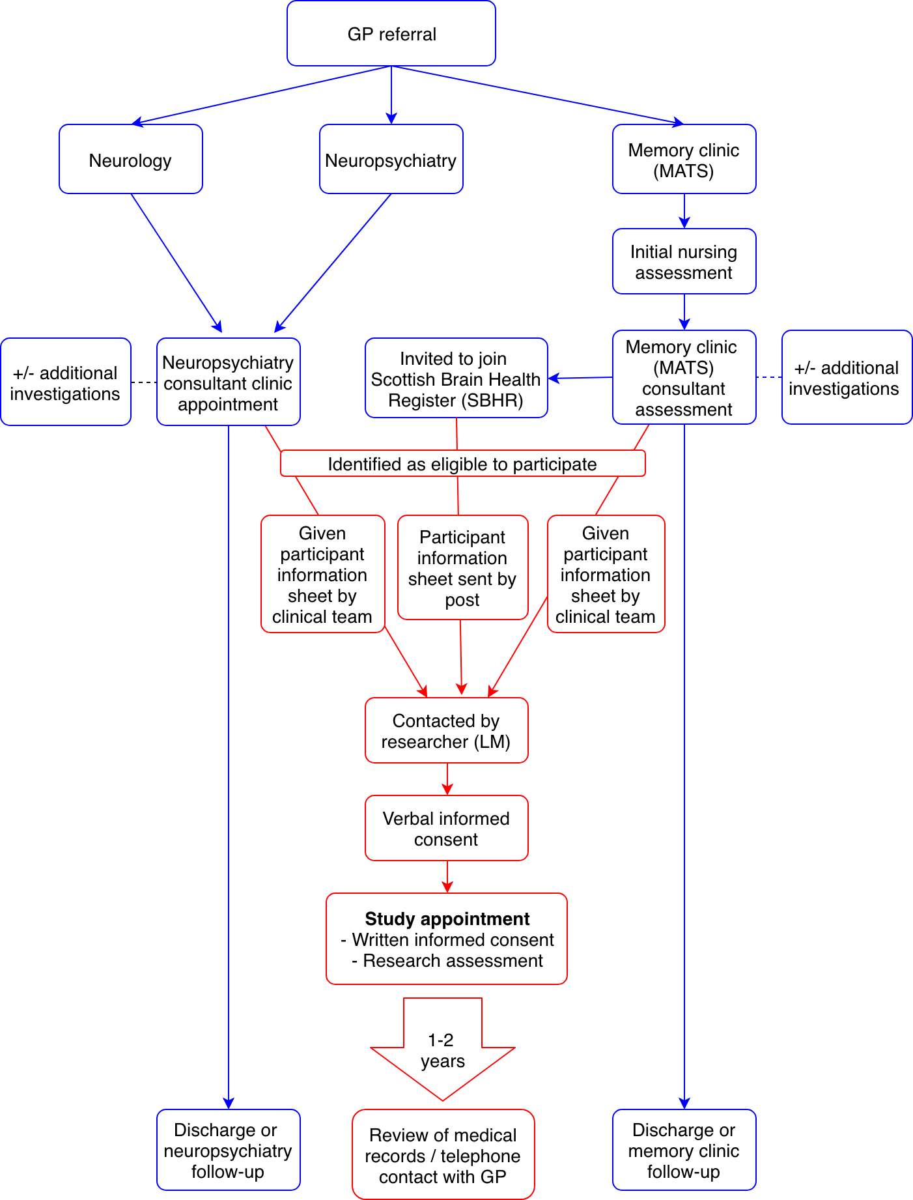

Appendix 2 - Panel assessment procedure

Purpose of panel assessment
- To establish a reference standard, against which the novel research assessment will be compared.
- To identify the impact of disclosure of different elements of the research assessment on the consensus diagnosis.

Panel members
The panel will consist of three members: a consultant psychiatrist of ageing (CR), a consultant neurologist (JS), and a consultant neuropsychiatrist (AC). The panel meetings will be chaired by the researcher who has undertaken the research assessments (LM), who after completing the research assessments and recording outcomes will become ‘unblinded’ to other clinical data.

Panel meetings
Panel meetings will be held at approximately quarterly intervals, when >20 subjects have completed both the research assessment and the usual clinical assessment process (i.e. clinical letter, cognitive assessments, and reports of any requested clinical assessments are available).
During each meeting, a researcher (LM) will present the clinical information to the panel (verbally and using the electronic medical record) in the order listed in Figure a. At each stage, the members of the panel will discuss the information provided and asked to reach a consensus on the most likely diagnosis.
The diagnosis at each stage will be recorded in ink in the CRF (so that no further changes can be made) before the panel are provided with any information from the next stage.

Figure 1 – Panel diagnoses
Stage | Information | Panel diagnosis
1 | Clinical history and mental state examination
 | Informant report
 | Cognitive examination (ACEiii)
 | ADL scale
 | Imaging where available | A – reference diagnosis
2 | Advanced imaging reports and CSF AD biomarker profile where available | B
3 | Research assessment – structured interview | C1
4 | Research assessment – neuro exam | C2
5 | Research assessment – cognitive tests | C3
6 | Research assessment – MINI and HADS | C4
7 | Research assessment – PHQ-15 | C5

It can be difficult to make a firm diagnosis in individuals with mild impairment or subjective symptoms, particularly in elderly people with comorbidities. A three character code (eg. 1AD, 2CF) will be used to indicate likely diagnosis at each stage, as illustrated in figure 3. An estimation by the panel of % confidence in the diagnosis will also be recorded. For the purposes of the primary analysis, however, a binary outcome will be used: ‘unlikely functional’ (1 and 2a), vs ‘likely functional’ (2b and 3).

Figure 2 – Coding of reference diagnosis
 |  | code | Binary outcome for primary analysis
Functional cognitive symptoms | Probable | 1 | Functional
 | Possible likely | 2a
 | Possible unlikely | 2b | Not functional
 | Unlikely | 3
Neurodegenerative disease | Probable | A
 | Possible | B
 | Unlikely | C
Medical or pharmacological cause of cognitive symptoms | Probable | D
 | Possible | E
 | Unlikely | F

Discrepancy between clinical and reference diagnosis.
In some cases, the reference diagnosis will be different from the clinical diagnosis. In these cases, the reference diagnosis and the basis of the difference will be communicated by letter to the clinician from the direct care team who has made the clinical diagnosis. It will be highlighted to the clinician where this the difference may be based on research measures of unknown accuracy and helpfulness. It will be up to the clinician from the direct care team to decide whether a review of diagnosis or treatment with the participant is necessary.
The reference diagnosis will not be communicated to the participant or the participant’s GP.
Appendix 3 – Basis of panel diagnoses

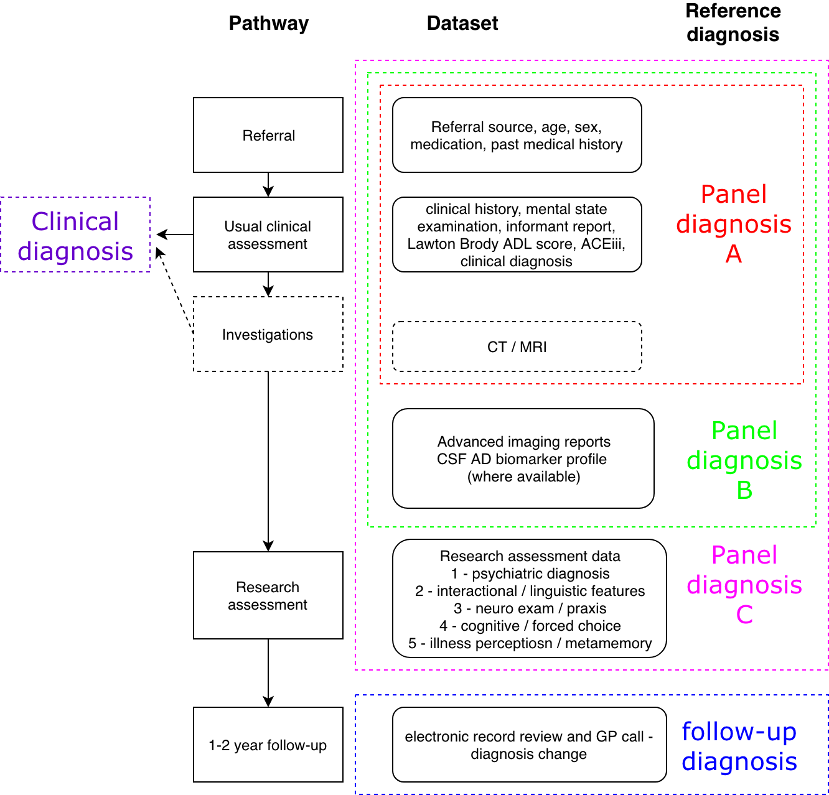

References

Almeida, O. P., Hill, K., Howard, R., & O’Brien, J. (1993). Demographic and clinical features of patients attending a memory clinic. International Journal of Geriatric Psychiatry, 8(6), 497–501.
Berrios, G., & Hodges, J. (2000). Memory disorders in psychiatric practice. Cambridge: Cambridge University Press.
Blackburn, D., Wakefield, S., Bell, S., Harkness, K., Venneri, A., & Reuber, M. (2014). Functional memory disorder; review from a memory clinic. Journal of Neurology, Neurosurgery and Psychiatry, 85(10), A8. https://doi.org/http://dx.doi.org/10.1136/jnnp-2014-309236.28
Bleuler, E. (1934). Textbook of Psychiatry. (A. A. Brill, Trans.) (2nd ed.). New York: MacMillan.
Espay, A. J., Aybek, S., Carson, A., Edwards, M. J., Goldstein, L. H., Hallett, M., … Morgante, F. (2018). Current Concepts in Diagnosis and Treatment of Functional Neurological Disorders. JAMA Neurology. https://doi.org/10.1001/jamaneurol.2018.1264
Hussey, D., Foy, K., & Meehan, K. (2009). Quality of dementia referrals to a later life psychiatry service. The Psychiatrist, 33(4).
Kiloh, L. G. (1961). Pseudo-dementia. Acta Psychiatrica Scandinavica, 37(4), 336–351. https://doi.org/10.1111/j.1600-0447.1961.tb07367.x
Le Couteur, D. G., Doust, J., Creasey, H., Brayne, C., Blackburn, D. J., Shanks, M. F., … Venneri, A. (2013). Re: Political drive to screen for pre-dementia: not evidence based and ignores the harms of diagnosis. British Medical Journal, 347(347), f5125. Retrieved from http://www.bmj.com/content/347/bmj.f5125/rr/664031
McKhann, G. M., Knopman, D. S., Chertkow, H., Hyman, B. T., Jack, C. R., Kawas, C. H., … Trojanowski, J. Q. (2011). The diagnosis of dementia due to Alzheimer’s disease: recommendations from the National Institute on Aging-Alzheimer’s Association workgroups on diagnostic guidelines for Alzheimer’s disease. Alzheimer’s & Dementia : The Journal of the Alzheimer’s Association, 7(3), 263–269. https://doi.org/10.1016/j.jalz.2011.03.005
McWhirter, L., Stone, J., Sandercock, P., & Whiteley, W. (2011). Hoover’s sign for the diagnosis of functional weakness: A prospective unblinded cohort study in patients with suspected stroke. Journal of Psychosomatic Research, 71(6), 384–386.
Menon, R., & Larner, A. J. (2011). Use of cognitive screening instruments in primary care: the impact of national dementia directives (NICE/SCIE, National Dementia Strategy). Family Practice, 28(3), 272–276. https://doi.org/10.1093/fampra/cmq100
Pennington, C., Hayre, A., Newson, M., & Coulthard, E. (2015). Functional Cognitive Disorder: A Common Cause of Subjective Cognitive Symptoms. Journal of Alzheimer’s Disease : JAD, 48 Suppl 1(s1), S19-24. https://doi.org/10.3233/JAD-150182
Reuber, M., Blackburn, D. J., Elsey, C., Wakefield, S., Ardern, K. A., Harkness, K., … Drew, P. (2018). An Interactional Profile to Assist the Differential Diagnosis of Neurodegenerative and Functional Memory Disorders. Alzheimer Disease and Associated Disorders. https://doi.org/10.1097/WAD.0000000000000231
Schmidtke, K., Pohlmann, S., & Metternich, B. (2008). The syndrome of functional memory disorder: definition, etiology, and natural course. The American Journal of Geriatric Psychiatry, 16(12), 981–988.
Stone, J., Pal, S., Blackburn, D., Reuber, M., Thekkumpurath, P., & Carson, A. (2015). Functional (Psychogenic) Cognitive Disorders: A Perspective from the Neurology Clinic. Journal of Alzheimer’s Disease, 48(S1), S5–S17.
Troyer, A. K., & Rich, J. B. (2002). Psychometric properties of a new metamemory questionnaire for older adults. The Journals of Gerontology. Series B, Psychological Sciences and Social Sciences, 57(1), P19-27. Retrieved from http://www.ncbi.nlm.nih.gov/pubmed/11773220
Wells, C. E. (1979). Pseudodementia. The American Journal of Psychiatry, 136(7), 895.
Williamson, J., & Larner, A. (2018). Attended with and head-turning sign can be clinical markers of cognitive impairment in older adults. International Psychogeriatrics. https://doi.org/10.1017/S1041610218000121
Yougov.uk, A. S. (2012). Are you worried about dementia? Retrieved from http://cdn.yougov.com/cumulus_uploads/document/xnbimbtb70/YG-Archives-AlzheimersSoc-DementiaAwarenessWeek-220512.pdf

