Nylanderia fulva Aggression Assay Protocol
Edward LeBrun
Aggression assay approach:
Every bait station to which Nf recruits is to be tested against both of its nearest neighbor bait stations. The first and last bait stations to be tested against each other. Each pairing will be replicated 3 times. In total ants from each bait card to which NF recruits will be used in 6 aggression trials (minimum of 30 workers needed per station).
General description aggression assays:
- 5 x 5 worker aggression assays.
- Ants are held in small tubs until tested. Holding tubs are not fluoned to minimize exposure to artificial odor cues. This is generally applicable. Except for sugar water, avoid any alien food, perfumed detergents, or other potential sources of artificial odors.
- Trials occur in fluoned glass dram vials. Neutral arena vials were 20 ml clear glass scintillation vials, 5.5 X 2.5 cm (height x diameter), the walls of which coated with Fluon™ excepting the bottom centimeter left clear for observation (Fig 1).
- Trials are staged at 30° C.
- Ideally trials occur within 24 hours of ant collection. Do not conduct trials after sunset or before dawn.
- Each pairing is replicated 3x.
- 2 people must work together. 1 person is the Observer and the other the Organizer.
- Observer is blind to identity of ants being tested.
- If possible, a positive (known aggressive pair) and negative (known non-aggressive pair) control are included in each set of assays to validate assay conditions. In the introduced range context, it may not be possible to include a positive control.
Specific protocol aggression assays:
- Using phorid aspirator or paint brush, from each nest collect workers into small tubs with wet paper towel and cotton ball soaked with 30% sugar.
  - Goal: 50 workers per tub.
  - From 1 nest collect 1 additional tub of ants. These will be negative controls.
- Isolate ants into arena vials. Using a small paint brush with a band of fluon 1 inch from bottom ants are removed from tubs and transferred to arena. A phorid type aspirator may also be used, but care must be taken not to suck too hard. If aspirator is used, screened vial must not be used for multiple tubs. Be careful not to include any dead ants, male ants, brood items, or queens.
- Organizer assigns codes to vials, keeping track of their actual identity.
- Allow ants a minimum of 10 minutes to adjust to vial and a maximum of 20 minutes before combining vials and beginning assay. Ants left isolated too long in arena vials can suffer stress.
- Interaction vials and vials waiting to be combined and observed are kept on warming mat at 30° C (Fig 1).
- Start assay by tipping one vial into another and moving code tape from empty vial to combined vial.
- Vial is not observed for first minute and then an observation is made once every 2 minutes. During each observation the observer watches the arena vial for 20 seconds and records the most aggressive interaction seen in that time period.
  - Behaviors are scored on a qualitative scale that runs from 0 to 5. See below.
  - Observer should wear magnifying glasses for this process and be sure not to breathe on the opening of the vial. A dust mask can facilitate the latter.
  - Arena vials under observation should be on a white background. (Paper taped to warming mat.)
- Each vial is scored for most aggressive interaction observed 4 times at 1, 3, 5, and 7 minutes after the ants are combined. Total assay length: 7 min.
- While Observer is conducting assays. Organizer sets up next pairs to be combined and places them on warming mat for observer to combine when ready. Observer also continues to remove ants from tubs and place in vials to finish complement of assays. Observer keeps track of how many replicates of each pair have been set up and how many are needed.
- Vials are cleaned between usages.
  - Vials are either cleaned with non-perfumed detergent and warm water and re-fluoned. Or, to preserve fluon, the bottom is cleaned with a cotton swab with ethanol and then rinsed with a cotton swab with water and then a dried with a cotton swab.
  - Cleaned vials are then placed in a warm location (eg. drying oven) and not reused for at least 24 hours to allow for drying and the volatilization of any compounds left behind after cleaning.
Aggression scale:
Table 1: N. fulva intraspecific aggression scale. Scale used for scoring interactions between workers in 5 x 5 neutral arena interaction assays. The most aggressive behavior observed in a 20 second scan of the arena was scored. Scores of 3 or greater represent increasing levels of aggression.
Score | Description of Behavior
0 | Ants come in contact and part.
1 | One or both ants antennate the other for 3 or more seconds OR trophallaxis OR allogrooming
2 | One ant bites and then releases the other.
3 | One ant bites and holds on for more than 3 seconds OR bites and releases two or more times consecutively.
4 | One ant bites and holds the other while curling its gaster tip under its body till the gaster is parallel with substrate, acidopore pointing at its opponent. Aggressor does not spray or otherwise release formic acid.
5 | One ant sprays formic acid at its opponent or both ants actively fight, typically forming a ball.

Spraying of formic acid, when it happens, is obvious. All ants in the vial simultaneously explode into frantic running.

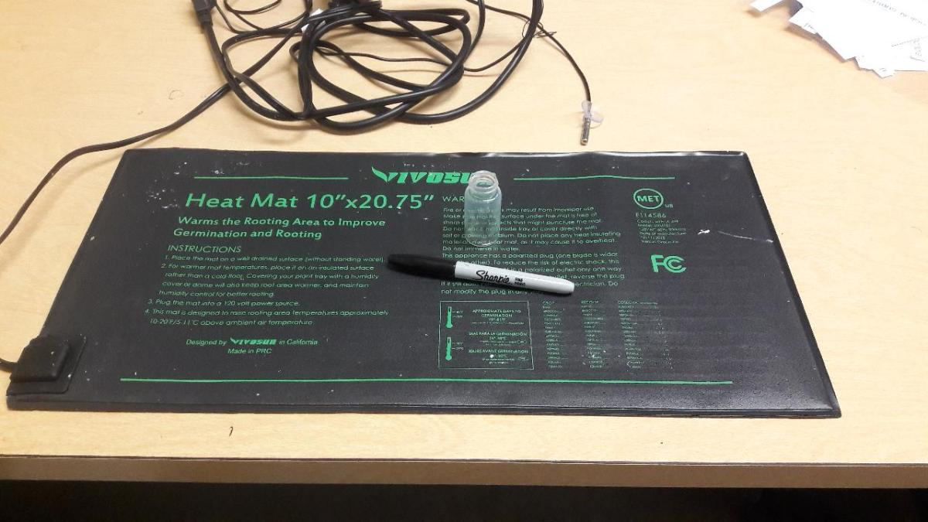

Figure 1: Warming mat with glass scintillation vial arena. Marker for scale.

