Leica SP8 Confocal Imaging

- Scope and Applicability: This protocol describes the setup and scanning using the Leica SP8 confocal microscope of fluorescently-labeled mouse brain tissue sections mounted on positively charged 1” x 3” microscope slides for U19 BRAIN Mouse Brain Cell Atlas Project.

- Materials:
  - 1x3 microscope slides to be scanned
  - Kim Wipes
  - Zeiss Pre-Moistened Lens Cleaning Wipes
- Equipment:
  - Leica SP8 TCS confocal microscope
    - PMT and HyD detectors
    - 10x Objective (Leica HC PL APO 10x/0.40)
    - Galvanometric stage insert
    - LCD display
  - Scan head
  - Compact Supply Unit (CSU)
  - CTR control box
  - EL6000 metal halide lamp
  - Control panel
  - Smart Move joystick
  - PC
    - Leica Application Suite (LAS) X software (v.3.5.1)
    - Mozilla Firefox
- Safety:
  - Nitrile Gloves
  - Eye protection
  - Lab coat
  - Caution: Immersol 518F immersion oil causes skin irritation; avoid contact with skin and eyes.
- Output:
  - TIFF files for 10x z-stack
  - TIFF file of maximum intensity projection
  - TXT file of experiment metadata

Warning: Personal Protective Equipment (PPE) should be used at all times while operating this protocol. If you are unsure what PPE you should be using, see your immediate supervisor.

- Setup:
  - Turn on the hardware. Note: Solid state lasers and the EL6000 widefield light source require minimal warm up. Adhere to the 15 min rule: leave on for at least 15 min before shutting off, leave off at least 15 min before restarting.
    - Turn on computer and monitors (Figure 1A) and log into your account.
    - Turn on the CTR Control Box (Figure 1B).
    - Turn on the laser power supplies (Figure 1C).
      - Power is switched on from left to right. Switch on the first switch (Scanner Power), wait for 5 seconds, turn on the second switch (Laser Power), wait for 5 seconds, and then turn the Laser Emission key to the ‘on’ position.
    - Turn on the EL6000 fluorescent light source (Figure 1D).
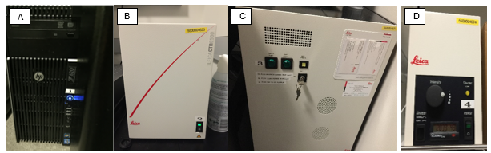
Figure 1. Leica SP8 power components. A) PC power. B) CTR control box.
C) Lasers in Compact Supply Unit (CSU) D) EL6000 metal halide lamp.

  - Launch the LAS X acquisition software for microscope control and image acquisition.
    - For Configuration, select “machine.xlhw” and for Microscope, select “DM6000.” Resonant should be switched "off”. Load settings at startup is optional, select if you want to reuse settings from a previous session (Figure 2).
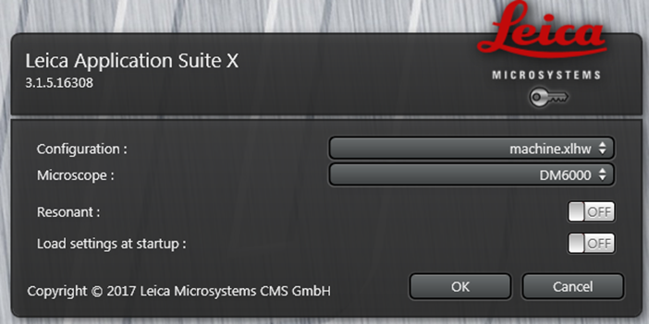
Figure 2. Leica Application Suite (LAS) X launcher.

    - Click “OK” to start initialization.
      - A message will pop up asking if you want to initialize the stage. Ensure that there is nothing on the stage and click “Yes”. Initialization is required for Tiling features.
  - Visually inspect and clean objectives
    - Using a pre-moistened lens wipe, wipe gently across the objective lens three times, using a clean area of the lens wipe each time. Repeat as needed.
- Methodology/Procedures:
  - Slide Setup
    - Using the Smart Move Joystick, adjust the stage to the appropriate, low position for loading a slide.
    - On the LCD touch screen, select the objective tab and set the objective to 10x. The eyeball button will direct light to the eyepieces (Figure 3).
    - Clean the slide to be imaged using a pre-moistened lens wipe.
    - Place and secure the glass slide on the stage, with the barcode on the left, using the two metal slide clips.
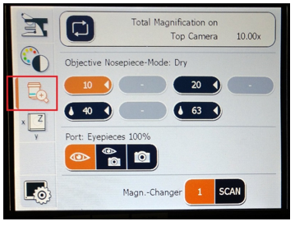
Figure 3. Microscope touch screen control. The objective is selected from third screen from the top. Sometimes the 10x objective does not display properly on the software the first time you turn it on. If this is the case: select a different objective, let the microscope change, and then reselect the 10x objective. It will display properly after this.

    - Carefully bring the stage to the objective using the Smart Move joystick on the “z coarse” setting, and switching to “z fine” when the stage nears the objective.
      - Optional: The upper (Focus) and lower (Home) stage positions may also be saved as limits using this feature on the LCD screen (See Appendix 10.1).
    - Using the Smart Move joystick, find the left most section on the slide.
    - On the LCD touch screen, select the color wheel tab (Figure 4).
      - From this screen, select the FLUO cube, open the IL-shutter and select the RFP or GFP filter cube (Figure 4).
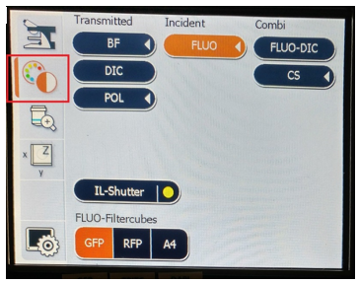
Figure 4. Microscope touch screen control. Light and shutter options can be found from the second screen from the top. FLUO-filter cubes may be selected to view green (GFP) red (RFP) or blue (DAPI/A4) channels.
    - Using the eyepieces and toggling between RFP and GFP filter cubes, find the area with both red and green signal by adjusting x-y position of the section using the Smart Move joystick.
      - Green signal is bilaterally expressed on the tissue slice. Starter cells, which express both green and red signals, are in only one hemisphere.
    - Switch to the RFP filter cube if not already selected.
    - Adjust x-y position of the section to center the red fluorescence signal.
    - Turn off the IL-Shutter.
  - Image Acquisition Setup
    - In the LAS X software, under the ‘Open projects’ tab, open the template project from Z:\Mesoscale\template\template10x.lif (Figure 5).
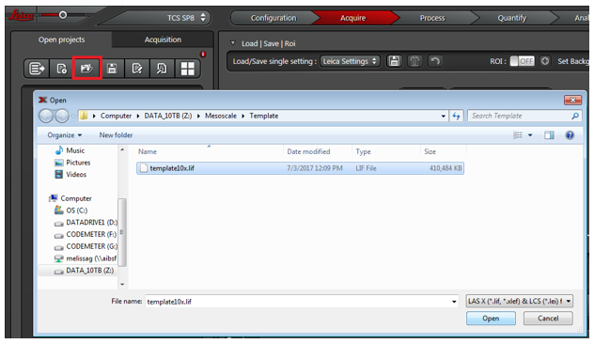
Figure 5. Open the file template.lif from the “Open projects” tab.

    - Expand the template project by clicking the arrow next to the .lif file and select the saved experiment “TileScan_001”. Click the "apply'' button to load all pre-defined laser parameters. You can also right click the experiment and select “Apply image settings” (Figure 6).
      - A message may pop up asking if you would like to switch on the lasers used in the template. Click “Yes”.

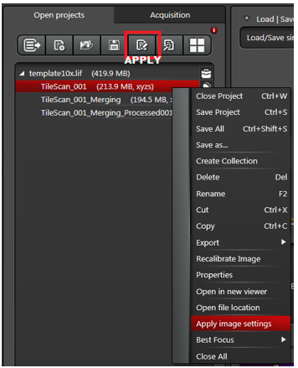
Figure 6. To load parameters from a saved experiment, a project first must be opened, expanded, and the experiment (TileScan_001) selected. Then, either click the “Apply” button or right click > Apply image settings

    - Create a new project by clicking the ''new" button (Figure 7).
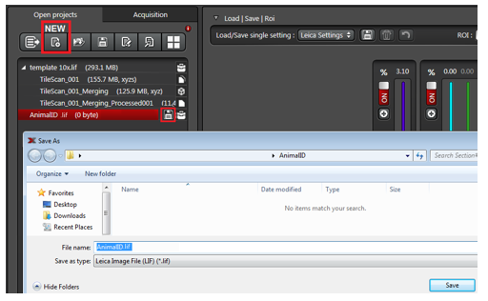
Figure 7. Create a new project and save the renamed project by clicking the “Save” button next to the file name or right click > Save As and choosing the correct file location.

    - Rename and save the new project.
      - Rename the new project (Right click > Rename) using the Animal ID from the slide label. Example: 274704.lif
      - Create the appropriate folders for the experiment files in Z:\Mesoscale.
        - Create a folder and rename as the AnimalID. The .lif file will be saved here.
        - Within the AnimalID folder, create folders for each Slide #.
        - Within the Slide # folders, create a folder for each Section #. Exported TIF files and metadata will be saved in these folders.
      - Click the “Save” button or right click > Save As and save the project in the corresponding AnimalID folder (Figure 7).
    - Click the "Acquisition" tab. The LAS X software is organized into three main sections (Figure 8): Scan Parameters on the left (A), Light path options in the middle (B), and Images on the right (C).
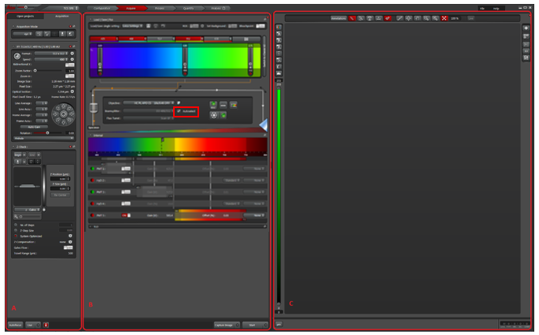
Figure 8. Main LAS X software window. This window has three portions: A) Scan parameters,
B) Light path, and C) Image

    - Check the “Autoselect” feature for the Beamsplitter to make sure that the Dichroic for DD 488/552 is used for all images (Red Box in Figure 8 Section B).
    - The correct lasers should have been turned on after applying template settings. If not, activate lasers you need by clicking on their on/off buttons (Figure 9).
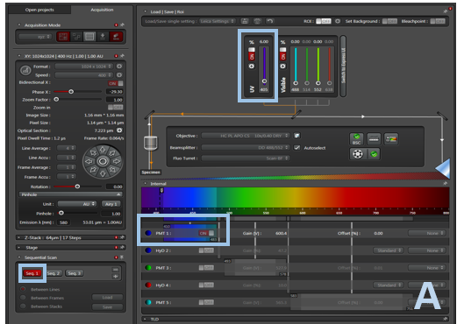
Figure 9A. Seq1 shows the parameters for acquiring DAPI fluorescence

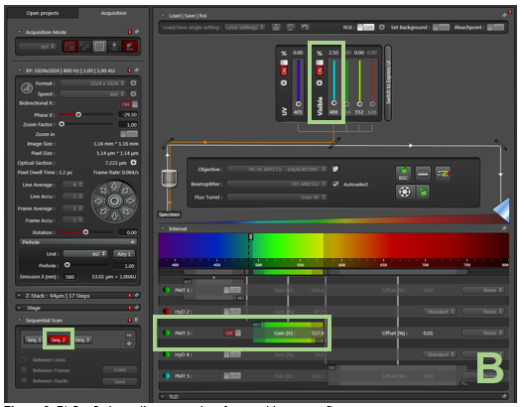
Figure 9B. Seq2 shows the parameters for acquiring green fluorescence

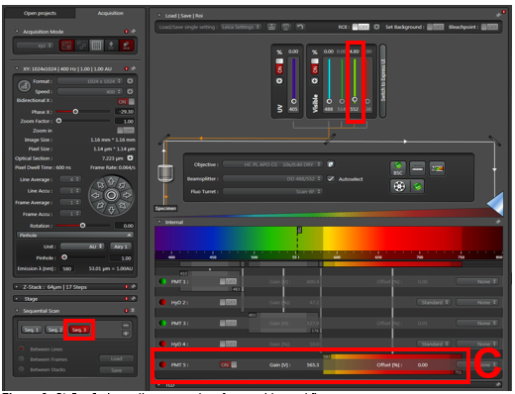
Figure 9C. Seq3 shows the parameters for acquiring red fluorescence

      - Toggle between Seq. 1, Seq. 2, and Seq. 3 to verify that the correct lasers are switched on for each (Figure 9).
        - With Seq. 1 selected, check that DAPI fluorescence will be acquired using laser 405 and PMT 1. (Figure 9a).
        - With Seq. 2 selected, check that green fluorescence will be acquired using laser 488 and PMT 3. (Figure 9b).
        - With Seq. 3 selected, check that red fluorescence will be acquired using laser 552 and PMT 5. (Figure 9c).
    - Note that you can toggle between Laser Interfaces, by observing the Classic UI format or the Express UI format. Figure 9A-C show the Classic UI format. The only difference between Express UI and the Classic UI is method for determining which lasers are activated. While the Classic UI determines laser activation by on/off buttons, the Express UI will highlight activated lasers in red that can be deactivated by clicking on the highlighted regions (Figure 10).
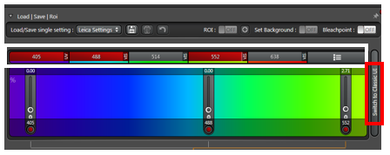
Figure 10. Express UI format displays activated lasers by highlighting them red (White Box where lasers for 405nm, 488nm, and 552nm are activated). To toggle back to Classic UI format shown in Figure 9A-C, click on the Switch to Classic UI button (Red Box).

    - Check that the scan parameters are correct:
      - Format: 1024 x 1024
      - Speed: 400 Hz
      - Bidirectional X: ON
      - Phase X: -29.30
      - Zoom factor: 1.00
      - Line average: 4
      - Tiling needs to be turned on manually (template will not do this for you) by clicking the “tiling” option so that it is highlighted red (Figure 11)
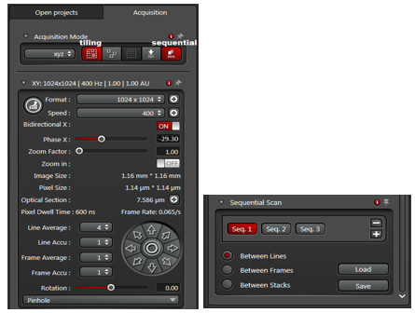
Figure 11. Correct acquisition parameters, with tiling and sequential scanning set to “on.” (Left) Sequential scanning options can be found at the bottom of the acquisition parameters column (Right)
      - Sequential Scan: Between lines (Figure 11)
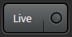
  - Gains and Offset Optimization using Look-Up Table (LUT)
    - Begin live view by clicking the button at the bottom of the screen.
    - Enable Look-Up Table (LUT) by selecting the LUT button in the image section of the software (Figure 12).
      - Clicking once will select a range-finding LUT and display it for the active window.
      - Clicking a second time will change the display to black and white.
      - Clicking a third time will return to the normal, assigned colors.
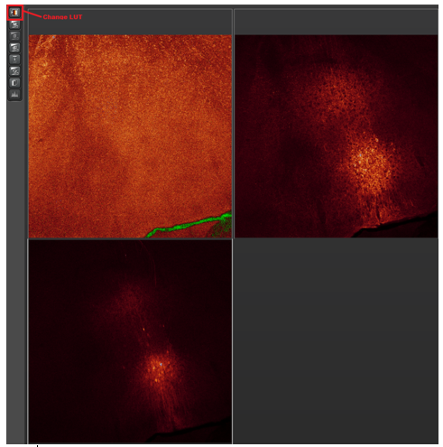
Figure 12. The LUT tool is used to optimize the image by using colors to clearly display areas that are over- or under-exposed. Areas below the range are displayed in green, above range is displayed in blue, and areas within range are displayed in red

    - With LUT enabled, optimize the image by toggling between seq. 1, 2, and 3, and adjusting the appropriate lasers’ power and gain.
      - Adjust laser power by either dragging the laser power bar or using the mouse scroll wheel (refer to Figure 9 for where laser power controls are).
      - Adjust gain by using the Smart Gain wheel on the control panel (Figure 13).
      - For optimal images, note that oversaturated pixels will display in blue, while true black pixels are represented in green. Areas within range display in red. The brightest area within the stack should display as speckled blue pixels (very slightly over-saturated) (Figure 12).
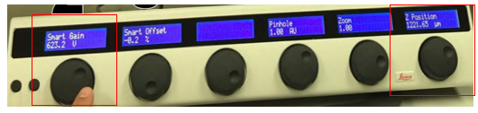
Figure 13. Smart Gain can be adjusted using the left wheel on the control panel. Z-position can be adjusted using the right wheel

    - Ensure laser power and gain is within the optimal ranges of the components:
      - Laser power should be set to <6% to avoid bleaching.
      - PMT smart gain should be set within 400-650 V.
      - HyD smart gain should be within 10-90%.
    - If there is no signal at the maximum laser power/gains, the following laser power/gain parameters should be used as placeholders:
      - Laser power should be set to 5%.
      - PMT smart gain should be set to 650 V.
      - HyD smart gain should be set to 90%.
    - Z-stack Setup
      - Expand the Z-Stack settings in the parameters column of the software window (Figure 14).

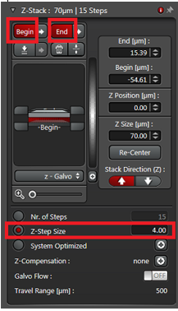
Figure 14. The Z-Stack settings are located under the parameters section of the software window. Begin and End buttons are used to set first and last planes of the z stack. Ensure that the button for “z-step size” is selected and set to 4 µm.

      - In live scanning mode, identify the top and bottom z locations by adjusting the z-position using the z-position wheel on the control panel (Figure 12).
        - Scroll the wheel to the left until you find the bottom plane. When it becomes dark, (LUT enabled helps here) click “Begin”.
        - Scroll the wheel to the right to find the top plane of the image. Adjust until it is dark and click “End”.
      - Select the radio button next to “z-step size” and set z-step size to 4 µm. Note: Most samples will be between 14-20 steps. Before scanning, check to make sure the z-range makes sense.
        - The diagram indicates the size and spacing of the stack and the current stage position. It may be re-scaled for better viewing using the slider provided (Figure 12).
        - See Appendix 10.2 for a detailed figure of z-stack controls.
  - Tile Scan Setup
    - If not already completed, turn tiling on in the Acquisition Mode menu to open the tile scan parameters (step 8.2.9, Figure 11). The tile scan “stage” window will appear in the parameters column (Figure 15).
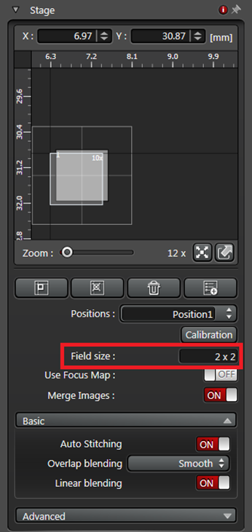
Figure 15. The Tile Scan settings are located under the parameters column of the software window. Verify the parameters are correct before starting a scan.

    - In the Field size text box, enter “2 x 2”.
    - Activate Merge Images, Auto Stitching, and Linear Blending.
    - Under Advanced make sure that the scan speed slider is changed from Fast Slow by moving the slider all the way to the left.
    - Ensure the sample is in the center of the desired tiling area. Adjust using the joystick if necessary.
  - Image Acquisition
    - Before acquiring the image, double check that all parameters are correct.
      - It may be a good idea to save these parameters to reuse any LAS X settings that weren’t defined by the template (tile scan, z stack settings) by clicking the “Save” button next to Load/Save single setting (Figure 16). This only needs to be completed once and the saved settings will only populate for your login.
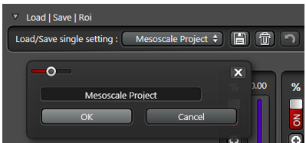
Figure 16. User settings can be saved for future use by clicking the “Save” button.
These settings can then be selected using the drop-down

    - Begin image acquisition by clicking the  button at the bottom of the screen. Each scan takes around 15 minutes to complete.
    - When the scan is complete, QC the image for any scanning artifacts and verify that all three channels scanned correctly. See Appendix 10.3 for image controls.
    - Rename the experiments just created.
      - Under the parameters column, switch from the “Acquisition” tab to the “Open projects” tab.
      - Rename the tile scan experiment using information from the slide “TileScan_001” AnimalID_Slide#_Section#_tilescan
      - Rename the stitched (“merging”) experiment
“TileScan_001_Merging001” AnimalID_Slide#_Section# _stitched
    - Delete the tile region and z stack by clicking the “garbage can” buttons in the respective sections.
    - Repeat step 8.1 to set up the next section.
    - Repeat steps 8.3.1-8.6.5 until all sections on all slides for that brain (AnimalID) have been imaged. Select and scan only 1 hemisphere per slice.
  - Image Processing
    - Under the parameters column, switch from the “Acquisition” tab to the “Open projects” tab.
    - Create a max projection image for each stitched experiment.
      - Select the stitched experiment (AnimalID_Slide#_Section# _Stitched).
      - At the top of the screen, switch from “Acquire” mode to “Process” mode (Figure 17).

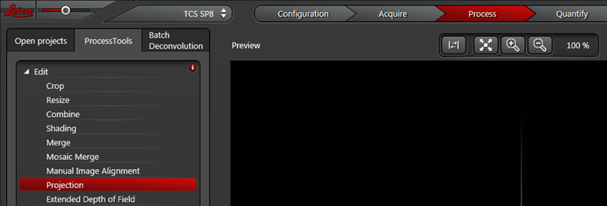
Figure 17. Process Tools can be found under the “Process” tab in the LAS X software.
From here, a max projection image can be created from a z-stack

      - Select the “Projection” process tool
      - Run the z-stack through this process tool by clicking
      - A new experiment will be populated in your project under the “Open Projects” tab. (AnimalID_Slide#_Section#_Stitched_Processed001).
      - Rename this experiment: AnimalID_Slide#_Section#_MIP
    - Save the project and export experiments as .TIF files.
      - Click the “Save” button next to the .lif project name to save changes.
      - In the folder you created in step 8.2.4.2.3, create two folders: “Stack” and “MIP”. “Stitched” exported files will be saved to the “Stack” folder and “MIP” exported files will be saved to the “MIP” folder.
      - Export stitched and MIP images to .TIF by right clicking each experiment and selecting > Export > TIF.
      - Ensure the following export parameters are correct (Figure 18):
        - Destination folder: Z:\Mesoscale\AnimalID\Slide#\Section#\MIP or
Z:\Mesoscale\AnimalID\Slide#\Section#\Stack

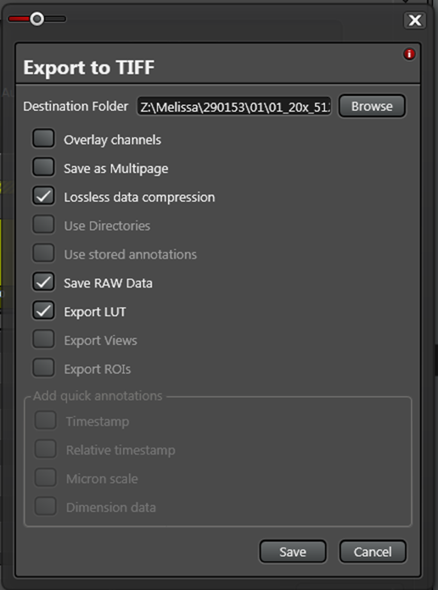
Figure 18. Parameters for image export to TIFF. Lossless data compression,
Save RAW Data and Export LUT are checked. All other parameters are unchecked.

        - Lossless data compression, Save RAW Data, and Export LUT are checked. All other parameters are unchecked.
        - Click Save.

- Take Down:
  - Clean objectives following the same procedure as described in step 7.3.
  - Log off and turn off the microscope.
    - Microscope components are to be shut off in reverse order of power-up (refer to Figure 1).
    - If a user is scheduled to use the Leica SP8 (found on the Institute Confocal Outlook calendar) the system may be left on for them. Follow up with the user to verify they will be using it and that they are familiar with the proper shut-down procedures. If the system will be unattended for more than an hour between users, then complete shutdown is necessary.

- Appendix
  - Setting and Restoring Home and Focus Positions
    - Select the x-y-z screen, fourth screen from the top, on the LCD display screen and select Z-mode from on the top-right.
    - When the stage is at a low, loading position, press the button at the bottom of the screen that displays a stage in a low position. It should say “Set/Clear Lower Limit.” Press “Set.”
    - Bring the stage up to the focus position.
    - Press the button at the bottom of the screen that displays a stage in a mid-position. It should say “Set/Clear Focus Position.” Press “Set.”
    - To return to either of these positions, return to this screen and press either the low position or mid position buttons next to the “Current Position” display to move to their saved z positions.
    - To clear either of the positions, press the “Clear” button under Set/Clear Limit. Clear any saved positions when you are done with working on the SP8, for the next user.
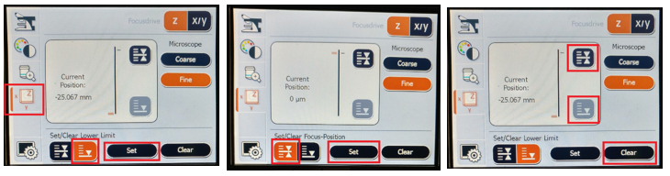
Figure 19. Setting and Restoring Home and Focus Positions
  - Other controls for Z stacks

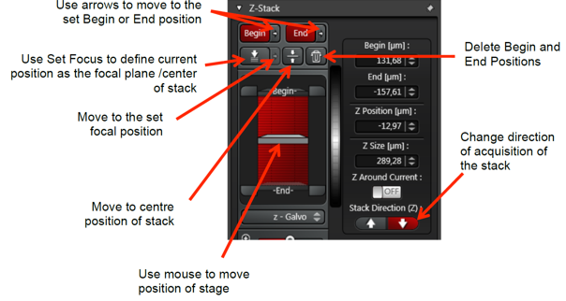
Figure 20. Other controls for Z stacks

  - Image display post-acquisition
    - Any of the Ch# buttons (1) turn on or off any given color.
    - The merged button (2) turns on a merged overlay of all channels
    - The “full screen” button (3) turns on a full screen display of your image.

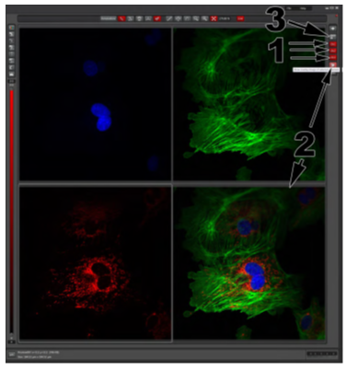
Figure 21. Image display post-acquisition

