Maintenance of TissueCyte System

- Scope: This document will provide detailed instructions for procedures needed for maintenance of the TissueCyte scanning systems.

- Materials:
  - Air blower
  - 100% Ethanol
  - Screwdriver set
  - Hex key set
  - Bearing grease (Dow Corning Molykote 1292)

- Equipment:
  - TissueCyte scanning system
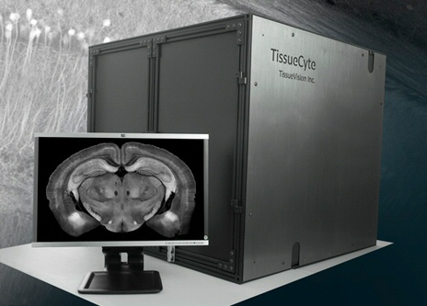

- Safety:
  - Do not have any body parts in the enclosure box while the machine is running.
  - Always wear PPE when using the system.
  - The enclosure door should be closed during normal operations.

- Output:
  - A functioning TissueCyte system

- Reference Documents:
  - EQ0067 TissueCyte Installation and Alignment Guide
    - https://www.protocols.io/view/tissuecyte-installation-and-alignment-guide-ber2jd8e/abstract
  - EQ0068 TissueCyte Troubleshooting Guide
    - https://www.protocols.io/view/tissuecyte-troubleshooting-guide-beryjd7w/abstract
  - PF0262 Core Protocol for Serial Imaging of Fluorescently-Labeled Mouse Brain on the TissueCyte 1000 System
    - https://www.protocols.io/view/core-protocol-for-serial-imaging-of-fluorescently-bdvmi646/abstract

Warning: Before performing any work on the TissueCyte system, the PMT power should be turned off and laser should be shuttered. Always check with the TissueCyte user group for the availability before scheduling any maintenance.

- Re-greasing of Vibratome Bearing:
  - Use Dow Corning 1292 Molykote Grease (or equivalent)
  - Remove the vibratome arm and bearing assembly, following instructions 8.4-8.9.
  - Place a small amount of grease on the inner surface of the bearing.
  - Rotate the cam shaft, drawing grease into the needle rollers inside the bearing.
  - Clean up excess grease.
  - Replace the bearing assembly and vibratome arm.

- Change of Vibratome Off-axis Bearing:
  - NOTE: The bearings on the mircrotomes (new as of early 2019) do not need regular replacement, but should be re-greased on a regular basis, following section 7.0.
  - The vibratome bearing slowly wears out with use and needs to be replaced.
  - Indication that the bearing needs to be replaced – if you are able to hear a noise from the bearing when it is cutting, that indicates that the bearing is getting old and needs to be replaced.
  - The bearing assembly consists of the motor, cam shaft, and holder. It is located at the right side of the top level as you open the enclosure door. It is fastened with four screws, marked S.
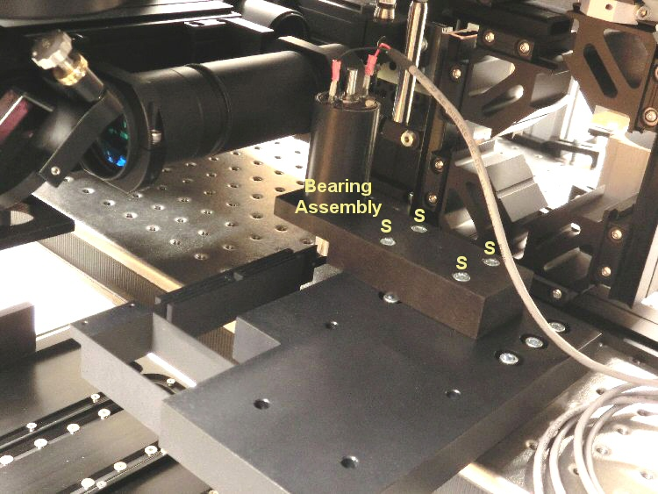

  - Make sure that bearing replacement is scheduled and that there is at least an hour for this procedure prior to the next run being started.
  - Make sure the laser is shuttered, and the PMTs are off prior to opening the TissueCyte doors.
  - Remove the vibratome arm from inside the TissueCyte using a 3/32 hex key.
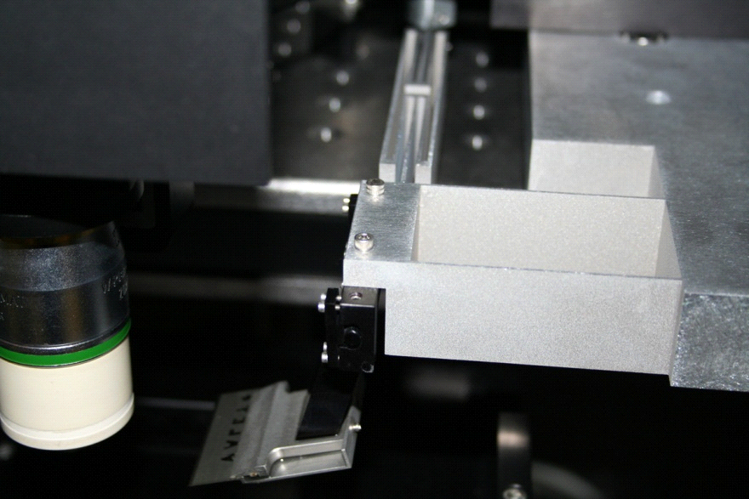
  - Remove the four ¼” screws (S) shown in figure below. The bearing assembly comes off.
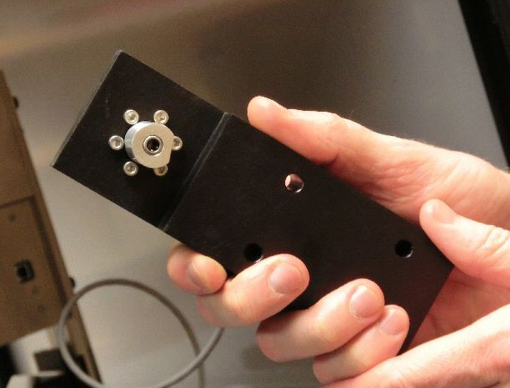

  - If you want to replace the whole bearing assembly, put the new bearing assembly in the place of the old one, and put the four screws back on. Tighten the screws securely using a hex key.
  - If you want to replace just the bearing part of the assembly, follow this procedure.
    - Remove the cam shaft from the bottom of the motor by unscrewing the small set screw (SS) using the .05” hex key.
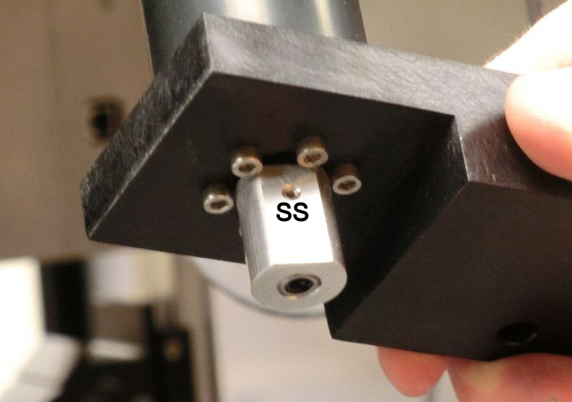
    - Remove the bearing from the center of the cam shaft, and replace it with a new bearing. Make sure that the orientation matches the previous bearing, and that it is inserted fully into the cam shaft.
    - Tighten the small set screw (SS). Replace the cam shaft onto the DC motor assembly. Make sure the cam shaft is inserted the same distance as it was previously.
    - Carefully replace the DC motor assembly onto the end of the metal vibratome assembly, being sure to not bend the delicate metal assembly which connects to the end of the vibratome. Replace the four ¼” screws.
  - Re-install the vibratome arm.
  - Reconnect the cables.

- Maintenance of the X and Y Positioning Stages:
  - The sample sits on a positioning stage with two perpendicular horizontal motion controls. The X (sideways) motion module sits at the bottom and the Y (front/back) module sits on the top.
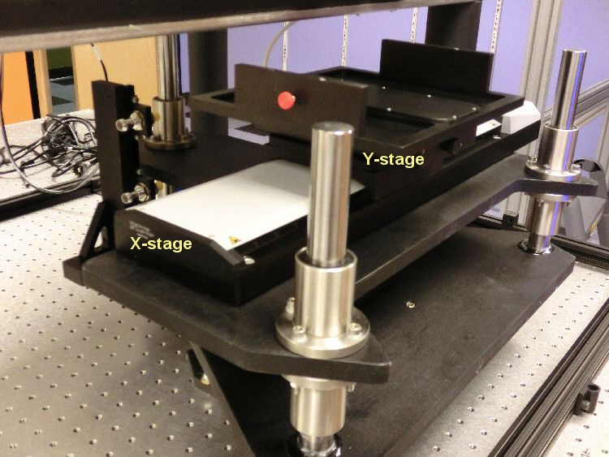

  - For normal operations, the stages do not require any maintenance. They have been treated with permanent lubricants, and no additional lubrication should be necessary.
    - After years of regular use, some stages have required the application of grease to the lead screw inside the stage. When doing this, take care not to get grease onto the encoder plate at the bottom of the assembly.
  - The z stage shafts also have long life lubricant on them and will not need further lubrication.
  - The X and Y stages are connected to the respective motor controllers (Mercury C-863 DC Motor Controllers) located on the controller board on the equipment rack.
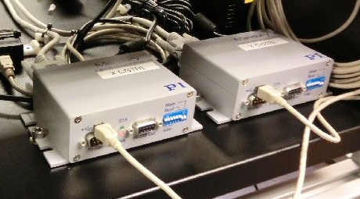

  - In case of failure of either X or Y stage, first check if the controller power supply (PI C890.PS) is malfunctional by checking its power output using a voltmeter. If so, request a replacement power supply to be shipped.
  - If the controller power supply is okay, then swap the X and Y controllers (which are identical) to check if the problem is with the controller. If so, ship the defective controller to TissueVision for a replacement.
  - If not, then the issue is with the stage (X stage or Y stage). Pack the respective stage carefully, preferably in anti-static packing, double-boxed and well-cushioned for extra protection. Make sure that the stage lays horizontally in the packing. Ship it to TissueVision for repair or replacement.
  - When reconnecting the cables to the stages (particularly the Y stage), make sure that the cable has enough flex for travel of the stages.
  - The stage controllers sometime cease to work (for example, following a power outage). In that case, you will have to re-initialize them with the following procedure.
    - If the top LED is red (which happens every time power is lost), reinitialize the controller through software.
    - If both top and bottom LEDs are red, disconnect the power cable from the controller, wait for 10 seconds, and connect it back again. Then it will come up only the top LED red, which can be fixed by reinitializing through software.

- Workstation Failure:
  - The workstation come in two parts, the Master and the Slave. If there is a software or hard drive failure on either of the workstations, request a new configured hard drive to be shipped. Note that the HD for Master and Slave unit are different.
  - Allow enough airflow around the workstations. Check if the fans are operational when the power is switched on.
  - If one of the workstations fails, request a new workstation to be shipped. While waiting for the new computer, call TissueCyte about the problem. The Master workstation has two cards in it. They have certain amount of redundancy so that even if one card goes bad, you may be able to access some functionality by swapping cards.

- Photomultiplier Tube (PMT) Failure:
  - Each TissueCyte system has a set of three photomultiplier tube assemblies for three different colors. They are enclosed in aluminum casings.
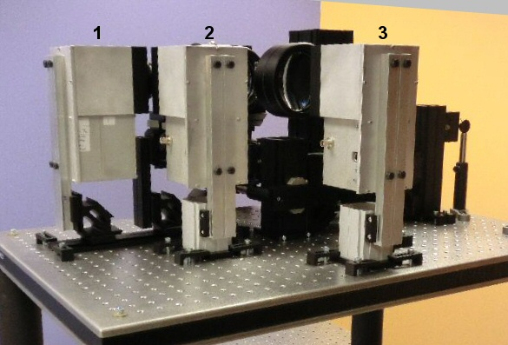

  - All PMT assemblies are identical and can be swapped if needed. Each PMT assembly has two connectors coming out from it (1) Standard USB connector cable that goes in the port U. (2) Yellow (TRIAX) cable that goes in the port T. These are fragile. Try to reduce the mechanical stress as much as possible when installing this cable.
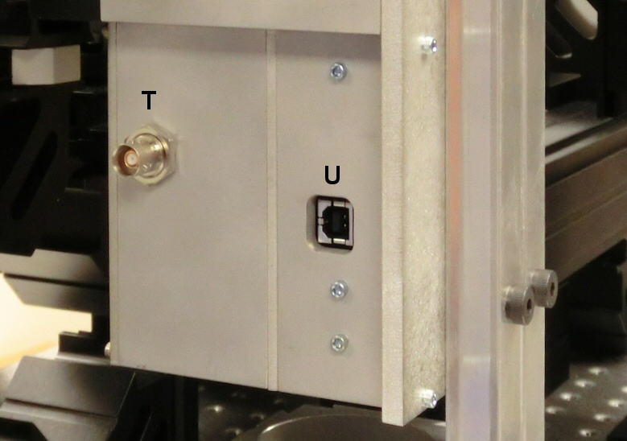

  - Pack the defective PMT module carefully (double boxed with ample cushioning) and ship it back to TissueVision.

- Dusting:
  - For cleaning the dust of various surfaces on and near the optics, use bulb blowers only.
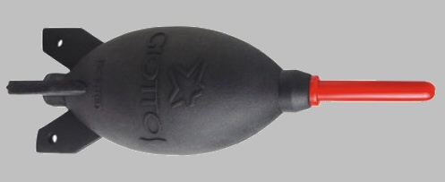
  - Do not use pressurized canned air, and also avoid using any kind of chemicals as cleaning solutions.
  - Always wear gloves while cleaning/dusting.

- Air Table:
  - The air table should be floating at all times of TissueCyte operation. You can make sure that the table is floating by pressing down lightly on the four corners of the table, one at a time.
  - If you find any of the corners not floating, adjust the floating lever of that corner (attached to the leg) to make it float.
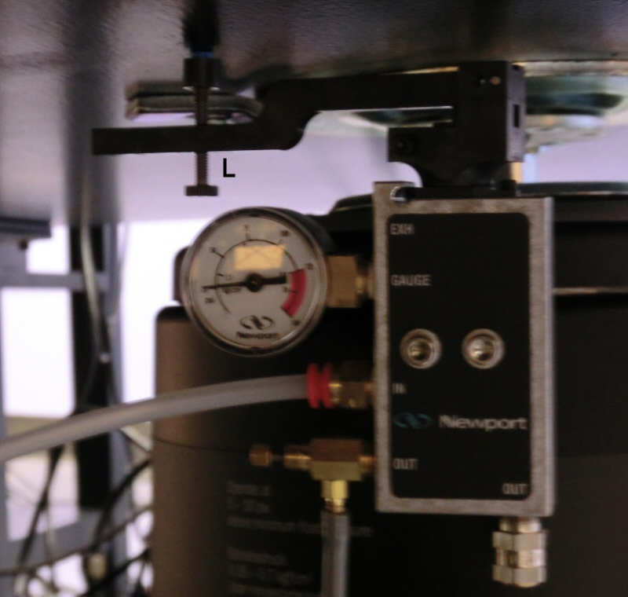

  - To ensure of proper damping when the table is disturbed, make sure that the pressure is set at approximately 30 PSI. Check the pressure regulator (usually on the floor under the table), and adjust the pressure using knob K if necessary. If the pressure is set too high, the table will go into oscillation when disturbed, which is not desired.
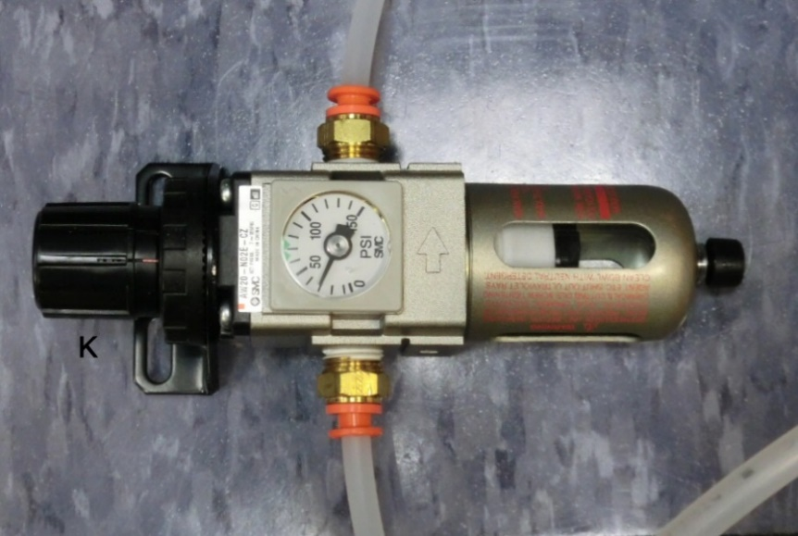
  - Make sure that the angle bar of the electronics rack is not touching the bottom of the table at the point P. There should be at least 1 inch gap between those two.
