Title: | BFI Software Operation
TPWI Doc Number: | TPWI-11
Applies To: | Slice Preps with BFIs

- Supplies:
  - Computer with BFI program installed
  - Compresstome (Precisionary Instruments VF-300) with attached camera
- Procedure:
    - Open the BFI program
    - Prior to slicing, enter username and ID number for the specimen being sliced. Enter date sliced and ACSF dates (where applicable).
    - After slicing and mounting the tissue, enter time sacrificed and dissection complete times in the BFI program.
    - Press the arrow button to the right of the screen to go to the live camera view.
    - When you are ready to begin taking pictures, press F1, the space bar, or the camera button to the right of the screen. The captured image will appear on the bottom portion of the screen. See Figure 1.
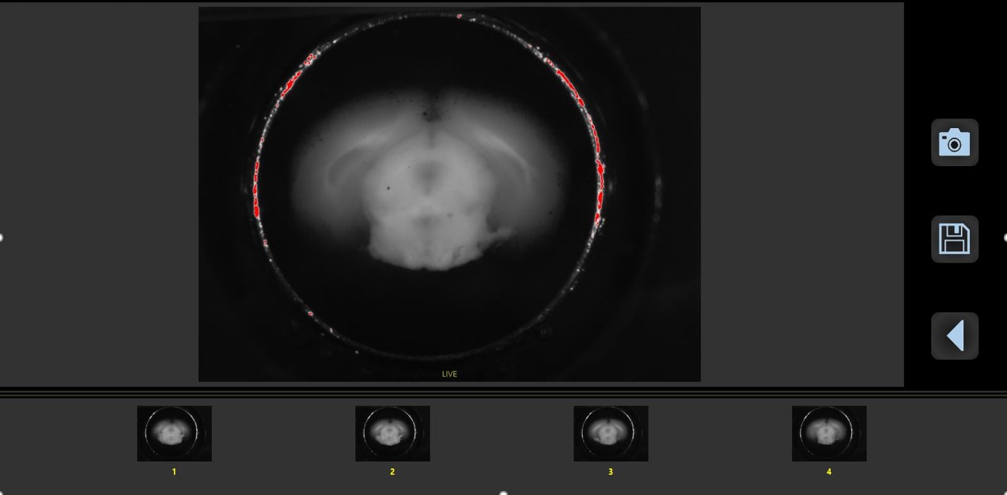Figure 1. Example of images captured

    - Pictures will begin on 1 and can be deleted by hovering over the icon picture and pressing the red X. You will need to confirm before you can delete a photo.
    - Hovering over a captured image will cause it to appear on the screen. The live feed can still be seen in the upper right corner.
    - Once all images have been captured, press the arrow button on the right side of the screen to fill out slicing complete and incubation complete times.
    - To save, return to the live image screen and press the save button on the right side of the screen.
    - All slicing information will be automatically saved to a CSV file and can be used for reference at any time.

