Multi-Patch Clamp Recording

- Scope and Applicability: Process to obtain multiple electrophysiological recordings from postnatal mouse and/or human brain slices.

- Materials:
  - #4 Paintbrush (Ted Pella 11862)
  - 1.7 ml Microfuge tubes (Olympus Plastics 224-282)
  - 70% EtOH
  - 20 µl microloader (Eppendorf 930001007)
  - ACSF.IX (SOP RP0233)
  - Internal solution (SOP RP0234)
  - Forceps (Roboz RS-5045)
  - Oxygen diffuser (Sigma 59277)
  - Mouse brain slices in ACSF.IV (SOP AF0099)
  - Pasteur Pipette (BD Falcon 357575), tip cut off
  - 1 ml syringe (BD 329654)
  - PTFE 0.22 µl syringe filter (Tisch Scientific SF17504)
  - 28 gauge MicroFil tip (WPI MF28G67-5)
  - Alexa Fluor 488 Hydrazide (Thermo Fisher Scientific A10436)
  - Cascade Blue Hydrazide, Trisodium salt (Thermo Fisher Scientific C687)
- Equipment:
  - Octo-patch Electrophysiology Rig
  - Cooler (VWR 80086-962)
- Safety:
  - Nitrile Gloves (for human tissue)
  - Eye protection (for human tissue)
  - Lab coat (for human tissue)
- Output:
  - Multiple electrophysiology recordings from brain slices in pxp and NWB (Igor packed experiment) files.
- Reference Documents:
  - AF0099 Slice Preparation and Blockface Imaging for Electrophysiology - Mouse
    - https://www.protocols.io/view/slice-preparation-and-blockface-imaging-for-electr-bdpqi5mw/abstract
  - PF0285 DAB Detection of Biocytin Labeled Tissue
    - https://www.protocols.io/view/dab-detection-of-biocytin-labeled-tissue-bdpji5kn/abstract
  - PF0289 Post Patch Clamp Slice Fixation
    - https://www.protocols.io/view/post-patch-clamp-slice-fixation-bdpii5ke/abstract
  - PF0299 Pulling Pipettes using the DMZ-Zeitz Universal
    - https://www.protocols.io/view/pulling-pipettes-using-the-dmz-zeitz-universal-bepzjdp6/abstract
  - PF0295 Human Neurosurgical Tissue Processing
    - https://www.protocols.io/view/human-neurosurgical-tissue-processing-bdvki64w/abstract
  - RP0233 ACSF.IX
    - https://www.protocols.io/view/artificial-cerebrospinal-fluid-ix-acsf-ix-beppjdmn/abstract
  - RP0234 Electrode Internal Solution with Biocytin II
    - https://www.protocols.io/view/electrode-internal-solution-with-biocytin-ii-bepnjdme/abstract

Warning: Personal Protective Equipment (PPE) should be used at all times while operating this protocol. If you are unsure what PPE you should be using, see your immediate supervisor.

- Setup:
  - Make ACSF.IX using SOP RP0233
    - Bubble ACSF at the rig with 95% Carbogen.
    - Start running MilliQ water or ACSF through tubing to chamber at least 30 minutes prior to recording.
    - Place harp in chamber and dip 40x objective into running solution to clean.
  - Pull glass pipettes according to SOP PF0299 to be used as electrodes. Pipettes should have a tip resistance between 3-6 MΩ.
  - Turn on cooler set to 4°C.
    - Retrieve an aliquot of internal solution (SOP RP0234) and appropriate dye from freezer and place in cooler once it has reached temperature.
      - For single transgenic specimens, use Alexa Fluor 488 dye.
      - For quadruple transgenic specimens, use Cascade Blue.
      - For Human tissue slices, use Neurobiotin 488.
    - Once internal solution and dye are thawed, mix 5 µl of dye into the internal solution, vortex to thoroughly incorporate.
    - Load the mixed solution into a 1 ml syringe.
    - Cap with filter and MicroFil, place in cooler.
  - Obtain tissue slices using SOP AF0099 Slice Preparation and Blockface Imaging for Electrophysiology – Mouse or SOP PF0295 Human Neurosurgical Tissue Processing.
  - Mouse tissue should incubate in ACSF.IV solution for at least 1 hour after slicing, but no more than 5 hours. Human tissue should incubate in ACSF.IV solution for at least 1 hour and can incubate indefinitely.
  - Perform any other regular maintenance items following the MultiPatch Maintenance document (Appendix 10.6)
  - Open IgorPro-64bit and run MultiPatch Configuration.
  - Open ACQ4 Manager and load Data Manager, Camera, and Multipatch modules (Figure 1).
    - In the Data Manager create a new ‘Day’.
    - Record relevant experiment meta-data retrieved from your Laboratory Information Management System.
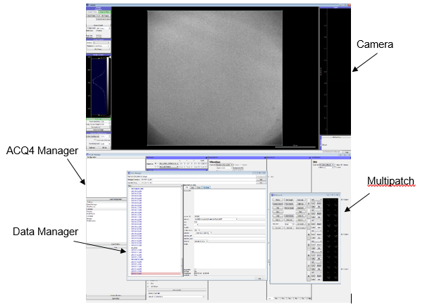
Figure 1. ACQ4 Manager and submodules

    - Turn on headstages to be used for experiment using the Control Pad (Figure 2).
      - The Control Pad (via the Multipatch Module) is one of the main interfaces for programmatically controlling pipette position and associated electrophysiology properties in MIES such as pressure.
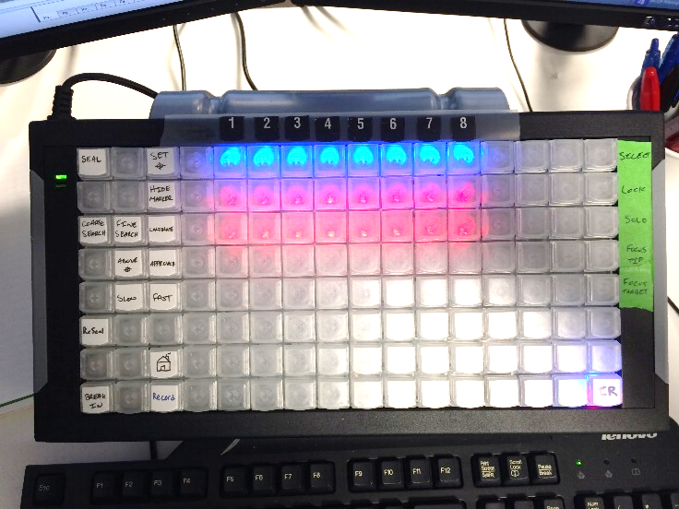
Figure 2. Multipatch Control Pad with headstages 1-8 selected
- Methodology/Procedures:
  - Loading a Slice: Follow instructions in ‘Loading a Slice’ Workflow (Appendix 10.2).
    - Turn on heater and allow bath to come to temperature.
    - Load slice on stage with Pasteur pipette.
      - Gently position the tissue in the center of the recording chamber using a paintbrush.
    - Use forceps to set the harp across the slice.
    - Acquire a mosaic image of the entire slice under 4x and then position the field of view over area of interest
    - Switch to 40x objective and dip into chamber
    - Focus onto the surface of the slice
    - Collect and subtract background
    - Assess slice quality and health (Table 1)

Value | Description of slice
1 | bad | Few or no healthy-looking cells, high slice edema.
2 | so-so | Some cells look good, apical dendrites not parallel to surface, medium-low cell density. Often L2/3 looks very swollen.
3 | good | Most cells look soft and plump (excluding shallow cells < 30 µm), apical dendrites nearly parallel to surface, medium cell density. Some cells look patchable deeper in L2/3.
4 | really good | Lots of nice looking cells, good apical dendrite alignment, medium-high cell density, and plenty of nice looking cells in L2/3 (although shallow cells < 30 µm may look shriveled)
5 | really really good | Cells look excellent, dendrites perfectly aligned, very high cell density in all layers (usually only seen in very young animals).
Table 1: Slice Quality Scale

Preparing Pipettes: Follow instructions on ‘Preparing Pipettes’ (Appendix 10.4)
    - Fill eight pipettes with internal solution up to or just past the shoulder (Figure 3 and 4)

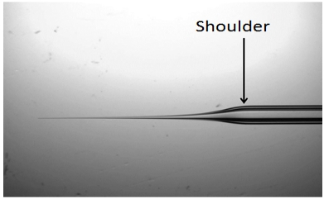
Figure 3. Shoulder of pipette

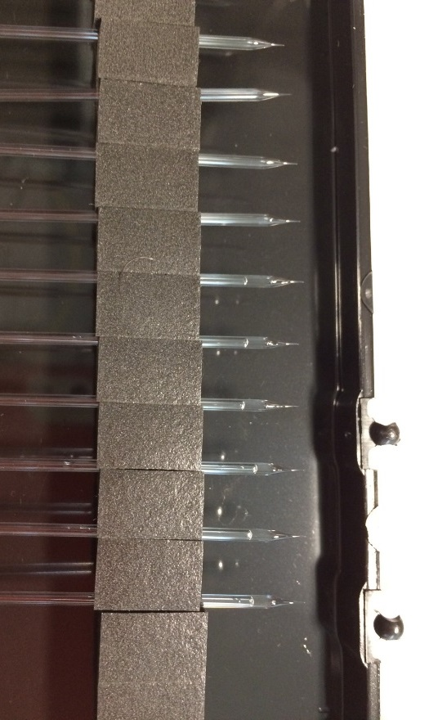
Figure 4. Eight filled pipettes

    - Load pipettes into headstages.
      - Carefully slide the glass pipette onto the silver wire and then tighten the holding screw.
      - Secure cross-talk shield in place alongside pipette.
      - Lower towards chamber.
    - Calibrate pipette positions under 4x magnification.
  - Selecting Cell Targets: Follow instructions on ‘Selecting Cell Targets’ (Appendix 10.3).
    - Switch to 40x objective and dip.
    - Find a region within the ROI with patchable cells appropriate for the experiment.
      - Use fluorescent reporters to target cell-types of interest.
    - Set the surface of the slice.
      - Try to find health cells at least >= 40 µm below the surface.
    - Use control pad to select up to 8 cells in a reasonable spatial arrangement.
  - Patching Cells: Follow instructions on ‘Patching Cells’ (Appendix 10.4).
    - Using the Multipatch Control Pad:
      - Select the pipette to be used for the current cell target.
      - Use Approach mode to apply positive pressure and bring pipette into the bath above the slice.
      - Re-calibrate position if necessary.
      - Look for evidence of positive pressure and ensure that the pipette tip is intact and of appropriate resistance (3-6 MΩ).
        - Retract the pipette and move to the next cell if the above are not met.
      - Send the pipette on an approach path to the cell target.
    - Switch pipette control to the native headstage control pad.
      - Use the X-axis turn dial in Approach mode to bring the pipette into the slice.
      - Being careful to avoid other cells, vessels, etc. in the slice continue to advance the pipette towards the target cell.
        - You may reconfirm the cell you are targeting by checking fluorescent expression and adjust as necessary.
    - When the tip of the pipette is on the cell and a dimple is beginning to form on the surface (Figure 5) enter Seal mode (Figure 6).
      - Seal mode releases positive pressure and either:
        - Begins an automatic negative pressure program within MIES.
        - Turns pressure control over to the user. In this case begin applying negative pressure to form a seal.

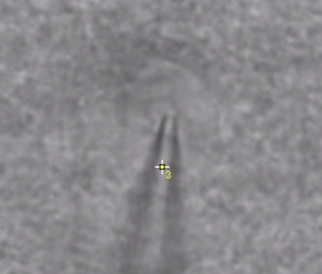
Figure 5: Targeted cell with dimple forming on surface

.
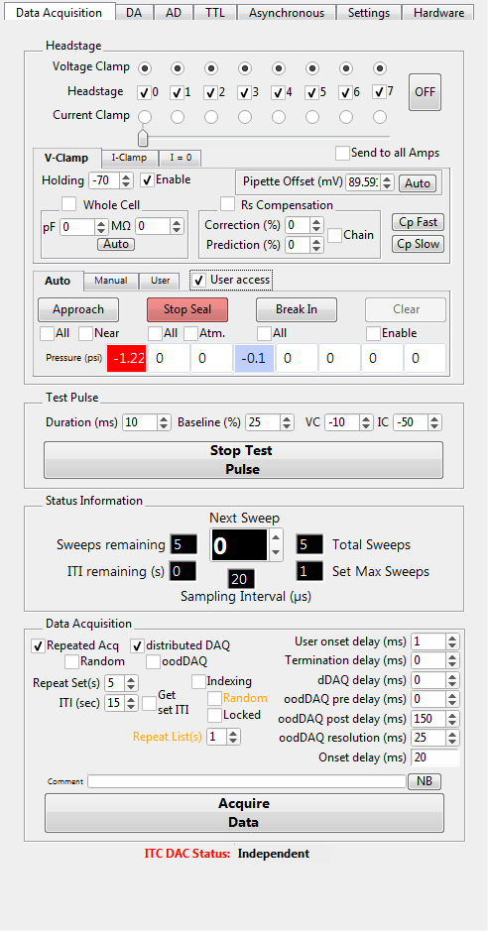
Figure 6: MIES DA_Ephys panel showing Seal mode selected. Headstage 0 is in User Seal mode (red), while headstage 4 is in Auto Seal mode (blue).

    - Continue to apply negative pressure until a 1 GΩ seal (giga-seal) is produced.
    - If a giga-seal is obtained, lock the pipette using the Multipatch Control Pad.
    - If a giga-seal is not obtained:
      - A viable loose seal (< 1 GΩ) may be obtained and you may keep the cell to observe if conditions improve.
      - The cell may spontaneously break in, again you may keep the cell and observe if conditions improve.
      - The cell will not be a viable recording and in this case de-select the headstage on the Multipatch Control Pad.
    - Repeat this procedure for all remaining pipettes.
    - If at least 2 pipettes form successful giga-seals or viable recordings continue the experiment, otherwise retract pipettes and either choose new targets within the same slice or use a new slice
  - Recording from multiple cells: Follow instructions on ‘Recording and Stimulation Protocol’ (Appendix 10.5).
    - After attempting to seal on all selected pipettes, return to those that still have a giga-seal and break into the cell.
      - This may be done with the Auto Break In or with User mode similar to sealing.
    - A successful break in will show little DC offset and low access resistance (Figure 7)
      - In Figure 7 AD 3, 8, 9, and 11 are examples of good recordings with little offset and good access resistance noted in green.
      - AD 1 is a moderate recording, there is some offset and access resistance is higher (55.2 MΩ). It is possible that slight repositioning of the pipette or negative pressure pulses could improve this recording.
      - AD 10 is a bad recording. There is greater offset and access is very high.
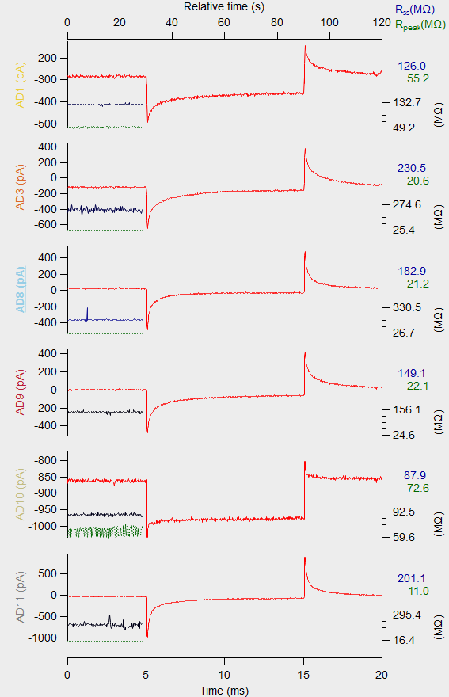
Figure 7: Example of 6 cells being recorded simultaneously

    - If you have obtained a recording of at least 2 cells continue with the Recording and Stimulation Protocol.
      - Concurrently obtain image stacks under IR, fluorescent cell reporter channels, and fluorescent pipette fill channel.
    - Once the necessary data is obtained or if cell health deteriorates end the experiment by slowly pulling off of the cells.
      - Using the Multipatch Control Pad turn back on any headstages that were turned off during patching.
      - Unlock any locked headstages.
      - With all headstages selected, retract pipettes and reseal if possible.
    - Once all of the headstages are well above the surface of the slice, turn off any holding currents and apply positive pressure until seal blows out.
      - Measure pipette drift.
    - Switch back to 4x objective.
  - Transfer slice to histology well plate with 4% PFA/2% glutaraldehyde following Post Patch Clamp Slice Fixation in PFA (PF0289).
    - Label well plate cover following multi_YYYYMMDD _21_A01
      - Well plates start at #21 and may increase when plate is filled.
      - A01 is the plate row and column respectively, change appropriately.
- Take Down:
  - Remove used pipettes from headstages and discard in sharps container.
  - Turn off heater and light sources.
  - Place bubbler and solution line into bottle of MilliQ water.
    - Place harp in chamber and dip 40x objective.
    - Allow water to flush through chamber for at least 10 minutes.
  - Discard of ACSF.IX down the drain and rinse bottle with MilliQ water.
  - Remove bubbler and solution line from water bottle.
  - Turn off pump and open.
  - Dispense 70% EtOH into chamber and allow to run through the line.
  - Turn off Carbogen airflow.

- Appendix:
  - MultiPatch Workflow
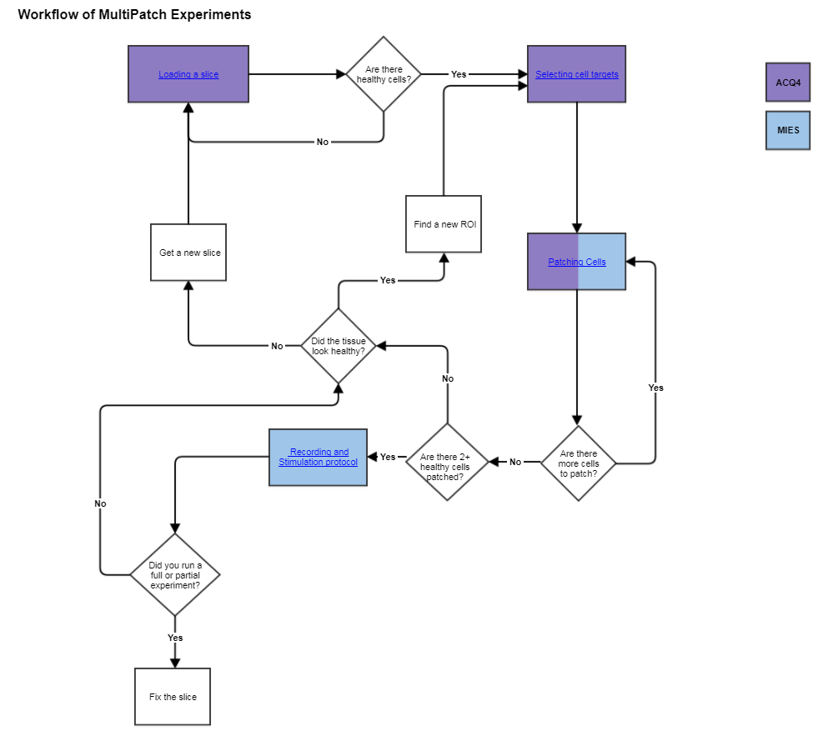

  - Loading a slice
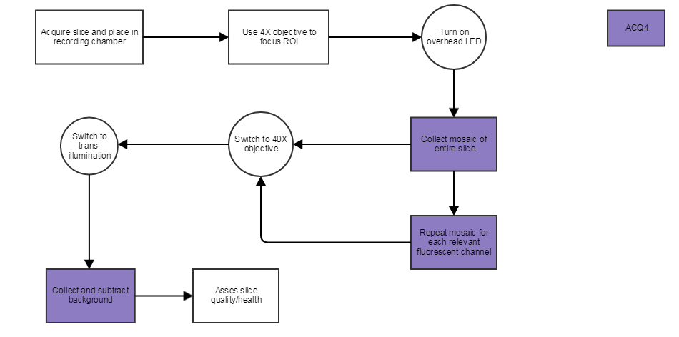

  - Selecting cell targets
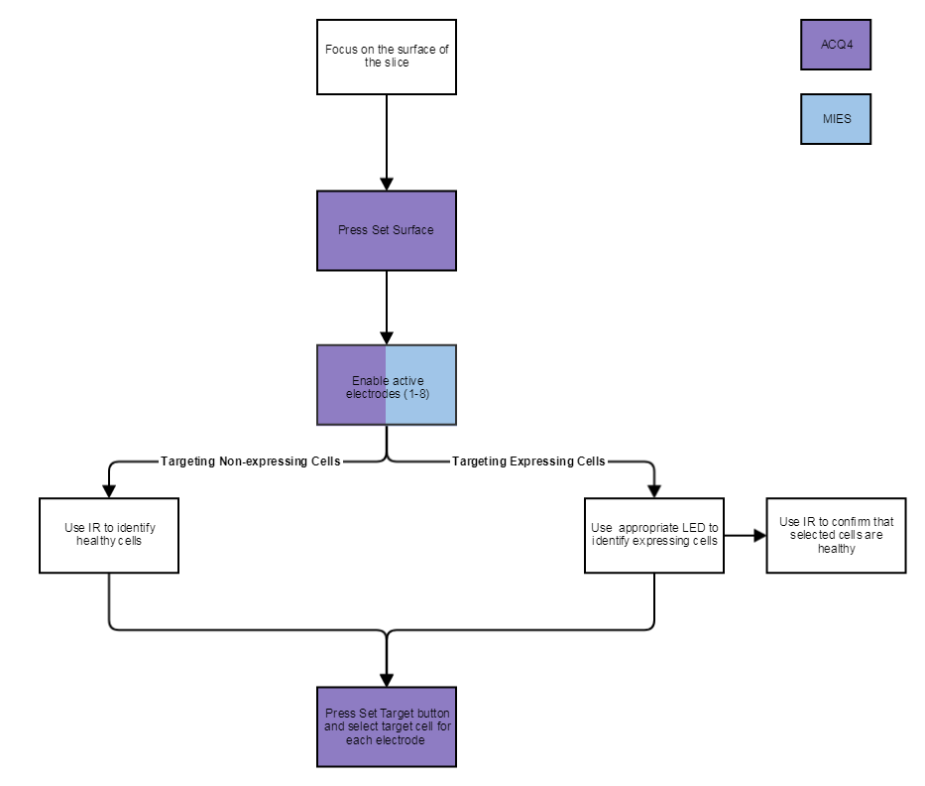

  - Patching Cells
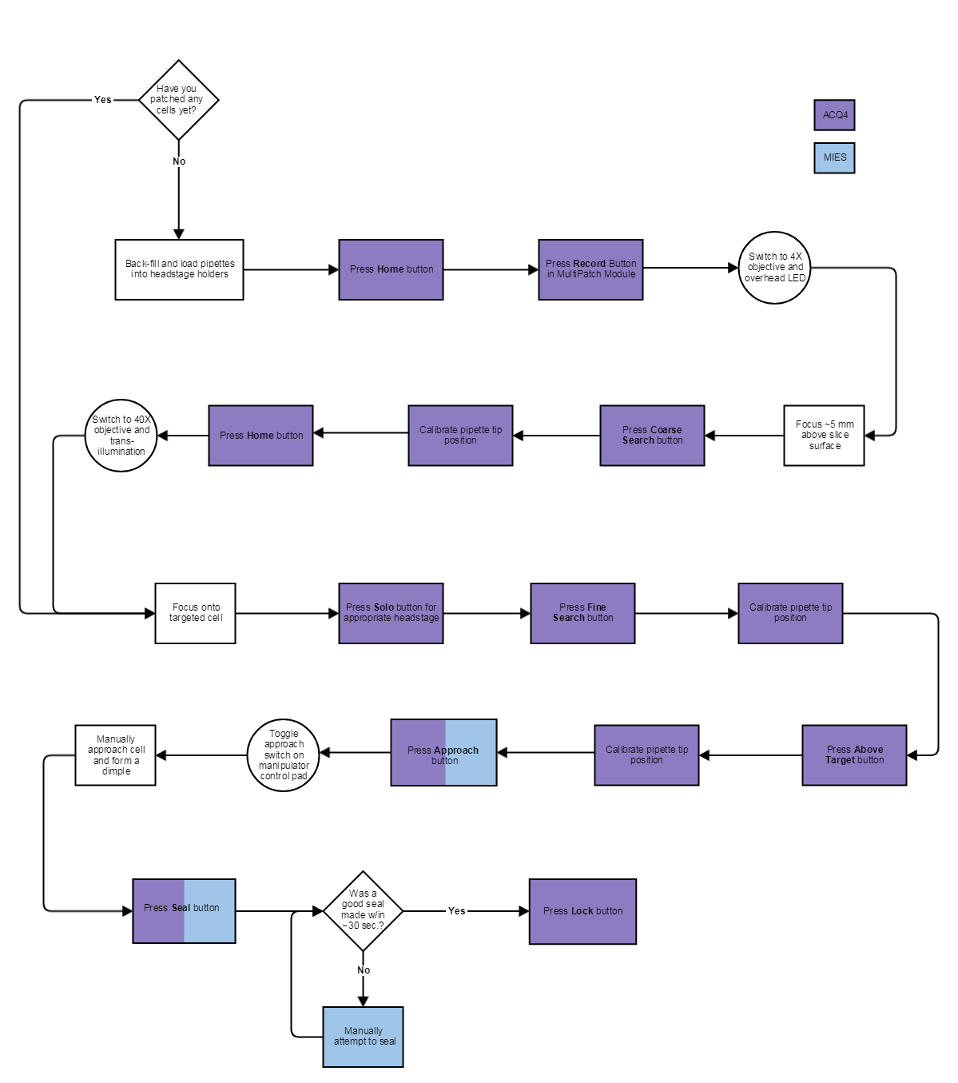

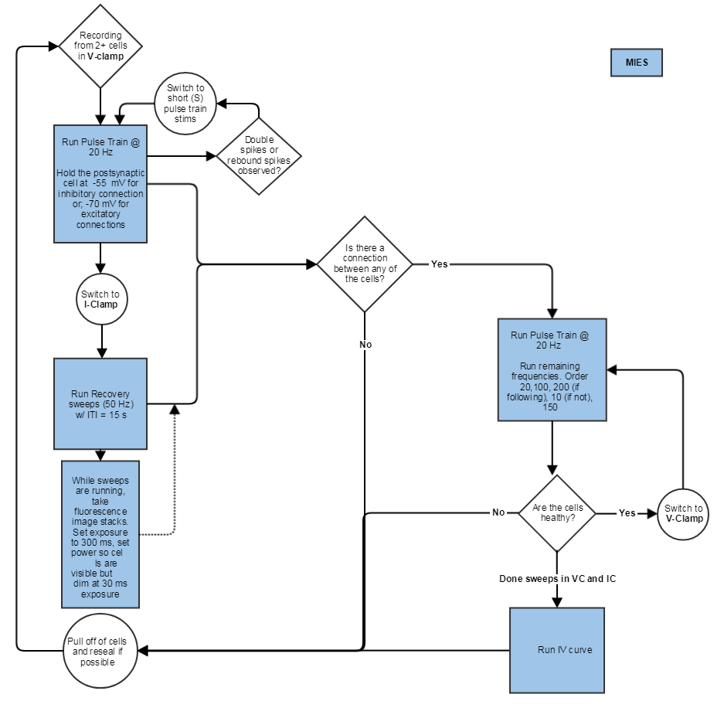
  - Recording and Stimulation Protocol

  - Multipatch Maintenance:
    - Weekly Maintenance:

    - Monthly Maintenance:

