HT-031: Mantis Chip Cleaning
- Prepare 70% EtOH
  - Prepare 100 mL of 70% EtOH in a 250 mL reagent bottle (MADE WEEKLY).
  - Remove the “WASH” tube from Wash Station 1 (right side) and discard the leftover EtOH.
  - Rinse the wash tube by spraying with RNAse away and 70% EtOH, then move the tube to Wash Station 2.
  - Remove the “WASH” tube from Wash Station 2 (left side) and replace with the tube taken from Wash Station 1.
  - Transfer 4ml to the “WASH” tube taken from Wash Station 2. Place the tube in Wash Station 1, making sure that the line feeds to the bottom of the tube.

- Load MANTIS wash protocol
- Prime water through the chips
  - Load the used TD chip with a new 1000uL tip that contains 150 uL of NFdH₂O. Load the other used chips (ATM, NT, NPM) with new 200 uL tips containing 150 uL of NFdH₂O.
  - Select a chip by clicking on the input number associated with the chip. The input number will be highlighted in grey to signify that it has been selected and the MANTIS will pick up the chip.
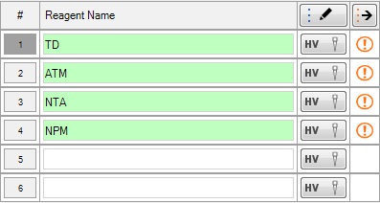
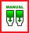
  - Manually prime each chip by holding down the “Manual Prime” button until all the NFdH₂O has run through the chip. Discard the tips once the chip has finished priming.
“Manual Prime” button:

- Wash chips with 70% EtOH
  - Load each chip with an empty 1000 uL tip.
  - Click on the “Wash All Inputs” button to begin flushing each chip with 70% EtOH. The empty tips will begin to fill up with the 70% EtOH from Wash Station 1, carefully discard the tips once the chips are detached from the Mantis.
  - Repeat the wash at least once with new tips each time.


“Wash All Inputs” button:

- Dry chips out
  - Manually prime each chip by holding down the “Manual Prime” button until all the 70% EtOH has run through the chip.
  - Carefully remove the chips from the magnetic chip pallets and place the chip in the designated falcon tube (without the cap on) to dry. It is best to gently apply pressure under the chip in order to remove them from the chip pallets, but it is important to avoid touching the nozzle of the chips.
  - Leave caps off of falcon tubes
  - Clean each magnetic chip pallet with 70% EtOH and Kimwipes.

- Clean chip port stations
  - Wipe down the inside of each chip port station with 70% EtOH and Kimwipes/cotton tipped applicators.

- Empty the waste tube
  - Empty the waste tube from the Waste Station.
  - Rinse the waste tube by spraying with RNAse away and 70% EtOH, then return the tube to the Waste Station.

