Nextera XT at 0.2X On the Mantis

- Scope and Applicability: Generate Nextera libraries using 0.2x reagents in a 96-well PCR plate using the Formulatrix Mantis instrument.

- Materials:
  - Library Tagmentation and PCR
    - Associated Library paperwork
    - 96-well plate with normalized cDNA at 50 pg/µL (Stored at 4ºC)
    - Library plate labels
    - 5x Eppendorf twin.tec® 96-well PCR Plates (VWR 47744-106)
    - Filtered pipette tips (GP-L200F, GP-L1000F)
    - Nextera XT DNA Sample Preparation Kit for 96 Samples (Illumina FC-131-1096)
    - Tagment DNA Buffer (TD) (15027866)
    - Amplicon Tagmentation Mix (ATM) (15031561)
    - Nextera PCR Master Mix (NPM) (15027920)
    - Neutralize Tagment Buffer (NT) (15031559)
    - Microseal ‘B’ Adhesive seal (BioRad MSB1001)
    - VWR Aluminum Foil seals for PCR, Sterile (VWR 60941-076)
    - Index primers combined at 2.5 µM each in 96 well plate format.
    - Small Kimwipes (VWR 21905-026)
  - Bead Purification of Library PCR product
    - Associated Library paperwork
    - MANTIS Plate (Library NTA) in Eppendorf twin.tec® 96 well PCR plate
    - Nuclease-Free Water (ThermoFisher AM9932)
    - Reservoir, 25 mL divided (VWR 41428-958)
    - Eppendorf twin.tec® 96 well PCR plates (VWR 47744-106)
    - AMPure XP Beads (Beckman Coulter A63882)
      - SeraMag Beads may be used as an alternative (Sera-Mag Select, GE Healthcare 29343057)
    - 1 mL Nunc Deep-well plates (VWR 73520-120)
    - Buffer EB (QIAGEN 19086)
    - 1.2 mL Square-well storage plate (Thermo Scientific AB-1127)
    - 100% ABS Grade Ethanol, pint (AAPER/Pharmco E200G-P)
    - 500 mL Reagent Bottles (VWR 28199-760)
    - 2 ml deep well sterile plate (VWR 10755-250)
    - Printed labels for Elution/Collection Plate, PicoGreen plate, and FA plate
    - Axygen Velocity 165 µL Filtered Bravo Tips (Axygen VTF-165-R-S)
    - Rainin 200 µL filtered pipette tips (GP-L200F)
    - 50 mL disposable serological pipet (VWR 53106-441)
    - FA marker plate ready for sample addition. (4°C)
    - 12.5 µL Filtered Integra GripTips (Integra 6455)

- Equipment:
  - Library Tagmentation and PCR
    - Formulatrix Mantis in a Pre-AMP PCR Clean Hood
    - Five Formulatrix molecular grade IMS (Injection Molded Silicone) chips for Mantis instrument (Formulatrix 233580) - replaces discontinued original Mantis chip (PN MCHSVM96)
    - Pre-AMP Ice pan
    - C1000 Thermocycler
    - Pre-AMP Integra-384 in a Pre-AMP PCR Clean Hood
    - Integra aluminum PCR blocks (room temp)
    - Integra aluminum PCR blocks x 2 (-20°C)
    - Aluminum 2 mL microtube rack x 2
    - Swing-bucket Pre-AMP Centrifuge
    - Pre-AMP hood minifuge
    - Pre-AMP hood Vortex Mixer
    - Lab Timer
    - P1000 and P200 single-channel pipettes
    - Plate Vortex Mixer
    - Plate sealer with heat sealing aluminum film for long-term cold storage
    - Plastic plate seal paddle
  - Bead Purification of Library PCR product
    - Pre-AMP Rainin E4-XLS+ 8-channel Electronic P200 Pipette (Rainin E8-200XLS+)
    - Hirschmann Pipetus serological pipette
    - Rainin P20 8-channel pipette (Rainin L8-20XLS+)
    - Pre-AMP PCR clean hood
    - Post-AMP PCR clean hood
    - Plate sealer with aluminum seals for long-term cold storage
    - VWR plate spinner (VWR 89184-608)
    - VWR Vortex Mixer
    - Agilent Technologies BRAVO Liquid Handling Robot in Post-AMP dead air box
    - Post-AMP Integra ViaFLO 384 Liquid Handler in Post-AMP hood
    - Post-AMP designated Integra 96-well aluminum blocks
    - Disposable Integra tip receptacles
    - 2x Agilent red aluminum inserts
    - Pre-AMP designated swing bucket centrifuge
    - Post-AMP designated swing bucket centrifuge
    - Working 4ºC Refrigerator for short term storage
    - 250 ml glass graduated cylinder for Ethanol use only

- Safety:
  - Nitrile Gloves
  - Eye protection
  - Lab coat
  - Disposable sleeves

Warning: Personal Protective Equipment (PPE) should be used at all times while operating this protocol. If you are unsure what PPE you should be using, see your immediate supervisor.

- Output:
  - Libraries ready for Illumina sequencing generated from single-cell amplified cDNA.

- Reference Documents:
  - HT-031: Mantis Chip Cleaning
  - HT-043: How to Clean Hoods—Daily and Deep-clean methods

- Setup:
  - Check out the Nextera XT kit (Illumina 15032354) along with the Index sets for each library from the Excel tracking document on SharePoint, recording the date and Library IDs.
    - Record the kit ID#s and Index set information on the library paperwork.
  - Fill the Pre-AMP ice pan with ice, place it inside the Pre-AMP hood, and place one of the aluminum 2 mL microtube blocks onto the ice to cool.
  - Bring the checked-out kit over to the hood and remove the Tagment DNA Buffer (TD) (15027866) tubes to thaw by placing them in the room temperature aluminum 2 mL microtube block located in the Pre-AMP hood.
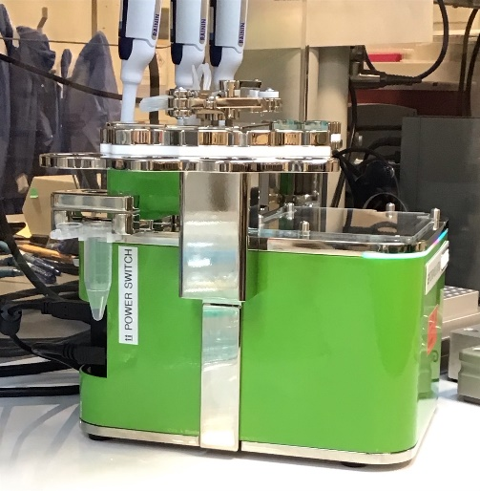
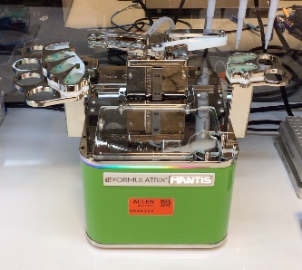
    - Move the tubes to the aluminum block in the ice tray after they thaw (~5 minutes).
  - Place both the Amplicon Tagmentation Mix (ATM) (15031561) and Nextera PCR Master Mix (NPM) (15027920) onto the aluminum 2 mL microtube rack in the ice tray.
    - The remaining reagents are not used for this protocol and may safely be thrown away.
  - Neutralize Tagment Buffer (NT) (15031559) is stored at room temperature fiberboard box in the main lab and is not with the rest of the kit reagents. Bring one tube of this reagent to the Pre-AMP hood and leave it in the aluminum 2 mL microtube rack at room temperature.
  - Use the plate vortexer to briefly vortex both the normalized cDNA plates along with the IDT index primer plates (10s @ 1996 RPM).
  - Spin down the plates in the Swing-bucket Pre-AMP Centrifuge @ 1000 x g for 1 minute.
    - Bring the normalized cDNA and Index plates over to the Pre-AMP Integra hood.
  - Label the Eppendorf twin.tec® 96-well PCR plates using the printed labels for easy readability.
  - Power on the Mantis instrument.
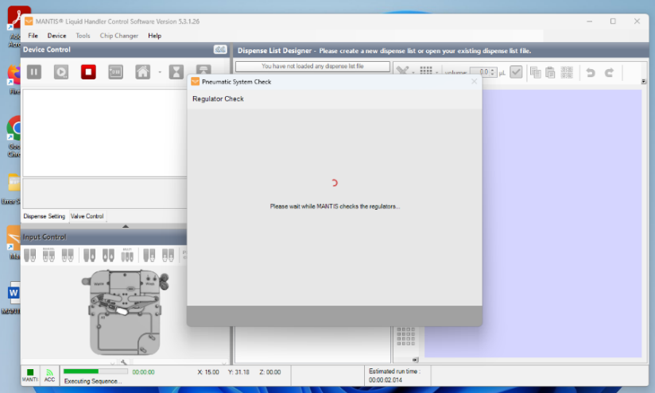
  - Start the Mantis control software and wait for the Mantis to initialize.

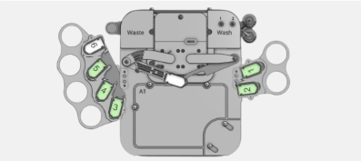
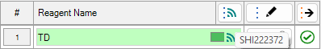
  - Load the five Mantis IMS reagent chips onto the instrument following the outline listed below:

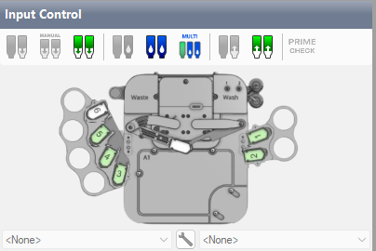


    - Each IMS Chip has an RFID scanned during initialization. IDs can be found etched on each chip or can be viewed by hovering the mouse pointer over the RFID icon  next to each chip’s name. Record these ID numbers next to their associated reagents on the Library paperwork’s coversheet.

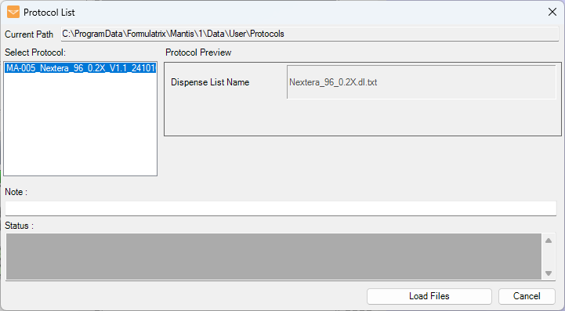
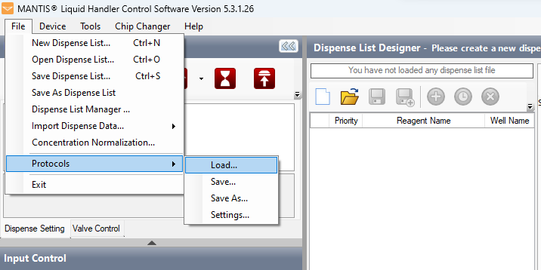
  - Load the MA-005_Nextera_96_.2X_V1.1_241011 protocol in the Mantis control software.

  - Load 150 µL of NFdH2O onto all five chips by using a P200 @ 150 µL, leaving the tips in each chip.
    - Make sure the chip surface has no residual fluid on it by gently wiping it with a small, clean Kimwipe (21905-026).
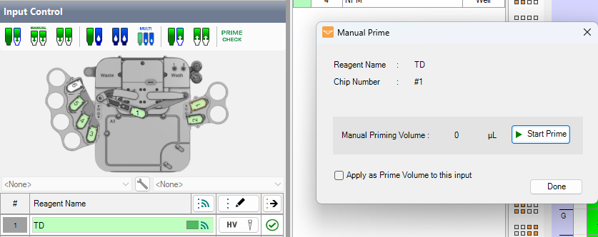
    - Prime the Chips: Click the number next to the chip, the “Manual Prime” button, then “Start Prime” to flush water completely through the chip.

      - Remove the tip and continue priming for 3 seconds after all the water has passed through the chip.
      - Repeat for all the chips and as necessary if prolonged periods of time have passed between chip use.

- Methodology/Procedures:
  - On the C1000 thermocycler, run program: (Tag4ul_mants) 55°C hold then 5 min -- 10°C for 10 min to pre-heat the block to 55°C.
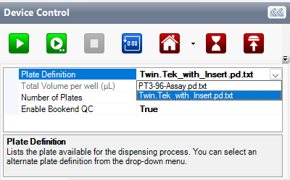
  - On the upper left corner, verify the plate definition is listed as “Twin.Tek_with_Insert” on the Mantis instrument.

    - Change it to this exact value from the pull-down menu if necessary.
  - Remove a pre-cooled Integra block from the 4°C and place it on the Mantis platform.
  - Place the labeled Eppendorf 96-well twin.tec® PCR plate onto the pre-cooled block on the Mantis. This is the Nextera XT Tagment Amplicon Plate or NTA.
  - Vortex the Tagment DNA Buffer (TD) (#15027866) on the Pre-AMP vortex genie using a speed of 9 for 10 pulses.
    - Spin down the tube using the Pre-AMP minifuge.
  - Use a P1000 @ 250 µL to load 250 µL of Tagment DNA Buffer (TD) (15027866) onto chip 1 (TD chip) on the Mantis.
  - Make sure the chip surface has no residual fluid on it by gently wiping it with a small, clean Kimwipe (21905-026).
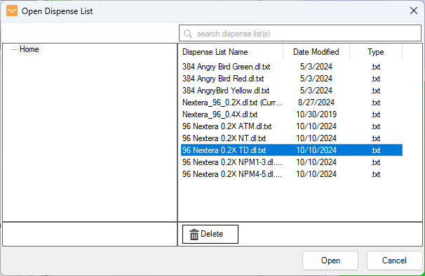
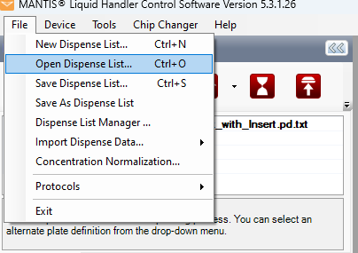
  - Load the “96 Nextera 0.2X TD” dispense list onto the Mantis.

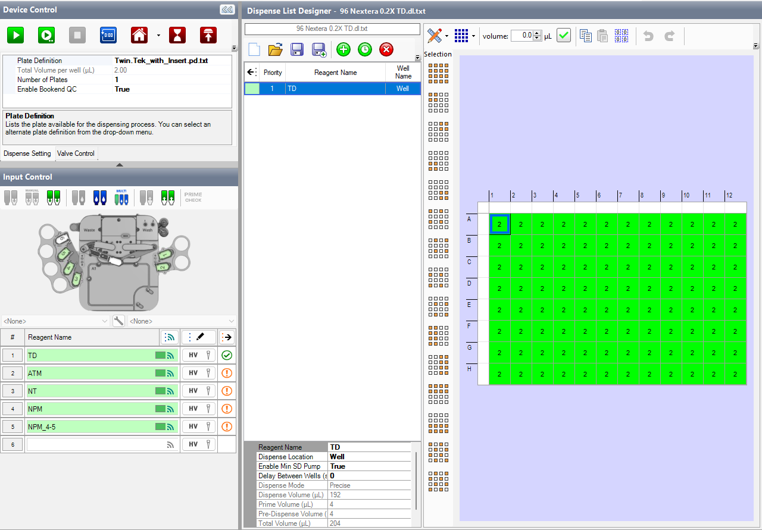
    - Verify the dispense volume (2.0 µL) and associated reagent chip are correct.
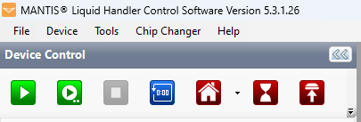
  - Press the green “Play” button on the upper left corner of the Mantis software to run the protocol.

    - Verify the chip passes droplet detection.
  - Visually confirm the volume was dispensed correctly by checking the bottom of the library plate for 2 µL in each well.
    - H12 is the most likely well to be short / missing volume so always check this well for proper liquid dispensing.
    - Check the dead volume remaining in the tip. Expected dead volumes (ul unused volume) are listed on the paperwork for each reagent.

  - Bring the library plate containing 2 µL of TD buffer over to the Pre-AMP Integra.
  - Place the Library plate onto deck position ‘B’ and the normalized cDNA plate onto deck position ‘AB’.
  - With a witness, verify the normalized AMP plate ID against the paperwork, along with additional verification of plate orientation and program.
  - Run the ‘cDNA ADD 1uL’ on the Integra to transfer 1 µL of normalized 50pg/µl cDNA to the library plate.
    - Verify the volume addition by visually checking the library plate, and tips on the Integra head, after this step.
  - Return the library plate to the pre-chilled Integra block on the Mantis platform.
  - Vortex the Amplicon Tagmentation Mix (ATM) (15031561) on the Pre-AMP vortex genie using a speed of 9 for 10 pulses.
    - Spin down the tube using the Pre-AMP minifuge.
  - Carefully load 130 µL of Amplicon Tagmentation Mix (ATM) (15031561) onto Chip 2 (ATM Chip) using a P200 @ 130 µL.
    - This reagent is viscous, so pipette slowly.
    - Make sure the chip surface has no residual fluid on it by gently wiping it with a small, clean Kimwipe (21905-026).
    - Double check the volume of ATM in the tip against the blue colored mockup tip in the hood.
  - Load the “96 Nextera 0.2X ATM” dispense list onto the Mantis.
    - Verify the dispense volume (1.0 µL) and associated reagent chip are correct.
  - Press the green “Play” button on the upper left corner of the Mantis software to run the protocol.
    - Verify the chip primes correctly passing droplet detection.
  - Visually confirm the volume was dispensed correctly by checking the bottom of the library plate paying special attention to H12.
    - Check the dead volume remaining in the tip. Expected dead volume should be listed on the paperwork.

  - Seal the library plate with BioRad Microseal ‘B’ using the plastic paddle.
  - Spin the library plate down in the Swing-bucket Pre-AMP Centrifuge at 1000 x g for 1 minute at 20°C.
  - Place the plate onto the thermocycler block running the Tag4ul_mants program, close and tighten the lid, then advance the protocol to start the 5-minute incubation.
  - Start the 5-minute timer to alert you towards the end of the protocol and begin setup for neutralization of the tagmentation reaction.
  - Vortex the Neutralize Tagment Buffer (NT) (15031559) on the Pre-AMP vortex genie using a speed of 9 for 10 pulses.
    - Spin down the tube using the Pre-AMP minifuge.
  - Carefully load 130 µL of Neutralize Tagment Buffer (NT) (15031559) onto Chip 3 (NT Chip) using a P200 @ 130 µL.
    - Make sure the chip surface has no residual fluid on it by gently wiping it with a small, clean Kimwipe (21905-026).
  - Load the “96 Nextera 0.2X NT” dispense list onto the Mantis.
    - Verify the dispense volume (1.0 µL) and associated reagent chip are correct.
  - Remove the library plate from the thermocycler as soon as the sample temperature reaches 10°C.
    - Place the library plate onto the Integra aluminum block on the Mantis platform.
    - End the Tag4ul_mants program on the C1000.
  - Press the green “Play” button on the upper left corner of the Mantis software to run the protocol.
    - Verify this passes droplet detection.
  - Visually confirm the volume was dispensed correctly by checking the bottom of the library plate paying extra attention to H12.
    - Check the dead volume remaining in the tip. Expected dead volume should be listed on the paperwork.

  - Seal the library plate with VWR aluminum plate seal (VWR 60941-076) using the plastic paddle.
  - Spin the library plate down in the Swing-bucket Pre-AMP Centrifuge at 1000 x g for 1 minute at 20°C.
  - Incubate the library plate on a room temperature Integra aluminum block for 5 minutes.
    - Start the timer after the library is spun down and placed on the Integra aluminum block.
  - Once the 5-minute room temperature incubation is complete, vortex the Nextera PCR Master Mix (NPM) (15027920) at speed 9 for 10 pulses.
  - Carefully load 333 µl of Nextera PCR Master Mix (NPM) (15027920) onto Chip 4, for libraries 1-3, and Chip 5 for libraries 4 and 5 (NPM Chips) using a P1000 @ 333 µL.
    - Make sure the chip surface has no residual fluid on it by gently wiping it with a small, clean Kimwipe (21905-026).
  - Load the “96 Nextera 0.2X NPM” dispense list associated with the library set ID onto the Mantis.
    - Verify the dispense volume (3.0 µL) and associated reagent chip are correct.
  - Press the green “Play” button on the upper left corner of the Mantis software to run the protocol.
    - Verify the chip passes droplet detection.
  - Visually confirm the volume was dispensed correctly by checking the bottom of the library plate.
    - Check the dead volume remaining in the tip. Expected dead volume should be listed on the paperwork.

  - Bring the library plate over to the Pre-AMP Integra.
  - Place the Library plate onto deck position ‘B’ and the appropriate Index plate per the paperwork onto deck position ‘AB’.
  - With a witness, verify the index plate ID against the paperwork, along with additional verification of plate orientation and program.
  - Run the ‘INDEX ADD 2uL’ on the Integra to transfer 2 µL of index primer to the library plate.
    - Verify the volume addition by visually checking the index plate after this step.
  - Seal the library plate with BioRad Microseal ‘B’ using the plastic paddle.
  - Spin the library plate down in the Swing-bucket Pre-AMP Centrifuge at 1000 x g for 1 minute at 20°C. Visually verify that each well has 10 µL reaction volume.
  - Place the plate onto a C1000 thermocycler block, close and tighten the lid, and run the 12xPCR_02X program (Table 1)

  - Record the thermocycler ID on the coversheet of the library paperwork.
  - Upon completion, proceed directly with SeraMag bead cleanup, or store the libraries at 4°C for up to 24 hours.
    - If storing the Library NTA plate at 4°C, spin down plates in the Swing-bucket Post-AMP Centrifuge at 1000 x g for 1 minute at 20°C. Carefully take off the BioRad Microseal ‘B’ and replace with heat sealing aluminum film.

- MANTIS Take Down:
  - Dispose of any leftover reagents.
  - Follow the steps outlined in HT-031: Mantis Chip Cleaning
  - Clean the hood by following HT-043

- MANTIS plate pre-clean prep (NFdH₂O addition to maintain consistent bead ratio)
  - Remove the Library NTA plate from either the C1000 thermocycler or the working 4ºC refrigerator and spin down in the Swing-bucket Post-AMP Centrifuge at 1000 x g for 1 minute at 20°C.
  - Pour 8 mL of NFdH₂O (Life Tech AM9932) into a 25 mL divided reservoir (VWR 41428-958) using the long side.
  - Aliquot 70 µL NFdH₂O into each well of Eppendorf twin.tec® 96 well PCR plate (VWR 47744-106), using the E4-XLS+ 8-channel pipette with multi-dispense settings of 70 µL, 2 aliquots, at aspirate and dispense speed 5.
  - Seal the plate and briefly centrifuge in the VWR plate spinner to collect.
  - Use the Post-AMP Integra to add 12.1 µL of water to the MANTIS plate using "12_1ul TwinTek" OR add 12.1 µL manually with P20 8-channel. This brings the final volume to 22.1 µL.
  - Write "H2O Added" on the plate, initial the H₂O added box on the coversheet of the paperwork, and seal the plate.
  - Proceed directly to cleanup or store the plate in the working 4ºC refrigerator.
  - For plates stored at 4ºC (prior to bead cleanup), spin down in the Swing-bucket Post-AMP Centrifuge at 1000 x g for 1 minute at 20°C.

- Cleanup reagent setup
  - Ensure that the AMPure XP Beads (Beckman Coulter A63882) have equilibrated to room temperature for at least 30 minutes before using them for sample cleanup. 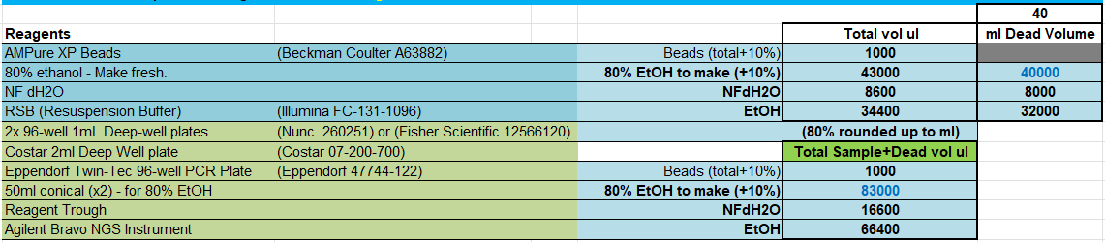
  - Vortex AMPure XP beads until evenly mixed. Referring to the table above, found in the paperwork, pipette the required bead volume into a 25 mL divided reagent trough (VWR 41428-958) using the long side of the reservoir.
  - Add 20.0 µL of AMPure XP (0.9x volume) to each well of a 1 mL deep-well Nunc plate (VWR 73520-120) using the 8-channel E4-XLS+ pipette and multi-dispense settings of: 20 µL volume, 6 dispenses, aspiration and dispense speeds of 2.
  - Seal the bead plate and briefly spin down (1000 x g for 15s), using the PRE-AMP swing-bucket plate centrifuge. Store plates at 4°C if cleanup is not done the same day as reagent setup.
  - Label the bead plate with a matching ID to the associated library plate.
  - Pour at least 6.0 mL of Qiagen EB (QIAGEN 19086) into a new 25 mL divided reagent trough, using the long side.
  - Using an 8-channel P200 at 120 µL, dispense 120 µL of Elution Buffer into each well of a new 1.2 mL Square-well storage plate Thermo Scientific AB1127. This will supply Elution Buffer for up to 5 plates.
  - Seal the elution reagent plate, label it as containing library EB, and briefly spin down (1000Xg for 15s) using PRE-AMP swing-bucket plate centrifuge. Store plates at room temperature if cleanup is not done the same day as reagent setup.
  - Label a Twin-Tec 96-well PCR plate with the pre-printed label associated with the correct cleaned and eluted library ID.
  - Consult Table 2 above (also found in the paperwork) for the volume of 80% Ethanol to prepare. Ethanol preparation should be done on the same day as cleanup.
  - Prepare this in a Pre-AMP hood, using the graduated cylinder adding 100% ABS grade Ethanol (AAPER E200G-P) to a new 500 mL reagent bottle (VWR 28199-760).
  - Volume should reflect what is listed next to the EtOH box on the paperwork. (34.4 mL/plate)
  - Use a serological pipette to add the listed volume of NFdH2O to the 500 ml reagent bottle (VWR 28199-760) containing the 100% Ethanol to make the final solution 80%. (8.6 ml/plate)
  - Label this 500 mL reagent bottle (VWR 28199-760) “80% EtOH”

- Bead Purification using BRAVO liquid handler
  - Open the "Multi-Source AMPure protocol" on V-works, located in the “Production” folder (BV-001_Multi_Source_AMPure_V4.10_(Axygen)_250909).
  - The protocol name is found on the coversheet next to the Bravo Purification box.
  - From the drop-down menu, select the appropriate source plate from the container list (96 Eppendorf Twin.tec PCR in Red Alum Insert).
  - Referring to table found on the paperwork, enter the source volume, bead volume, and elution recovery volume.
- Magnetic Bead (AMPure XP or SeraMag) Volume = 20 µL
- DNA Volume = 22.1 µL
- Elution Volume = 22 µL
  - Enter the number of sample columns you wish to purify (use 12 for a full plate).
  - Make sure the "tip selection" box matches the current tip and deck loadout. Update if necessary.
  - Check the deck layout on V-works and ensure it matches:
1) 2 mL Waste plate
2) 165 µL Filtered Tips (new)
3) Elution/Collection Plate on red aluminum insert
4) Empty
5) Shaker with sealed NUNC bead plate
6) Samples in pre-selected container resting on red aluminum insert
7) Magnet (empty)
8) Used tip container
9) Sterile tip box lid (80% EtOH)
    - Ensure that the bead plate has equilibrated to room temperature for at least 30 minutes before using them for sample cleanup if the plate was prepped and stored at 4°C.
  - After confirming the setup, remove plate seals and have a witness confirm all the selections, form entries and deck layout positions.
  - Initial and fill out the coversheet of the paperwork for:
    - Person conducting the Bravo purification.
    - Note the purification date.
    - Note the purification start time.
    - Witness initials.
    - Circle which Bravo instrument was used.
  - Run the program by clicking on the “Run MultiSource AMPure Protocol” button on the form.
    - Do not click on the “Run” button on the menu bar above the protocol.
  - Table 3 lists each BRAVO protocol step and approximate times.
 | Process (Bravo) | Time Taken | Elapsed Time
OFF magnet | Start | 0:00 | 0:00
ON magnet | DNA Addition (to beads) | 0:00 | 0:01
 | Mixing | 0:02 | 0:03
 | Shaking | 0:00 | 0:03
 | 8 minute incubation | 0:08 | 0:11
 | 5 minute magnet | 0:05 | 0:16
 | Remove Supernatant 1 | 0:02 | 0:18
 | Ethanol Wash 1 1 | 0:01 | 0:19
 | 1 min incubation | 0:01 | 0:20
 | Ethanol Aspiration 1 1 | 0:01 | 0:21
 | Ethanol Wash 2 1 | 0:02 | 0:23
 | 1 min incubation | 0:01 | 0:24
 | Ethanol Aspiration 2 1 | 0:01 | 0:25
 | 5 min Bead Drying @ 45C | 0:05 | 0:30
 | Elution 1 | 0:01 | 0:31
 | Mixing | 0:02 | 0:33
 | Shaking | 0:00 | 0:33
 | 5 minute incubation | 0:05 | 0:38
 | 2 minute magnet | 0:02 | 0:40
 | Aspirate / Finish | 0:01 | 0:41

    - Switch out tips as needed and directed (alarm will briefly sound).
      - Reset the tip boxes on the V-works form, the run will not continue without this.
    - Once directed, after the addition of ethanol for the second wash, replace the 80% EtOH reagent trough with the Elution Buffer (EB) plate and press “continue” on the Bravo computer.
    - Upon completion, remove the Library Elution plate, seal it. Spin down at 1000 x g using POST-AMP swing-bucket plate centrifuge.
    - Visually confirm the presence of Elution Buffer in all the wells as the Bravo will sometimes short aspirate, or mis-aspirate completely, from one-or-more wells.
      - Under witness, manually recover any volume from the bead plate on a magnet to the elution plate.
      - Note the affected wells and lab personnel on the coversheet of the paperwork.
      - Some volume will remain in the bead plate as the Bravo adds 2ul to the stated elution volume listed on the form.
    - Take the spun-down library elution plate over to the Post-AMP Integra.
    - Use the pre-printed plate labels to label a new Eppendorf twin.tec 96-well PCR plate (VWR 47744-106) with the associated “PG_” plate name.
    - Label another Eppendorf twin.tec 96-well PCR plates (VWR 47744-106) with the associated library normalization name. (LN plate name).
    - Use a pre-printed FA plate label to label one of the marker plates from the 4°C with the associated library name.
    - Place the library elution plate onto the Post-AMP Integra in position “AB” on top of an Integra 96-well aluminum block.
    - Place the labeled PG plate onto deck position B.
    - Using the Post-AMP Integra, run the 3ul TWINTEK program on the Post-AMP Integra.
      - Follow the on-screen prompts.
    - Seal the PG plate and cover the library elution plate before ejecting the used tips into a disposable tip waste receptacle.
    - Place the library normalization plate onto the Post-AMP Integra deck in position “B”.
    - Run the 5ul TWINTEK protocol and follow the on-screen prompts.
    - Seal the LN plate and cover the library elution plate before ejecting the used tips into a disposable tip waste receptacle.
    - Load the labeled FA plate onto the Post-AMP Integra deck in position “B”.
    - Run the 1ul FA Plate protocol and follow the on-screen prompts.
    - Seal both the library elution plate and the FA plate.

- Post-cleanup take down:
  - Run Shut Down protocol on BRAVO. Close BRAVO software. Switch off robot, Inheco Multi TEC unit underneath the robot, and BRAVO room plate sealer.
  - Discard bead cleanup waste into chemical waste container.
  - Cap the waste container closed, but do not over tighten.
  - Discard used labware and wipe BRAVO deck clean.
  - Close the BRAVO hood and turn on UV light.
  - Switch off Post-AMP Integra liquid handler.
  - Wipe the equipment clean.
  - Close the Post-AMP hood and turn on UV light.
  - Ensure that all sample plates and aliquots have been sealed and stored appropriately before leaving the lab.

