Somato-dendritic cell morphology - data processing and structure
Osten Lab, CSHL

Table of contents
Table of contents 2
Abstract 3
Metadata 3
OLST Image Reconstruction 4
Method 4
Implementation 5
Reconstruction – part 1 5
Level 0 Data description 7
Image Reconstruction - Quality Control 7
Cell morphology detection & Registration to CCF space 8
Method 8
Registration to CCF space 8
Implementation 8
Level 1 data description 8
CCF Region Wise Cell morphology 10
Method 10
Data Compression for Archival 10
Data set size 12

Abstract
The cellular morphology of neurons offers key insights into cell type diversity and classification, brain function, and neural circuit assembly. For example, pairing neuronal morphology and anatomical location is useful to classify many cell types in the retina, demonstrating that at least for these neurons their cell type specific anatomy is tightly linked to cell type-specific functions. we have developed a new type of microscopy, called oblique light-sheet tomography (OLST), which combines vibratome sectioning and light-sheet fluorescence microscopy.Images of somatodendritic morphologies have varying brightness, both within individual arbors and across cells, and apparent discontinuities can appear due to background noise. In order to be able to process large volumes of somatodendritic tracing, we have developed a supervised machine learning-based image enhancement approach. The branching patterns of the arbors (the skeletons) will be obtained automatically, with visual inspection using the tools available in ImageJ.
Specific Aim 2: Quantify and atlas the brainwide morphologies of molecularly defined cell types. This aim will generate a comprehensive structural brain atlas of somatodendritic cell-type morphologies across all CCF anatomical areas.

Introduction

This document describes the materials and methods used to process data generated from Oblique Light Sheet Tomography (OLST) to quantify the somatodendritic morphology of molecularly defined cell types.

Metadata
For the morphology of cell-types project the brains are imaged using OLST and the serial section datasets are acquired at x-y resolution = 0.4 micron and z resolution = 2.5 microns for 54-56 sections (the physical sections are 250 microns thick) depending upon the rostro-caudal axial length of the brain.
The total size of uncompressed raw data is ~9 TB, after compression it is ~5 TB (LZMA2 compression using 7-zip File Manager). Each z-serial section is composed of 4000 x 17 = 680,000 tiles, with each tile saved in proprietary 12-bit packed format.
Each dataset is associated with the following METADATA:
- Mice derivate strain (e.g. C57BL/6 etc.)
- Mice Origin (JAX etc)
- Mice Room ID
- Mice Cage ID
- Sex (male or female)
- Date of Birth
- Age (in weeks)
- Cell type specific cre mouse line (e.g Emx-Cre, Chat-Cre etc)
- Virus injection (rAAV9/CAG-Flex-GFP, PHP.eB: CAG-DIO-mNeonGreen etc)
- Virus titer (titer vg/ml)
- Date of injection
- Date of perfusion
- Date of imaging
- Date of clearing (start and end date)
- Date of gelatin embedding
- Imaging machine id (e.g. OLST)
- Laser wavelength
- Camera (red or green)
- Surface measured on z-stage
- Imaging plane measured on z-stage
- Blade Height
- Total number of sections
- Data processing server (e.g. brain2, brain5 etc.)
- Raw and processed data storage server location (brainstore 4, 5 etc.)

OLST Image Reconstruction

Method
The reconstruction involves many steps namely – conversion, shearing and transforming, stitching – along y-axis first and then z-axis to generate the whole brain volume. The images are captured by a sCMOS camera (Andor Zyla 4.2) and streamed onto the computer using a 10tap cameralink cable. The data is stored in Andor’s proprietary file format (*.dat – Mono-12packed bit format). The first step of the reconstruction involves the unpacking of the data and saving it as a 16-bit TIFF format. During this step, the average of all the image tiles is also calculated to determine the illumination field of the setup. The images can be stitched together by either specifying a predetermined overlap or using position information from the linear X and Y stages. The image sequence is still in the oblique orientation. The next step involves downsizing this sequence to give us an image stack that is used for viewing/registration purposes. At this point the stack is at (2.5x2.5um – downsized to 16% of original size). Now, this stack is sheared and stitched to give us a coronal orientation. The stitching is done using the Stitching plugin in Fiji. During stitching, the user has the option to blend/maximum intensity/no blending/mean/median the tiles at the overlap. This process also creates a volume thumbnail for a quick inspection of the imaging quality and downstream process of image registration with reference atlas.

Implementation

Reconstruction – part 1
- Open Matlab and then locate the folder with the script (reconstructOPTVolume.m).
- Update the parameters in the matlab command line.
  - Param_file_name : Metadata (ParameterFile.json) from acquisition that is in the root folder.
  - OutputDirectory : Name of the output directory with the path to store the reconstructed data.
  - scaleFactor : The downsizing ratio (0.1624)
  - outputImageBitDepth : 0 for 16-bit and 1 for 8-bit tiff
  - doIlluminationCorrection : 0 for no illumination and 1 for illumination correction.
  - Region wise reconstruction can be done using the following parameters
    - zStart : The z-section start number.
    - zEnd : The z-section end number.
    - startY : The y-section start number.
    - endY : The y-section end number.
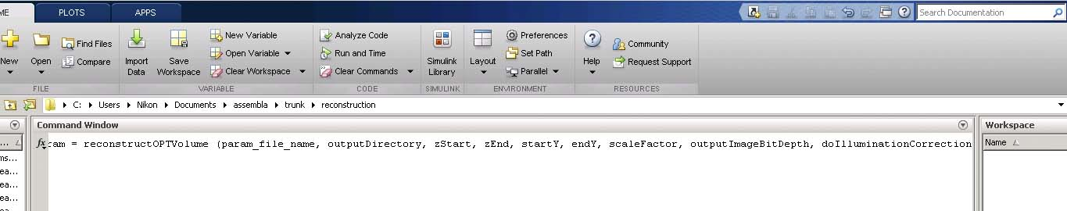

Figure 1: Reconstruction script showing the parameters as variables.

- Once the reconstruction is done, open the reconstruction root folder and create the following subfolders: Stitched_2pt5um, MaxIntProj, Stitched_10um, Keptstack_10um.
- Open Fiji and then create a macro to stitch the 2.5um individual stacks. Create a maximum intensity projection image of the individual z-stacks in the MaxIntProj folder.
- Create another downsized image of about 10um of the individual z-sections and store it in the Stitched_10um folder.
- The volumetric image has overlap along z. This is hard cropped in Fiji using the substack option. Save this substack in Keptstack_10um folder.

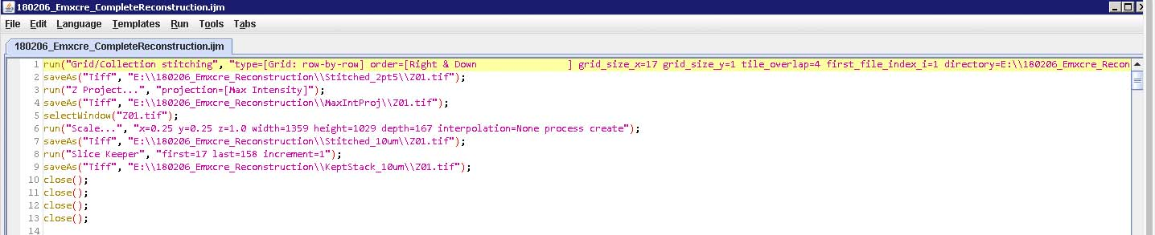
Figure 2: Fiji macro showing stitching, maximum intensity projection, downsizing to 10um, substack to remove overlap between z-sections parameters.

- The kept stack contains individual Z-sections with the following resolution – 10x10x1.76um.
- All the z-sections are loaded in Fiji and then saved as a image sequence in a new sub folder called Series_10um.
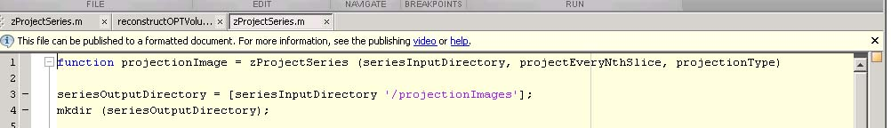
- This series then subsampled along z to obtain a near isotropic resolution (10x10x10.6um) using the matlab code (zprojectseries.m). The series is then saved as a tiff stack in the subfolder Wholebrain.

Figure 3: Matlab code to create a Maximum Intensity z-projection for every 6 slices to give an resolution of 10.6um along z.

- This near isotropic 10um resolution image is further downsized using the Scale function in ImageJ to give a resolution of 25x25x26.5um. This image series is saved as a stack in the subfolder Wholebrain.
  - Inputs given by
    - seriesInputDirectory – the path to the Series_10um
    - projectEveryNthSlice – in our case 6 (to obtain a resolution of 10.6um along z)
    - projectionType – ‘max’ – maximum intensity along the 6 slices.

Level 0 Data description

The output from the reconstruction contain the following files
- Individual Z folders, each containing 17 tiff stacks of 4000 with the 2.5x2.5um along x and y. Corrected tif files that contain 17 tiff stacks with 167 sections with resolution of 2.5x2.5x1.76um.
- Stitched image files of the imaged channel. This contains the coronal section files at 2.5x2.5x1.76um resolution.
- Maximum intensity projection images of individual z-sections at 2.5x2.5um resolution with the z-resolution being the physical thickness of individual sections (250um).
- Stitched_10um folder containing individual z sections downsampled to 10x10x1.7um.
- Keptstack_10um folder containing the individual z-sections with the overlap region between the z-sections removed.
- Series_10um folder containing a series of images of all the z-sections.
- projectionImages folder containing a near isotropic downsized image at 10x10x10.6um resolution.
- Wholebrain folder containing tiff stacks with 10x10x10.6um and 25x25x26.5um resolution that will be used for registration to CCF space.
- sumTiledirectory folder with the average tile used for illumination correction.

Image Reconstruction - Quality Control

- Visualize the whole brain stacks (10x10x10.6um and 25x25x26.5um) in Fiji for checking the overall quality of the acquisition.

Cell morphology detection & Registration to CCF space

Method

Convolutional neural networks (CNN) (Lecun et al. 1998) are used to detection of cells and other structures. Our segmentation tool has capability to detect cytoplasmic signals imaged using fluorescent light microscopes. The morphology detection is based on Segnet framework developed by Matlab. These tools require a nvidia CUDA-enabled GPU to process these detections. The networks have both variable hidden layers and field of view depending on the feature that is being detected. The output of these networks will be swc files that contain the somatodendritic morphology information of individual neurons.

Registration to CCF space
This module registers the downsampled sample brain (25um voxel) to CCF space. It is executed in 2 steps, first the affine and then followed by b-spline registration. The registration uses Mattes mutual information as similarity measure (Mattes et al. 2003). We use a toolbox for image registration call elastix (Klein et al. 2010). It is based on ITK (Ibáñez 2003). (Niedworok et al. 2016)

Implementation
Presently, cell morphology can be analyzed using two different ways to give us the swc files.

- NeuroGPS – a package that can do automatic reconstruction of large-scale neuronal populations with dense neurites.
- Semantic Segmentation – a Matlab based image-processing toolbox.

Level 1 data description
- The morphology of the neurons will be stored as swc files (http://research.mssm.edu/cnic/swc.html).

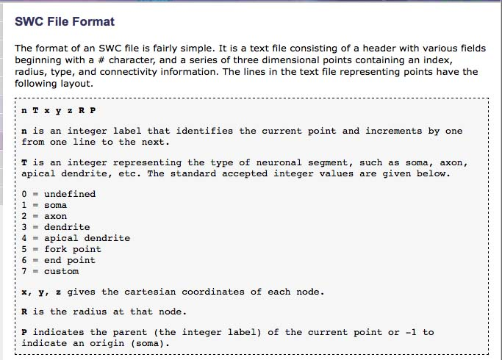
Figure 4: swc file format description.
- The raw images can be opened using Fiji and the swc files opened using the plugin (Simple Neurite Tracer) and the corresponding morphology can be qualitatively assessed.

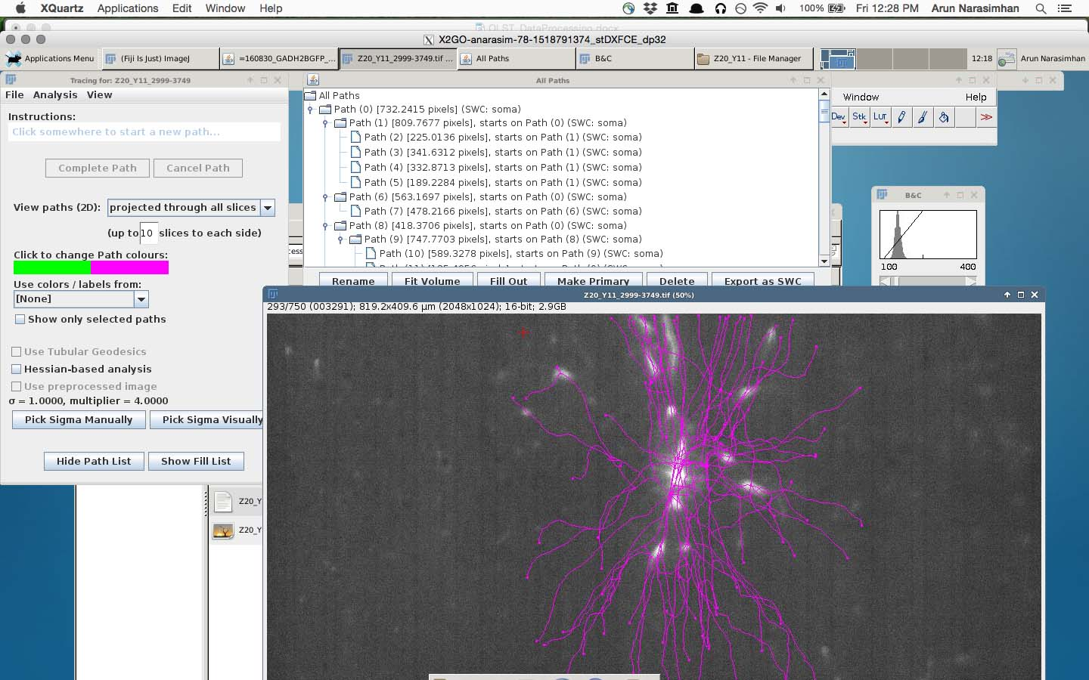
Figure 5: Qualitative assessment of morphology by overlapping the image with the swc file.
- For registration, open the result file of registration in the elastixOutput folder in warping with the fixed image (the downsized warpable image) and synchronize the stack slices and mouse pointers and look for congruous edges and corners of the image stacks.

CCF Region Wise Cell morphology

Method
With the registration parameters the swc files are transformed to CCF space and with the CCF labels the region wise morphology is determined.

Data Compression for Archival
After the steps of reconstruction and automated morphology segmentation, the corresponding raw folders (the files containing the tiles from OLST acquisition) are compressed using 7-zip File Manager. The compression involves using the LZMA2 compression method and Ultra compression level.
Document the size of the raw data before compression which is approximately 11 TB and after compression it is approximately 5.2TB. The reconstructed folders (excluding the 100% images) are not compressed and the size of the folder is about 1.2 TB.
There is provision for converting the Data Level 0: reconstructed images to JP2 file format.
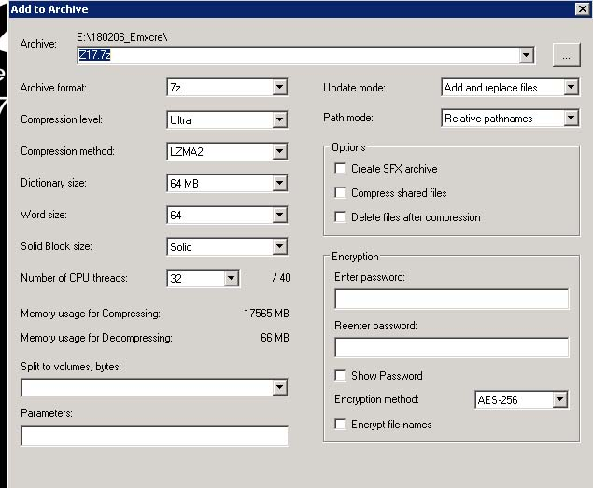
Figure 6: 7-zip File Manager window showing the compression parameters.

Data set size
Data type | Data Level | Data description | Usage Per Brain before compression | Usage per month with compression (4 brains)
Raw |  | Raw saved (*.dat) | 11TB | 22TB
Processed | Level 0 data | Oblique raw images and stitched coronal sections at 2.5x2.5x1.76µm | ~750GB | ~3TB
Processed | Level 1 data | Cell morphology | <1GB | ~4GB
Processed | Level 2 data | Registration | <1GB | ~4GB
Processed | Processed Data | Processed | ~750GB | ~3TB
Total | Raw+Processed |  | 12TB | 25TB

OLST raw data: Every month we expect to produce ~40 TB of raw, uncompressed data (1 brain per week). After LZMA2 compression, the data size will be reduced to 22 TB.
Level 0,1,2: The typical size of a processed data folder which contains image reconstruction, cell detection and registration is about 1 TB per brain, which amounts to 4 TB per month for 4 brains. If JP2 is used then the compression will increase.

