Oyster Shell Sectioning, Micromilling and Stable Isotope Analysis Standard Operating Protocol

The following SOP follows the manufacturer’s instructions and isotope ratio analytical protocols published in Ostermann & Curry (2000) and by the University of California Davis Stable Isotope Facility procedures online at: https://stableisotopefacility.ucdavis.edu/carbonate.html

- Shell sectioning
- Sample mounting
- Micromilling
- Isotope analysis
1) Shell sectioning
- Remove thumb screw, end cap bushing and outer flange from drive shaft
- Install blade on drive shaft against inner flange relieved surface
- Slip on outer flange and end cap bushing, then hand tighten thumb screw to complete installation.

Figure 1 Blade installation

- Lift off door on right side of saw to access lubricant pan
- Grasp knob on slide lock, pull slide lock outward until lock disengages, and lower lubricant pan tray and swing it outward.
- Remove lubricant pan and fill with de-ionized water until it immerses blade approximately ¼”. If removed, re-insert specimen basket back into pan.
- Replace full lubricant pan on tray. With slide lock still pulled out, swing tray inward to stop. Press slide lock inward to stop and then, while maintaining light pressure on slide lock, lift tray upward until slide lock engages. Press slide lock fully in to secure tray.
- Replace door to lubricant tray.
Figure 2 Lubricant tray

- Loosen the set knob and slip the counter balance weight to rear of weight shaft to hold the support arm in upright position.
- Clamp the oyster shell in place in the saddle chuck. This shell will need to be cut several times to remove the non-target portions of the shell and to isolate the shell umbo for sectioning. The final cut should bisect the shell hinge through the umbo perpendicular to growth increments.
- Attach the loaded chuck to the support arm with the mounting thumb screw.
- After the chuck is secured, move the support arm to the far left by adjusting the micrometer head.
- Slide the counter-balance weight toward the front of the unit until balance is achieved and tighten the set knob.
- Attach the loaded chuck to the support arm with the mounting thumb screw.
- After the chuck is secured, move the support arm to the far left by adjusting the micrometer head.
- Slide the counter-balance weight toward the front of the unit until balance is achieved and tighten the set knob.
Figure 3 Support arm and mounting

- Set the thumb screw in the support arm to shut off the saw by depressing the cut-off switch arm at the completion of the cut.
- Adjust the micrometer to position the specimen for cutting. Weight can be applied to the work in increments of 25 grams by proper selection of the four weights. Relatively light weights are recommended to reduce surface damage to specimen.
- Care should be taken during the loading operation not to nick the blade or drop the specimen on the blade edge.
- Adjust the speed control knob to the desired speed while holding the specimen arm by hand above the blade. A speed setting of 6-7 (200 rpm) on the control dial is recommended.
- Place the blade wiper with the drip lip side down. The brushes of the blade wiper should be contacting either side of the blade for most of their width. Be sure not to allow the blade to cut the metal drip lip on the blade wiper.
- After the speed control is set, press the start button and carefully lower the specimen arm onto the blade to commence cutting. The cutting light will come on when the start switch is pressed.
- When the cut is completed, the cut-off switch arm is automatically depressed which, in turn, lights the complete light and stops the saw.
- Remove the chuck from the arm and release the specimen from the chuck. Re-clamp the specimen in the chuck as needed and commence cutting operation from Step 14 as needed.

2) Sample mounting
- Remove the final cut section of the shell from the saw. This cut should expose the growth increments in the shell hinge bisecting the resilifer through the umbo.
- Use a diamond-tipped etching implement to inscribe the shell sample identification number onto a petrographic glass slide. Place the sectioned shell on this slide under the laminar flow hood for 24 hours to completely dry.
- Once dry, the shell is ready for mounting to the slide. Position the section in the middle of the slide. Use the cyanoacrylic glue pen to deliver glue to the shell edge adjacent to the slide. Glue should be added around the entire perimeter of the shell edge to make a secure bond at all points between the shell and the adjacent slide.
- Let the shell sit until the glue is completely dry (at least 6 hours). Test the shell to ensure it is securely mounted to the adjacent slide. If the shell is loose and not securely mounted, repeat gluing procedure until secure.
3) Micromilling
- Turn on the mill via the switch on the back of the plate. Turn on computer attached to video camera adjacent to mill.
- On the computer, open the micromilling software and let it initiate automatic stage calibration. Slide the bar for the “Reflected Light” up to illuminate stage.
- Using double-sided sticky tape, affix slide with sample to stage in middle of circular plate.
- Set sample thickness by clicking “Sample Thickness” on the Setup Checklist. This will initiate an automatic sequence with instructions for identifying the top of the sample (whose thickness will vary). This needs to be repeated prior to every drilling sequence, within and between samples (different samples will have different heights, and samples may vary in thickness from one end to another).
- Once the sample thickness is set, move the drill to a portion of the sample which will not be used for actual analyses (a test area).
- Drill a small test hole in this area for reference. Before moving the drill away from the test hole (keep the drill positioned directly over this hole to start with), initiate the “Drill XY Offset” sequence on the Setup Checklist. This sequence will calibrate the distance needed to move when switching from Drill and Scope views. The sequence will start by automatically recording the position of the drill bit (over the test hole) and then switch to Scope view. The crosshairs should directly overlap the test hole center. If it is not directly over the hole, move the cross hairs with the scroll bars so that the crosshairs are directly over the test hole. Then complete the sequence so the new offset parameters are recorded. This offset only needs to be calibrated once at the beginning of a drilling day (unless the mill has been jostled or moved significantly during the day).
- Check the default raster parameters prior to drawing sample rasters. The default settings (adjusted as needed to achieve the minimum sample mass of 1 mg) are:
  - Scan speed: 35 µm/sec
  - Passes: 1
  - Raster dimensions: between 1400x700 to 1500x900 µm
  - Raster spacing: 100 µm
  - Drill speed: 10%
  - Depth: 450 µm
- Draw a sample raster on targeted area for sampling. The raster should be placed in the foliated calcite region just under the resilifer surface (see Surge et al. 2003 for guidance). Endpoints can be adjusted manually via the “Edit Endpoints” feature to ensure exact raster dimensions. Confirm that the depth is set to 450 µm.

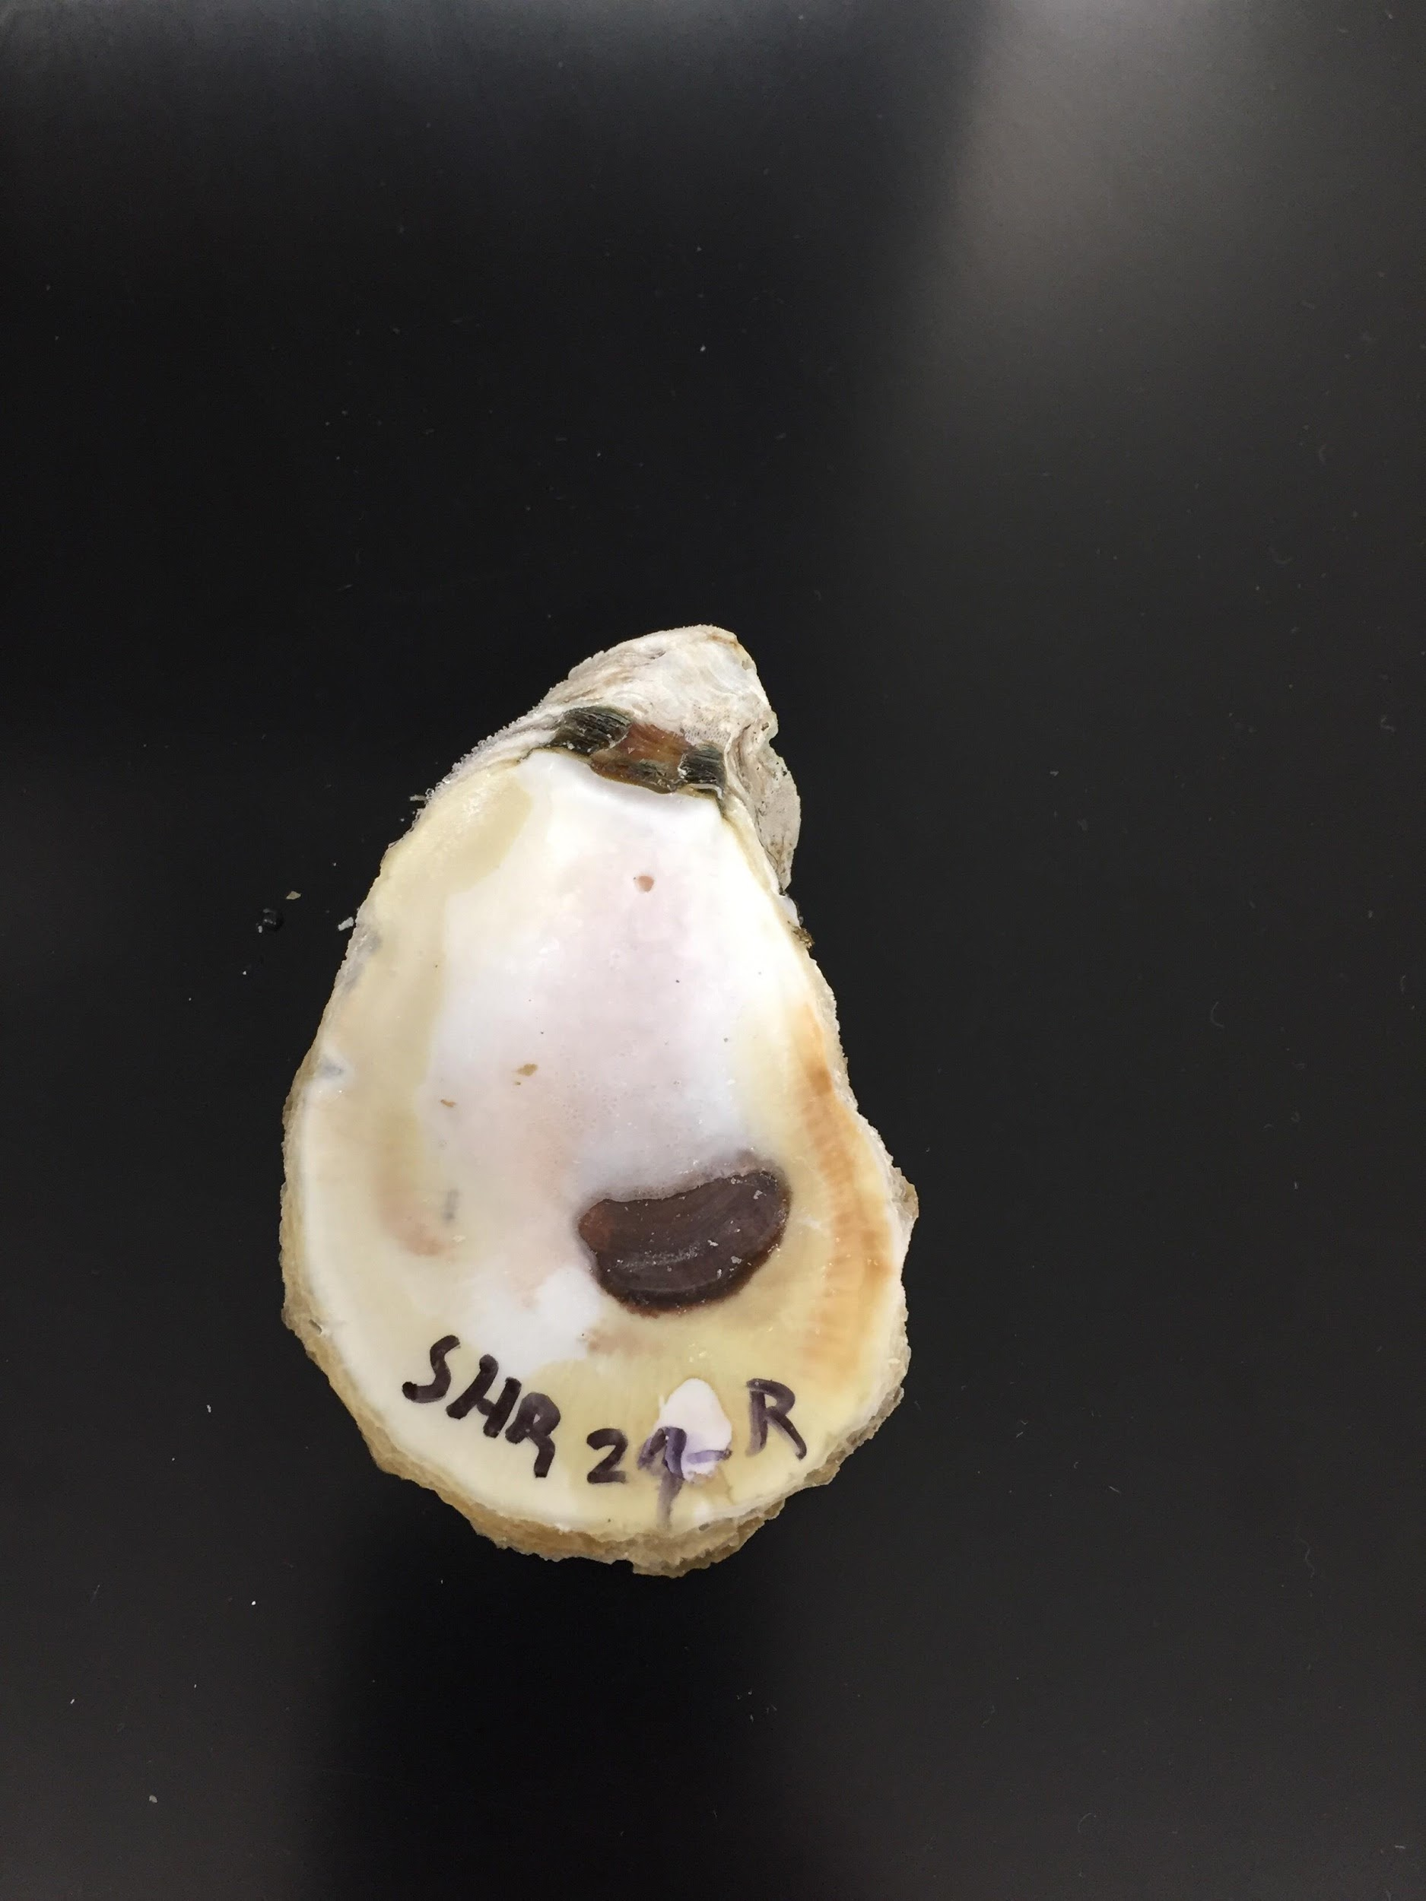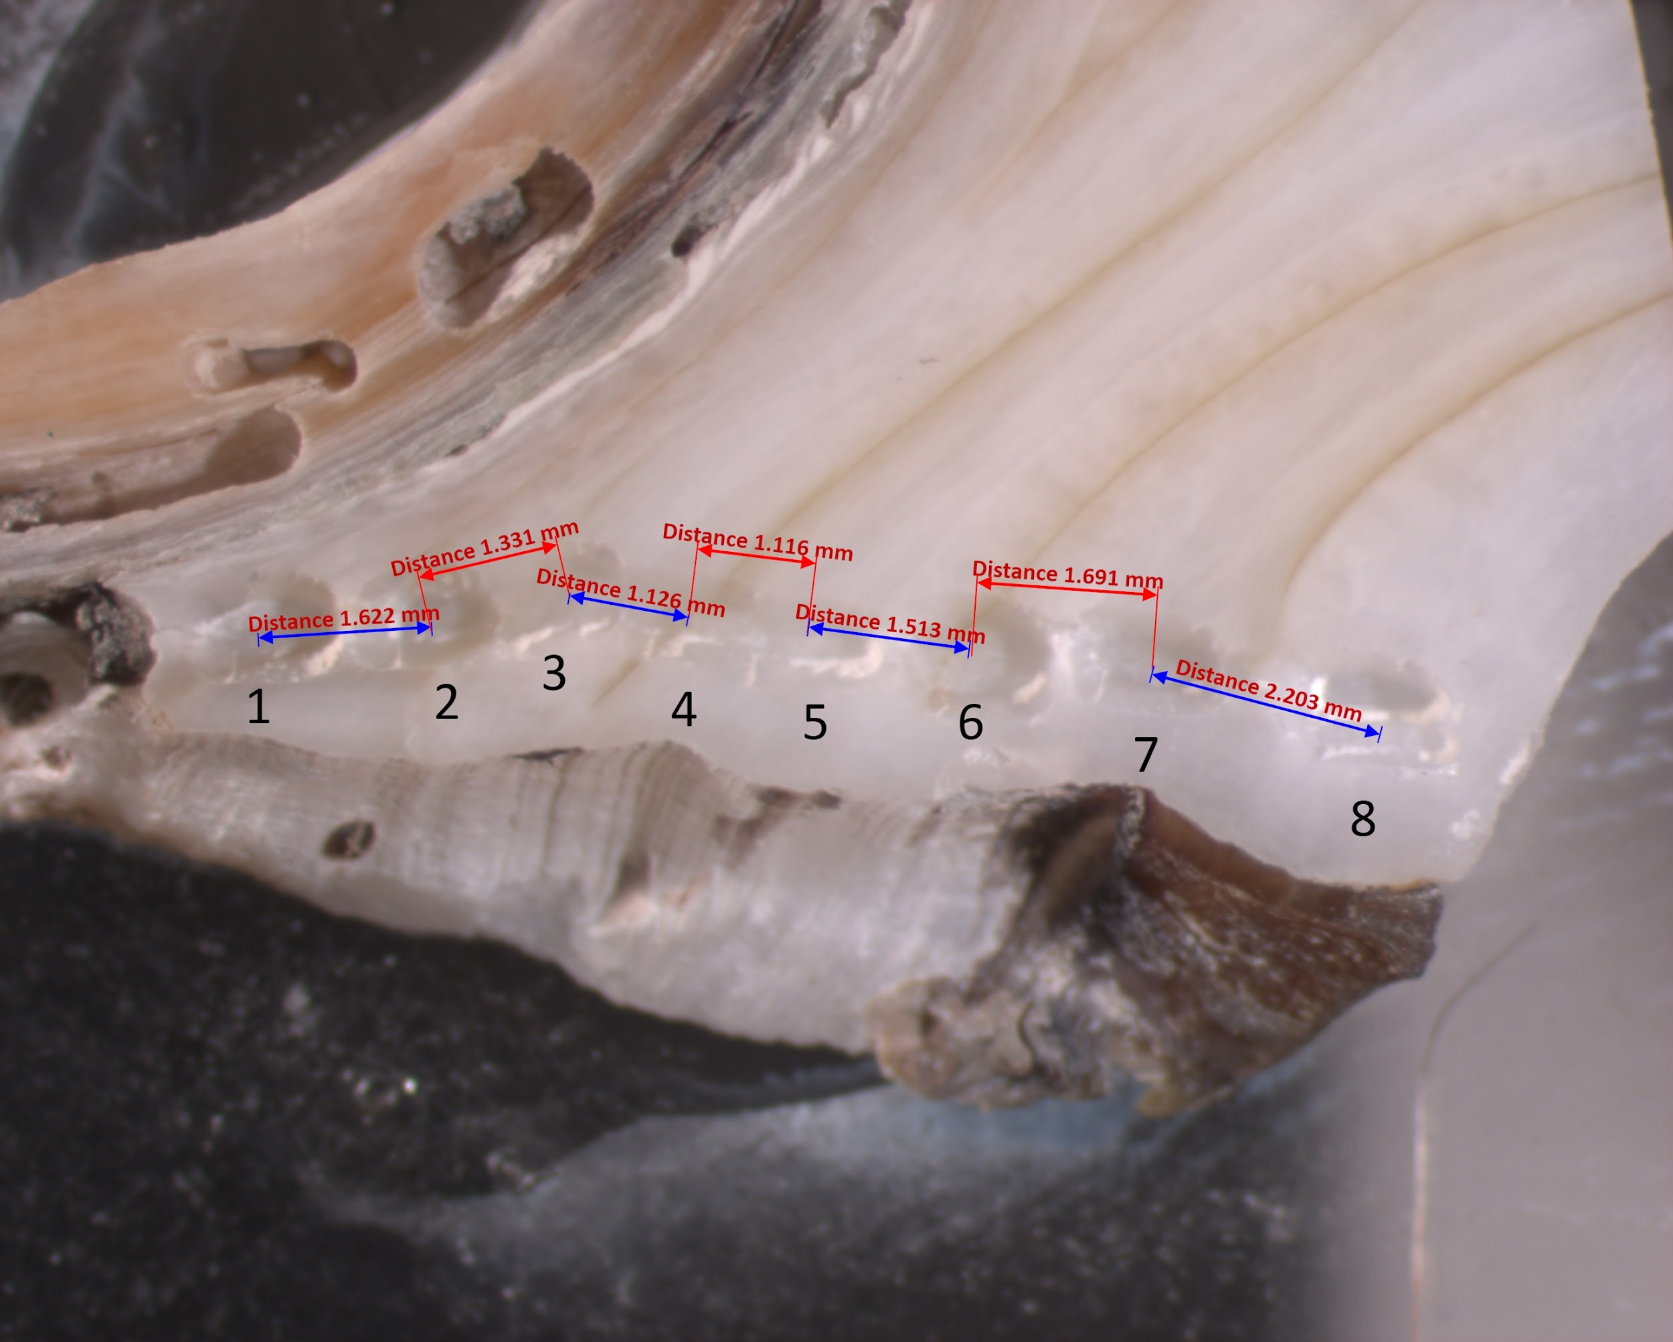
A
Oldest
material
Newest
material
B
Figure 4 Example sectioned shell with raster placement illustration

- Prior to drilling, blast the sample surface and drill bit with compressed air to remove any surface contamination. Also, retrieve the platinum weighing boat from the balance area and hold it firmly with forceps. Blast the boat with compressed air to ensure the boat has no prior sample in it and is clean and ready for a new sample. Place the clean boat back on the balance and tare the balance so the boat weight is recorded.
- Initiate drilling sequence by clicking “Run Experiment”. Ensure the “Enable Drill” box is checked so drill turns. As the raster is drilled, watch the sample carefully to ensure the slide is still firmly affixed to the stage and not moving. If the slide is loose, abort the drilling sequence and re-attach the slide with additional tape.
- While the drill sequence is progressing, prepare a piece of was weighing paper by folding it once lengthwise at a right angle. The paper should be placed flat on the table in front of you so one half of the paper is flat on the table and the other is standing up perpendicular to the table.
- Once a successful drill sequence has concluded, there will be powder on the sample at the site of drilling. Be very careful at this point and do not exhale on the sample and blow all the powder away. Move the drill to Scope view to remove the drill bit from over the sample. Very carefully, twist the sample slide parallel to the stage so that the tape loosens, and the slide can be gently lifted up from the stage.
- Move the sample over to the folded weighing paper and tip the slide so the powder falls onto the paper on the table. Use the vertical side of the paper as a wall to catch any powder that falls forward as you tip the sample. Gently tap the slide a few times against the table and paper to shake loose any powder remaining in the raster hole.
- Remove the platinum weighing boat from the balance and place next to the paper. Gently pick up the wax paper, tilting so the folded part of the paper catches the powder in the crease. Tip the paper into the boat so the powder falls gently into the boat. Open the crease slightly as you tip and tap the rear of the paper to make sure all powder is captured in the boat.
- Carefully pick up the full boat with forceps and transfer onto the balance. Close the air shields to the balance and let it come to rest for an accurate weighing.
- Record the sample weight.
- Remove the full weighing boat with powder and tip into wide-mouth 1 dram sample vials (Clear Screw Thread Sample Vials 15 x 45 mm, Qorpak/GLC-00980). Cap tightly and label with oyster ID and sample position number. Place capped and labeled vials in containers for shipping to the UC Davis Stable Isotope Facility for analysis.

4) Isotope analysis
Stable isotope ratios of δ¹³C and δ¹⁸O in extracted oyster shell samples will be conducted at the UC Davis Stable Isotope Facility following standard protocols as published by Ostermann & Curry (2000) and detailed online:
https://stableisotopefacility.ucdavis.edu/carbonate.html

- Powdered carbonate samples are dried at 60°C in a drying oven overnight.
- Dried sample is weighed to 0.3 mg into 12-ml Labco borosilicate exetainer vials (Labco/9RK8W) and capped.
- Vials are loaded into an autosampler rack held at 70°C and flush/filled with helium at 100ml/min for 10-min using a CTC PAL autosampler device.
- Several drops of phosphoric acid (103%) are manually injected through a septum into each vial using a syringe to liberate CO₂ from the carbonate.
- Vials are returned to the autosampler rack to equilibrate for 24h at 30°C.
- The vial headspace is analyzed for CO₂ using a ThermoFisher Scientific GasBench II device with a 100 µl sample loop connected to a ThermoFisherScientific Delta V Plus gas-isotope ratio mass spectrometer.
- A pure CO₂ reference gas is used to calculate provisional delta (δ) values of the sample peak. Final δ values are obtained after adjusting the provisional values for changes in linearity and instrumental drift such that correct δ¹³C and δ¹⁸O values for laboratory reference materials are obtained.
- Certified reference standards NBS 18 (-5.01‰, -23.01‰, for δ¹³C and δ¹⁸O respectively), NBS 19 (+1.95‰, -2.20‰, for δ¹³C and δ¹⁸O respectively), and LSVEC (-46.60‰, -26.70‰, for δ¹³C and δ¹⁸O respectively) are used to calibrate data on the VPDB scale. The long-term standard deviation is 0.1‰ for δ¹³C and 0.2‰ for δ¹⁸O.

References
Surge, D.M., Lohmann, K.C., and Goodfriend, G.A. (2003). Reconstructing estuarine conditions: oyster shells as recorders of environmental change, Southwest Florida. Estuarine Coastal and Shelf Science 57, 737-756.

Ostermann, D.R., and Curry, W.B. (2000). Calibration of stable isotopic data: an enriched δ¹⁸O standard used for source gas mixing detection and correction. Paleoceanography 15, 353-360.

