Patch-Seq Recording and Extraction

- Scope and Applicability: Process to obtain electrophysiological recordings and cellular contents from neurons in postnatal mouse and/or human brain slices

- Materials:
  - #0 Paintbrush (Ted Pella 11810)
  - 5 or 20 ml Luer Lock syringe (Monoject 8881520657)
  - 20 µl microloader pipette tips (Eppendorf 930001007)
  - 70% Ethanol (RP0032)
  - 96 well microcentrifuge tube racks (3, at least 1 metal) (Thermo Fisher XTPCR96)
  - ACSF.III (SOP RP0220)
  - Patch-Seq internal solution, in 5 µl aliquots (SOP RP0235)
  - Patched cell containers (provided by molecular biology)
  - Capillary glass (Warner Instruments G150F-3)
  - DNA Away (Thermo Fisher 7010)
  - Dry ice
  - Forceps (Roboz RS-5045)
  - Harp, tissue hold-down (Warner)
  - Ice buckets
  - Kimwipes
  - Mouse or human brain slices in holding ACSF (SOP AF0099 and SOP PF0295)
  - Nuclease-free water (Ambion AM9932)
  - Oxygen diffuser
  - Plastic 3 ml Pasteur pipette, with tip cut off
  - RNase Zap (Invitrogen AM9780)
  - Squirt bottle
  - Wet ice
- Equipment:
  - Electrophysiology Rig
  - 1-20 µl pipettor
  - Expulsion device (1 ml Luer Lock syringe connected by tubing to empty pipette holder)
  - Microcentrifuge (Cole Parmer UX-17310-09 or equivalent)
  - PCR hoods
  - Pipette puller (Narishige PC-10)
- Safety:
  - Nitrile Gloves
  - Lab coat
- Output:
  - Electrophysiology recordings from mouse or human neurons in *.pxp (Igor packed experiment) and *.nwb files
  - Cellular contents of mouse or human neurons in microcentrifuge tubes containing S4 buffer
- Reference Documents:
  - AF0099 Slice Preparation and Blockface Imaging for Electrophysiology - Mouse
    - https://www.protocols.io/view/slice-preparation-and-blockface-imaging-for-electr-bdpqi5mw/abstract
  - PF0285 DAB Detection of Biocytin Labeled Tissue
    - https://www.protocols.io/view/dab-detection-of-biocytin-labeled-tissue-bdpji5kn/abstract
  - PF0289 Post Patch Clamp Slice Fixation
    - https://www.protocols.io/view/post-patch-clamp-slice-fixation-bdpii5ke/abstract
  - PF0295 Human Neurosurgical Tissue Processing
    - https://www.protocols.io/view/human-neurosurgical-tissue-processing-bdvki64w/abstract
  - RP0220 ACSF.III
    - https://www.protocols.io/view/artificial-cerebrospinal-fluid-iii-acsf-iii-beptjdnn/abstract
  - RP0222 ACSF.IV
    - https://www.protocols.io/view/artificial-cerebrospinal-fluid-iv-acsf-iv-bepsjdne/abstract
  - RP0228 ACSF.VIII
    - https://www.protocols.io/view/artificial-cerebrospinal-fluid-viii-acsf-viii-beprjdm6/abstract
  - RP0235 Patch-Seq Internal Solution with Biocytin
    - https://www.protocols.io/view/patch-seq-internal-solution-with-biocytin-bdvti66n/abstract

Warning: Personal Protective Equipment (PPE) should be used at all times while operating this protocol. If you are unsure what PPE you should be using, see your immediate supervisor.

NOTE: The equipment is sensitive to static charge. Be sure to touch the metal surface of the air table to ground yourself before touching any equipment.

- Setup:
  - Obtain tissue slices using SOP AF0099 for mouse or SOP PF0295 for human tissue.
  - Mouse tissue should incubate in ACSF.IV solution for at least 1 hour after slicing, but no more than 5 hours. Human tissue should incubate in ACSF.VIII solution for at least 1 hour and can incubate indefinitely.
  - Verify that room level morning duties have been performed as specified in Morning Maintenance section (Appendix 10.4.).
  - Start up and clean the ephys rig and workstation as specified in the Morning Maintenance section (Appendix 10.4.).
  - Open your Laboratory Information Management and sign in.
  - Label enough patched cell containers for the day, including controls.
    - The date goes on the side of the tube in YYMMDD format.
    - The three-digit tube number, with the range corresponding to the user, goes on the cap.
  - Pull glass pipettes on Narishige PC-10 puller to be used as electrodes.

- Methodology/Procedures:
  - An overview of the process is detailed below – each of these steps is run through a custom workflow sequencing engine.
  - Load a slice into the chamber with a Pasteur pipette. Use the closed tips of forceps to position the tissue in the center of the stage (Figure 2). Note whether or not the slice is flipped in the JSON form.
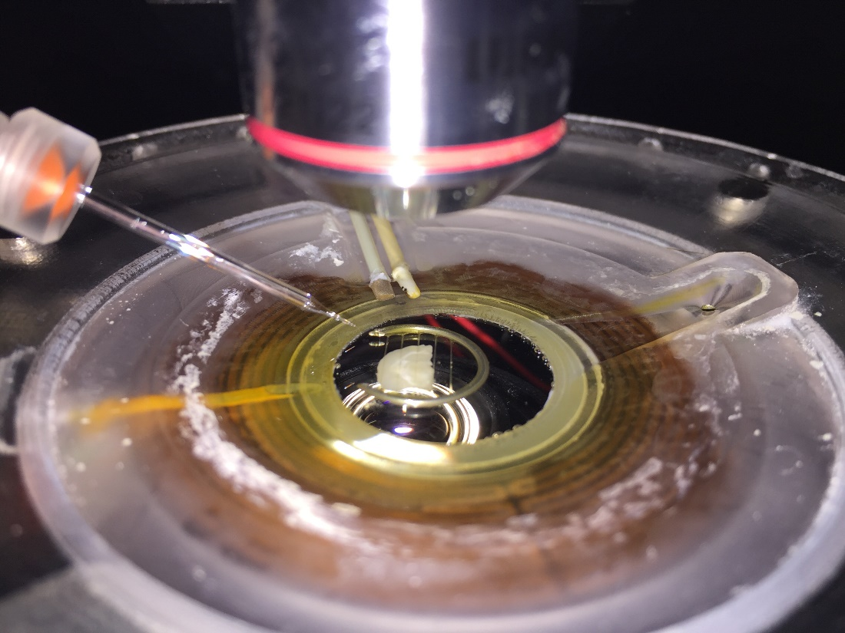
Figure 2: Slice loaded in the chamber with harp.

  - Use forceps to set the harp across the slice (Figure 2).
  - Follow prompts for the custom workflow sequencing engine.
  - Switch to the 40x objective to locate individual cells.
  - Lower the objective to the slice using the coarse focus, be sure that the white part of the objective is immersed in the bath.
  - Follow the prompts from the custom workflow sequencing engine to collect 4x corner images of the slice. When finished taking images, click No.
  - Identify a cell to patch.
    - Switch to the 40x objective by flipping the Approach switch on the PatchPad. Also, switch the PatchPad to the slow speed. Manually lower the objective if it is not submerged in the bath and bring the tissue into the plane of focus.
    - Using the PatchPad to move the stage/objective, search for healthy looking cells below the cut surface of the slice (see Appendix 10.2 for examples of healthy vs. unhealthy cells). Target Cre+ or Cre- cells depending on the region of interest plan.
    - Once a healthy cell has been selected, switch back to the 4x objective.
  - Wipe the electrode wire with nuclease-free water.
  - Using a fresh microloader tip on a 20 µl pipettor, fill the tip of the glass pipette with ~1 µl of internal solution. Slide the microloader tip almost to the end of the pipette and push the plunger down to fill. It may be necessary to flick and/or shake the pipette to eliminate bubbles and ensure the solution is all the way in the tip.
  - Attach the glass pipette to the channel one headstage (Figure 3).
    - Carefully slide the pipette onto the silver wire and then tighten the holding screw a quarter turn past finger tight.

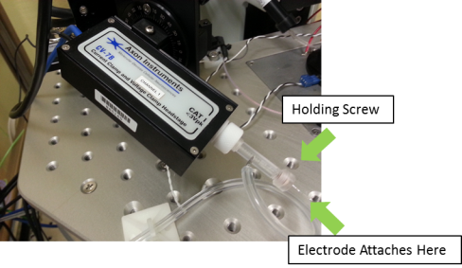
Figure 3: Attaching the pipette to the headstage

  - Apply between 70 and 80 mbar of positive pressure (blowing) to the pipette by pushing in on the syringe and then turning the stopcock to seal off the pressure to the pipette.

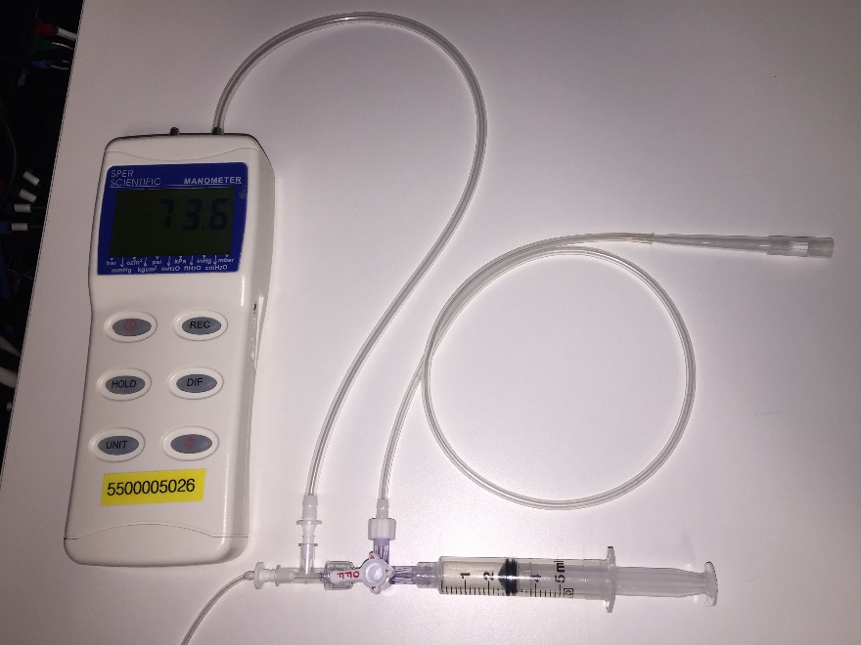
Figure 4: A manometer connected to a syringe enables control of the pipette pressure

  - Use the Control Cube to move the pipette into the bath and above the slice, centering it in the scope’s field of view.
  - Check the resistance (R_{ss}) of the electrode.
    - The R_{ss} value will be displayed next to the test pulse. The target range for the electrode is typically in the 3-7 MΩ range. Electrodes outside of the range specified should be replaced.
  - Switch back to the 40x objective. Switch both the PatchPad and the Control Cube to the slow speed to prevent any collisions, then lower both the objective and the pipette to the surface of the tissue.
    - Visualize positive pressure from the pipette on screen. Check the tip for clogs of any sort. See Appendix 10.1 for helpful tips on pipettes.
  - Focus down to the target cell with the PatchPad and center it in the field of view. When ready, click OK in the custom workflow sequencing engine to collect a 40x image of the cell.
  - Focus back up to the pipette at the surface of the tissue. Click the Auto Cp Fast button to remove transients (blue arrow in Figure 6). Note: this may not be completely successful with so little internal solution. Zero the resistance on the pipette by clicking the lock symbol under Pipette Offset and then clicking Auto to reset (green arrow in Figure 6). When ready, click OK in the custom workflow sequencing engine to collect the InBath sweep.

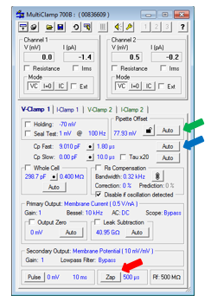
Figure 6: MultiClamp Commander window

  - Lower the pipette to the target cell using the Control Cube. Try to approach the cell at an angle until the pipette is sitting on top of the target cell and leaving a slight dimple in the cell’s surface (Figure 7).
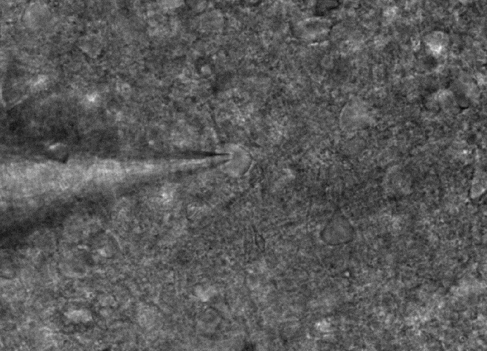
Figure 7: Pipette is shown indenting the top of the cell with positive pressure

  - Release the positive pressure and begin to apply negative pressure (suction) to seal onto the cell. As the seal resistance increases, begin to apply holding potential, eventually holding the cell at -70 mV. If necessary, click Auto Cp Fast again. A successful GΩ seal is signaled by an R_{ss} greater than 1000 MΩ (Figure 8). When a GΩ seal is achieved, click OK in the custom workflow sequencing engine to collect the CellAttached sweep.

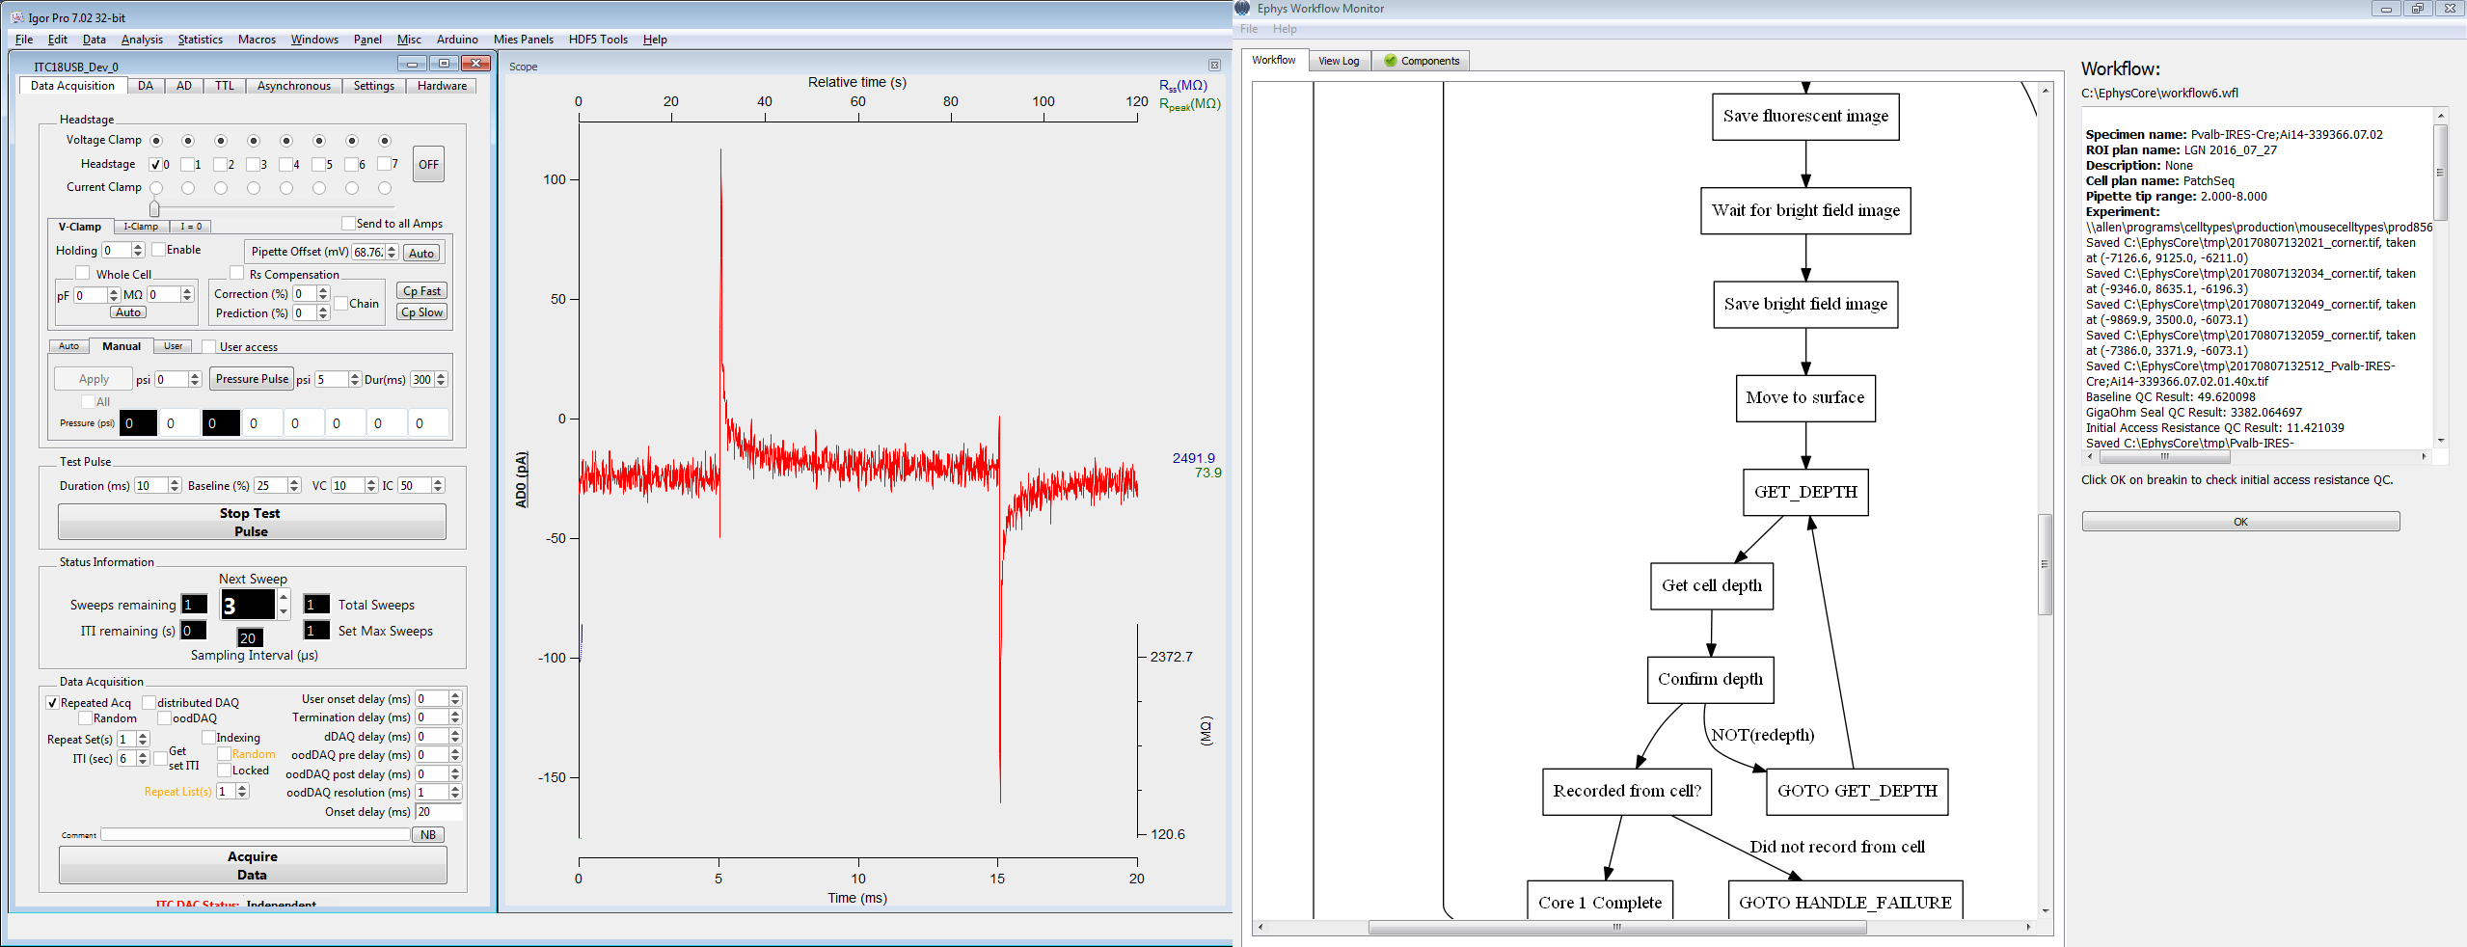
Figure 8: Oscilloscope showing successful seal with a resistance greater than 1 GΩ

    - If the custom workflow sequencing engine does not read a GΩ seal, it will give the option to Abort the attempt, Try Again, or Ignore to move on without collecting a successful GΩ Cell Attached sweep.
    - If the resistance never reaches 1 GΩ, consider it a failed attempt and click Abort in the custom workflow sequencing engine.
      - Switch back to the 4x objective. Focus on the pipette tip and click OK to collect an image of the cell’s location.
      - Remove pipette from of the bath.
      - Unseat the headstage, unscrew the pipette holder to slide the pipette off the wire, and discard the pipette in a sharps container.
      - Return to step 8.6 and find a new cell to patch.
  - Break into the cell with quick pulses of negative pressure. Cells that make easy seals are generally easier to break into. If a cell is resisting break-in, it may help to Zap it (red arrow in Figure 6). If break-in is successful, the graph will look similar to Figure 9. Once whole cell configuration has been achieved, click OK in the custom workflow sequencing engine to collect the break in sweep.

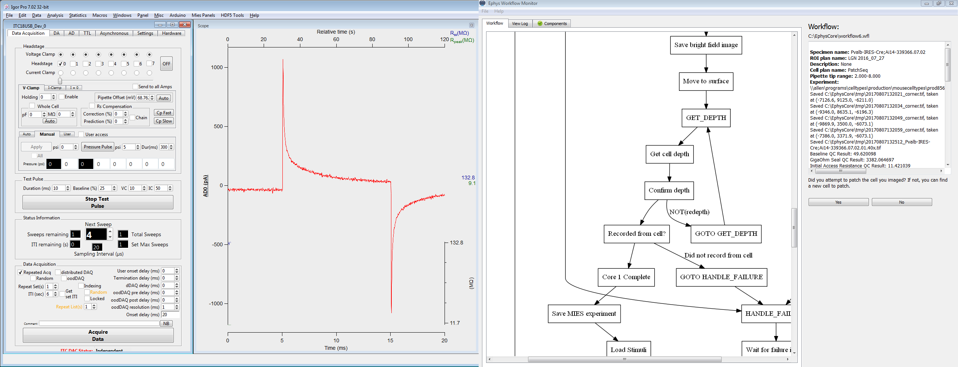
Figure 9: Oscilloscope test pulse showing that the pipette has successfully broken into a cell

    - If the break in sweep does not meet the QC criteria, e.g. the access resistance is more than 20 MΩ, the custom workflow sequencing engine will give the option to Abort the attempt, Try Again, or Ignore to move on without collecting a successful break in sweep.
    - If break-in is unsuccessful, consider it a failed attempt and click Abort in the custom workflow sequencing engine. Repeat the steps described in 8.19.2.1-8.19.2.4 to finish and save this attempt before finding a new cell to patch.
  - Click Yes in the custom workflow sequencing engine, then follow the prompts to collect 40x epifluorescence and bright field images of the cell.
  - Following the custom workflow sequencing engine’s prompt, focus up to the surface of the slice and click OK to measure the cell’s depth.
  - Switch to current clamp and run appropriate stimulus sets.
    - Record information and observations in the JSON form, as applicable.
    - Monitor pipette placement and adjust if it drifts. Try to keep the pipette centered on the cell.
  - Extraction phase After specified recording time, switch back to voltage clamp and begin extraction. Note extraction start and stop time in JSON form.
    - Re-center the pipette on the cell, if necessary, then slowly apply negative pressure while visualizing the shape of the soma and the stability of the cell membrane in the test pulse window. Continue to increase the pressure as long as the patch appears stable. The amount of pressure a cell can withstand will depend on cell type and size, health and pipette size.
      - If the membrane begins to destabilize, release the negative pressure, wait until it has stabilized, then try again.
      - If the seal is lost completely, release the negative pressure immediately and move to expulsion step.
    - Use confluence guide for recommended extraction settings to guide process.
  - Retraction phase Once the cell has visibly shrunk, retract the pipette slowly, focusing on obtaining a nucleated patch.
    - Re-center the pipette on the cell, if necessary, then adjust and lock off the negative pressure.
  - Once the pipette has been completely retracted from the tissue, switch back to the 4x objective and press the H out button on the Control Cube to bring the pipette out of the bath. Remove the pipette from the holder and expel the contents into a patched cell container.
    - Insert the pipette into the expulsion device.
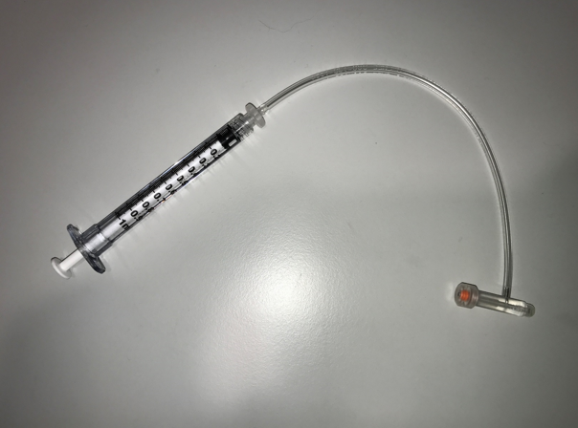
Figure 10: Patchseq Expulsion Device
    - Apply a small amount of positive pressure to the syringe (~0.1 ml, but this may vary depending on the syringe).
    - Open the cap of a numbered patched cell container and carefully insert the pipette, slowly immersing the tip in the buffer and gently touching the bottom of the tube. Watch as the pipette’s contents drain into the buffer, raising the pipette out as the last of the contents empty into the tube.
    - Spin down the contents of the tube in the microcentrifuge for 5 sec, if there are bubbles.
    - Place in metal rack on dry ice to flash freeze and store.
    - Note the tube ID and the outcome of sample expulsion, including the presence/size of any bubbles and whether or not the solution traveled up the shank of the pipette, in the JSON form.
  - Follow the prompts to finish experiment, package the data, and upload to your Laboratory Information Management System.
  - Follow the prompts to either record from another cell or finish with the tissue slice.
    - If finished with the slice, fix it according to the Post Patch Clamp Slice Fixation SOP (PF0289). Note the histology well name in the JSON form.
    - Enter patched cell containers, Cre status, and structure into your Laboratory Information Management System under the appropriate specimen ID.
- Take Down:
  - Clean and shut down the ephys rig as specified in the Evening Maintenance section (Appendix 10.5.).
  - Ensure that room level evening duties are performed as specified in the Evening Maintenance section (Appendix 10.5.).
- Appendix:
  - Issues with Glass Pipettes:
    - Clogged or broken pipettes must be replaced before attempting to patch a cell.
    - A clogged pipette tip (Figure 9) can be caused by old or unfiltered internal solution or by debris that the pipette picks up when moving through the tissue. A clogged tip is often evident by a higher than normal resistance.
      - Applying more pressure to clear a clog is likely to blow out too much internal solution so it is recommended that the pipette be replaced rather than attempting this.
    - A broken pipette tip (Figure 11) is usually caused by improper handling or manipulating and will not allow a proper seal. A broken tip is evident by a very small resistance (on the order of 100 KΩ).
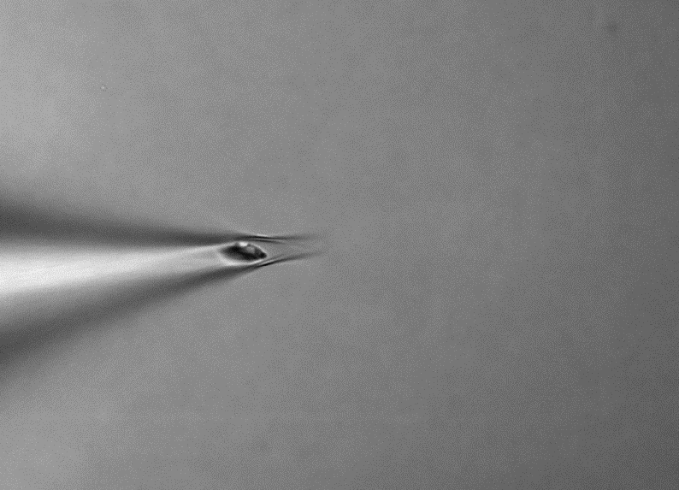 | 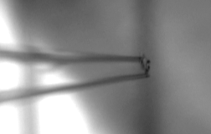
Figure 11: Clogged tip | Figure 12: Broken tip

  - Choosing healthy cells:
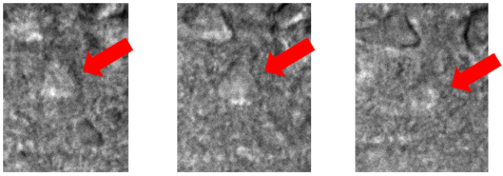
Figure 13 | Figure 14 | Figure 15
Figure 13-15: Healthy looking cells are plump, have 3 dimensions, and contrast when focusing through them.
The three images show the top, middle and bottom of a cell as the microscope focuses downward through the cell.

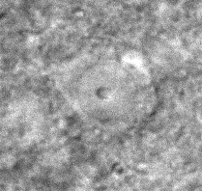 | 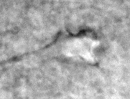 | 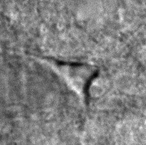
Figure 16: Cells that resemble a fried egg have a collapsed nucleus and are not patchable. They will generally break down when a pipette with positive pressure passes near them. | Figure 17: Wrinkled or shriveled cells are also unhealthy and will not patch easily or will die shortly after being patched. | Figure 18: Cells with dark shadows on the sides or with highly visible dendrites branching out have begun shriveling and should not be considered for patching.

  - Pipette Pulling:
    - Pipettes for patch-seq are made on a Narishige PC-10 puller.
    - Below are example pull settings to make pipettes with the desired resistance of 3-5 MΩ. These may need to be adjusted over time or for different cell types. If the resistance is too high, decrease the stage 2 heat. If the resistance is too low, increase the stage 2 heat. Do this carefully as the knob is very sensitive.
Stage 1 Heater Level | Stage 2 Heater Level
64.3 | 41.0

  - Morning Maintenance
    - Materials List:
      - MilliQ dH2O
      - 24 well plate
      - 24 well plate insert
    - Equipment List:
      - Bubble level
      - Thermometer
      - Lab timer
    - Clean Vacuum Flask:
      - Remove stopper from flask and pour contents of flask down municipal drain.
      - Rinse the flask and place back at rig
      - Replace stopper
    - Carbogen/ACSF Preparation:
      - Remove ACSF.III from deli refrigerator and place at rig.
      - Place fritted gas cylinder in bottle containing ACSF.III.
      - Turn the valve labeled “Carbogen” anti-clockwise to the open position and make sure that carbogen is flowing into ACSF.III solution.
    - Rig Startup:
      - Turn on pump
        - Allow MilliQ dH2O to flow through the pump for at least 30 minutes to allow heater to properly warm up. Always have liquid flowing through the perfusion line while it is heating up to avoid overheating!
        - Verify that MilliQ dH2O is flowing and running across the sample chamber.
      - Turn on heating controller
      - Verify that the vacuum is pulling solution off of sample chamber and into vacuum flask.
      - Verify that solution level looks correct (Solution level at sample stage should be just enough for immersion of 40X objective).
      - Turn on manipulator drivers
      - Check bubble rate for carbogen bottle (moderate bubble rate).
      - Flip on each light source (IR, green, blue) and verify that each is working (Make sure that light intensity is turned up to sufficient level to detect)
      - Check that air table is turned on
        - Gently nudge each corner of the air table to determine if floating or not.
        - If necessary, turn on air to table by turning the valve labeled “Compressed air” in the anti-clockwise direction.
      - Fill ice bucket with ice and remove internal solution from freezer at least 10 minutes prior to recording to allow for thawing.
        - Fill individual blue ice buckets with ice and aliquot 200 µL into individual microtubes and place into metal cold blocks for each rig.
      - Transfer slices from PFA to 1X PBS(-):
        - Turn on PFA hood for plate transfer.
        - Every morning transfer slices in 4%PFA well plate to the plate insert filled with 1X PBS(-).
      - Pre-Recording Check:
        - Verify that perfusion solution has been running for at least 30 minutes and that the temperature in the chamber is 34 C +/- 1 C. Adjust as necessary and record controller settings.
        - Remove perfusion tube from MilliQ dH2O and place in ACSF.III bottle and allow to perfuse for 10 minutes before beginning experiment.
  - Evening Maintenance
    - Materials List:
      - 20 ml of 70% ethanol
      - 2x 250 ml of MilliQ dH2O
      - Spray bottle of 70% ethanol
    - Clean perfusion lines:
      - Remove perfusion tube from ACSF and submerge in 20 ml of 70% EtOH and allow to run through the system for about 30 seconds.
      - Remove tube from 70% EtOH and submerge in 250 ml MilliQ dH2O for about 5 minutes.
    - Clean carbogen bubbler:
      - Remove carbogen bubbler from ACSF.III and place in 250 ml of MilliQ dH2O. Let bubble for about 10 min.
        - Remove bubbler from water and turn carbogen valve clockwise to off position.
      - Remove all carbogen bubbler from ACSF.IV and place into 500 ml of MilliQ dH2O. Let bubble for about 10 min.
        - Pour water down the drain and refill with new MilliQ dH2O for the next day.
        - Remove bubblers from water and turn each carbogen valves to off position and turn carbogen source off.
    - Shut down equipment:
      - Turn off heating control
      - Turn off pump
      - Turn off manipulator drivers.
      - Turn off PFA hod and put specimen plates into refrigerator
    - Clean tissue slice holder:
      - With lid off, remove tissue slice holder insert from outer container and rinse with MilliQ dH2O and scrub outer container with clean abrasive sponge (Be cautious of the netting on the tissue slice holder insert; do not try to scrub netting with sponge as it will tear).
      - Spray tissue slice holder insert and outer container with 70% EtOH, and let sit for a few minutes
      - Rinse with MilliQ dH2O and place back at bench with lid and tissue slice holder insert removed so that all parts can dry overnight

