High fidelity electrophysiological, morphological and transcriptomic cell characterization using a refined Patch-seq protocol
Materials and Reagents
- 0.2 ml PCR 8-strips (USA Scientific 1402-8100)
- 5 or 20 ml syringe with Luer-Lok tip (BD 309646 or 302830)
- 1.5 ml DNA/RNA LoBind tubes (Eppendorf 022431021)
- 20 µl microloader pipette tips (Eppendorf 930001007)
- 3 ml transfer pipets (Falcon 357575)
- 5 ml DNA/RNA LoBind tubes (Eppendorf 0030108310)
- 50 ml conical tubes (Falcon 352098)
- 70% ethanol
- 96-well PCR tube plates (Corning 432053 and Axygen R-96-PCR-FSP)
- Adenosine 5′-triphosphate magnesium salt (ATP-Mg) (Sigma A9187)
- Biocytin (Sigma B4261)
- Capillary filamented glass (Warner Instruments G150F-3)
- Carbogen source
- Disposable plastic spatulas (VWR 80081-188)
- DNA AWAY (Thermo 7010)
- Dry ice
- EGTA, for molecular biology (Sigma E3889)
- Fluorophore (choose one)
- Alexa Fluor 405 Cadaverine (Invitrogen A30675)
- Alexa Fluor 488 Hydrazide (Invitrogen A10436)
- Alexa Fluor 594 Hydrazide (Invitrogen A10438)
- Cascade Blue hydrazide, Trisodium Salt (Invitrogen C687)
- Forceps (Roboz RS-5045)
- Gas dispersion tubes (VWR 39533) or diffusers (Supelco 59277)
- Glycogen, RNA grade (Thermo R0551)
- Guanosine 5’-triphosphate sodium salt hydrate (GTP-Na) (Sigma G8877)
- Harp/slice anchor (Warner Instruments 64-1418)
- HEPES, 1M (Sigma H3537)
- HS NGS Fragment Kit (Agilent DNF-474-1000)
- Ice buckets (Corning 432129)
- Kimwipes
- Nextera XT DNA Sample Preparation Kit (Illumina FC-131-1096).
- Nitrile gloves
- Nuclease-free water (Invitrogen AM9932)
- P1000 pipette tips (Rainin GPL1000F)
- P20 pipette tips (Rainin GPL20F)
- P200 pipette tips (Rainin GPL200F)
- Paintbrushes, #0 (Ted Pella 11810)
- Potassium chloride, 2 M, RNase-free (Invitrogen AM9640G)
- Potassium D-gluconate (K-gluconate) (Sigma G4500)
- Potassium hydroxide, 1 N (VWR BDH7212-1)
- Quant-iT PicoGreen dsDNA Assay Kit (Invitrogen P7589)
- RNase AWAY (Invitrogen 10328011) or RNaseZap (Invitrogen AM9780)
- RNase inhibitor 40 U/µl (Takara 2313B)
- SMART-Seq v4 Ultra Low Input RNA Kit for Sequencing (Takara 634894)
- Sodium phosphocreatine (Sigma P7936)
- Steriflip 0.22 µm filter units (Millipore SCGP00525 or SE1M179M6)
- Ultrafree-MC 0.22 µm centrifugal filters (Millipore UFC30GV0S)
- Wash bottle
- Weigh boats
- Weigh paper
- Wet ice
- Whole Mouse Brain Total RNA (Zyagen MR-201)

Equipment
- 100 ml glass beaker designated for Patch-seq solution preparation
- 100 ml graduated cylinder designated for Patch-seq solution preparation
- 8-channel P10 or P20 pipette
- Calibrated balance
- Electrophysiology rig
  - Data Acquisition Interface (HEKA InstruTECH ITC-18 USB)
  - Amplifier (Molecular Devices MultiClamp 700B)
  - Scientifica SliceScope Pro microscope with PatchStar micromanipulator
  - Camera (pco.pixelfly usb)
  - Pump (Gilson minipuls 3)
  - Heated perfusion tube (ALA Scientific Instruments HPT-2)
  - Temperature controller (npi electronic TC-20)
- Expulsion device (1 ml Luer-Lok syringe connected by tubing to empty pipette holder, see Cadwell et al., 2017).
- Eye protection
- Lab coat
- Magnetic stir bar remover
- Manometer (VWR 33500-086)
- Microcentrifuge (Cole Parmer UX-17310-09)
- Osmometer (Vapro 5600)
- P1000 pipette
- P20 pipette
- P200 pipette
- pH meter
- Pipette puller (Narishige PC-10)
- RNase-free hood (AirClean Systems PCR Workstation)
- RNase-free stir bar designated for Patch-seq solution preparation
- Stir plate
- Vacuum pump (Gast DOA-P104-AA) with Tygon tubing

Software
- Axon MultiClamp 700B Commander (Molecular Devices, https://www.moleculardevices.com/)
- Igor Pro (WaveMetrics, https://www.wavemetrics.com/)
- MIES (Allen Institute, https://github.com/AllenInstitute/MIES/)
- Metadata logging tool (e.g Allen Institute, https://alleninstitute.github.io/jem/src/JEM.html)

Procedure
- Solution Preparation
  - Prepare artificial cerebral spinal fluid (ACSF) solutions for mouse transcardial perfusion or human surgical tissue transportation and slicing, slice incubation, and recording, as previously reported in Gouwens et al., 2019 and 2020 (mouse perfusion or human transport and slicing ACSF, mouse or human slice incubation ACSF, and recording ACSF on protocols.io). Additional precautions should be taken when making the solutions. All steps should be performed in a clean environment and solutions should be filtered with a 1 liter 0.45 µm filter system (Corning 430516).
  - Prepare Patch-seq internal solution with biocytin. All steps should be performed in an RNase-free hood. *The instructions below are designed/formulated for a high throughput laboratory. Desired volumes can be altered as necessary.*
    - Prepare working stocks of reagents. These should be used for Patch-seq internal solution only and stored in RNAse-free conditions. Label the stock bottles with contents, preparer’s initials, preparation date, storage requirement and expiration date.
    - EGTA stock: Prepare a 192 mM stock solution by first dissolving 3.65 g of EGTA in 32 ml nuclease-free water in a labeled 50 ml conical tube. Add 1 N KOH dropwise until the EGTA goes into solution (this may take up to 10 ml). Bring the final volume up to 50 ml with nuclease-free water. Store the stock solution at 4 °C for up to 60 days.
    - Fluor dye stock: Prepare a ~10 mM stock by adding 175 µl of nuclease-free water into 1 mg unit of desired dye in 1.5 ml LoBind tube. Aliquot 25 µl quantities of stock into PCR strips.
    - Label each tube with its expiration date.
    - Store at -20 °C for up to 6 months.
    - Set up hood.
      - Set up the stir plate and gather all materials in the RNase-free hood.
      - Obtain an RNase-free stir bar and place it in the glass beaker designated for Patch-seq solution preparation.
      - Wipe all surfaces with RNase AWAY or RNaseZap, then 70% EtOH.
    - Prepare internal stock solution - 80 ml final volume.
      - Using a graduated cylinder, measure 60 ml of nuclease-free water. Add the water to the glass beaker.
      - Obtain a glass dish or tray and place a mixture of wet and dry ice onto it. Place the beaker down into the ice mixture for the duration of the process. Place the glass beaker in the glass dish on a stir plate and begin stirring at a high setting (7 or higher).
      - Using a calibrated balance, weigh out 2.06 g of K-gluconate. Slowly add weighed K-gluconate to the glass beaker while stirring.
      - Using a P200 pipettor, add 160 µl of the 2 M KCl solution to the glass beaker while stirring.
      - Using a P1000 pipettor, add 800 µl of the 1 M HEPES to the glass beaker while stirring.
      - Using a calibrated balance, weigh out 40.56 mg of ATP-Mg. Slowly add weighed ATP-Mg to the glass beaker while stirring.
      - Using a calibrated balance, weigh out 12.56 mg of GTP-Na. Slowly add weighed GTP-Na to the glass beaker while stirring.
      - Using a calibrated balance, weigh out 204.08 mg of sodium phosphocreatine. Slowly add weighed sodium phosphocreatine to the glass beaker while stirring.
      - Using a calibrated balance, weigh out 400 mg of biocytin. Slowly add weighed biocytin to the glass beaker while stirring.
      - Using a P200 pipettor, add 82 µl of the 192 mM EGTA stock solution to the glass beaker while stirring.
      - Using a P200 pipettor, add 80 µl of the 20 mg/ml glycogen solution to the glass beaker while stirring.
      - Continue stirring at a high speed (setting 7 or higher) until all the chemicals are fully in solution. This should only require less than a minute.
      - Using a calibrated pH meter in a fume hood, measure the pH of the internal solution. Adjust the pH to 7.3 by adding 1 N KOH in 40 µl increments. Caution: use small incremental volumes to avoid overshooting the 7.3 target pH. If this happens, the prep must be discarded.
      - Remove stir bar using a magnetic stir bar remover.
      - Adjust final volume to 78 ml with nuclease-free water using the graduation marks on the side of the glass beaker (if calibrated) or a graduated cylinder.
      - Measure the osmolarity of a 10 µl sample of the solution using an osmometer. If the osmolarity is not 220-230 mOsm, adjust as needed:
        - If the osmolarity is too high, add nuclease-free water.
        - If the osmolarity is too low, add K-gluconate in µg increments.
        - Confirm that the correct osmolarity has been reached after addition of K-gluconate or water.
      - Filter the internal solution through a Steriflip 0.22 µm filter system.
        - Using Tygon tubing, attach the filter system to the Gast vacuum pump. Turn on the pump.
      - Aliquot internal stock solution into 10 ml quantities (this volume can be changed dependent on the frequency of usage).
        - Label the tubes with the expiration date.
        - Store 5 ml aliquots at -80 °C for up to 60 days.
      - Every two weeks thaw a 10 ml aliquot to prepare internal stock solution for final additions.
        - Using a P20 pipettor, add 125 µl of RNase inhibitor (40 U/µl) to 10 ml of internal solution.
        - Using a P20 pipettor, add 50 µl of the desired fluorophore stock (~10 mM) to the same 10 ml of internal solution.
        - Transfer 500 µl of internal solution into each of 20 Millipore centrifugal filters. Spin down at 200x g until the solution has passed through the PVDF membrane (3 minutes).
        - Repeat this step with a fresh set of filters to ensure solution is free of particles.
        - Measure and record the final osmolarity of a 10 µl sample of the solution using an osmometer. Final osmolarity should be ~330-335 mOsm.
        - Aliquot 200 µl (or desired daily quantity) into 1.5 ml LoBind tubes (37-39 tubes per 10ml), using a P1000 pipette.
        - Label and store tubes in a freezer box at -80 °C.
      - Test new batches of internal solution for contamination. At some point before recordings/experiments begin, the internal will need to be validated to ensure it is free of contaminants.
        - 5 µl of internal solution is added to a “blank” and is processed for Smarter reaction. Bioanalyzer traces are examined and if amplifiable content is detected, the batched should be discarded and made again.
  - Prepare collection buffer “blanks”
    - Combine SMART-Seq v4 lysis buffer at 0.83x of the manufactured concentration, RNase Inhibitor (0.17 U/µl), and ERCCs (External RNA Controls Consortium) (Baker et al., Risso et al.) (MIX1 at 1x10⁻⁸) to make collection buffer.
    - Fill 0.2 ml PCR tubes with 10.4 µl of collection buffer in each and store at -80 °C.
- Daily Setup
  - Prepare slices.
    - Prepare mouse or human brain slices as previously reported (Gouwens et al., 2019 and 2020, Bakken et al., 2020, protocols.io, protocols.io)
    - Slice health is key in obtaining good electrophysiological, transcriptomic and morphological data.
    - Allow the slices to rest in incubation ACSF for at least 1 hour after slicing.
  - Set up laminar flow hoods.
    - Wipe down the ice buckets and 96-well plates with DNA AWAY, RNase AWAY or RNaseZap, and nuclease-free water. Additionally, to maintain a sterile working environment, wipe down the hoods with 70% ethanol.
    - Fill three ice buckets – one with wet ice and two with dry ice. Place tubes containing lysis buffer (“blanks”) in a plastic 96-well plate on wet ice. Internal solution and sample tubes will be placed on dry ice.
  - Prepare internal solution for immediate use.
      - Retrieve a 200 µl aliquot of internal solution from the -80 °C freezer and thaw.
    - Re-filter the internal solution, to ensure it is free of contaminants, by transferring it to a Millipore centrifugal filter and spinning it down at 200x g until the solution has passed through the PVDF membrane (3 minutes).
    - Aliquot 5 µl quantities into 0.2 ml PCR tube strips, using an 8-channel P10 or P20 pipette.
    - Place the PCR strips containing internal solution in a plastic 96-well plate on dry ice. *These are designed for single use and remain on dry ice until time of recording*
  - Set up and clean electrophysiology rig and surrounding workspace.
    - Wipe down the headstage and pipette holder with DNA AWAY, RNase AWAY or RNaseZap, and nuclease-free water (in that order). Wipe down the electrode wire with nuclease-free water only.
    - Wipe down the desk area (including manipulator and stage controllers, keyboard, and computer mouse) with 70% ethanol.
    - Perfuse oxygenated recording ACSF at 2 mL/min for approximately 10 minutes prior to placing a slice on the rig. The temperature in the chamber should be 34 ± 1 °C.
    - You should have a tool (e.g. electronic lab notebook) to log metadata and associate it with the raw data. As an example, we use the online JEM form listed under Software.
  - Pull patch pipettes.
    - Pull pipettes using a Narishige PC-10. Aim for a resistance of 3.5-5 MΩ. Do not pull more than three pairs of pipettes at a time as the heater coil will get too hot, negatively impacting the shape of the pipettes.
    - It is imperative to use filamented pipettes. The amount of internal solution to be used for each experiment is small and requires the filament to ensure physical contact with the electrode wire.

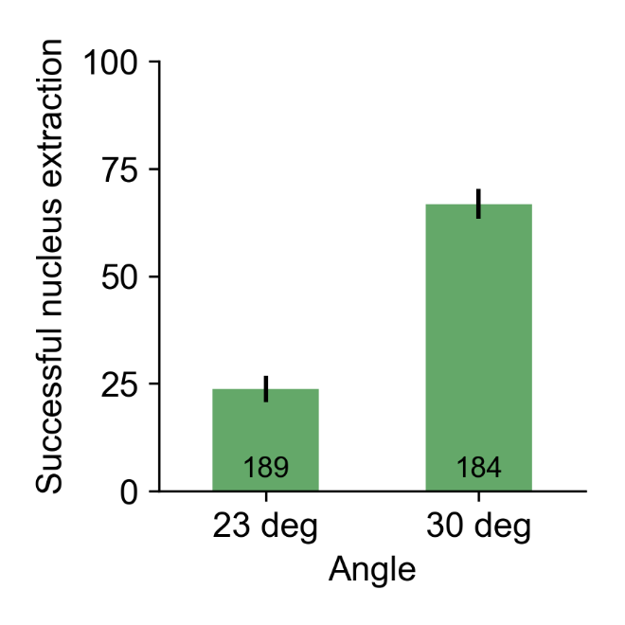

Figure 1. Successful nucleus extraction is influenced by angle of pipette and manipulator. The success of extracting the nucleus at the conclusion of a recording is significantly higher when the pipette and manipulator are at a steeper angler (23° versus 30°).

    - Pipettes should be stored in a closed box until ready to be used.
    - Pull fresh pipettes each day, as pipettes left overnight will make it harder to seal and potentially increase the risk of contamination.
- Whole Cell Patch Clamp Electrophysiology Recording
  - Set the approach angle of the micromanipulator to 30°. This steeper angle results in greater success when extracting nuclei (see Figure 1).
  - Using a transfer pipet with the tip cut off, transfer a tissue slice from the holding carousel to the rig chamber.
    - Use a clean paintbrush or the closed tips of forceps to position the tissue in the center of the chamber.
    - Use the forceps to set the harp on top of the slice, positioning it so the region of interest is between harp strings.

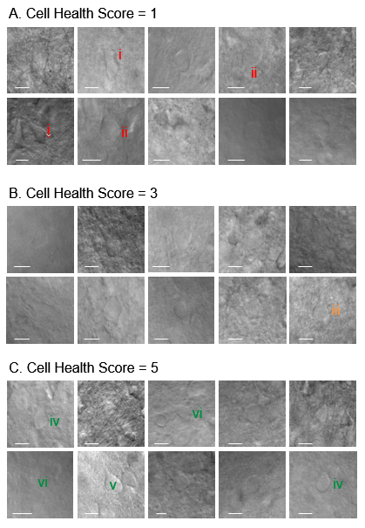
Figure 2. Cell health examples. Examples of cell health calls, their corresponding images under brightfield 40x magnification and representative features. A. Cell health score = 1 features include: i) shriveled/dark edge or ii) flat and swollen appearance. B. Cell health score = 3 features include: iii) smoother, more defined soma. C. Cell health score = 5 features include: iv) well defined soma, v) plump, 3D shape and/or vi) soft and lighter/dim in appearance.

  - Identify a cell to patch under 40x magnification.
    - It is extremely important to pick a healthy cell, e.g. plump and smooth, not shriveled or blown out (Figure 2).
    - If patching a fluorescently labeled cell, it should also be clearly defined (and have visible dendrites) under the appropriate fluorescent filter.
  - Wipe the electrode wire using a Kimwipe and nuclease-free water.
  - Using a fresh microloader tip on a 20 µl pipette, fill the tip of the glass pipette with approximately 1-2 µl of internal solution.
    - Slide the microloader tip almost to the end of the pipette and push the plunger down to fill.
    - It may be necessary to flick and/or shake the pipette to eliminate bubbles and ensure the solution is all the way in the tip.
  - Attach the pipette to the pipette holder/headstage. Apply some positive pressure (30-70 mbar) and insert the tip of the pipette into the bath; the pipette resistance should measure about 3.5-5 MΩ.
  - Bring the pipette just above the slice surface. Increase the positive pressure to ~70 mbar, if necessary. Use Auto Pipette Offset to compensate for the junction potential difference; the pipette offset should be 60-80 mV. Visually check for clogs in the pipette, as these will prevent successful sealing.
  - With the internal-filled pipette, approach the cell; a pressure wave should be observed as the pipette enters the tissue.
    - Once the pipette enters the tissue, it is important to navigate quickly to the target cell to avoid picking up debris.
    - It can be helpful to approach the cell at an angle while maneuvering carefully to avoid other cells and blood vessels.
  - Bring the pipette tip into contact with the cell, slightly pressing on the membrane until a small dimple appears or the access resistance increases by at least 0.2 MΩ. Quickly release the positive pressure. As the seal resistance increases, apply holding voltage, eventually holding the cell at -70 mV. Apply negative pressure, if necessary, in order to achieve a GΩ seal.
    - If a cell seals up quickly, it should be okay to apply the -70 mV holding voltage all at once.
    - If a cell is slower to seal, it can be helpful to lower the holding voltage more gradually.
  - Once the seal resistance reaches at least 1 GΩ, use Auto Cp Fast to compensate for pipette capacitance. Adjust the Cp Fast values manually, if necessary.
  - Position the pipette towards the center of the cell and apply small bursts of negative pressure (-50 to -150 mbar) and/or zap (starting at 25 µs) to break into the cell.
    - Upon break-in, the access resistance should be less than 20 MΩ and less than 15% of the input resistance. If the access resistance is too high, attempt to lower it by applying negative pressure and/or using zap. If the access cannot be improved to meet QC criteria, abort the recording and find a new cell at least 250 µm away. *AIBS QC criteria*
    - It can be helpful to apply a small amount of suction (<10 mbar) after break-in to combat swelling caused by the relatively high osmolarity of the internal solution. This is more important for larger cells.
  - Once whole cell configuration has been achieved, perform the acquisition protocols specific to the area of interest.
- Extraction Phase - upon completion of electrophysiological examination, extract the cytosol with a focus on positioning the pipette near the nucleus and maintaining the seal.
  - Re-center the pipette on the cell, if necessary.
    - Locate the nucleus, if possible, and press the pipette right up against the nuclear membrane. Note that the pipette may be above the nucleus and will need to be re-centered in the x, y, and z directions.
    - The nucleus is sometimes visible as a dark circle when viewed with the fluorescent filter.
    - If the nucleus is not visible, center the pipette on the plumpest part of the cell.
  - Slowly apply negative pressure while visualizing the shape of the soma and the stability of the cell membrane in the test pulse window. Continue to increase the pressure as long as the patch appears stable. The amount of pressure a cell can withstand will depend on species, cell type, size, health and the size of the pipette but will generally be in the -30 to -50 mbar range.
    - If the membrane begins to destabilize (visually or through test pulse), release the negative pressure, wait until it has stabilized, then try again.
    - If the nucleus gets sucked in, immediately release the negative pressure and continue to retraction and expulsion.
    - If the seal is lost completely (<50 MΩ), discard the pipette and find a new cell. This usually indicates the somatic membrane has completely deconstructed and will not result in a high quality biocytin/Alexa fill.
- Retraction Phase - once the cell has visibly shrunk (or after about 2 minutes), retract the pipette with a focus on obtaining a nucleated patch.
  - Re-center the pipette on the cell/nucleus again. When re-centering the pipette, the nucleus may be visible (brightfield or fluorescence, Figure 3). If possible, try to “nudge” the pipette against the edge of the nucleus. This is helpful in increasing the success of nucleus extraction.
    - If the membrane begins to destabilize, reduce or release the negative pressure and try to re-center the pipette on the cell.
  - With continued negative pressure, move the pipette tip towards the edge of the membrane, checking for the nucleus to follow. Once the nucleus has been pulled to the edge of the cell membrane, switch the approach of the pipette from cartesian to diagonal mode. Pull the pipette out of the cell very slowly, keeping a close eye on the tip to ensure the nucleus is secured.
    - It is essential to pause at intervals to let the membrane relax, rather than pull at a constant rate.
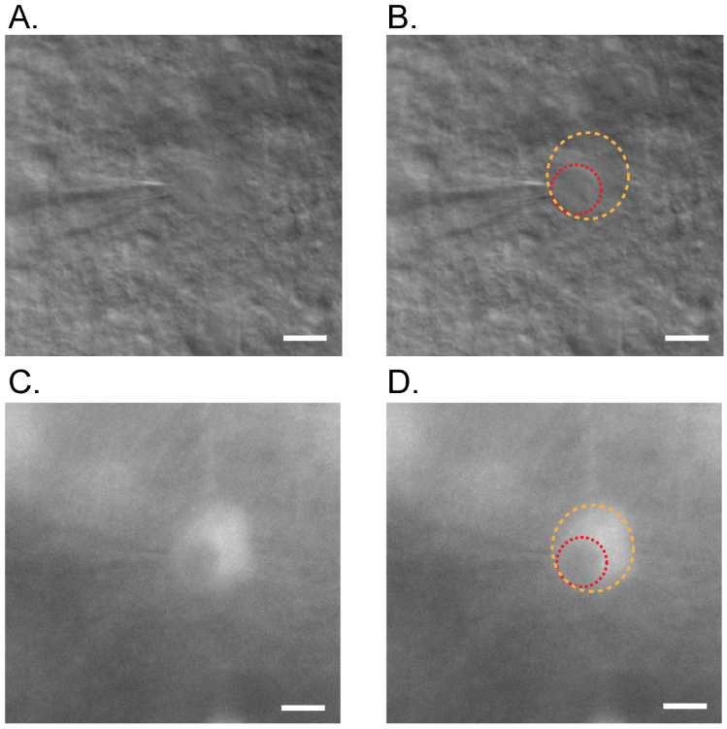
Figure 3. Example of soma and nucleus identification. A. At the conclusion of a patch-seq recording, the soma is often slightly swollen and difficult to see under brightfield 40x image, but many times the nucleus is visible and will aid in re-centering the pipette in preparation for nucleus extraction. B. An orange dotted line is drawn around the soma and a red dotted line is drawn around the nucleus to assist in identification. If using a fluorescent reporter to identify and cells of interest, switching to the appropriate filter to view native fluorescence will help in identifying the outer limits of the somatic membrane and nucleus (C and D).

    - It is typical to retract at a rate of 1 µm per second or less. This retraction can take anywhere from 1-10 minutes, depending on size of the cell/nucleus. Bigger nuclei generally take longer.
    - The access resistance should remain low at first. If the pipette starts to pull away without the nucleus, the access resistance may start to increase. If this occurs, re-position the pipette against the nucleus (the access resistance should decrease again), increase the negative pressure, and attempt to retract again.
    - Watch for the edges of the nucleus to become more visible as it pulls out of the cell. At this point, the seal resistance will increase, often quite rapidly.
    - If the nucleus looks like it is getting sucked in, release the negative pressure immediately and continue retracting.
    - If at any point the nucleus is lost and cannot be retrieved, a decision needs to be made as to whether to discard the pipette or move on to the expulsion phase (F). Patch-seq samples without the nucleus often contain insufficient mRNA quantity.
    - If a GΩ seal is achieved during retraction, assume the somatic membrane has resealed, forming a nucleated patch. Even if the seal on the nucleus is subsequently lost, proceed with retraction and expulsion. If, however, the seal is lost completely (<50 MΩ) without ever achieving a GΩ seal, this usually indicates a complete rupture of the somatic membrane and is unlikely to result in a successful biocytin/Alexa fill. In this case, a decision needs to be made to abandon the experiment or continue to expulsion phase (F).
  - Continue retracting the pipette until it is fully removed from the slice.
    - Once the nucleus has been obtained with a high post-seal resistance (>1000 MΩ), it is safe to increase the speed of retraction.
    - If the post-seal resistance never reaches 1 GΩ, but the nucleus is still attached to the pipette once it is fully retracted out of the slice, attempt to suck in the nucleus by increasing the negative pressure.
      - Once the nucleus has been sucked in, release the negative pressure immediately so as not to contaminate the sample.
      - Sucking in the nucleus at this point helps ensure that it is not lost due to a weak seal when the pipette is removed from the bath.
- Expulsion Phase - once the pipette has been removed from the tissue, expel the cytosol and nucleus into a lysis buffer “blank.”
  - Remove the pipette from the bath and detach it from the holder.
  - Insert the pipette into the expulsion device and tighten the holding screw.
  - Apply a small amount of positive pressure to the expulsion device (displace about 0.05-0.1 ml of a 1 ml syringe, which is equivalent to approximately 10-20 mbar); the pressure required to efficiently expel the contents without introducing air bubbles may vary depending on the syringe and the tubing length. It is important to titrate the proper amount of pressure to apply.
      - Too little pressure will leave solution in the pipette.
      - Too much pressure will result in bubbles that displace the solution, forcing it up the walls of the tube and the shank of the pipette. This may result in loss of cytosolic and/or nuclear material.
  - Open the cap of a PCR tube containing the collection buffer. Carefully insert the pipette into the tube and submerge the tip into the lysis buffer solution. Break off a small piece of the tip by gently touching the side wall or bottom of the tube while it is submerged. The small amount of positive pressure previously applied will force the contents out of the pipette. Watch carefully as the pipette contents drain into the solution and simultaneously raise the pipette out of the solution as the last of the contents empties into the tube.
  - Spin down the contents of the tube in a microcentrifuge for about 5 seconds at ~6000 rpm.
  - Label the tube and place it in a metal 96-well plate on dry ice to flash freeze and store.
  - Sample tubes can remain on dry ice for the remainder of the day and then transferred to a -80 °C freezer until Smarter processing.
    - Samples have been stored at -80°C for up to 2 years with no evidence of material degradation.
- Biocytin Fill
  - Use the appropriate fluorescent filter to check the Alexa fill for rapid feedback on fill quality. If triple modality is necessary, but there is no Alexa fill visible, a decision needs to be made about whether to proceed with mRNA processing of the previously deposited sample. Figure 4 shows a strong relationship between a Bad Fill call by the operator and a Failed final morphology call.
  - If proceeding to another cell, start at Section C.3 again. Otherwise move on to the next step.
  - Before transferring the slice to 4% PFA with 2.5% glutaraldehyde for fixation, remove the harp and allow the slice to rest for a few minutes.

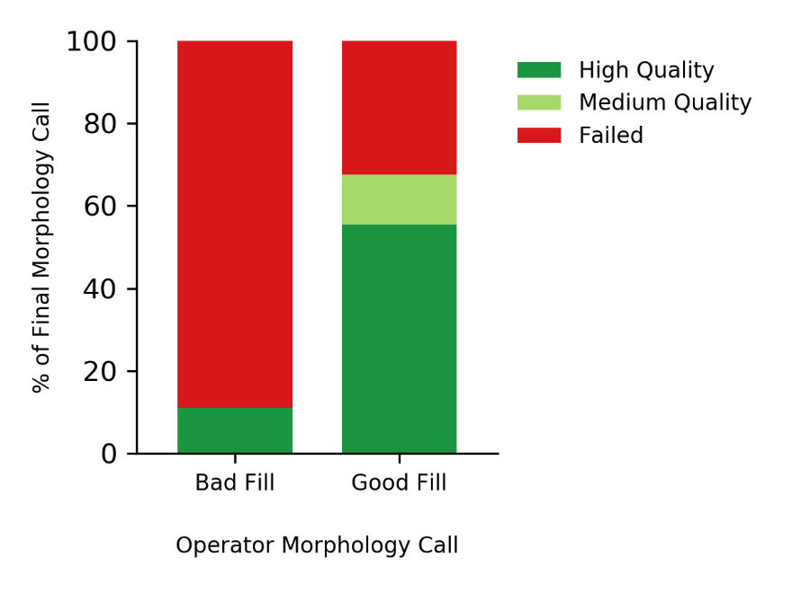
Figure 4. Observation accuracy. For rapid feedback upon completion of whole-cell patch clamp recording, operators viewed the cell to provide a judgment call on the quality of the fill as indicated by fluorescent Alexa fill (Bad Fill or Good Fill). These calls were compared with the final morphology call as indicated by the biocytin fill and image processing. If the operators judged the fill as Bad, it had a 90% chance of receiving a Failed final morphology call. A Good Fill call, on the other hand, had a nearly 70% chance of having High or Medium Quality morphology.

- Biocytin Processing
  - See Gouwens et al., 2019 and 2020 for standardization of biocytin staining and image processing (protocols.io).
- mRNA Processing
  - Refer to the manufacturer instructions for Takara SMART-Seq v4 Ultra Low input RNA Kit for Sequencing at 1x to perform the amplification reaction.
    - Allen Institute uses 20 PCR cycles for amplification of patched nuclei.
  - Prepare 88 sample tubes and a control strip on ice for processing.
    - The control is a 0.2 ml PCR 8-strip tube containing 11.6 µl of collection buffer with various positive and negative inputs. The 8-strip is comprised of:
      - 2 wells without cells (termed ERCC)
      - 2 wells without cells or ERCC (containing only SMART-Seq v4 lysis buffer at 0.83x of the manufactured concentration and RNase Inhibitor (0.17 U/µl), termed NTC)
      - 2 wells with 10 pg of Whole Mouse Brain Total RNA
      - 2 wells of 10 pg Control RNA provided in the Takara kit.
  - Perform purification of the amplification product via bead cleanup (use a 1x bead ratio) with a final elution volume of 17 µl (Elution Buffer: 10mM Tris-Cl, pH 8.5) for each sample and control.
  - Perform quality check analysis on the amplification product.
    - Quantify sizing and yield of the amplification product on Fragment Analyzer by preparing with HS NGS Fragment Kit (see Figure 5).
    - Quantify yield of amplification product with Invitrogen Quant-iT PicoGreen dsDNA Assay Kit.
    - Confirm control products fall within expectations for negative and positive presence of product.
    - Determine whether each sample has successfully completed the amplification reaction (see Figure 5).
      - Samples typically receive a Pass call if more than 50% of the product falls within the size range of 400-6000 bp.
      - Samples typically receive as Fail call if less than 40% of the product falls inside the size range of 400-6000 bp.
      - Samples with 40-50% of product the size range of 400-6000 bp should take further consideration of the content and Fragment Analyzer trace to determine a Pass or Fail call.
      - The optimal yield for the amplification product is over 7000 pg.
      - Samples below 6000 pg should be considered for a Fail call if the Fragment Analyzer trace does not provide the presence of product.
      - Confirm that the PicoGreen and Fragment Analyzer measurements of yield are consistent with each other by calculating the PG/FA yield ratio. The ratio typically falls between the range of 0.80 to 1.20.

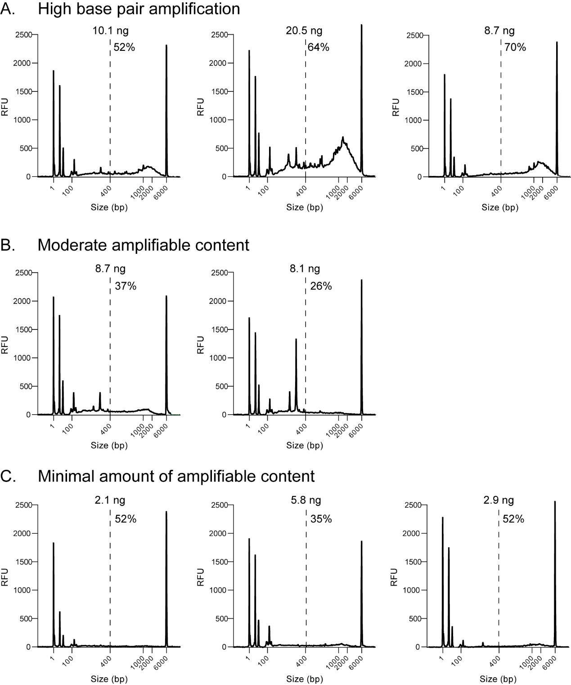
Figure 5. Example electrophoretograms obtained by fragment analyzer of cDNA amplifications from patch-seq samples. Several examples are shown for cells that had (A) high b.p., (B) moderate, and (C) negligible amounts of amplifiable material. Dashed lines indicate the boundary (400 b.p.) of high versus low b.p. amplification. Percentage of material that corresponds to above >400 b.p. is listed in each panel.

- Library prep
  - Normalize the concentration of the cDNA 50 pg/µl by diluting the samples with appropriate volumes of Nuclease-Free Water added to a 2-4 µl aliquot of amplification product.
  - Refer to the manufacturer protocol for Nextera XT DNA Sample Preparation Kit.
    - A reduction in volume from the manufacturer’s protocol is applied to input and all reagents, use 0.2x of the volumes instructed for each reaction to prepare the library. Five plates of 96-samples can be processed using one Nextera XT DNA Sample Preparation Kit.
    - The libraries are indexed by custom 10-base unique dual-index primers designed and manufactured by IDT (Integrated DNA Technologies).
      - Samples and controls each receive a unique index from our selection of 768 unique indexes via 8x96 plates.
      - During the processing, each sample receives 2 µl of index primers (forward and reverse combined) at a concentration of 2.5 µM each.
  - Perform purification of library product via bead cleanup (use a 0.9x bead ratio) with a final elution volume of 22 µl (Elution Buffer: 10mM Tris-Cl, pH 8.5) for each sample and control.
  - Perform quality check analysis on the library product.
    - Quantify sizing and concentration of the library product on Fragment Analyzer by preparing with HS NGS Fragment Kit.
    - Quantify concentration of library product with Invitrogen Quant-iT PicoGreen dsDNA Assay Kit.
    - Confirm control products fall within expectations for negative and positive presence of product.
    - Determine whether each sample has successfully completed the library reaction.
      - Confirm that library Pass/Fail calls are consistent with their corresponding amplification calls.
      - The Fragment Analyzer traces need to be examined for appropriate shape, the average size for the samples should be around 300 bp.
      - The concentration of the product will usually be around 1.5 ng/µl.
      - Confirm that the PicoGreen and Fragment Analyzer measurements of concentration are consistent with each other by calculating the PG/FA yield ratio. The ratio typically falls between the range of 0.80 to 1.20.
  - Normalize 5 µl of the library product to 4-8 nM by diluting the samples with appropriate volumes of Nuclease-Free Water. Calculate nM by using average size obtained from the Fragment Analyzer and concentration obtained from the PicoGreen assay.
- Sequencing
- Pool samples within one 96-index set together by taking 2 µl from each sample to a total of 192 µl at the normalized 2-10 nM concentration.
- Further multiplex the libraries by pooling together 8x96 libraries with compatible index sets to run on each lane of an Illumina NovaSeqS2-XP to achieve ~500K PE50 reads per sample. Every pooled library must be at the same normalized molarity for even read depth among all samples.
- A portion of the final library pool is then sent to an outside vendor (The Broad Institute Inc, Clinical Research Sequencing Platform LLC) for sequencing on NovaSeqSP-XP instrument.

Table 1. Patch-seq internal solution
Reagent | Supplier, Part # | Concentration
K-gluconate | Sigma G4500 | 110 mM
KCl solution (2 M), RNase-free | Invitrogen AM9640G | 4 mM
HEPES solution (1 M) | Sigma H3537 | 10 mM
ATP-Mg | Sigma A9187 | 1 mM
GTP-Na | Sigma G8877 | 0.3 mM
Sodium phosphocreatine | Sigma P7936 | 10 mM
EGTA, for molecular biology; 192 mM stock | Sigma E3889 | 0.2 mM
Glycogen solution, RNA grade (20 mg/ml) | Thermo R0551 | 20 µg/ml
Biocytin | Sigma B4261 | 13.4 mM
RNase inhibitor | Takara 2313B | 0.5 U/µl
Fluor stock  (variant dependent on preference) |  | ~50 µM

Table 2. ACSF solutions
Reagent | Supplier, Part # | Mouse Slicing ACSF (ACSF I) | Human Slicing ACSF (ACSF VII) | Mouse Incubation ACSF  (ACSF IV) | Human Incubation ACSF (ACSF VIII) | Recording ACSF (ACSF III)
Calcium chloride dihydrate | Sigma C3306 | 0.5 mM | 0.5 mM | 2 mM | 2 mM | 2 mM
D-glucose (dextrose) | Sigma G7021 | 25 mM | 25 mM | 25 mM | 25 mM | 12.5 mM
HCl | VWR BDH7419-1 | 98 mM | 92 mM | 0 | 0 | 0
HEPES | Sigma H3375 | 20 mM | 20 mM | 20 mM | 20 mM | 0
Kynurenic acid | Sigma K3375 | 0 | 0 | 0 | 0 | 1 mM
Magnesium sulfate | Sigma M1880 | 10 mM | 10 mM | 2 mM | 2 mM | 1 mM
Monosodium phosphate | Sigma S9638 | 1.25 mM | 1.2 mM | 1.25 mM | 1.2 mM | 1.25 mM
Myo-inositol | Sigma I5125 | 3 mM | 0 | 3 mM | 0 | 0
N-acetyl-L-cysteine | Sigma A7250 | 12 mM | 0 | 12.3 mM | 0 | 0
N-methyl-D-glucamine | Sigma M2004 | 96 mM | 92 mM | 0 | 0 | 0
Picrotoxin | Abcam ab120315 | 0 | 0 | 0 | 0 | 0.1 mM
Potassium chloride | Sigma P9333 | 2.5 mM | 2.5 mM | 2.5 mM | 2.5 mM | 2.5 mM
Sodium bicarbonate | Sigma S5761 | 25 mM | 30 mM | 25 mM | 30 mM | 26 mM
Sodium chloride | VWR JT4058 | 0 | 0 | 94 mM | 92 mM | 126 mM
Sodium L-ascorbate | Sigma A7631 | 5 mM | 5 mM | 5 mM | 5 mM | 0
Sodium pyruvate | VWR JT3354 | 3 mM | 3 mM | 3 mM | 3 mM | 0
Taurine | Sigma 86329 | 0.01 mM | 0 | 0.01 mM | 0 | 0
Thiourea | Sigma T7875 | 2 mM | 2 mM | 2 mM | 2 mM | 0

References
Allen Institute for Brain Science 2020. Artificial Cerebrospinal Fluid I (ACSF.I). protocols.io dx.doi.org/10.17504/protocols.io.bezkjf4w
Allen Institute for Brain Science 2020. Artificial Cerebrospinal Fluid III (ACSF.III) V.3. protocols.io dx.doi.org/10.17504/protocols.io.beptjdnn
Allen Institute for Brain Science 2020. Artificial Cerebrospinal Fluid IV (ACSF.IV) V.3. protocols.io dx.doi.org/10.17504/protocols.io.bepsjdne
Allen Institute for Brain Science 2020. Artificial Cerebrospinal Fluid VII (ACSF.VII). protocols.io dx.doi.org/10.17504/protocols.io.beznjf5e
Allen Institute for Brain Science 2020. Artificial Cerebrospinal Fluid VIII (ACSF.VIII) V.3. protocols.io dx.doi.org/10.17504/protocols.io.beprjdm6
Allen Institute for Brain Science 2020. DAB Detection of Biocytin Labeled Tissue V.5. protocols.io dx.doi.org/10.17504/protocols.io.bg5yjy7w
Allen Institute for Brain Science 2020. Human Neurosurgical Tissue Processing V.7. protocols.io dx.doi.org/10.17504/protocols.io.bf66jrhe
Allen Institute for Brain Science 2020. Slice Preparation and Blockface Imaging for Electrophysiology – Mouse V.4. protocols.io dx.doi.org/10.17504/protocols.io.be2gjgbw
Baker SC, et al., The External RNA Controls Consortium: a progress report. Nature Methods 2: 731-734 (2005).
Bakken TE, et al., Evolution of cellular diversity in primary motor cortex of human, marmoset monkey, and mouse. BioRxiv, (2020).
Cadwell CR, et al., Multimodal profiling of single-cell morphology, electrophysiology, and gene expression using Patch-seq. Nature Protocols 12: 2531-2553 (2017).
Dobin A, et al., STAR: Ultrafast universal RNA-seq aligner. Bioinformatics 29: 15-21 (2013).
Gouwens NW, et al., Classification of electrophysiological and morphological neuron types in the mouse visual cortex. Nature Neuroscience 22: 1182-1195 (2019).
Gouwens NW, et al., Toward an integrated classification of neuronal cell types: morphoelectric and transcriptomic characterization of individual GABAergic cortical neurons. BioRxiv, (2020).
Risso D, et al., Normalization of RNA-seq data using factor analysis of control genes or samples. Nature Biotechnology 32: 896-902 (2014).

