Real Time Polymerase Chain Reaction to identify and characterize Neisseria meningitidis

Standard Operating Procedure (SOP)

Title: Real Time Polymerase chain reaction (qPCR) to identify and characterize Neisseria meningitidis (N.m.)

Revision Date: 30 October 2017 | Effective Date: 01 November 2017
 | Version #: 3.0
Authorized by Principal Investigators and/or their designee(s):

Printed Name, Title Signature Date

…………………………………..………. ………………………...………

Printed Name, Title Signature Date

…………………………………..………. ………………………...………

Printed Name, Title Signature Date

…………………………………..………. ………………………...………

Printed Name, Title Signature Date

…………………………………..………. ………………………...………

Printed Name, Title Signature Date

…………………………………..………. ………………………...………

Name of study staff who have read and  understood this  Standard Operating Procedure | Signature | Date

Table of contents:

I. OBJECTIVE 3
II. RESPONSIBILITY 3
III. MATERIAL AND REAGENTS 4
IV. PROCEDURE 4
A. PCR 1 Room (“Clean room” or “Pre-PCR room”) 6
B. Master Mix (MMx) preparation 7
MMx 1: sod C, porA, cnl 7
MMx 2: A, W, X 8
MMx 3: B, C, Y 9
MMx 4: H, E, Z 9
C. PCR 2 Room or DNA template addition room: Adding DNA 10
D. PCR 3 Room, Amplification 10

V. Results interpretation 12
A. Automatic analysis 13
B. Manual analysis 13

Appendix 1: Example of samples spreadsheet for 40 samples 3 NTC and standard curves 15
Appendix 2: Example of MMx spreadsheet 16
Appendix 3: Preparation of Standard Curves 17
Appendix 4: Use reverse repetitive pipetting to ensure accuracy: 18
Appendix 5: Primers and probes dilutions: 19
Appendix 6: Sequences and dyes for primers and probes: Erreur ! Signet non défini.

OBJECTIVE

This Standard Operating Procedure (SOP) describes the technique to be used for the molecular identification of Neisseria meningitidis (N.m.) through 4 multiplexes real-time PCR (qPCR) reactions for the identification of capsulated N.m and 9 serogroups (A, B, C, E, H, W, X, Y, Z) as well as non-capsulated N.m (cnl)

The objective is to be able to identify most capsulated N.m strains and non-capsulated strains in a series of reactions that start by testing the most expected common strains found in carriers in the African Meningitis Belt and progressively test the less common strains.

RESPONSIBILITY
A suitably trained lab technician will perform the technique on the sample.

MATERIAL AND REAGENTS

Material
DNA hood
Water bath
Microtubes Safe-Lock (1,5ml-2ml)
Micropipettes P1000, P200, P20, P10
Barrier tips 1000, 200, 20, 10
96 microtubes reversible carrier
Racks
Vortex
Mini centrifuge
96-well Fast Thermal Cycling Plates (ABI ref: 4346907)
FG, optical cap (8 CAPS/STRIPS) (ABI ref: 4323032)
Real Time PCR Fast 7500 (ABI)
96 wells plate microcentrifuge
96 wells plate holder
Reagents:
PBS
Molecular Biology Grade sterile water
FG, Taqman GEx Master Mix 5ml (ABI ref: 4369016)

Or:
4370048 TaqMan® Gene Expression Master Mix, 1 Mini-Pack (1 x 1 mL)

Or

4369542 TaqMan® Gene Expression Master Mix, 10-Pack (10 x 5 mL)
Please, avoid the following reagent that does not allow multiplex PCR:
4440046 Taqman Universal Master Mix II with UNG

Primers and probes from ABI/CDC (see Appendix 3)

PROCEDURE
This procedure is to be performed on all swab oro-pharyngeal collected samples after culture or FTA minicard collection and DNA extraction. This real-time Polymerase Chain Reaction (qPCR) will allow identification of Neisseria meningitidis (N.m.), as well as its serogroups (A, W, X, B, C, Y, H, E, Z, cnl).

With these 4 multiplexes, one would be able to identify the presence of N.m., then if it is groupable or not, and if groupable which serogroup it belongs to.

The first step is to do the multiplex 1; porA, sodC, cnl (MMx1):
- if sample is positive for sodC and/or porA and NOT cnl: groupable N.m continue to Multiplex 2
- if sample is positive for sodC and/or porA and cnl: non groupable N.m, stop there.
- if sample is negative for por A and positive for cnl: not an N.m, stop there

Second step, is to do Multiplex 2; A, W, X (MMx2):
-sample is positive for A: N.m.A
-sample is positive for W: N.m.W
-sample is positive for X: N.m.X

If a sample gives no positive result with Multiplex 2, continue to Multiplex 3; B, C, Y (MMx3) and similarly if a sample does not give a positive result, continue to Multiplex 4; H, E, Z (MMx4).

If no positive results are obtained with all 4 MMx, the sample is considered as non-groupable with our technique

Preparation of Map of samples plate and qPCR MMx excel spreadsheets PRIOR TO going into PCR laboratories and preferably the day before:

- Identify samples to amplify and list them in the appropriate ‘(PorA cnl sodC) qPCR spreadsheet Samples and MMx’ (see Appendix 1 for BLANK samples spreadsheet).

- Standard curve used for quantitation and used as positive controls:

Please, use the relevant reference strains (from ATTC or from our already identified strains to prepare the McFarland 4 dilutions of bacteria and the extracted DNA – Appendix 3) used as positive controls for each multiplex PCR.

- Negative controls:
Please, use, at least 1 negative control (water) per 10 samples tested.

- Using Appendix 2, complete the appropriate ‘qPCR MMx spreadsheet’ (see Appendix 2 for BLANK MMx spreadsheet). Once completed, these spreadsheets should be filed/recorded in the PCR folder and saved on the computer in an electronic “PCR Folder” with the date of the PCR under the format “(PorA cnl sodC) qPCR spreadsheet_Samples and MMx_XZ_DDMMMYY” XZ being the initials of the person performing the PCR on that date. (Example: PorA cnl sodC RT PCR spreadsheet_Samples and MMx_JO_04May14).
- Go to the Biobank and select all samples aliquots needed for this experiment (50 ul not more), including positive controls needed at different dilutions to prepare the standard curve.

PCR 1 Room (“Clean room” or “Pre-PCR room”)

Note: We advise to give PCR rooms colours. Clean = green.

This is where the Master Mix with all PCR necessary reagents is prepared. All reagents are dispensed under a PCR Station devoted to this purpose, in a room that is considered “clean”, not DNA contaminated (especially by Amplicons from already PCR amplified DNA or bacterial genomic DNA). In our case, the Taqman GEx Master Mix (MMx) contains already all necessary reagents and we just add primers, probes (in PCR room 1 – “Pre-PCR room).
Please, be sure to use the following reference for ABI MMx (with UNG if possible):

4370048 TaqMan® Gene Expression Master Mix, 1 Mini-Pack (1 x 1 mL)

Or

4369542 TaqMan® Gene Expression Master Mix, 10-Pack (10 x 5 mL)

Please, avoid the following reagent that does not allow multiplex PCR:

4440046 Taqman Universal Master Mix II with UNG

Note: This room should always be kept clean using bleach and ethanol and should be closed after any preparation. Specific (green?) lab coats are used for this crucial step and should be wear prior to entering the room.

Before starting: Take out of the –20°C freezer, primers and probes and allow them to thaw on a green carrier. Prepare a bin with diluted bleach.
Primers and probes should be prepared from stock solutions according to appendix 5.

Master Mix (MMx) preparation

MMx 1: sod C, porA, cnl

The total volume depends of the number of samples to be tested, plus controls:
In our example: 6 samples, 2 negative controls and 2 X 4 dilutions of positive controls for the standard curve to do quantification (1X4 positive controls for N.m. and 1X4 for cnl)

In order to avoid having a limited volume, one additional single volume is added for < 50 tests. Thus: for 6 samples to be tested: a MMx for 17 should be prepared (6 samples+ 8 positive controls + 2 negative controls + 1 volume = 17)

In each well add: = 21 µl of MMx after labelling each lane (A, B, C etc...) and column (1, 2, 3, etc...) with a black pen and dividing the plate into two equal parts to make dispensing easier.

Master mix (MMx) | x1 | 17
H₂O Molecular Biology Grade | 2.00 | 34.00
RT-porA-F | 0.5 | 8.50
RT-porA-R | 0.5 | 8.50
Probe RT-porA-P (FAM) | 1.0 | 17.00
RT-cnl-Fa | 0.5 | 8.50
RT-cnl-Fb | 0.5 | 8.50
RT-cnl-R | 0.5 | 8.50
Probe RT-cnl-P (VIC) | 1.0 | 17.00
RT-SodC-F | 0.5 | 8.50
RT-SodC-R | 0.5 | 8.50
Probe RT-SodC-P (NED) | 1.0 | 17.00
TaqMan GenEx Master Mix | 12.50 | 212.50
total volume master mix | 21.0 | 357.00
add per tube | 21 | 21
DNA | 4.0 | 4.0
final volume per well | 25 | 25.0

MMx 2: A, W, X

For example: 40 samples, 3 negative controls and 3 X 4 dilutions of positive controls for the standard curve to do quantification (1X4 positive controls for A, 1X4 for W and 1X4 for X) – see samples spreadsheet template in appendix 1.

In order to avoid having a limited volume, two additional volumes are added for > 50 tests. Thus: for 40 samples to be tested: a MMx for 57 should be prepared (40 samples+ 12 positive controls + 3 negative controls + 2 additional volumes = 57)

Master mix (MMx) | x1 | 57
H₂O Molecular Biology Grade | 2.00 | 114.00
A (F) F2531 | 0.50 | 28.50
A (R ) R2624 | 0.50 | 28.50
Probe RT-csaB-P (VIC) | 1.00 | 57.00
W135 (F) F857 | 0.50 | 28.50
W135 (R ) R964 | 0.50 | 28.50
Probe Pb907i (FAM) | 1.00 | 57.00
X (F) F173 | 0.50 | 28.50
X(R ) R237 | 0.50 | 28.50
Probe Pb196 (Cy5) | 1.00 | 57.00
Taqman GEx Master Mix | 12.50 | 712.50
total volume master mix | 20.50 | 1197.00
add per tube | 21 | 21
DNA | 4.0 | 4.0
final volume per well | 25.0 | 25

MMx 3: B, C, Y

For example: 6 samples, 2 negative controls and 3 X 4 dilutions of positive controls for the standard curve to do quantification (1 positive control for B, 1 for C and 1 for W).
In order to avoid having a limited volume, one additional single volume is added per 50 tests. Thus: for 6 samples to be tested: a MMx for 11 should be prepared (6 samples+ 12 positive controls + 2 negative controls + 1 volume = 21)

Master mix (MMx) | x1 | 21
H₂O Molecular Biology Grade | 2.5 | 18
B (F) | 0.5 | 12
B (R ) | 0.5 | 12
Probe Pb839i (CY5) | 1.0 | 12
C (F) | 0.5 | 12
C (R ) | 0.5 | 12
Probe Pb495i (FAM) | 1.0 | 12
Y (F) | 0.5 | 12
Y (R ) | 0.5 | 12
Probe RT-csy-P (VIC) | 1.0 | 12
Taqman GEx Master Mix | 12.5 | 150
total volume master mix | 21 | 276
add per tube | 21 | 21
DNA | 4.0 | 4.0
final volume per well | 25 | 25

MMx 4: H, E, Z

Similar example:

Master mix (MMx) | x1 | 21
H₂O Molecular Biology Grade | 2.5 | 18
RT-cshC-F | 0.5 | 12
RT-cshC-R | 0.5 | 12
RT-cshC-P VIC | 1.0 | 12
RT-cseE-F | 0.5 | 12
RT-cseE-R | 0.5 | 12
RT-cseE-P FAM | 1.0 | 12
RT-cszC-F | 0.5 | 12
RT-cszC-R | 0.5 | 12
RT-cszC-P NED | 1.0 | 12
Taqman GEx Master Mix | 12.5 | 150
total volume master mix | 21 | 276
add per tube | 21 | 21
DNA | 4.0 | 4.0
final volume per well | 25 | 25

- Close the wells using the optical cap (Do not to write anything on the cover, and clean the top of the plate once closed using a paper towel) and go to PCR Room 2. Avoid sealing the cap too tightly.

PCR 2 Room or DNA template addition room: Adding DNA

Note: We advise to give PCR rooms colours. DNA = blue.

Take out of the –20°C freezer, samples to be tested, and allow them to thaw on a blue carrier under a PCR station after cleaning with bleach and ethanol and preparing a bin with diluted bleach. Please, be sure to have a sufficient bleach volume to cover all the used tips that will contain DNA to ensure a proper decontamination.

- Add 4 µl of each sample to the 21 µl of MMx.
  - Total volume = 25 µL

Add the DNA one well at a time, and seal the caps tightly afterwards.
It is recommended to use a paper towel with bleach to clean up the pipettes and to clean up gloves between each DNA drop.

PCR 3 Room, Amplification

Note: We advise to give PCR rooms colours. Dirty = red.

Use the appropriate template program on the ABI 7500 or Vii7 (.edt files that should be saved as .eds files – a .edt files exist for each multiplex amplification – sodC porA cnl; A W X; B, C, Y; H, E, Z – including the appropriate standard curves)

Turn on the Machine
Open the 7500 software v2.0.6
Click on advanced Setup
In the Experiment properties folder:
- Enter the experiment name and optional information
- Make sure that:
the selected instrument is “7500 Fast” or “Vii7” (96 wells)
the selected type of experiments is “Quantitation-Standard Curve”
the selected reagents are “Taqman® Reagents”
the selected ramp speed is “Standard- 2h to complete a run”

- Go to the Plate set up Folder:

- Define Target and samples:
In the Define target section, enter your target name (ex: porA, Nma…), specify the dye and the quencher (see Appendix 3)
In the Define Sample section, enter your list of samples to be tested

- Assign Target (dyes – VIC, NED, FAM, Cy5 and HEX – see appendix 5) and samples
To assign a target to a well, select the well by clicking on it, and then click on the target of interest (assign box), you can assign more than one target to one well
To assign a sample to a well, do the same, select the well and click on the sample name (assign box), you can only assign one sample per well
Select ROX as a dye to use as passive reference

- Go to the Run method Folder

- Put the reaction volume (25 µL)
- Enter the cycling conditions as follow:
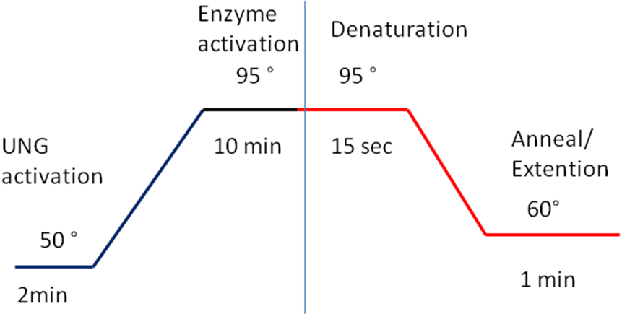

Once done, save the file as a template if it is the first time, or save as a new document with appropriate date and initials.
Important: Remove all bubbles from the wells, by flicking the bottom of the plate, and then centrifuge the plate with a plate centrifuge. Put the 96 wells plate in the tray and click on start run.
NB: you will not be able to start the run if you do not save the document

Results interpretation

Once your reaction is done, you will see on the left part of the screen your amplification plots and on the right side, your samples.
The interpretation consists in determining the cycle at which the amplification (fluorescence) reaches a chosen cycle threshold (Ct) for each sample.
In order to determine the Ct, you need to define your baseline start (start of amplification) and your threshold.
Then, the result Ct will correspond to the cycle at which the threshold meets the amplification curve of your sample.
Each target should have one threshold, but each sample can have a different baseline start.

First of all, you want to look at the raw probes signals, in each well. To do so, select the well and click on “Multicomponent Plot” on the left side of the screen, you should see as many lines as target found in this well, if there is amplification; you should see a Sigmoid, an S shaped amplification. Linear amplifications are signs of a degraded probe.

Automatic analysis

1- Click on analysis settings
2- Make sure that all targets have automatic threshold, baseline start and end
3- Click on apply analysis setting
4- Then Click on analysis

If you choose “view well table”, you will see the Ct for each sample for the appropriate target.
In the automatic analysis, the program chooses the parameters for you; it is thought to be the best setting, but you can also decide to do it manually.

Manual analysis

1- Click on “analysis settings” > Edit Default Settings> deselect Automatic threshold and Baseline (Check that no target has auto settings)
2- Click on “apply analysis setting”
3- On the left part of the screen, chose plot type: ΔRn vs Cycle; Graph type: Linear
4- Select one target (analysis cannot be done with “All” selected)
5- Select all the wells containing that target on your plate
6- Click on “show threshold and baseline”
7- On the plot, place the start baseline (green) between 0 and 3 cycles and the end baseline (red) where the first amplification starts
8- Move the threshold so that the line touches the first amplification 2-4 cycles after the cycle you chose to place the end baseline at.
Repeat the above from 4-8 for each Target

Then choose “view well table” to see the Ct for each sample for the appropriate target

In the ‘qPCRSample Spreadsheet Results’, record the Ct for each sample for every appropriate target

Usually, samples will be considered positive for a target if Ct is below 30 and doubtful if between 30 and 35. All CTs above 35 are considered negative.

Note: This was in our context, but, could vary depending of the machine and local conditions.

Appendix 1: Example of samples spreadsheet for 40 samples 3 NTC and standard curves

Multiplex A, W135, X PCR Real time
Date: DDMMMYY |  |  | TECH INITIALS __XZ_
 | 1 | 2 | 3 | 4 | 5 | 6 | 7 | 8 | 9 | 10 | 11 | 12
A | A McF 4.0 dil 1 | X McF 4.0 dil 1 |  | Sample 5 |  | Sample 13 |  | Sample 20 |  | Sample 27 |  | Sample 34
B | A McF 4.0 dil 2 | X McF 4.0 dil 2 |  | Sample 6 |  | Sample 14 |  | Sample 21 |  | Sample 28 |  | Sample 35
C | A McF 4.0 dil 3 | X McF 4.0 dil 3 |  | Sample 7 |  | Sample 15 |  | Sample 22 |  | Sample 29 |  | Sample 36
D | A McF 4.0 dil 4 | X McF 4.0 dil 4 |  | Sample 8 |  | Sample 16 |  | Sample 23 |  | Sample 30 |  | Sample 37
E | W McF 4.0 dil 1 | Sample 1 |  | Sample 9 |  | NTC |  | NTC |  | NTC |  | Sample 38
F | W McF 4.0 dil 2 | Sample 2 |  | Sample 10 |  | Sample 17 |  | Sample 24 |  | Sample 31 |  | Sample 38
G | W McF 4.0 dil 3 | Sample 3 |  | Sample 11 |  | Sample 18 |  | Sample 25 |  | Sample 32 |  | Sample 39
H | W McF 4.0 dil 4 | Sample 4 |  | Sample 12 |  | Sample 19 |  | Sample 26 |  | Sample 33 |  | Sample 40

Appendix 2: Example of MMx spreadsheet

Serogrouping PCR Multiplex MMx Real Time
Date: | TECH INITIALS _OM___
Master mix (MMx) | x1 | 0 |  | Program:
H₂O Molecular Biology Grade | 2.50 | 0.00 |  | 50°C | 02:00
A (F) | 0.5 | 0.00 |  | 95°C | 10:00
A (R ) | 0.5 | 0.00 |  | 95°C | 00:15
RT-csaB-P VIC | 1.0 | 0.00 |  | 60°C | 01:00
W135 (F) | 0.5 | 0.00 |  | 4°C | Indefinitely
W135 (R ) | 0.5 | 0.00
probe FAM (5985) | 1.0 | 0.00 |  | 50 cycles
X (F) | 0.5 | 0.00
X(R ) | 0.5 | 0.00
probe Cy5 (5991) | 1.0 | 0.00
TaqMan GenEx Master Mix | 12.50 | 0.00
total volume master mix | 21.0 | 0.00
add per tube | 21
DNA | 4.0 | 4.0
final volume per tube | 25

Appendix 3: Preparation of Standard Curves

ATCC control strains or other well characterized strains (through molecular biology) will be used to perform serial dilutions starting McFarland 4 (12 X 10⁸ CFU per ml). Serial dilutions base 10 will be made ten times. Dilutions of overnight cultured bacteria will be made in 2000 μl of PBS.

Practically, resuspend bacteria in 4 ml to reach McFarland = 4. Take 100 μl out of this volume and dispense them in an Eppendorf microtube containing 900 μl of PBS. Next, proceed similarly taking 100 μl of mixed solution of PBS and bacteria and dispense them in a different Eppendorf microtube containing 900 μl of PBS. Proceed similarly 8 more times, following the table below and discard the last 100 μl. Please, be sure to flush properly with your pipette each tube before diluting.

Serial Dilution 10 | Expected CFU in 200 μl | Volume taken | Dispense in volume of
In 4 ml PBS | 1,200,000,000 | 100 μl | NA
2 | 120,000,000 | 100 μl | 1000 μl
3 | 12,000,000 | 100 μl | 1000 μl
4 | 1,200,000 | 100 μl | 1000 μl
5 | 120,000 | 100 μl | 1000 μl
6 | 12,000 | 100 μl | 1000 μl
7 | 1,200 | 100 μl | 1000 μl
8 | 120 | 100 μl | 1000 μl
9 | 12 | 100 μl | 1000 μl
10 | 1,2 | Discard last 100 μl | 1000 μl

Boiled the bacteria according to LAB SOP#13, proceed to a Qiagen Minikit extraction of 300 μl of dilutions 3, 4, 5, 6 and 7 of mixed bacteria/PBS with elution in a volume of 200 μl. Only 4 μl of Qiagen DNA of dilutions 3, 4, 5, 6 and 7 will be used as the standard curve.

Serial Dilution 10 | Expected CFU in 200 μl | Expected CT | Expected CFU in 4 μl of DNA per PCR
1 | 360,000,000 | 10 | 7,200,000
2 | 36,000,000 | 15 | 720,000
3 | 3,600,000 | 18 | 72,000
4 | 360,000 | 22 | 7,200
5 | 36,000 | 25 | 720
6 | 3,600 | 27 | 72
7 | 360 | 29 | 7
8 | 36 | 30 | 1
9 | 4 | 32 | 0
10 | 0 | 35 | 0

Appendix 4: Use reverse repetitive pipetting to ensure accuracy:

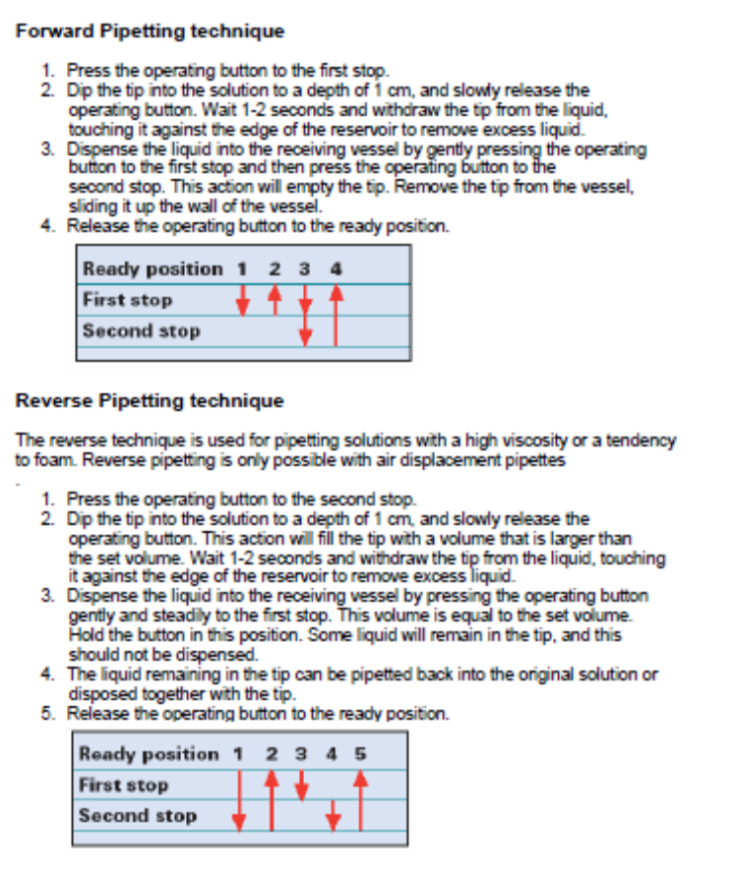

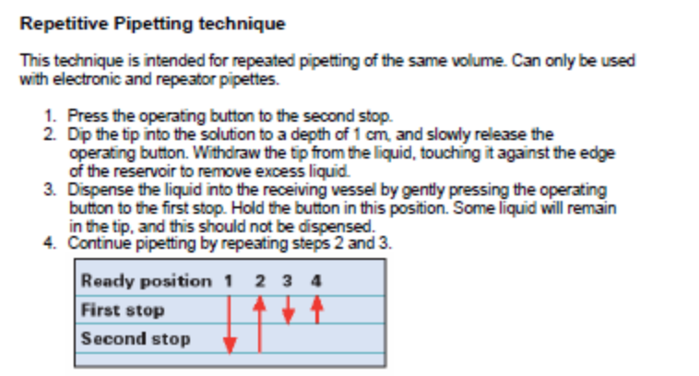
Appendix 5: Primers and probes dilutions:

How to dilute ABI primers and probes:

PRIMERS:

ABI primers are received lyophilised at an amount of 80 nmol

First of all, we want them at a STOCK SOLUTION of 100 μM (100 pmoles/μl)

Therefore, we dilute them in 800 μl of Molecular Biology Grade water.

Next, we want to use them at a WORKING SOLUTION depending of the primers

0.5 μl of the working solution will be used for each primer per PCR reaction.

- For porA F and R, we want to have them at a working concentration of 30 μM

Therefore, we will dilute the stock solution following: 60 μl + 140 μl of Molecular Biology Grade water
Final concentration in 25 μl of MMx: 600 nM

- For cnl F and R, we want to have them at a working concentration of 45 μM

Thus, we divided the stock solution by 2.2 [90 μl + 110 μl of Molecular Biology Grade water].
Final concentration in 25 μl of MMx: 900 nM

- For sodC F and R, we want to have them at a working concentration of 30 μM

Therefore, we will dilute the stock solution following: 60 μl + 140 μl of Molecular Biology Grade water
Final concentration in 25 μl of MMx: 600 nM

- For A F and R, we want to have them at a working concentration of 45 μM

Thus, we divided the stock solution by 2.2 [90 μl + 110 μl of Molecular Biology Grade water].
Final concentration in 25 μl of MMx: 900 nM

- For W F and R, we want to have them at a working concentration of 30 μM

Therefore, we will dilute the stock solution following: 60 μl + 140 μl of Molecular Biology Grade water
Final concentration in 25 μl of MMx: 600 nM

- For X F and R, we want to have them at a working concentration of 45 μM

Thus, we divided the stock solution by 2.2 [90 μl + 110 μl of Molecular Biology Grade water].
Final concentration in 25 μl of MMx: 900 nM

- For B F and R, we want to have them at a working concentration of 45 μM

Thus, we divided the stock solution by 2.2 [90 μl + 110 μl of Molecular Biology Grade water].
Final concentration in 25 μl of MMx: 900 nM

- For C F and R, we want to have them at a working concentration of 30 μM

Therefore, we will dilute the stock solution following: 60 μl + 140 μl of Molecular Biology Grade water
Final concentration in 25 μl of MMx: 600 nM

- For Y F and R, we want to have them at a working concentration of 45 μM

Thus, we divided the stock solution by 2.2 [90 μl + 110 μl of Molecular Biology Grade water].
Final concentration in 25 μl of MMx: 900 nM

- For Z F and R, we want to have them at a working concentration of 45 μM

Thus, we divided the stock solution by 2.2 [90 μl + 110 μl of Molecular Biology Grade water].
Final concentration in 25 μl of MMx: 900 nM

- For H F and R, we want to have them at a working concentration of 30 μM

Therefore, we will dilute the stock solution following: 60 μl + 140 μl of Molecular Biology Grade water
Final concentration in 25 μl of MMx: 600 nM

- For E F and R, we want to have them at a working concentration of 30 μM

Therefore, we will dilute the stock solution following: 60 μl + 140 μl of Molecular Biology Grade water
Final concentration in 25 μl of MMx: 600 nM

PROBES:

ABI probes are received diluted at a concentration of 100 μM. This is the STOCK SOLUTION (100 pmoles/μl)

Next, we want to use them at a WORKING SOLUTION depending of the probes

1 μl of the working solution will be used per PCR reaction.

- For porA P (5’FAM – 3’MGB), we want to have it at a working solution of 5 μM

Thus, we divided the stock solution by 20 [10 μl + 190 μl of Molecular Biology Grade water].
Final concentration in 25 μl of MMx: 200 nM

- For cnl P (5’VIC – 3’MGB), we want to have it at a working solution of 7.5 μM

Thus, we divided the stock solution by 13.34 [15 μl + 185 μl of Molecular Biology Grade water].
Final concentration in 25 μl of MMx: 300 nM

- For sodC P (5’NED – 3’MGB), we want to have it at a working solution of 2.5 μM

Therefore, we will dilute the stock solution following: 5 μl + 195 μl of Molecular Biology Grade water
Final concentration in 25 μl of MMx: 100 nM

- For A P (5’VIC – 3’MGB), we want to have it at a working solution of 7.5 μM

Thus, we divided the stock solution by 13.34 [15 μl + 185 μl of Molecular Biology Grade water].
Final concentration in 25 μl of MMx: 300 nM

- For W P (5’FAM – 3’BHQ), we want to have it at a working solution of 5 μM

Thus, we divided the stock solution by 20 [10 μl + 190 μl of Molecular Biology Grade water].
Final concentration in 25 μl of MMx: 200 nM

- For X P (5’Cy5 – 3’BHQ), we want to have it at a working solution of 7.5 μM

Thus, we divided the stock solution by 13.34 [15 μl + 185 μl of Molecular Biology Grade water].
Final concentration in 25 μl of MMx: 300 nM

- For B P (5’Cy5 – 3’MGB), we want to have it at a working solution of 7.5 μM

Thus, we divided the stock solution by 13.34 [15 μl + 185 μl of Molecular Biology Grade water].
Final concentration in 25 μl of MMx: 300 nM

- For C P (5’FAM – 3’BHQ), we want to have it at a working solution of 5 μM
Thus, we divided the stock solution by 20 [10 μl + 190 μl of Molecular Biology Grade water].
Final concentration in 25 μl of MMx: 200 nM

- For Y P (5’HEX – 3’BHQ), we want to have it at a working solution of 7.5 μM

Thus, we divided the stock solution by 13.34 [15 μl + 185 μl of Molecular Biology Grade water].
Final concentration in 25 μl of MMx: 300 nM

- For Z P (5’Cy5 – 3’MGB), we want to have it at a working solution of 7.5 μM

Thus, we divided the stock solution by 13.34 [15 μl + 185 μl of Molecular Biology Grade water].
Final concentration in 25 μl of MMx: 300 nM

- For E P (5’FAM – 3’MGB), we want to have it at a working solution of 5 μM

Thus, we divided the stock solution by 20 [10 μl + 190 μl of Molecular Biology Grade water].
Final concentration in 25 μl of MMx: 200 nM

- For H P (5’VIC – 3’MGB), we want to have it at a working solution of 5 μM

Thus, we divided the stock solution by 20 [10 μl + 190 μl of Molecular Biology Grade water].
Final concentration in 25 μl of MMx: 200 nM

