Preparation of Gelatin Slide Coating Solution

- Scope and Applicability: Preparation of gelatin solution to be used for coating glass microscope slides.

- Materials:
  - Gelatin powder (Type A, 275 bloom, Fisher G8-500 or equivalent)
  - Chrome alum, Chromium (III) Potassium Sulfate dodecahydrate (Sigma 243361 or equivalent)
  - MilliQ water

- Equipment:
  - Heated stir plate
  - Thermometer
  - Stir bar
  - Calibrated balance
  - Glass Erlenmeyer flask or beaker (500 ml or appropriate size, as determined by desired yield)

- Safety:
  - Nitrile Gloves
  - Lab coat
  - Safety glasses

- Output:
  - 0.3% gelatin solution with chrome alum

- Reference Documents
  - N/A

Warning: Personal Protective Equipment (PPE) should be used at all times while operating this protocol. If you are unsure what PPE you should be using, see your immediate supervisor.

- Setup:
  - Determine the required volume of gelatin solution.
  - Determine the correct size glass container to use, to hold solution.

- Methodology/Procedures:
  - Add the required volume of MilliQ water to a glass container according to Table 1.

Table 1: 0.3% Gelatin Solution
Reagent | Final Volume  100 ml | Final Volume  250 ml | Final Volume  500 ml
MilliQ water | 100 ml | 250 ml | 500 ml
Gelatin powder | 300 mg | 750 mg | 1500 mg
Chromium Potassium Sulfate | 50 mg | 125 mg | 250 mg

  - Once the water has reached 65°C, gently add the gelatin powder (avoid clumps).
  - Heat the water to 65°C on a heated stir plate.
  - Stir gently until gelatin goes into solution; avoid introducing bubbles into the solution. The solution will be clear when gelatin is dissolved.
  - Once the gelatin is fully dissolved, add the Chromium Potassium Sulfate. Stir until dissolved.
  - Reduce heat and cool gelatin to ~50°C prior to dipping slides. Slides should be coated immediately.

- Take Down:
  - Unused solution can be diluted ≥2X with warm water and poured down the municipal drain.
  - Rinse the containers thoroughly with hot water then clean appropriately with MilliQ water and 70% EtOH.

- Technical Information:

  - This SOP is based upon the IHC World Online protocol:

http://www.ihcworld.com/_protocols/histology/gelatin_slides.htm

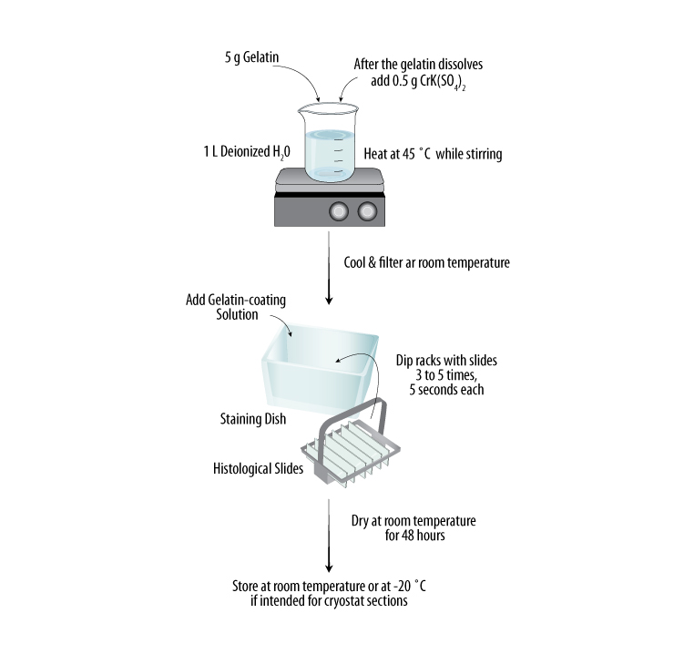
3g Gelatin
After the gelatin dissolves
Add 0.5g Chromium Potassium Sulfate
1L MilliQ water
Heated to 65°C
Stir gently to minimize bubbles

Coat slides in gelatin solution for 30 seconds
Staining container
1x3 slides in staining rack
Dry at room temperature in a dust and lint-free environment
Transfer into slide boxes ready for use and for storage at room temperature
Cool solution to 40-50°C and filter into staining container

Process modified from:
http://www.rndsystems.com/ihc_detail_objectname_gelatin_slides.aspx

