Pulling Pipettes using the DMZ-Zeitz Universal

- Scope and Applicability: For the manufacture of glass pipettes for patch clamp electrophysiology using the DMZ-Zeitz Universal puller.

- Materials:
  - Glass capillaries (Sutter Instruments BF150-86-10 or equivalent)
  - Internal solution (RP0234)
  - ACSF.IX (RP0233)
  - Pipette storage box (Sutter Instruments BX20)
  - 3.0 mm heating filaments (DMZ-Zeitz Universal)
- Equipment:
  - Pipette puller (DMZ-Zeitz Universal)
  - Ephys Rig
- Safety:
  - Nitrile Gloves
  - Eye protection
  - Lab coat
- Output:
  - Pulled micropipette of desired length, taper, tip size, and resistance.
    - Patch pipettes of equal length with tip diameter of 1-1.5 µm and resistance of 3-6 MΩ.
- Reference Documents:
  - RP0234 Electrode Internal Solution with Biocytin II
    - https://www.protocols.io/view/electrode-internal-solution-with-biocytin-ii-bepnjdme/abstract
  - PF0298 Multi-Patch Clamp Recording
    - https://www.protocols.io/view/multi-patch-clamp-recording-bdpgi5jw/abstract
  - RP0233 ACSF.IX
    - https://www.protocols.io/view/artificial-cerebrospinal-fluid-ix-acsf-ix-beppjdmn/abstract
  - Operation Manual: DMZ-Zeitz Universal Puller
    - https://www.zeitz-puller.com/support/maintenance/

Warning: Personal Protective Equipment (PPE) should be used at all times while operating this protocol. If you are unsure what PPE you should be using, see your immediate supervisor.

- Setup:
  - Turn on the power to the pipette puller.
- Methodology/Procedures:
  - Pipettes Used for Whole Cell Patch Clamp Recording
    - To pull pipettes using an established program:
      - Turn on puller using MAINS switch
      - Press P(A), enter desired program number, press E, and press Ready
      - Insert a glass pipette into the open glass holders.
        - On the left DMZ-Zeitz puller, ensure the pipette is pushed all the way to the right, making contact with the right positioning knob (Figure 1)
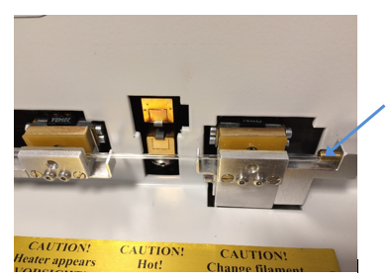
Figure 1: Left puller with pipette seated against knob (arrow)

        - On the right DMZ-Zeitz puller, push the glass pipette all the way to the left, making contact with the stop (Figure 2).
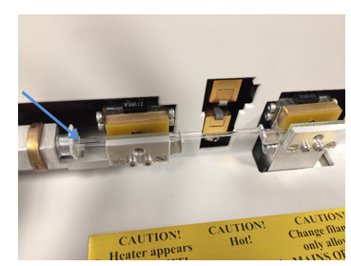
Figure 2: Right puller with pipette seated against stop (arrow)

      - Close the safety shield
      - Press START to run the program and pull pipettes.
      - Place pulled pipettes into a storage box for further use.
    - Creating a New Program for Pipettes Used for Whole Cell Patch Clamp Recording:
      - Select an open, unused program number.
      - Set up the program with the initial values for a patching pipette found in the operation manual for a single pull program (Table 1).
        - For single pull programs, the first digit of P(B)AD = 0. Otherwise, the first digit represents the time of polishing protocol.
        - Consult manual for explanations of each value.

 | H | t(F1) | F(TH) | F1 | s(TH) | s(F2) | t(H) | F2 | s(H) | AD
P(A) | 520 | 380 | 012 | 300 | 022 | 030 | 030 | 600 | 020 | 121
P(B) | 520 | 092 | 016 | 070 | 008 | 004 | 030 | 070 | 000 | 000

Table 1: Initial parameters for single pull program

      - Pull pipettes as described in previous section (8.1.1)
      - Measure the resistance and diameter of the pipette:
        - Fill the pipette with internal solution (SOP RP0234).
        - Fill the bath with ACSF.IX (SOP RP0233)
        - Load pipette onto a head stage of an Ephys Rig. Only measure one pipette in the bath at one time.
        - Lower the pipette into the bath and apply a 10 mV test pulse to determine the resistance of the tip (Figure 3).
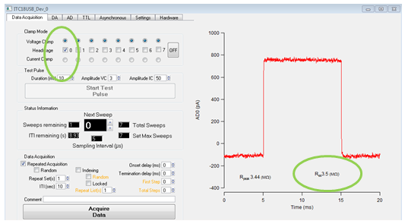
Figure 3: 10mV test pulse showing tip resistance circled in green

        - Measure the tip diameter under high magnification. Measure across the darkest part of the tip.
      - Correct the pipette resistance and diameter:
        - Adjust P(A)H to maintain a first pull duration of approximately 25 s.
        - Adjust P(B)t(F1) to adjust diameter/resistance. Increase P(B)t(F1) for a larger diameter/lower resistance, and lower P(B)t(F1) for a smaller diameter/higher resistance.
      - Pull 3 sets of pipettes from the new program to ensure consistency of resistances within the desired range (3-6 MΩ) and diameter (1-1.5 µm).
- Take Down:
  - Ensure the safety shield is closed.
  - Turn of pipette puller.
- Technical Information:
  - Changing the Filament
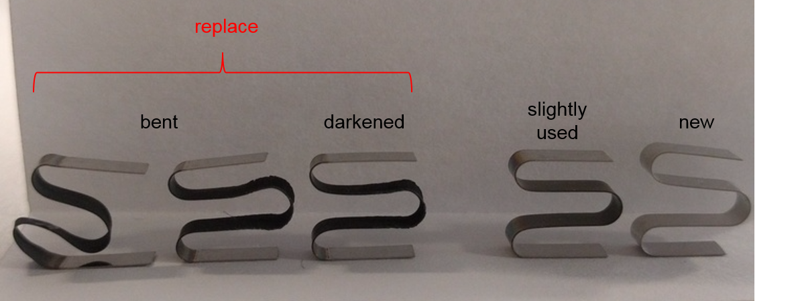
Figure 4: Difference between new filament and ones that need to be replaced

    - The operations manual (https://www.zeitz-puller.com/support/maintenance/) has full instructions for changing the puller filament, consult for more detail.
    - Turn the puller off and unplug.
    - Wait 5 minutes for heating mechanism to cool down if it was in use.
    - Remove the 4 screws holding the lower part of the right-hand cover panel
    - Grasp the panel at the right-hand corner and remove it by pulling it up and towards yourself.
    - Give the spindle a few turns using a screwdriver inserted in the slit until the heating filament holder is in its most advanced position.
      - Do not screw the spindle out completely!
    - Loosen the small black grub screw of the upper filament holder using the hexagonal key from the spare parts box.
    - Loosen the knurled screw of the lower filament holder.
    - Pull the filament out of the slots.
    - Insert new filament as far as it will go into the slots.
    - Partially and gently tighten the screws.
    - Adjust the horizontal and vertical position of the filament by moving the upper and lower parts of the filament.
      - Ensure that you do not bend the filament
    - Tighten the screws and screw the metal cover back into place.
    - Leave the heater in its advanced position
      - Do not screw the spindle completely out of its hole.

