Genetic sampling of Acropora for the Applied Biosystems™ Axiom™ Coral Genotyping Array – 550961 (384f) and Applied Biosystems™ Axiom™ Coral Genotyping Array – 550962 (Mini 96)

Kitchen SA, Von Kuster G, Vasquez Kuntz KL, Reich HG, Miller W, Griffin S, Fogarty ND, Baums IB (2020) STAGdb: a 30K SNP genotyping array and Science Gateway for Acropora corals and their dinoflagellate symbionts. bioRxiv 10.1101/2020.01.21.914424:2020.2001.2021.914424.
doi:10.1101/2020.01.21.914424.

Goal: Sample and preserve tissues for genotyping with the Axiom array

Sampling colonies:
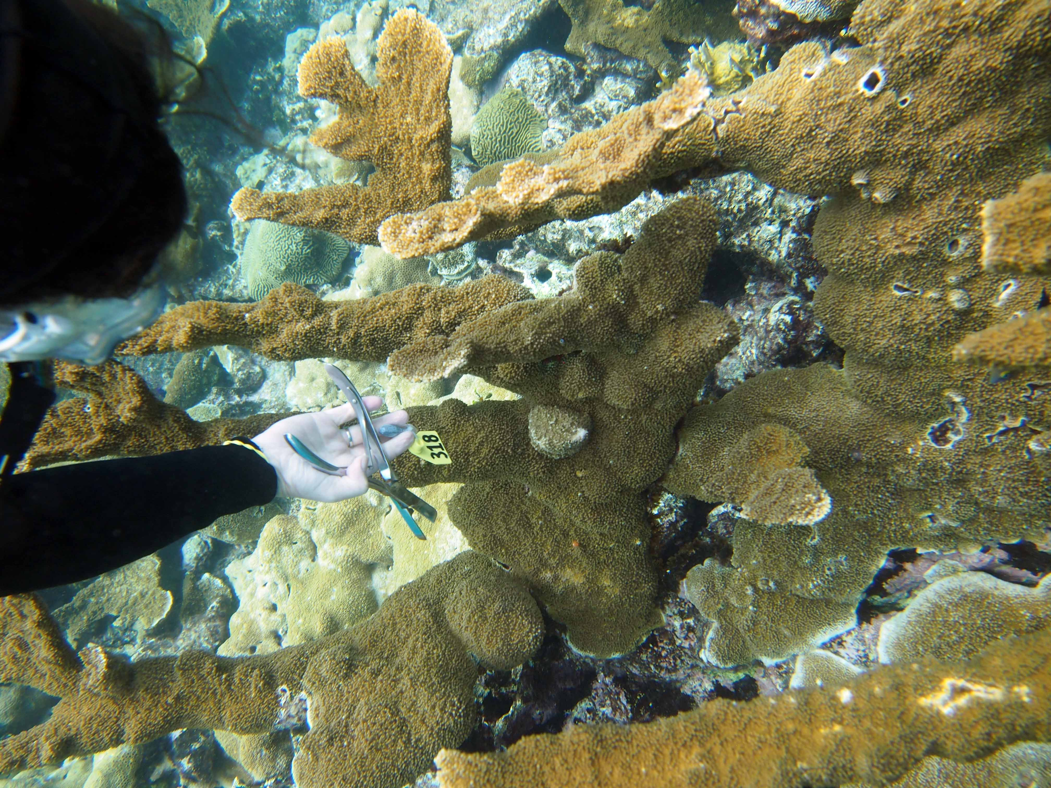
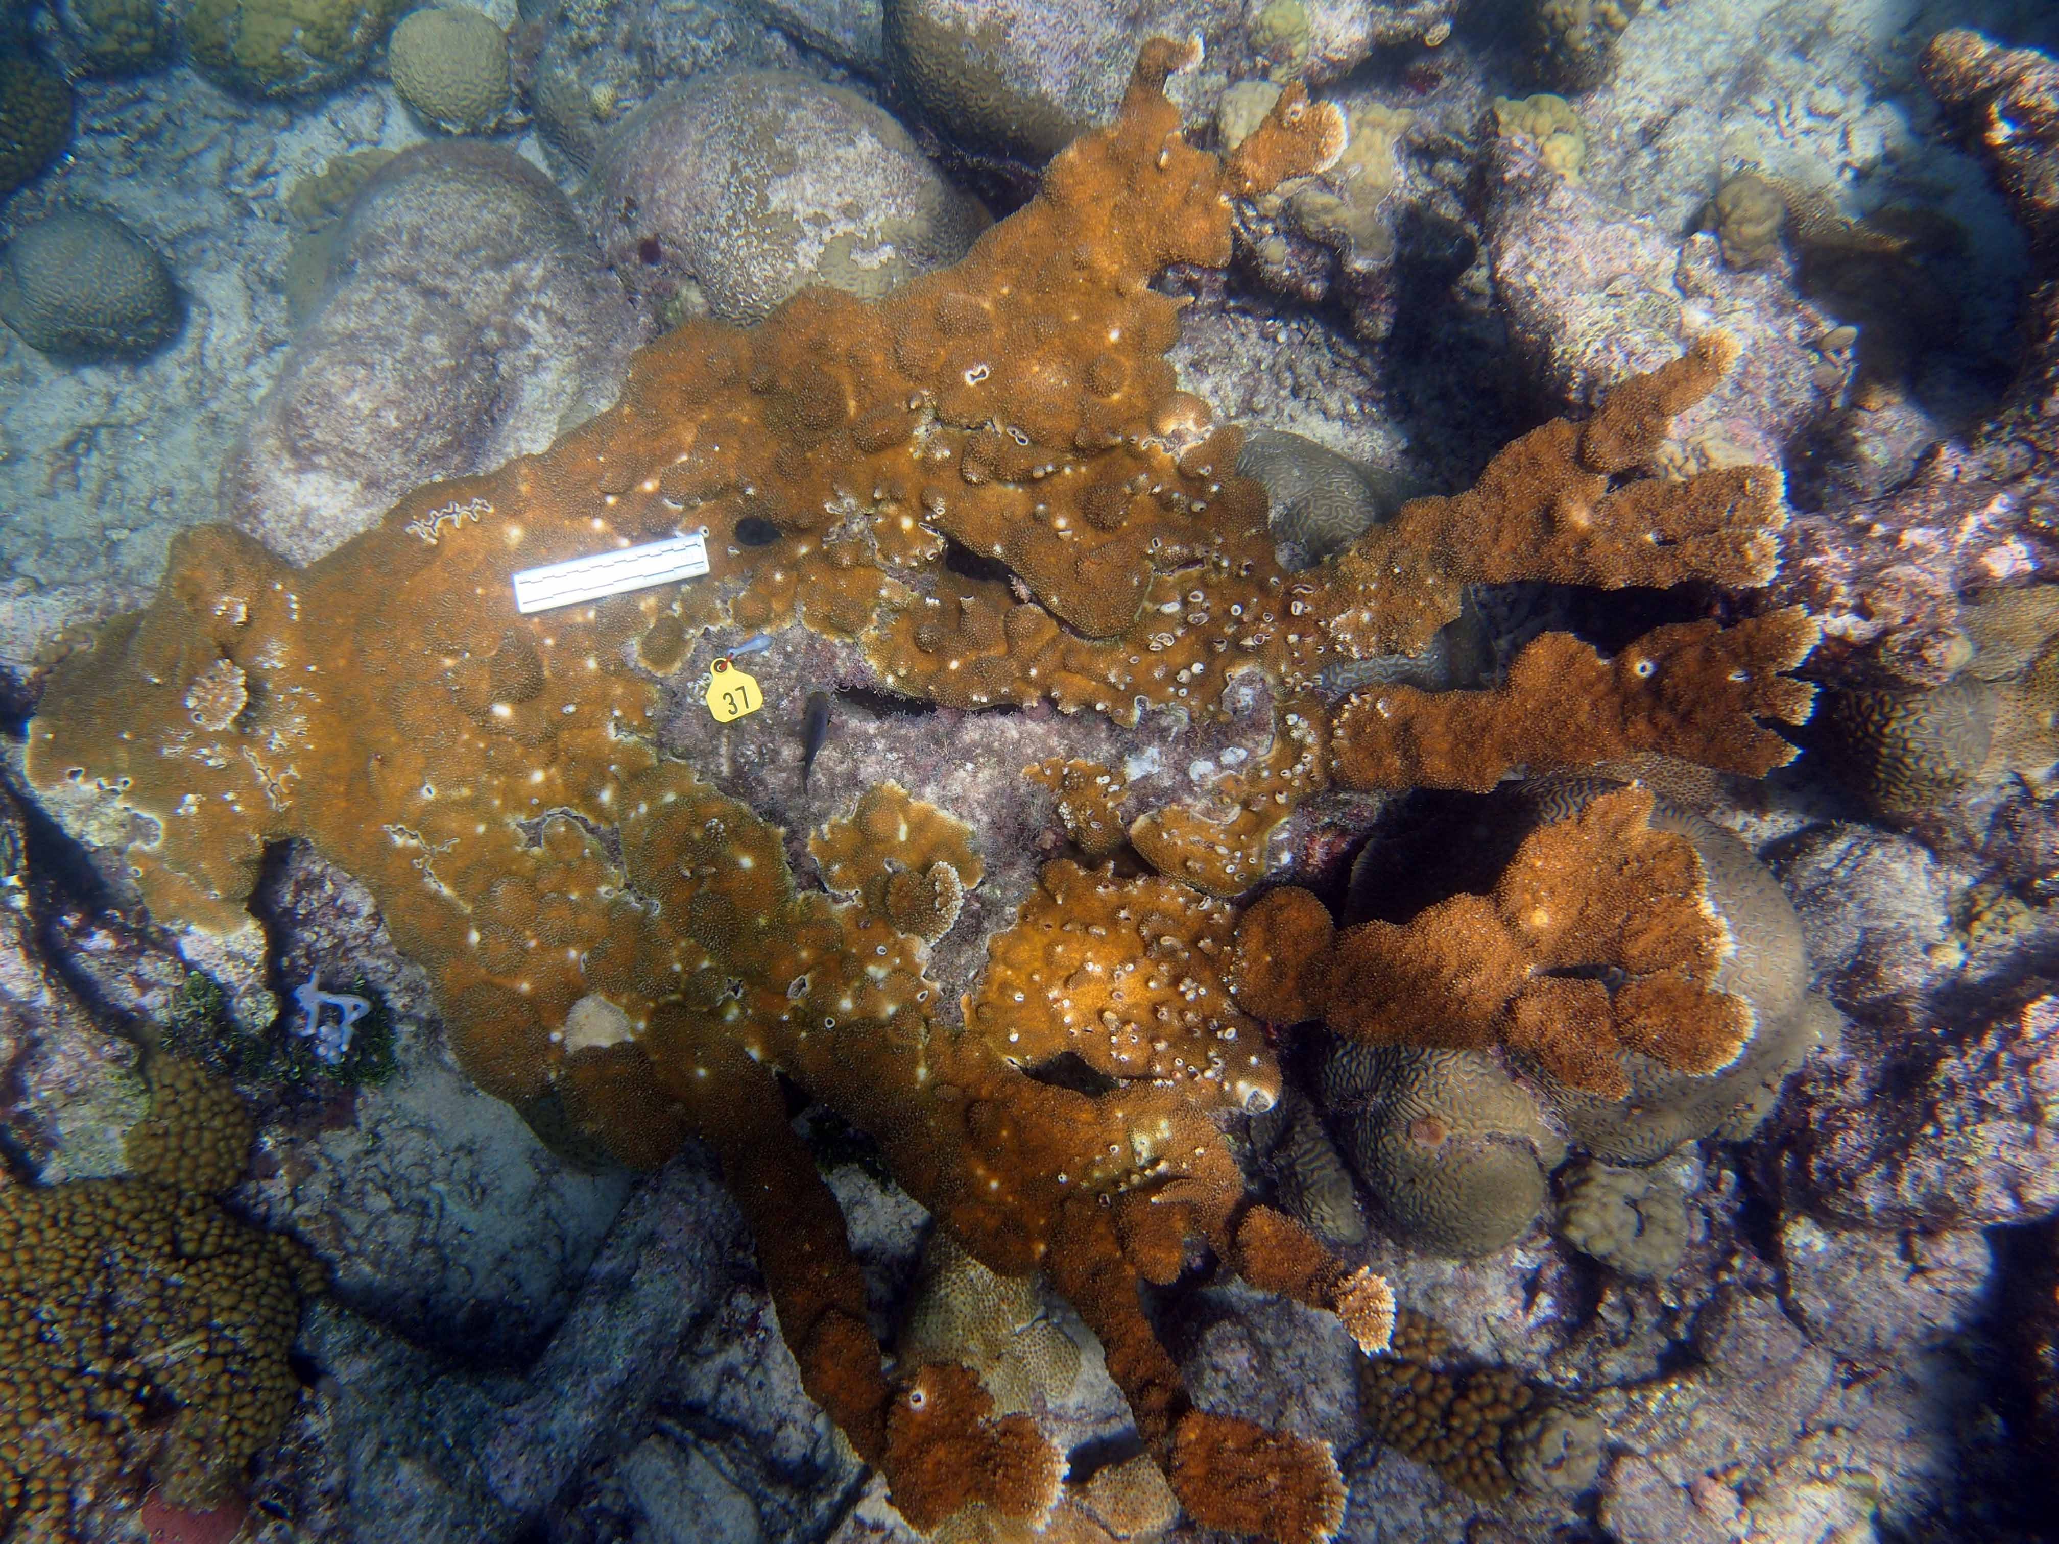
The colonies to be sampled are identified by dropping a fishing weight with flagging tape or cow tags on them. This method allows for labeling the colonies underwater so that the sample and any pictures/measurements can be matched up later. We use 1 oz fishing weights that have a numbered cow tag attached with a zip tie (Fig 1). After taking a photo / measurements of the colonies with the flag visible, we transfer flag and sample into a zip lock bag. This flag number is then recorded along with the vial number (see below), date and dive site to provide a unique identifier for that sample. The second diver can then collect the samples and label them by placing the flags together with the samples in individual ziplock bags. Any other labeling scheme (such as pre-labeled Ziplocs) works as well.
Fig 1 Sampling Acropora. We use cow tags with fishing weights to cross reference colonies. The coral snipper is used to cut 3-4 polyps from the growing edge of the colonies. Polyps are placed together with the fishing weight into a zip lock bag until they can be preserved.

Sample preservation: Samples should be preserved in 95% non-denatured Ethanol, or high percentage liquor (rum, vodka) in a pinch. It is very important that the ethanol is NON-DENATURED – even trace amounts of methanol RUIN the samples. Regardless of the preservation solution, samples should be kept at the coolest place possible (freezer, fridge, shade) while avoiding repeated freeze/thaw cycles. If you anticipate that you will ship samples shortly after sampling, place them in the fridge/shade and then transfer to the freezer when they are at their final destination.
Sample labeling: If possible, use printed labels that are ethanol and freezer proof. We use a Brady Printer (portable enough for fieldwork, can run on batteries) and Labxpert labels. Low tech solution: Please place a piece of regular paper labeled with pencil inside the sample jar with the following information: date, site, species, flag number. Underwater paper can be used but the fancy kind made out of plastic will melt in Ethanol and destroys the sample so take care to use the kind made out of coated paper instead. It saves a lot of time if you pre-label the jars with a permanent, printed label, though. Only one sample should be stored in each vial. Labels written on with sharpie placed on the outside of the vial will become illegible within days!

Underwater Sampling sheet:
Date: 28 Mar 07 | Divers: IB, NP |  | Region:  Fiji | Site: 3
# | Species | Flag # | Height (cm) | Width (cm) | Length (cm) | Comments | depth (m) | Dive
1 | Porites lobata | 65 |  |  |  |  | 3 | Dive 1
2 | Porites lobata | 54 | 50 | 60 | 60 |  | 5 | Dive 1
3 | Porites lobata | 70 | 50 | 60 | 90 |  | 8 | Dive 1

Sample Inventory:
Vial | Species | Atoll | Site | Date | Collector | Site/field comment | Box # | Flag
G105 | Porites lobata | MR | Pt. Espejo | 3-Mar-07 | Iba | Site 1 | G1 | 52
G110 | Porites lobata | MR | Pt. Espejo | 3-Mar-07 | Iba | Site 1 | G1 | 54

Sampling strategy “Polar Plots” (Fig 2): In order to answer questions of reef connectivity and clonal (genet) structure the following sampling regime has been designed to maximize the chance of detecting all genotypes (important for the reef connectivity) and to estimate the spatial extent of a genet (clone) simultaneously (Baums IB, Miller MW, Hellberg ME (2006) Geographic variation in clonal structure in a reef building Caribbean coral, Acropora palmata. Ecol Monogr 76:503-519. doi:10.1890/0012-9615).

Acropora populations are surveyed using SCUBA. Live Acropora patches can be surveyed and sampled using a polar grid. Three nested circles of 15m, 10m and 5m radius are used, comprising a “set” of circles. Each of these circles is subdivided into sectors of 5 degrees and 50 cm increments. Random numbers are generated to determine what colony within this grid will be sampled. A set of random numbers for the three circles of a set are provided (see example below). A stake in the center of the patch will be pounded into the reef (if a GPS is available, mark the site at which the stake is located or a close to it as possible). Using a measuring tape attached to the center stake and a compass, the coordinates are located. (Alternatively, the measuring tape is tied to a prominent feature on the reef, if permanent stakes are not permitted or desired). The colony underneath each of the coordinates is sampled until 8 samples per circle are achieved (24 per set). The following rules must be observed: if there is no colony found at the random coordinate, the coordinate will be crossed out and the next number will be sampled. No colony can be sampled twice. A colony is defined as a continuous, upright entity of skeleton with a stalk that attaches it to the bottom. If colony density allows it, a circle directly adjacent but non-overlapping will be established and surveyed in the same manner. Please note the distance and heading between the two center stakes. Coral size is estimated in the field by using a PVC rod marked in 5 cm increments. For each colony, two diameters perpendicular to each other (length and width) and the maximal colony height are taken. Live coral cover is estimated in % to the nearest 10 percent. Coral density is estimated by counting the number of all colonies occurring in the set of circles. Additional coral condition like disease, bleaching, snails and damselfish are noted on the sheets.
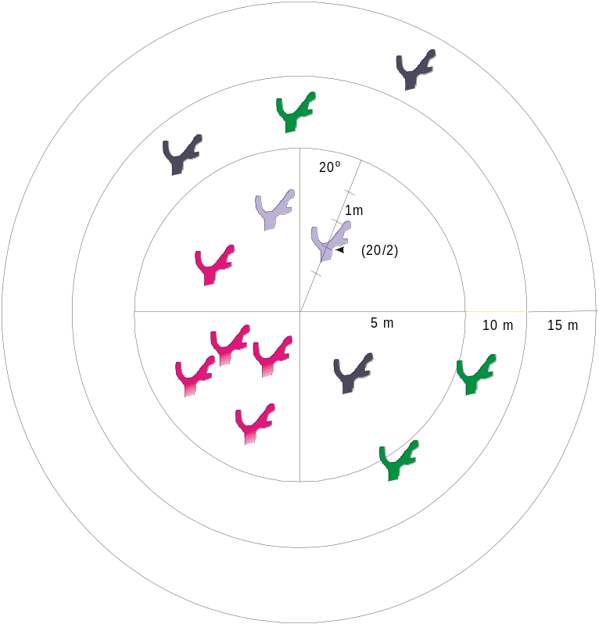Fig 2 Sampling scheme for A. palmata patches. The radii for a set are 5m, 10m and 15m. The circles are divided in 10º sections with 0.5m subdivision so that every sampled colony is assigned a coordinate, consisting of a degree and a distance from the center stake e.g. (20/2) would be 20º and 2 m. A different color indicates a different genotype as determined by microsatellite analyses. Coral density is counted for the whole set.

Sampling strategy 2 – scarce A. palmata: If A. palmata colonies are few, and all colonies can be sampled, it is not necessary to use the random numbers and the circles. In this case, all colonies are sampled, their length, widths and live cover are recorded, and the total number of colonies is counted (should equal the number sampled). Their location can be recorded using a center point from which a distance (measuring tape) and a heading (compass) are taken. Alternatively, a handheld GPS device can be used (newer cameras have them built in but accuracy is often poor).

Sampling strategy 3 – Clonal structure not of interest: If clonal structure is not of interest and only the connectivity of the area in question is to be assessed the following much simplified sampling strategy can be used. A diver swims along the reef taking samples haphazardly. Samples should be spaced at least 5-10 m apart. A small piece of the growing edge of the colony is snipped off and placed into a labeled ziplock bag (see sampling strategy 1). If time allows, GPS readings of each colony can be taken. For this purpose, a standard handheld GPS unit is mounted on a floatation cushion. A snorkler swims above the SCUBA diver taking the coral samples. The snokler takes a GPS point over each sampled colony. Alternatively, an underwater camera with built in GPS function can be used by the diver. Care must be taken to match the GPS readings with the colony sample number. The target sample size per reef should be 50 colonies. This procedure may be repeated at other reefs of interest.

What is a patch and how many samples do we need? For statistical analysis of the genetic data we need 50 individuals per population. A population is defined as a reef. In case of the circle approach, this would mean 2 sets per reef. If colonies are scarce, as many colonies as possible are sampled.

Sample Preservation
3- 6 polyps of the growing tip per identified colony will be snipped off using a coral cutter and placed in a zip lock bag together with the labeled, 1 oz fishing weight. The coral cutter is wiped clean between samples.

On the boat:
- Zip lock bags with coral samples are kept in a bucket with seawater in the shade until return to shore.
On shore:
- On shore tissue samples are transferred into 95% (190 proof) non-denatured Ethanol. This can be difficult to get so triple check that you have bought non-denatured ethanol. Even trace amounts of methanol destroy the sample.
- Use forceps to transfer tissues into tubes while minimizing the amount of seawater that enters the tube.
- Razor blades or scalpels can be used to cut samples to size but be sure to wipe clean between samples.
- We use small squares of tinfoil that we change between samples to avoid contamination while processing samples
- Use 2ml cryovials with o-rings
- Label vials with ethanol- and freezer- proof labels. Sharpie WILL come off so do not use. If printed labels are not available, write sample ID with pencil on a regular sheet of paper and place in jar.
- Store samples as cold as possible while avoiding frequent freeze/thaw cycles in a fridge or -20C freezer.
- Clean labeled wishing weights by rinsing in freshwater.

Shipping
- Small quantities of Ethanol can be shipped as dangerous goods in exempted quantities by qualified shippers and with the appropriate labeling and packaging. Do not attempt to ship without proper training as the fines can be steep.
- Corals are listed under CITES and require local collection and export permits. These can take months to procure so start early.

Date |  |  | Location
 | 5 meter radius
Sample ID | Sample # | Angle | Distance | Height | Width | Length | Cond | # snails
 | 1 | 60 | 1.0
 | 2 | 120 | 4.5
 | 3 | 280 | 1.5
 | 4 | 230 | 4.0
 | 5 | 130 | 1.5
 | 6 | 200 | 4.0
 | 7 | 180 | 3.0
 | 8 | 250 | 4.5
 | 9 | 90 | 4.0
 | 10 | 360 | 3.0
 | 11 | 190 | 4.5
 | 12 | 90 | 3.0
 | 13 | 300 | 0.5
 | 14 | 210 | 1.5
 | 15 | 240 | 1.0
 | 16 | 260 | 2.5
 | 17 | 110 | 0.5
 | 18 | 270 | 3.0
 | 19 | 120 | 0.5
 | 20 | 70 | 3.0
 | 21 | 30 | 4.5
 | 22 | 250 | 4.5
 | 23 | 160 | 4.5
 | 24 | 330 | 2.5
 | 25 | 140 | 4.5
 | 26 | 160 | 0.5
 | 27 | 140 | 3.0
 | 28 | 20 | 2.5
 | 29 | 60 | 2.0
 | 30 | 40 | 3.5

Example random number sheet: This sheet provides random numbers for the 5 meter radius circle. Together with the sheets for the 10 m and 15m radius circles this comprises one set. Numbers are crossed out if colonies are not found under a particular coordinate or the colony has already been sampled until 8 colonies have been sampled per circle. The coral sample is identified by the Set number (roman numeral, e.g. I), the radius of the circle (e.g. 5m) and the coordinate (e.g. 50degree, 2.5 m).

