Slice Preparation and Blockface Imaging for Electrophysiology

- Scope and Applicability: This protocol describes the procedure for transcardial perfusion of an adult mouse, followed by dissection, embedding, slicing, and blockface imaging of the mouse brain using either a Leica vibratome or a compresstome. The output tissue is suitable for use in electrophysiological recordings and/or live cell filling applications.

- Materials:
  - 2% Low melt Agarose (Sigma A0576)
  - Tissue ink (Bradley Products, Inc. 1013-3)
  - 70% Ethanol (RP0032)
  - ACSF.I (RP0218)
  - ACSF.IV (RP0222)
  - Obrien Angular Scissors (Roboz RS-5928)
  - Blue Absorbent Pads (Fischer Scientific 14-206-59 or equivalent)
  - Blunt tip perfusion needles, 25G
  - Bracken Forceps (Roboz RS-5211)
  - Flat head forceps
  - Nuclease Free Water
  - Carbogen source (house, tank)
  - Deionized Water
  - Double Ended Freer Elevator (Roboz RS-8820)
  - Dumont Forceps (Roboz RS-5045)
  - 5/8” 25 G Needles
  - Gas Dispersion Tube (VWR 39533)
  - Heat Sink (Precisionary Instruments)
  - Isoflurane (Piramal Critical Care Inc. 330250)
  - Wet ice
  - Kimwipes
  - Paper towels
  - Mayo Scissors (Roboz RS-6875SC)
  - Aluminum foil
  - Nose Cone
  - 1 ½” 18 G needle
  - MB-10
  - Paintbrush (Ted Pella #1)
  - Peristaltic pump tubing (1/16” ID, 1/16” OD, 1/16” wall thickness)
  - One Petri Dish (3051 Corning)
  - Round Pyrex dish (VWR 89090-658)
  - PELCO Pre-Exe 6-well plates (Ted Pella 36157-1)
  - PBS (RP0001)
  - Ice bucket
  - Scalpel (Feather 2976#11)
  - Large Ring 4” Scissors (Roboz RS-5852)
  - Moria perforated spoon (Fine Science Tools 10370-18)
  - Razor blade (VWR 94-0391)
  - Desired angle specimen syringe (Precisionary Instruments)
  - Stirbar
  - Styrofoam board
  - Krazy Glue All-Purpose w/ Brush (KG925 or equivalent)
  - Black sharpie marker
  - Micro-Dissecting Scissors (Roboz RS-5914)
  - Postnatal mouse (reserved in LabTracks)
  - 12-well Brain Slice Keeper chambers (SciSys BSK12)
  - Plastic disposable Pasteur pipette, cut to increase opening size to be able to fit slice.
  - ¾” OD x ½” ID x 0.600” 316 Stainless steel washers (McMaster-Carr or equivalent)
  - Nylon mesh (SciSys or equivalent)
  - Labels (TPWI-003)
  - Screwdriver
  - Ceramic razor blade (Cadence EF-INZ10 or equivalent)

- Equipment:
  - 4°C refrigerator
  - Class II Biological Safety Cabinet
  - Harvard Apparatus Peristaltic Pump 66 (MA1-55-7766)
  - VetEquip Table Top Laboratory Animal Anesthesia System (901806) with associated tubing (Feeder Tube) and induction chamber
  - Compresstome (Precisionary Instruments VF-300) with attached camera
  - Leica VT1200S Vibratome with vibrocheck and accessories for slicing
  - Computer/laptop computer with custom BFI software installed
  - Two LED strips containing three lights each, with attached power source (6 LEDs)
  - T-Cube LED driver (Thorlabs M00424246)
  - Thermomixer (VWR 89232-910 or equivalent)
  - Oxygen Diffuser
  - Microwave
  - Water bath (VWR 89501-460, or equivalent)
  - Stirplate (VWR 74451-152 or equivalent)

- Safety:
  - Universal precautions should be used when handling animals
  - Disposable lab coat
  - Gloves
  - Eye Protection
- Output:
  - Acute mouse brain slices of desired thickness in oxygenated ACSF that are suitable for use in electrophysiological recordings and/or live cell filling applications. Tissue sliced on a compresstome will also have block face images (BFI’s) for each slice.

- Reference Documents:
  - QC1011 Tissue Quality Evaluation for Brain Perfusion/Dissection Specimens
    - https://www.protocols.io/view/tissue-quality-evaluation-for-brain-perfusion-diss-bd8yi9xw/abstract
  - RP0001 Phosphate Buffered Saline (PBS)
    - https://www.protocols.io/view/phosphate-buffered-saline-pbs-bezgjf3w/abstract
  - RP0218 ACSF.I
    - https://www.protocols.io/view/artificial-cerebrospinal-fluid-i-acsf-i-bezkjf4w/abstract
  - RP0222 ACSF.IV
    - https://www.protocols.io/view/artificial-cerebrospinal-fluid-iv-acsf-iv-bepsjdne/abstract
  - Harvard Apparatus Peristaltic Pump 66 manual
    - “557766_Pump_66,67_Manual.pdf”
  - VetEquip Table Top Laboratory Animal Anesthesia System Operation Manual
    - “LAAS Manual.pdf”
  - Compresstome VF-300 operation manual
    - “Compresstome-VF-300-0Z-User-Manual-Edited-8-14.pdf”
  - Leica VT1200S Vibratome Manual
    - “leica VT1200S.pdf”

Warning: Personal Protective Equipment (PPE) should be used at all times while performing this protocol. If you are unsure what PPE you should be using, see your immediate supervisor.

Isoflurane Warning: If you smell excessive amounts of Isoflurane consult the surgical workstation guide in Section 11.2 to make sure all parts of the rig are functioning properly. Contact EH&S personnel or your supervisor immediately if it continues. If you feel light-headed or develop a headache, check apparatus and report it to your supervisor. Supplemental Isoflurane monitoring is available on request; arrange with the EH&S department if desired.

- Setup:
  - Prepare 2% Agarose
    - If using the compresstome:
      - Ensure thermomixer is set to 350rpm and 43˚C.
      - Place 500 ml beaker on the balance and tare the scale.
      - Add 0.5 g low melt Agarose.
      - Pour in 25 g 1x PBS.
      - Add 2-3 drops of black tattoo ink, and record final weight.
      - Swirl to mix.
      - Heat in microwave for 1.5 minutes, swirling occasionally.
      - Put beaker back on the balance and add MilliQ water to bring the total weight up to recorded weight from step 7.1.1.5.
      - Aliquot Agarose into Eppendorf tubes and put in tube holes in the Thermomixer.
    - If using the Leica vibratome:
      - Obtain petri dish and cover
      - Place 500 ml beaker on the balance and tare the scale.
      - Add 0.75 g low melt Agarose
      - Pour in 37.5 g 1x PBS.
      - Swirl to mix
      - Heat in microwave for 1.5 minutes, swirling occasionally.
      - Put beaker back on the balance and add MilliQ water to bring the total weight back up 38.25 g.
      - Pour agarose into petri dish and store at 4ºC until ready to use.
  - Fill ice bucket with wet ice, and setup for slicing.
    - If cutting on a compresstome:
      - Turn on compresstome and ensure slice thickness, advance knob, and oscillation knob are all set to appropriate values. Advance and oscillation settings will vary by machine and should be evaluated by an experienced user for optimal performance.
        - Set slice thickness to desired value (this will be project dependent and should be confirmed prior to prep, default value for compresstome ephys slicing is 350 µm).
        - Set the advance knob such that the blade takes approximately 20 seconds to complete a full pass. This setting will generally range from 0.9-1.1.
        - Oscillation knob should be set so that the motor makes an audible chatter, but not so high that it creates a loud buzzing noise. This setting will generally range from 2.7-4.
      - Plug in the LED strips. Turn knob of T-Cube clockwise to turn lights on.
        - Verify visually that all six lights are working.
      - Turn on the laptop and open the BFI software. Verify that there is a live image showing.
      - Obtain 1L of fresh ACSF.I and 500 ml of fresh ACSF.IV for each mouse to be perfused and place on ice. ACSF.I should be kept on ice at all times.
Note: ACSF should not be used if older than 72 hours (< 48 hours if possible).

      - Fill one BSK12 with ACSF.IV (~500 ml), keep at room temperature [referred to as ‘Holding chamber’].
      - Fill another BSK12 with ACSF.I and place in the water bath (set to 34°C) [referred to as ‘Recovery chamber’]
      - Fill one round Pyrex dish with approximately 150 ml chilled ACSF.I. Place the dish in a tray filled with wet ice on a stir plate. Add a stir bar, slice carriers, and oxygen diffuser stone in the Pyrex dish filled with ACSF.I. Turn stir plate on and set to preset mode 4 (no heat, 350 RPM).
      - Place the other oxygen diffuser stone into the bottle of ACSF.I on ice.
      - Turn on Carbogen and ensure the ACSF is lightly bubbling in both BSK chambers, the staging chamber, as well as the ACSF.I bottle. Allow all ACSF to bubble for at least 10 minutes before use.
      - Place the heat sink in the wet ice.
      - Identify the desired angle at which the brain should be sliced, then use a black sharpie marker to color the entire mounting face of the appropriately angled specimen syringe.
    - If cutting on a Leica:
      - Turn on vibratome and ensure slice thickness, speed, and vertical (z-axis) deflection of the blade are all set to appropriate values.
        - Set slice thickness to desired value (this will be project dependent and should be confirmed prior to prep, default value for Leica ephys slicing is 300µm).
        - Set the speed to 0.12mm/s
        - Set the vertical deflection calibration within -.01 to 0.1 using the Vibrocheck feature:
          - Loosen the blade holder with screwdriver and place ceramic razor blade in it. Tighten to secure.
          - Slide Leica’s Vibrocheck onto the mount and lock into place.
          - Lower blade using the white line guides for proper alignment.
          - Plug Ethernet cable into Vibrocheck
          - The system will prompt which buttons to press with a flashing light. In case it isn’t clear, the order should be “Down” and “Run/Stop”
          - Stop the vibration and adjust screw until it is within the acceptable parameters of -0.1 to 0.1. If the reading is negative, turn towards the negative (clockwise) and positive (counter clockwise) if positive.
          - Raise the blade and press “Down” to end the calibration. Remove cable and Vibrocheck.
      - Remove agarose dish from the fridge and cut a small block appropriate in size to rest the brain against.
      - Identify the desired angle at which the brain should be sliced and ensure you use the correct vibratome chuck (90 or 107 degree).
      - Dry the surface of the vibratome chuck with a kimwipe and apply superglue to the surface. The amount of superglue used should match the size of the agarose block.
      - Place the agarose block onto the superglue and allow it to dry at room temp for at least 3-5 minutes (see Figure 1 for example of placement).

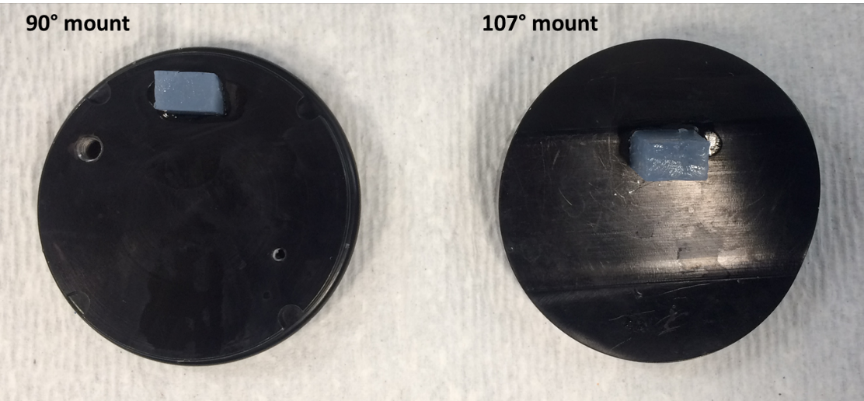
Figure 1. Placement of agar block on both 90 and 107 degree mounting plates

      - Place the vibratome bath into the holder and cover the bath with lid. Carefully fill the holder with wet ice being careful not to let any get into bath and impact ACSF formulation.
      - Obtain 1L of fresh ACSF.I and 500 ml of fresh ACSF.IV for each mouse to be perfused and place on ice. ACSF.I should be kept on ice at all times.

Note: ACSF should not be used if older than 72 hours (< 48 hours if possible).

      - Fill one BSK12 with ACSF.IV (~500 ml), keep at room temperature [referred to as ‘Holding chamber’].
      - Fill another BSK12 with ACSF.I and place in the water bath (set to 34° C) [referred to as ‘Recovery chamber’]
      - Turn on Carbogen and ensure the ACSF is lightly bubbling in both BSK chambers and the rest of the ACSF.I in a bottle is bubbling on ice. Allow all ACSF to bubble for at least 10 minutes before use.
  - Set up for the perfusion
    - Obtain a bottle of Isoflurane (stored at room temperature).
    - Attach the 18G blunt needle to the Luer connector by twisting it on tightly.
    - Cover Styrofoam board with aluminum foil.
    - Place nose cone on one end of Styrofoam board.
    - Place paper towel in induction chamber.
    - Immediately before perfusion, pour approx. 50 ml of chilled ACSF.I (freshly bubbled) into 50 ml conical tube or clean glass jar designated for ACSF and place tube in a tube rack in the hood. Put the feeder end of the pump tube in the conical tube. Turn the pump on and prime the tube until liquid is being expelled from the needle at the end of the line.

- Methodology:
  - Perfuse the mouse with chilled, bubbled ACSF. I.
    - Turn oxygen gauge to 1% and Isoflurane to 5 on the VetEquip table top laboratory anesthesia system and place the mouse in the induction chamber.
    - Once the mouse has stopped moving and its breathing has changed to about once per second remove the mouse from chamber (at least 3 minutes).
    - Use the toe pinch reflex test to determine whether the mouse is anesthetized. If the mouse reacts, place back in the chamber for an extra 1-2 minutes, then remove and recheck toe pinch reflex.
    - After the mouse has been anesthetized in induction chamber, switch Isoflurane flow to the nose cone.
    - Position the mouse supine on Styrofoam board, with nose inserted into the nose cone.
    - Pin all four paws to the board with 5/8’’ 25 G needles.
    - Spray the body of the mouse with 70% EtOH.
    - Using the micro dissecting scissors cut the entire ventral surface of skin over thorax.
    - Grasp the xiphoid process with the Dumont forceps. Carefully snip the diaphragm to open the thoracic cavity.
    - While holding the xiphoid process, snip up both sides of the rib cage with the micro dissecting scissors. Avoid nicking any internal organs.
    - Using the micro dissecting scissors carefully snip the right atrium. The bracken forceps can be used to stabilize the heart for this step.
    - Insert the 18 G blunt perfusion needle into the left ventricle directing the tip of the needle toward the aorta. Note: Exsanguination will not occur if needle is placed in the right ventricle or crosses the septum. Observation of fluid flowing from the nose/mouth indicates flow through the pulmonary artery and will result in suboptimal brain perfusion.

    - Release the needle and tubing to lay flat against the board. Ensure that the needle remains in place in the heart during this process.
    - Run chilled, bubbled ACSF.I using pump mode by pressing the red “Run/Stop” button. Note: If perfusate is observed through nose/mouth, or if liver is not clearing, stop the pump, reposition the needle, (directed toward aorta,) and then continue pumping. Turn off the Isoflurane once 10ml has been pumped.
    - Once 25 ml has been pumped, press the “Run/Stop” button again to stop the pump. The liver should be cleared of blood after perfusion.
    - Remove the needles from the animal and leave the oxygen on for a couple of minutes to clear the system.
  - Evaluate perfusion and dissection quality per SOP QC1011.
  - Dissect out the brain and prepare for slicing.
    - Immediately following perfusion with ACSF.I, remove the head of the mouse using the Mayo scissors.
    - Using the large ring scissors, start at the neck and make an incision across the top of the head toward the nose to begin to expose the skull.
    - Make cuts through each ear to further pull back the tissue from the skull.
    - Cut excess tissue off the back of the skull.
    - Cut the bone with the Obrien angled scissors starting at the opening in the occipital bone in the back of the skull and working forward, staying above the ears, around the parietal bone and above the eye sockets on either side. Keep the flat side of the scissors under the bone and always lift upward while cutting to avoid damaging the tissue.
    - Peel back the frontal and parietal bones with forceps. Use scissors to cut the dura mater.
    - Fill one 100 mm petri dish with some of the chilled, bubbled ACSF.I.
    - Using the Freer elevator, remove the brain from the skull and place in the small petri dish containing chilled, bubbled ACSF.I.
    - Use the Moria spoon to place brain on a piece of filter paper. Use either a razor blade or a scalpel blade to remove unwanted brain regions, creating a flat mounting surface.
      - If slicing caudal to rostral, remove the anterior 1/3 of the brain and the entire cerebellum. Use the anterior side as the mounting surface.
      - If slicing rostral to caudal, remove the cerebellum only. Use the posterior side of brain as the mounting surface.
      - If slicing sagittally, remove the cerebellum and ½ of the hemisphere that will not be collected. Use the trimmed hemisphere as the mounting surface.
    - Return brain to chilled, bubbled ACSF.I immediately after trimming.
  - For Leica Slicing
    - Apply a small amount of superglue to the vibratome chuck next to the agarose block.
    - Remove the remaining section of brain from the ACSF.I using a moria spoon or forceps and gently dab onto filter paper or a paper towel 2-3 times to remove excess liquid. Then with the flat head forceps, place the appropriate side of the brain onto the super glue so that the blade will hit the cortex first during slicing.
      - Ensure that the brain is flat on the vibratome chuck, and securely mounted before putting in bath.
    - Begin slicing
      - Place holder with bath in vibratome and lock in place. Adjust the vibratome chuck so that the agarose is positioned farthest away from the blade and the brain is mounted so that the blade will hit cortical surface first.
      - Fill the bath just below the top with chilled, oxygenated ACSF.I, and bubble solution in bath with carbogen for duration of slicing.
      - Fill another small petri dish with enough chilled, oxygenated ACSF.I to cover the bottom.
      - Lower the blade using the guides on the blade holder assembly to appropriately align (Figure 2).

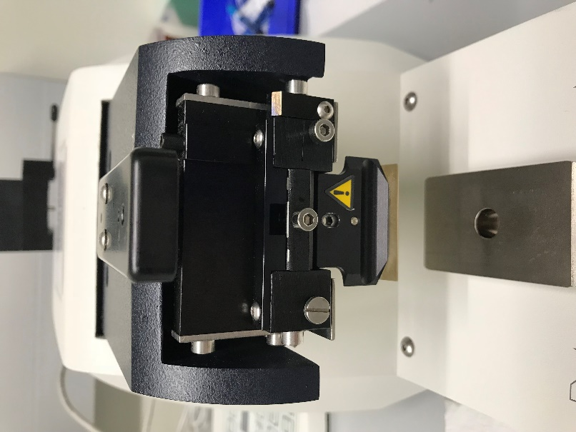
Figure 2. Correct blade alignment

      - Raise the vibratome stage by pressing the “Up” button until the blade is positioned about 1-2mm above the surface of the brain.
      - Advance the blade towards the brain using the “Forward Arrow” button. When the blade reaches an appropriate starting position, press and hold the “Start Position” button to set the starting parameter.
      - Advance the blade pass the brain and towards the agarose block until it just touches the surface of the agarose. Press and hold the “Stop Position” to set the stop parameter.
      - Press the Run/Stop button to start sectioning. If the blade is well above the tissue surface, press “Pause” and then “Run/Stop” twice. This will advance the blade one full section. Repeat until the blade just begins to cut the surface of the brain.
      - Collect slices from region(s) of interest. The slices that come before can be discarded. Slices that include the region of interest are to be gently transferred to the petri dish with a paint brush. Be sure to keep track of orientation as you do.
        - Brush should be placed underneath middle of slice along midline to lift out of slicing bath and avoid contact with cortex and ephys ROI as much as possible.
      - If slicing coronally, hemisect the brain slice with a scalpel by slicing down the middle of the brain separating the left and right hemispheres and transfer to waterbath using preferred method:
        - Transfer slices to waterbath one by one:
          - Transfer each hemisphere to its designated well in the “recovery chamber (in water bath)” using the wide mouth plastic Pasteur pipette being careful to minimize ACSF transfer. Start a timer for 10 minutes as you transfer the first pair of hemispheres.
          - Continue to slice and transfer until you have 6 slices (12 hemispheres).
          - Once 10 minutes have passed, begin transferring the first pair of hemispheres (1 by 1) to the “holding chamber”. Transfer the subsequent slices 1 minute after as that is about how long it takes for the vibratome to make one pass. Be sure to adjust timing if one slice was longer or shorter to ensure the tissue was allowed 10 minutes in the holding chamber. To minimize mixing between ACSF.I and ACSF.IV, wait for each slice to fall to the bottom of the pipette before transferring.
        - Transfer slices to waterbath all at once:
          - After hemisecting slices in petri dish filled with chilled oxygenated ACSF.I, keep all slices lined up on edge of petri dish so that slice # and orientation is preserved. Once final slice is collected and hemisected, transfer all into their designated wells in recovery chamber (in water bath) using the wide mouth plastic Pasteur pipette being careful to minimize ACSF transfer. Start a timer for 10 minutes.
      - When the 10-minute timer goes off, using wide mouth Pasteur pipette, transfer all slices (1 by 1, in order) to the holding chamber (room temperature) filled with ACSV.IV in the same well position. To minimize mixing between ACSF.I and ACSF.IV, wait for each slice to fall to the bottom of the pipette before transferring.

  - For compresstome slicing with BFIs:
    - Verify the number on both the specimen syringe and metal holder match the number of the compresstome to be used, as these are not interchangeable between machines. Apply a small amount of superglue to the tip of the specimen syringe.
    - Remove the remaining section of brain from the ACSF.I using a moria spoon or forceps and gently dab onto filter paper or a paper towel 2-3 times to remove excess liquid. Place the appropriate side of the brain onto the super glue.
      - Ensure that the brain is centered on syringe.
    - Attach the metal holder to the specimen syringe. Remove heat sink from ice and encase metal holder.
    - Use a semi-wide mouth plastic Pasteur pipette to cover the tissue with warm Agarose from one of the warming Eppendorf tubes.
    - Close the heat sink around the metal holder for 10 seconds, or until Agarose is visibly solidified.
    - Begin slicing and acquiring blockface images.
      - Insert specimen syringe into the bath of the compresstome up to the guard on the specimen syringe. Rotate the specimen syringe so that the tissue is orientated with the dorsal side up.
      - Fill the bath with chilled, bubbled ACSF.I (~250 ml) and bubble solution in bath with carbogen for duration of slicing.
      - Fill another small petri dish with enough chilled, bubbled ACSF.I to cover the bottom.
      - Unlock the motor from the standby position, move the motor forward and lock it down in the cutting position.
      - Flip selector switch on the motor to fast forward until the bar extends out and touches the end of the specimen syringe and then continue advancing until the tissue is exposed on the cutting edge. Flip selector switch back to neutral.
      - Open the BFI program and input relevant information prior to slicing.
      - Begin cutting tissue by flipping selector switch on the control box to single and pressing start.
      - When full face images are visible, begin acquiring blockface images by pressing the F1 key, space bar or the camera button on the right side of the screen.
      - Images will appear below the live image on the bottom of the screen. Make sure an image is acquired before each slice.
    - Collect slices from region(s) of interest. The slices that come up before/after the desired region can be discarded. Slices that are to be collected are lifted with a paintbrush, separated from Agarose, and placed in the carousels in the ‘Staging chamber’ (filled with chilled ACSF.I).
      - Slices are loaded clockwise beginning at the thermistor hole. Wells are numbered 1-6 (see Figure 3).
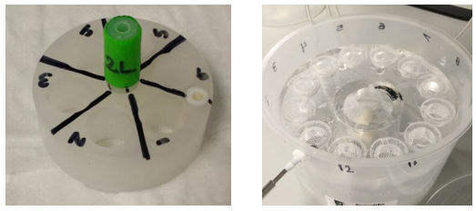
Figure 3. Tissue slice carousel (left) and holding chamber, right.

    - If hemisecting the slice, use a paintbrush to transfer it to the 2nd petri dish of ACSF.I.
      - Using a razor blade or a scalpel blade, cut the slice down the middle, separating the left and right hemispheres of the brain.
      - Using a wide mouth plastic Pasteur pipette, gently remove the Agarose from around each hemisphere, taking care not to lose orientation.
      - Transfer each hemisphere to its designated slice carousel using the wide mouth plastic Pasteur pipette.
    - Continue collecting tissue until the last ‘keeper’ slice has been generated, then, using a wide mouth plastic Pasteur pipette, transfer all slices (1 by 1, in order) to the recovery chamber (in the water bath) in the designated well position (Well positions are indicated on the wall of the chamber). Start a timer for 10 minutes.
    - When the 10-minute timer goes off, using wide mouth Pasteur pipette, transfer all slices (1 by 1, in order) to the holding chamber containing ACSF.IV (room temperature) in the same well position. To minimize mixing between ACSF.I and ACSF.IV, wait for each slice to fall to the bottom of the pipette before transferring.
    - After all block face images have been acquired and slicing is complete, input slice end time and incubation complete time into BFI software.
  - Fill out completion time on labels.
  - Transfer holding chamber and slices to drop-off location.
    - Using forceps, place a well cover over each well, mesh side down.
    - Remove chamber from carbogen line and carefully walk out to drop-off location.
    - Reattach the holding chamber to its color-coded, assigned carbogen line and ensure the ACSF.IV in holding chamber is bubbling.
    - Using forceps, remove well covers. Clip appropriate labels to the color-coded clips on the shelf above drop-off location.
    - Cover the holding chamber and rinse well covers with DI water before next use.

- Take Down
  - Compresstome:
    - Drain the compresstome bath into a large beaker or waste bottle.
      - Waste ACSF can be disposed of down the sink.
    - Rinse the bath with two rinses of MilliQ water.
      - MilliQ water rinse can be disposed of down the sink.
    - Remove leftover tissue and super glue from the specimen syringe by using a razor blade to scrape it off.
    - Dispose of remaining tissue and super glue in a biohazard waste disposal bin.
  - Leica:
    - Press “Down” to lower holder and reset position. Raise blade holder and remove blade.
    - Rinse blade and any part of the blade holder that was submerged in ACSF with Nuclease Free water.
      - Dry all parts of the blade holder with kimwipe including the back corner, screw, and the holder itself.
      - To ensure all moisture is removed, place a folded paper towel in blade holder and tighten. Leave until the next prep.
    - Waste ACSF from the bath can be disposed of down the sink.
    - Remove leftover tissue and super glue from the vibratome chuck by using a razor blade to scrape it off. Dispose of leftover tissue and glue in biohazard waste.
    - Rinse the chuck, bath, and holder with hot water and DI water.
      - Dry with kimwipe
      - If this is the last prep of the day, you can spray down chuck, bath, and holder with 70% EtOH. Allow to air dry overnight.
  - After the last perfusion, run deionized or MilliQ water through the tubing for at least 6 ml. Then remove the tubing from the water and run air through the tubing to dry it, until all the water is removed.
  - Place Styrofoam board, scissors, forceps, and needles used during perfusion, specimen syringe, waste beakers and petri dishes in the sink and rinse with hot water.
  - After hot water rinse, spray with 70% EtOH.
  - Place on a blue absorbent pad to dry.
  - Clean out anesthesia chamber by throwing out the paper towel and spraying and wiping the chamber down with MB10.
  - Place mouse remains in a carcass bag and dispose of appropriately.
  - Place used blades in biohazard sharp disposal container.
  - Check to make sure that all Isoflurane, Oxygen, and Carbogen valves have been turned off.

- Technical Information
  - Lab Animal Anesthesia System (901806), User Guide and Operating Manual
  - Compresstome VF-300 User Guide:
http://www.youtube.com/watch?v=qDP01YC9wvU&list=PL29437B1E9BB78090

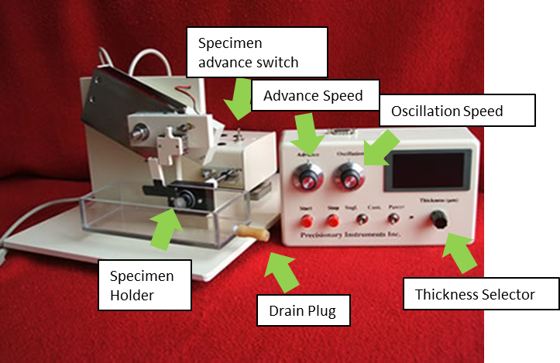
Figure 4. Diagram of compresstome.

- Appendix
  - Prepare carousel well covers.
    - Lay out several paper towels. Place desired number of washers on paper towels, with the flat side facing up.
    - Use scissors to cut out several 1”x1” sections of nylon mesh.
    - Liberally apply superglue to the upper face of each washer. Gently lay a nylon square onto each washer and leave them to dry overnight.
    - Trim excess mesh from each washer using scissors. Rinse final product with DI water before use.

  - Surgical Workstation Guide
Step 1 | Check all valves on red, purple and yellow lines of the Isoflurane system to make sure all valves are secure.
Step 2 | Turn on the wall oxygen regulator; set level to 50 psi.
Step 3 | Turn on the induction chamber vacuum valve by turning the switch parallel with the purple line.
Step 4 | Make sure the vacuum is functioning by placing finger near outlet
Step 5 | Open the vacuum valve and Isoflurane valves.
Step 6 | Direct the red line flow to the induction chamber.
Step 7 | Turn the Isoflurane regulator to setting 3.0-5.0 (3-5%).
Step 8 | Turn the Oxygen regulator to setting 1.0 (1 L/min).
Step 9 | Check for noticeable isoflurane odor. If the smell of isoflurane is strong, there is a leak in the system.
Step 10 | Charge the induction chamber for at least 30 seconds prior to placing the mouse in the induction chamber.
Step 11 | Open lid to induction chamber, place mouse inside, then close lid.
Step 12 | Once the mouse is fully unconscious, turn off the Isoflurane and Oxygen.
Step 13 | Leave the vacuum from the induction chamber on.
Step 14 | Turn on vacuum to the scoop underneath the nosecone on the surgical rig by making the valve horizontal to the purple line.
Step 15 | Double check the scoop’s vacuum by placing a finger near the outlet.
Step 16 | Switch the isoflurane system from the induction chamber (red line) to the nosecone (yellow line) by closing the red line valve and opening the valve to the yellow line.
Step 17 | Turn on the isoflurane to 1.5% and the oxygen to 0.6 L/min and begin surgical procedure.
Step 18 | Check for noticeable isoflurane odor. If the smell of isoflurane is strong, there is a leak in the system.
Step 19 | Leave the vacuum to the induction chamber on for 5 minutes to ensure isoflurane in the induction chamber is completely removed.
Step 20 | When surgery is finished turn off Isoflurane and Oxygen.
Step 21 | Let scoop vacuum remain on at least 5 minutes before turning off. It is ok to leave on until next surgery.

