Slice Preparation with Tissue Dissociation - Mouse

- Scope and Applicability: This protocol describes the procedure for transcardial perfusion of an adult mouse, followed by brain dissection, embedding, slicing, blockface imaging, ROI microdissection, and tissue dissociation. The output of this protocol is a cell suspension that can be sorted via FACS for single-cell transcriptional profiling.

- Materials:
  - 2% Low melt Agarose (Sigma A0576)
  - Tissue ink (Bradley Products, Inc. 1013-3)
  - 70% Ethanol (RP0032)
  - ACSF.I (RP0218)
  - Obrien Angular Scissors (Roboz RS-5928)
  - Blue Absorbent Pads (Fischer Scientific 14-206-59 or equivalent)
  - Blunt tip perfusion needles, 25G
  - Bracken Forceps (Roboz RS-5211)
  - Carbogen
  - Deionized Water
  - MilliQ Water
  - Trehalose Dihydrate (Sigma T9531 or equivalent)
  - 250ml Polystyrene Storage Bottle (Corning or equivalent)
  - Double Ended Freer Elevator (Roboz RS-8820)
  - Dumont Forceps (Roboz RS-5045)
  - 5/8” 25 G Needles
  - Heat Sink (Precisionary Instruments)
  - Isoflurane (Piramal Critical Care Inc. 330250)
  - Wet ice
  - Kimwipes
  - Paper towels
  - Mayo Scissors (Roboz RS-6875SC)
  - Aluminum foil
  - Nose Cone
  - 1 ½” 18 G needle
  - MB-10
  - Paintbrush (Ted Pella #1)
  - Peristaltic pump tubing (1/16” ID, 1/16” OD, 1/16” wall thickness)
  - Two Petri Dishes (3051 Corning)
  - Two Round Pyrex dishes (VWR 89090-658)
  - Two PELCO Pre-Exe 6-well plates (Ted Pella 36157-1)
  - PBS (RP0001)
  - Ice bucket
  - Scalpel (Feather 2976 #11)
  - Large Ring 4” Scissors (Roboz RS-5852)
  - Moria perforated spoon (Fine Science Tools 10370-18)
  - Razor blade (VWR 94-0391
  - Specimen syringe (Precisionary Instruments)
  - Papain (Worthington Biochemical PDS kit, LK003176/LK003178).
    - If Papain is unavailable, Pronase (Sigma P6911, Roche 10165921001, Millipore 537088 or equivalent) may be used.
  - Fetal Bovine Serum (HyClone SH30070.02)
  - 30% BSA (Sigma 126625 or equivalent)
  - 9” glass Pasteur pipettes
  - Plastic disposable Pasteur pipettes, cut to increase opening size to be able to fit slice.
  - Filter paper
  - Isoflurane
  - Sylgard-coated dishes
  - Stir bar
  - Styrofoam board
  - Superglue
  - Black sharpie marker
  - Micro-Dissecting Scissors (Roboz RS-5914)
  - 1 ml Polystyrene Microcentrifuge Tubes (Fisherbrand 04-978-145)
  - 5 ml Syringe (VWR BD309646 or equivalent)
  - 20g needle (VWR BD305175 or equivalent)
  - Postnatal mouse

- Equipment:
  - 4°C Refrigerator
  - Water bath (VWR 89501-460, or equivalent)
  - Class II Biological Safety Cabinet
  - Harvard Apparatus Peristaltic Pump 66 (MA1-55-7766)
  - VetEquip Table Top Laboratory Animal Anesthesia System (901806) with associated tubing (Feeder Tube) and induction chamber
  - Compresstome (Precisionary Instruments VF-300) with attached camera
  - Laptop computer with custom camera viewer software
  - Two LED strips containing three lights each, with attached power source
  - T-Cube LED driver (Thorlabs M00424246)
  - Thermomixer (VWR 89232-910 or equivalent)
  - Dry oven set to 35ºC (Thermo Scientific PR305225G or equivalent)
  - Oxygen Diffuser
  - Laboratory Microwave
  - Vortex
  - Stirplate (VWR 74451-152 or equivalent)
  - Fluorescent dissecting microscope, camera and image acquisition software (Nikon SMZ1500, or equivalent)
  - -20°C freezer.
  - Laboratory Portable Bunsen Burner (PRO-2121)

- Safety:
  - Universal precautions should be used when handling animals
  - Disposable lab coat
  - Gloves
  - Eye Protection
  - This procedure should be performed by IACUC-approved and trained personal only.
- Output:
  - Single-cell suspensions suitable for analysis via FACS and transcriptional profiling.

- Reference Documents: (Include all that apply)
  - QC1011 Tissue Quality Evaluation for Brain Perfusion/Dissection Specimens
    - https://www.protocols.io/view/tissue-quality-evaluation-for-brain-perfusion-diss-besmjec6/abstract
  - RP0218 ACSF.I
    - https://www.protocols.io/view/artificial-cerebrospinal-fluid-i-acsf-i-bezkjf4w/abstract
  - TPWI-001 Mouse Cell Prep Sorting
  - Harvard Apparatus Peristaltic Pump 66 manual
    - “557766_Pump_66,67_Manual.pdf”
  - VetEquip Table Top Laboratory Animal Anesthesia System Operation Manual:
    - “LAAS Manual.pdf”
  - Compresstome VF-300 operation manual
    - “Compresstome-VF-300-0Z-User-Manual-Edited-8-14.pdf”

Warning: Personal Protective Equipment (PPE) should be used at all times while performing this protocol. If you are unsure what PPE you should be using, see your immediate supervisor.

Isoflurane Warning: Acute over-exposure to waste anesthetic gases (WAG) may cause eye irritation, headache, nausea, drowsiness or dizziness. Repeated exposure may cause damage to cardiovascular system and central nervous system. Refer to MSDS for additional information.

Only approved and appropriately trained personnel may perform this procedure.

- Setup:
  - Prepare 250 ml 0.132M Trehalose Stock (if needed)
    - Using a graduated cylinder, measure and add 200 ml MilliQ water into a clean beaker containing a stir bar. Place beaker on a stir plate at medium speed.
    - Weigh out and add 12.485 g Trehalose dihydrate.
    - Once Trehalose has fully dissolved, transfer solution back to a graduated cylinder.
    - Adjust final volume to 250 ml and transfer to a clean 250 ml Corning bottle.
    - 0.132M Trehalose can be stored at 4˚C for up to 30 days.
  - Prepare fire-polished pipettes (if needed)
    - Place portable Bunsen burner on stand so that nozzle is facing upwards.
    - Make sure the safety switch is unlocked. Open the gas valve by turning the red knob on the back of the device.
    - Firmly pull the trigger to light the flame.
    - Turn the gas down until the flame is at a steady peak and not wavering in the air.
    - Using tweezers, remove the cotton filter from a glass 9” pipette.
    - Hold the skinny neck of the pipette over the peak of the flame about ½” from the point on the pipette where the taper begins.
    - As the glass begins to melt, pull the ends of the pipette away from each other.
    - Discard the broken off skinny end of the pipette.
    - Using a pair of tweezers, gently break off the very tip of the fired pipette end. There should now be a small opening at the end of the pipette.
    - Place the broken end of the pipette back into the flame for brief, three second intervals to smooth out the broken glass. Inspect the glass each time to ensure the pipette tip has not closed.
    - Repeat steps 7.15.1 – 7.15.9, varying the time the pipette is held in the flame by a few seconds, until you have pipettes with fire-polished ends of large (~600 µm), medium (~300 µm), medium-small (~200 µm) and small (~150 µm) thickness. Pipette size is estimated when priming with ACSF, where the largest bore will pull up solution the fastest.
  - Prepare FBS aliquots (if needed)
    - Turn water bath on and set to 34˚C.
    - Once water bath has reached desired temperature, remove the bottle of fetal bovine serum from the freezer and place in the water bath to thaw.
    - After 10 minutes in the bath, gently swirl the contents of the bottle to ensure the mixture is homogeneous. Repeat every 10 minutes until contents have thawed completely.
    - Using a serological pipette, remove 25 ml of fetal bovine serum from the bottle and dispense into a 50 ml conical tube. Return the bottle and its remaining contents to the freezer.
    - Using a P200 pipette, aliquot 200 µl fetal bovine serum from the conical tube into each Eppendorf tube.
    - Extra fetal bovine serum aliquots can be stored at -20˚C for up to 6 months.
  - Prepare 140 units/ml Pronase aliquots (if needed)
    - Verify on certificate of analysis the units/mg of the Pronase lot to be used.
    - Determine amount of Pronase needed to make 25 ml worth of aliquots:

3500 units / # units per mg Pronase = mg Pronase needed for 25 ml stock

    - Add 25 ml MilliQ water to a small beaker that contains a stir bar.
    - Place the beaker on a stir plate and begin stirring at a medium speed.
    - Weigh out and add amount of Pronase from equation above to the stirring MilliQ.
    - Once the Pronase has dissolved, remove from stir plate and aliquot 250 µl into 1.7 ml Eppendorf tubes.
    - Extra Pronase aliquots can be stored at -20˚C for up to 6 months.
  - Prepare 2% Agarose
      - Ensure thermomixer is set to 350 rpm and 43˚C.
      - Place 500 ml beaker on the balance and tare the scale.
      - Add 0.5 g low melt Agarose.
      - Pour in 25 g 1x PBS.
      - Add 2-3 drops of black tattoo ink, and record final weight.
      - Swirl to mix.
      - Heat in microwave for 1.5 minutes.
      - Put beaker back on the balance and add MilliQ water to bring the total weight up to recorded weight from step 7.5.1.5.
      - Aliquot Agarose into Eppendorf tubes and put in tube holes in the Thermomixer.
  - Prepare 30 U/ml Papain (if using Papain)
    - Determine volume of ACSF.IT required to prepare 30 U/ml solution.
      - Check the Units of activity for the specific vial/lot of Papain to be used and calculate volume of ACSF to add using the following equation:

# Units Stock Vial/30 U final volume = Volume ACSF.IT to add (ml)

      - In the example above, if stock Papain vial contains 125 U, then 125/30=4.167 ml of ACSF.IT should be added to reach 30 U/ml working volume.
    - Remove metal seal from Papain vial, exposing rubber plug.
    - Attach a 20g needle to a 5 ml syringe. Use it to measure out ACST.IT.
    - Insert needle through plug of Papain vial and dispense ACSF.IT. Invert 8-10 times or as necessary to ensure all powder has been dissolved. Briefly vortex the papain solution if needed.
    - Place vial in dry oven set to 35ºC until ready for use (minimum 30 min before digestion).
  - Prepare 0.2% BSA solution (if using Papain).
    - Using a serological pipette, add 14.75 ml ACSF.IT to a labeled 50 ml conical tube.
    - Using a p200 pipette, add 150 µl of FBS.
    - Using a p200 pipette, add 100 µl 30% BSA. Invert 4-5 times to mix.
  - Setup the compresstome for slicing
    - Fill ice bucket with wet ice.
    - Turn on compresstome and ensure slice thickness, advance knob, and oscillation knob are all set to appropriate values. Advance and oscillation settings will vary by machine and should be evaluated by an experienced user for optimal performance.
      - Set desired slice thickness. Default is 250 µm.
      - Set the advance knob such that the blade takes approximately 20 seconds to complete a full pass. This setting will generally range from 0.9-1.1.
      - Oscillation knob should be set so that the motor makes an audible chatter, but not so high that it creates a loud buzzing noise. This setting will generally range from 2.7-3.4.
    - Plug in the LED strips. Turn knob of T-Cube clockwise to turn lights on.
    - Verify visually that all six lights are working.
    - Turn on the laptop and open the Camera Viewer software. Check to make sure that there is a live image showing.
    - Obtain 1L of fresh ACSF.I for each mouse to be perfused and place on ice.
Note: ACSF should be less than 48 hours old, and not used if older than 72 hours.

    - Prepare 10% 0.132M Trehalose in ACSF.I (ACSF.IT)
      - Using a graduated cylinder, measure 135 ml ACSF.I.
      - Add 15 ml 0.132M Trehalose to the graduated cylinder.
    - Fill one round Pyrex dish with ACSF.IT (if using Papain, be sure to reserve approximately 15ml for the 0.2% BSA solution). Place the dish in a tray filled with wet ice on a stir plate. Add a stir bar, slice carriers, and oxygen diffuser stone in the dish. Turn stir plate on and set to preset mode 4 (no heat, 350 RPM).
    - Put the other oxygen diffuser stone into the bottle of ACSF.I on ice.
    - Turn on Carbogen and ensure both the ACSF.IT and bottle of ACSF.I are lightly bubbling. Allow both to bubble for at least 10 minutes before use.
    - Place the heat sink in the wet ice.
    - Identify the desired angle at which the brain should be sliced, then use a black sharpie marker to color the entire mounting face of the appropriately angled specimen syringe.
  - Set up for the perfusion.
    - Obtain a bottle of Isoflurane from the Legend Drug cabinet (stored at room temperature) following the protocol outlined in the Institute Controlled Substance and Legend Drug policy.
    - Attach the 18G blunt needle to the Luer connector by twisting it on tightly.
    - Cover Styrofoam board with aluminum foil.
    - Place nose cone on one end of Styrofoam board.
    - Place paper towel in induction chamber.
    - Pour approx. 50 ml of ACSF.I into a 50 ml conical tube or glass jar and place in the hood. Put the feeder end of the pump tube in the ACSF.I. Turn the pump on and prime the tube until liquid is being expelled from the needle at the end of the line.

- Methodology:
  - Perfuse the mouse with ice cold, oxygenated ACSF. I.
    - Turn oxygen gauge to 1% and Isoflurane to 5 on the VetEquip table top laboratory anesthesia system, and place the mouse in the induction chamber.
    - Once the mouse has stopped moving and its breathing has changed to about once per second remove the mouse from chamber (at least 3 minutes).
    - Use the toe pinch reflex test to determine whether the mouse is anesthetized. If the mouse reacts, place back in the chamber for an extra 1-2 minutes, then remove and recheck toe pinch reflex.
    - After the mouse has been anesthetized in induction chamber, switch Isoflurane flow to the nose cone.
    - Position the mouse supine on Styrofoam board, with nose inserted into the nose cone.
    - Pin all four paws to the board with 5/8’’ 25 G needles.
    - Spray the body of the mouse with 70% EtOH.
    - Using the micro dissecting scissors cut the entire ventral surface of skin over thorax.
    - Grasp the xiphoid process with the Dumont forceps. Carefully snip the diaphragm to open the thoracic cavity.
    - While holding the xiphoid process, snip up both sides of the rib cage with the micro dissecting scissors. Avoid nicking any internal organs.
    - Using the micro dissecting scissors carefully snip the right atrium. The bracken forceps can be used to stabilize the heart for this step.
    - Insert the 18 G blunt perfusion needle into the left ventricle directing the tip of the needle toward the aorta (see Figure 1 for anatomical reference). Note: Exsanguination will not occur if needle is placed in the right ventricle or crosses the septum. Observation of fluid flowing from the nose/mouth indicates flow through the pulmonary artery and will result in suboptimal brain perfusion.
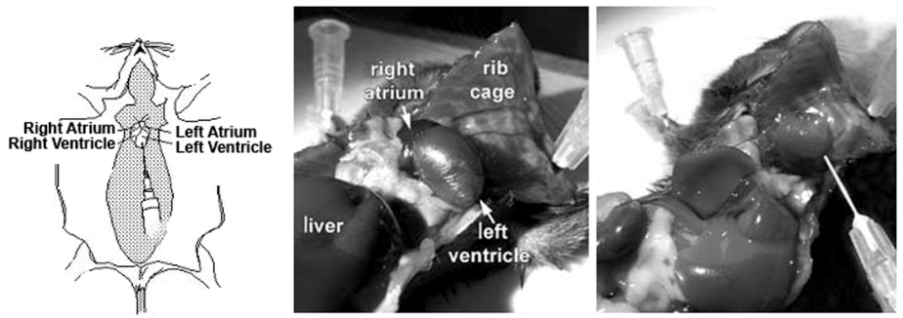
Figure 1. Anatomical Reference for Mouse Preparation and Needle Placement

    - Release the needle and tubing to lay flat against the board. Ensure that the needle remains in place in the heart during this process.
    - Run chilled, bubbled ACSF.I using pump mode by pressing the red “Run/Stop” button. Note: If perfusate is observed through nose/mouth, or if liver is not clearing, stop the pump, reposition the needle, (directed toward aorta,) and then continue pumping. Turn off the Isoflurane once 10ml has been pumped.
    - Once 25ml has been pumped, press the “Run/Stop” button again to stop the pump. The liver should be cleared of blood after perfusion.
    - Remove the needles from the animal and leave the oxygen on for a couple of minutes to clear the system.
  - Evaluate perfusion and dissection quality per SOP QC1011.
  - Dissect out the brain and prepare for slicing.
    - Immediately following perfusion with ACSF.I, remove the head of the mouse using the Mayo scissors.
    - Using the large ring scissors, start at the neck and make an incision across the top of the head toward the nose to begin to expose the skull.
    - Make cuts through each ear to further pull back the tissue from the skull.
    - Cut excess tissue off the back of the skull.
    - Cut the bone with the Obrien angled scissors starting at the opening in the occipital bone in the back of the skull and working forward, staying above the ears, around the parietal bone and above the eye sockets on either side. Keep the flat side of the scissors under the bone and always lift upward while cutting to avoid damaging the tissue.
    - Peel back the frontal and parietal bones with forceps. Use scissors to cut the dura mater.
    - Fill one 100 mm petri dish with chilled, bubbled ACSF.I.
    - Using the Freer elevator, remove the brain from the skull and place in the small petri dish containing ACSF.I.
    - Use the Moria spoon to place brain on a piece of filter paper. Use either a razor blade or a scalpel blade to remove unwanted brain regions, creating a flat mounting surface.
      - If slicing caudal to rostral, remove the anterior 1/3 of the brain and entire cerebellum. Use the anterior side as the mounting surface.
      - If slicing rostral to caudal, remove the cerebellum only. Use the posterior side of brain as the mounting surface.
    - Return brain to chilled, bubbled ACSF.I immediately after trimming.
    - Verify the number on both the specimen syringe and metal holder match the number of the compresstome to be used, as these are not interchangeable between machines. Apply a small amount of superglue to the tip of the specimen syringe.
    - Using the Moria spoon, remove the remaining section of brain from the ACSF.I. Gently touch the bottom of the spoon onto filter paper or a paper towel 2-3 times to remove excess liquid, then place the appropriate side of the brain onto the super glue.
      - Ensure that the brain is centered on syringe.
    - Attach the metal holder to the specimen syringe. Remove heat sink from ice and encase metal holder.
    - Use a semi-wide mouth plastic Pasteur pipette to cover the tissue with warm Agarose from one of the warming Eppendorf tubes.
    - Close the heat sink around the metal holder for 10 seconds, or until Agarose is visibly solidified.
  - Begin slicing and acquiring blockface images.
    - Insert specimen syringe into the bath of the compresstome up to the guard on the specimen syringe. Rotate the specimen syringe so that the tissue is orientated with the dorsal side up.
    - Fill the bath with chilled, bubbled ACSF.I (~250 ml).
    - Fill another small petri dish with enough chilled, bubbled ACSF.I to cover the bottom.
    - Unlock the motor from the standby position, move the motor forward and lock it down in the cutting position.
    - Flip selector switch on the motor to fast forward until the bar extends out and touches the end of the specimen syringe and then continue advancing until the tissue is exposed on the cutting edge. Flip selector switch back to neutral.
    - Begin cutting tissue by flipping selector switch on the control box to single.
    - When full face images are visible, begin acquiring blockface images by pressing the F1 key.
      - Images will appear in the image album. Make sure an image is acquired before each slice (See Figure 2).
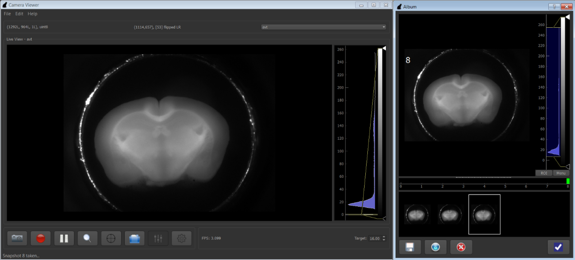
Figure 2. Blockface Image Interface and Album View

    - Collect slices from region(s) of interest. The slices that come up before/after the desired region can be discarded. Slices that are to be collected are lifted with a paintbrush and placed in the petri dish filled with chilled, bubbled ACSF.I.
      - Using a razor blade or a scalpel blade, cut the slice down the middle, separating the left and right hemispheres of the brain.
      - Using a wide mouth Pasteur pipette, gently remove the Agarose from around each hemisphere, taking care not to lose orientation. Transfer each hemisphere to the designated slice carousel using the wide mouth plastic Pasteur pipette.
      - Slices are loaded clockwise beginning at the thermistor hole. Wells are numbered 1-6. See Figure 3.
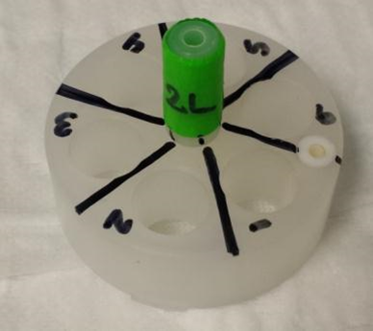
Figure 3. Slice carousel and numbering scheme.

    - Continue collecting tissue until all desired slices have been hemisected and at least 12 blockface images have been acquired.
    - After all blockface images have been acquired, and slicing is complete, upload the images to your Laboratory Information Management System.
  - Using a P1000 or plastic Pasteur pipette, fill a Sylgard-coated dissecting dish with 3 ml of 10% 0.132M Trehalose in ACSF.I.
  - Place one of the slices in the Sylgard-coated dish and transfer to a fluorescent dissecting microscope with an attached camera.
  - Dissect out regions of interest.
    - Acquire brightfield overview image of whole slice.
    - Acquire fluorescent overview image of whole slice.
    - Using microdissecting tools, dissect the regions of interest, leaving them in the cutout section.
    - Acquire brightfield overview image of the slice with ROI cutouts.
    - Acquire fluorescent overview image of the slice with ROI cutouts.
    - Acquire brightfield zoomed-in image of the ROI cutouts.
    - Acquire fluorescent zoomed-in image of the slice with ROI cutouts.
    - Using the microdissecting tools, separate the ROI cutouts from the rest of the tissue.
    - Obtain a wide bore P1000 pipette tip.
    - Using a wide bore P1000 pipette tip, aspirate the ROI cutouts, along with a little bit of the ACSF that is on the dish and dispense into a labeled 1 ml Polystyrene tube. Keep tube at room temperature until all dissections are complete.
      - If using Pronase for digestion, keep tubes on wet ice at all times during dissections.
    - Repeat steps 8.6 – 8.7.10 for the desired number of sections, as well as a QC sample from near the ROI which will be used for validating sample prep, FACS and gating.
  - Begin enzyme digestion
    - If using Papain
      - Using a p1000 pipette, remove as much supernatant as possible from micro-dissected tissue pieces in sample tube. Add 0.5-1 ml Papain (try to maximize number of samples digested per Papain vial).
      - Gently tap side of tube to ensure tissue pieces are not stuck together or are mostly separated from each other, then place tube in dry oven at 35ºC for 30 minutes. Note: it may be necessary to rest the tube at an angle to keep tissue from sinking to the bottom. If pieces are not separating, it may be necessary to gently swirl tube 15 minutes into the digestion.
    - If using Pronase
      - Prepare 6.6667units/ml digestion solution
        - Obtain 4.475 ml of bubbled ACSF.I and add to a 15 ml conical tube.
        - Using a P1000 pipette, add 0.525 ml 0.132M Trehalose.
        - Using a P1000 pipette, add contents of thawed 250 µl Pronase aliquot.
        - Gently invert 2-3 times to mix.
      - Using a standard P1000 pipette tip, remove the ACSF from the 1 ml Polystyrene tube containing microdissected tissue samples. Take care not to aspirate any of the cutouts.
      - Add 1 ml of the digestion solution to each 1 ml Polystyrene tube.
      - Allow to sit at room temperature for a time equal to the age of the mouse + 15 minutes, up to a maximum of 75 minutes.
      - Example – A p56 mouse would need 56 minutes + 15 minutes of digestion time.
      - Prepare the 1% FBS in ACSF.I solution when there are about 15 minutes left in the Pronase incubation.
        - Obtain an aliquot of FBS from the -20°C freezer and allow to thaw.
        - Add 8.9 ml of chilled bubbled ACSF.I to a 15 ml conical tube.
        - Add 100 µl of FBS to the ACSF.I. Take care not to create too many bubbles.
        - Add 1 ml 0.132M Trehalose.
        - Invert 3-4 times to mix.
  - Once enzyme digestion is complete, use a P1000 pipette to aspirate the digestion solution from the 1 ml Polystyrene tube.
  - Dispense 1 ml of wash buffer Papain into the 1 ml Polystyrene tube.
    - If using Papain, wash with 0.2% BSA solution.
    - If using Pronase, wash with 1% FBS in ACSF.IT
  - Allow the ROI cutouts to settle back to the bottom of the Eppendorf tube.
  - Repeat 8.10 – 8.11 two more times.
  - On the 3rd rinse, add only 0.5 ml Papain wash buffer and do not aspirate the solution from the 1 ml Polystyrene tube. If using Papain, place washed samples on wet ice for 5 minutes.
  - Triturate the tissue to generate a single cell suspension.
    - Obtain the fire polished pipettes and rubber bulbs and attach the bulbs to the pipettes. Note: Pipette sizes required will vary and be determined by size/amount/type of tissue to be dissociated.
    - Prime each pipette by aspirating a small amount (~1 ml) of wash buffer and dispensing into a waste container.
    - Using the largest pipette, aspirate the solution + ROI cutouts ~10 times, being careful to go slowly and not to introduce bubbles. (Bubbling and aspirating too quickly will shear the cells, reducing their viability.)
    - Repeat step 8.14.2-8.14.3 with the one or two remaining pipettes, going from largest to smallest.
    - Following the last trituration, the solution should be cloudy with no visible particles.
  - Immediately following trituration, store the cell suspension on wet ice and proceed to flow cytometer.

- Take Down
  - After the last perfusion, run deionized water through the tubing for at least 6 ml. Then remove the tubing from the water and run air through the tubing to dry it, until all the water is removed.
  - Drain the compresstome bath into a large beaker or waste bottle.
    - Waste ACSF can be disposed of down the sink.
  - Rinse the bath with two rinses of MilliQ water.
    - MilliQ water rinse can be disposed of down the sink.
  - Remove leftover tissue and super glue from the specimen syringe by using a razor blade to scrape it off.
    - Dispose of remaining tissue and super glue in a biohazard waste disposal bin.
  - Place Styrofoam board, scissors, forceps, and needles used during perfusion, specimen syringe, waste beakers and petri dishes in the sink and rinse with hot water.
  - After hot water rinse, spray with 70% EtOH.
  - Place on a blue absorbent pad to dry.
  - Aspirate hot water into each fire-polished pipette 3-5 times to rinse, then return to designated location.
  - Clean out anesthesia chamber by throwing out the paper towel and spraying and wiping the chamber down with MB-10.
  - Place mouse remains in a carcass bag, and dispose of appropriately.
  - Place used blades in biohazard sharp disposal container.
  - Check to make sure that all Isoflurane, Oxygen, and Carbogen valves have been turned off.
- Technical Information
  - Compresstome VF-300 User Guide:
    - http://www.youtube.com/watch?v=qDP01YC9wvU&list=PL29437B1E9BB78090

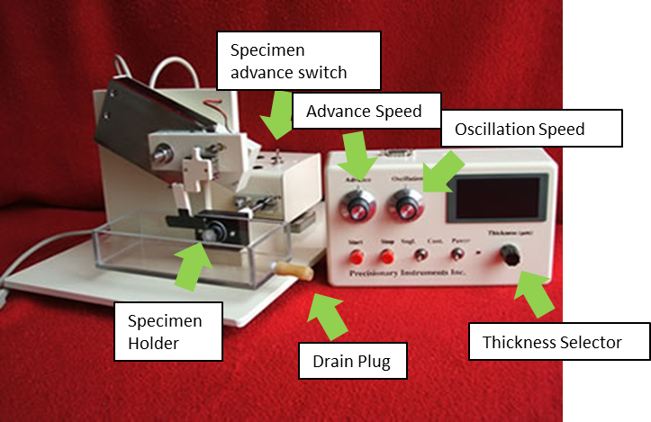
Figure 4. Diagram of compresstome

- Appendix
  - Surgical Workstation Guide
Step 1 | Check all valves on red, purple and yellow lines of the Isoflurane system to make sure all valves are secure.
Step 2 | Turn on the wall oxygen regulator; set level to 50 psi.
Step 3 | Turn on the induction chamber vacuum valve by turning the switch parallel with the purple line.
Step 4 | Make sure the vacuum is functioning by placing finger near outlet
Step 5 | Open the vacuum valve and Isoflurane valves.
Step 6 | Direct the red line flow to the induction chamber.
Step 7 | Turn the Isoflurane regulator to setting 3.0-5.0 (3-5%).
Step 8 | Turn the Oxygen regulator to setting 1.0 (1 L/min).
Step 9 | Check for noticeable isoflurane odor. If the smell of isoflurane is strong, there is a leak in the system.
Step 10 | Charge the induction chamber for at least 30 seconds prior to placing the mouse in the induction chamber.
Step 11 | Open lid to induction chamber, place mouse inside, then close lid.
Step 12 | Once the mouse is fully unconscious, turn off the Isoflurane and Oxygen.
Step 13 | Leave the vacuum from the induction chamber on.
Step 14 | Turn on vacuum to the scoop underneath the nosecone on the surgical rig by making the valve horizontal to the purple line.
Step 15 | Double check the scoop’s vacuum by placing a finger near the outlet.
Step 16 | Switch the isoflurane system from the induction chamber (red line) to the nosecone (yellow line) by closing the red line valve and opening the valve to the yellow line.
Step 17 | Turn on the isoflurane to 1.5% and the oxygen to 0.6 L/min and begin surgical procedure.
Step 18 | Check for noticeable isoflurane odor. If the smell of isoflurane is strong, there is a leak in the system.
Step 19 | Leave the vacuum to the induction chamber on for 5 minutes to ensure isoflurane in the induction chamber is completely removed.
Step 20 | When surgery is finished turn off Isoflurane and Oxygen.
Step 21 | Let scoop vacuum remain on at least 5 minutes before turning off. It is ok to leave on until next surgery.

  - Process Overview: Steps covered in this SOP are shown in yellow.
